**MARVIN ODON GOZO**

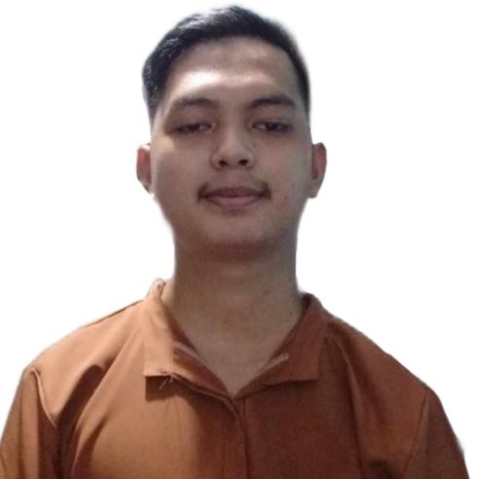267 Saturnina compound, Sauyo, Quezon City

Mobile +639164406140

Email: [gozo.marvin23@gmail.com](mailto:gozo.marvin23@gmail.com)

**OBJECTIVE**

Motivated and Dedicated Information Technology student with a strong foundation in programming. Seeking an internship opportunity in a dynamic company to apply classroom learning and to gain hands-on experience in professional field.

**PERSONAL DATA**

Date of Birth September 10, 2001

Place of Birth Valenzuela City

Civil Status Single

Citizenship Filipino

Religion Catholic

Height 1.79cm

Weight 53kg

Father’s Name Benedicto P. Gozo

Mother’s Name Marciana O. Gozo

**EDUCATIONAL BACKGROUND**

**Primary** Payatas B. Elementary School

2008 – 2014

**Secondary** Justice Cecilia Munoz Palma High School

2014 – 2018

Justice Cecilia Munoz Palma Senior

High School

Tech VOC ICT - ANIMATION

2018 - 2020

**Tertiary**  Quezon City University

Bachelor of Science in Information Technology

2020 – Present

**Skills**

Knowledgeable in:

* HTML
* CSS
* Javacsript Ajax
* Php

**CHARACTER REFERENCES**

**Jan-Lucky Verdadero - Food Handler at Andoks**

09511444227

**Jonathan Guro – Customer Service Representative**

09452655324

**Mac Morphy Jimenez – Messenger at TCA Digital Square**

09303543166

*I hereby certify that the above statements are true and correct*

**

Marvin O. Gozo

**Applicant’s Signature**