Module 2 Assignment 2

## Silas, Kimberly

tidyverse.quiet = TRUE  
library(tidyverse) #tidyverse set of packages and functions

## -- Attaching packages --------------------------------- tidyverse 1.2.1 --

## v ggplot2 3.1.0 v purrr 0.3.2   
## v tibble 2.1.1 v dplyr 0.8.0.1  
## v tidyr 0.8.3 v stringr 1.4.0   
## v readr 1.3.1 v forcats 0.4.0

## -- Conflicts ------------------------------------ tidyverse_conflicts() --  
## x dplyr::filter() masks stats::filter()  
## x dplyr::lag() masks stats::lag()

library(GGally) #create ggcorr and ggpairs plots

##   
## Attaching package: 'GGally'

## The following object is masked from 'package:dplyr':  
##   
## nasa

library(MASS) #access to forward and backward selection algorithms

##   
## Attaching package: 'MASS'

## The following object is masked from 'package:dplyr':  
##   
## select

library(leaps) #best subset selection

bike <- read_csv("hour.csv")

## Parsed with column specification:  
## cols(  
## instant = col_double(),  
## dteday = col_date(format = ""),  
## season = col_double(),  
## yr = col_double(),  
## mnth = col_double(),  
## hr = col_double(),  
## holiday = col_double(),  
## weekday = col_double(),  
## workingday = col_double(),  
## weathersit = col_double(),  
## temp = col_double(),  
## atemp = col_double(),  
## hum = col_double(),  
## windspeed = col_double(),  
## casual = col_double(),  
## registered = col_double(),  
## count = col_double()  
## )

bike = bike %>% mutate(season = as_factor(as.character(season))) %>%  
mutate(season = fct_recode(season,  
"Spring" = "1",  
"Summer" = "2",  
"Fall" = "3",  
"Winter" = "4"))%>%   
mutate(yr = as_factor(as.character(yr)))%>%   
mutate(mnth = as_factor(as.character(mnth))) %>%   
mutate(hr = as_factor(as.character(hr)))%>%   
mutate(holiday = as_factor(as.character(holiday))) %>%  
mutate(holiday = fct_recode(holiday,  
"NotHoliday" = "0",  
"Holiday" = "1")) %>%  
mutate(workingday= as_factor(as.character(workingday))) %>%  
mutate(workingday = fct_recode(workingday,  
"NotWorkingDay" = "0",  
"WorkingDay" = "1")) %>%  
mutate(weathersit = as_factor(as.character(weathersit))) %>%  
mutate(weathersit = fct_recode(weathersit,  
"NoPrecip" = "1",  
"Misty" = "2",  
"LightPrecip" = "3",  
"HeavyPrecip" = "4"))  
 bike

## # A tibble: 17,379 x 17  
## instant dteday season yr mnth hr holiday weekday workingday  
## <dbl> <date> <fct> <fct> <fct> <fct> <fct> <dbl> <fct>   
## 1 1 2011-01-01 Spring 0 1 0 NotHol~ 6 NotWorkin~  
## 2 2 2011-01-01 Spring 0 1 1 NotHol~ 6 NotWorkin~  
## 3 3 2011-01-01 Spring 0 1 2 NotHol~ 6 NotWorkin~  
## 4 4 2011-01-01 Spring 0 1 3 NotHol~ 6 NotWorkin~  
## 5 5 2011-01-01 Spring 0 1 4 NotHol~ 6 NotWorkin~  
## 6 6 2011-01-01 Spring 0 1 5 NotHol~ 6 NotWorkin~  
## 7 7 2011-01-01 Spring 0 1 6 NotHol~ 6 NotWorkin~  
## 8 8 2011-01-01 Spring 0 1 7 NotHol~ 6 NotWorkin~  
## 9 9 2011-01-01 Spring 0 1 8 NotHol~ 6 NotWorkin~  
## 10 10 2011-01-01 Spring 0 1 9 NotHol~ 6 NotWorkin~  
## # ... with 17,369 more rows, and 8 more variables: weathersit <fct>,  
## # temp <dbl>, atemp <dbl>, hum <dbl>, windspeed <dbl>, casual <dbl>,  
## # registered <dbl>, count <dbl>

Leaving the yr, mnth, and hr factors as numbers would cause ggcorr to attempt to make a correlation on those columns

ggcorr(bike, label = "TRUE", label_round = 2)

## Warning in ggcorr(bike, label = "TRUE", label_round = 2): data in  
## column(s) 'dteday', 'season', 'yr', 'mnth', 'hr', 'holiday', 'workingday',  
## 'weathersit' are not numeric and were ignored

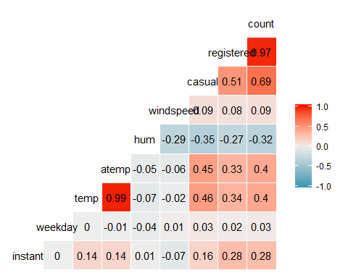 The atemp (normalized feeling temp in celsius) and temp (normalized temp in celsius)has the strongest correlation to count both with a .4

ggplot(bike,aes(x=season,y=count)) + geom_boxplot()

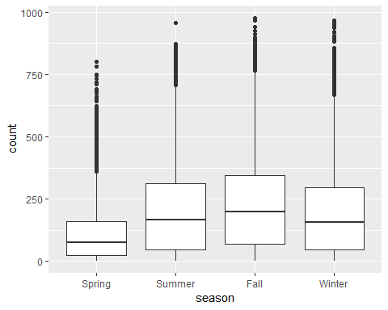

ggplot(bike,aes(x=yr,y=count)) + geom_boxplot()

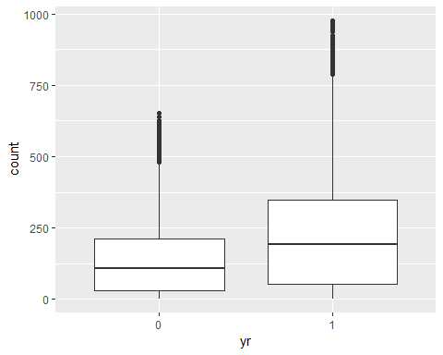

ggplot(bike,aes(x=mnth,y=count)) + geom_boxplot()

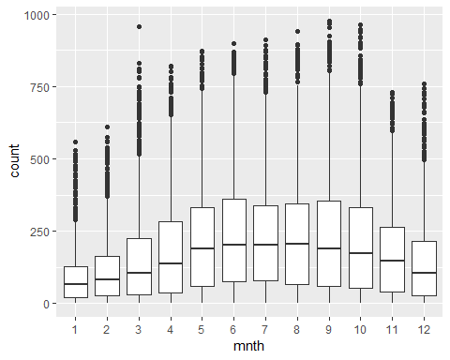

ggplot(bike,aes(x=hr,y=count)) + geom_boxplot()

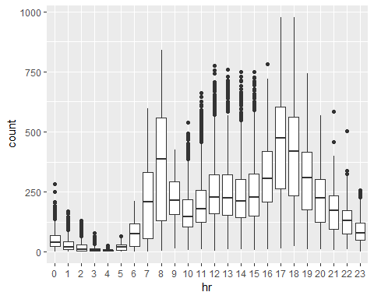

ggplot(bike,aes(x=holiday,y=count)) + geom_boxplot()

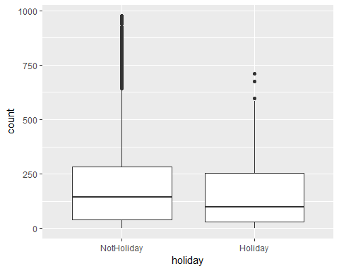

ggplot(bike,aes(x=workingday,y=count)) + geom_boxplot()

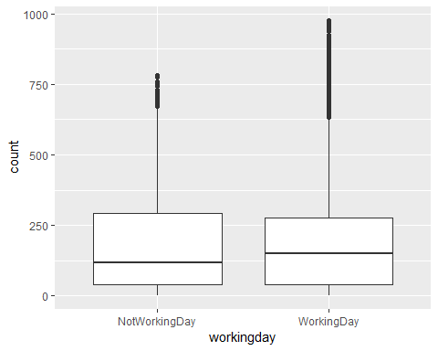

ggplot(bike,aes(x=weathersit,y=count)) + geom_boxplot()

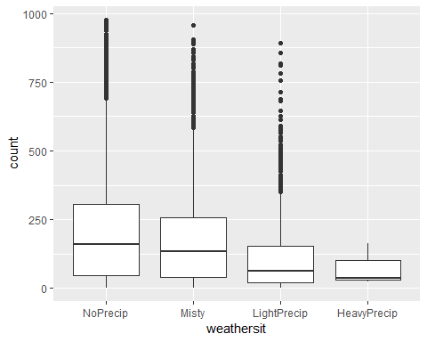 Based on the boxplots above it would appear that season has a slight effect on the bike share service counts in DC, mnth shows a more indepth look at how the seasons breakdown effects the counts with a more distinct rise in the warmer months, weathersit is the last obvious effect on count. Holiday and workingday appears to have little to no effect on the counts.

bike2 = bike %>% dplyr::select(-c(instant, dteday, registered, casual))  
allmod = lm(count ~. , bike2)   
summary(allmod)

##   
## Call:  
## lm(formula = count ~ ., data = bike2)  
##   
## Residuals:  
## Min 1Q Median 3Q Max   
## -396.57 -60.52 -7.94 51.34 440.09   
##   
## Coefficients:  
## Estimate Std. Error t value Pr(>|t|)   
## (Intercept) -82.9524 6.5953 -12.577 < 2e-16 ***  
## seasonSummer 38.2221 4.8541 7.874 3.63e-15 ***  
## seasonFall 32.0083 5.7453 5.571 2.57e-08 ***  
## seasonWinter 67.9953 4.8805 13.932 < 2e-16 ***  
## yr1 85.4355 1.5629 54.664 < 2e-16 ***  
## mnth2 3.4226 3.9199 0.873 0.38260   
## mnth3 14.2635 4.4063 3.237 0.00121 **   
## mnth4 6.2084 6.5444 0.949 0.34280   
## mnth5 20.6186 7.0032 2.944 0.00324 **   
## mnth6 6.3022 7.1983 0.876 0.38131   
## mnth7 -13.1385 8.0710 -1.628 0.10357   
## mnth8 8.0369 7.8701 1.021 0.30718   
## mnth9 32.2709 6.9940 4.614 3.98e-06 ***  
## mnth10 15.8639 6.4811 2.448 0.01439 *   
## mnth11 -9.8985 6.2357 -1.587 0.11244   
## mnth12 -6.3012 4.9530 -1.272 0.20331   
## hr1 -17.3027 5.3448 -3.237 0.00121 **   
## hr2 -26.3862 5.3635 -4.920 8.75e-07 ***  
## hr3 -37.1333 5.4022 -6.874 6.47e-12 ***  
## hr4 -40.2915 5.4076 -7.451 9.71e-14 ***  
## hr5 -23.5197 5.3726 -4.378 1.21e-05 ***  
## hr6 35.3685 5.3584 6.601 4.22e-11 ***  
## hr7 170.3957 5.3479 31.862 < 2e-16 ***  
## hr8 310.7889 5.3415 58.184 < 2e-16 ***  
## hr9 163.1036 5.3471 30.503 < 2e-16 ***  
## hr10 108.4659 5.3692 20.202 < 2e-16 ***  
## hr11 133.8822 5.4090 24.752 < 2e-16 ***  
## hr12 173.1943 5.4553 31.748 < 2e-16 ***  
## hr13 168.1661 5.4930 30.615 < 2e-16 ***  
## hr14 152.3190 5.5239 27.574 < 2e-16 ***  
## hr15 161.7800 5.5347 29.230 < 2e-16 ***  
## hr16 223.9020 5.5231 40.539 < 2e-16 ***  
## hr17 377.5972 5.4908 68.769 < 2e-16 ***  
## hr18 345.6362 5.4547 63.365 < 2e-16 ***  
## hr19 236.9568 5.4036 43.851 < 2e-16 ***  
## hr20 157.3201 5.3742 29.273 < 2e-16 ***  
## hr21 107.8563 5.3524 20.151 < 2e-16 ***  
## hr22 70.9150 5.3423 13.274 < 2e-16 ***  
## hr23 32.1128 5.3380 6.016 1.82e-09 ***  
## holidayHoliday -20.6964 4.8515 -4.266 2.00e-05 ***  
## weekday 2.3997 0.3882 6.182 6.46e-10 ***  
## workingdayWorkingDay 4.7935 1.7241 2.780 0.00544 **   
## weathersitMisty -10.3762 1.9190 -5.407 6.49e-08 ***  
## weathersitLightPrecip -65.1539 3.2337 -20.148 < 2e-16 ***  
## weathersitHeavyPrecip -61.7563 58.8830 -1.049 0.29429   
## temp 115.9516 29.4751 3.934 8.39e-05 ***  
## atemp 128.2429 30.5806 4.194 2.76e-05 ***  
## hum -82.4959 5.5479 -14.870 < 2e-16 ***  
## windspeed -29.0663 7.0473 -4.124 3.73e-05 ***  
## ---  
## Signif. codes: 0 '***' 0.001 '**' 0.01 '*' 0.05 '.' 0.1 ' ' 1  
##   
## Residual standard error: 101.7 on 17330 degrees of freedom  
## Multiple R-squared: 0.6863, Adjusted R-squared: 0.6855   
## F-statistic: 790 on 48 and 17330 DF, p-value: < 2.2e-16

emptymod = lm(count ~1, bike2)   
summary(emptymod)

##   
## Call:  
## lm(formula = count ~ 1, data = bike2)  
##   
## Residuals:  
## Min 1Q Median 3Q Max   
## -188.46 -149.46 -47.46 91.54 787.54   
##   
## Coefficients:  
## Estimate Std. Error t value Pr(>|t|)   
## (Intercept) 189.463 1.376 137.7 <2e-16 ***  
## ---  
## Signif. codes: 0 '***' 0.001 '**' 0.01 '*' 0.05 '.' 0.1 ' ' 1  
##   
## Residual standard error: 181.4 on 17378 degrees of freedom

forwardmod = stepAIC(emptymod, direction = "forward", scope=list(upper=allmod,lower=emptymod),  
 trace = TRUE)

## Start: AIC=180764.7  
## count ~ 1  
##   
## Df Sum of Sq RSS AIC  
## + hr 23 286734681 285026910 168713  
## + temp 1 93677759 478083832 177657  
## + atemp 1 91907421 479854170 177721  
## + hum 1 59618351 512143240 178853  
## + mnth 11 42909976 528851615 179431  
## + season 3 37729358 534032233 179584  
## + yr 1 35876722 535884870 179641  
## + weathersit 3 12285030 559476561 180393  
## + windspeed 1 4970060 566791531 180615  
## + holiday 1 546889 571214702 180750  
## + workingday 1 524387 571237204 180751  
## + weekday 1 413728 571347863 180754  
## <none> 571761591 180765  
##   
## Step: AIC=168712.5  
## count ~ hr  
##   
## Df Sum of Sq RSS AIC  
## + atemp 1 50518941 234507969 165324  
## + temp 1 50101685 234925225 165355  
## + mnth 11 44822160 240204750 165761  
## + season 3 39619754 245407156 166117  
## + yr 1 36875130 248151780 166307  
## + weathersit 3 13766672 271260238 167858  
## + hum 1 4924310 280102600 168412  
## + windspeed 1 1476211 283550699 168624  
## + holiday 1 561784 284465126 168680  
## + workingday 1 485366 284541544 168685  
## + weekday 1 483601 284543309 168685  
## <none> 285026910 168713  
##   
## Step: AIC=165324  
## count ~ hr + atemp  
##   
## Df Sum of Sq RSS AIC  
## + yr 1 33463769 201044200 162650  
## + weathersit 3 9227265 225280704 164632  
## + hum 1 7008684 227499285 164799  
## + season 3 6580442 227927527 164835  
## + mnth 11 5854560 228653409 164907  
## + weekday 1 570376 233937593 165284  
## + holiday 1 274006 234233963 165306  
## + temp 1 152153 234355816 165315  
## + windspeed 1 120557 234387412 165317  
## + workingday 1 90170 234417799 165319  
## <none> 234507969 165324  
##   
## Step: AIC=162650.2  
## count ~ hr + atemp + yr  
##   
## Df Sum of Sq RSS AIC  
## + weathersit 3 8408358 192635842 161914  
## + season 3 7190305 193853896 162023  
## + mnth 11 6486062 194558138 162102  
## + hum 1 4341837 196702363 162273  
## + weekday 1 607387 200436814 162600  
## + holiday 1 324763 200719438 162624  
## + windspeed 1 109311 200934889 162643  
## + workingday 1 106404 200937797 162643  
## + temp 1 91735 200952465 162644  
## <none> 201044200 162650  
##   
## Step: AIC=161913.7  
## count ~ hr + atemp + yr + weathersit  
##   
## Df Sum of Sq RSS AIC  
## + season 3 7771024 184864818 161204  
## + mnth 11 7464989 185170852 161249  
## + hum 1 805099 191830743 161843  
## + weekday 1 616698 192019144 161860  
## + holiday 1 413536 192222305 161878  
## + workingday 1 212428 192423414 161897  
## + temp 1 134482 192501360 161904  
## + windspeed 1 44407 192591435 161912  
## <none> 192635842 161914  
##   
## Step: AIC=161204.1  
## count ~ hr + atemp + yr + weathersit + season  
##   
## Df Sum of Sq RSS AIC  
## + mnth 11 2051323 182813495 161032  
## + hum 1 1810161 183054657 161035  
## + weekday 1 632036 184232782 161147  
## + holiday 1 392702 184472116 161169  
## + temp 1 352584 184512234 161173  
## + workingday 1 214973 184649845 161186  
## <none> 184864818 161204  
## + windspeed 1 158 184864660 161206  
##   
## Step: AIC=161032.2  
## count ~ hr + atemp + yr + weathersit + season + mnth  
##   
## Df Sum of Sq RSS AIC  
## + hum 1 2356411 180457084 160809  
## + weekday 1 613576 182199919 160976  
## + holiday 1 312321 182501174 161004  
## + temp 1 233052 182580443 161012  
## + workingday 1 203953 182609542 161015  
## <none> 182813495 161032  
## + windspeed 1 68 182813428 161034  
##   
## Step: AIC=160808.7  
## count ~ hr + atemp + yr + weathersit + season + mnth + hum  
##   
## Df Sum of Sq RSS AIC  
## + weekday 1 497678 179959407 160763  
## + holiday 1 322997 180134087 160780  
## + workingday 1 194139 180262945 160792  
## + windspeed 1 114287 180342797 160800  
## + temp 1 100025 180357059 160801  
## <none> 180457084 160809  
##   
## Step: AIC=160762.8  
## count ~ hr + atemp + yr + weathersit + season + mnth + hum +   
## weekday  
##   
## Df Sum of Sq RSS AIC  
## + holiday 1 248424 179710983 160741  
## + workingday 1 172469 179786937 160748  
## + windspeed 1 113513 179845893 160754  
## + temp 1 84730 179874676 160757  
## <none> 179959407 160763  
##   
## Step: AIC=160740.7  
## count ~ hr + atemp + yr + weathersit + season + mnth + hum +   
## weekday + holiday  
##   
## Df Sum of Sq RSS AIC  
## + windspeed 1 112990 179597993 160732  
## + temp 1 101887 179609096 160733  
## + workingday 1 91109 179619873 160734  
## <none> 179710983 160741  
##   
## Step: AIC=160731.8  
## count ~ hr + atemp + yr + weathersit + season + mnth + hum +   
## weekday + holiday + windspeed  
##   
## Df Sum of Sq RSS AIC  
## + temp 1 169398 179428595 160717  
## + workingday 1 89245 179508747 160725  
## <none> 179597993 160732  
##   
## Step: AIC=160717.4  
## count ~ hr + atemp + yr + weathersit + season + mnth + hum +   
## weekday + holiday + windspeed + temp  
##   
## Df Sum of Sq RSS AIC  
## + workingday 1 80003 179348591 160712  
## <none> 179428595 160717  
##   
## Step: AIC=160711.7  
## count ~ hr + atemp + yr + weathersit + season + mnth + hum +   
## weekday + holiday + windspeed + temp + workingday

summary(forwardmod)

##   
## Call:  
## lm(formula = count ~ hr + atemp + yr + weathersit + season +   
## mnth + hum + weekday + holiday + windspeed + temp + workingday,   
## data = bike2)  
##   
## Residuals:  
## Min 1Q Median 3Q Max   
## -396.57 -60.52 -7.94 51.34 440.09   
##   
## Coefficients:  
## Estimate Std. Error t value Pr(>|t|)   
## (Intercept) -82.9524 6.5953 -12.577 < 2e-16 ***  
## hr1 -17.3027 5.3448 -3.237 0.00121 **   
## hr2 -26.3862 5.3635 -4.920 8.75e-07 ***  
## hr3 -37.1333 5.4022 -6.874 6.47e-12 ***  
## hr4 -40.2915 5.4076 -7.451 9.71e-14 ***  
## hr5 -23.5197 5.3726 -4.378 1.21e-05 ***  
## hr6 35.3685 5.3584 6.601 4.22e-11 ***  
## hr7 170.3957 5.3479 31.862 < 2e-16 ***  
## hr8 310.7889 5.3415 58.184 < 2e-16 ***  
## hr9 163.1036 5.3471 30.503 < 2e-16 ***  
## hr10 108.4659 5.3692 20.202 < 2e-16 ***  
## hr11 133.8822 5.4090 24.752 < 2e-16 ***  
## hr12 173.1943 5.4553 31.748 < 2e-16 ***  
## hr13 168.1661 5.4930 30.615 < 2e-16 ***  
## hr14 152.3190 5.5239 27.574 < 2e-16 ***  
## hr15 161.7800 5.5347 29.230 < 2e-16 ***  
## hr16 223.9020 5.5231 40.539 < 2e-16 ***  
## hr17 377.5972 5.4908 68.769 < 2e-16 ***  
## hr18 345.6362 5.4547 63.365 < 2e-16 ***  
## hr19 236.9568 5.4036 43.851 < 2e-16 ***  
## hr20 157.3201 5.3742 29.273 < 2e-16 ***  
## hr21 107.8563 5.3524 20.151 < 2e-16 ***  
## hr22 70.9150 5.3423 13.274 < 2e-16 ***  
## hr23 32.1128 5.3380 6.016 1.82e-09 ***  
## atemp 128.2429 30.5806 4.194 2.76e-05 ***  
## yr1 85.4355 1.5629 54.664 < 2e-16 ***  
## weathersitMisty -10.3762 1.9190 -5.407 6.49e-08 ***  
## weathersitLightPrecip -65.1539 3.2337 -20.148 < 2e-16 ***  
## weathersitHeavyPrecip -61.7563 58.8830 -1.049 0.29429   
## seasonSummer 38.2221 4.8541 7.874 3.63e-15 ***  
## seasonFall 32.0083 5.7453 5.571 2.57e-08 ***  
## seasonWinter 67.9953 4.8805 13.932 < 2e-16 ***  
## mnth2 3.4226 3.9199 0.873 0.38260   
## mnth3 14.2635 4.4063 3.237 0.00121 **   
## mnth4 6.2084 6.5444 0.949 0.34280   
## mnth5 20.6186 7.0032 2.944 0.00324 **   
## mnth6 6.3022 7.1983 0.876 0.38131   
## mnth7 -13.1385 8.0710 -1.628 0.10357   
## mnth8 8.0369 7.8701 1.021 0.30718   
## mnth9 32.2709 6.9940 4.614 3.98e-06 ***  
## mnth10 15.8639 6.4811 2.448 0.01439 *   
## mnth11 -9.8985 6.2357 -1.587 0.11244   
## mnth12 -6.3012 4.9530 -1.272 0.20331   
## hum -82.4959 5.5479 -14.870 < 2e-16 ***  
## weekday 2.3997 0.3882 6.182 6.46e-10 ***  
## holidayHoliday -20.6964 4.8515 -4.266 2.00e-05 ***  
## windspeed -29.0663 7.0473 -4.124 3.73e-05 ***  
## temp 115.9516 29.4751 3.934 8.39e-05 ***  
## workingdayWorkingDay 4.7935 1.7241 2.780 0.00544 **   
## ---  
## Signif. codes: 0 '***' 0.001 '**' 0.01 '*' 0.05 '.' 0.1 ' ' 1  
##   
## Residual standard error: 101.7 on 17330 degrees of freedom  
## Multiple R-squared: 0.6863, Adjusted R-squared: 0.6855   
## F-statistic: 790 on 48 and 17330 DF, p-value: < 2.2e-16

The r squared is good, the pvalue as is consistent with what we predicted above with weathersit, season, and month have effects on count but weekday and holiday having insignificant pvalues to show a coorelation

#backward  
backmod = stepAIC(allmod, direction = "backward", trace = TRUE)

## Start: AIC=160711.7  
## count ~ season + yr + mnth + hr + holiday + weekday + workingday +   
## weathersit + temp + atemp + hum + windspeed  
##   
## Df Sum of Sq RSS AIC  
## <none> 179348591 160712  
## - workingday 1 80003 179428595 160717  
## - temp 1 160156 179508747 160725  
## - windspeed 1 176051 179524643 160727  
## - atemp 1 182001 179530592 160727  
## - holiday 1 188342 179536933 160728  
## - weekday 1 395552 179744144 160748  
## - mnth 11 2421524 181770116 160923  
## - hum 1 2288255 181636846 160930  
## - season 3 2401689 181750281 160937  
## - weathersit 3 4210067 183558658 161109  
## - yr 1 30924840 210273432 163474  
## - hr 23 196839388 376187980 173539

summary(backmod)

##   
## Call:  
## lm(formula = count ~ season + yr + mnth + hr + holiday + weekday +   
## workingday + weathersit + temp + atemp + hum + windspeed,   
## data = bike2)  
##   
## Residuals:  
## Min 1Q Median 3Q Max   
## -396.57 -60.52 -7.94 51.34 440.09   
##   
## Coefficients:  
## Estimate Std. Error t value Pr(>|t|)   
## (Intercept) -82.9524 6.5953 -12.577 < 2e-16 ***  
## seasonSummer 38.2221 4.8541 7.874 3.63e-15 ***  
## seasonFall 32.0083 5.7453 5.571 2.57e-08 ***  
## seasonWinter 67.9953 4.8805 13.932 < 2e-16 ***  
## yr1 85.4355 1.5629 54.664 < 2e-16 ***  
## mnth2 3.4226 3.9199 0.873 0.38260   
## mnth3 14.2635 4.4063 3.237 0.00121 **   
## mnth4 6.2084 6.5444 0.949 0.34280   
## mnth5 20.6186 7.0032 2.944 0.00324 **   
## mnth6 6.3022 7.1983 0.876 0.38131   
## mnth7 -13.1385 8.0710 -1.628 0.10357   
## mnth8 8.0369 7.8701 1.021 0.30718   
## mnth9 32.2709 6.9940 4.614 3.98e-06 ***  
## mnth10 15.8639 6.4811 2.448 0.01439 *   
## mnth11 -9.8985 6.2357 -1.587 0.11244   
## mnth12 -6.3012 4.9530 -1.272 0.20331   
## hr1 -17.3027 5.3448 -3.237 0.00121 **   
## hr2 -26.3862 5.3635 -4.920 8.75e-07 ***  
## hr3 -37.1333 5.4022 -6.874 6.47e-12 ***  
## hr4 -40.2915 5.4076 -7.451 9.71e-14 ***  
## hr5 -23.5197 5.3726 -4.378 1.21e-05 ***  
## hr6 35.3685 5.3584 6.601 4.22e-11 ***  
## hr7 170.3957 5.3479 31.862 < 2e-16 ***  
## hr8 310.7889 5.3415 58.184 < 2e-16 ***  
## hr9 163.1036 5.3471 30.503 < 2e-16 ***  
## hr10 108.4659 5.3692 20.202 < 2e-16 ***  
## hr11 133.8822 5.4090 24.752 < 2e-16 ***  
## hr12 173.1943 5.4553 31.748 < 2e-16 ***  
## hr13 168.1661 5.4930 30.615 < 2e-16 ***  
## hr14 152.3190 5.5239 27.574 < 2e-16 ***  
## hr15 161.7800 5.5347 29.230 < 2e-16 ***  
## hr16 223.9020 5.5231 40.539 < 2e-16 ***  
## hr17 377.5972 5.4908 68.769 < 2e-16 ***  
## hr18 345.6362 5.4547 63.365 < 2e-16 ***  
## hr19 236.9568 5.4036 43.851 < 2e-16 ***  
## hr20 157.3201 5.3742 29.273 < 2e-16 ***  
## hr21 107.8563 5.3524 20.151 < 2e-16 ***  
## hr22 70.9150 5.3423 13.274 < 2e-16 ***  
## hr23 32.1128 5.3380 6.016 1.82e-09 ***  
## holidayHoliday -20.6964 4.8515 -4.266 2.00e-05 ***  
## weekday 2.3997 0.3882 6.182 6.46e-10 ***  
## workingdayWorkingDay 4.7935 1.7241 2.780 0.00544 **   
## weathersitMisty -10.3762 1.9190 -5.407 6.49e-08 ***  
## weathersitLightPrecip -65.1539 3.2337 -20.148 < 2e-16 ***  
## weathersitHeavyPrecip -61.7563 58.8830 -1.049 0.29429   
## temp 115.9516 29.4751 3.934 8.39e-05 ***  
## atemp 128.2429 30.5806 4.194 2.76e-05 ***  
## hum -82.4959 5.5479 -14.870 < 2e-16 ***  
## windspeed -29.0663 7.0473 -4.124 3.73e-05 ***  
## ---  
## Signif. codes: 0 '***' 0.001 '**' 0.01 '*' 0.05 '.' 0.1 ' ' 1  
##   
## Residual standard error: 101.7 on 17330 degrees of freedom  
## Multiple R-squared: 0.6863, Adjusted R-squared: 0.6855   
## F-statistic: 790 on 48 and 17330 DF, p-value: < 2.2e-16

I did not see a significant difference in numbers between the forward and backward, the only thing was the order in which the predictors were ordered. Working day may also be represented by the weekday variable

bike = bike %>% mutate(yr = as.integer(yr)-1)

bike = bike %>% dplyr::select(-c(instant, dteday, registered, casual))  
allmod = lm(count ~. , bike)   
summary(allmod)

##   
## Call:  
## lm(formula = count ~ ., data = bike)  
##   
## Residuals:  
## Min 1Q Median 3Q Max   
## -396.57 -60.52 -7.94 51.34 440.09   
##   
## Coefficients:  
## Estimate Std. Error t value Pr(>|t|)   
## (Intercept) -82.9524 6.5953 -12.577 < 2e-16 ***  
## seasonSummer 38.2221 4.8541 7.874 3.63e-15 ***  
## seasonFall 32.0083 5.7453 5.571 2.57e-08 ***  
## seasonWinter 67.9953 4.8805 13.932 < 2e-16 ***  
## yr 85.4355 1.5629 54.664 < 2e-16 ***  
## mnth2 3.4226 3.9199 0.873 0.38260   
## mnth3 14.2635 4.4063 3.237 0.00121 **   
## mnth4 6.2084 6.5444 0.949 0.34280   
## mnth5 20.6186 7.0032 2.944 0.00324 **   
## mnth6 6.3022 7.1983 0.876 0.38131   
## mnth7 -13.1385 8.0710 -1.628 0.10357   
## mnth8 8.0369 7.8701 1.021 0.30718   
## mnth9 32.2709 6.9940 4.614 3.98e-06 ***  
## mnth10 15.8639 6.4811 2.448 0.01439 *   
## mnth11 -9.8985 6.2357 -1.587 0.11244   
## mnth12 -6.3012 4.9530 -1.272 0.20331   
## hr1 -17.3027 5.3448 -3.237 0.00121 **   
## hr2 -26.3862 5.3635 -4.920 8.75e-07 ***  
## hr3 -37.1333 5.4022 -6.874 6.47e-12 ***  
## hr4 -40.2915 5.4076 -7.451 9.71e-14 ***  
## hr5 -23.5197 5.3726 -4.378 1.21e-05 ***  
## hr6 35.3685 5.3584 6.601 4.22e-11 ***  
## hr7 170.3957 5.3479 31.862 < 2e-16 ***  
## hr8 310.7889 5.3415 58.184 < 2e-16 ***  
## hr9 163.1036 5.3471 30.503 < 2e-16 ***  
## hr10 108.4659 5.3692 20.202 < 2e-16 ***  
## hr11 133.8822 5.4090 24.752 < 2e-16 ***  
## hr12 173.1943 5.4553 31.748 < 2e-16 ***  
## hr13 168.1661 5.4930 30.615 < 2e-16 ***  
## hr14 152.3190 5.5239 27.574 < 2e-16 ***  
## hr15 161.7800 5.5347 29.230 < 2e-16 ***  
## hr16 223.9020 5.5231 40.539 < 2e-16 ***  
## hr17 377.5972 5.4908 68.769 < 2e-16 ***  
## hr18 345.6362 5.4547 63.365 < 2e-16 ***  
## hr19 236.9568 5.4036 43.851 < 2e-16 ***  
## hr20 157.3201 5.3742 29.273 < 2e-16 ***  
## hr21 107.8563 5.3524 20.151 < 2e-16 ***  
## hr22 70.9150 5.3423 13.274 < 2e-16 ***  
## hr23 32.1128 5.3380 6.016 1.82e-09 ***  
## holidayHoliday -20.6964 4.8515 -4.266 2.00e-05 ***  
## weekday 2.3997 0.3882 6.182 6.46e-10 ***  
## workingdayWorkingDay 4.7935 1.7241 2.780 0.00544 **   
## weathersitMisty -10.3762 1.9190 -5.407 6.49e-08 ***  
## weathersitLightPrecip -65.1539 3.2337 -20.148 < 2e-16 ***  
## weathersitHeavyPrecip -61.7563 58.8830 -1.049 0.29429   
## temp 115.9516 29.4751 3.934 8.39e-05 ***  
## atemp 128.2429 30.5806 4.194 2.76e-05 ***  
## hum -82.4959 5.5479 -14.870 < 2e-16 ***  
## windspeed -29.0663 7.0473 -4.124 3.73e-05 ***  
## ---  
## Signif. codes: 0 '***' 0.001 '**' 0.01 '*' 0.05 '.' 0.1 ' ' 1  
##   
## Residual standard error: 101.7 on 17330 degrees of freedom  
## Multiple R-squared: 0.6863, Adjusted R-squared: 0.6855   
## F-statistic: 790 on 48 and 17330 DF, p-value: < 2.2e-16

emptymod = lm(count ~1, bike)   
summary(emptymod)

##   
## Call:  
## lm(formula = count ~ 1, data = bike)  
##   
## Residuals:  
## Min 1Q Median 3Q Max   
## -188.46 -149.46 -47.46 91.54 787.54   
##   
## Coefficients:  
## Estimate Std. Error t value Pr(>|t|)   
## (Intercept) 189.463 1.376 137.7 <2e-16 ***  
## ---  
## Signif. codes: 0 '***' 0.001 '**' 0.01 '*' 0.05 '.' 0.1 ' ' 1  
##   
## Residual standard error: 181.4 on 17378 degrees of freedom

forwardmod = stepAIC(emptymod, direction = "forward", scope=list(upper=allmod,lower=emptymod),  
 trace = TRUE)

## Start: AIC=180764.7  
## count ~ 1  
##   
## Df Sum of Sq RSS AIC  
## + hr 23 286734681 285026910 168713  
## + temp 1 93677759 478083832 177657  
## + atemp 1 91907421 479854170 177721  
## + hum 1 59618351 512143240 178853  
## + mnth 11 42909976 528851615 179431  
## + season 3 37729358 534032233 179584  
## + yr 1 35876722 535884870 179641  
## + weathersit 3 12285030 559476561 180393  
## + windspeed 1 4970060 566791531 180615  
## + holiday 1 546889 571214702 180750  
## + workingday 1 524387 571237204 180751  
## + weekday 1 413728 571347863 180754  
## <none> 571761591 180765  
##   
## Step: AIC=168712.5  
## count ~ hr  
##   
## Df Sum of Sq RSS AIC  
## + atemp 1 50518941 234507969 165324  
## + temp 1 50101685 234925225 165355  
## + mnth 11 44822160 240204750 165761  
## + season 3 39619754 245407156 166117  
## + yr 1 36875130 248151780 166307  
## + weathersit 3 13766672 271260238 167858  
## + hum 1 4924310 280102600 168412  
## + windspeed 1 1476211 283550699 168624  
## + holiday 1 561784 284465126 168680  
## + workingday 1 485366 284541544 168685  
## + weekday 1 483601 284543309 168685  
## <none> 285026910 168713  
##   
## Step: AIC=165324  
## count ~ hr + atemp  
##   
## Df Sum of Sq RSS AIC  
## + yr 1 33463769 201044200 162650  
## + weathersit 3 9227265 225280704 164632  
## + hum 1 7008684 227499285 164799  
## + season 3 6580442 227927527 164835  
## + mnth 11 5854560 228653409 164907  
## + weekday 1 570376 233937593 165284  
## + holiday 1 274006 234233963 165306  
## + temp 1 152153 234355816 165315  
## + windspeed 1 120557 234387412 165317  
## + workingday 1 90170 234417799 165319  
## <none> 234507969 165324  
##   
## Step: AIC=162650.2  
## count ~ hr + atemp + yr  
##   
## Df Sum of Sq RSS AIC  
## + weathersit 3 8408358 192635842 161914  
## + season 3 7190305 193853896 162023  
## + mnth 11 6486062 194558138 162102  
## + hum 1 4341837 196702363 162273  
## + weekday 1 607387 200436814 162600  
## + holiday 1 324763 200719438 162624  
## + windspeed 1 109311 200934889 162643  
## + workingday 1 106404 200937797 162643  
## + temp 1 91735 200952465 162644  
## <none> 201044200 162650  
##   
## Step: AIC=161913.7  
## count ~ hr + atemp + yr + weathersit  
##   
## Df Sum of Sq RSS AIC  
## + season 3 7771024 184864818 161204  
## + mnth 11 7464989 185170852 161249  
## + hum 1 805099 191830743 161843  
## + weekday 1 616698 192019144 161860  
## + holiday 1 413536 192222305 161878  
## + workingday 1 212428 192423414 161897  
## + temp 1 134482 192501360 161904  
## + windspeed 1 44407 192591435 161912  
## <none> 192635842 161914  
##   
## Step: AIC=161204.1  
## count ~ hr + atemp + yr + weathersit + season  
##   
## Df Sum of Sq RSS AIC  
## + mnth 11 2051323 182813495 161032  
## + hum 1 1810161 183054657 161035  
## + weekday 1 632036 184232782 161147  
## + holiday 1 392702 184472116 161169  
## + temp 1 352584 184512234 161173  
## + workingday 1 214973 184649845 161186  
## <none> 184864818 161204  
## + windspeed 1 158 184864660 161206  
##   
## Step: AIC=161032.2  
## count ~ hr + atemp + yr + weathersit + season + mnth  
##   
## Df Sum of Sq RSS AIC  
## + hum 1 2356411 180457084 160809  
## + weekday 1 613576 182199919 160976  
## + holiday 1 312321 182501174 161004  
## + temp 1 233052 182580443 161012  
## + workingday 1 203953 182609542 161015  
## <none> 182813495 161032  
## + windspeed 1 68 182813428 161034  
##   
## Step: AIC=160808.7  
## count ~ hr + atemp + yr + weathersit + season + mnth + hum  
##   
## Df Sum of Sq RSS AIC  
## + weekday 1 497678 179959407 160763  
## + holiday 1 322997 180134087 160780  
## + workingday 1 194139 180262945 160792  
## + windspeed 1 114287 180342797 160800  
## + temp 1 100025 180357059 160801  
## <none> 180457084 160809  
##   
## Step: AIC=160762.8  
## count ~ hr + atemp + yr + weathersit + season + mnth + hum +   
## weekday  
##   
## Df Sum of Sq RSS AIC  
## + holiday 1 248424 179710983 160741  
## + workingday 1 172469 179786937 160748  
## + windspeed 1 113513 179845893 160754  
## + temp 1 84730 179874676 160757  
## <none> 179959407 160763  
##   
## Step: AIC=160740.7  
## count ~ hr + atemp + yr + weathersit + season + mnth + hum +   
## weekday + holiday  
##   
## Df Sum of Sq RSS AIC  
## + windspeed 1 112990 179597993 160732  
## + temp 1 101887 179609096 160733  
## + workingday 1 91109 179619873 160734  
## <none> 179710983 160741  
##   
## Step: AIC=160731.8  
## count ~ hr + atemp + yr + weathersit + season + mnth + hum +   
## weekday + holiday + windspeed  
##   
## Df Sum of Sq RSS AIC  
## + temp 1 169398 179428595 160717  
## + workingday 1 89245 179508747 160725  
## <none> 179597993 160732  
##   
## Step: AIC=160717.4  
## count ~ hr + atemp + yr + weathersit + season + mnth + hum +   
## weekday + holiday + windspeed + temp  
##   
## Df Sum of Sq RSS AIC  
## + workingday 1 80003 179348591 160712  
## <none> 179428595 160717  
##   
## Step: AIC=160711.7  
## count ~ hr + atemp + yr + weathersit + season + mnth + hum +   
## weekday + holiday + windspeed + temp + workingday

summary(forwardmod)

##   
## Call:  
## lm(formula = count ~ hr + atemp + yr + weathersit + season +   
## mnth + hum + weekday + holiday + windspeed + temp + workingday,   
## data = bike)  
##   
## Residuals:  
## Min 1Q Median 3Q Max   
## -396.57 -60.52 -7.94 51.34 440.09   
##   
## Coefficients:  
## Estimate Std. Error t value Pr(>|t|)   
## (Intercept) -82.9524 6.5953 -12.577 < 2e-16 ***  
## hr1 -17.3027 5.3448 -3.237 0.00121 **   
## hr2 -26.3862 5.3635 -4.920 8.75e-07 ***  
## hr3 -37.1333 5.4022 -6.874 6.47e-12 ***  
## hr4 -40.2915 5.4076 -7.451 9.71e-14 ***  
## hr5 -23.5197 5.3726 -4.378 1.21e-05 ***  
## hr6 35.3685 5.3584 6.601 4.22e-11 ***  
## hr7 170.3957 5.3479 31.862 < 2e-16 ***  
## hr8 310.7889 5.3415 58.184 < 2e-16 ***  
## hr9 163.1036 5.3471 30.503 < 2e-16 ***  
## hr10 108.4659 5.3692 20.202 < 2e-16 ***  
## hr11 133.8822 5.4090 24.752 < 2e-16 ***  
## hr12 173.1943 5.4553 31.748 < 2e-16 ***  
## hr13 168.1661 5.4930 30.615 < 2e-16 ***  
## hr14 152.3190 5.5239 27.574 < 2e-16 ***  
## hr15 161.7800 5.5347 29.230 < 2e-16 ***  
## hr16 223.9020 5.5231 40.539 < 2e-16 ***  
## hr17 377.5972 5.4908 68.769 < 2e-16 ***  
## hr18 345.6362 5.4547 63.365 < 2e-16 ***  
## hr19 236.9568 5.4036 43.851 < 2e-16 ***  
## hr20 157.3201 5.3742 29.273 < 2e-16 ***  
## hr21 107.8563 5.3524 20.151 < 2e-16 ***  
## hr22 70.9150 5.3423 13.274 < 2e-16 ***  
## hr23 32.1128 5.3380 6.016 1.82e-09 ***  
## atemp 128.2429 30.5806 4.194 2.76e-05 ***  
## yr 85.4355 1.5629 54.664 < 2e-16 ***  
## weathersitMisty -10.3762 1.9190 -5.407 6.49e-08 ***  
## weathersitLightPrecip -65.1539 3.2337 -20.148 < 2e-16 ***  
## weathersitHeavyPrecip -61.7563 58.8830 -1.049 0.29429   
## seasonSummer 38.2221 4.8541 7.874 3.63e-15 ***  
## seasonFall 32.0083 5.7453 5.571 2.57e-08 ***  
## seasonWinter 67.9953 4.8805 13.932 < 2e-16 ***  
## mnth2 3.4226 3.9199 0.873 0.38260   
## mnth3 14.2635 4.4063 3.237 0.00121 **   
## mnth4 6.2084 6.5444 0.949 0.34280   
## mnth5 20.6186 7.0032 2.944 0.00324 **   
## mnth6 6.3022 7.1983 0.876 0.38131   
## mnth7 -13.1385 8.0710 -1.628 0.10357   
## mnth8 8.0369 7.8701 1.021 0.30718   
## mnth9 32.2709 6.9940 4.614 3.98e-06 ***  
## mnth10 15.8639 6.4811 2.448 0.01439 *   
## mnth11 -9.8985 6.2357 -1.587 0.11244   
## mnth12 -6.3012 4.9530 -1.272 0.20331   
## hum -82.4959 5.5479 -14.870 < 2e-16 ***  
## weekday 2.3997 0.3882 6.182 6.46e-10 ***  
## holidayHoliday -20.6964 4.8515 -4.266 2.00e-05 ***  
## windspeed -29.0663 7.0473 -4.124 3.73e-05 ***  
## temp 115.9516 29.4751 3.934 8.39e-05 ***  
## workingdayWorkingDay 4.7935 1.7241 2.780 0.00544 **   
## ---  
## Signif. codes: 0 '***' 0.001 '**' 0.01 '*' 0.05 '.' 0.1 ' ' 1  
##   
## Residual standard error: 101.7 on 17330 degrees of freedom  
## Multiple R-squared: 0.6863, Adjusted R-squared: 0.6855   
## F-statistic: 790 on 48 and 17330 DF, p-value: < 2.2e-16

I did not see a change in the model when changing the yr to integer.