BOMS

Bharathbrands Office Management System

----------------------------------------------------------------------------------------------

STAFF LOGIN:

***CORRECTION:1*** – Is this necessary to edit, the file which was sent by the admin by the staff ? instead of add new task, share task would be better. They can share with their friends.(or else, no need of add new task for staffs, edit and delete function.

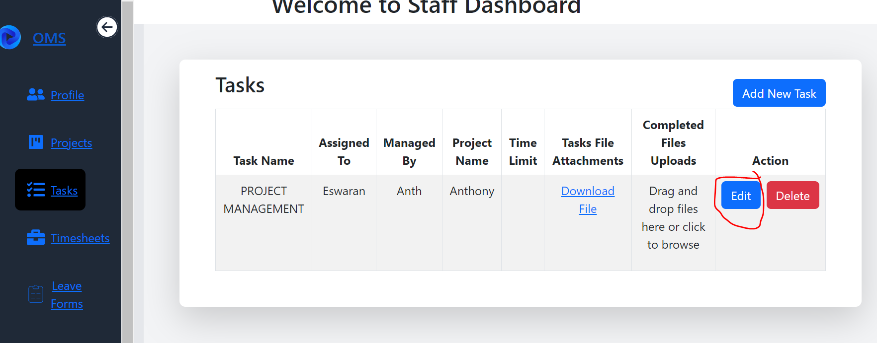

***CORRECTION:2***

Total no of days, can be displayed by default (it can be detected from start date and end date)

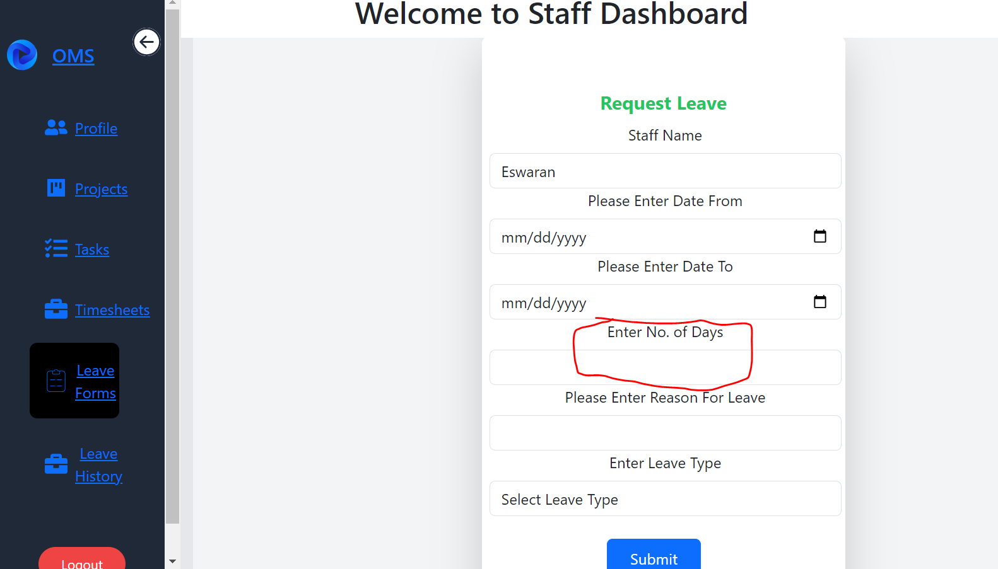

ADMIN LOGIN:

***CORRECTION:3***

Near by click here to browse, keep a button saying attach here.

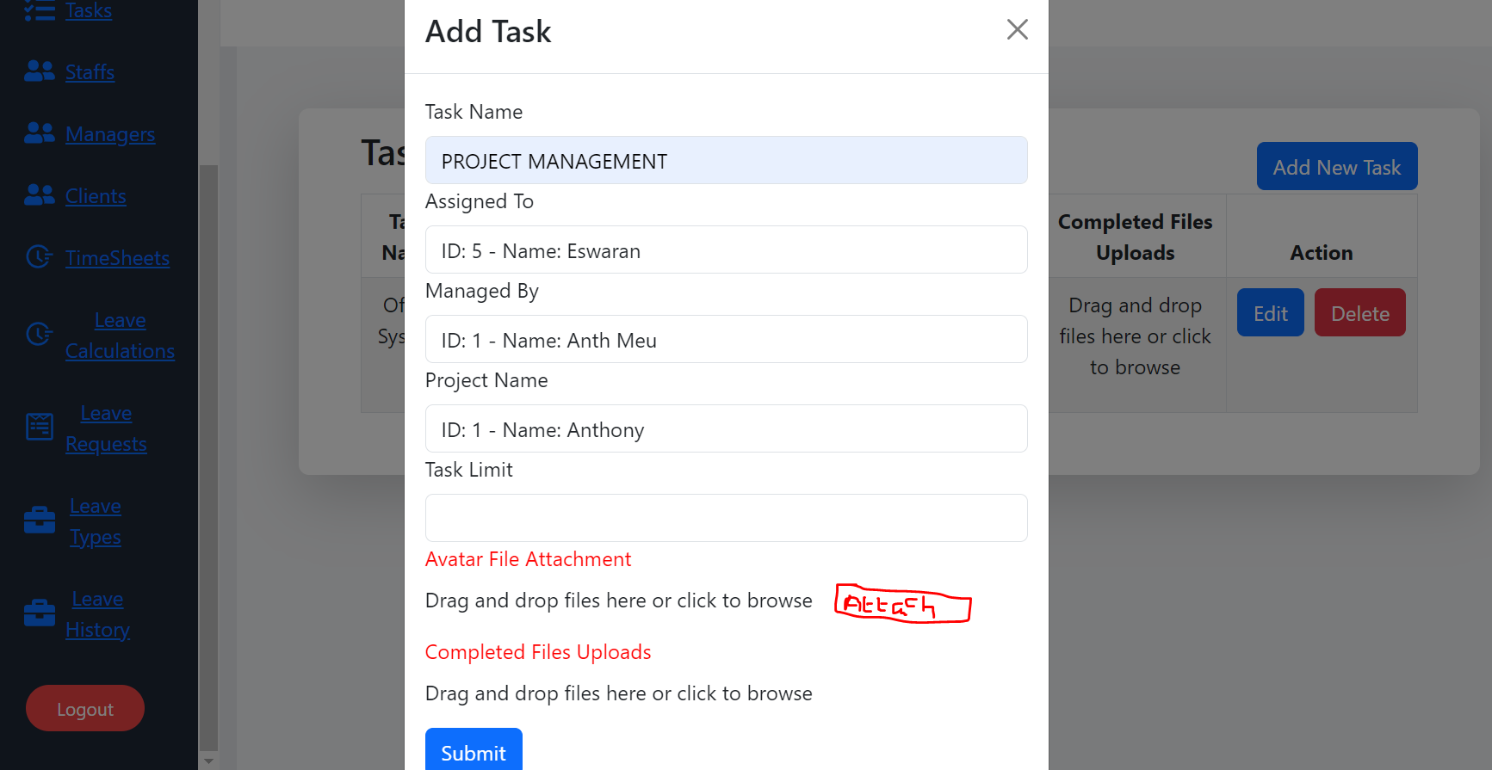

***CORRECTION:4***

After applying leave, as a staff, name of the staff is not displayed.

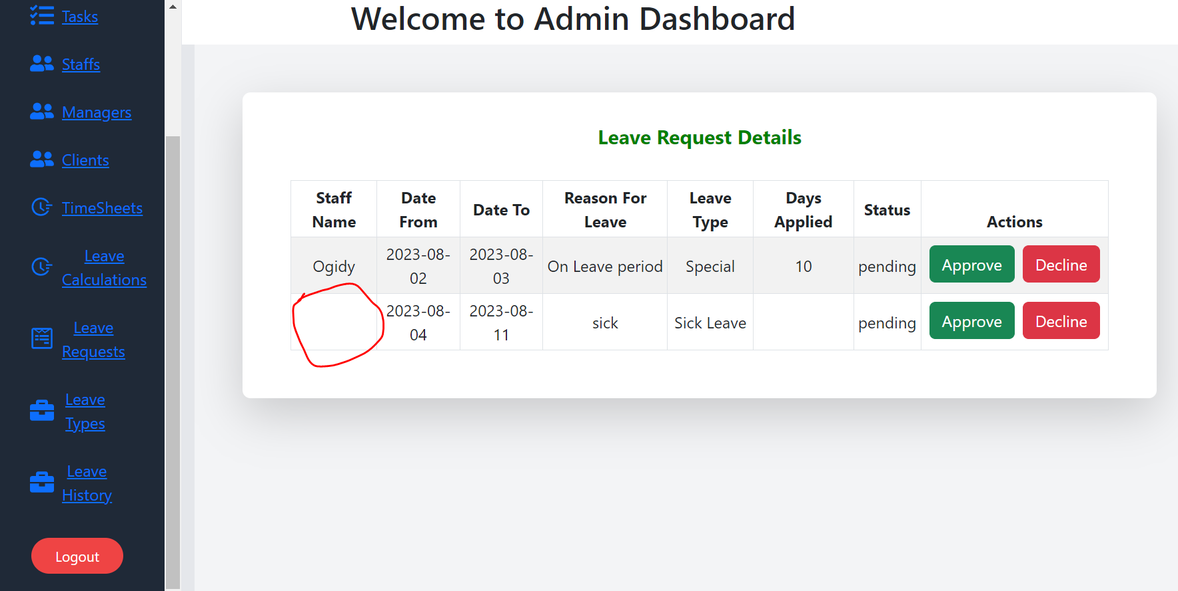

***CORRECTION:5***

When the leave form is submitted, an popup message must be displayed in admin leave request and after the leave is accepted, the popup message must be displayed in staff leave history.

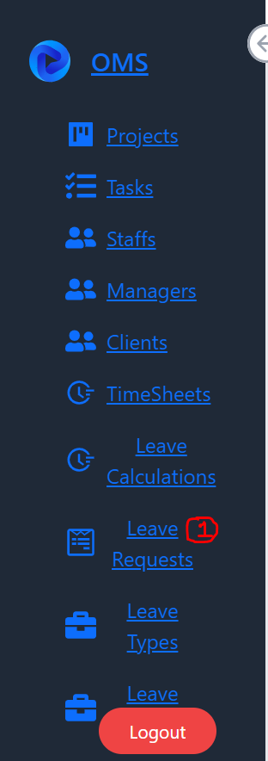 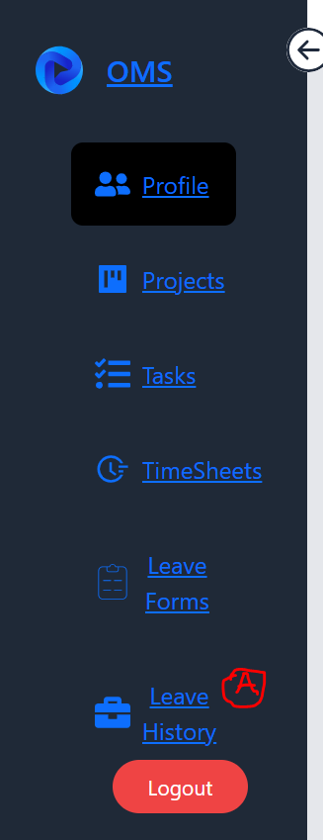

***CORRECTION:6***

OMS link can be also inserted along with the username and password

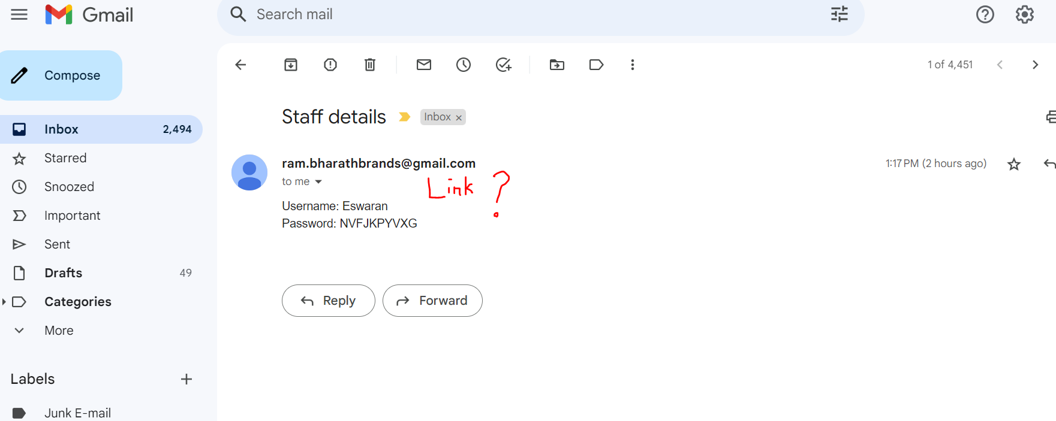

***CORRECTION:7***

Whenever any task is assigned by the admin to the staff, there must be popup or any notification must be displayed.

