BOMS

Bharathbrands Office Management System

----------------------------------------------------------------------------------------------

STAFF LOGIN:

***CORRECTION:1-*** The name is in drop down, it must be, by default the logged in staff name.

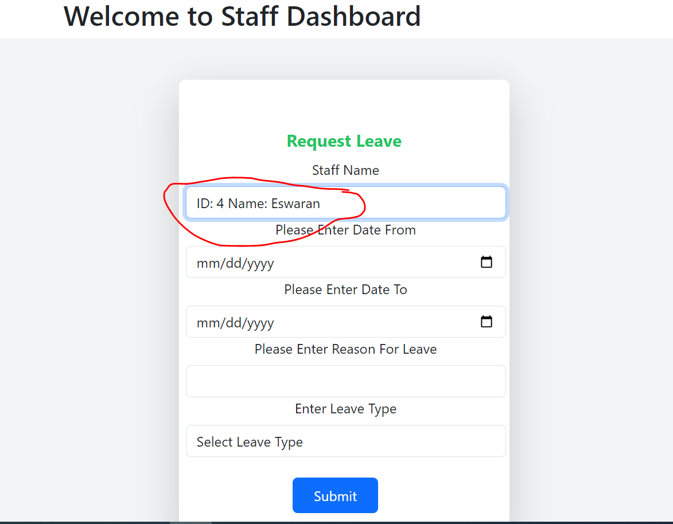

***CORRECTION:2-*** After submitting leave request, there must be pop showing, leave request submitted successfully.

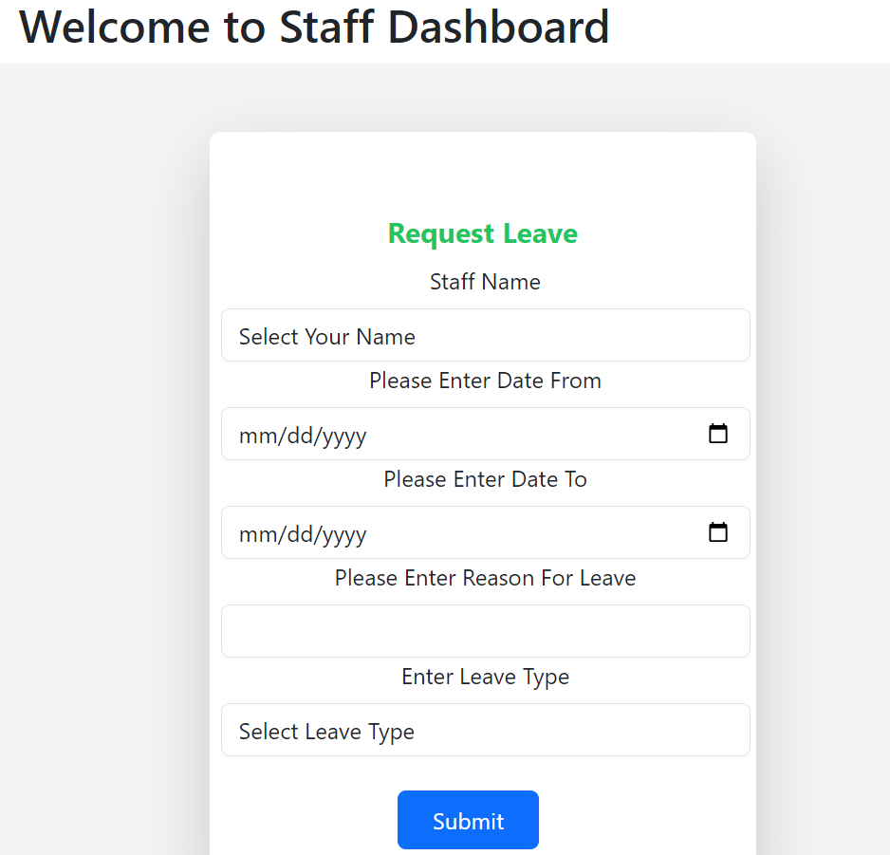

***CORRECTION:3-*** No of days, applied for leave can be added below date.

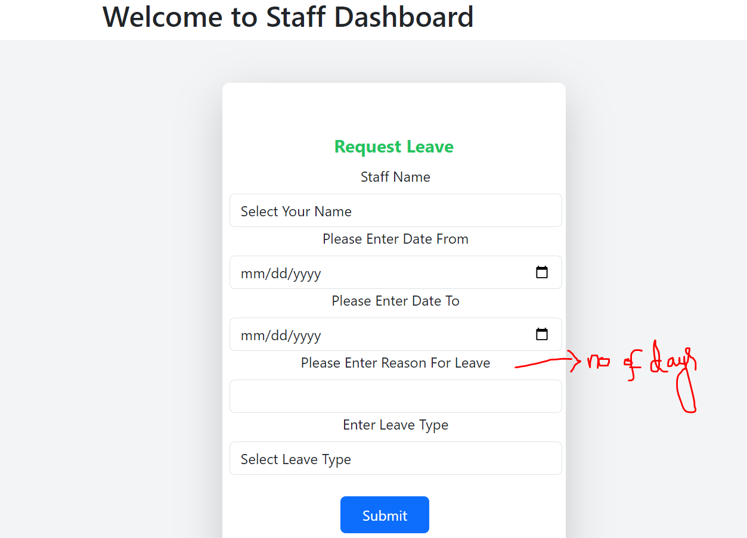

ADMIN LOGIN:

***CORRECTION:4-*** Leave history is hidden and not functioning.

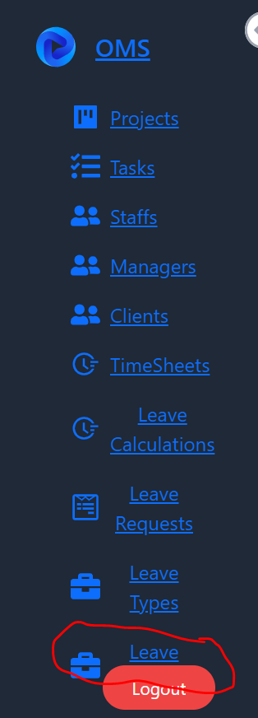

***CORRECTION:5-*** After the leave has been approved, the no of days must be deducted from total no of leave for that particular leave type.

Leave applied for 2 days Once leave applied, it should popup

In admins leave request Leave is approved by the admin

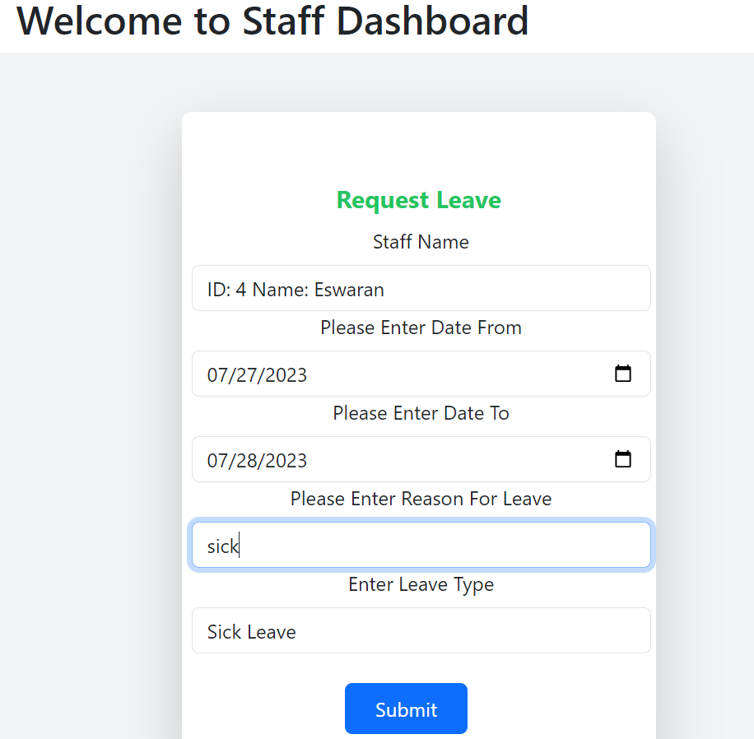 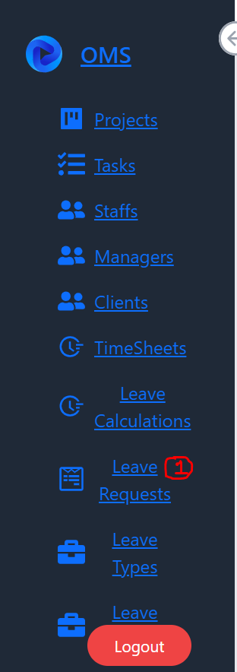 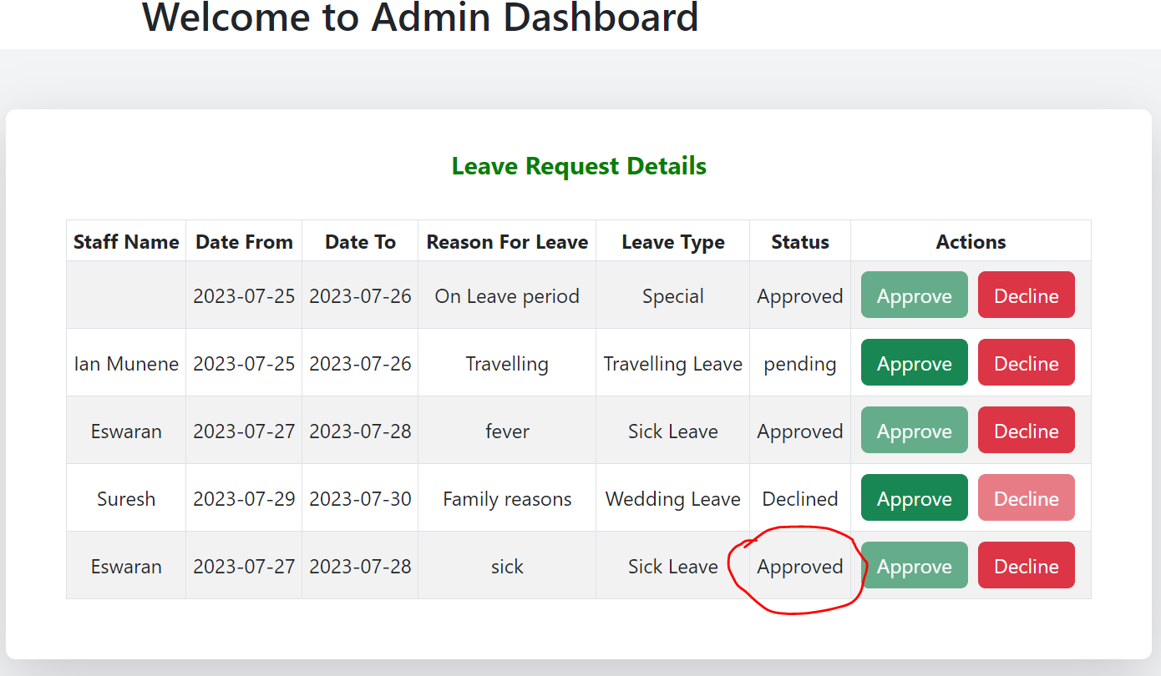

Once the leave is approved, automatically, no of days approved must be subtracted as used days for particular type of leave.

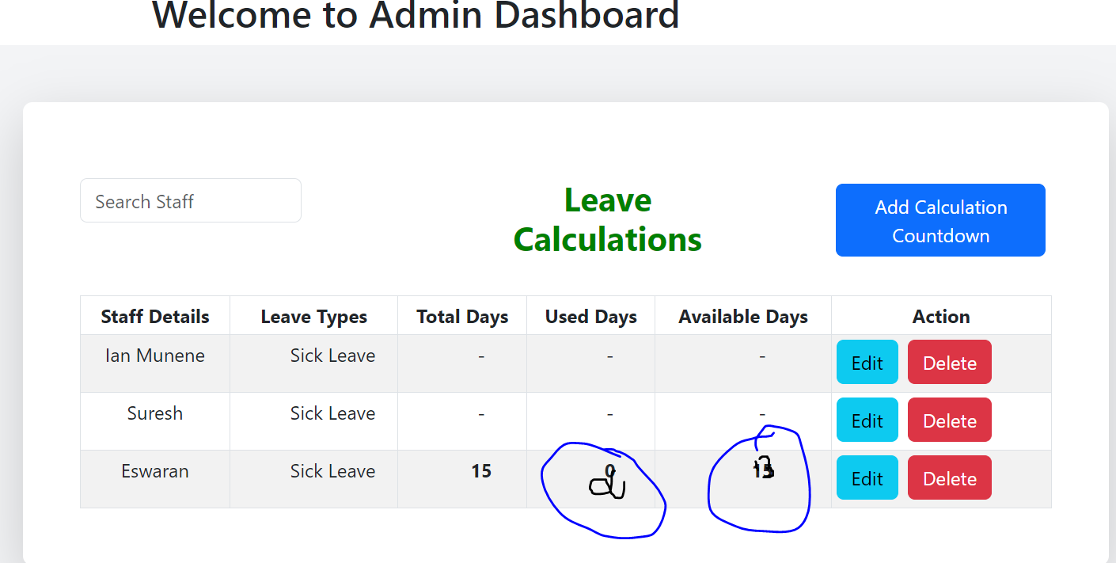

***CORRECTION:6***

When the leave form is submitted, an popup message must be displayed in admin leave request and after the leave is accepted, the popup message must be displayed in staff leave history.

 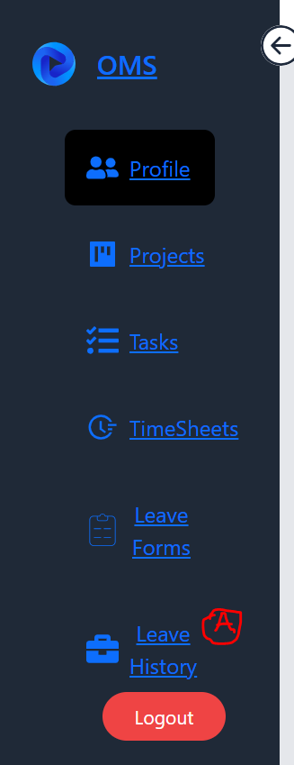

***CORRECTION:7***

The auto generated password through mail, can be added with the office management system link, then user name: same email id, then password.

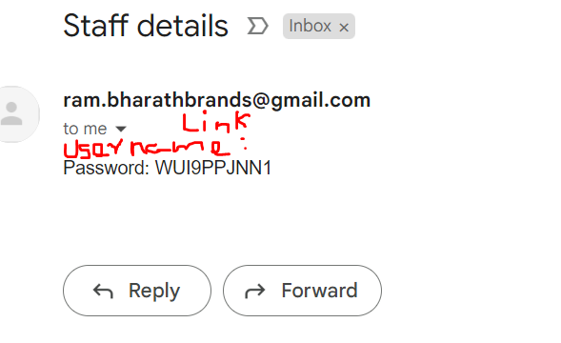

***CORRECTION:8***

Whenever any task is assigned by the admin to the staff, there must be popup or any notification must be displayed.

