**Korean Financial Market Optimization**

Course Name: MGE 20101(Operations Research I)

Group 7: 20141676김다함

20141738이상섭

20171345김가헌

20171370김남교

Submission Date:

Index

1. Executive Summary
2. Introduction

“The way to make an investment in stocks is to invest in index fund. Index fund is so called goods favorable to investors.” Along with this phrase by Warren Buffett, the steady growth trend of the world index fund market, the rapid growth of the domestic index fund market has boosted our interest in the index fund market. However, due to the characteristic of index funds, the risk is bound to follow. We were in doubt, if an investor takes the risk, can an investor be able to earn a return above the average market rate? The average annual return rate on three years of treasury bonds in Korea was 1.78%, with a standard deviation of 0.27%. Is the index fund invested by many investors truly optimized (outperforms the average annual market rate and has a reasonable risk rate)? We selected KODEX KTOP 30, which consists of 30 stocks representing the Korean economy, among the stocks listed in the domestic KOSPI and KOSDAQ markets. The average annual return rate of KTOP30 is 1.57%, with a standard deviation of 0.83%. The risk ratio is higher than three years of treasury bonds in Korea, but the return rate is rather underperformed. Therefore, we want to try to form an optimal portfolio to reduce the standard deviation value and increase the average annual return. Mathematically prove Modern portfolio theory and risk management (Value at Risk, Conditional Value at Risk and Expected shortfall measure) and We are trying to form an optimal portfolio based on the Markowitz theory. If the actual market data can be used to obtain the optimal solution, investors will be able to achieve higher returns than the average annual market rate by reducing their relatively low risk rates.

To optimize Korean financial market portfolio, our team utilized the Markowitz theory and stochastic programming. Markowitz theory is the core financial theory about diversified investment, and stochastic programming is the framework used to design optimization model related to the uncertainty in mathematical optimization field. Here is the related knowledge we reviewed through the literatures.

* Theory of Portfolio Selection (Harry M. Markowitz – Portfolio Theory and the Financial Crisis)

The theory is structured by Harry Markowitz that if investors make portfolio by diversifying investment, he or she can reduce risk. According to the assumptions of the portfolio theory, the returns and risks considered in the decision-making process of an investment can be expressed as means and variances, respectively, and that a portfolio composition can benefit from a reduction in variances unless the correlation coefficient between assets is one.

* Stochastic programming (John R. Birge & Francois Louveaux - Introduction to Stochastic Programming)

In the field of mathematical optimization, stochastic programming is a framework for modeling optimization problems associated with uncertainty. While the problem of deterministic optimization is formalized as known parameters, real-world problems mostly involve unknown parameters. The process of creating a model and obtaining optimal answers by assigning probabilities to these unknown parameters is central to stochastic programming. Stochastic programming is being applied in various fields such as finance, transportation, and energy. In this project, the stochastic programming technique was utilized for the Korean financial market optimization.

* Mathematical backtesting technique (Backtesting Expected Shortfall – Carlo Acerbi & Balazs Szekely)

This paper is dealt with process of obtaining ES, applying mathematical backtesting technique. ES is the average value of loss in investment over VaR. And VaR, is the measure for the risk for loss on investment. Our group knew exactly what backtesting is through this paper, created Markowitz optimization portfolio based on past 3 years’ data, and applied backtesting to obtain the values of its VaR and ES.

* The form of the report and how to write a good report (보고서의 법칙 - Baek Seungwon)

In order to write a clear and more readable report, our group referred to this book. This book provides a concise overview of the pattern, format, and how to write the report. By reference to the book, we decided to organize the report into an executive summary, introduction, problem statement, solution procedure, results & conclusion, and also tried to make every reader understands the detailed composition of the report even though he or she lacked financial knowledge.

1. Problem Statement

Goal of this portfolio optimization is to increasing return while reducing risk at same time. To state this goal in mathematical way, we need to define terms and notation we are going to use.

n investor has a fixed amount of money to invest in a portfolio of n

risky assets S1, . . . , Sn and a risk-free asset S0. Then random return of asset i over this period [0,1] is

$$R_{i}≔\frac{S^{i}-{S_{0}}^{i}}{{S_{0}}^{i}}$$

And also, we let $$μ=E\left[R\right]=expected return vector form$$

$Q=Cov\left(R\right)$ = variance-covariance matrix

Under this notation we let

Decision variables : xi (i = 1,2,3,…n) proportion of wealth invested in asset i

Objective function : the investor wants to maximize expected return while minimizing risk

Constraints :

$\sum_{i}{x_{i}}=1$ (entire wealth in assumed to be invested)

$x_{i}≥0$ (short selling of asset i is not allowed)

$\sum_{x_{i}∈G}{x_{i}}≤b$ (bounds on exposure to group of assets, b: initial wealth)

In here, let $R={\left[R_{1}…R_{n}\right]}^{T}$ be random vector of asset returns and $μ=E\left[R\right]$ be the expected return vector. Then we can calculate random return of the portfolio y as

$$\frac{\sum_{i}{y_{i}S_{1}^{i}}-\sum_{i}{y_{i}{S_{0}}^{i}}}{\sum_{i}{y_{i}{S_{0}}^{i}}}=\sum_{i}{\frac{y_{i}S_{0}^{i}}{\sum_{i}{y_{i}S_{0}^{i}}}}⋅\frac{{S_{1}}^{i}-{S_{0}}^{i}}{{S_{0}}^{i}}$$

And expected portfolio return and variance as

$$E\left[R^{T}x\right]=\sum_{i}{x_{i}E\left[R_{i}\right]}=μ^{T}x$$

$$σ^{2}\left(R^{T}x\right)=E\left[\left|{\left(R-μ\right)}^{T}x\right|\right]$$

Under this setting we want to imply classical portfolio model made by Henry Markowitz, which suggest 3 models for optimal solution.

First model:

$$\max_{x∈R}μ^{T}x$$

$$μ^{T}x≥r$$

$$\sum_{i=1}^{n}{x_{i}}=1$$

Second model: $$\max_{x∈R^{n}}{μ^{T}}x$$

$$x^{T}Qx≤σ^{2}$$

$$\sum_{i=1}^{n}{x_{i}}=1$$

Third model:

$$\max_{x∈R^{n}}{μ^{T}}x-λx^{T}Qx$$

$$\sum_{i=1}^{n}{x_{i}}=1$$

Where $l_{i}≤x_{i}≤u_{i}$, $\tilde{x_{i}}\left(i=1,⋯,n\right)$, $λ$ >0 is risk-aversion parameter.

We also computed risk measure called Value at Risk(VaR) and Conditional Value at Risk(CVaR or Expected Shortfall) to confirm our portfolio optimized in perspective if risk management. Our another goal is to optimize our solution considering VaR and CVaR. Thus maximize expected return of portfolio while minimizing VaR or CVaR.

Minimize ${\text{VaR}}_{h,α}=-x_{h,α}$

$Minimize {\text{CVaR}}_{h,α}\left(X\right)=-E\left(X | X<x_{h,α}\right)=-α^{-1}\int_{-∞}^{x_{h,α}}{xf\left(x\right)} dx.$

${maximize }_{x∈R}μ^{T}x$

where $P\left(X<x_{h,α}\right)=α$

$x^{T}Qx≤σ^{2}$, $μ^{T}x≥r$ $\sum_{i=1}^{n}{x_{i}}=1$

1. Solution Procedure_ Markowitz portfolio optimization

<Theoretical parts>

Goal of Markowitz portfolio optimization is to minimize risk(volatility of portfolio movement) while maximizing returns. The goal is expressed in 3 forms at problem statements part. All three models can be solved with quadratic programming techniques. Also, since Q is positive semidefinite symmetric matrix (have positive eigenvalues and symmetric), it can be seen as convex function.. combining these characteristics, we can say that it is convex quadratic programs.

$$\min_{x}{x^{T}}Qx$$

Such that $μ^{T}x≥r$

$$Ax≥a$$

$$Bx=b$$

In given market if, Sj can be replicated by linear combination, such as $S^{j}=\sum_{i≠j}{ξ_{i}S^{i}}$, then portfolio of $\sum_{i}{y_{i}}S^{i}$ form can said to be equivalent to $\sum_{i≠j}{\left(y_{i}+y_{j}ξ_{i}\right)S^{i}}$. And also we assumed that Q is positive semidefinite symmetric matrix at beginning of this session, we can say that

$$σ_{min}^{2}≔\min_{x}{x^{T}}Qx$$

Such that $Ax≥, Bx=b$

And in here $r\left(σ\right)$ can said to be well-defined if $σ≥σ_{min}$. So we can say that $r\left(σ\right)$ has feasible solution and thus

$$r\left(σ\right)=\max_{x}{μ^{T}}x$$

$Ax≥a$*, $Bx=b$*

$x^{T}Qx≤σ^{2}$*, $μ^{T}x≥r$*

So using above optimality condition, we can say that $σ\left(r\right)$ and $r\left(σ\right)$ are inverse of each other. In addition from above relationship,

$$μ^{T}x≤r\left(\sqrt{x^{T}Qx}\right)$$

Is all feasible x, and $x^{*}$ is point obtained from solving above problem statements with $σ^{2}= x^{T}Qx$ condition. Then we can say that optimal portfolio should satisfy below relationship.

$$μ^{T}x^{*}=r\left(\sqrt{x^{T}Qx}\right)$$

This curve( $r↦σ\left(r\right)$) is called efficient and $σ≥σ_{min}$ is called efficient frontier.

If we look at efficient frontier curve ( $r↦σ\left(r\right)$) is convex function for $r≥r_{min}$. Let $x^{1},x^{2}$ be efficient frontier corresponding to the risk levels $σ\left(r^{1}\right),σ\left(r^{2}\right)$, where $r^{1},r^{2}≥r_{min}$ are consider the portfolio

$$x=θx^{1}+\left(1-θ\right)x^{2}$$

Where $θ∈\left(0,1\right)$

Then $Ax≥a, Bx=b$ and $μ^{T}x=θr^{1}+\left(1-θ\right)r^{2}=:r$

Thus we can say that x is feasible. So

$$σ^{2}\left(r\right)=\min_{y}{y^{T}}Qy$$

Where $Ay≥a, By=b, μ^{T}y≥r$

This shows that

$$σ^{2}\left(r\right)=σ^{2}\left(θr^{1}+\left(1-θ\right)r^{2}\right)≤x^{T}Qx$$

$=θ^{2}x^{1⊤}Qx^{1}+2θ\left(1-θ\right)x^{1⊤}Qx^{2}+{\left(1-θ\right)}^{2}x^{2⊤}Qx^{2}$

By Cauchy Schwartz inequality $≤θ^{2}x^{1⊤}Qx^{1}+2θ\left(1-θ\right)\sqrt{x^{1⊤}Qx^{1}}\sqrt{x^{2⊤}Qx^{2}}+{\left(1-θ\right)}^{2}x^{2⊤}Qx^{2}$

$={\left(θ\sqrt{x^{1⊤}Qx^{1}}+\left(1-θ\right)\sqrt{x^{2⊤}Qx^{2}}\right)}^{2}$

$={\left(θσ\left(r^{1}\right)+\left(1-θ\right)σ\left(r^{2}\right)\right)}^{2}$

So, $σ\left(r\right)$ $≤$ $\left(θσ\left(r^{1}\right)+\left(1-θ\right)σ\left(r^{2}\right)\right)$ thus $σ$ is convex function.

Next step is to calculate market price of risk. Consider investable assets that contains one risk free asset $S^{0}$ with return $r_{f}$ and n risky assets ($S^{1},…,S^{n}$) with random return vector R and $E\left[R\right]=μ$. So we denote

$\tilde{x}=\left[\begin{matrix}x_{0} \\ x\end{matrix}\right]$, $\tilde{R}=\left[\begin{matrix}r_{f} \\ R\end{matrix}\right], μ=\left[\begin{matrix}r_{f} \\ μ\end{matrix}\right]$

And we let our covariance matrix of $\tilde{R}$ then has block structure

$\tilde{Q}$ = $\left[\begin{matrix}0 & 0 \\ 0 & Q\end{matrix}\right]$ where $Q≻0$

With above notation, we can rewrite Markowitz portfolio optimization problem as

$${\min_{x}{\tilde{x}}}^{T}Q\tilde{x}$$

Such that $\tilde{A}\tilde{x}≥\tilde{a}$, $\tilde{B}\tilde{x}=b$, $\tilde{μ}\tilde{x}≥\tilde{r}$

$\tilde{A}=\left[\begin{matrix}0 & e \\ a & A\end{matrix}\right], \tilde{B} =\left[bB\right]$, $\tilde{a}$ = $\left[\begin{matrix}0 \\ a\end{matrix}\right]$

Where $e=\left[1 ... 1\right]$ and $\tilde{B}$ has first row $\left[1 e\right]$

To balance the portfolio risk, let $e_{0}={\left[\begin{matrix}1 & 0\end{matrix}\right]}^{T}$ be the portfolio that corresponds to investing the entire wealth in the risk-free asset, and note that $e_{0}$ is feasible. Note that the constraints $\tilde{B}\tilde{x}=b$ contains the self-financing condition $\sum_{i}{\tilde{x_{i}}}=1$. The constraint structure assumed above implies that for all $x∈R^{n}$ satisfying $Ax≥a$ and $Bx=b$ and for all $θ≤1$, the portfolio $\left(\begin{matrix}θe_{0} \\ \left(1-θ\right)x\end{matrix}\right)$ is feasible.

Now consider the Markowitz problem,

$$\min_{x}{x^{T}}Qx$$

Such that $Ax≥a$, $Bx=b, μ^{T}x≥r$

Let $r\left(σ\right), σ\left(r\right), r_{min}, σ_{min}$ be introduced earlier, and let $\tilde{r}\left(\tilde{σ}\right)$, $\tilde{σ}\left(\tilde{r}\right), {\tilde{σ}}_{min}, {\tilde{r}}_{min}$ be corresponding objects for ,problem. Note that ${\tilde{σ}}_{min}=0$, ${\tilde{r}}_{min}=r_{f}$. So, let’s assume that feasible solution for some $r>r_{f}$, since we are investing positive portion of our wealth to risky assets.

So, Efficient frontier can be expressed with $\tilde{\{x}\left(θ\right\}: θ≤1\}$ ray which is solution of above optimization problem.

$$\tilde{x}\left(θ\right)=\left(\begin{matrix}θe_{0} \\ \left(1-θ\right)x^{m}\end{matrix}\right)$$

In other words, for any $\tilde{σ^{2}}≥0$ there exists a $θ≤1$ such that the portfolio $\tilde{x}\left(θ\right)$ achieves the maximum return ${\tilde{μ}}^{T}\tilde{x}\left(θ\right)=\tilde{r}\left(\tilde{σ}\right)$ at the risk level (${\tilde{σ}}^{2}$).

To prove efficient frontier ray, let $\tilde{x}={\left[\begin{matrix}θ & x^{T}\end{matrix}\right]}^{T}$ be an optimal portfolio with return $\tilde{r}$. Since $\sum_{i}{\tilde{x_{i}}}=1$ and $\sum_{i=1}^{n}{\tilde{x_{i}}}≥0$, we have $θ≤1$. Without loss of generality, we may assume that $θ≤1$.

Further, the structure of $\tilde{A}$ implies that $Ax≥a$ and hence $Ax^{*}≥a$, where $x^{*}={\left(1-θ\right)}^{-1}x$. And structure of B implies $Bx^{*}={\left(1-θ\right)}^{-1}Bx={\left(1-θ\right)}^{-1}\left(B\tilde{x}-θb\right)=b$. Thus $x^{*}$ is feasible for Markowitz portfolio optimization problem with target return level $r^{*}=μ^{T}x^{*}$

Furthermore, we have $\tilde{r}={\tilde{μ}}^{T}\tilde{x}=θ_{r_{f}}+\left(1-θ\right)r^{*}$ and $σ^{2}\left(\tilde{r}\right)=\tilde{x}\tilde{Q}\tilde{x}=x^{T}Qx={\left(1-θ\right)}^{2}σ_{*}^{2}$ where $σ_{*}^{2}=x^{*^{T}}Qx^{*}$. Now let $x^{m}$ an optimal solution of Maximum of Sharpte ratio problem, let $r_{m}=μ^{T}x^{m}$

, $σ_{m}^{2}=x^{m^{T}}Qx^{m}$, $ϑ=\left(r_{m}-\tilde{r}\right)\left(r_{m}-r_{f}\right)$. According to market condition, we can say $\tilde{r},r_{m}>r_{f}$

and thus $ϑ<1$. So portfolio

$$\tilde{x}\left(ϑ\right)={\left[\begin{matrix}ϑ & \left(1-ϑ\right)x^{m^{T}}\end{matrix}\right]}^{T}$$

And expected return $$\tilde{r}=ϑr_{f}+\left(1-ϑ\right)r_{m}$$

By constructing $ϑ$, we can say risk is

$${\left(1-ϑ\right)}^{2}σ_{m}^{2}$$

Furthermore, as we checked beginning of proof,

$$\frac{{\left(r^{*}-r_{f}\right)}^{2}}{σ_{*}^{2}}≤\frac{{\left(r_{m}-r_{f}\right)}^{2}}{σ_{m}^{2}}$$

So we have

${\left(1-ϑ\right)}^{2}σ_{m}^{2}≤{\left(1-ϑ\right)}^{2}{\left(\frac{r_{m}-r_{f}}{r_{*}-r_{f}}\right)}^{2}σ_{*}^{2}$

$=\left(\frac{r_{f}-r_{m}-\tilde{r}-r_{m}}{r_{*}-r_{f}}⋅\frac{r_{m}-r_{f}}{r_{*}-r_{f}}\right)σ_{*}^{2}={\left(\frac{\tilde{r}-r_{f}}{r_{*}-r_{f}}\right)}^{2}σ_{*}^{2}$

$={\left(\frac{θr_{f}+\left(1-θ\right)r_{*}-r_{f}}{r_{*}-r_{f}}\right)}^{2}σ_{*}^{2}={\left(1-θ\right)}^{2}σ_{*}^{2}$

Therefore, unless $x^{*}$ solves the maximum Sharpe ratio problem, $\tilde{x}\left(ϑ\right)$ contradicts the optimality of $\tilde{x}$

So portfolio, xm is chosen as an optimal solution of maximum Sharpe ratio problem which is shown below. In here denominator is risk of portfolio and numerator is risk premium which is risk return.

$\max_{x}{\frac{μ^{T}x-r_{f}}{\sqrt{x^{T}Qx}}}$*b*

Such that $Ax≥a$*, $Bx=b$*

In here another implicit assumption on the problem data A,a,B,b is that the feasible set $\{x∈R^{n}:Ax≥a, Bx=b\}$ is nonempty and that optimal solution of Sharpe ratio problem exists. To solve Sharpe ratio problem, we use homogenization. Since first constraint in $Bx=b$, $e^{T}x=1$ can be rewrite $μ^{T}x-r_{f}$ as ${\left(μ-r_{f}e\right)}^{T}x$. Note that if $y=τx$ for some $τ>0$ then,

$$\frac{{\left(μ-r_{f}e\right)}^{T}x}{\sqrt{x^{T}Qx}}=\frac{{\left(μ-r_{f}e\right)}^{T}y}{\sqrt{y^{T}Qy}}$$

If $μ^{T}x>r_{f}$ we may choose $τ>0$ such that ${\left(μ-r_{f}e\right)}^{T}y=1$. Therefore, we can rewrite Sharpe ratio problem as

$$\min_{\left(y,τ\right)}{y^{T}}Qy$$

Such that ${\left(μ=r_{f}e\right)}^{T}y=1$

$Ay≥τa$, $By=τb, τ≥0$

And we convert optimal solution $\left(y^{*},τ^{*}\right)$ into optimal solution by setting $x^{*}=τ^{-1}y^{*}$. Note that $τ$ cannot be zero in any feasible solution. Therefore, the portfolio corresponding to $x^{m}$ is called market portfolio, the ray $\{\tilde{x}\left(θ\right):θ≤1\}$ the efficient frontier, and the gradient

$\frac{μx^{m}-r_{f}}{\sqrt{{x^{m}}^{T}Qx^{m}}}$ is the maximum Sharpe ratio

So, an investor is willing to take on an additional unit of risk (measured in terms of the standard deviation of portfolio returns) only is the expected return increases by the maximum Sharpe ratio.

<practical application>

With python programming, we can follow Markowitz portfolio optimization. Our group used KOSPI top 30 company as stock parts and Republic of Korea Treasury bill 3 year as risk free investment vehicle.

|  |  |  |
| --- | --- | --- |
| Stock Code | Corporate Name | 3-year Return Rate(%) |
| 005930 | 삼성전자 | 54.96 |
| 000660 | SK하이닉스 | 97.86 |
| 005935 | 삼성전자우 | 58.25 |
| 035420 | NAVER | -1.42 |
| 005380 | 현대차 | -12.37 |
| 207940 | 삼성바이오로직스 | 145.20 |
| 012330 | 현대모비스 | -10.00 |
| 068270 | 셀트리온 | 100.88 |
| 051910 | LG화학 | 26.38 |
| 055550 | 신한지주 | -2.18 |
| 017670 | SK텔레콤 | 4.43 |
| 051900 | LG생활건강 | 49.05 |
| 105560 | KB금융 | 0.83 |
| 028260 | 삼성물산 | -35.67 |
| 005490 | POSCO | -10.29 |
| 034730 | SK | 19.54 |
| 015760 | 한국전력 | -48.68 |
| 000270 | 기아차 | 28.53 |
| 006400 | 삼성SDI | 144.19 |
| 018620 | 삼성에스디에스 | 37.71 |
| 032830 | 삼성생명 | -35.14 |
| 096770 | SK이노베이션 | 2.885 |
| 033780 | KT&G | -10.62 |
| 035720 | 카카오 | IPO |
| 003550 | LG | 13.61 |
| 036570 | 엔씨소프트 | 100.74 |
| 066570 | LG전자 | 41.92 |
| 000810 | 삼성화재 | -22.48 |
| 090430 | 아모레퍼시픽 | -45.63 |
| 086790 | 하나금융지주 | 5.39 |
| bond | 대한민국 국고채 3년물 | 6.29 |

We are going to build our Markowitz optimized portfolio with above enlisted investment vehicles.

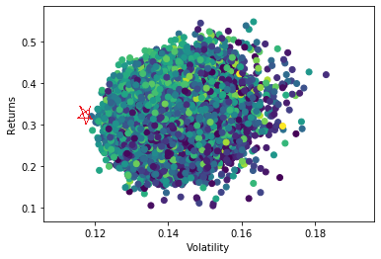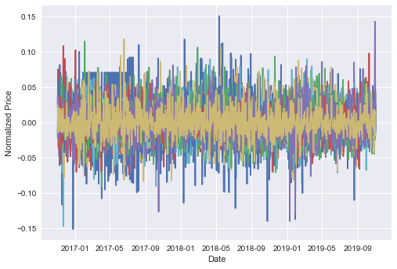

*Daily return of KOSPI 30, and 3-year random portfolio generation(5000)*

As shown graphically, we generated 5000 sample portfolios with random weight. Among these samples, we found out maximum return while minimizing risk point. We checked Sharpe ratio of this point to check whether this portfolio satisfy Markowitz portfolio optimization techniques.



So, if we calculate Sharpe ratio of this optimal portfolios, it will be $\frac{0.3202}{0.1191}=0.0294$.Thus, compare to KODEX KTOP 30’s performance, which is sold by Samsung Securities team (return =7.41%, volatility =0.2859). thus we can say that our portfolio weight scheme is much more optimized than their portfolio.

|  |  |  |
| --- | --- | --- |
|  | KODEX KTOP 30 | Markowitz optimal portfolio |
| Return | 7.41% | 32.02% |
| Standard deviation | 0.2859 | 0.1191 |
| Sharpe Ratio | 0.2591 | 0.0294 |

1. Solution Procedure_ stochastic financial planning for portfolio manager

<Theoretical parts>

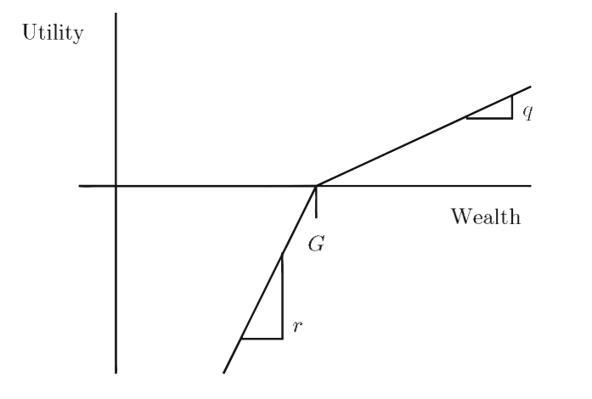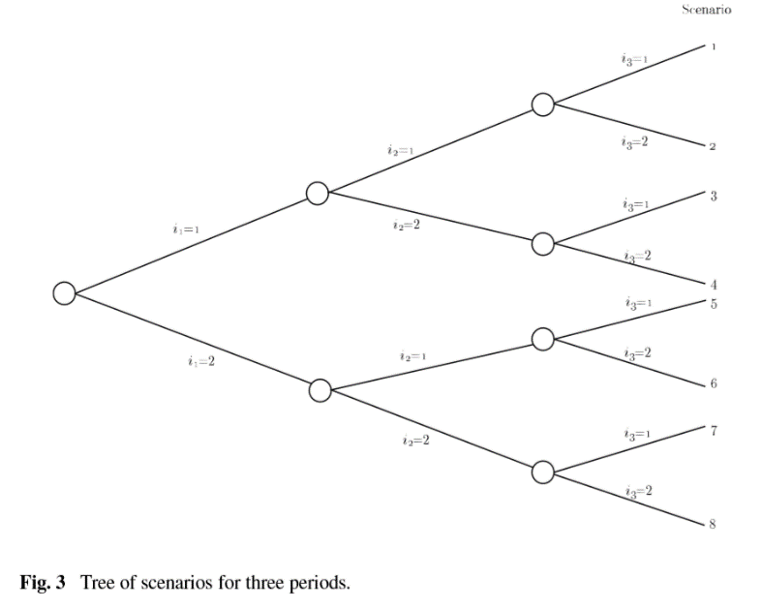After that we used stochastic programming method to check whether it can reach our financial plan in stably. To see this, we used “financial planning problem” which is proposed by Mulvey and Vladimirou(1989, 1991,1992) , Ziemba and Vickson(1975), Zenios(1993).

*Utility function of wealth at year Y for goal G, Tree of scenario with periods =3, number of scenario=2*

Goal of our program is to simply calculate probability and penalty weighted sum of these terms.

If we express this with equation form:

$$\sum_{s_{H}}{⋯\sum_{s_{1}}{p\left(s_{1},…,s_{H}\right)\left(-rw\left(s_{1},…,s_{H}\right)+qy\left(s_{1},…,s_{H}\right)\right)}}$$

So, in general form we can say change with optimization problem form with probability – goal- penalty weight condition attached. in here, we used gain utility(q) = 1, loss penalty(r) = 10, annual goal(G) =4%, number of scenarios = 2. Mathematical expression for this problem is shown below:

$$\sum_{s_{H}}{⋯\sum_{s_{1}}{p\left(s_{1},…,s_{H}\right)\left(-rw\left(s_{1},…,s_{H}\right)+qy\left(s_{1},…,s_{H}\right)\right)}}$$

$$\max{z}=\sum_{s}{p\left(s\right)\left(qy\left(s\right)-rw\left(s\right)\right)}$$

$$\sum_{i=1}^{I}{x\left(i,1,s\right)}=b∀s∈S$$

$\sum_{i=1}^{I}{ξ\left(i,t,s\right)x\left(i,t-1,s\right)}-\sum_{i=1}^{I}{x\left(i,t,s\right)}=0,∀s∈S$, $t=2,…,H,$

$$\sum_{i=1}^{I}{ξ\left(i,H,s\right)x\left(i,H,s\right)}-y\left(s\right)+w\left(s\right)=G,$$

$$\left(\sum_{s^{t}∈S_{J\left(s,t\right)}^{t}}{p\left(s^{t}\right)x\left(i,t,s^{'}\right)}\right)-\left(\sum_{s^{t}∈S_{J\left(s,t\right)}^{t}}{p\left(s^{'}\right)}\right)x\left(i,t,s\right)=0,$$

$∀1≤i ≤I$, $∀1≤t ≤H$, $∀s ∈S$, $x\left(i,t,s\right)≥0$, $y\left(s\right)≥0$, $w\left(s\right)≥0$, $∀1≤i ≤I$, $∀1≤t ≤H$, $∀s ∈S$

<practical application>

To solve this problem, we used CVXPY(ECOS) solver in python. And to rum this effectively, we K-means cluster to our portfolio into 10 clusters to ease computation. Before computation, we converted our portfolio’s index (return, standard deviation) into annual measure to compare with annual goal (G).

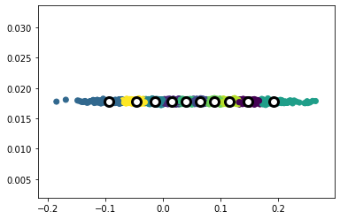

*Visual graphic of K-means clustering of our random sample portfolio (5000)*

As result of K-means clustering, we classified clusters into 10 parts, and each of them have below portion.

cluster 0: 6.68% cluster 5: 3.06%

cluster 1: 13.16% cluster 6: 15.60%

cluster 2: 15.86% cluster 7: 13.50%

cluster 3: 2.96% cluster 8: 10.22%

cluster 4: 11.96% cluster 9: 7.00%

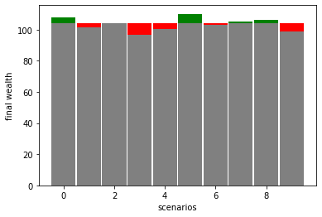

Green part shows that we achieved our goal (G) and red parts shows that we failed to achieve goal(G) So, we can say that we we can achieve annual return (4%) with probability 60%.

1. Solution Procedure_ Value at Risk and Conditional Value at risk

<Theorical part>

Next part is about risk management of our portfolio. We introduce VaR and CVaR measure to manage our risk. Since Markowitz portfolio optimization consider standard deviation as only risk measure, it cannot deal with extreme situations. Value at Risk(VaR) is developed by quants in JP Morgan and it is defined as the smallest level of loss for which the probability of experiencing a loss above this level is smaller than 1 − α. In other words, the loss will exceed VaRα with probability at most 1−α.

So consider an investment decision represented by vector $x∈R^{n}$. Let loss over investment under the outcome $w∈Ω$ be $L\left(x,w\right)$. For fixed x, the loss function $L\left(x,.\right)$ is random variable that takes positive values when loss is incurred, and negative ones when gain occurs.

For fixed value of x let,

$$Ψ\left(x,γ\right)≔P\left[L\left(x,⋅\right)≤γ\right]=F_{L\left(x,⋅\right)}\left(γ\right)$$

be the cumulative distribution function of the loss function L(x, ·) associated with holding the investment x. For $α∈\left[0,1\right]$ ( $α=.95$ usually) the value at risk on the confidence level α is defined by

$$VaR_{α}\left(x\right)≔\min_{γ∈R}{γ}$$

Such that $Ψ\left(x,γ\right)≥α$

Thus we can say that $Ψ\left(x,VaR_{α}\left(x\right)\right)=α$

To express optimization related to Value at Risk into mathematical terms, let a set of risky assets $S^{1},…,S^{n}$ have multivariate normal returns $R∼N\left(μ,Q\right)$ over the investment period [0, 1]. Suppose we want to find the portfolio $x^{*}$ that minimize VaR in confidence level ($α$). In here, we let e total value of the invested capital is w, loss incurred by the portfolio x over the investment period can be expressed as $-wR^{T}x$.

So, this problem can be described as below:

$$x^{*}=arg\min_{x∈R^{n}}{VaR_{α}\left(x\right)}$$

Such that $Ax≥a, Bx=b$

In here objective function is :

$$VaR_{α}\left(x\right)=\min_{γ∈R}{γ}$$

Such that $\int_{\left\{r:-wr^{T}x≤γ\right\}}{\frac{exp\left\{-\frac{1}{2}\left(r-μ\right)Q^{-1}\left(r-μ\right)\right\}}{\sqrt{{\left(2π\right)}^{n}det\left(Q\right)}}} dr≥α$

Problems arise in here. First, VaR is not convex. Which means that we cannot use convex solver to solve this optimization problem. In addition, VaR doesn’t satisfy subadditivity property which is essential for coherent measure. Lastly, VaR pays no attention to the magnitude of losses when the rare extremal event of experiencing a loss above the level VaR occurs.

To overcome this, we use conditional value at risk(CVaR) which sometimes called as Expected Shortfall. This measures tail Value at Risk.

$$CVaR_{α}\left(x\right)≔\frac{1}{1-α}\int_{\left\{w:L\left(x,w\right)≥Var_{α}\left(x\right)\right\}}{L\left(x,w\right)P\left[dw\right]}$$

$=E\left[L\left(x,w\right)\right|\left|L\left(x,w\right)≥VaR_{α}\left(x\right)\right]$

Using CVaR measure, we can build new optimization problem instead of VaR:

$x^{*}=arg\min_{x∈R^{n}}{CVaR_{α}\left(x\right)}$ where $x∈F$

in here $F_{α}\left(x,γ\right)$ is convex function and thus F is convex set (see below 1 proof). So, we can generally solve optimization problem

Let $β\left(x\right)=P\left[L\left(x,w\right)≥VaR_{α}\left(x\right)\right]$ and consider auxiliary function $F_{α}\left(x,γ\right)≔γ+\int_{Ω}{\frac{\left(L\left(x,ω\right)-γ\right)}{β\left(x\right)}}+P\left[dω\right]$ then we can say that:

1. For any fixed x, the function $γ↦F_{α}\left(x,γ\right)$ is convex

Since ${\left(L\left(x,w\right)-γ\right)}_{+}$ is convex function in $γ$, we can say that $γ_{1}$, $γ_{2}$ and $τ∈\left[0,1\right]$.

$F_{α}\left(x,τγ_{1}+\left(1-τ\right)γ_{2}\right)≤ τγ_{1}+\left(1-τ\right)γ_{2}+\int_{Ω}{\left(τ\frac{\left(L\left(x,w\right)-γ_{1}\right)}{β\left(x\right)}+\left(1-τ\right)\frac{\left(L\left(x,w\right)-γ_{2}\right)}{β\left(x\right)}\right)} P\left[dw\right]$

= $τ F_{α}\left(x,γ_{1})+\left(1-τ\right)F_{α}(x,γ_{2}\right)$

So, $F_{α}\left(x,γ\right)$ is convex in $γ$

1. $VaR_{α}\left(x\right)$ is minimizer of the problem $min_{γ}F_{α}\left(x,γ\right)$

Using above proof of convexity, we need to check that $F_{α}\left(x,γ\right)$ is stationary at $γ=VaR_{α}\left(x\right).$

For any set S $∈Ω$ let $χ_{S}=\left\{\begin{aligned}1, &if ω∈ S \\ 0, &otherwise\end{aligned}\right.$ be indicator function.

So, $\frac{∂}{∂γ}F_{α}\left(x,VaR_{α}\left(x\right)\right)=1-\int_{Ω}{\frac{χ_{\left\{ω:L\left(x,ω\right)≥VaR_{α}\left(x\right)\right\}}\left(ω\right)}{β\left(x\right)}P\left[dω\right]}=1-\frac{P\left[L\left(x,ω\right)≥VaR_{α}\left(x\right)\right]}{β\left(x\right)}=0$

$F_{α}\left(x,Var_{α}\left(x\right)\right)=CVaR_{α}\left(x\right)$

So, $F_{α}\left(x,VaR_{α}\left(x\right)\right)=VaR_{α}\left(x\right)+\int_{Ω}{\frac{{\left(L\left(x,ω\right)-VaR_{α}\left(x\right)\right)}_{+}}{β\left(x\right)}P\left[dω\right]}$

$=VaR_{α}+\int_{\left\{w:L\left(x,ω\right)≥VaR_{α}\left(x\right)\right\}}{\frac{L\left(x,w\right)}{β\left(x\right)}P\left[dω\right]}-VaR_{α}\left(x\right)\frac{P\left[L\left(x,w\right)≥VaR_{α}\left(x\right)\right]}{β\left(x\right)}$

$=VaR_{α}\left(x\right)+CVaR_{α}\left(x\right)-VaR_{α}\left(x\right)$

$=CVaR_{α}\left(x\right)$

<practical part>

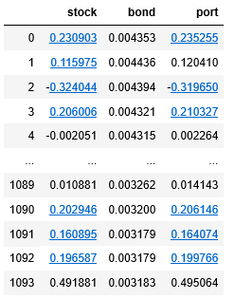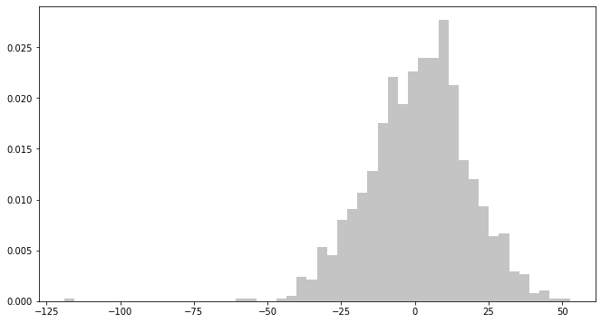First, we adapted our Markowitz optimal portfolio into daily form in pandas Data Frame which is shown below.

As shown above we can check portfolio daily return and its distribution which is almost normal distribution. So, we adapt student-T distribution to calculate VaR and CVaR. Results are shown below.

