Data Preparation and Initial Analysis
Data and scope. We use the NOAA Global Drifter Program (GDP) hourly dataset, accessed through CloudDrift [1], to assess data availability for forecasts at 1 hour, 1 day and 1 week. Our study window (25–45°N, 80–50°W) covers the Gulf Stream and neighbouring waters rather than defining the current’s exact boundary. The extracted subset contains 8,138,225 records from 1,481 drifters, spanning November 1990 to October 2022. Available fields include position, time, velocity, sea surface temperature (SST) and quality indicators.
Processing and quality. The pipeline reads and caches data in blocks, filters positions, maps observations to drifter IDs and checks missing values and timestamps. Continuous segments require the same drifter, adjacent source indices and exactly one-hour intervals, preventing windows from crossing gaps or regional exits. The subset has no missing timestamps, duplicate drifter–time pairs or missing velocity components. SST is 3.39% missing and remains optional. Regional position completeness follows from spatial filtering; uncertainty fields and quality flags still require screening.
Initial findings. We identify 5,725 continuous segments with a median duration of 288 hours (12 days). Using 24 hours of history, 1,465, 1,455 and 1,394 drifters provide eligible windows for 1-hour, 24-hour and 168-hour forecasts, respectively. The one-week task offers 7,403,575 overlapping candidate origins. These counts support data feasibility, not independent sample size or prediction accuracy. Figure 1 illustrates spatial coverage and the range of continuous durations.
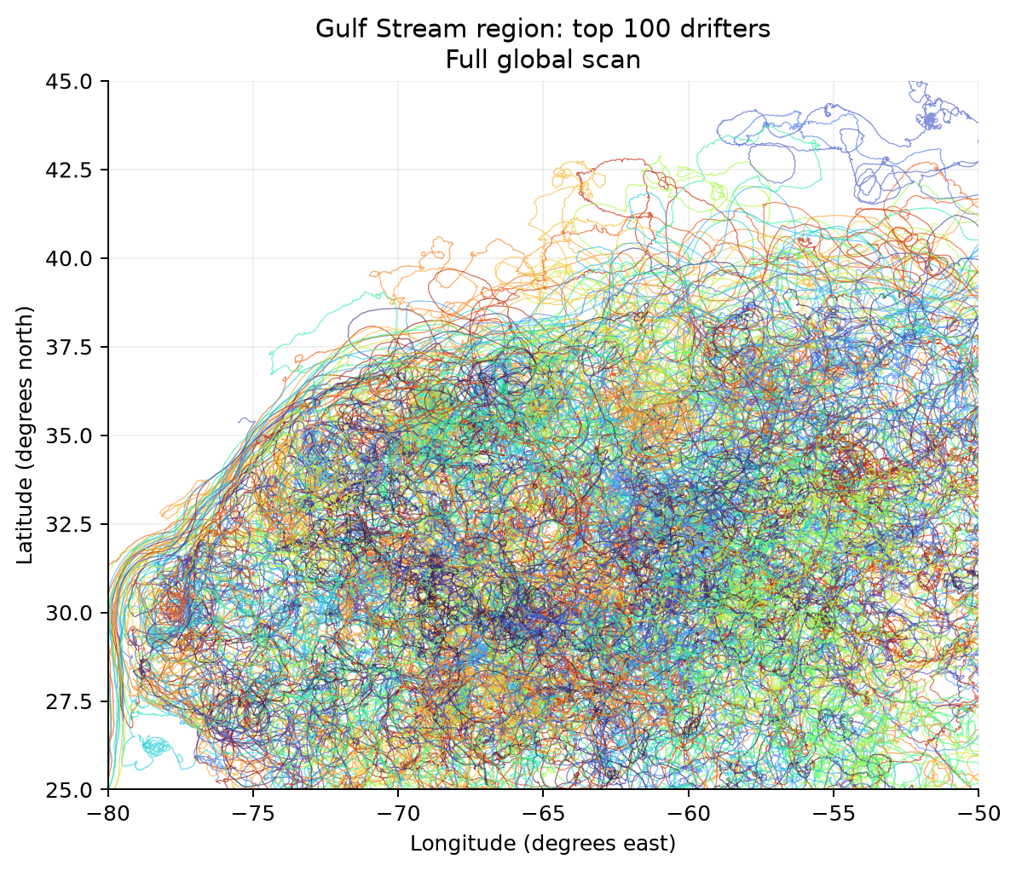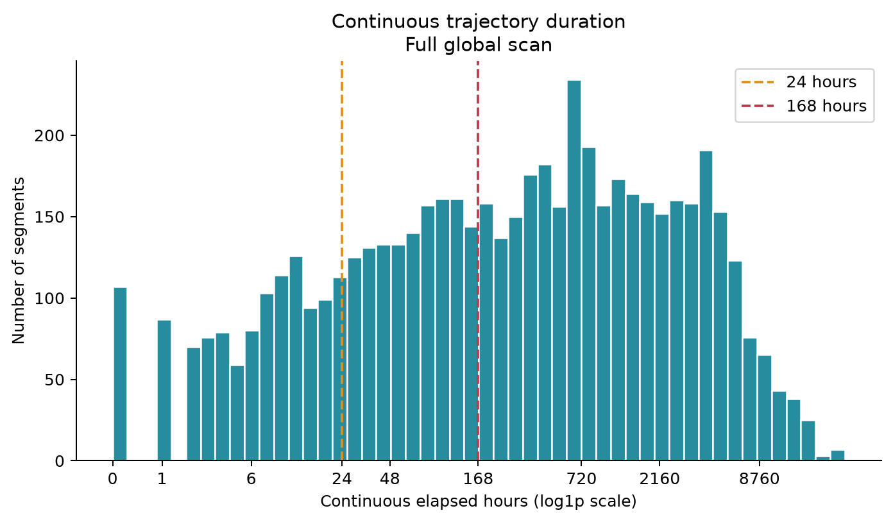
Figure 1. Left: trajectories of the 100 drifters with the most regional observations, plotted separately by segment; this is not a random sample. Right: continuous duration distribution with 24- and 168-hour reference lines. A 24-hour history plus a one-week forecast requires 192 hours (193 points).
Feasibility and next steps. The complete dataset and a random 100-drifter development subset are exported as Parquet with metadata and segment summaries. We will confirm features and quality rules with the modelling team, then separate training, validation and test sets by drifter ID. Imputation, scaling and mean-flow estimation will use training data only. Current windows require all historical and future positions to remain inside the region; forecasts beyond its boundary need additional trajectory extraction.
[1] NOAA GDP hourly data, accessed via CloudDrift. DOI: 10.25921/x46c-3620. Regional statistics and figures: project EDA outputs.

