Amir Hammoud

Setha Proeung

Nhan Vo

3/9/2021

**Practice SQL 25-36**

**25-28:**

**25. Find the total of all payments made by each customer (98)**

SELECT CUSTOMERNAME, SUM(AMOUNT) AS TOTALPAYMENTS

FROM CUSTOMERS

NATURAL JOIN PAYMENTS

GROUP BY CUSTOMERNAME;

|  |  |
| --- | --- |
| CUSTOMERNAME | TOTALPAYMENTS |
| AV Stores, Co. | 148410.09 |
| Alpha Cognac | 60483.36 |
| Amica Models & Co. | 82223.23 |
| Anna's Decorations, Ltd | 137034.22 |
| Atelier graphique | 22314.36 |
| Australian Collectables, Ltd | 44920.76 |
| Australian Collectors, Co. | 180585.07 |
| Australian Gift Network, Co | 55190.16 |
| Auto AssociÃ©s & Cie. | 58876.41 |
| Auto Canal+ Petit | 86436.97 |
| Auto-Moto Classics Inc. | 21554.26 |
| Baane Mini Imports | 104224.79 |
| Bavarian Collectables Imports, Co. | 31310.09 |
| Blauer See Auto, Co. | 75937.76 |
| Boards & Toys Co. | 7918.60 |
| CAF Imports | 46751.14 |
| Cambridge Collectables Co. | 32198.69 |
| Canadian Gift Exchange Network | 70122.19 |
| Classic Gift Ideas, Inc | 57939.34 |
| Classic Legends Inc. | 69214.33 |
| Clover Collections, Co. | 49898.27 |
| Collectable Mini Designs Co. | 80375.24 |
| Collectables For Less Inc. | 73533.65 |
| Corporate Gift Ideas Co. | 132340.78 |
| Corrida Auto Replicas, Ltd | 112440.09 |
| Cruz & Sons Co. | 87468.30 |
| Daedalus Designs Imports | 61781.70 |
| Danish Wholesale Imports | 107446.50 |
| Diecast Classics Inc. | 98509.25 |
| Diecast Collectables | 65541.74 |
| Double Decker Gift Stores, Ltd | 29586.15 |
| Down Under Souveniers, Inc | 154622.08 |
| Dragon Souveniers, Ltd. | 156251.03 |
| Enaco Distributors | 68520.47 |
| Euro+ Shopping Channel | 715738.98 |
| Extreme Desk Decorations, Ltd | 66704.94 |
| Frau da Collezione | 25358.32 |
| FunGiftIdeas.com | 88627.49 |
| Gift Depot Inc. | 95424.63 |
| Gift Ideas Corp. | 49967.78 |
| Gifts4AllAges.com | 33533.47 |
| GiftsForHim.com | 56662.38 |
| Handji Gifts& Co | 105420.57 |
| Heintze Collectables | 89909.80 |
| Herkku Gifts | 97562.47 |
| Iberia Gift Imports, Corp. | 50987.85 |
| Kelly's Gift Shop | 114497.19 |
| King Kong Collectables, Co. | 45480.79 |
| L'ordine Souveniers | 90143.31 |
| La Corne D'abondance, Co. | 86553.52 |
| La Rochelle Gifts | 116949.68 |
| Land of Toys Inc. | 107639.94 |
| Lyon Souveniers | 67659.19 |
| Marseille Mini Autos | 71547.53 |
| Marta's Replicas Co. | 90545.37 |
| Men 'R' US Retailers, Ltd. | 41506.19 |
| Microscale Inc. | 29230.43 |
| Mini Auto Werke | 51059.99 |
| Mini Caravy | 75859.32 |
| Mini Classics | 78432.16 |
| Mini Creations Ltd. | 101872.52 |
| Mini Gifts Distributors Ltd. | 584188.24 |
| Mini Wheels Co. | 66710.56 |
| Motor Mint Distributors Inc. | 77726.59 |
| Muscle Machine Inc | 177913.95 |
| Norway Gifts By Mail, Co. | 69059.04 |
| Online Diecast Creations Co. | 116449.29 |
| Online Mini Collectables | 55577.26 |
| Osaka Souveniers Co. | 62361.22 |
| Oulu Toy Supplies, Inc. | 95706.15 |
| Petit Auto | 62253.85 |
| QuÃ©bec Home Shopping Network | 68977.67 |
| Reims Collectables | 126983.19 |
| Rovelli Gifts | 127529.69 |
| Royal Canadian Collectables, Ltd. | 66812.00 |
| Royale Belge | 29217.18 |
| Salzburg Collectables | 85060.00 |
| Saveley & Henriot, Co. | 130305.35 |
| Scandinavian Gift Ideas | 76776.44 |
| Signal Collectibles Ltd. | 42570.37 |
| Signal Gift Stores | 80180.98 |
| Souveniers And Things Co. | 91655.61 |
| Stylish Desk Decors, Co. | 80556.73 |
| Suominen Souveniers | 103896.74 |
| Super Scale Inc. | 70378.65 |
| Technics Stores Inc. | 104545.22 |
| Tekni Collectables Inc. | 38281.51 |
| The Sharp Gifts Warehouse | 59551.38 |
| Tokyo Collectables, Ltd | 105548.73 |
| Toms SpezialitÃ¤ten, Ltd | 89223.14 |
| Toys of Finland, Co. | 95546.46 |
| Toys4GrownUps.com | 93803.30 |
| UK Collectables, Ltd. | 61167.18 |
| Vida Sport, Ltd | 108777.92 |
| Vitachrome Inc. | 72497.64 |
| Volvo Model Replicas, Co | 43680.65 |
| West Coast Collectables Co. | 43748.72 |
| giftsbymail.co.uk | 71783.75 |

**26. Find the largest payment made by a customer (1)**

SELECT MAX(AMOUNT) AS LARGESTPAYMENT

FROM PAYMENTS;

|  |
| --- |
| LARGESTPAYMENT |
| 120166.58 |

**27. Find the average payment made by a customer (1)**

SELECT AVG(AMOUNT) AS AVGPAYMENT

FROM PAYMENTS;

|  |
| --- |
| AVGPAYMENT |
| 32431.6455 |

**28. What is the total number of products per product line (7)**

SELECT PRODUCTLINE, COUNT(PRODUCTNAME) AS NUMOFPRODUCTS

FROM PRODUCTS

NATURAL JOIN PRODUCTLINES

GROUP BY PRODUCTLINE;

|  |  |
| --- | --- |
| PRODUCTLINE | NUMOFPRODUCTS |
| Classic Cars | 38 |
| Motorcycles | 13 |
| Planes | 12 |
| Ships | 9 |
| Trains | 3 |
| Trucks and Buses | 11 |
| Vintage Cars | 24 |

**29-32:**

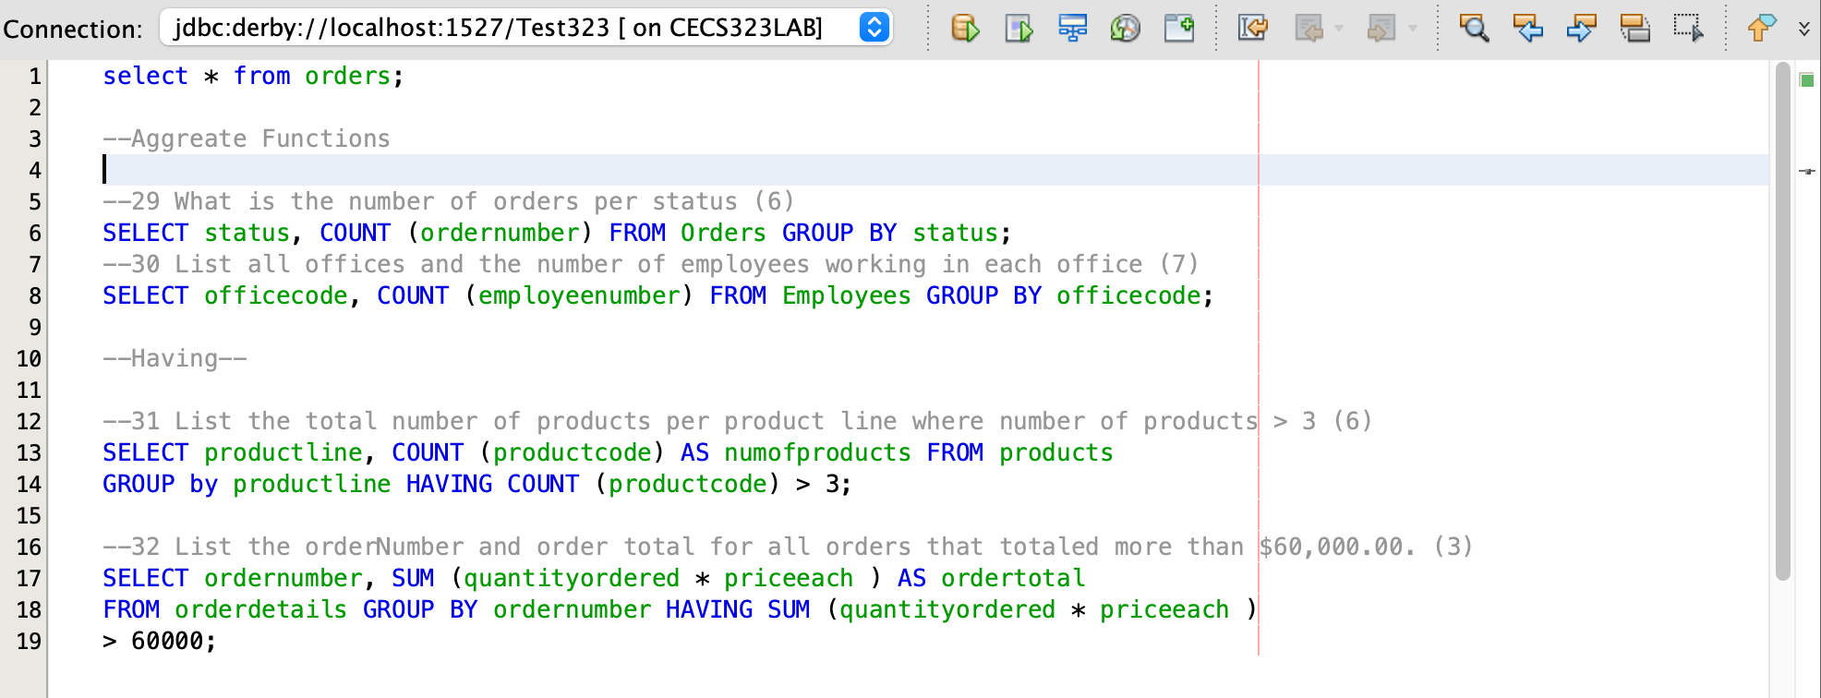

**29**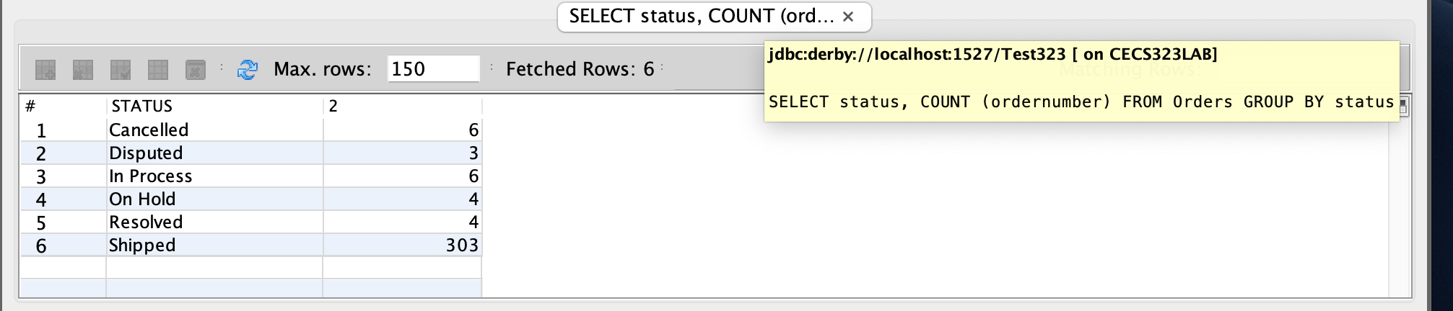

**30**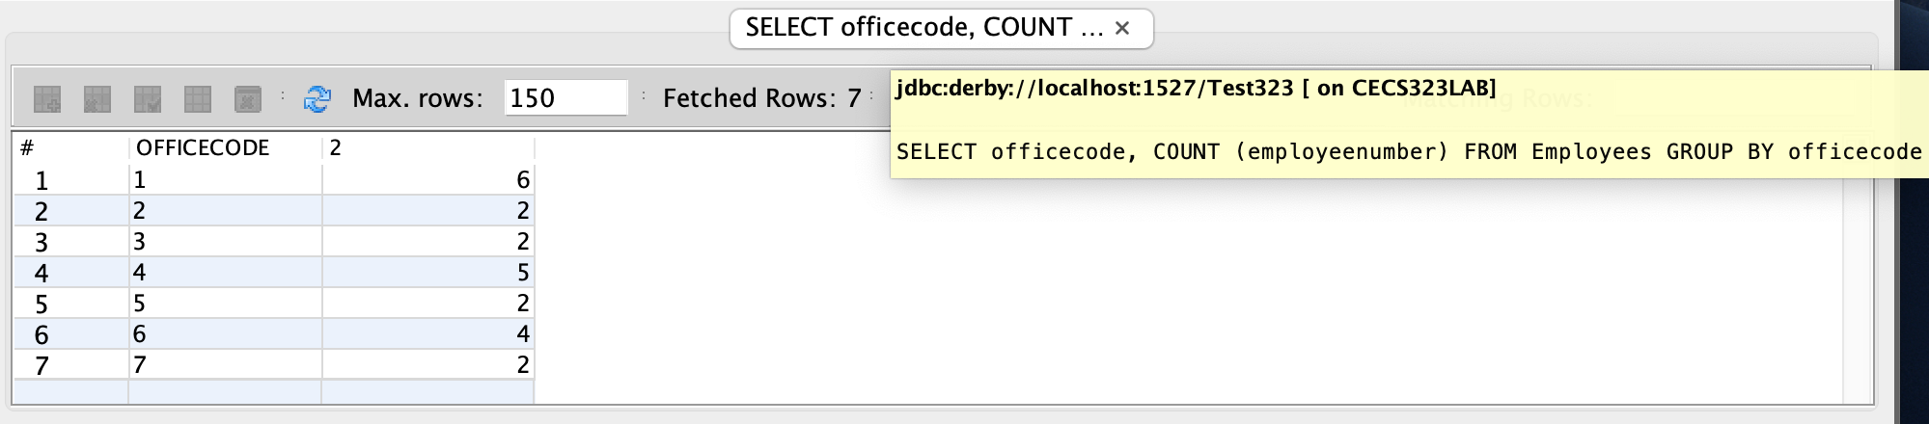

**31**

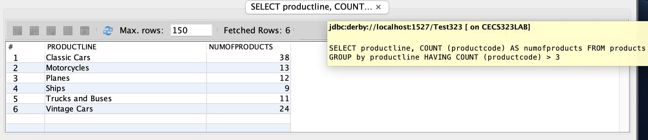

**32**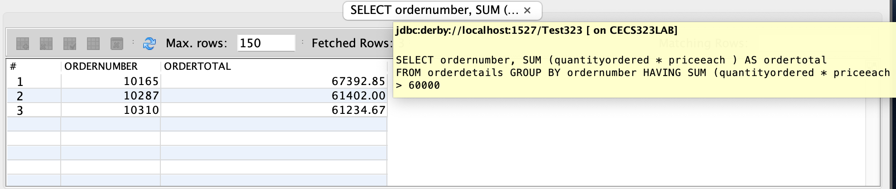

/* 33)

List the products and the profit that we have made on them. The profit in each order for a

given product is (priceEach – buyPrice) * quantityOrdered. List the product’s name and

code with the total profit that we have earned selling that product. Order the rows

descending by profit. Only show those products whose profit is greater than $60,000.00. (11)*/

SELECT products.productName, products.productCode, SUM((priceEach-buyPrice) * quantityOrdered) AS profit

FROM products INNER JOIN orderDetails ON products.PRODUCTCODE=orderDetails.PRODUCTCODE GROUP BY products.productName, products.productCode

HAVING SUM((priceEach-buyprice) * quantityOrdered) > 60000 ORDER BY profit DESC;

/* 34)

List the average of the money spent on each product across all orders where that product

appears when the customer is based in Japan. Show these products in descending order

by the average expenditure (45).*/

SELECT products.PRODUCTNAME, AVG(orderDetails.QUANTITYORDERED*orderDetails.PRICEEACH) as moneySpent FROM products

INNER JOIN orderDetails ON products.PRODUCTCODE=orderDetails.PRODUCTCODE INNER JOIN orders ON orders.ORDERNUMBER=orderDetails.ORDERNUMBER

INNER JOIN customers ON customers.CUSTOMERNUMBER=orders.CUSTOMERNUMBER

WHERE customers.COUNTRY='Japan' GROUP BY products.PRODUCTNAME ORDER BY moneySpent DESC;

/* 35)

What is the profit per product (MSRP-buyprice). Order by productName. (110)

*/

SELECT productname, (msrp-buyprice) AS profitPerProduct FROM products ORDER BY products.PRODUCTNAME;

/* 36)

List the Customer Name and their total orders (quantity * priceEach) across all orders that

the customer has ever placed with us, in descending order by order total for those

customers who have ordered more than $100,000.00 from us ordered by Customer total

in descending order. (32)

*/

SELECT customers.CUSTOMERNAME, SUM(orderDetails.QUANTITYORDERED*orderDetails.PRICEEACH) as totalOrder FROM customers INNER JOIN orders ON customers.CUSTOMERNUMBER=orders.CUSTOMERNUMBER

INNER JOIN orderDetails ON orders.ORDERNUMBER=orderDetails.ORDERNUMBER GROUP BY customers.CUSTOMERNAME

HAVING SUM(orderDetails.QUANTITYORDERED*orderDetails.PRICEEACH)>100000 ORDER BY totalOrder DESC;

**33**

|  |  |  |
| --- | --- | --- |
| PRODUCTNAME | PRODUCTCODE | PROFIT |
| 1992 Ferrari 360 Spider red | S18_3232 | 135996.78 |
| 1952 Alpine Renault 1300 | S10_1949 | 95282.58 |
| 2001 Ferrari Enzo | S12_1108 | 93349.65 |
| 2003 Harley-Davidson Eagle Drag Bike | S10_4698 | 81031.3 |
| 1968 Ford Mustang | S12_1099 | 72579.26 |
| 1969 Ford Falcon | S12_3891 | 72399.77 |
| 1928 Mercedes-Benz SSK | S18_2795 | 68423.18 |
| 2002 Suzuki XREO | S12_2823 | 67641.47 |
| 1980s Black Hawk Helicopter | S18_1662 | 64599.11 |
| 1948 Porsche Type 356 Roadster | S18_3685 | 62725.78 |
| 1917 Grand Touring Sedan | S18_1749 | 60945 |

**34**

|  |  |
| --- | --- |
| PRODUCTNAME | MONEYSPENT |
| 2003 Harley-Davidson Eagle Drag Bike | 6700.745 |
| 1969 Corvair Monza | 5862 |
| 1970 Triumph Spitfire | 5721.6 |
| 1952 Alpine Renault 1300 | 5691.84 |
| 1958 Setra Bus | 5491.54 |
| 1993 Mazda RX-7 | 5164.77 |
| 1995 Honda Civic | 5052.72 |
| 1948 Porsche Type 356 Roadster | 4966.14 |
| HMS Bounty | 4779.5 |
| 1969 Ford Falcon | 4765.1 |
| 1940 Ford Pickup Truck | 4639.97 |
| 1980s Black Hawk Helicopter | 4399.52 |
| 1912 Ford Model T Delivery Wagon | 4040.3 |
| 1982 Camaro Z28 | 3914.55 |
| 1997 BMW F650 ST | 3905.86 |
| 18th century schooner | 3774 |
| 1900s Vintage Bi-Plane | 3730.1 |
| 1903 Ford Model A | 3671.64 |
| 1996 Moto Guzzi 1100i | 3654.385 |
| The Mayflower | 3277.12 |
| 1904 Buick Runabout | 3238.59 |
| The USS Constitution Ship | 3108 |
| 1940 Ford Delivery Sedan | 3064.32 |
| American Airlines: MD-11S | 2940.45 |
| P-51-D Mustang | 2782.785 |
| 1900s Vintage Tri-Plane | 2724 |
| 1997 BMW R 1100 S | 2616.84 |
| 1928 British Royal Navy Airplane | 2473.515 |
| ATA: B757-300 | 2462 |
| America West Airlines B757-200 | 2437.24 |
| Collectable Wooden Train | 2294 |
| 1928 Ford Phaeton Deluxe | 2226.9 |
| Corsair F4U ( Bird Cage) | 2110.98 |
| F/A 18 Hornet 1/72 | 1984 |
| 1960 BSA Gold Star DBD34 | 1896.6 |
| 1930 Buick Marquette Phaeton | 1857.6 |
| American Airlines: B767-300 | 1841.49 |
| 1936 Harley Davidson El Knucklehead | 1756.5 |
| 1937 Horch 930V Limousine | 1677.94 |
| 1962 City of Detroit Streetcar | 1363.68 |
| Boeing X-32A JSF | 1340.82 |
| 1996 Peterbilt 379 Stake Bed with Outrigger | 1254 |
| The Schooner Bluenose | 1173.48 |
| 1939 Cadillac Limousine | 1046.01 |
| 1936 Mercedes Benz 500k Roadster | 615.45 |

**35**

|  |  |
| --- | --- |
| PRODUCTNAME | PROFITPERPRODUCT |
| 18th Century Vintage Horse Carriage | 43.98 |
| 18th century schooner | 40.55 |
| 1900s Vintage Bi-Plane | 34.26 |
| 1900s Vintage Tri-Plane | 36.22 |
| 1903 Ford Model A | 68.29 |
| 1904 Buick Runabout | 35.11 |
| 1911 Ford Town Car | 27.24 |
| 1912 Ford Model T Delivery Wagon | 41.6 |
| 1913 Ford Model T Speedster | 40.53 |
| 1917 Grand Touring Sedan | 83.3 |
| 1917 Maxwell Touring Car | 41.67 |
| 1926 Ford Fire Engine | 35.85 |
| 1928 British Royal Navy Airplane | 42.68 |
| 1928 Ford Phaeton Deluxe | 35.77 |
| 1928 Mercedes-Benz SSK | 96.19 |
| 1930 Buick Marquette Phaeton | 16.58 |
| 1932 Alfa Romeo 8C2300 Spider Sport | 48.77 |
| 1932 Model A Ford J-Coupe | 68.65 |
| 1934 Ford V8 Coupe | 28.11 |
| 1936 Chrysler Airflow | 39.93 |
| 1936 Harley Davidson El Knucklehead | 36.34 |
| 1936 Mercedes Benz 500k Roadster | 19.28 |
| 1936 Mercedes-Benz 500K Special Roadster | 29.65 |
| 1937 Horch 930V Limousine | 39.45 |
| 1937 Lincoln Berline | 42.12 |
| 1938 Cadillac V-16 Presidential Limousine | 24.19 |
| 1939 Cadillac Limousine | 27.17 |
| 1939 Chevrolet Deluxe Coupe | 10.62 |
| 1940 Ford Delivery Sedan | 35.22 |
| 1940 Ford Pickup Truck | 58.34 |
| 1940s Ford truck | 36.32 |
| 1941 Chevrolet Special Deluxe Cabriolet | 41.29 |
| 1948 Porsche 356-A Roadster | 23.1 |
| 1948 Porsche Type 356 Roadster | 79.12 |
| 1949 Jaguar XK 120 | 43.62 |
| 1950's Chicago Surface Lines Streetcar | 35.42 |
| 1952 Alpine Renault 1300 | 115.72 |
| 1952 Citroen-15CV | 44.62 |
| 1954 Greyhound Scenicruiser | 28.13 |
| 1956 Porsche 356A Coupe | 42.13 |
| 1957 Chevy Pickup | 62.8 |
| 1957 Corvette Convertible | 78.87 |
| 1957 Ford Thunderbird | 37.06 |
| 1957 Vespa GS150 | 29.22 |
| 1958 Chevy Corvette Limited Edition | 19.45 |
| 1958 Setra Bus | 58.77 |
| 1960 BSA Gold Star DBD34 | 38.85 |
| 1961 Chevrolet Impala | 48.51 |
| 1962 City of Detroit Streetcar | 21.09 |
| 1962 LanciaA Delta 16V | 44.32 |
| 1962 Volkswagen Microbus | 66.45 |
| 1964 Mercedes Tour Bus | 47.87 |
| 1965 Aston Martin DB5 | 58.48 |
| 1966 Shelby Cobra 427 S/C | 21.13 |
| 1968 Dodge Charger | 42.28 |
| 1968 Ford Mustang | 99.23 |
| 1969 Chevrolet Camaro Z28 | 35.1 |
| 1969 Corvair Monza | 61.94 |
| 1969 Dodge Charger | 56.43 |
| 1969 Dodge Super Bee | 31.36 |
| 1969 Ford Falcon | 89.97 |
| 1969 Harley Davidson Ultimate Chopper | 46.89 |
| 1970 Chevy Chevelle SS 454 | 24.25 |
| 1970 Dodge Coronet | 25.43 |
| 1970 Plymouth Hemi Cuda | 47.88 |
| 1970 Triumph Spitfire | 51.7 |
| 1971 Alpine Renault 1600s | 22.65 |
| 1972 Alfa Romeo GTA | 50.32 |
| 1974 Ducati 350 Mk3 Desmo | 45.92 |
| 1976 Ford Gran Torino | 73.5 |
| 1980s Black Hawk Helicopter | 80.42 |
| 1980â€™s GM Manhattan Express | 42.38 |
| 1982 Camaro Z28 | 54.62 |
| 1982 Ducati 900 Monster | 22.16 |
| 1982 Ducati 996 R | 16.09 |
| 1982 Lamborghini Diablo | 21.52 |
| 1985 Toyota Supra | 50.56 |
| 1992 Ferrari 360 Spider red | 91.44 |
| 1992 Porsche Cayenne Turbo Silver | 48.5 |
| 1993 Mazda RX-7 | 58.03 |
| 1995 Honda Civic | 48.36 |
| 1996 Moto Guzzi 1100i | 49.95 |
| 1996 Peterbilt 379 Stake Bed with Outrigger | 31.03 |
| 1997 BMW F650 ST | 32.97 |
| 1997 BMW R 1100 S | 51.84 |
| 1998 Chrysler Plymouth Prowler | 62.22 |
| 1999 Indy 500 Monte Carlo SS | 75.24 |
| 1999 Yamaha Speed Boat | 34.41 |
| 2001 Ferrari Enzo | 112.21 |
| 2002 Chevy Corvette | 44.97 |
| 2002 Suzuki XREO | 84.35 |
| 2002 Yamaha YZR M1 | 47.19 |
| 2003 Harley-Davidson Eagle Drag Bike | 102.64 |
| ATA: B757-300 | 59.32 |
| America West Airlines B757-200 | 30.92 |
| American Airlines: B767-300 | 40.19 |
| American Airlines: MD-11S | 37.76 |
| Boeing X-32A JSF | 16.89 |
| Collectable Wooden Train | 33.28 |
| Corsair F4U ( Bird Cage) | 38.9 |
| Diamond T620 Semi-Skirted Tanker | 47.46 |
| F/A 18 Hornet 1/72 | 25.6 |
| HMS Bounty | 50.69 |
| P-51-D Mustang | 35.48 |
| Pont Yacht | 21.3 |
| The Mayflower | 43.31 |
| The Queen Mary | 45.68 |
| The Schooner Bluenose | 32.67 |
| The Titanic | 49.08 |
| The USS Constitution Ship | 38.31 |

**36**

|  |  |
| --- | --- |
| CUSTOMERNAME | TOTALORDER |
| Euro+ Shopping Channel | 820689.54 |
| Mini Gifts Distributors Ltd. | 591827.34 |
| Australian Collectors, Co. | 180585.07 |
| Muscle Machine Inc | 177913.95 |
| La Rochelle Gifts | 158573.12 |
| Dragon Souveniers, Ltd. | 156251.03 |
| Down Under Souveniers, Inc | 154622.08 |
| Land of Toys Inc. | 149085.15 |
| AV Stores, Co. | 148410.09 |
| The Sharp Gifts Warehouse | 143536.27 |
| Salzburg Collectables | 137480.07 |
| Kelly's Gift Shop | 137460.79 |
| Anna's Decorations, Ltd | 137034.22 |
| Souveniers And Things Co. | 133907.12 |
| Corporate Gift Ideas Co. | 132340.78 |
| Saveley & Henriot, Co. | 130305.35 |
| Danish Wholesale Imports | 129085.12 |
| Rovelli Gifts | 127529.69 |
| Reims Collectables | 126983.19 |
| L'ordine Souveniers | 125505.57 |
| Scandinavian Gift Ideas | 120943.53 |
| Online Diecast Creations Co. | 116449.29 |
| Corrida Auto Replicas, Ltd | 112440.09 |
| Vida Sport, Ltd | 108777.92 |
| Handji Gifts& Co | 107746.75 |
| UK Collectables, Ltd. | 106610.72 |
| Tokyo Collectables, Ltd | 105548.73 |
| Technics Stores Inc. | 104545.22 |
| Diecast Classics Inc. | 104358.69 |
| Baane Mini Imports | 104224.79 |
| Suominen Souveniers | 103896.74 |
| Mini Creations Ltd. | 101872.52 |