**Chapter 1**

**Worksheets**

**Name**: Nhan Vo

**Email**: vothanhnhan108@gmail.com

**Course/Section**: ECON 1- 50259

**Fill in the Blank**

**Please add the appropriate word or words to complete the sentences.**

1. According to the invisible hand theory, efficiency is dependent on the activity of self-interest individuals interacting in free markets.
2. In a market system, all goods, services, and resources are allocated based on willingness and ability.
3. Society has a dilemma determining what should be produced because resources are scarce.
4. Because our wants are unlimited and the resources to fulfill these wants have limits, we are forced to choose among a set of alternatives.
5. Opportunity Cost is what is given up to accomplish something.
6. Efficient producers are low opportunity cost producers because they give up less.
7. Consumers determine what will be produced. Producers determine how it will be produced to combine resources in production.
8. Only those who are willing and able will have goods and services allocated to them.
9. Resources are productive inputs.
10. An example of labor is an accountant or building contractor.
11. An example of Land could be an office building constructed on a plot of land.
12. A production possibility model shows the number of any two goods that can be produced.
13. The downward slope of the curve or frontier tells us there is an inverse relationship between the two variables being measured.
14. If an economy is producing inside the frontier it is inefficient and has some idle resources.
15. If an economy is producing on the production possibility frontier it is efficiently employing all available resources.
16. A point outside the frontier is an impossible combination of goods and services with the current state of knowledge.
17. Comparative Advantage states producing efficiently at a relatively low opportunity cost means we give up fewer resources to achieve our output compared to another.
18. Empirical evidence may be described as evidence relating to or based on experience or observation.
19. Positive statements are declarations of fact such as a statistic.
20. Normative economic statements are opinions based on social or cultural norms.
21. In the construction of all economic experiments analysts must use other things being equal. The purpose of this clause is to isolate variables in problems to determine what causes a change.

**Equations**

**Please use the following equation(s) to help solve problems for this chapter.**

**Equation for Per Unit Opportunity Cost**

Related concepts: comparative advantage, production possibilities model (PPF).

To calculate per unit opportunity cost we must set up a relative ratio or proportions. We will use quantities of goods or services produced in the ratio. In our example, we will produce good *x* or good *y*.

Producer A:  =   and   =

Producer B:   =   and   =

Some students may be more accustomed to  than =.

For example, producer A can generate 65 tons of agricultural goods or 70 tons of industrial goods. These output levels represent the limits of goods production.

 =   and   =

 1 = 1.08       1 = .93

Using this table we may find all the ratios for some alternative productions in the model.

|  |  |  |
| --- | --- | --- |
| **Producer A** | **Agricultural** | **Industrial** |
|  | 50 | 45 |
|  | 25 | 65 |

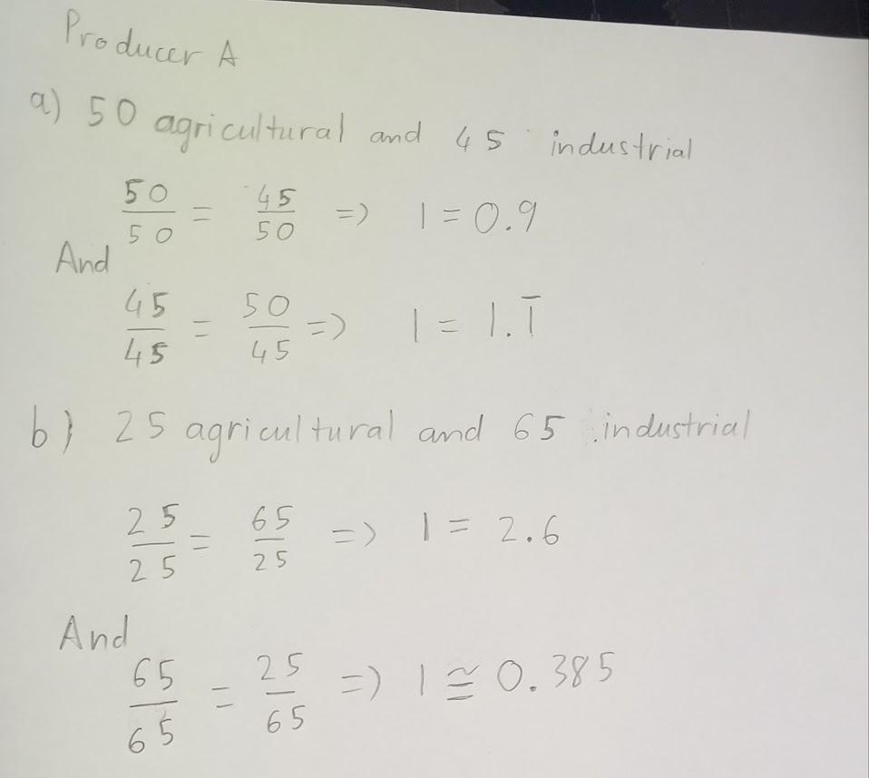

**Graph Map**

Please graph two hypothetical production possibilities models. In one of the graphs, please construct a frontier with the two variables having a constant rate of change. In the other draw the constraint with the two goods or services having a varied rate of change. What would make the frontier linear or nonlinear?

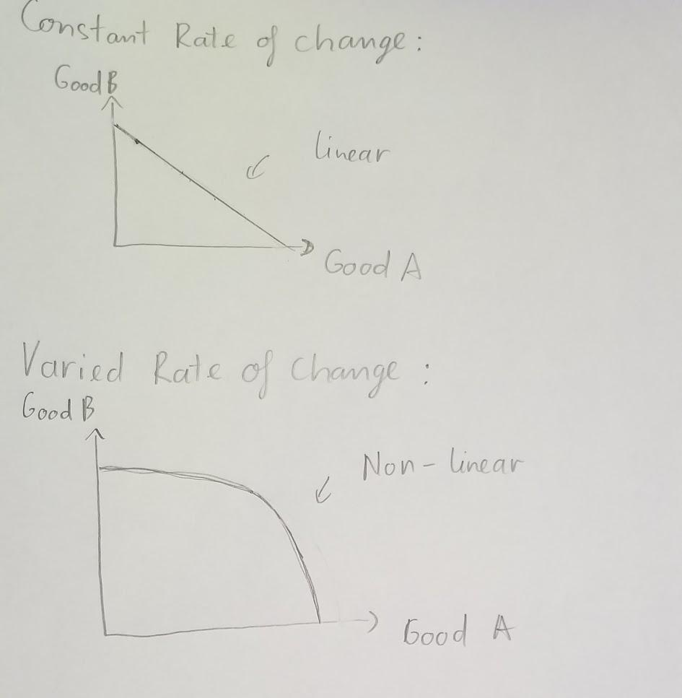

A frontier line is linear when there is a constant rate of change between two products A and B. It indicated that if A increases by a certain amount, B will decrease by the same certain amount, constant opportunity cost. A frontier line is non-linear when there is a varied rate of change between two products A and B. If we increase the production of product A, the production of product B will decrease higher than that amount of the increase.

**Math it Graph it Write it**

Question 1

Please use the information in the table to answer the following questions. For example, if Colombia produced 300 units of tobacco, they would produce zero units of coffee.

|  |  |  |
| --- | --- | --- |
| **Country** | **Tobacco** | **Coffee** |
| Colombia | 300 | 900 |
| Cuba | 250 | 500 |

1. What is the opportunity cost for Colombia to produce one unit of coffee? Tobacco?
2. What is the opportunity cost for Cuba to produce one unit of coffee? Tobacco?
3. Please construct the production possibilities models (PPFs) for each country. Other things being equal, the resources within each country have a constant opportunity cost and are suited to produce coffee or tobacco.
4. Which country has a comparative advantage with regard to coffee production? Why?

Answer:

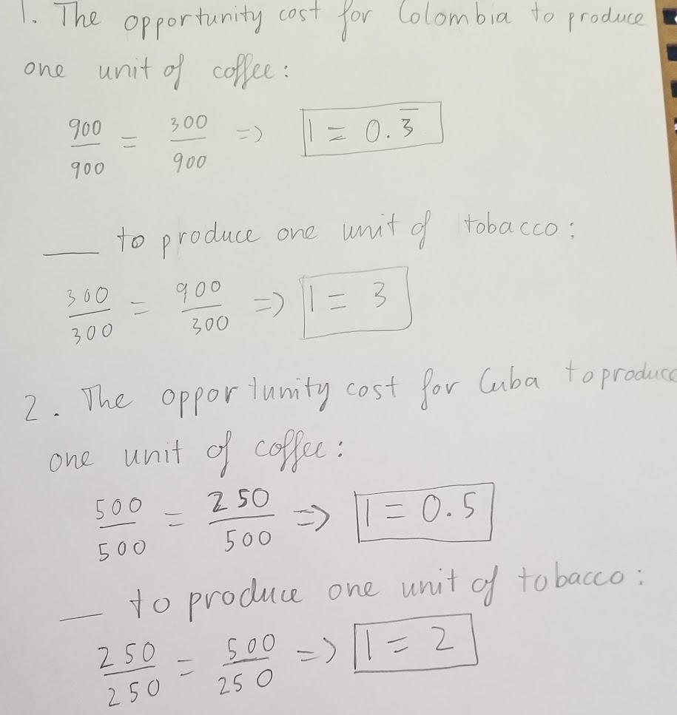

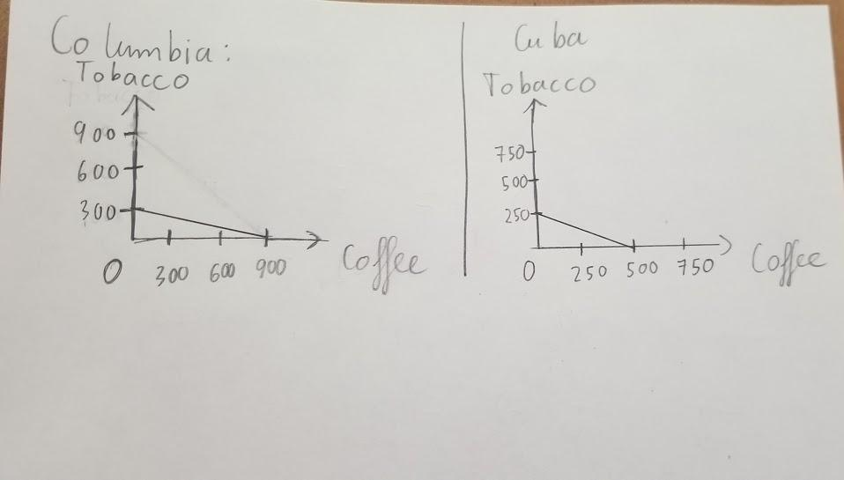

4. Colombia has a comparative advantage in producing coffee when she only gives up approximately 0.3 unit while Cuba gives up 0.5 unit. On the other hand, Cuba has a comparative advantage in producing tobacco when she only gives up 2 units compared to 3 units of Colombia.

Question 2

Please use the PPF data below to answer the following questions.  Assume the points satisfy the assumption of full employment and fixed technology in this economy.  The two goods the economy produces are bags of tea and bags of snacks in these combination:

Points           Tea                  Snacks

A              0                      14

B                    1                      13

C                  2                      10

D         `   3                      6

E                   4                      0

1. What is the opportunity cost per-unit gained when moving production from point

i.                    B to C?                                            iii.        E to D?

ii.                  A to B?                                            iv.        D to C?

  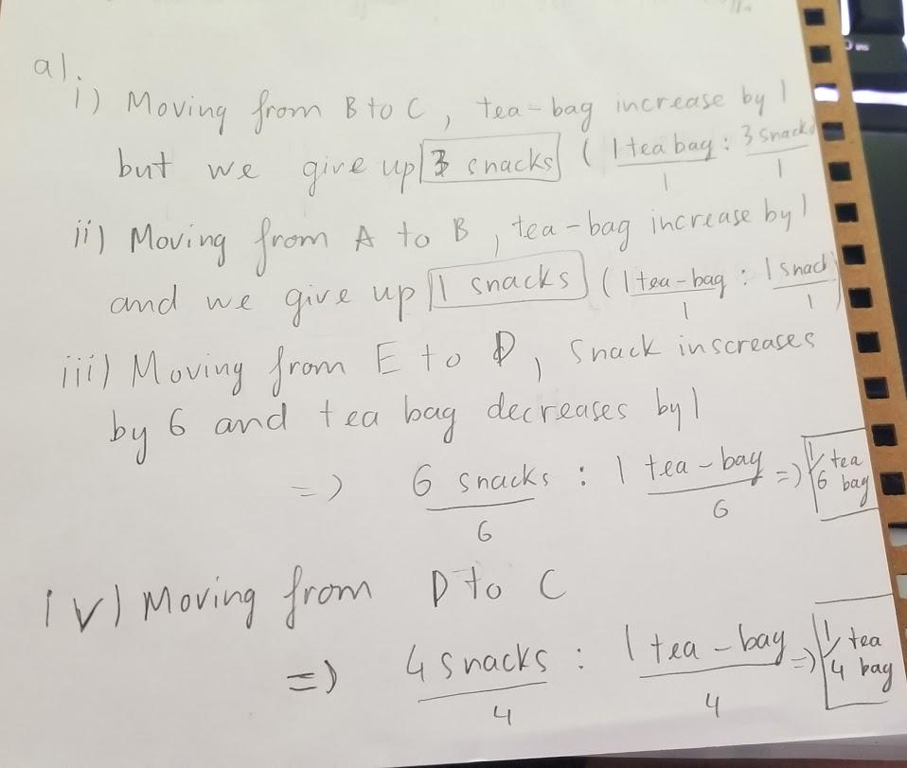

1. If the economy is currently producing 10 bags of snacks, what is the opportunity cost of producing two more bags of tea?

Gain:loss= 2/2:10/2 =5 bags of snacks.

1. Is point B efficient? Why?

Yes point B is efficient because point B is on the production possibility frontier. It means that all of the resources and technology are being used efficiently.

1. If the economy is currently producing at a point F, which is 3 bags of tea and 5 bags of snacks, what is the economy doing?

It means that the economy is producing inefficiently. The resources and technology are being wasted.

1. Why does this PPF have a bowed-out (concave) shape?

Because the resources needed to produce tea-bags and snack-bags are not unlimited. We cannot fully produce both of them at maximum amounts simultaneously. We have to choose the most efficient way to produce them. This is the law of increasing opportunity cost.

1. How can the economy increase its production of both tea and snacks?

The economy can increase the available resources through technology or more employers. On the other hand, one economy can trade with another to increase the capacity of production.

1. Using the data, draw the PPF and show the change from question (f) on the graph.

