پیش گزارش 5 – کیمیا منتظری – 9931078

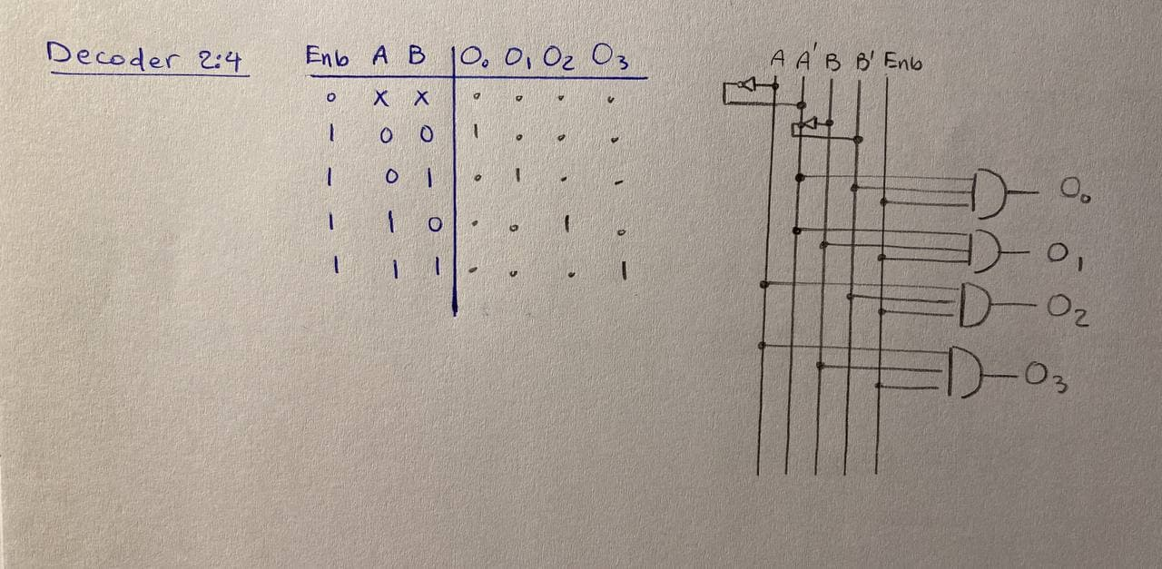**1)** Decoder (2x4)

module decoder2x4(a,b,enb,O0,O1,O2,O3);

input a,b,enb;

output O0,O1,O2,O3;

not g1(a_not, a);

not g2(b_not, b);

and g3(O0, a_not, b_not, enb);

and g4(O1, a_not, b, enb);

and g5(O2, a, b_not, enb);

and g6(O3, a, b, enb);

endmodule

**2)** Priority Encoder(4x2)

|  |  |  |  |  |  |
| --- | --- | --- | --- | --- | --- |
| **I3** | **I2** | **I1** | **I0** | **O1** | **O0** |
| 0 | 0 | 0 | 0 | X | X |
| 0 | 0 | 0 | 1 | 0 | 0 |
| 0 | 0 | 1 | X | 0 | 1 |
| 0 | 1 | X | X | 1 | 0 |
| 1 | X | X | X | 1 | 1 |

|  |  |  |  |  |
| --- | --- | --- | --- | --- |
| **I2, I3** / **I0, I1** | **00** | **01** | **11** | **10** |
| **00** | X | 1 | 1 | 0 |
| **01** | 1 | 1 | 1 | 1 |
| **11** | 1 | 1 | 1 | 1 |
| **10** | 0 | 0 | 0 | 0 |

**O0 = I3 + I1I2’**

|  |  |  |  |  |
| --- | --- | --- | --- | --- |
| **I2, I3** / **I0, I1** | **00** | **01** | **11** | **10** |
| **00** | X | 0 | 0 | 0 |
| **01** | 1 | 1 | 1 | 1 |
| **11** | 1 | 1 | 1 | 1 |
| **10** | 1 | 1 | 1 | 1 |

**O1 = I3 + I2**

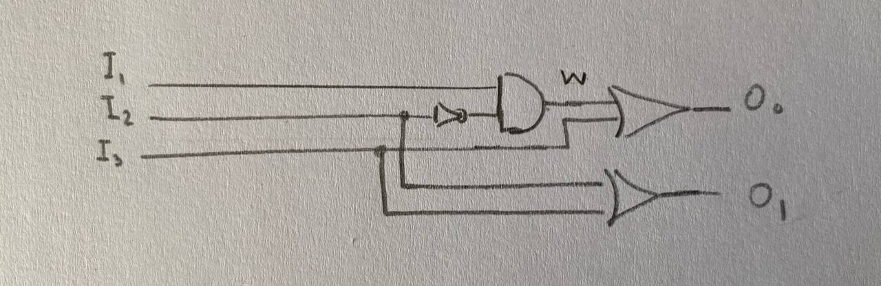

2

W1

module encoder4x2(I0, I1, I2, I3, O0, O1);

input I0, I1, I2, I3;

output O0, O1;

wire w1, w2;

not g1(w1, I2);

and g2(w2, I1, w1);

or g3(O0, w2, I3);

or g4(O1, I2, I3);

endmodule

**3)** Multiplexer(4x1)

|  |  |  |
| --- | --- | --- |
| **S0** | **S1** | **f** |
| 0 | 0 | I0 |
| 0 | 1 | I1 |
| 1 | 0 | I2 |
| 1 | 1 | I3 |

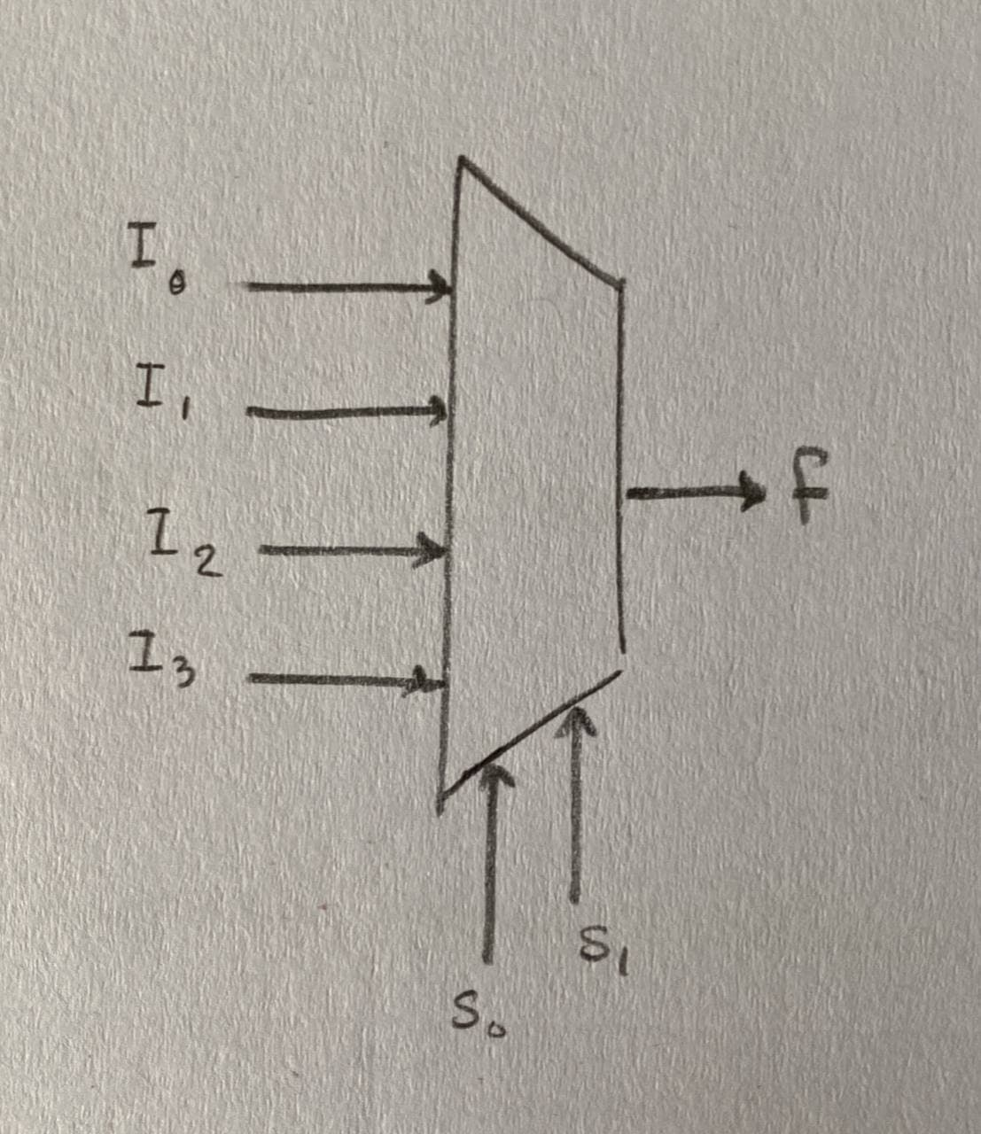

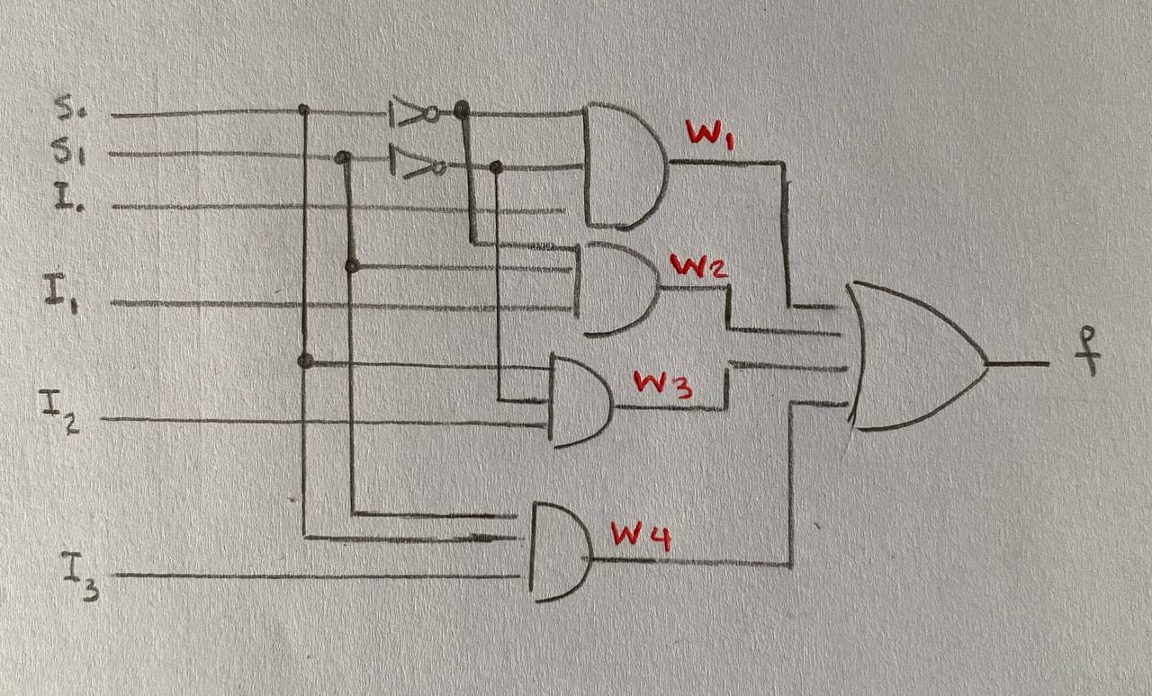**f = (S0’)(S1’)(I0) + (S0’)(S1)(I1) + (S0)(S1’)(I2) + (S0)(S1)(I3)**

module multiplexer4x1(s0,s1,I0,I1,I2,I3,f);

input s0,s1,I0,I2,I3;

output f;

wire w1,w2,w3,w4;

not g1(s0_not, s0);

not g2(s1_not, s1);

and g3(w1, s0_not, s1_not, I0);

and g4(w2, s0_not, s1, I1);

and g5(w3, s0, s1_not, I2);

and g6(w4, s0, s1, I3);

or g7(f, w1, w2, w3, w4);

endmodule