**Kimberly Deas BINF 5120 Assignment 2**

**Section 1/Question 1**

I selected the paper titled, Improving HIV Surveillance Among Transgender Populations in Tennessee ([LGBT Health.](https://www.ncbi.nlm.nih.gov/pubmed/26698656) 2016 Jun;3(3):208-13, <https://www.ncbi.nlm.nih.gov/pubmed/26698656>).

This paper sought to examine how data on the transgender population is collected in the state to Tennessee. The goal of better data collection methods, is to improve prevention and treatment of HIV infection in a community of individuals who are disproportionately infected with HIV.

Data on HIV infected transgender individuals in Tennessee has been gathered since 2007 in a statewide database called The Enhanced HIV/AIDS Reporting System or eHARS. This is a browser-based application that is provided by the Centers for Disease Control and Prevention(CDC) to track persons infected with HIV or that have a diagnosis of AIDS. Some of the challenges in gathering accurate information on transgender people is related to the variables designating a person’s gender at birth and the gender they identify with when seeking care and treatment for HIV. The variables birth_sex and current_gender are used in Tennessee to reflect a change in a patient’s gender identification. However, accuracy in this variable is questionable since birth_sex is a required field to complete and current_gender is not.

Data analysis for this study was carried out using both chi-squared and Fischer’s exact test. The chi square test is commonly used in the literature and is a test for independence between 2 or more groups. The Fischer’s exact test is used similarly in data sets where frequencies or proportions are expected to be small. To determine the difference in proportions between HIV prevalence and reporting completeness of current_gender, the chi-squared tested was used. The Fischer’s exact test was used to access the differences in the numbers of transgender individuals reporting both the current_gender and birth_sex categories. SAS software was used in all data analysis.

The results of the study show that the incidence and prevalence of HIV/AIDS in Tennessee is consistent with populations/areas of the state that have traditionally reported high incidences in the past. Using chi squared tests, higher rates of HIV prevalence/incidence were statistically significant ( p < 0.01) when comparing the different metropolitan areas of the state. And these areas are typically urban, matching what is seen in other states particularly in the South. There were also statistically significant differences when comparing various regions of the state.

Most important to the quality of the data collected on transgender individuals, was that there were statewide and regional differences in the frequency of individuals who self-selected current_gender. This potentially resulted in both underreporting of this important variable and highlights the potential of interviewer’s own bias when interviewing clients. Thus, the validity of the results in this study could be called into question, though useful information for future studies could be gathered from this study.

**Section 2/Question 2**

**Variable Name Data Type**

Type Character

Age Numeric

Height Numeric

Weight Numeric

FILENAME F1 'C:\Users\Kimist99\Desktop\RutgersU\BINF5120\BINF5120_Assign2\Demo11.txt';

DATA Demo11;

INFILE F1 DLM='09'X;

INPUT TYPE $ AGE HEIGHT WEIGHT;

RUN;

PROC **PRINT** DATA=Demo11;

RUN;

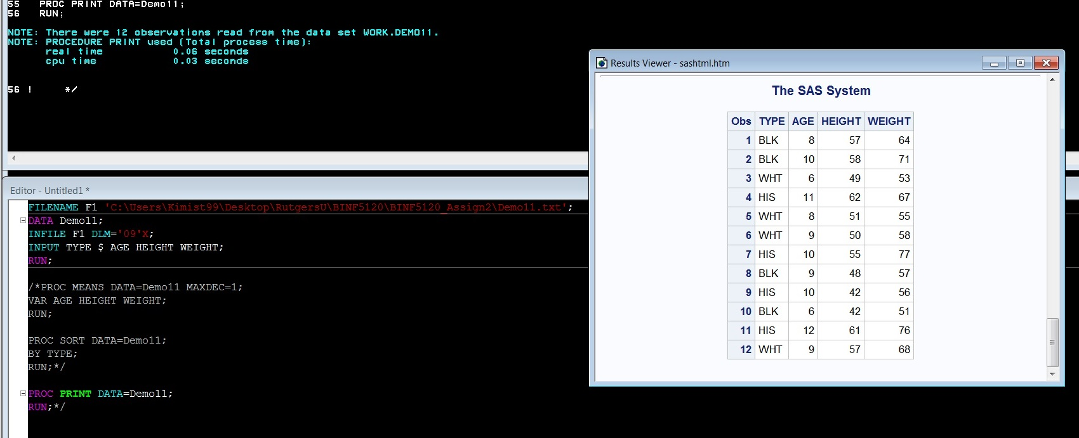

**Section 2/Question 3**

FILENAME F1 'C:\Users\Kimist99\Desktop\RutgersU\BINF5120\BINF5120_Assign2\Demo11.txt';

DATA Demo11;

INFILE F1 DLM='09'X;

INPUT TYPE $ AGE HEIGHT WEIGHT;

RUN;

PROC **MEANS** DATA=Demo11 MAXDEC=1;

VAR AGE HEIGHT WEIGHT;

RUN;

PROC **SORT** DATA=Demo11;

BY TYPE;

RUN;

PROC **PRINT** DATA=Demo11;

RUN;

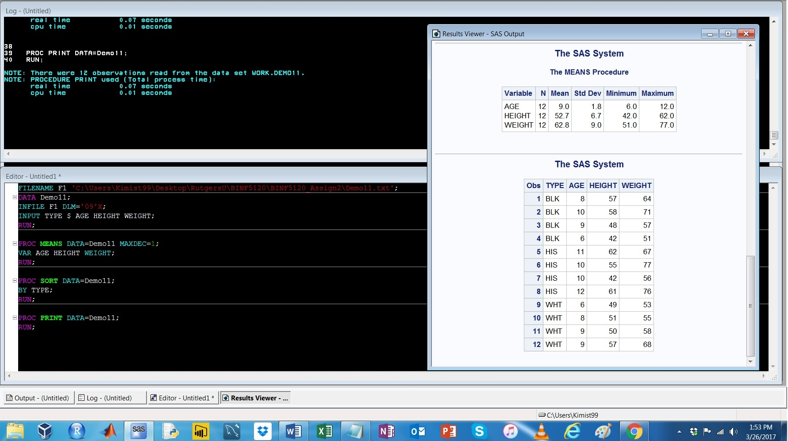

**Section 2/Question 4**

FILENAME F1 'C:\Users\Kimist99\Desktop\RutgersU\BINF5120\BINF5120_Assign2\Demo11.txt';

DATA Demo11;

INFILE F1 DLM='09'X;

INPUT TYPE $ AGE HEIGHT WEIGHT;

RUN;

PROC **FREQ** DATA=Demo11;

TABLE TYPE*WEIGHT;

RUN;

PROC **PRINT** DATA=Demo11;

RUN;

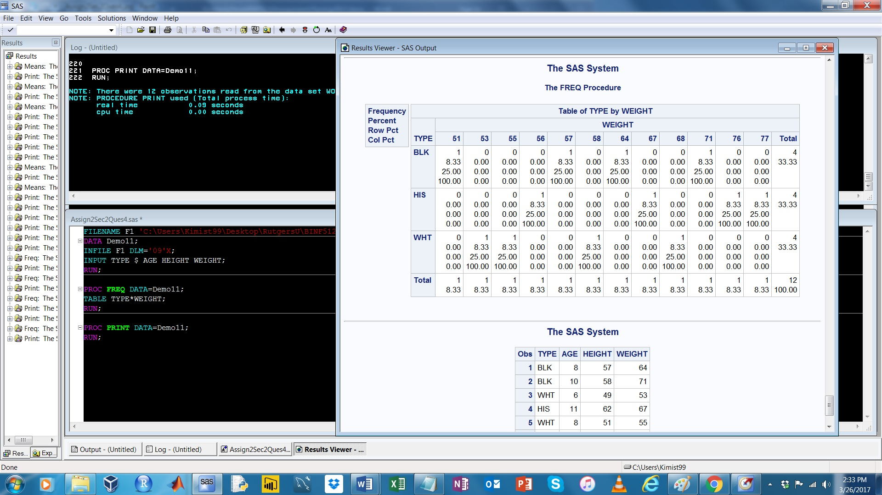

**Section 3/Question 5**

FILENAME F1 'C:\Users\Kimist99\Desktop\RutgersU\BINF5120\BINF5120_Assign2\Demo12.txt';

DATA Demo12;

INFILE F1 DLM='09'X;

INPUT GENDER $ AGE SBP DBP;

RUN;

PROC **PRINT** DATA=Demo12;

RUN;

**Output Code:**

|  |
| --- |
| The SAS System |

| **Obs** | **GENDER** | **AGE** | **SBP** | **DBP** |
| --- | --- | --- | --- | --- |
|  |  |  |  |  |
| **1** | 1 | 55 | 124 | 88 |
| **2** | 2 | 52 | 128 | 86 |
| **3** | 1 | 63 | 126 | 64 |
| **4** | 1 | 83 | 154 | 54 |
| **5** | 2 | 37 | 104 | 70 |
| **6** | 2 | 50 | 118 | 78 |
| **7** | 2 | 55 | 130 | 86 |
| **8** | 1 | 40 | 126 | 88 |
| **9** | 2 | 37 | 100 | 56 |
| **10** | 2 | 57 | 164 | 70 |
| **11** | 1 | 21 | 122 | 66 |
| **12** | 2 | 85 | 138 | 66 |
| **13** | 2 | 84 | 124 | 54 |
| **14** | 1 | 69 | 124 | 68 |
| **15** | 1 | 55 | 132 | 82 |
| **16** | 2 | 37 | 106 | 76 |
| **17** | 2 | 59 | 110 | 76 |
| **18** | 2 | 73 | 218 | 94 |
| **19** | 1 | 78 | 148 | 84 |
| **20** | 2 | 51 | 128 | 68 |
| **21** | 1 | 71 | 130 | 62 |
| **22** | 1 | 69 | 170 | 92 |
| **23** | 1 | 52 | 116 | 78 |
| **24** | 1 | 25 | 132 | 76 |
| **25** | 2 | 57 | 108 | 72 |
| **26** | 1 | 70 | 130 | 58 |
| **27** | 1 | 85 | 182 | 66 |
| **28** | 2 | 60 | 170 | 86 |
| **29** | 2 | 80 | 202 | 76 |
| **30** | 2 | 57 | 122 | 74 |
| **31** | 1 | 26 | 104 | 58 |
| **32** | 1 | 28 | 114 | 70 |
| **33** | 1 | 56 | 144 | 90 |
| **34** | 2 | 25 | 102 | 56 |
| **35** | 2 | 64 | 132 | 56 |
| **36** | 2 | 68 | 106 | 58 |
| **37** | 1 | 75 | 144 | 70 |
| **38** | 1 | 70 | 116 | 64 |
| **39** | 1 | 26 | 114 | 64 |
| **40** | 1 | 20 | 126 | 74 |
| **41** | 1 | 25 | 124 | 78 |
| **42** | 1 | 76 | 148 | 68 |
| **43** | 1 | 81 | 122 | 54 |
| **44** | 2 | 32 | 104 | 66 |
| **45** | 2 | 38 | 128 | 78 |
| **46** | 2 | 63 | 132 | 72 |
| **47** | 1 | 66 | 140 | 66 |
| **48** | 2 | 60 | 108 | 58 |
| **49** | 2 | 37 | 100 | 74 |
| **50** | 1 | 75 | 158 | 88 |
| **51** | 1 | 55 | 152 | 76 |
| **52** | 1 | 36 | 112 | 68 |
| **53** | 1 | 37 | 114 | 80 |
| **54** | 2 | 20 | 108 | 70 |
| **55** | 1 | 59 | 120 | 74 |
| **56** | 1 | 85 | 136 | 54 |
| **57** | 1 | 72 | 106 | 62 |
| **58** | 2 | 31 | 120 | 72 |
| **59** | 2 | 31 | 126 | 86 |
| **60** | 2 | 63 | 168 | 86 |
| **61** | 1 | 27 | 124 | 82 |
| **62** | 2 | 67 | 172 | 86 |
| **63** | 2 | 71 | 156 | 78 |
| **64** | 2 | 51 | 112 | 74 |
| **65** | 2 | 60 | 146 | 82 |
| **66** | 1 | 65 | 140 | 60 |
| **67** | 2 | 20 | 88 | 50 |
| **68** | 1 | 51 | 114 | 72 |
| **69** | 2 | 69 | 176 | 84 |
| **70** | 2 | 43 | 142 | 100 |
| **71** | 2 | 45 | 118 | 60 |
| **72** | 2 | 61 | 128 | 64 |
| **73** | 1 | 73 | 144 | 50 |
| **74** | 2 | 47 | 162 | 86 |
| **75** | 1 | 61 | 166 | 70 |
| **76** | 2 | 80 | 180 | 80 |
| **77** | 1 | 40 | 138 | 96 |
| **78** | 2 | 29 | 100 | 66 |
| **79** | 1 | 26 | 118 | 52 |
| **80** | 1 | 85 | 138 | 32 |
| **81** | 1 | 62 | 158 | 88 |
| **82** | 2 | 40 | 166 | 88 |
| **83** | 1 | 20 | 102 | 62 |
| **84** | 2 | 54 | 130 | 76 |
| **85** | 2 | 23 | 124 | 82 |
| **86** | 2 | 51 | 116 | 68 |
| **87** | 1 | 23 | 130 | 88 |
| **88** | 1 | 74 | 148 | 52 |
| **89** | 1 | 21 | 112 | 68 |
| **90** | 2 | 44 | 102 | 60 |
| **91** | 1 | 23 | 114 | 82 |
| **92** | 2 | 34 | 120 | 68 |
| **93** | 2 | 26 | 108 | 40 |
| **94** | 1 | 24 | 128 | 82 |
| **95** | 2 | 49 | 128 | 76 |
| **96** | 1 | 38 | 122 | 76 |
| **97** | 1 | 26 | 124 | 72 |
| **98** | 1 | 31 | 108 | 70 |
| **99** | 2 | 62 | 110 | 72 |
| **100** | 1 | 85 | 160 | 58 |
| **101** | 2 | 67 | 116 | 60 |
| **102** | 1 | 26 | 126 | 82 |
| **103** | 1 | 41 | 122 | 76 |
| **104** | 1 | 43 | 136 | 64 |
| **105** | 2 | 85 | 128 | 44 |
| **106** | 1 | 45 | 120 | 90 |
| **107** | 1 | 44 | 138 | 94 |
| **108** | 2 | 26 | 110 | 74 |
| **109** | 2 | 65 | 142 | 58 |
| **110** | 2 | 22 | 106 | 54 |
| **111** | 1 | 41 | 108 | 70 |
| **112** | 1 | 37 | 132 | 86 |
| **113** | 1 | 63 | 108 | 68 |
| **114** | 2 | 83 | 178 | 82 |
| **115** | 2 | 34 | 100 | 62 |
| **116** | 2 | 64 | 144 | 66 |
| **117** | 1 | 75 | 108 | 68 |
| **118** | 2 | 64 | 122 | 64 |
| **119** | 2 | 72 | 134 | 64 |
| **120** | 1 | 50 | 128 | 84 |
| **121** | 2 | 22 | 108 | 66 |
| **122** | 2 | 22 | 120 | 54 |
| **123** | 2 | 61 | 100 | 58 |
| **124** | 1 | 41 | 136 | 84 |
| **125** | 2 | 32 | 122 | 60 |
| **126** | 2 | 28 | 100 | 74 |
| **127** | 1 | 32 | 134 | 84 |
| **128** | 1 | 51 | 126 | 82 |
| **129** | 2 | 61 | 118 | 62 |
| **130** | 1 | 41 | 100 | 68 |
| **131** | 2 | 43 | 108 | 74 |
| **132** | 1 | 50 | 122 | 66 |
| **133** | 2 | 63 | 152 | 80 |
| **134** | 1 | 42 | 114 | 74 |
| **135** | 2 | 40 | 92 | 70 |
| **136** | 1 | 44 | 110 | 62 |
| **137** | 2 | 43 | 126 | 66 |
| **138** | 2 | 36 | 122 | 78 |
| **139** | 1 | 45 | 140 | 80 |
| **140** | 2 | 44 | 124 | 78 |
| **141** | 1 | 68 | 136 | 54 |
| **142** | 1 | 54 | 144 | 64 |
| **143** | 1 | 21 | 110 | 58 |
| **144** | 2 | 51 | 102 | 62 |
| **145** | 1 | 61 | 142 | 64 |
| **146** | 1 | 77 | 126 | 60 |
| **147** | 1 | 66 | 116 | 70 |
| **148** | 2 | 77 | 116 | 54 |
| **149** | 2 | 61 | 152 | 74 |
| **150** | 2 | 42 | 110 | 80 |
| **151** | 2 | 78 | 140 | 26 |
| **152** | 2 | 45 | 98 | 76 |
| **153** | 1 | 59 | 124 | 74 |
| **154** | 1 | 23 | 122 | 64 |
| **155** | 2 | 58 | 160 | 74 |
| **156** | 1 | 39 | 138 | 90 |
| **157** | 2 | 37 | 120 | 68 |
| **158** | 1 | 35 | 114 | 68 |
| **159** | 1 | 41 | 118 | 78 |
| **160** | 2 | 24 | 108 | 58 |
| **161** | 1 | 30 | 124 | 82 |

**Section 3/Question 6**

FILENAME F1 'C:\Users\Kimist99\Desktop\RutgersU\BINF5120\BINF5120_Assign2\Demo12.txt';

DATA Demo12;

INFILE F1 DLM='09'X;

INPUT GENDER $ AGE SBP DBP;

RUN;

/*PROC PRINT DATA= Demo12;

RUN;*/

PROC **SURVEYSELECT** DATA= Demo12

METHOD= SEQ

SAMPRATE= 0.1

SEED= 1224

OUT= Ques6;

;

RUN;

/*PROC PRINT DATA= Ques6;

RUN;*/

PROC **UNIVARIATE** DATA= Ques6;

VAR SBP DBP;

RUN;

ODS SELECT BASICINTERVALS;

PROC **UNIVARIATE** DATA= Ques6 CIBASIC;

VAR SBP DBP;

RUN;

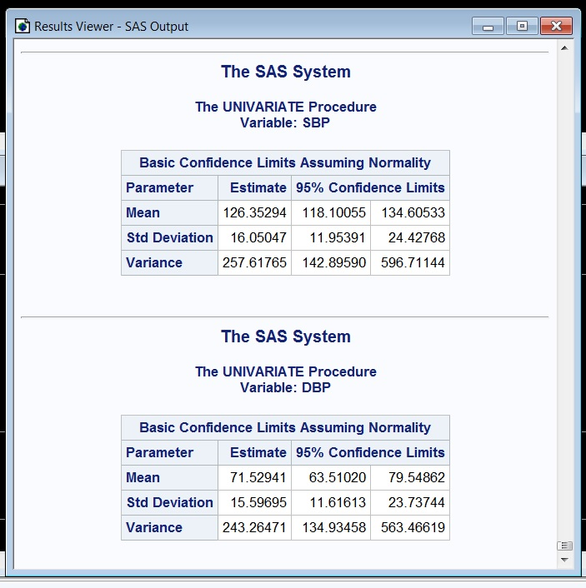

**Section 3/Question 7**

Questions 6 and 7 gave very similar results and this is somewhat predicted due to the way the samples were collected for each question.

FILENAME F1 'C:\Users\Kimist99\Desktop\RutgersU\BINF5120\BINF5120_Assign2\Demo12.txt';

DATA Demo12;

INFILE F1 DLM='09'X;

INPUT GENDER $ AGE SBP DBP;

RUN;

PROC **SURVEYSELECT** DATA= Demo12

METHOD= SYS

SAMPSIZE= 17

OUT= Ques7;

ID _all_;

RUN;

PROC **PRINT** DATA= Ques7;

RUN;

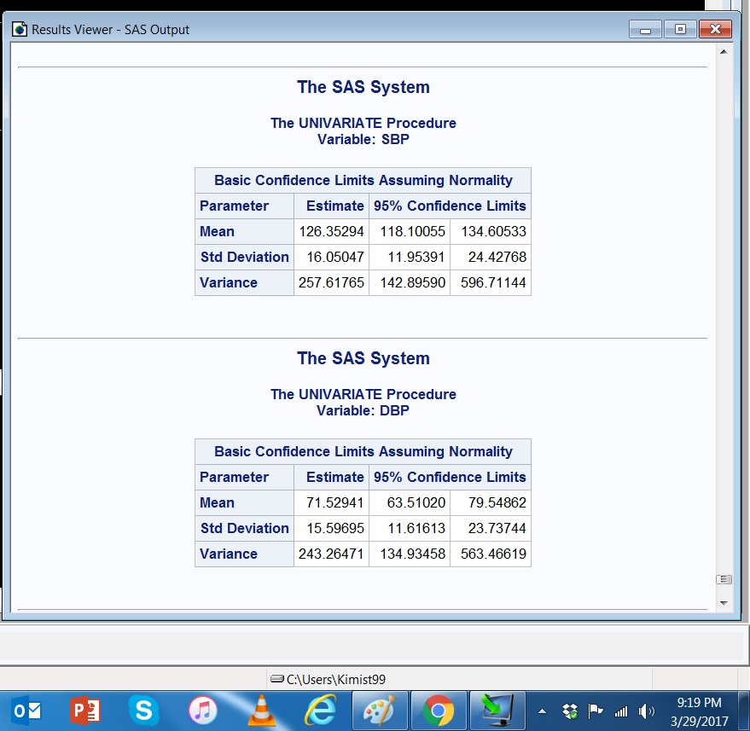

**Section 3/Question 8**

The results for question #8 specifically the standard deviation and variance, were both very different from the results obtained in both #6 and #7 and seeding the sample in question #8, probably contributes to these. Allowing for duplicates potentially skews the data away from a normal distribution. Both the SD and variance, give information about the spread of data from the mean and both are significantly different in question #8 compared to #6 and #7.

FILENAME F1 'C:\Users\Kimist99\Desktop\Demo12.txt';

DATA Demo12;

INFILE F1 DLM='09'X;

INPUT GENDER $ AGE SBP DBP;

RUN;

PROC **SURVEYSELECT** DATA= Demo12

METHOD= URS

SAMPSIZE= 17

SEED= 12345

OUT= Ques8;

ID _ALL_;

RUN;

PROC **UNIVARIATE** DATA= Ques8;

VAR SBP DBP;

RUN;

ODS SELECT BASICINTERVALS;

PROC **UNIVARIATE** DATA= Ques8 CIBASIC;

VAR SBP DBP;

RUN;

PROC **PRINT** DATA= Ques8;

RUN;

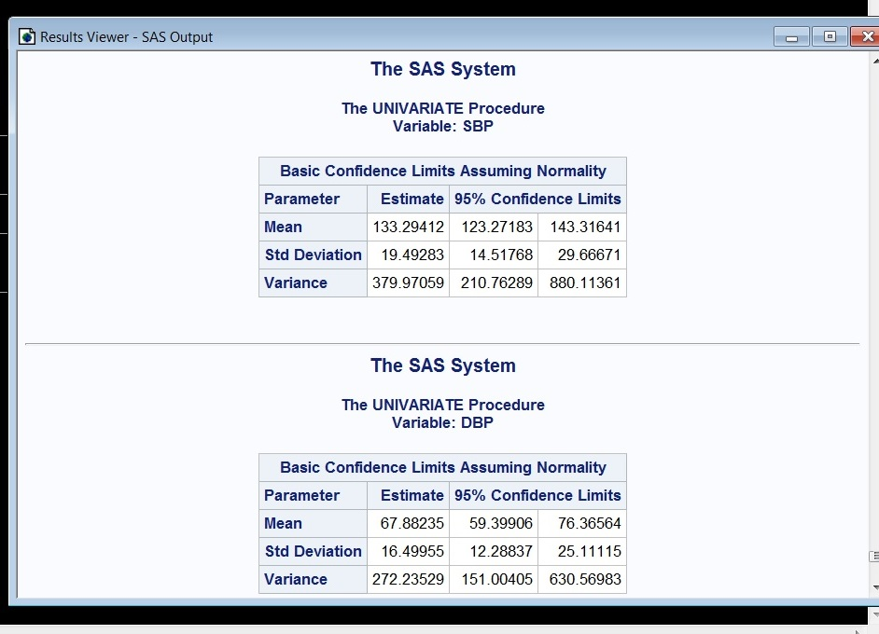

**Section 3/Question 9**

The variance in question #8 is significantly different from the one obtained in question #9 owing to the differences between a sample using the URS and SRS methods of statistical analysis. As a result, the information contained in the URS run is less reliable or reflective to the population of data being examined than the data collected using the SRS method. As in the previous question comparing the

FILENAME F1 'C:\Users\Kimist99\Desktop\RutgersU\BINF5120\BINF5120_Assign2\Demo12.txt';

DATA Demo12;

INFILE F1 DLM='09'X;

INPUT GENDER $ AGE SBP DBP;

RUN;

PROC **SURVEYSELECT** DATA= Demo12

METHOD= SRS

SAMPSIZE= 17

OUT= Ques9;

ID _ALL_;

RUN;

PROC **UNIVARIATE** DATA= Ques9;

VAR SBP DBP;

RUN;

ODS SELECT BASICINTERVALS;

PROC **UNIVARIATE** DATA= Ques9 CIBASIC;

VAR SBP DBP;

RUN;

PROC **PRINT** DATA= Ques9;

RUN;

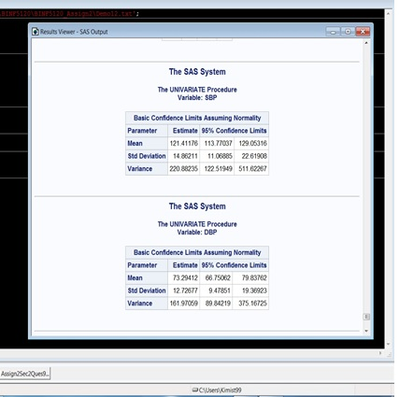

**Section 3/Question 10**

The data for systolic blood pressure (SBP) is not normally distributed and is skewed slightly to the left (see image below). There are also numerous outliers on the right tail of the histogram which contributes to the skewed/non normalized results. The data for diastolic blood pressure (DBP) is reasonably normally distributed, although there are outliers on the left tail of the histogram (see image below).

FILENAME F1 'C:\Users\Kimist99\Desktop\Demo12.txt';

DATA Demo12;

INFILE F1 DLM='09'X;

INPUT GENDER $ AGE SBP DBP;

RUN;

PROC **SORT** DATA=DEMO12;

BY DESCENDING SBP;

RUN;

PROC **UNIVARIATE** DATA=DEMO12;

VAR SBP DBP;

HISTOGRAM;

RUN;

PROC **PRINT** DATA=Demo12;

RUN;

