Kimlong Seng

Project 01

1. Vulnerability
2. Prinf(input) in the badfuntion, Format String Vulnerability happen when u write printf without a proper parameter (%) i.e. printf(string) instead of printf(“%s”, string).

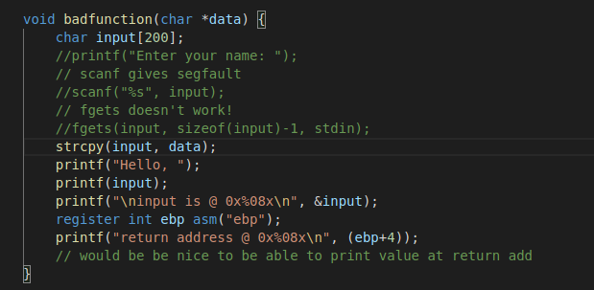

1. Exploit
2. Setting up.
3. Passing in my name with parameter to see the program reaction and examing the stack memory
4. Getting ready to hijack the exit function
5. Getting the shellcode read

