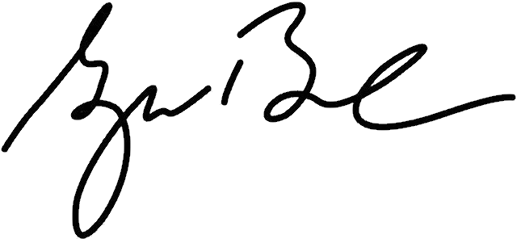

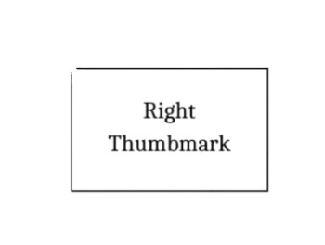
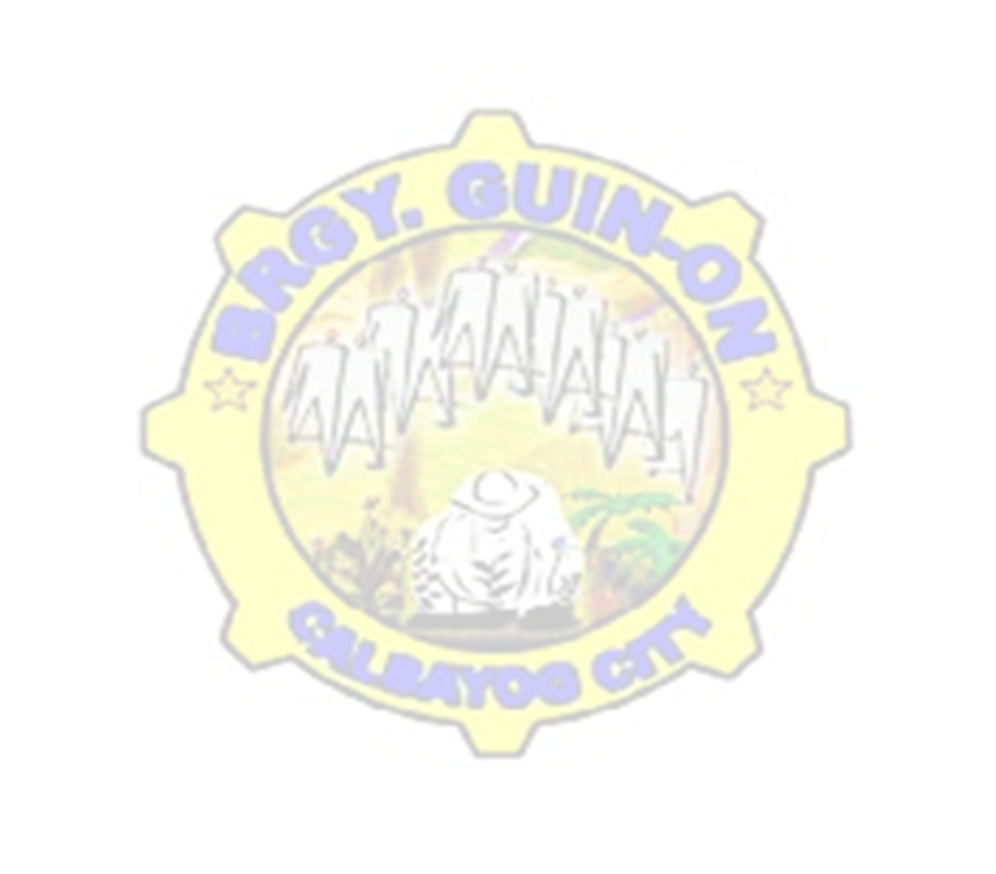




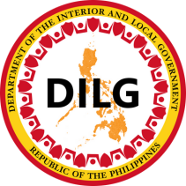
APPLICANT NAME PLACEHOLDER
Issued this {this_day} day of {month}, {year} at Brgy. Guin-on, Calbayog City, Samar, Philippines.

Further certifies that he/ she has no derogatory record and has good moral character as per our Barangay record in concerned.
This certification is issued upon the request of the above- named person for whatever legal intent and purpose this may serve.

THIS IS TO CERTIFY that, {fullname} of legal age, male/female, single/married/widow/ widower, Filipino citizen, whose name and signature/right thumb mark appears below is a BONAFIDE and permanent resident of BRGY. GUIN-ON, Calbayog City, Samar.
To whom it may concern,

BARANGAY CERTIFICATION
HON. BENJAMIN O. JAROPOJOP
Punong Barangay

CRISANTA L. MERILLES
Brgy. Secretary

Applicant Signature over Printed Name

Not Valid
Without Seal
Republic of the Philippines
Barangay Guin-on
Calbayog City
Office of the Sangguniang Barangay
BRGY. OFFICIALS
Hon. ruel i. eya
Chair, Committee on Peace & Order & Disaster Coordination

Hon. myrlin a. monsanto
Chair, Committee on Agriculture &
Fisheries, Livelihood & Cooperatives

Hon. carina c. jaropojop
Chair, Committee on Health & Sanitation, Beautification & Environment Protection

Hon. isagani r. caÑete
Chair, Committee on Laws, Rules &
Regulations & Information

mrs. GILDA A. LOYOLA
Brgy. Treasurer

mrs. Crisanta l. Merilles
Brgy. Secretary

Hon. lian t. diosa
Chair, Committee on Education &
Culture, Human Rights, Women &
Family

Hon. sabas n. adisas
Chair, Committee on Infrastructure,
Barangay Project & Sustainable
Development

Hon. martinito d. malabarbas
Chair, Committee on Finance,
Appropriation & Social Services

Hon. benjamin o. jaropojop
Punong Barangay

CTC #: {ctc_no}
Date Issued: {ctc_date_issued}
Place Issued: {ctc_place_issued}

