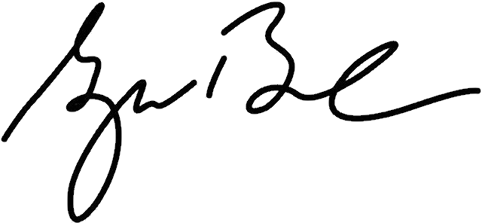

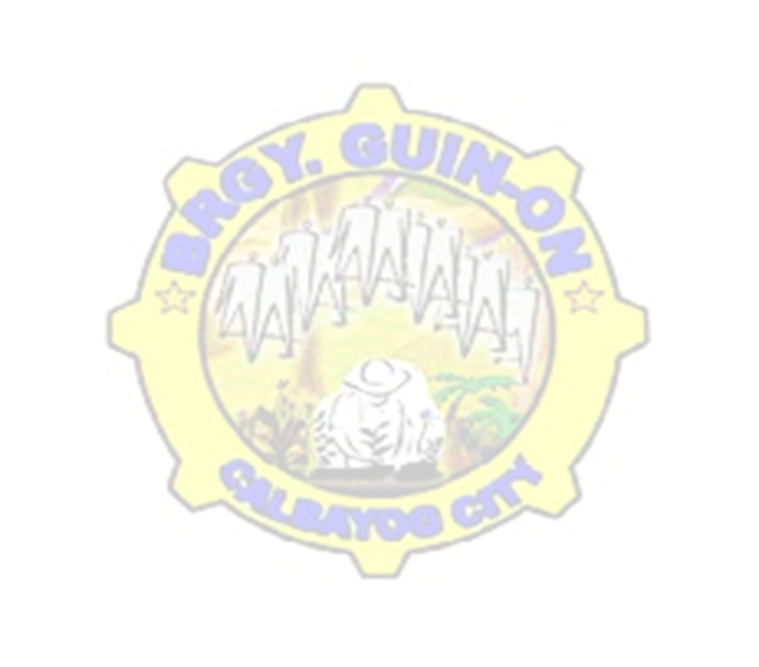





APPLICANT NAME PLACEHOLDER
Issued this {this_day} day of {month}, {year} at Brgy. Guin-on, Calbayog City, Samar, Philippines.

THIS IS TO CERTIFY that, {fullname} is a Bonafide resident of Brgy. Guin-on, Calbayog City, Samar.
Certify further that, family census of records filed in the Barangay office shows that his/her family is one of those who belong to a family with low income/earning and is considered as one of the Indigent Family in the Barangay.
This certification is issued upon the request of the above- named person for whatever legal intent and purpose this may serve.

To whom it may concern,

CERTIFICATE OF INDIGENCY
HON. BENJAMIN O. JAROPOJOP
Punong Barangay

CRISANTA L. MERILLES
Brgy. Secretary

Applicant Signature over Printed Name

Not Valid
Without Seal
Republic of the Philippines
Barangay Guin-on
Calbayog City
Office of the Sangguniang Barangay
BRGY. OFFICIALS
Hon. ruel i. eya
Chair, Committee on Peace & Order & Disaster Coordination

Hon. myrlin a. monsanto
Chair, Committee on Agriculture &
Fisheries, Livelihood & Cooperatives

Hon. carina c. jaropojop
Chair, Committee on Health & Sanitation, Beautification & Environment Protection

Hon. isagani r. caÑete
Chair, Committee on Laws, Rules &
Regulations & Information

mrs. GILDA A. LOYOLA
Brgy. Treasurer

mrs. Crisanta l. Merilles
Brgy. Secretary

Hon. lian t. diosa
Chair, Committee on Education &
Culture, Human Rights, Women &
Family

Hon. sabas n. adisas
Chair, Committee on Infrastructure,
Barangay Project & Sustainable
Development

Hon. martinito d. malabarbas
Chair, Committee on Finance,
Appropriation & Social Services

Hon. benjamin o. jaropojop
Punong Barangay

CTC #: {ctc_no}
Date Issued: {ctc_date_issued}
Place Issued: {ctc_place_issued}

