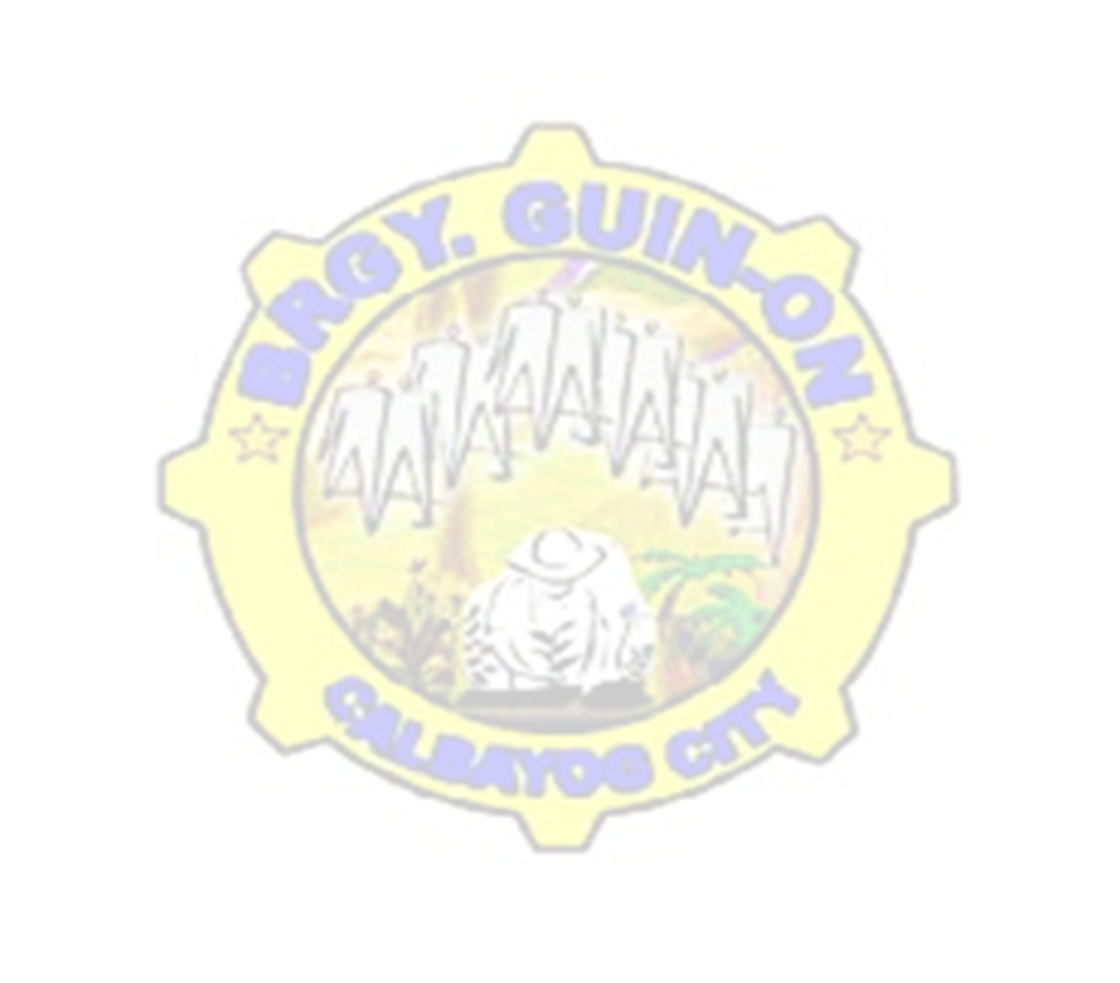



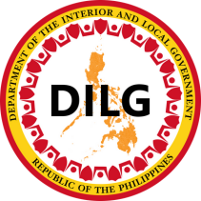
m
Issued this ___ day of JANUARY, 2024 at Brgy. Guin-on, Calbayog City, Samar, Philippines.

Further certifies that he/ she has no derogatory record and has good moral character as per our Barangay record in connected.
THIS IS TO CERTIFY that, _____________________ of legal age, male/female, single/married/widow/ widower, Filipino citizen, whose name and signature/right thumb mark appears below is a BONAFIDE and permanent resident of BRGY. GUIN-ON, Calbayog City,
Republic of the Philippines
Barangay Guin-on
Calbayog City
Office of the Sangguniang Barangay
BRGY. OFFICIALS
mrs. GILDA A. LOYOLA
Brgy. Treasurer

mrs. Crisanta l. Merilles
Brgy. Secretary

Hon. isagani r. caÑete
Chair, Committee on Laws, Rules &
Regulations & Information

Hon. lian t. diosa
Chair, Committee on Education &
Culture, Human Rights, Women &
Family

Hon. sabas n. adisas
Chair, Committee on Infrastructure,
Barangay Project & Sustainable
Development

Hon. carina c. jaropojop
Chair, Committee on Health & Sanitation, Beautification & Environment Protection

Hon. martinito d. malabarbas
Chair, Committee on Finance,
Appropriation & Social Services

Hon. myrlin a. monsanto
Chair, Committee on Agriculture &
Fisheries, Livelihood & Cooperatives

Hon. ruel i. eya
Chair, Committee on Peace & Order & Disaster Coordination

Hon. benjamin o. jaropojop
Punong Barangay

Not Valid
Without Seal

CTC #: __________________
Date Issued: ______________
Place Issued: ______________

Applicant Signature over Printed Name

HON. BENJAMIN O. JAROPOJOP
Punong Barangay

CRISANTA L. MERILLES
Brgy. Secretary

BARANGAY CLEARANCE
To whom it may concern,






m
Issued this ___ day of JANUARY, 2024 at Brgy. Guin-on, Calbayog City, Samar, Philippines.

Further certifies that he/ she has no derogatory record and has good moral character as per our Barangay record in connected.
THIS IS TO CERTIFY that, _____________________ of legal age, male/female, single/married/widow/ widower, Filipino citizen, whose name and signature/right thumb mark appears below is a BONAFIDE and permanent resident of BRGY. GUIN-ON, Calbayog City,
Republic of the Philippines
Barangay Guin-on
Calbayog City
Office of the Sangguniang Barangay
BRGY. OFFICIALS
mrs. GILDA A. LOYOLA
Brgy. Treasurer

mrs. Crisanta l. Merilles
Brgy. Secretary

Hon. isagani r. caÑete
Chair, Committee on Laws, Rules &
Regulations & Information

Hon. lian t. diosa
Chair, Committee on Education &
Culture, Human Rights, Women &
Family

Hon. sabas n. adisas
Chair, Committee on Infrastructure,
Barangay Project & Sustainable
Development

Hon. carina c. jaropojop
Chair, Committee on Health & Sanitation, Beautification & Environment Protection

Hon. martinito d. malabarbas
Chair, Committee on Finance,
Appropriation & Social Services

Hon. myrlin a. monsanto
Chair, Committee on Agriculture &
Fisheries, Livelihood & Cooperatives

Hon. ruel i. eya
Chair, Committee on Peace & Order & Disaster Coordination

Hon. benjamin o. jaropojop
Punong Barangay

Not Valid
Without Seal

CTC #: __________________
Date Issued: ______________
Place Issued: ______________

Applicant Signature over Printed Name

HON. BENJAMIN O. JAROPOJOP
Punong Barangay

CRISANTA L. MERILLES
Brgy. Secretary

BARANGAY CLEARANCE
To whom it may concern,






m
Issued this ___ day of JANUARY, 2024 at Brgy. Guin-on, Calbayog City, Samar, Philippines.

Further certifies that he/ she has no derogatory record and has good moral character as per our Barangay record in connected.
THIS IS TO CERTIFY that, _____________________ of legal age, male/female, single/married/widow/ widower, Filipino citizen, whose name and signature/right thumb mark appears below is a BONAFIDE and permanent resident of BRGY. GUIN-ON, Calbayog City,
Republic of the Philippines
Barangay Guin-on
Calbayog City
Office of the Sangguniang Barangay
BRGY. OFFICIALS
mrs. GILDA A. LOYOLA
Brgy. Treasurer

mrs. Crisanta l. Merilles
Brgy. Secretary

Hon. isagani r. caÑete
Chair, Committee on Laws, Rules &
Regulations & Information

Hon. lian t. diosa
Chair, Committee on Education &
Culture, Human Rights, Women &
Family

Hon. sabas n. adisas
Chair, Committee on Infrastructure,
Barangay Project & Sustainable
Development

Hon. carina c. jaropojop
Chair, Committee on Health & Sanitation, Beautification & Environment Protection

Hon. martinito d. malabarbas
Chair, Committee on Finance,
Appropriation & Social Services

Hon. myrlin a. monsanto
Chair, Committee on Agriculture &
Fisheries, Livelihood & Cooperatives

Hon. ruel i. eya
Chair, Committee on Peace & Order & Disaster Coordination

Hon. benjamin o. jaropojop
Punong Barangay

Not Valid
Without Seal

CTC #: __________________
Date Issued: ______________
Place Issued: ______________

Applicant Signature over Printed Name

HON. BENJAMIN O. JAROPOJOP
Punong Barangay

CRISANTA L. MERILLES
Brgy. Secretary

BARANGAY CLEARANCE
To whom it may concern,






m
Issued this ___ day of JANUARY, 2024 at Brgy. Guin-on, Calbayog City, Samar, Philippines.

Further certifies that he/ she has no derogatory record and has good moral character as per our Barangay record in connected.
THIS IS TO CERTIFY that, _____________________ of legal age, male/female, single/married/widow/ widower, Filipino citizen, whose name and signature/right thumb mark appears below is a BONAFIDE and permanent resident of BRGY. GUIN-ON, Calbayog City,
Republic of the Philippines
Barangay Guin-on
Calbayog City
Office of the Sangguniang Barangay
BRGY. OFFICIALS
mrs. GILDA A. LOYOLA
Brgy. Treasurer

mrs. Crisanta l. Merilles
Brgy. Secretary

Hon. isagani r. caÑete
Chair, Committee on Laws, Rules &
Regulations & Information

Hon. lian t. diosa
Chair, Committee on Education &
Culture, Human Rights, Women &
Family

Hon. sabas n. adisas
Chair, Committee on Infrastructure,
Barangay Project & Sustainable
Development

Hon. carina c. jaropojop
Chair, Committee on Health & Sanitation, Beautification & Environment Protection

Hon. martinito d. malabarbas
Chair, Committee on Finance,
Appropriation & Social Services

Hon. myrlin a. monsanto
Chair, Committee on Agriculture &
Fisheries, Livelihood & Cooperatives

Hon. ruel i. eya
Chair, Committee on Peace & Order & Disaster Coordination

Hon. benjamin o. jaropojop
Punong Barangay

Not Valid
Without Seal

CTC #: __________________
Date Issued: ______________
Place Issued: ______________

Applicant Signature over Printed Name

HON. BENJAMIN O. JAROPOJOP
Punong Barangay

CRISANTA L. MERILLES
Brgy. Secretary

BARANGAY CLEARANCE
To whom it may concern,






m
Issued this ___ day of JANUARY, 2024 at Brgy. Guin-on, Calbayog City, Samar, Philippines.

Further certifies that he/ she has no derogatory record and has good moral character as per our Barangay record in connected.
THIS IS TO CERTIFY that, _____________________ of legal age, male/female, single/married/widow/ widower, Filipino citizen, whose name and signature/right thumb mark appears below is a BONAFIDE and permanent resident of BRGY. GUIN-ON, Calbayog City,
Republic of the Philippines
Barangay Guin-on
Calbayog City
Office of the Sangguniang Barangay
BRGY. OFFICIALS
mrs. GILDA A. LOYOLA
Brgy. Treasurer

mrs. Crisanta l. Merilles
Brgy. Secretary

Hon. isagani r. caÑete
Chair, Committee on Laws, Rules &
Regulations & Information

Hon. lian t. diosa
Chair, Committee on Education &
Culture, Human Rights, Women &
Family

Hon. sabas n. adisas
Chair, Committee on Infrastructure,
Barangay Project & Sustainable
Development

Hon. carina c. jaropojop
Chair, Committee on Health & Sanitation, Beautification & Environment Protection

Hon. martinito d. malabarbas
Chair, Committee on Finance,
Appropriation & Social Services

Hon. myrlin a. monsanto
Chair, Committee on Agriculture &
Fisheries, Livelihood & Cooperatives

Hon. ruel i. eya
Chair, Committee on Peace & Order & Disaster Coordination

Hon. benjamin o. jaropojop
Punong Barangay

Not Valid
Without Seal

CTC #: __________________
Date Issued: ______________
Place Issued: ______________

Applicant Signature over Printed Name

HON. BENJAMIN O. JAROPOJOP
Punong Barangay

CRISANTA L. MERILLES
Brgy. Secretary

BARANGAY CLEARANCE
To whom it may concern,

