|  |  |  |  |
| --- | --- | --- | --- |
| **Project agreement for semester work IVIS** | | | **IVIS 2018** |
| Main topic | Sports | | e.g. Sports, Food, Politics, … |
| Student 1 | martin.kimmig@students.fhnw.ch, 6Ieng | | eMail-Address, Module name |
| Student 2 (opt.) | joel.dumont@students.fhnw.ch, 6Ieng | |
| Language | German | English |  |
| Title (preliminary) | Working title (may be changed later)  Football Club Efficiency | | |
| Dates | Preferred delivery and presentation date  Delivery: May 29 2018, Presentation: Jun 5, 2018  Delivery: Jun 5 2018, Presentation: Jun 12, 2018 | | |

|  |  |
| --- | --- |
| Summary | Describe your concept in 500 characters  Our main target is to find correlations between investment in soccer clubs and their success, as well as the corelation between player injuries and their club's success. For our research we will focus on the german soccer league ("Bundesliga"). Perhaps we will compare our findings with other soccer leagues. |
| Data sources | Provide URLs to at least 2 data sources  https://footystats.org  https://www.fussballdaten.de/bundesliga/  https://www.transfermarkt.de |

|  |  |  |
| --- | --- | --- |
| **Schedule** | Est. time | Comment |
| (1) data analysis | 8.00 h |  |
| (2) story concept | 8.00 h |  |
| (3) data acquisition | 10.00 h |  |
| (4) data integration | 8.00 h |  |
| (5) chart sketching | 10.00 h |  |
| (6) implementation | 20.00 h |  |
| (7) design | 12.00 h |  |
| (8) documentation | 12.00 h |  |
| (9) presentation | 10.00 h | preparation and presentation |
| Total | 98 h | Make sure to plan at least 45 hours per student. |

Appendix

Additional material such as sketches, etc

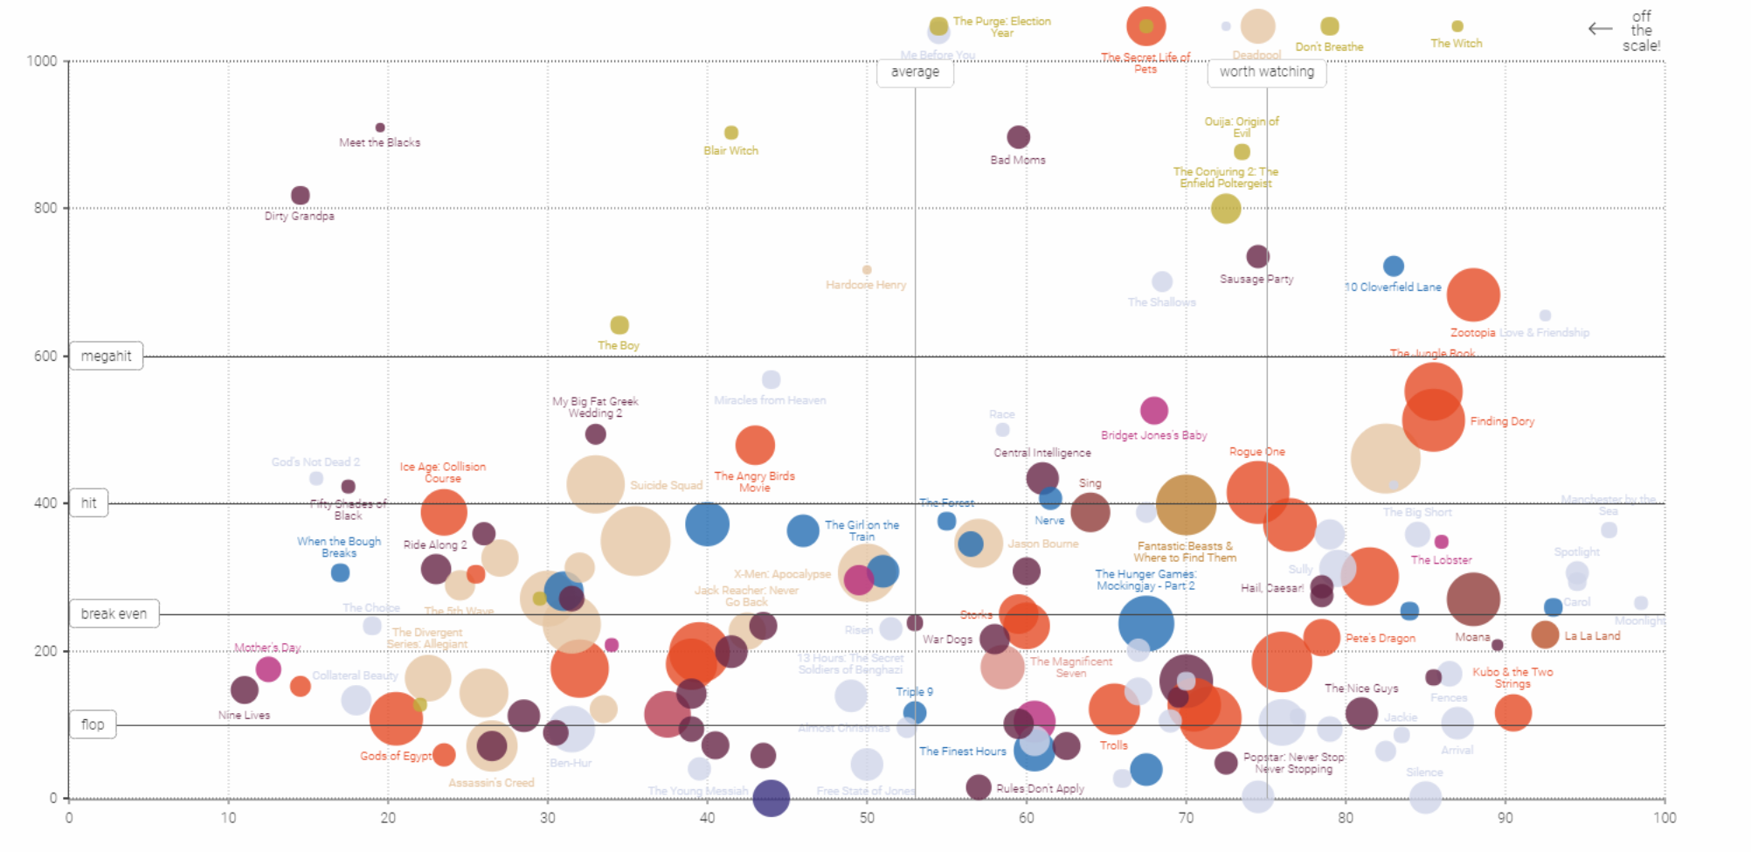

Story:

What makes a football club successful?

Is it the money? Unfairness? High stamina (kilometres run). Number of coach changes, foreigners or fans? Or even luckiness like having less injured players.

At football there exists many statistics, therefore we are confident to find interesting and useful data, to answer those questions and make them displayable in a bubble plot like the one above.

Successful means placement in the league at the end of the season.

The x-axis will represent the turnover whereas the y-axis represents the success.

Teams are represented by their club emblem. The higher the number of members (including fans) of a team the bigger gets the emblem picture.

Interactions will be possible by selecting filters on the mentioned statistics. Through hovering over an emblem, one will get detail information (name and selected filters).

We also plan to implement a draggable slider underneath the plot to move the years (Like on this example: <http://romsson.github.io/dragit/example/nations.html>)

We think we can gather football data of all the mentioned statistics for the last 30 years.