AfriSafeBench: Evaluating LLM Recognition of AI Safety and Governance Risks in African Healthcare AI Deployments
Kimberly Atta-Peters
University of St. Thomas, Minnesota
Hackathon track: Open Track | Project type: Evaluation + Tool

Abstract
AfriSafeBench is a benchmark and governance-support tool for testing whether large language models can identify AI safety and governance risks in African healthcare AI deployment scenarios. I evaluated 25 scenarios across seven African countries and ten risk categories using three Groq-accessible models, for 75 total evaluations. The best mean coverage was openai/gpt-oss-20b at 72.00%, followed by llama-3.1-8b-instant at 70.67% and llama-3.3-70b-versatile at 68.00%. The benchmark showed strong recognition of bias and privacy risks but weaker recognition of resource-constrained deployment, vendor dependency, local validation, and monitoring risks. AfriSafeBench also includes a framework-guided report mode that retrieves WHO, NIST, UNESCO, OECD, and African Union guidance to generate governance recommendations from corrected scenario reviews.

1. Introduction
Healthcare AI tools are increasingly deployed in settings where data quality, infrastructure, procurement, clinical staffing, language, and regulatory capacity differ from the environments in which many models are developed. In African healthcare contexts, safety failures may appear not only as technical errors but also as biased triage, weak human oversight, missing local validation, unclear accountability, unsafe medical advice, or vendor dependency that threatens continuity of care.
AfriSafeBench addresses a practical AI safety question: can LLMs identify governance and safety risks in African healthcare AI deployment scenarios before those risks become real-world failures? This matters because many deployment risks are structural rather than obvious. A model may appear clinically useful while still failing because it was not locally validated, cannot be maintained after donor funding ends, gives unsafe advice, or shifts responsibility away from health workers.
Our main contributions are:
• A 25-scenario benchmark focused on African healthcare AI deployment risks across seven countries and ten governance categories.
• A three-model evaluation with scored coverage, missed-risk analysis, and human-audited rescoring flags for semantic matches.
• A framework-guided report mode that turns corrected benchmark reviews into governance recommendations using WHO, NIST, UNESCO, OECD, and African Union guidance.

2. Related Work
AfriSafeBench builds on AI risk-management and governance frameworks including the NIST AI Risk Management Framework, WHO guidance on AI for health, UNESCO's Recommendation on AI ethics, OECD AI Principles, and the African Union Continental AI Strategy. It also draws from scenario-based evaluation and retrieval-augmented governance workflows, where model outputs are grounded in external policy or safety documents.
The closest existing approaches are generic AI compliance tools, LLM-as-reviewer systems, and safety benchmarks that test whether models can recognize harmful or unsafe behavior. AfriSafeBench differs by centering Global South healthcare deployment conditions: local validation, infrastructure constraints, procurement dependency, health-worker oversight, and governance capacity. Someone would use this method when they need to know not just whether a model can discuss AI ethics in general, but whether it can notice risks that appear in realistic African healthcare deployment settings.

3. Methodology
I created 25 African healthcare AI deployment scenarios covering Ghana, Kenya, Nigeria, South Africa, Rwanda, Uganda, and Tanzania. Each scenario includes a country, healthcare context, deployment description, severity, expected risk categories, and researcher-defined explanation. The ten risk categories were: Bias and Fairness; Human Oversight; Transparency and Explainability; Safety and Reliability; Data Governance and Privacy; Monitoring and Incident Reporting; Distribution Shift and Local Validation; Vendor Dependency; Resource-Constrained Deployment; and Misinformation or Unsafe Medical Advice.
Each of the three models reviewed all 25 scenarios and returned structured JSON with identified risks, severity, explanations, and an overall assessment. Expected risk categories were compared against model-detected categories using a 0/1/2 rubric: 2 for a scenario-specific match, 1 for a generic or partial match, and 0 for a missed or incorrect risk. Because models often use different wording for the same concept, rescoring adds human-review flags whenever semantic matching changes the result. This prevents silent score inflation while avoiding false misses caused by wording differences.
Model | Role in comparison
llama-3.1-8b-instant | Smaller, faster Llama baseline
llama-3.3-70b-versatile | Larger Llama model
openai/gpt-oss-20b | Different model family

4. Results
The completed benchmark contains 75 evaluations. Overall model performance was close: openai/gpt-oss-20b averaged 72.00% coverage, llama-3.1-8b-instant averaged 70.67%, and llama-3.3-70b-versatile averaged 68.00%. No model was reliably complete across all risk types.
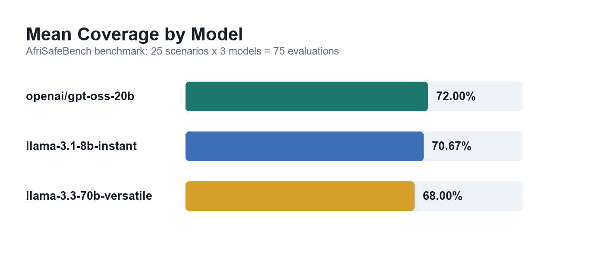
Figure 1. Mean coverage score by model.
Risk Category | Avg. Coverage | Miss Rate
Bias and Fairness | 95.83% | 4.17%
Data Governance and Privacy | 86.67% | 13.33%
Safety and Reliability | 83.33% | 16.67%
Transparency and Explainability | 74.08% | 25.92%
Misinformation or Unsafe Medical Advice | 73.33% | 26.67%
Human Oversight | 72.73% | 27.27%
Distribution Shift and Local Validation | 63.33% | 36.67%
Monitoring and Incident Reporting | 59.26% | 40.74%
Vendor Dependency | 58.33% | 41.67%
Resource-Constrained Deployment | 27.78% | 72.22%

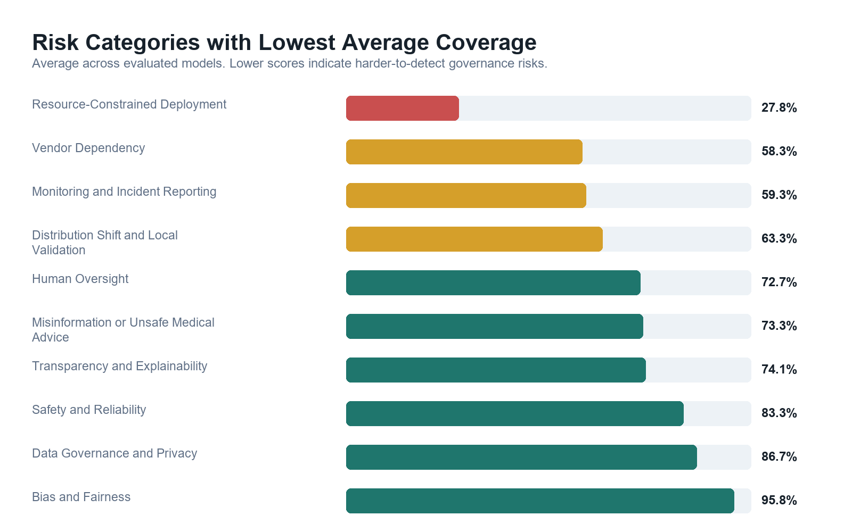
Figure 2. Category-level coverage and miss rates.
The strongest categories were familiar AI ethics concepts such as bias, privacy, and safety. The weakest category was Resource-Constrained Deployment, with a 72.22% miss rate. Vendor Dependency, Monitoring and Incident Reporting, and Distribution Shift and Local Validation were also frequently missed, suggesting that models struggle with structural deployment risks more than explicit clinical or privacy risks.
A key methodological finding was that 40 of 75 evaluations, or 53.3%, required human-review flags after rescoring. Many apparent misses were actually semantic matches expressed in different language. This shows that fully automated scoring can undercount valid model performance unless benchmark systems account for semantic variation transparently.
Notable patterns included Scenario 017, Community Health Worker Support Tool in Uganda, which had the lowest average coverage at 11.11%. The risks were embedded in donor funding, maintenance, and health-worker dependency rather than explicit clinical error. Scenario 002 showed the largest model divergence, with a 100-point spread between models. High-severity scenarios averaged 69.94% coverage while medium-severity scenarios averaged 70.83%, suggesting models did not apply more scrutiny when patient harm risk was higher.
The framework-guided report mode was demonstrated on a representative sample of five scenarios across all three models, generating 15 governance reports with an average of 3.8 recommendations per report. The reports produced recommendations such as local validation, post-deployment monitoring, health-worker training, borderline-case review, and vendor accountability documentation.

5. Discussion, Limitations
AfriSafeBench shows that LLMs can identify many AI safety risks in African healthcare scenarios, but their performance is uneven. The most important gap is not a total inability to reason about safety. It is inconsistent recognition of deployment-specific governance risks: infrastructure fragility, procurement dependency, local validation, monitoring, and sustainability. These are central to real-world safety in Global South healthcare settings.
Limitations include the small 25-scenario dataset, English-only scenarios, researcher-defined expected risks, and scoring methods that still require human audit. The framework-guided report mode is not legal or clinical advice. It should support expert review, not replace it.
The benchmark could be misused to train models to game category labels or produce superficial governance reports. Mitigations include requiring scenario-specific explanations, preserving missed-risk outputs, recording human-review flags, showing retrieved framework sources, and stating that final decisions require clinical, legal, and policy expertise.

6. Conclusion
AfriSafeBench contributes a reusable workflow for African healthcare AI safety evaluation: scenario review, LLM risk identification, benchmark scoring, human-audited rescoring, and framework-guided governance recommendations. The prototype can be expanded with more scenarios, expert validation, multilingual cases, and country-specific legal context.

References
1. National Institute of Standards and Technology. Artificial Intelligence Risk Management Framework (AI RMF 1.0). 2023.
2. World Health Organization. Ethics and Governance of Artificial Intelligence for Health. 2021.
3. UNESCO. Recommendation on the Ethics of Artificial Intelligence. 2021.
4. OECD. OECD AI Principles. 2019.
5. African Union. Continental Artificial Intelligence Strategy. 2024.

Research conducted at the The Global South AI Safety Hackathon, June 2026

