Blue Cheese Stuffed Strawberries
Sure, chocolate-covered strawberries are the perfect dessert for Valentine’s Day, but they can be the perfect appetizer too! Blue cheese stuffed strawberries topped with chopped pecans and drizzled with balsamic vinegar will not only get the taste buds jumping for joy, but they also look amazing.

You’ll begin by hallowing out fresh strawberries. From there, combine 3 ounces of cream cheese and ½ cup of crumbled blue cheese until smooth. Fill each berry with the mixture, add the pecans and chill. Not only are these quick, but we promise they’re impressive!
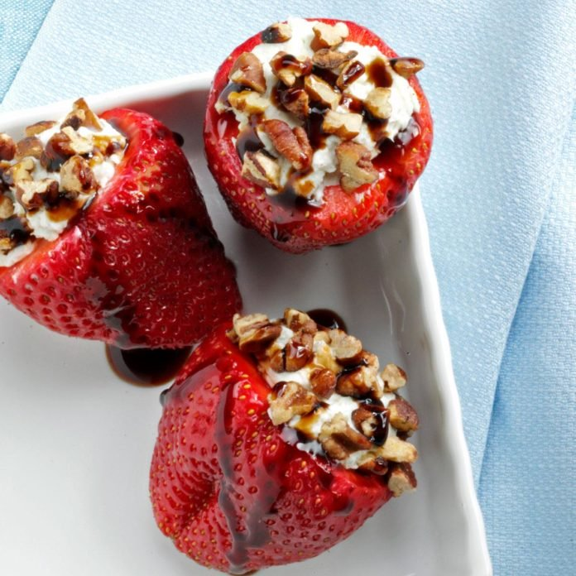

End sweetly with a bite of heaven. These dates are the ultimate delicious Valentine’s Day starters—or the perfect addition to your dessert menu! Filled with rich dark chocolate and topped with a pinch of salt, they create a perfect balance of sweetness and slight savoriness. Moreover, the combination of flavors not only delights the taste buds but also provides an unforgettable finish to any meal.
Best of all, they’re very easy to prepare, making them a simple yet indulgent addition to your special celebration.
Ingredients:
- 12 Medjool dates (pitted)
- ½ cup dark chocolate chunks
- Flaky sea salt
Steps:
- Stuff dates with chocolate.
- Bake at 325°F for 5 minutes until chocolate melts.
- Sprinkle with salt.
Tip: Add a bit of almond extract to the chocolate for extra depth.
https://gladkokken.no/en/recipes/surf-n-turf-meat-lobster-recipe

