Question 1

Kimberly
Role: - Defining the Theme.
Teamworker Participated immediately on choosing the theme while leaving space for others.
Rapid response meeting and observing deadlines

Jake
Role: - Case studies and collecting the work into one designed document.
Shaper took the whole initiative be a leader. He created the group chat and got members involved in a harmonious manner.
Implementer Get things done in fact Jake took the job to put everything together in one document.

Kai
Role: - Social effect
Teamworker collaborated effectively with the group projects and goals.
Focused on task The research was highly performed in depth.

Matthew
Role: - Relevance of the theme
Teamworker Co-operator and listens carefully
Rapid response meeting and observing deadlines

All Group Members
Skill Utilization: - in the initial meeting, it was collectively agreed that each team member will choose the task that he/she will work on depending on individual skills.

Question 2

- We had our first meeting in class so we could decide the theme we were going to work on and which role we were going to take.
- We mainly communicated through chats via Teams but we also clarified some issues when we met at school which helped everyone puts his mind at rest on certain issues.

Question 3

Main Challenge
We targeted a date to discuss our progress, but we had to postpone as not everyone was ready from the task. So, our main challenge was time management as we did not all do the work at the same time and some members of the team got worried about reaching the deadline.

Conflicts
There were no conflicts at all because when we faced the challenge mentioned before. We all collaborated, and everyone was reassured that everything was under control.

Question 4

(We can choose 1 for each member from this list)

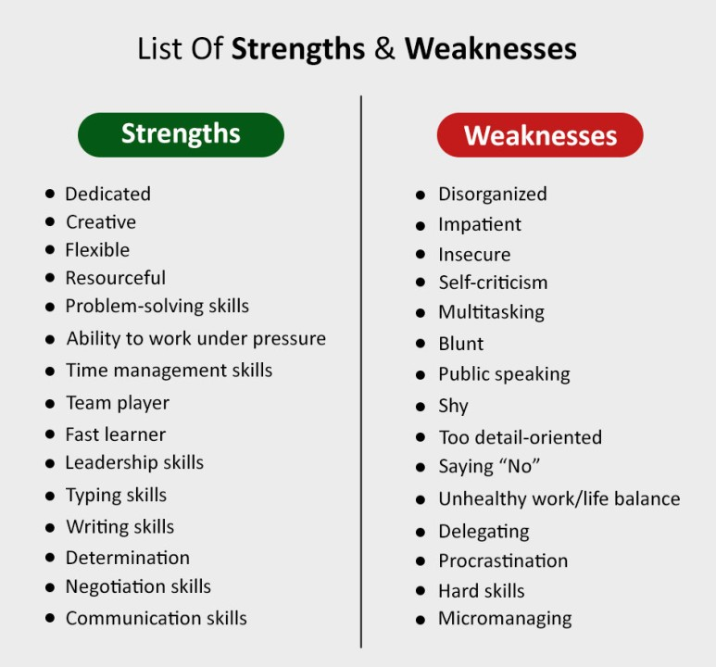

2 advantages of receiving constructive feedback
https://ca.indeed.com/career-advice/career-development/constructive-feedback-meaning

Conclusion
Respectful all group members have been respectful for one another.

