HARVARD CITE THEM RIGHT

A Guide to Harvard
Cite them Right Referencing:
Structuring Citations for Credibility and Integrity


ACTIVITY BOOKLET

Ms Nikita Pisani
BA(Hons), MA(Melit.), CELTA, GTC(VET)

ACTIVITY 1
You are researching the topic of your assignment and have selected a few ideas (see the box below) from a book titled How to Manage, written by Jo Owen and published in 2019. (Note: Owen is the surname of the author.)
The role of the coach is not to make all the tackles and score all the goals for the team. The role of the coach is to help the team achieve all these things, to bring out the best in each individual and to organise members effectively. (p. 96)

All these excuses come down to lack of trust in the team and an inflated sense of the manager’s unique skill. And they all condemn the manager to becoming overworked and the team to becoming overdependent on the manager. The team will only grow if the manager can delegate and trust it. (p. 99)

Complete the following citations and then answer the questions:
Owen (_____________) explains that the role of the coach is not “to make all the tackles and score all the goals for the team” (________).

It has been pointed out that it is not the role of the coach to make everything for the team members (___________, __________).

According to ___________ (__________), the excuses many managers use to explain why they do not delegate show that they do not trust their team.

All the excuses given by managers to explain why they do not delegate in their team members “come down to lack of trust in the team and an inflated sense of the manager’s unique skill” (___________, ___________, ________).

Think and Reflect:
- Why is the author’s surname not included in brackets in some of the citations above?
________________________________________________________________________________________________________________________________

Activity 2
You have used in your assignment this article published online in the newspaper The Economist. Complete the citation and answer the question below:

Falling bank shares

European banks are in the eye of a new financial storm

Feb 13th 2016


IF THE start of the year has been desperate for the world’s stockmarkets, it has been downright disastrous for shares in banks. Financial stocks are down by 19% in America. The declines have been even steeper elsewhere. Japanese banks’ shares have plunged by 36% since January 1st; Italian banks’ by 31% and Greek banks’ by a horrifying 60% (see chart). The fall in the overall European banking index of 24% has brought it close to the lows it plumbed in the summer of 2012, when the euro zone seemed on the verge of disintegration until Mario Draghi, the president of the European Central Bank (ECB), promised to do “whatever it takes” to save it.

In fact, the bank shares have plunged so dramatically that the overall European bank index has come “. . . close to the lows it plumbed in the summer of 2012” (_________________, _____________).

Activity 3
Which of these two citations is correct? Explain why.
- After sharp falls after the Brexit results, the financial markets seem to be recovering (The Wall Street Journal, 2016).

2. After sharp falls after the Brexit results, the financial markets seem to be recovering (http://www.wsj.com/europe, 2016).

Activity 4
You are using this article published online in the newspaper The Guardian. Complete the citation.

Rolls-Royce cuts dividend for first time in almost 25 years
The engineering group has slashed in half its final payment to shareholders in the first dividend cut since 1992
Julia Kollewe Friday 12 February 2016


Rolls-Royce has cut its dividend payment to shareholders for the first time in almost 25 years and warned of further job cuts to come. The final dividend payment to investors has been slashed by 50%, to 7.1p a share. Analysts had expected a 30% reduction.
But relief that the engineering group had not issued another profits warning saw its shares jump 13%, to 602p, although the share price has still halved in value over the past two years.
Sandy Morris, analyst at the company’s house broker Jefferies, said: “The unchanged 2016 guidance should help stop the rot in sentiment. The 50% cut in the final dividend is a painful step, but Rolls makes a fairly clear commitment to a progressive dividend policy.”

Rolls-Royce shareholders have not received good news this week, after the company “. . . cut its dividend payment for the first time in almost 25 years” (________________, ______________).

Cross-cultural training can be defined as the “… broad field of interest in international trading and, in more recent times, the global economy and globalization” (________________, _____________, p. 144).
Activity 5
You have used information from TATE website in your assignment (http://www.maersk.com/en/markets). Complete the citation.
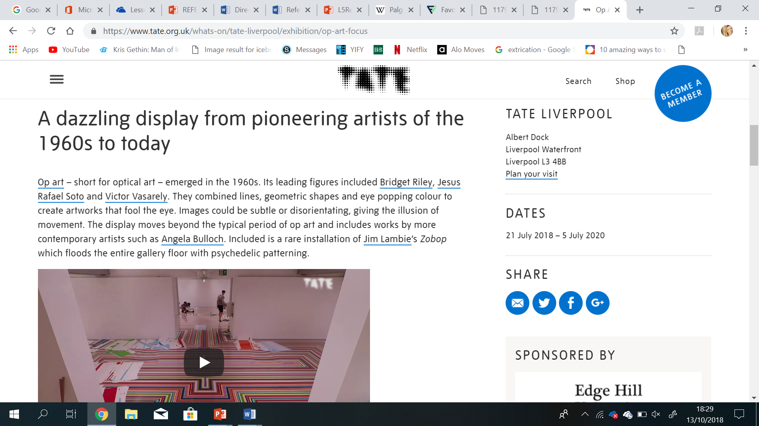
Three pioneering figures in optical art include Bridge Riley, Jesus Rafael Soto and Victor Vasarely (________________, _____________).

Activity 6
You have used information from the Lego website in your assignment (http://www.lego.com/en-us/aboutus/lego-group/the_lego_history). Complete the citation.

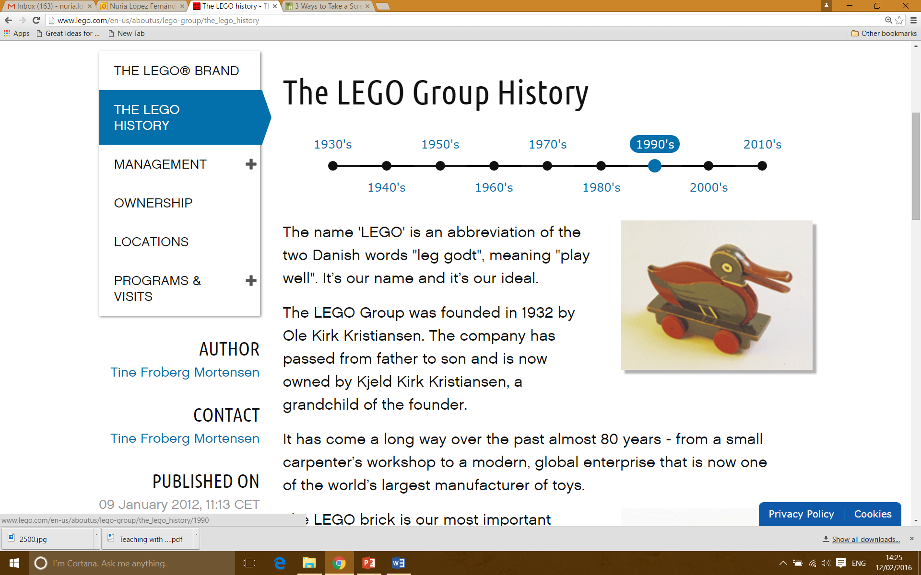
LEGO is still in the hands of the family which founded the company in 1932. Nowadays LEGO is owned by Kjeld Kirk Kristiansen, a grandchild of its founder, Ole Kirk Kristiansen (________________, _____________).

Activity 7
You have used information from one chapter of a book titled Applied Linguistics and Material Development (2013), edited by Brian Tomlinson. The authors of the chapter you have used are Chris Mounsey and Michael Smith. Complete the citation:

Cross-cultural training can be defined as the “… broad field of interest in international trading and, in more recent times, the global economy and globalisation” (_________________, ___________, ____________).

Activity 8
In Essential Study Skills. The Complete Guide to Success at University (2012) the authors, Tom Burns and Sandra Sinfield, make reference to Tony Buzan’s (1989) work.
Now complete this citation:
Tony Buzan (1989) points out the importance of active revision if we do not want to forget 98% of what we have learned (cited in _______________, 2012).

(Most of the activities were taken and adapted from LearnHigher.com)

