MOCK Assignment Practice – English for Academic Purposes

TASK A. Identify whether the statements below are True or False.
 | Statement | True or False
1 | The Discussion is not necessary in an academic paper. | F
2 | All academic texts follow the IMRaD structure.
3 | The ‘R’ in IMRaD stands for Reporting.
4 | The abstract of a journal article only provides the results of the research.
5 | The Introduction section can reveal a gap in the field of research.

Task B. The text below is an extract from a journal article. Read it carefully and answer in full the questions that follow.

Journal Article Title: Exploring Innovation in the Creative Arts Industry: A Study of Emerging Trends

Abstract
The creative arts industry has long been recognized as a major driver of culture and economy globally. This study explores the emerging trends and innovations within the creative arts sector, focusing on the role of technology, interdisciplinary collaboration, and evolving business models. The research aims to understand how these factors influence artistic production, distribution, and consumption. Using a mixed-methods approach, this study analyzes qualitative interviews with industry professionals and quantitative data from market trends. Findings reveal that the integration of new technologies, such as AI and virtual reality, is reshaping artistic practices, while collaboration across disciplines is fostering more dynamic and diverse works. The study concludes by discussing the implications of these trends for artists, audiences, and the future of the industry.

Introduction
The creative arts industry encompasses a wide range of fields, including visual arts, music, theater, film, literature, and digital media. Over the past decade, technological advancements and shifting societal attitudes have had profound effects on how art is created, shared, and experienced. Traditionally, the industry was dominated by a few key players and rigid structures, but today, new opportunities for innovation have emerged through digital platforms, global connectivity, and collaborative practices.
This research aims to investigate the current state of innovation within the creative arts industry. Specifically, it examines the ways in which emerging technologies, such as artificial intelligence, virtual reality, and blockchain, are influencing the production and distribution of art. Additionally, this study looks at how collaboration across different artistic disciplines is enabling new forms of creativity. By identifying and analyzing these trends, this study seeks to offer a deeper understanding of the future trajectory of the creative arts industry.

Questions for the Introduction Section:
- How have technological advancements reshaped the traditional structures of the creative arts industry?
________________________________________________________________________________________________________________________________________________
- Why is collaboration across disciplines increasingly important in today’s creative arts landscape?
________________________________________________________________________________________________________________________________________________

Methods
This study employed a mixed-methods approach to gather both qualitative and quantitative data. First, semi-structured interviews were conducted with 15 professionals working in various sectors of the creative arts industry, including visual artists, musicians, filmmakers, and technology experts. These interviews provided insights into how participants are integrating emerging technologies into their creative processes and how they view the future of the industry.
In addition, quantitative data was collected from industry reports and surveys to analyze market trends, focusing on the growth of digital platforms, the adoption of new technologies, and consumer behavior. The data were analyzed using descriptive statistics to identify key patterns and correlations. The combination of interviews and market data allowed for a comprehensive view of the current landscape of innovation in the creative arts industry.

Questions for the Methods Section:
- How does the mixed-methods approach benefit the study of innovation in the creative arts industry?
________________________________________________________________________________________________________________________________________________
- Why were industry professionals selected as the primary sources of qualitative data for this research?
________________________________________________________________________________________________________________________________________________

Task C: Read the following TWO short extracts on Creativity carefully.
Compare Extract A with Extract B and point out the difference in style (tone, format, and citations) by indicating which of the extracts is more academic. Justify your reasoning with examples from each text.

Extract A
Creativity and Innovation
REDUNDANT PHRASING “due to the fact that” -> BECAUSE
Is creativity a quality that you either have or don’t have? Some of us seem to be born with this great innate ability to think imaginatively, while others are more logical or practical-minded. But there’s been a shift recently in this way of thinking and new studies suggest that creativity is indeed a skill that we can develop over time (Mounsey). So, this doesn’t mean that if you feel you’re not very creative or creative enough, you’re doomed forever. Is something that can actually be learned and developed!
But what really is Creativity?
Creativity has been defined as the act of turning new and imaginative ideas into reality, i.e. creativity is characterised by the fact that you are able to perceive the world in new and innovative ways. To find hidden patterns, to make connections between seemingly unrelated phenomena, and to generate solutions. It mainly involves two processes: thinking, and then, producing. It’s amazing what we can do if we just believe a bit more in ourselves. Really!

EXTRACT B

The Neuroscience of Creativity: A Gestalt Perspective
By Todd Burley

Abstract
It is common to look for the roots of creativity in some aspect of the individual. It is assumed that the creative person must have a unique characteristic or characteristics unavailable to others. Usually, these characteristics are sought in reductionist versions of personality theory, intellect and more recently, in some aspects of the neuroscience revolution.

Unlike other theories of psychotherapy and personality, Gestalt theory takes the field as its basic unit of observation. By field, Gestaltists mean that the whole context or ecosystem of which the person and his or her neuropsychological system is a part or portion works as one, and that it is impossible and misleading to try to understand and observe a person “apart from” the field of which they are a portion. Paradoxically, the way we know the field or “about” the field is through a person’s contact with other aspects of the field, which gives rise to awareness and, from a neurocognitive perspective, awareness (Damasio, 1999) and experience, or one’s personal phenomenology. Thus, the creative person’s neurological and neuropsychological makeup, from a Gestalt perspective, is a part or portion of the field.

Creativity is a field phenomenon and, as will be discussed and explored throughout this paper, neuroscience leads away from reductionistic explanations and clarifies the concept of creativity
as a field phenomenon.
Write your answers here:
Tone: (Identify the attitude of the authors, look at the type of vocabulary used – is it formal or Informal? Specific or general? Does the author remain objective throughout, with the aim of imparting information to the reader, or is there an element of bias within the text? How do you know? Is there use of informal features – such as contractions, rhetorical questions, informal vocabulary, and so on) Make sure to provide examples from the text to support your answers.)

Text A:

Text B:

Citations: (Comment on the correct use and presence of in-text citations, or lack thereof, within both extracts.)

Text A:

Text B:

Format: (Comment on the overall layout of the text, how it is visually laid out – use of paragraphs, heading and sub-headings, and so on.)

Text A:

Text B:

Conclusion: (What is your overall conclusion? Which text is more formal or academic? How have you come to this conclusion?)

Outcome 2: Use an academic style of writing when working on assignments and dissertations.

Task D: Go through EXTRACT A above and find examples of the features below.

- TWO contractions:

- One example of informal vocabulary:
- One example of a non-cited quote or information:
- TWO examples of the first or
second person:
- One abbreviation:

- One rhetorical question:

Outcome 3: Reproduce secondary content by means of direct and indirect quoting methods.

Task E: Identify the MAIN IDEA(S) of either EXTRACT A or EXTRACT B and paraphrase it in about 200 words.

Type your paraphrase here:

Rubric:
Marking Guide | Mark(s) Allocated | Mark(s) Achieved
Used a clear and appropriate signal phrase in the first sentence | 1
Identified the most relevant points (no irrelevant information) | 3
Paraphrased the information appropriately | 3
Responded to the main ideas in the summary | 2
Took a position on the information in the summary | 2
Had good grammar and style | 2
Had minimal mistakes in spelling and punctuation | 2
Total Mark | 15

Task E: Fill in the gaps by writing the in-text citations from the references provided at the bottom. [10 marks, 1 mark each]
The analysis of the power of suggestion of photography in nowadays online media must take into account the post-modern context of contemporary society ^{7 & 8} (______________________).
¹ _ __ (__) and ² ___ ( ___ )both claim that this is particularly evident in the preference of photo reporters to select significant elements in the informational field, but also in the proliferation of photographs in which special, picturesque, funny, contradictory, ironic or sarcastic details are captured. Focusing on these points indicates the mutation generated by the post-modern culture from the sober and immobile state of classical photography to the alive, artistic, more natural elements of life ^{9 &10}(_______________________) Such snapshots are sought after and appreciated ³ (_________), being appropriated by the online users and distributed, placed in new contexts, both because of their aesthetic qualities, and for amusement or debate, which are sometimes very intense ^{6 & 5&4}
(_______________________________________________________).

References:
1. Mounsey, H. B., 2000. Creative Black & White:Digital Photography Tips and Techniques. Indianapolis: Wiley Publishing, Inc.
2. Kobre, K., & Jonhson, K., 2013. Photojournalism: The Professionals’ Approach (7th ed.). Oxford: Focal Press.
3. Freeman, M., & Feininger, A. (2018). Black & White Photography: The timeless art of monochrome în the post-digital age. London: Ilex Photo.
4. Hershberger, A. E., Freeman, M., Smith, J., & Leddy, T. (2021). Krauss's Foucault and the foundations of postmodern history of photography. History of Photography, 30(1), 55-67.
5. Hjort, L. (2014). New visualities and the digital wayfarer: Reconceptualizing camera phone photography and locative media. Mobile Media & Communication, 2(1), 40 –57.
6. Chamberlain, A. (2009). Comunicarea prin imagini. Iasi: Polirom.
7. Smith, M. (2016). Everyday Aesthetics and Photography. Aisthesis, VII(1), 45-62.
8. Smith, M. (2019). It has not been—it is. The signaletic transformation of photography. Journal of Aesthetics & Culture, 4(1), 1-10.
9. Chamberlain, B., Liu, L., Oliva, A., and Torralba, A. 2019. Recognising city identity via attribute analysis of geo-tagged images. In Proceedings of the 14th European Conference on Computer Vision. Springer, pp. 519-34.
10. Chamberlain, B., 2019. Visualising data. Journal of Machine Learning Research, 25(1), pp. 124-6.

Outcome 4: Apply proper referencing conventions when citing secondary content.

Task F: Below are five different sources you have consulted for a research project. Using the Word in-built referencing tool, create a reference list in Harvard style. Ensure that all elements of a reference are properly identified and inputted to generate a properly structured reference list.
Provide a reference for the sources below.
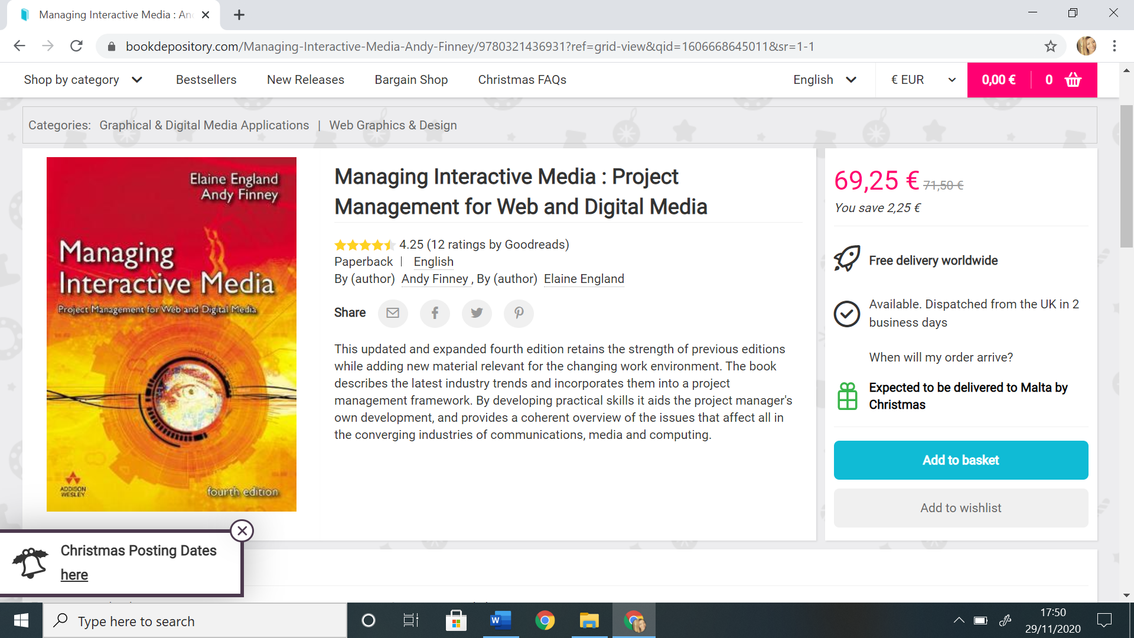



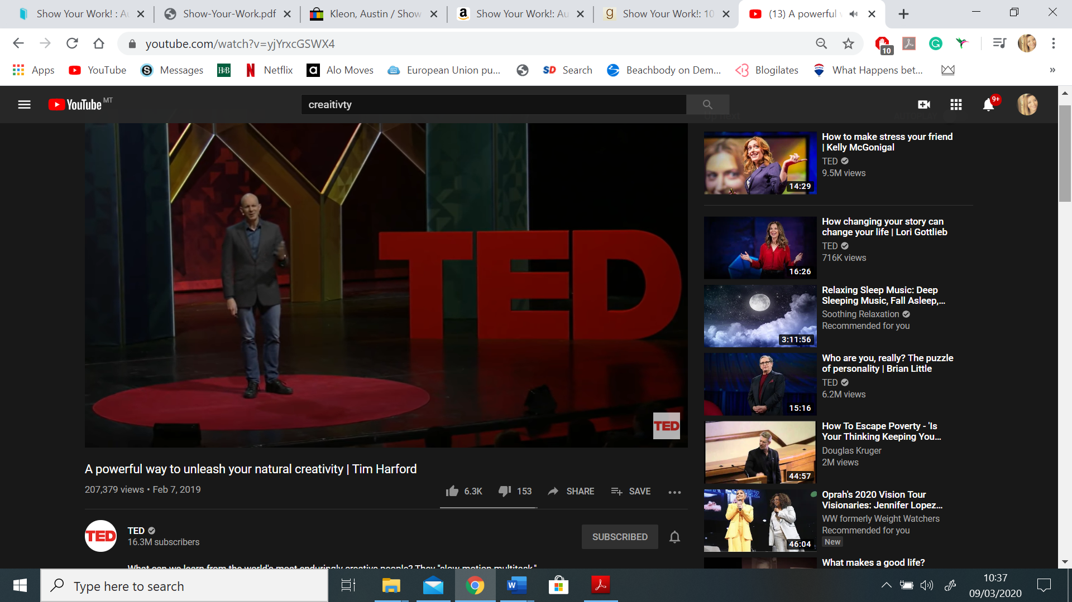
URL: www.ted.com
Date of access: 01.01.2025

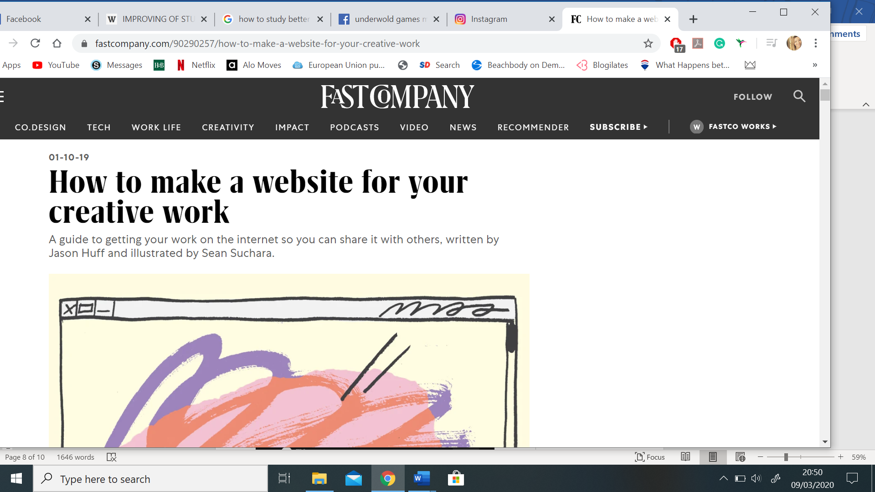

URL: https://www.fastcompany.com/90290257/how-to-make-a-website-for-your-creative-work
Date of access: 01.01.2025

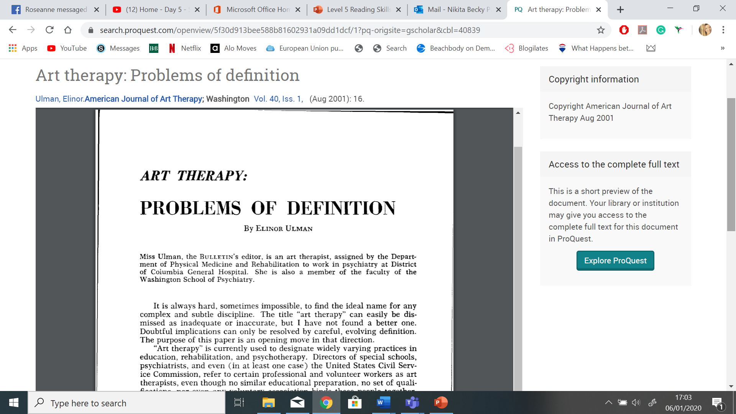

Write your References here:

END OF MOCK SYNOPTIC

