
Reflective research portfolio
Advertising


Kimberly Parascandalo

Introduction
I chose advertising as a topic for this research since advertisements have always had a huge impact on society. In this journal, I will be discussing the historic movements and how they changed the designs according to different eras.
Key events, social contexts and major international movements
Historic Movements
During the Industrial Revolution (1760-1840), there were significant changes in agriculture, manufacturing, transportation, and social structure. It started in England, where manual labour and skilled artisans were being replaced by machinery and mass production. During that period, the agricultural industry advanced in techniques and practices, resulting in an increased supply of food and raw materials since the invention of steam engines. It had a positive impact for economy, politics, and social life that allowed us to get to where we are today, but it had some negative effects on human rights and regulations for employees.
How it changed Graphic Design?
- Typographic communication
  - Advertisements
  - Books
  - Posters
  - Printing
- Mass communications
- Visual information was dramatically altered
  - Typefaces
    - Sizes
    - Styles
    - Fat-faces and slab serifs were very popular
    - Innovation of sans-serif type
- Growth of magazines, newspapers (Willetts, 2020)
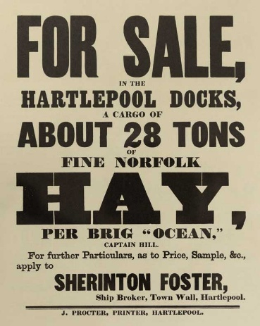
Figure 1 Printed ephemera using different Typefaces

