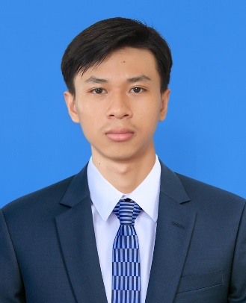

**EXPERIENCE:**

**- Freelance as website frontend developer.**

April. 2025 - Jul. 2025

* Designed & developed responsive, user-friendly website interface with ReactJS & TailwindCSS.
* Collaborate with clients to gather the requirement & solutions.
* Delivered projects on time while maintaining clear communication & providing ongoing support.

**- Create Project for self-learning (Backend).**

January. 2025 – Present

* Developed 2 e-commerce backend website using PHP & MySQL for control the database of the website.
* Create Rest API for using in the frontend project.

**- Create Project for self-learning (Frontend).**

January. 2024 – Present

* Designed & developed responsive, user-friendly e-commerce website interface with ReactJS & TailwindCSS.
* Collaborated as part of a team to build the frontend for a home decoration products store.
* Integrated category filtering and sorting functionalities for an improved shopping experience.
* Implemented add-to-cart and checkout workflows with dynamic quantity controls and stock validation.
* Adopted component-based architecture to ensure scalability and reusability of code.
* Worked with Git & GitHub for version control and collaborative development.
* Conducted UI/UX testing to refine design choices and enhance usability.

**HOBBIES**

* Coding
* Gaming
* Vacation

**LANGUAGES**

* Khmer: Native
* English: Intermediate

**REFERENCES**

* Name: John Doe
* Tel: 09876543
* Email: example@gmail.com

**SKILLS**

* MS Office
* HTML
* CSS
* JavaScript
* ReactJS
* TailwindCSS & Bootstrap
* Git/GitHub
* Figma
* PHP
* MySQL
* Java
* Problem-Solving
* Teamwork

**EDUCATION:**

**- Sre Nhor Primary School** (2011-2017)

**- Sovannaphumi High School** (2017-2023)

**- Bachelor Degree of Computer Science – Royal University of Phnom Penh** (2023-Present)

I’m a computer science student who loves creating and designing websites. I enjoy solving problems, learning new skills, and working on projects that make a difference. Beside of creating website, I would love to learn about the data analysis and mobile app developer in the next few years. My goal is to grow as a developer and bring ideas to life.

**Position: Website Developer**

**ANG KIMSOR**

**CONTACTS**

Facebook.com

angkimsor@gmail.com

email

Phnom Penh, Cambodia

087 932 289

* Donec turpis mauris, auctor vitae sollicitudin in, elementum efficitur tellus.
* Aenean nec turpis tortor. Ut placerat varius vivera vestibulum eu dictum purus.
* Ut lacinia commodo erat id vulputate. Orci varius natoque penatibus et magnis dis parturient montes, nascetur ridiculus mus.