**Name: HAI KIMSRENG**

**Id: e20210812**

**Group: GIC-A**

**Assignment 05:**

**Lap01:**

* **Using flex**

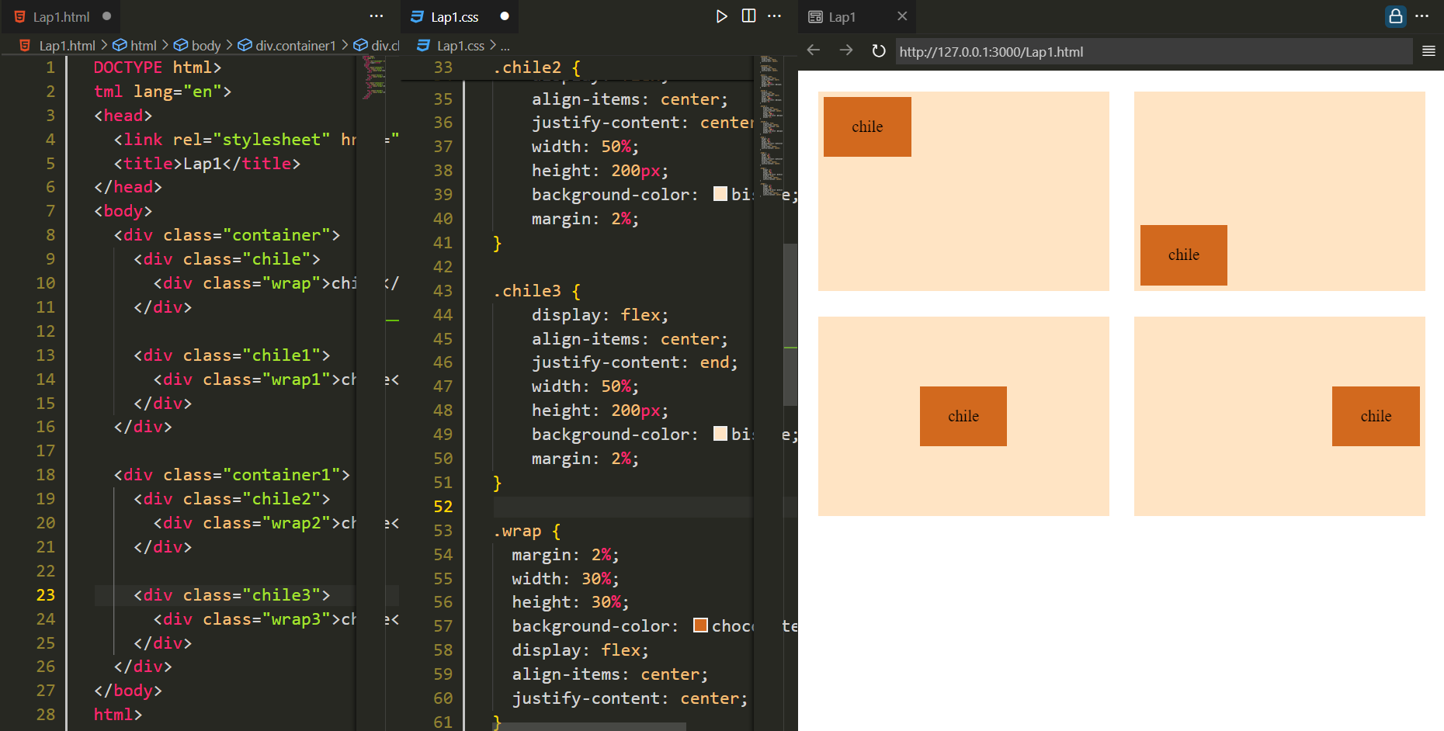

* **Using relative**

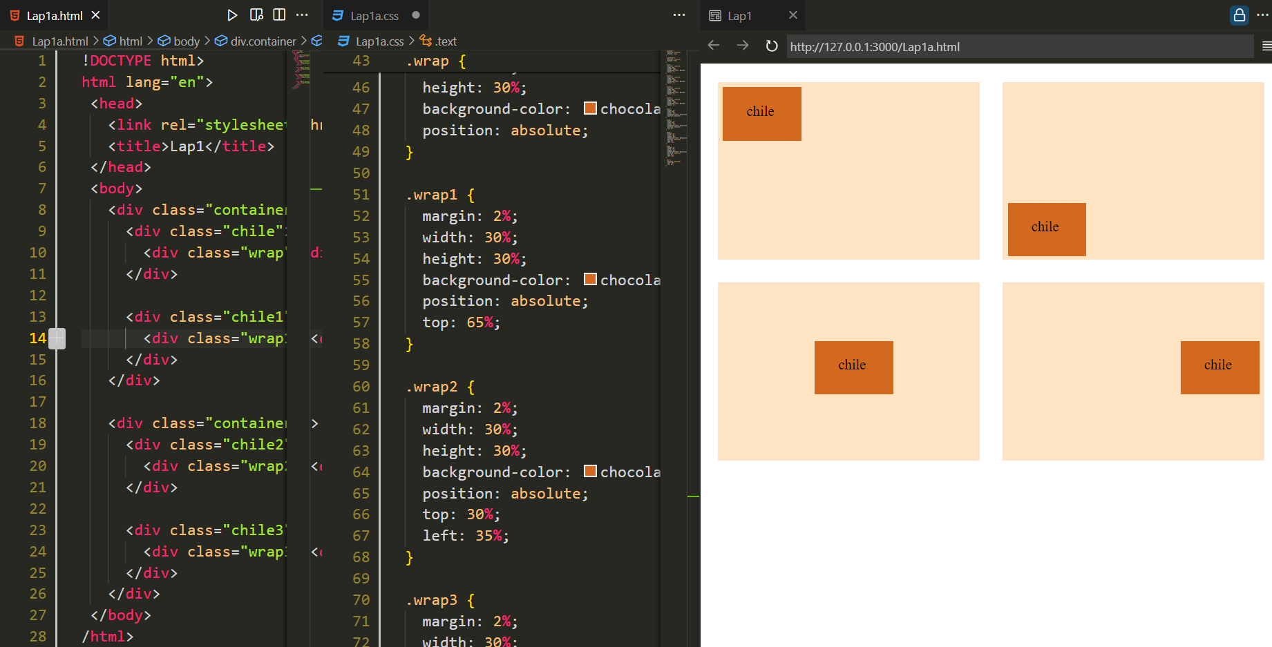

**Lap02:**

* **Using flex**

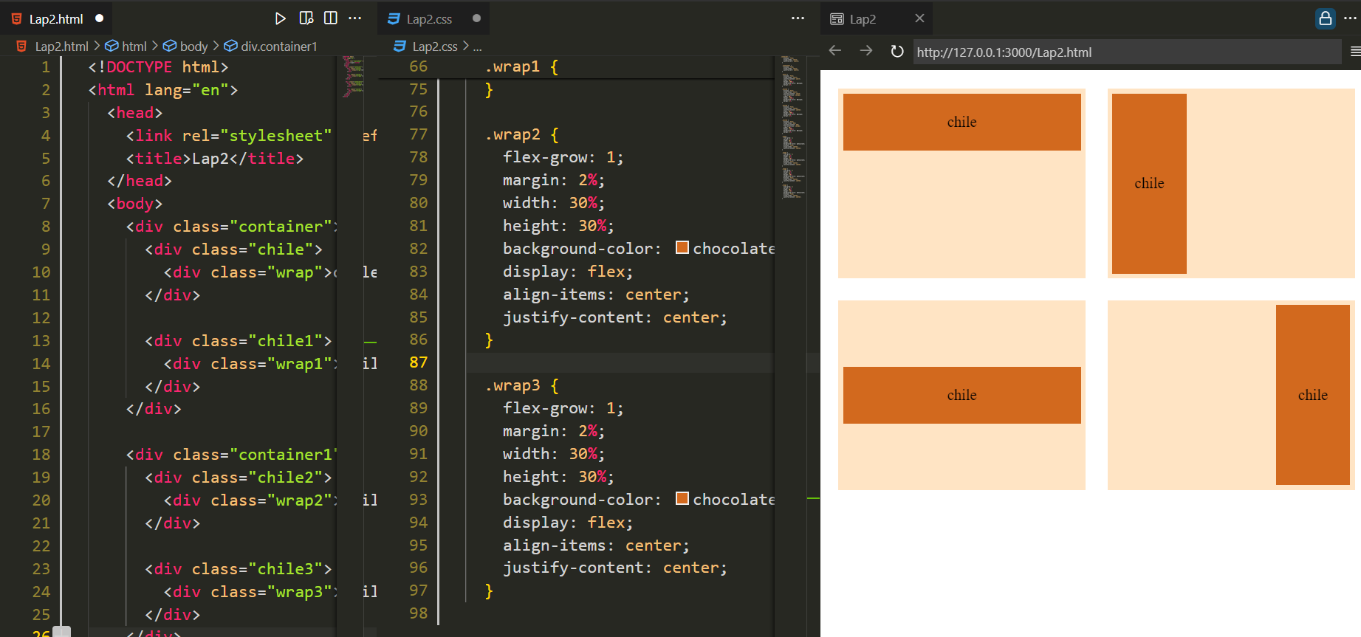

* **Using relative**

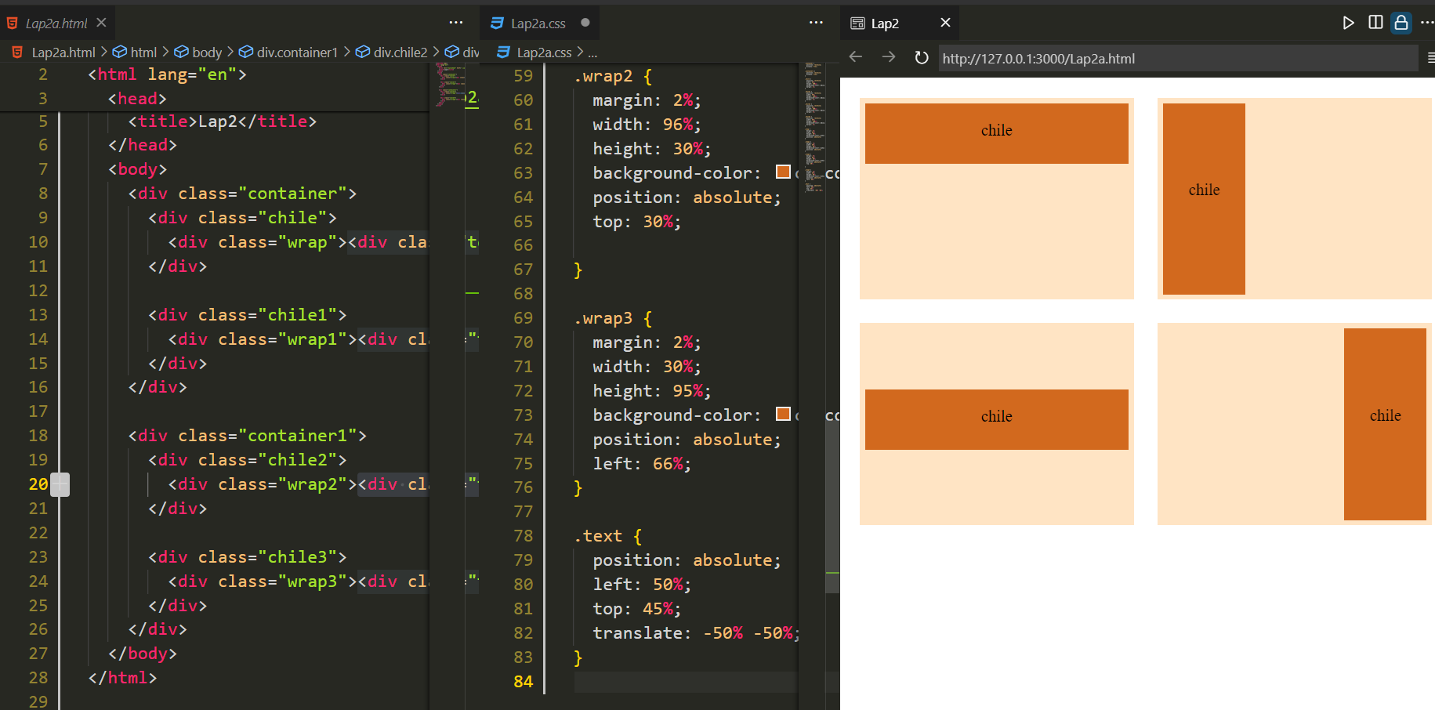

**Lap03:**

* **Using flex**

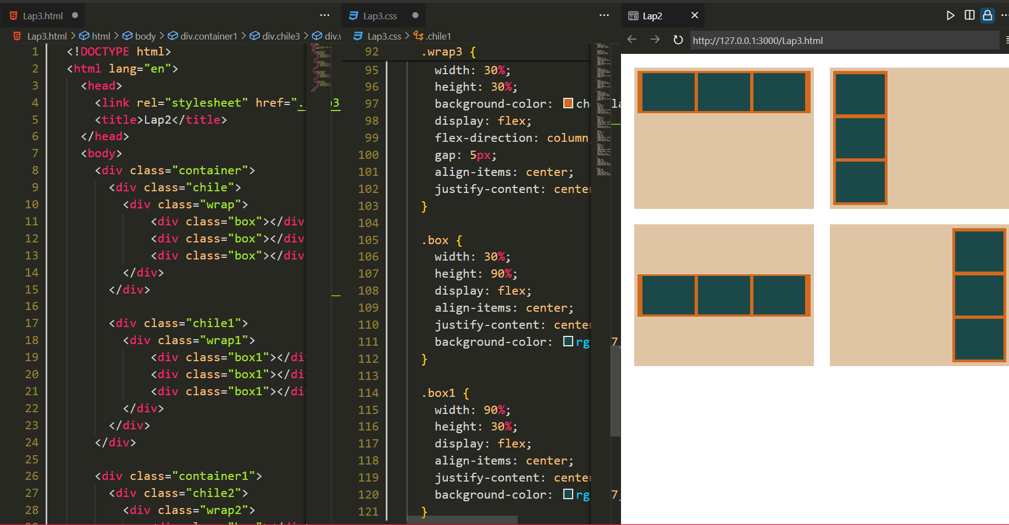

* **Using relative**

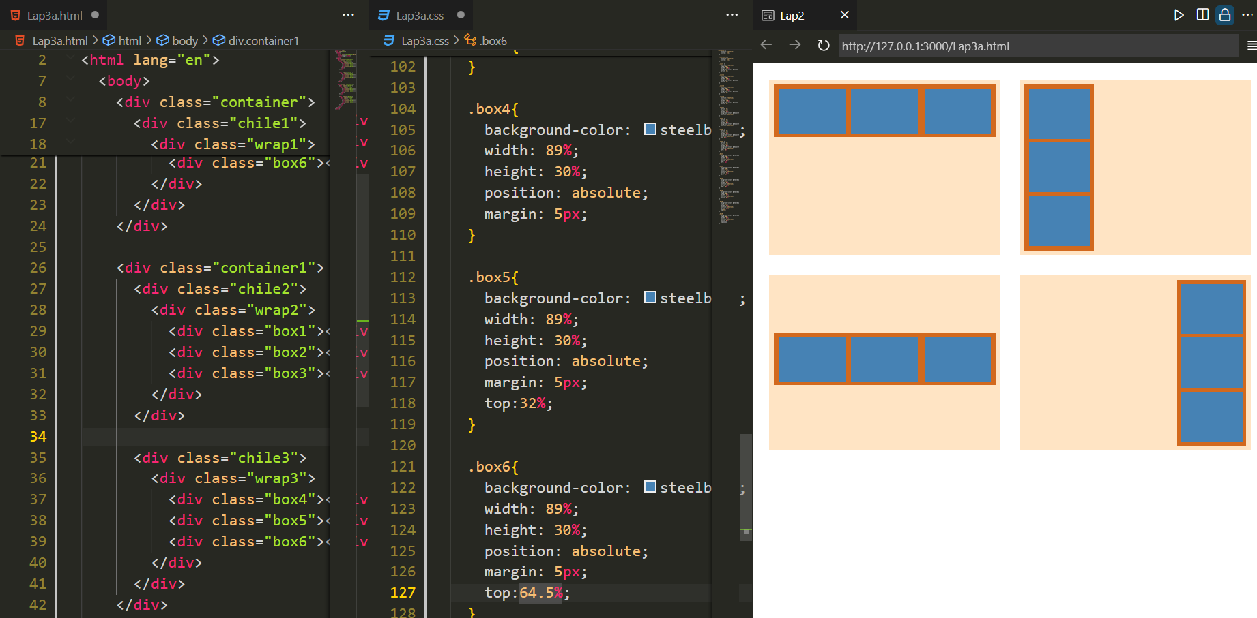

**Lap04:**

* **Using flex**

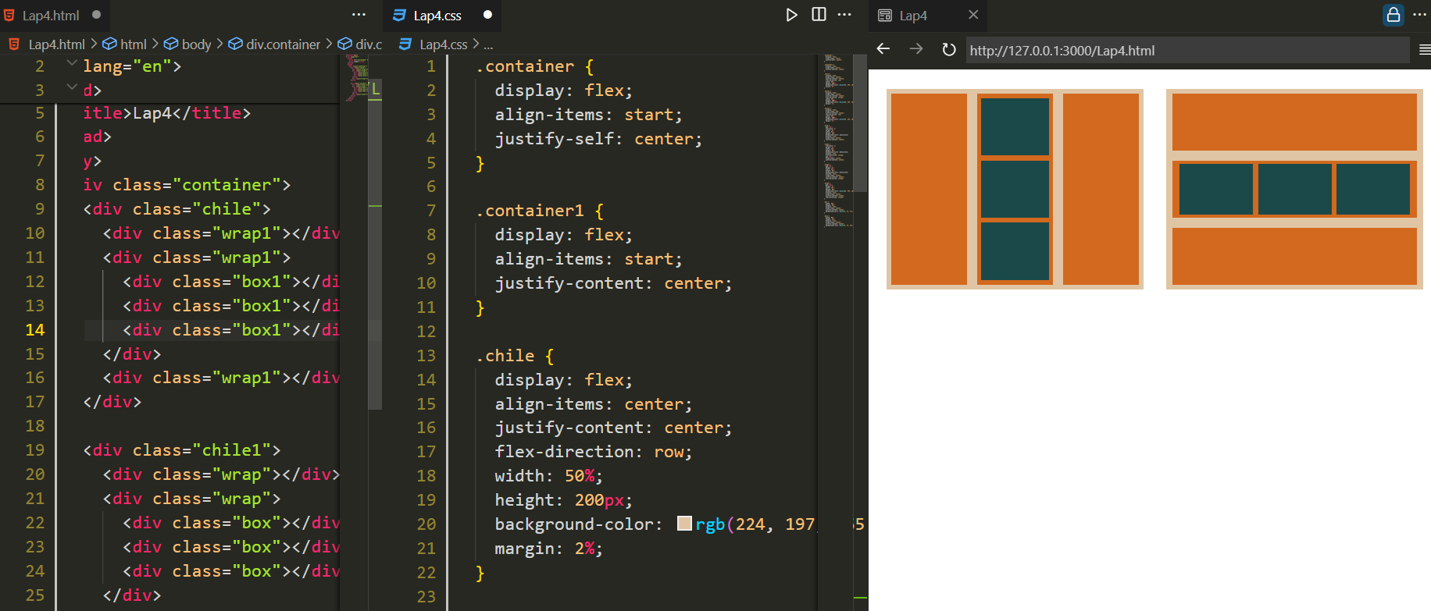

**Lap05:**

* **Using relative**

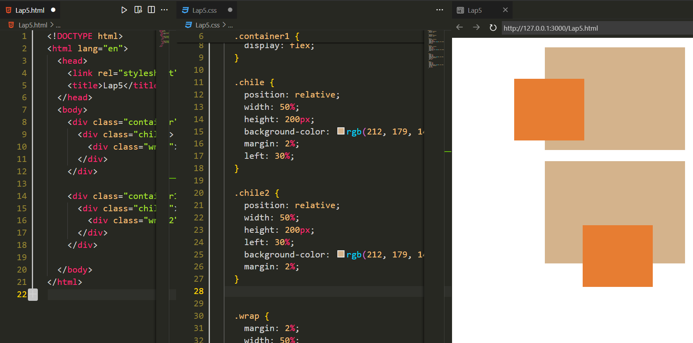

**Lap06:**

* **Using relative:**

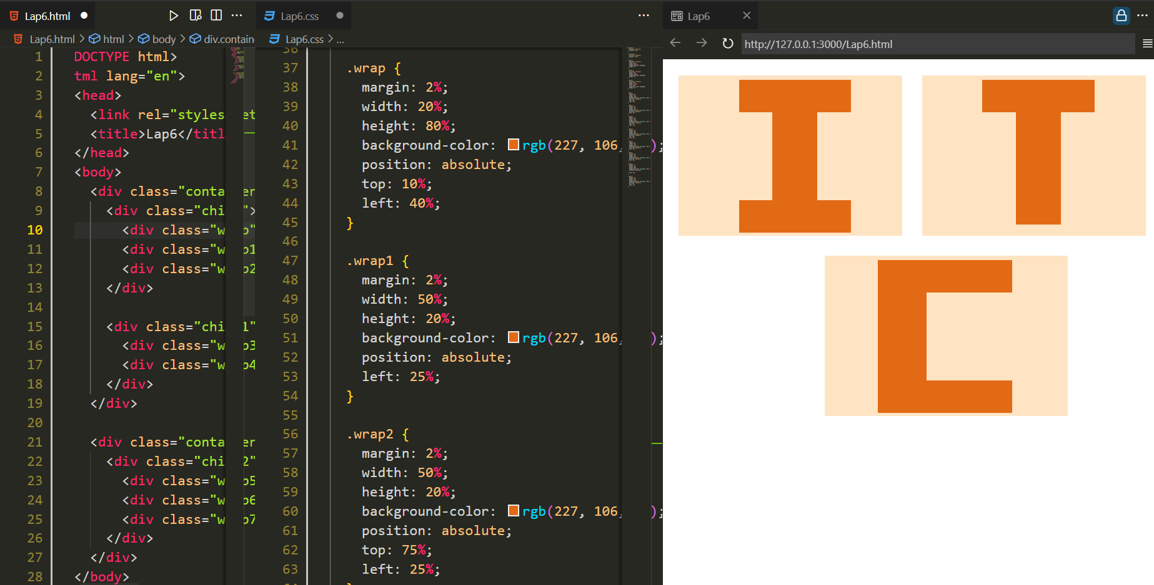

* **GIC**

