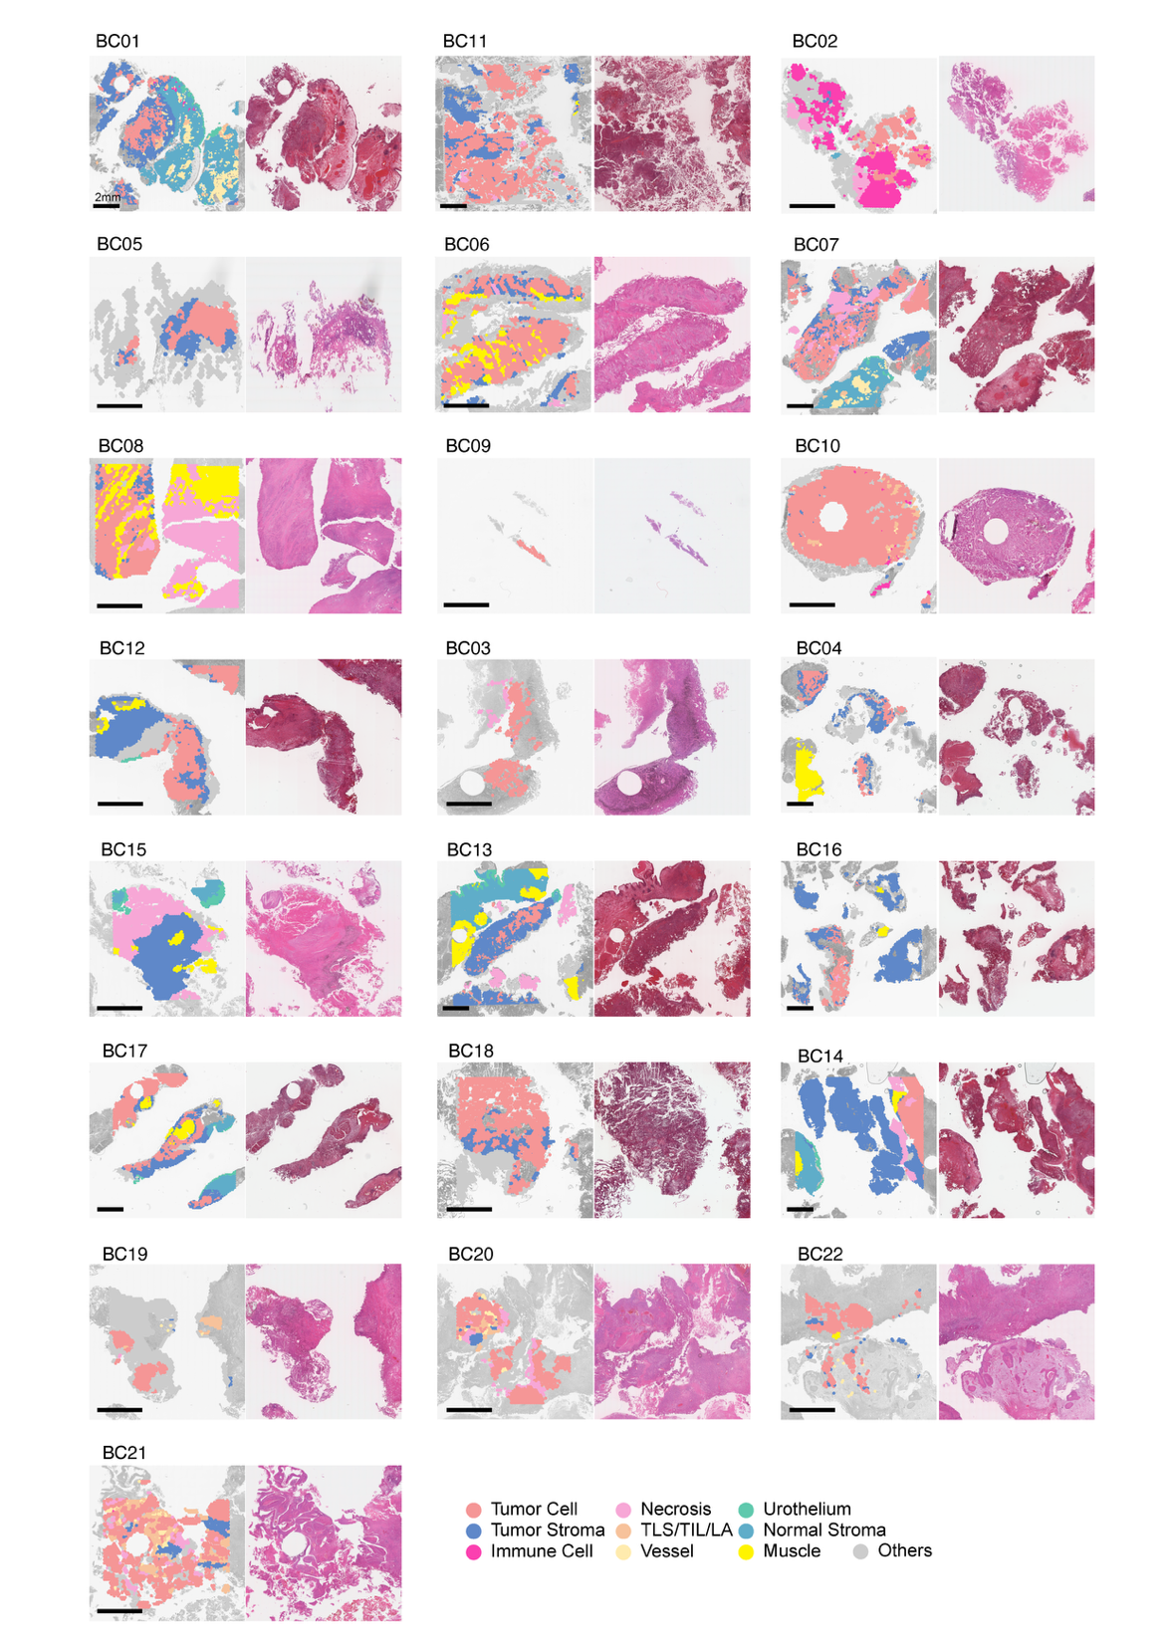
Figure S1 | Pathology-guided spatial annotation across 22 MIBC tumors. Representative pathology-informed spatial maps (left) and H&E images (right) for all 22 pre-treatment MIBC samples profiled by spatial transcriptomics. Manual annotation delineated tissue compartments including tumor cell, tumor stroma, TLS/TIL/LA, necrosis, muscle, urothelium, vessel, and normal stroma, enabling standardized region classification across patients.
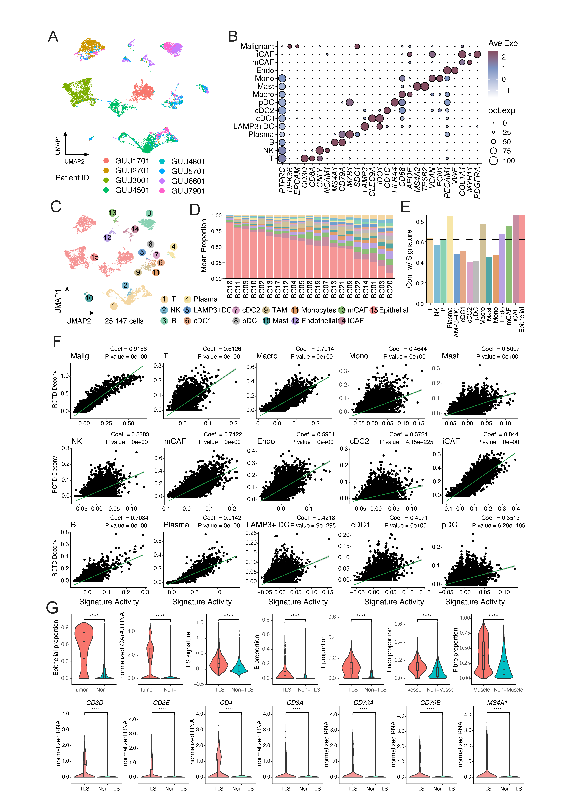
Figure S2 | Validation of spatial deconvolution accuracy and cell-type compartmentalization. (a) UMAP projection of single-cell RNA-seq profiles from eight MIBC tumors colored by patient ID. (b) Dot plot showing canonical marker gene expression across 15 annotated cell types used for spatial deconvolution, including immune, stromal, endothelial, and malignant populations. Dot size represents the percentage of expressing cells, and color indicates average expression. (c) UMAP embedding of 25,147 single cells from eight MIBC tumors, revealing 15 major transcriptional cell types including immune, epithelial, endothelial, and stromal lineages. (d) Cell-type deconvolution of spatial transcriptomes using the single-cell reference. Stacked barplots depict inferred proportions across samples. (e) Correlation between deconvolved cell-type proportions and marker gene signatures, validating deconvolution accuracy across major cell lineages. (f) Scatter plots comparing RCTD-inferred cell-type proportions with gene signature activity across spatial barcodes. Pearson correlation coefficients and p-values are indicated. Most major lineages, including epithelial (malignant), T, B, plasma, and fibroblast subsets show high correlation, validating deconvolution accuracy. (g) Violin plots illustrating region-specific enrichment of cell types and gene signatures across annotated spatial compartments. Tumor regions are enriched for epithelial cells and show higher GATA3 expression, while TLS regions exhibit increased B and T cell fractions and TLS signature activity. Endothelial and fibroblast populations are predominantly localized to vessel and muscle compartments, respectively.

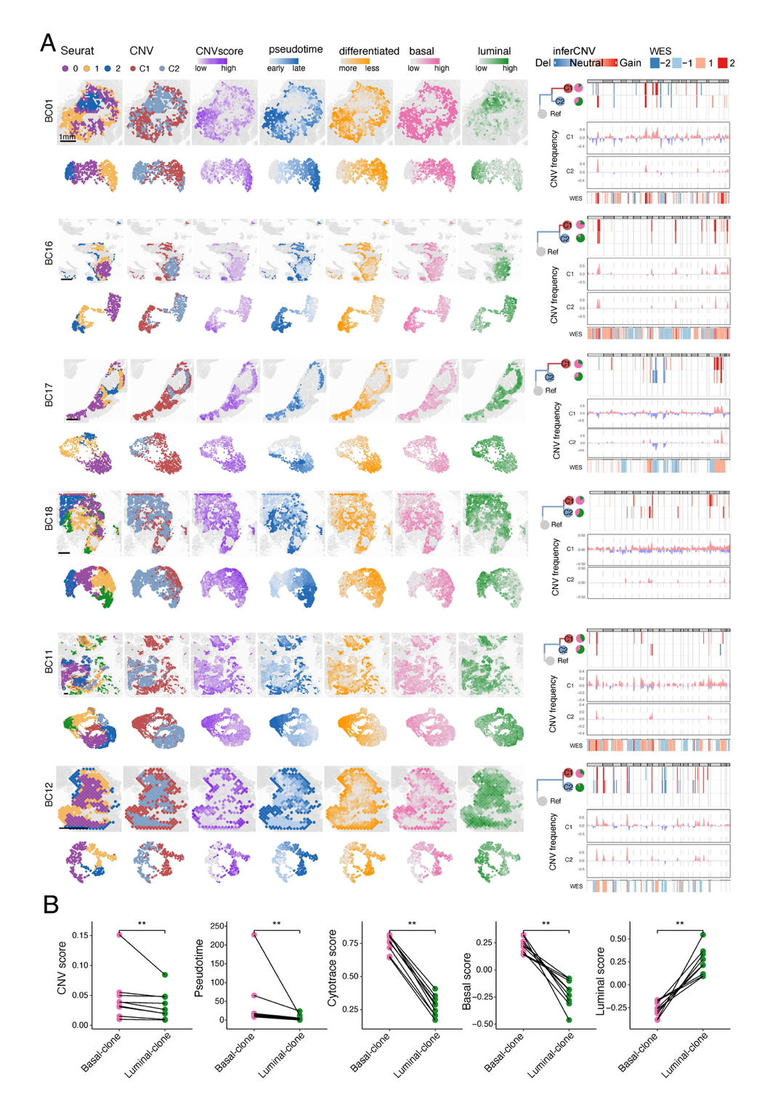
Figure S3 | Additional tumors demonstrating spatial CNV-based subclones and transcriptional divergence. (a) Spatial visualization of another six representative tumors (BC01, BC16, BC17, BC18, BC11, BC12) showing Seurat clusters, CNV-inferred subclones (C1/C2), CNV burden (CNVscore), pseudotime trajectory, differentiation potential (CytoTRACE), and basal/luminal signature scores. UMAPs of each feature are shown below each spatial panel. Right panels display WES-derived CNV profiles for each subclone. (b) Quantitative comparison of CNVscore, pseudotime, CytoTRACE, basal score, and luminal score between CNV-defined basal and luminal subclones across tumors.
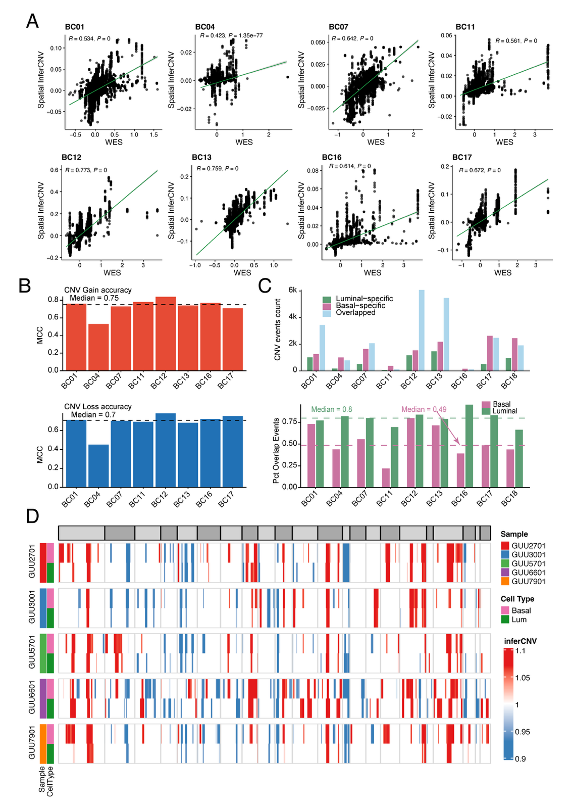
Figure S4 | Cross-platform concordance of CNV profiles inferred from spatial transcriptomics and WES. (a) Correlation between spatial RNA-inferred CNV signals (inferCNV) and WES-derived CNV profiles across individual tumors. Each dot represents a gene, and the green line indicates the linear regression fit. Pearson correlation coefficients (R) and corresponding P values are shown for each sample. (b) Concordance of CNV gain (left) and loss (right) events between spatial inferCNV and WES-derived CNVs across samples, measured by Matthews correlation coefficient (MCC). Dashed lines indicate the median MCC across samples. . (c) Comparison of CNV events between luminal and basal tumor compartments. (Top) Number of CNV events classified as luminal-specific, basal-specific, or shared (overlapped) across samples. (Bottom) Proportion of shared CNV events within luminal and basal compartments for each sample. Dashed lines indicate median values across samples. (d) Heatmap of inferCNV-inferred copy number profiles across single malignant cells from five MIBC tumors. Cells are grouped by sample (rows) and cell type (basal vs luminal, left annotation). Columns represent chromosomal segments. CNV signal intensity is color-coded from blue (loss) to red (gain).

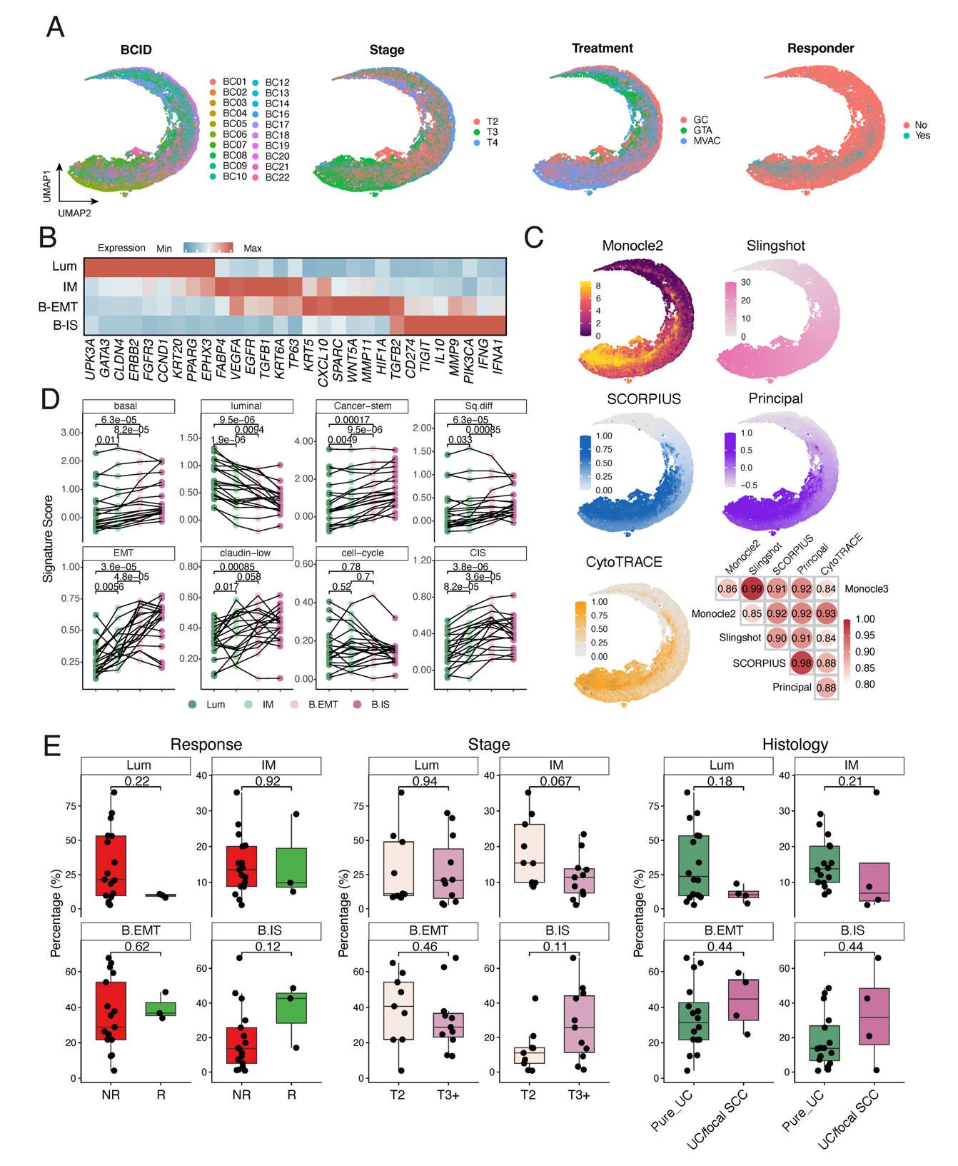
Figure S5 | Transcriptional and functional features across the luminal-to-basal differentiation continuum. (a) UMAP embedding of all pathology-annotated tumor spots, colored by tumor ID, pathological stage, treatment regimen (GC, GTA, MVAC), and response status. (b) Heatmap showing average expression of selected lineage, EMT, and immune-related genes across spatial tumor states (Luminal, Intermediate [IM], Basal-EMT and Basal-Immune Suppressive [B.IS]). (c) Validation of trajectory inference using multiple methods. (d) Signature score comparisons across tumor states for key programs including basal, luminal, cancer stemness, squamous differentiation, EMT, claudin-low, cell cycle, and CIS-associated signatures. (e) Association between spatial tumor state composition and clinical features. Boxplots showing the proportions of tumor states (Lum, IM, B-EMT, and B-IS) across clinical variables, including response (left), tumor stage (middle), and histological subtype (right). Each point represents one tumor sample. P values were calculated using two-sided statistical tests as indicated.

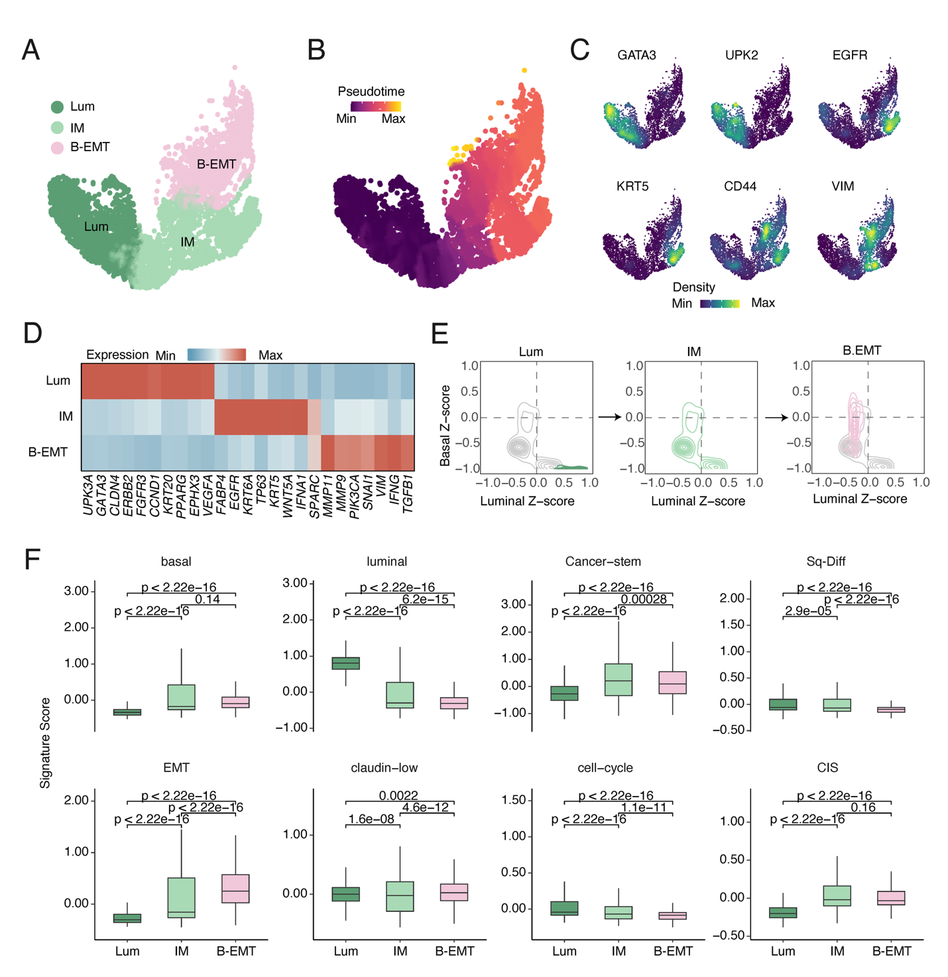
Figure S6 | Single-cell analysis recapitulates the spatial luminal-to-basal differentiation continuum. (a) UMAP embedding of tumor epithelial cells profiled by single-cell RNA-seq, colored by inferred tumor state (Luminal, Intermediate [IM], and Basal-EMT [B.EMT]). (b) Pseudotime inference reconstructs a continuous luminal-to-basal trajectory. (c) Expression of representative marker genes (GATA3, UPK2, EGFR, KRT5, CD44, VIM) projected onto the UMAP, illustrating gradual transcriptomic shifts along the differentiation axis. (d) Heatmap showing average expression of luminal, basal, EMT, and immune-related genes across the three tumor states. (e) Distribution of basal and luminal signature Z-scores across Luminal, IM, and B.EMT cells, illustrating progressive transcriptional transitions. (f) Boxplots comparing signature scores across tumor states for canonical programs including basal, luminal, cancer stemness, squamous differentiation, EMT, claudin-low, cell cycle, and CIS signatures.

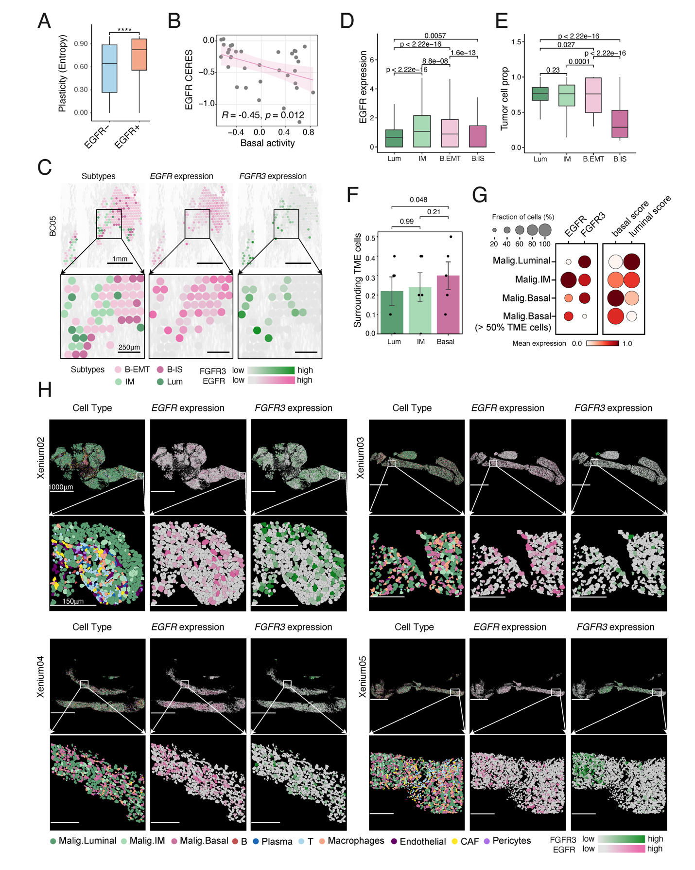
Figure S7 | Spatial validation of lineage-associated EGFR and FGFR3 expression patterns. (a) Comparison of transcriptional plasticity (Shannon entropy) between EGFR⁺ and EGFR⁻ tumor spots. (b) Correlation between EGFR dependency score from CCLE (CERES) and basal signature activity, showing that higher basal activity is associated with increased EGFR dependency. (c) Representative spatial maps show mutually exclusive expression of EGFR and FGFR3 across subtype-defined tumor regions. (d) Violin plots showing EGFR expression across tumor cell states (Luminal, IM, B.EMT, and B.IS). Statistical significance was assessed using two-sided Wilcoxon rank-sum tests. (e) Boxplots showing tumor cell proportions across different tumor states (Luminal, IM, B.EMT, and B.IS). (f) Fraction of surrounding tumor microenvironment (TME) cells for tumor cells across Luminal, IM, and Basal states. (g) Dot plot showing mean expression of EGFR and FGFR3 and signature activity and fraction of cells (dot size) across malignant subtypes. (h) Representative spatial maps from Xenium datasets (Xenium02–05) showing cell type annotation, EGFR expression, and FGFR3 expression, with zoom-in views highlighting local details.

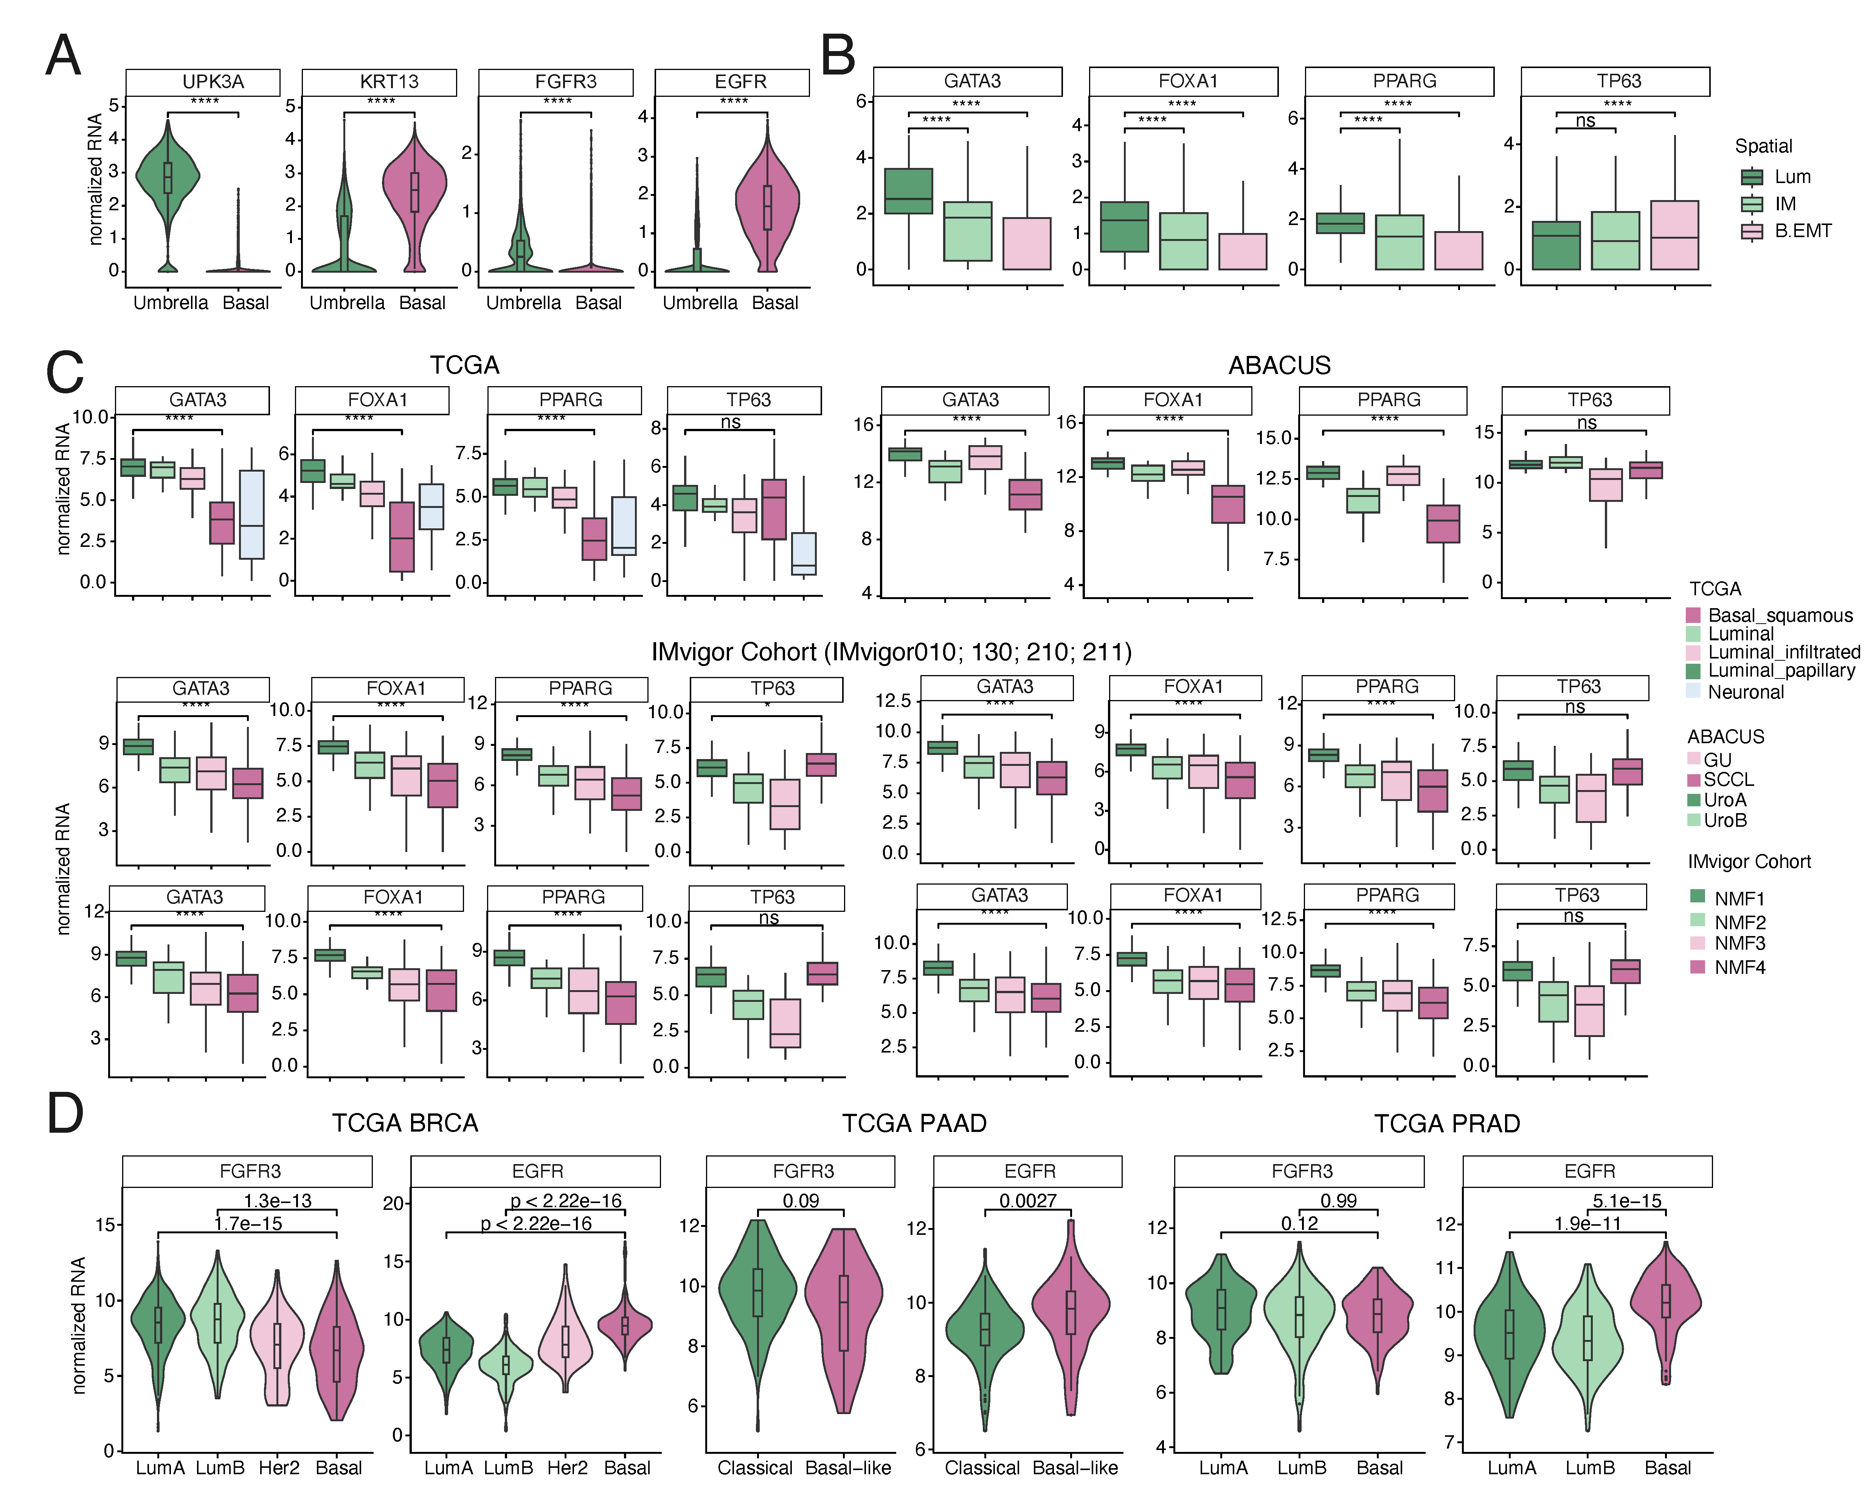
Figure S8 | Lineage-associated expression of FGFR3–EGFR signaling and transcriptional regulators across normal tissue, tumor states, and independent cohorts. (a) Expression of luminal and basal marker genes and receptor tyrosine kinases in normal urothelial compartments. Luminal markers (UPK3A) and FGFR3 are enriched in umbrella cells, whereas basal markers (KRT13) and EGFR are enriched in basal cells. (b) Expression of lineage-associated transcription factors across spatially defined tumor states. Luminal transcription factors (GATA3, FOXA1, PPARG) are enriched in luminal tumor regions, whereas TP63 shows higher expression in IM and basal/EMT states. (c) Validation of lineage-associated transcriptional programs across independent bulk cohorts (TCGA, ABACUS, and IMvigor). Luminal subtypes show higher expression of luminal transcription factors, whereas basal-like subtypes exhibit reduced luminal signatures and relative enrichment of basal-associated programs. (d) Cross-cancer comparison of FGFR3 and EGFR expression across tumor subtypes in TCGA BRCA, PAAD, and PRAD cohorts. EGFR expression is consistently higher in basal-like subtypes across cancer types, whereas FGFR3 expression shows tumor-type–specific patterns.

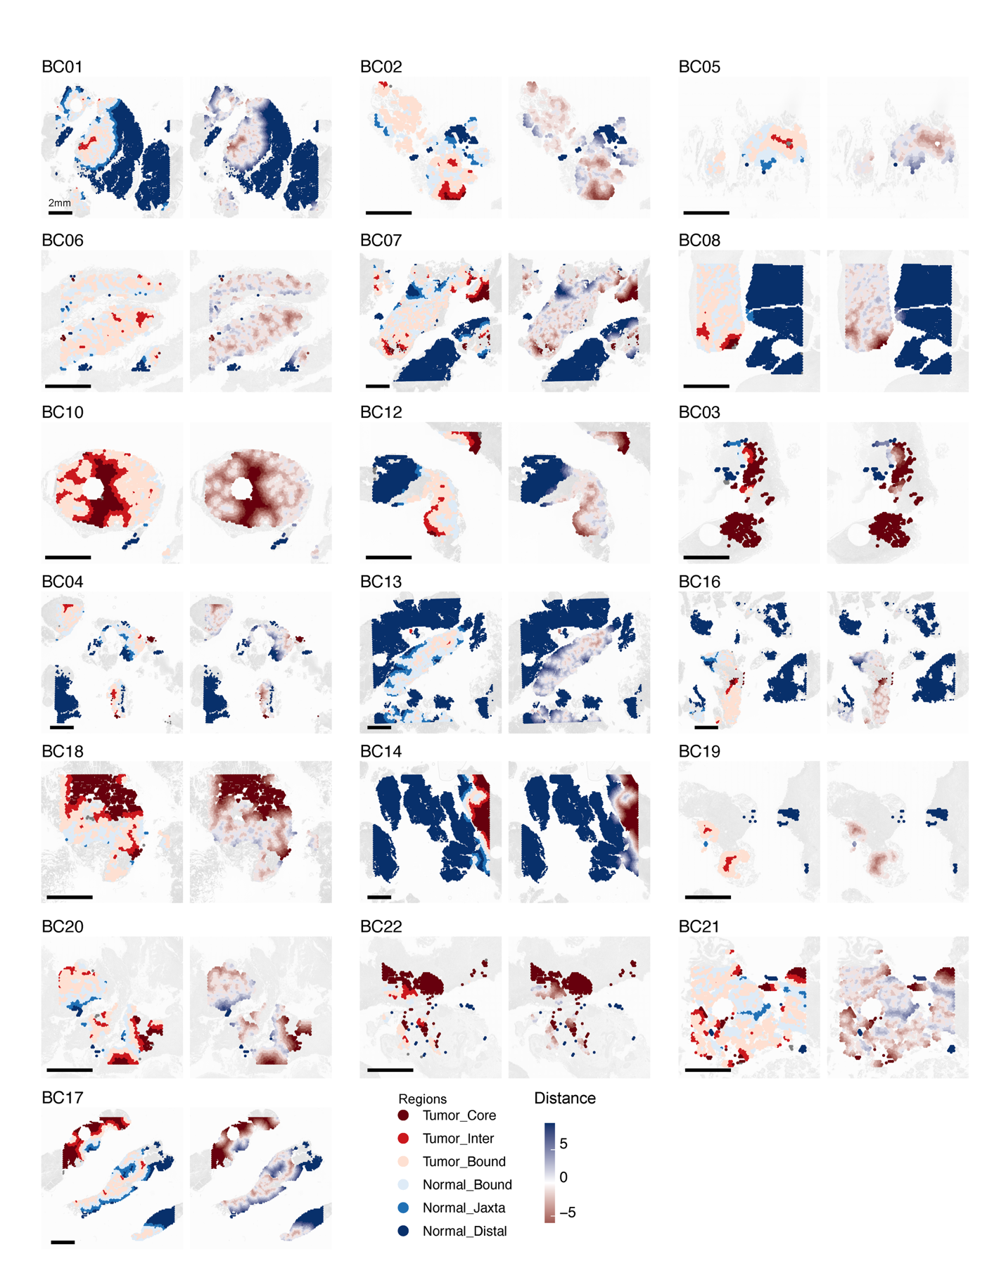
Figure S9 | Pathology-guided spatial annotation across all MIBC tumors. (left) Annotated spatial maps showing tumor-normal compartments and zonal segmentation based on relative distance to tumor-normal boundary. (right) Corresponding H&E images for all 22 MIBC samples profiled by spatial transcriptomics.

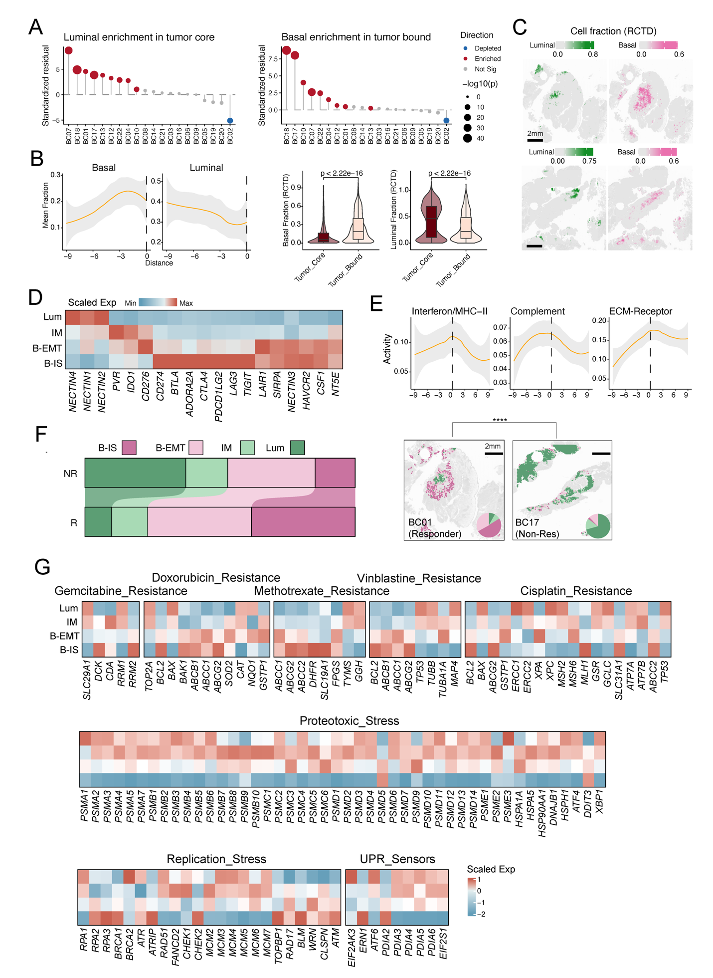
Figure S10 | Spatial tumor states associate with chemotherapy response and stress-related gene expression. (a) Cohort-level assessment of lineage enrichment across spatial regions. Left, enrichment of luminal-like programs in tumor core regions across individual samples. Right, enrichment of basal-like programs at tumor boundaries (invasive margins). Each point represents one tumor sample, with enrichment values calculated as standardized residuals relative to expected distributions. Red points indicate enrichment, whereas blue points indicate depletion. Point size reflects statistical significance (−log10(P value)). Samples are ordered by enrichment magnitude. (b) Changes in deconvoluted tumor cell fractions along the spatial axis from tumor core to boundary. Top panels show smoothed trends of mean basal and luminal tumor cell fractions as a function of distance. Bottom panels show comparisons between tumor core and boundary regions, indicating increased basal fractions and decreased luminal fractions toward the boundary. (c) Representative spatial maps of deconvoluted tumor cell fractions using RCTD. Luminal tumor cells are predominantly localized in tumor cores, whereas basal/EMT tumor cells are enriched toward peripheral and invasive regions. (d) Heatmap of selected immunoregulatory gene expression across spatial tumor states. (e) Pathway activity scores for hypoxia, interferon/MHC-II signaling, and ECM–receptor interaction along the tumor-normal boundary. (f) (left) Proportion of tumor subtypes (Luminal, IM, B.EMT, B.IS) stratified by neoadjuvant chemotherapy response (Responder [R] vs Non-responder [NR]). (right) Spatial subtype distribution and proportion pie charts in a representative responder tumor (BC01) and non-responder tumor (BC17). (g) Heatmaps showing scaled expression of gene signatures associated with chemotherapy resistance (gemcitabine, doxorubicin, methotrexate, vinblastine, and cisplatin), proteotoxic stress, replication stress, and unfolded protein response (UPR) sensors across spatial tumor subtypes.

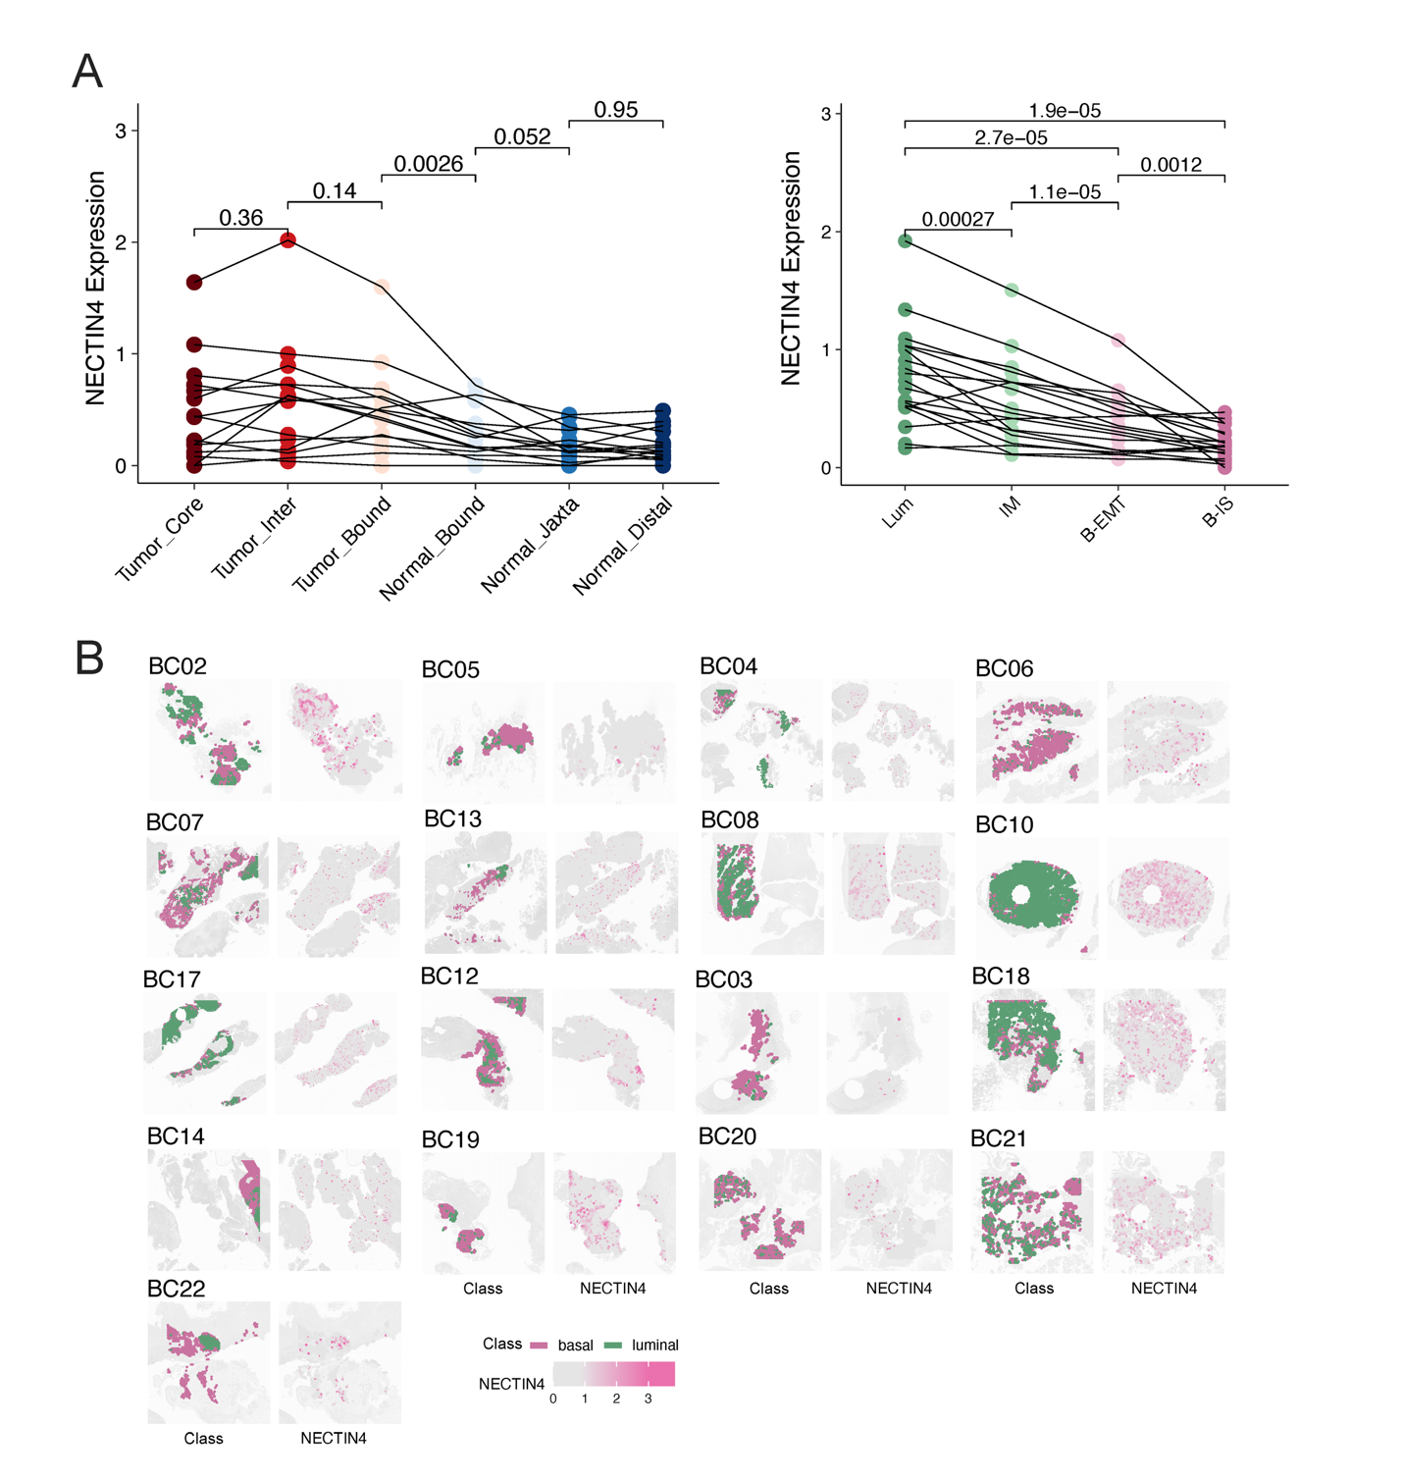
Figure S11 | NECTIN4 expression is enriched in luminal tumors and declines at the tumor-normal boundary. (a) (left) NECTIN4 expression across tumor and normal spatial regions (Tumor_Core, Tumor_Intermediate, Tumor_Boundary, Normal_Boundary, Normal_Juxta, Normal_Distal). (right) NECTIN4 expression across spatial tumor subtypes (Luminal, IM, B.EMT, B.IS). (b) Representative spatial expression maps of NECTIN4 across all 22 MIBC tumors. Each row displays spatial annotations (Regions, Class, NECTIN4 expression) for an individual sample.

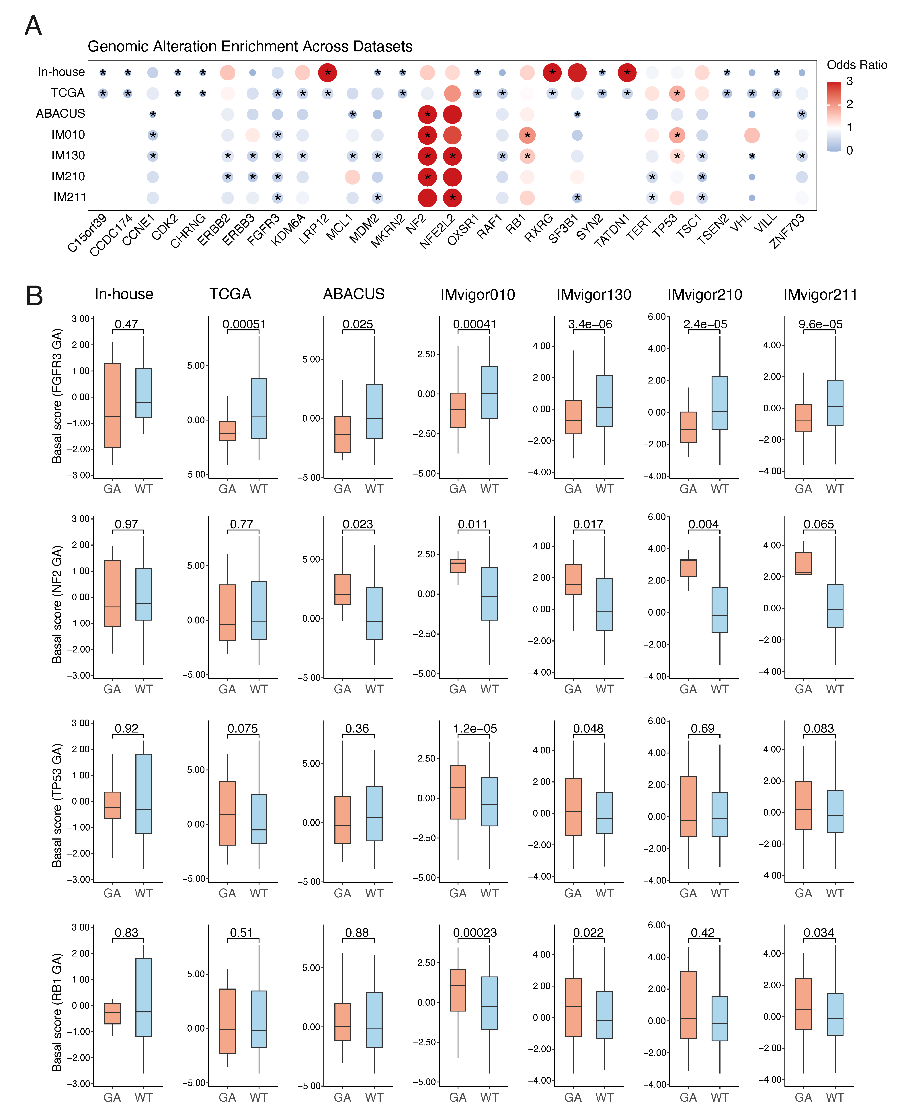
Figure S12 | Subtype-associated genomic alterations and their relationship with basal program activity. (a) Dot plot showing enrichment of selected genomic alterations across basal versus luminal subtypes in seven MIBC cohorts (in-house, TCGA, ABACUS, IMvigor010, 130, 210, 211). Dot size and color indicate odds ratio of association; asterisks denote statistically significant associations (Fisher's exact test, p < 0.05). (b) Boxplots comparing basal signature scores between genomically altered (GA) and wild-type (WT) tumors for FGFR3, NF2, TP53, and RB1 in each cohort. P-values from Wilcoxon rank-sum tests are indicated above each plot.

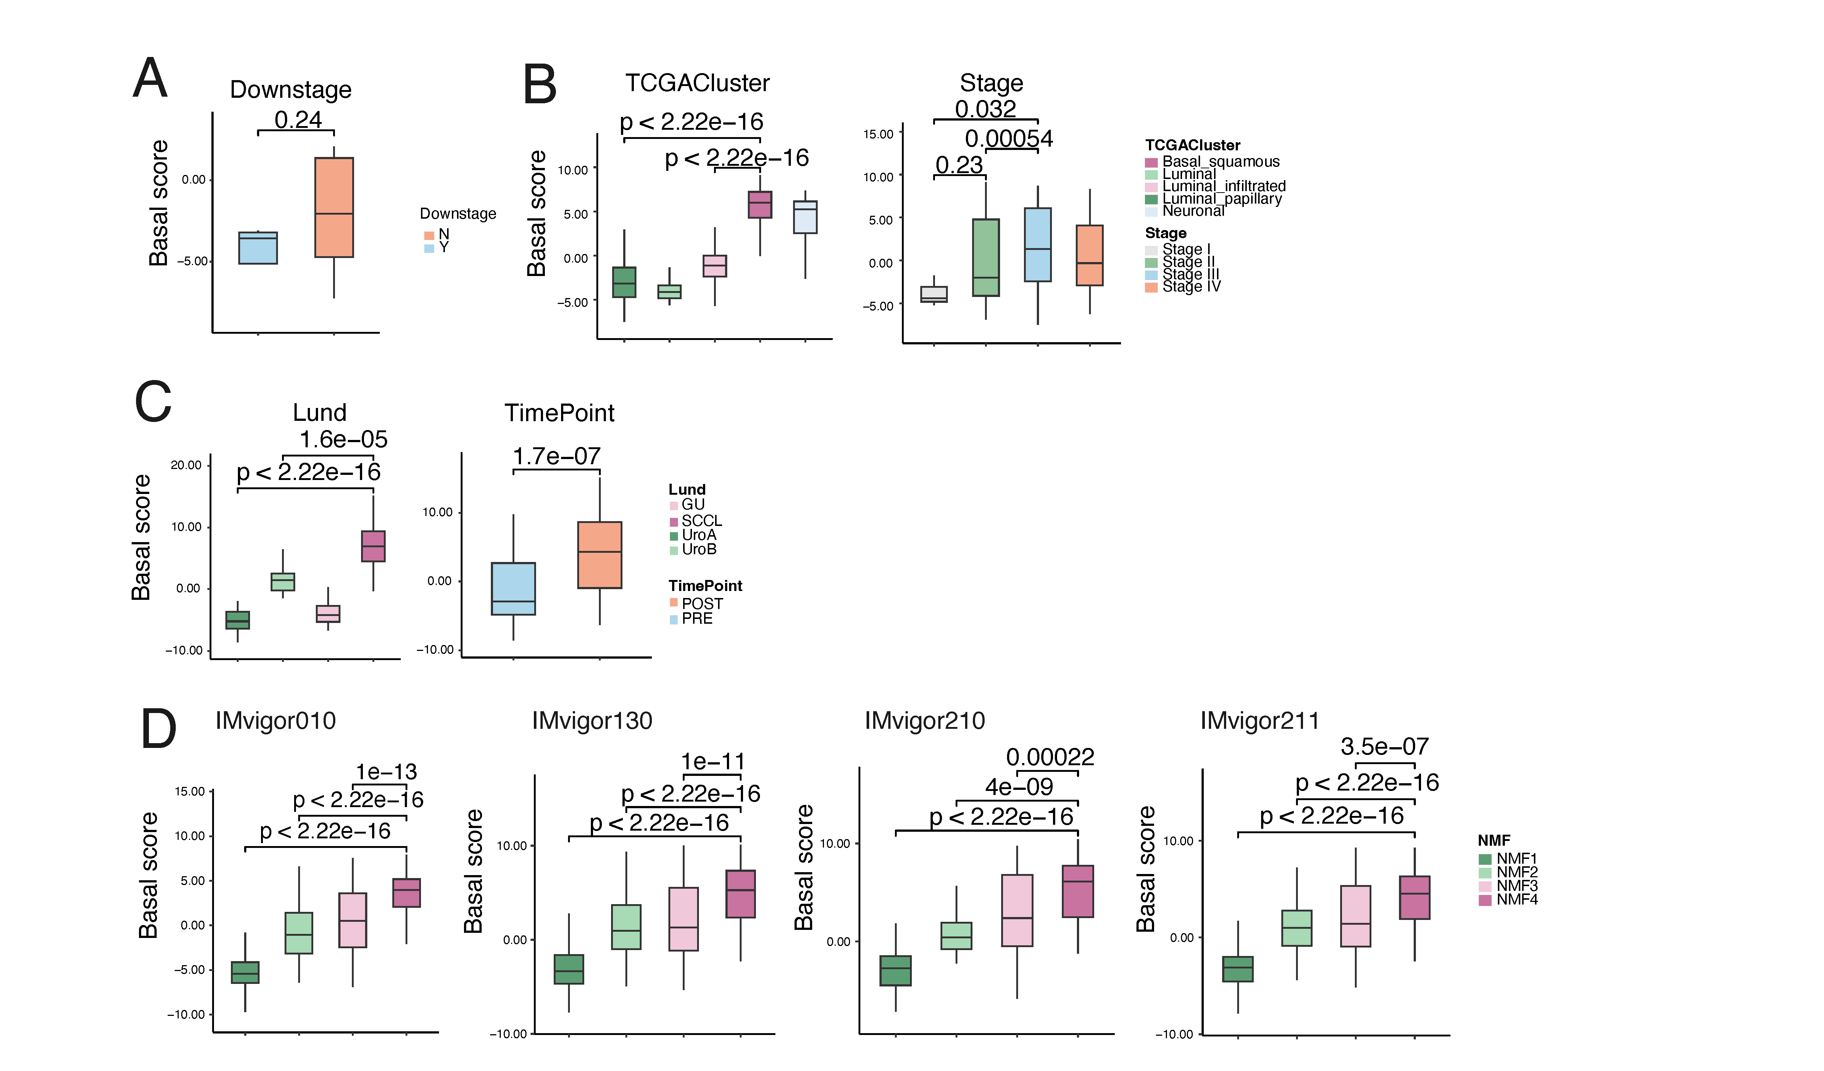
Figure S13 | Associations between basal signature scores and clinical or molecular features across MIBC cohorts. (A) Basal signature scores comparing tumors with and without downstaging. (B) Basal signature scores across TCGA molecular subtypes (left) and pathological stages (right). (C) Basal signature scores across Lund molecular subtypes in the ABACUS cohort (left) and between pre- and post-treatment samples (right). (D) Basal signature scores across NMF-defined subtypes in independent immunotherapy cohorts, including IMvigor010, IMvigor130, IMvigor210, and IMvigor211.

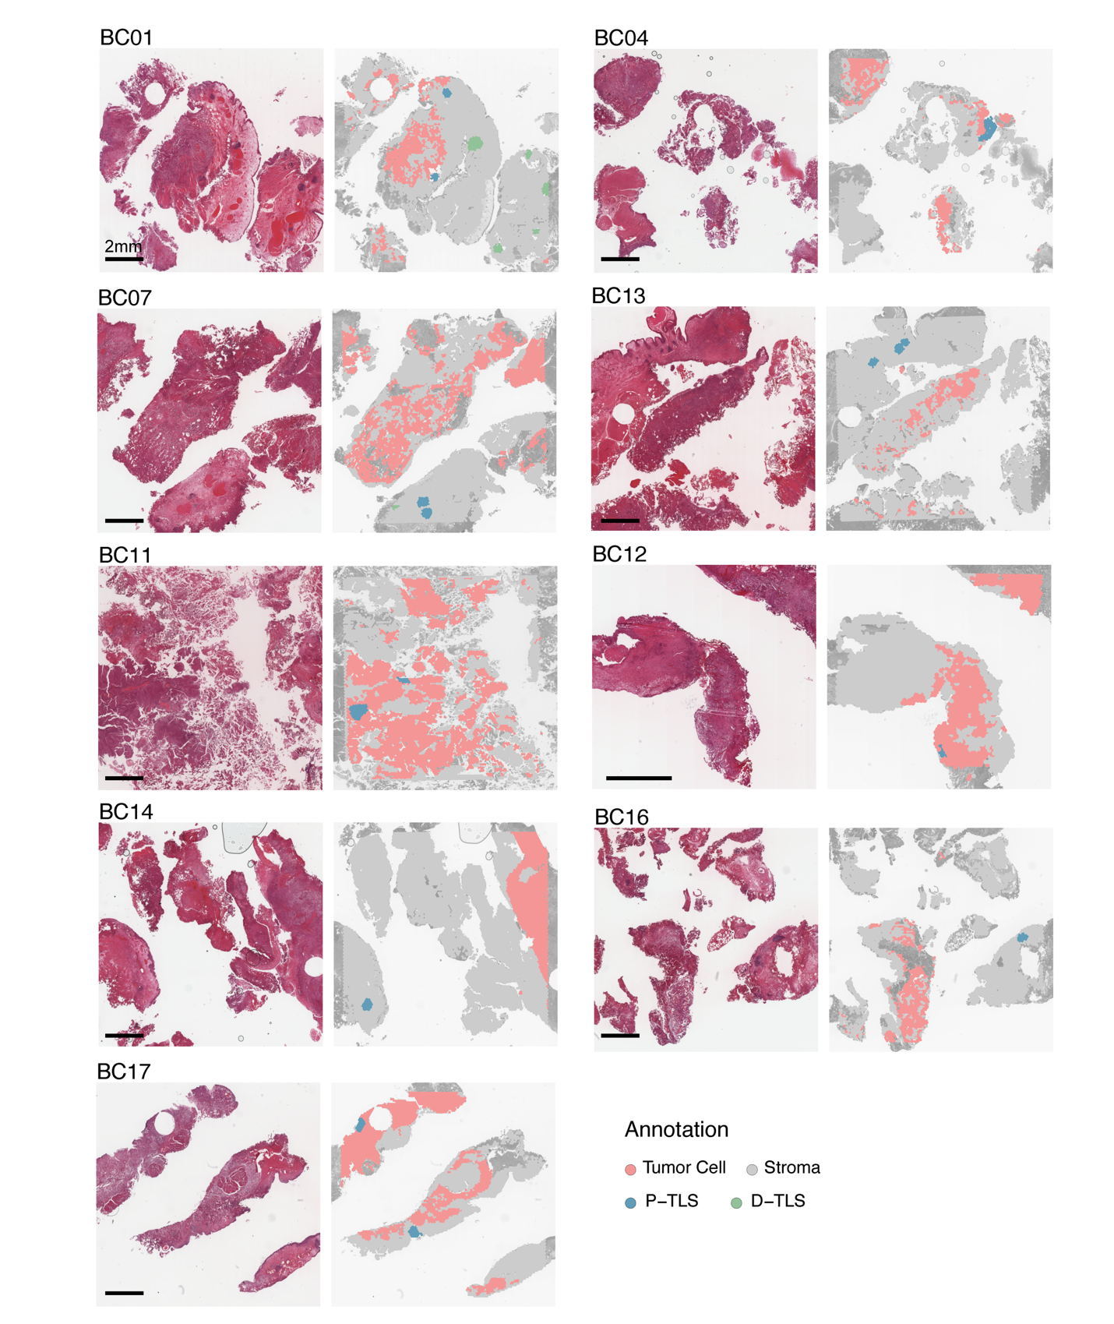
Figure S14 | Pathologist-guided TLS annotation confirms spatial transcriptomic predictions. Representative H&E images (left) and matched pathologist annotation overlays (right) for 10 tumor samples. Tumor cells (red), stroma (gray), and iSTAR-predicted TLS regions (blue and green) are shown for visual confirmation of TLS localization relative to tumor boundaries.

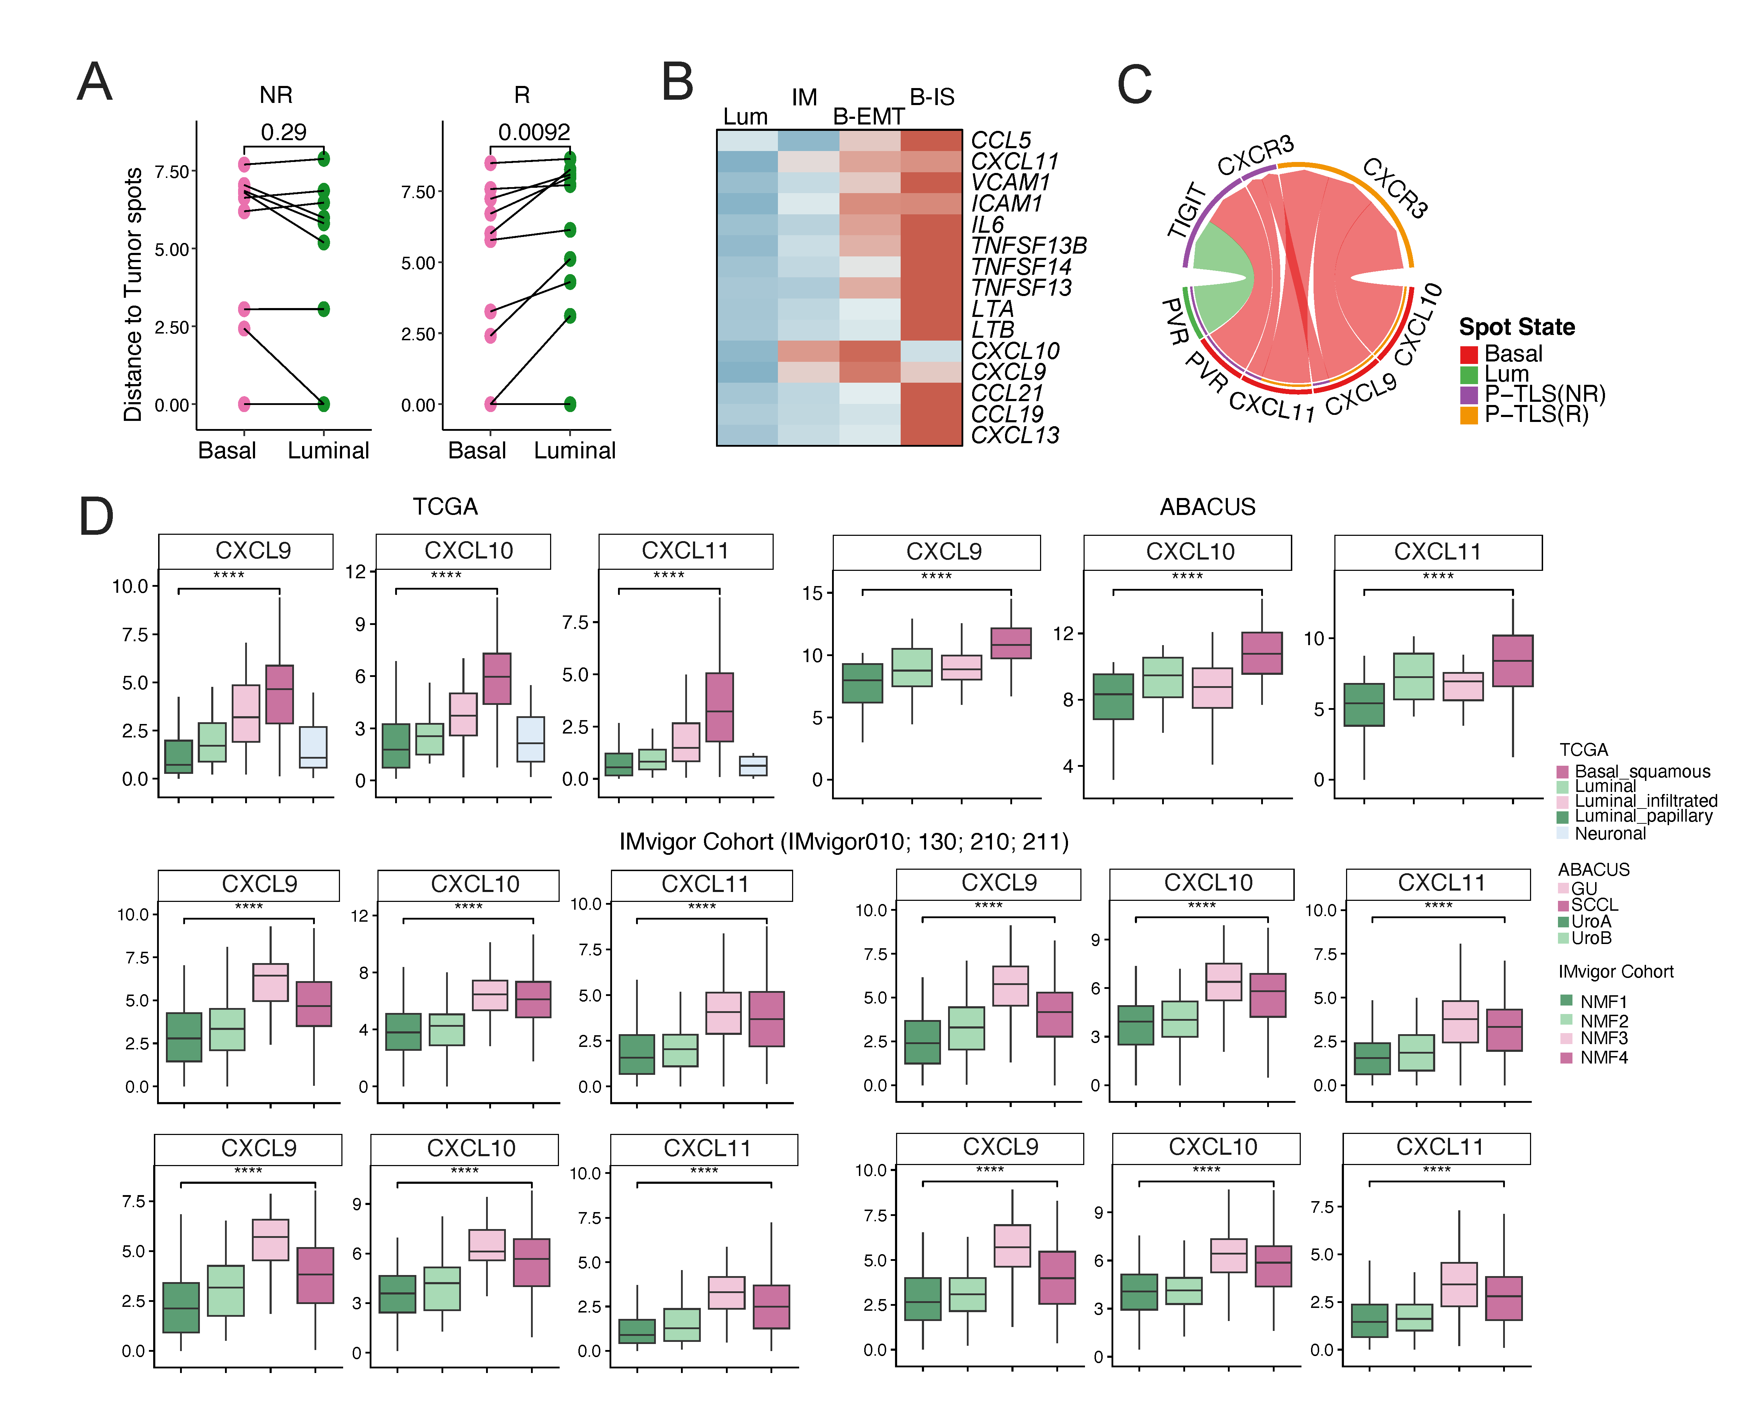
Figure S15 | Lineage-associated chemokine programs and tumor–TLS interactions. (a) Quantification of TLS distance to basal or luminal tumor regions in responders and non-responders. (b) Heatmap showing the expression of selected TLS-associated chemokines and immune-related genes across tumor states (Luminal, IM, B.EMT, and B.IS). (c) Chord diagram illustrating major ligand–receptor interactions between tumor states and TLS-associated compartments, highlighting CXCL–CXCR3, and PVR-related signaling pathways. (d) Boxplots showing the expression of CXCL9, CXCL10, and CXCL11 across molecular subtypes in TCGA, ABACUS, and IMvigor cohorts.

