Образец оформления отчёта по Лабораторной работе.

|  |  |
| --- | --- |
| **К Г Э У** | МИНИСТЕРСТВО ВЫСШЕГО ОБРАЗОВАНИЯ И НАУКИ РОССИЙСКОЙ ФЕДЕРАЦИИ  **Федеральное государственное бюджетное образовательное учреждение**  **высшего образования**  **«КАЗАНСКИЙ ГОСУДАРСТВЕННЫЙ ЭНЕРГЕТИЧЕСКИЙ УНИВЕРСИТЕТ»**  (ФГБОУ ВО «КГЭУ») |

**Кафедра Информатики и информационных управляющих систем**

**ОТЧЁТ ПО ЛАБОРАТОРНОЙ РАБОТЕ №3**

**ПОСТРОЕНИЕ ПРОГРАММ С АЛГОРИТМАМИ ВЕТВЛЕНИЯ**

|  |  |
| --- | --- |
| **Исполнитель:** | Соловьёв Леонид |
| **Группа:** | ПИ-1-22 |
|  |  |
|  |  |

Казань – 2022  
1.1  
  
Код  
#include<iostream>

#include <cmath>

int main()

{

float N, x, sum = 0, U;

std::cout << "Input N: "; std::cin >> N;

std::cout << "Input x: "; std::cin >> x;

U = x * x;

for (int i = 1; i <= N; i++) {

U = ((U / x) + (1. / pow(x, i)));

std::cout << "x" << i << " = " << U << '\n';

sum += U;

}

std::cout << "Sum = " << sum;

return 0;

}  
Решение

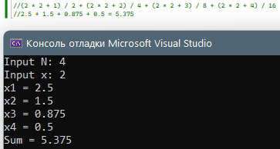

1.2  
  
Код  
#include<iostream>

#include <cmath>

int main()

{

float N, x, sum = 0, U, base, k;

std::cout << "Input N: "; std::cin >> N;

std::cout << "Input x: "; std::cin >> x;

U = log(3 * x + 1) * pow(x, 3) / 1;

for (int i = 1; i <= N; i++) {

sum += U;

std::cout << "x" << i << " = " << U << '\n';

k = log(3 * x + i + 1) / log(3 * x + i);

U *= (k * pow(x, 3) / (i + 1));

}

std::cout << "Sum = " << sum;

return 0;

}  
Решение  
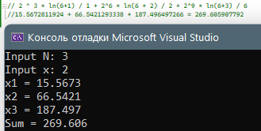

1.3  
  
Код  
#include<iostream>

#include <cmath>

int main()

{

float N, x, sum = 0, U;

std::cout << "Input N: "; std::cin >> N;

std::cout << "Input x: "; std::cin >> x;

U = 1. / x;

for (int i = 1, k = 3; i <= N; i++, k += 2) {

U *= (x * x) / (2 * i - 1) / (2 * i);

sum += U;

std::cout << "x" << i << " = " << U << '\n';

}

std::cout << "Sum = " << sum;

return 0;

}  
Решение  
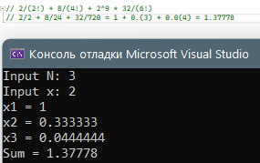\

1.4  
  
Код  
#include<iostream>

#include <cmath>

int main()

{

float N, x, sum = 0, U;

std::cout << "Input N: "; std::cin >> N;

std::cout << "Input x: "; std::cin >> x;

U = x * x;

for (int i = 1, k = 1; i <= N; i++) {

k += 2;

U = ((U * (k - 2)) + (pow(i, 3) - pow((i - 1), 3))) / k;

sum += U;

std::cout << "x" << i << " = " << U << '\n';

}

std::cout << "Sum = " << sum;

return 0;

}  
Решение  
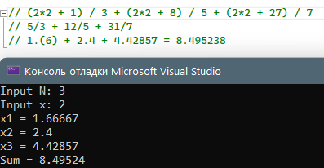  
  
  
  
  
  
  
  
  
  
  
  
  
  
  
  
  
  
  
1.5  
  
Код  
#include<iostream>

#include <cmath>

int main()

{

float N, x, sum = 0, U, k;

std::cout << "Input N: "; std::cin >> N;

std::cout << "Input x: "; std::cin >> x;

U = x / sin(x);

for (int i = 1; i <= N;) {

sum += U;

std::cout << "x" << i << " = " << U << '\n';

i++;

k = sin((i - 1) * pow(x, (i - 1))) / sin(i * pow(x, i));

U *= x * k;

}

std::cout << "Sum = " << sum;

return 0;

}  
Решение  
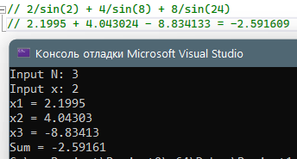

1.6  
  
Код  
#include<iostream>

#include <cmath>

int main()

{

float N, x, sum = 0, U, y;

std::cout << "Input N: "; std::cin >> N;

std::cout << "Input x: "; std::cin >> x;

U = -cos(x)/pow(3, 3);

for (int i = 1; i <= N;) {

sum += U;

std::cout << "x" << i << " = " << U << '\n';

i++;

y = cos(i * x) / cos((I - 1) * x);

U *= -1 * y * pow(3 * (I - 1), 3) / pow(3 * i, 3);

}

std::cout << "Sum = " << sum;

return 0;

}  
Решение  
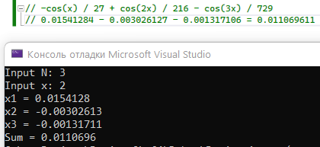

1.7  
  
Код  
#include<iostream>

#include <cmath>

int main()

{

float N, x, sum = 0, U;

std::cout << "Input N: "; std::cin >> N;

std::cout << "Input x: "; std::cin >> x;

U = 1;

int const x3 = pow(x, 3);

for (int i = 1; i <= N; i++) {

U *= 3 * cos(i * x3);

sum += U;

std::cout << "x" << i << " = " << U << '\n';

U /= cos(i * x3);

}

std::cout << "Sum = " << sum;

return 0;

}  
Решение  
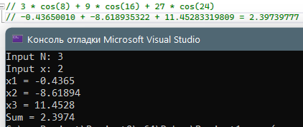

1.8  
  
Код  
#include<iostream>

#include <cmath>

int main()

{

float N, x, sum = 0, U;

std::cout << "Input N: "; std::cin >> N;

std::cout << "Input x: "; std::cin >> x;

U = 1;

int const x3 = pow(x, 3);

for (int i = 1; i <= N; i++) {

U *= pow(cos(i * x), i) / pow(cos((i - 1) * x), i - 1) / i;

sum += U;

std::cout << "x" << i << " = " << U << '\n';

}

std::cout << "Sum = " << sum;

return 0;

}  
Решение  
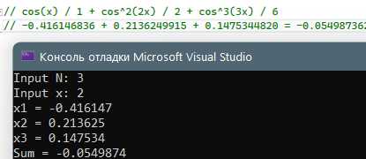  
  
  
  
  
  
  
  
  
  
  
  
  
  
  
  
  
  
  
  
  
1.9  
  
Код  
#include<iostream>

#include <cmath>

int main()

{

float N, x, sum = 0, U;

std::cout << "Input N: "; std::cin >> N;

std::cout << "Input x: "; std::cin >> x;

int const x3 = pow(x, 3);

for (int i = 1; i <= N; i++) {

U = (log(i) - pow(x, 2 * i - 1)) / (4 * i + pow(x, i + 2));

sum += U;

std::cout << "x" << i << " = " << U << '\n';

}

std::cout << "Sum = " << sum;

return 0;

}  
Решение  
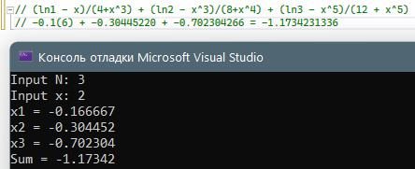  
  
  
  
  
  
  
  
  
  
  
  
  
  
  
  
  
  
  
  
  
1.10  
  
Код  
#include<iostream>

#include <cmath>

int main()

{

double N, x, sum = 0, U;

std::cout << "Input N: "; std::cin >> N;

std::cout << "Input x: "; std::cin >> x;

for (int i = 1; i <= N; i++) {

int fact = 1;

for (int k = 1; k <= i; k++) {

fact *= k;

}

U = (3 * pow(x, 3 * i) - tan(i)) / (2 * fact + pow(i, 2));

sum += U;

std::cout << "x" << i << " = " << U << '\n';

}

std::cout << "Sum = " << sum;

return 0;

}  
Решение  
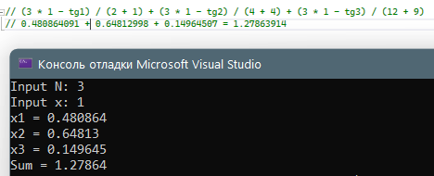  
  
  
  
  
  
  
  
  
  
  
  
  
  
  
  
  
  
  
1.11  
  
Код  
#include<iostream>

#include <cmath>

int main()

{

double N, x, sum = 0, U;

std::cout << "Input N: "; std::cin >> N;

std::cout << "Input x: "; std::cin >> x;

U = -1;

for (int i = 1; i <= N; i++) {

U *= -1 / cos((i - 1) * x) * cos(i * x) / (2 * i) / (2 * i - 1);

sum += U;

std::cout << "x" << i << " = " << U << '\n';

}

std::cout << "Sum = " << sum;

return 0;

}  
Решение  
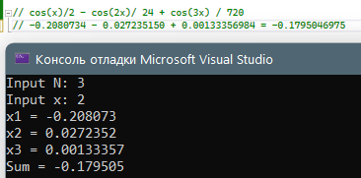

1.12  
  
Код  
#include<iostream>

#include <cmath>

int main()

{

double N, x, sum = 0, U;

std::cout << "Input N: "; std::cin >> N;

std::cout << "Input x: "; std::cin >> x;

U = x;

for (int i = 1; i <= N;) {

sum += U;

std::cout << "x" << i << " = " << U << '\n';

i++;

U *= x*x/i;

}

std::cout << "Sum = " << sum;

return 0;

}  
Решение  
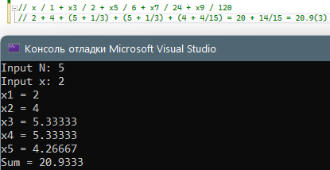

2.1  
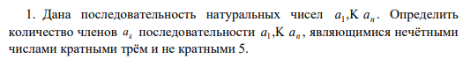  
Код  
#include <iostream>

#include <cmath>

int main()

{

int n, count = 0;

std::cout << "Input n(n<=30): "; std::cin >> n;

while (n > 30 || n < 0) {

std::cout << "Invalid array size\n";

std::cout << "Input n(n<=30): "; std::cin >> n;

}

int mass[30];

for (int i = 1; i <= n; i++) {

std::cout << "Input a" << i << ": "; std::cin >> mass[i - 1];

}

for (int i = 1; i <= n; i++) {

std::cout << "a" << i << ": " << mass[i - 1] << "\t\t";

}

std::cout << '\n';

for (int i = 1; i <= n; i++) {

if (mass[i - 1] % 2) {

if (mass[i - 1] % 3 == 0 && mass[i - 1] % 5 != 0) {

std::cout << "a" << i << ": true\t";

count += 1;

} else

std::cout << "a" << i << ": false\t";

} else

std::cout << "a" << i << ": false\t";

}

std::cout << "\nCount = " << count;

return 0;

}  
Решение  
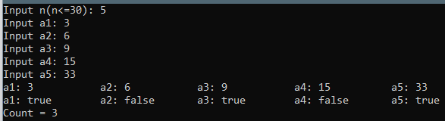  
  
  
  
  
  
  
  
  
  
  
2.2  
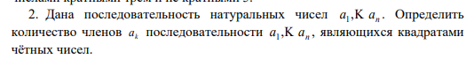  
Код  
#include <iostream>

#include <cmath>

int main()

{

int n, count = 0;

std::cout << "Input n(n<=30): "; std::cin >> n;

while (n > 30 || n < 0) {

std::cout << "Invalid array size\n";

std::cout << "Input n(n<=30): "; std::cin >> n;

}

int mass[30];

for (int i = 1; i <= n; i++) {

std::cout << "Input a" << i << ": "; std::cin >> mass[i - 1];

}

for (int i = 1; i <= n; i++) {

std::cout << "a" << i << ": " << mass[i - 1] << "\t\t";

}

std::cout << '\n';

for (int i = 1; i <= n; i++) {

if (mass[i - 1] % 2 == 0) {

if (pow((int)sqrt(mass[i - 1]), 2) == mass[i - 1]) {

std::cout << "a" << i << ": true\t";

count += 1;

}

else

std::cout << "a" << i << ": false\t";

}

else

std::cout << "a" << i << ": false\t";

}

std::cout << "\nCount = " << count;

return 0;

}

Решение  
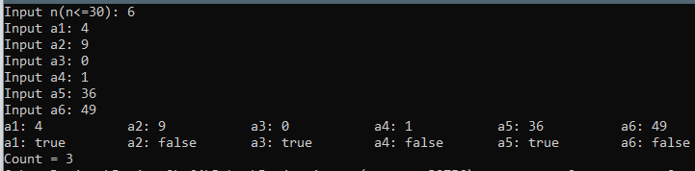  
  
  
  
  
  
  
  
  
  
2.3  
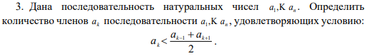  
Код  
#include <iostream>

#include <cmath>

int main()

{

int n, count = 0;

std::cout << "Input n(n<=30): "; std::cin >> n;

while (n > 30 || n < 0) {

std::cout << "Invalid array size\n";

std::cout << "Input n(n<=30): "; std::cin >> n;

}

int mass[30];

for (int i = 1; i <= n; i++) {

std::cout << "Input a" << i << ": "; std::cin >> mass[i - 1];

}

for (int i = 1; i <= n; i++) {

std::cout << "a" << i << ": " << mass[i - 1] << "\t\t";

}

std::cout << '\n';

for (int i = 0; i <= (n - 1); i++) {

if (i == 0 || i == (n - 1)) {

std::cout << "a" << i + 1 << ": false\t";

} else {

if (mass[i] < ((float)(mass[i - 1] + mass[i + 1]) / 2)) {

std::cout << "a" << i + 1 << ": true\t";

count += 1;

} else

std::cout << "a" << i + 1 << ": false\t";

}

}

std::cout << "\nCount = " << count;

return 0;

}  
Решение  
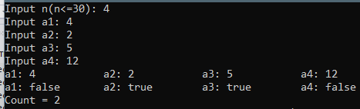  
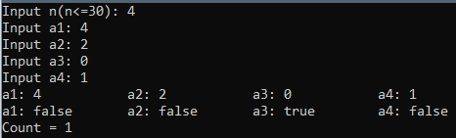

2.4  
  
Код  
#include <iostream>

#include <cmath>

int main()

{

int n, count = 0, left = 1, right = 1;

std::cout << "Input n(n<=30): "; std::cin >> n;

while (n > 30 || n < 0) {

std::cout << "Invalid array size\n";

std::cout << "Input n(n<=30): "; std::cin >> n;

}

int mass[30];

for (int i = 1; i <= n; i++) {

std::cout << "Input a" << i << ": "; std::cin >> mass[i - 1];

}

for (int i = 1; i <= n; i++) {

std::cout << "a" << i << ": " << mass[i - 1] << "\t\t";

}

std::cout << '\n';

for (int i = 1; i <= n; i++) {

left *= 2;

right *= i;

if (i < 4) {

std::cout << "a" << i << ": false" << '(' << left << ">" << right << ")\t";

continue;

}

if (left < mass[i - 1] && mass[i - 1] < right) {

std::cout << "a" << i << ": true" << '(' << left << ',' << right << ")\t";

count += 1;

} else {

std::cout << "a" << i << ": false" << '(' << left << ',' << right << ")\t";

}

}

std::cout << "\nCount = " << count;

return 0;

}  
Решение  
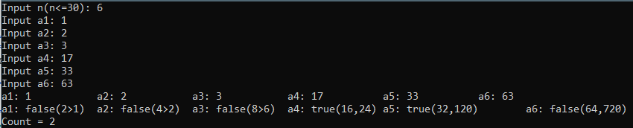  
  
  
  
  
  
  
  
2.5  
  
Код  
#include <iostream>

#include <cmath>

int main()

{

int n, count = 0;

std::cout << "Input n(n<=30): "; std::cin >> n;

while (n > 30 || n < 0) {

std::cout << "Invalid array size\n";

std::cout << "Input n(n<=30): "; std::cin >> n;

}

int mass[30];

for (int i = 1; i <= n; i++) {

std::cout << "Input a" << i << ": "; std::cin >> mass[i - 1];

}

for (int i = 1; i <= n; i++) {

std::cout << "a" << i << ": " << mass[i - 1] << "\t\t";

}

std::cout << '\n';

for (int i = 1; i <= n; i++) {

std::cout << "a" << i << ":";

if (i % 2 == 0 && mass[i-1] % 2 == 0) {

std::cout << "true \t";

count += 1;

} else {

std::cout << "false \t";

}

}

std::cout << "\nCount = " << count;

return 0;

}  
Решение  
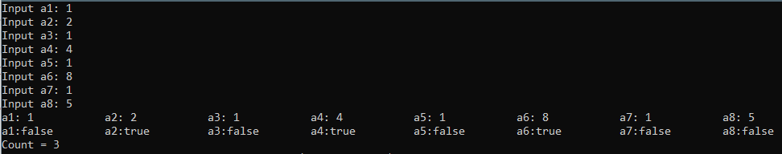  
  
  
  
  
  
  
  
  
  
  
  
  
  
2.6  
  
Код  
#include <iostream>

#include <cmath>

int main()

{

int n, count = 0, left = 1, right = 1, mul = 1;

std::cout << "Input n(n<=30): "; std::cin >> n;

while (n > 30 || n < 0) {

std::cout << "Invalid array size\n";

std::cout << "Input n(n<=30): "; std::cin >> n;

}

int mass[30];

for (int i = 1; i <= n; i++) {

std::cout << "Input a" << i << ": "; std::cin >> mass[i - 1];

}

for (int i = 1; i <= n; i++) {

std::cout << "a" << i << ": " << mass[i - 1] << "\t\t";

}

std::cout << '\n';

for (int i = 1; i <= n; i++) {

left += 1;

right *= i;

if (i < 3) {

std::cout << "a" << i << ": false" << '(' << left << ">" << right << ")\t";

continue;

}

if (left < mass[i - 1] && mass[i - 1] < right) {

std::cout << "a" << i << ": true" << '(' << left << ',' << right << ")\t";

count += 1;

mul *= mass[i - 1];

}

else {

std::cout << "a" << i << ": false" << '(' << left << ',' << right << ")\t";

}

}

std::cout << "\n1/mul = " << 1. / mul;

return 0;

}  
Решение  
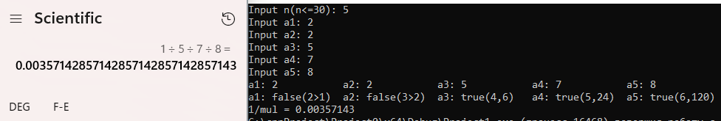

2.7  
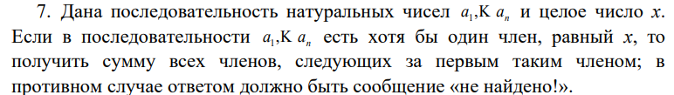

Код  
#include <iostream>

#include <locale.h>

int main() {

setlocale(LC_ALL, "Russian");

int n = 0, x, sum = 0;

std::cout << "Input n(n<=10): "; std::cin >> n;

while (n > 10 || n < 0) {

std::cout << "Invalid array size\n";

std::cout << "Input n(n<=10): "; std::cin >> n;

}

int mass[10];

std::cout << "Input x: "; std::cin >> x;

int i = 1;

m0: {

for (; i <= n; i++) {

std::cout << 'a' << i << ": "; std::cin >> mass[i - 1];

if (mass[i - 1] == x) {

goto m1;

}

sum += mass[i - 1];

if (i == n) {

goto m2;

}

}

}

m1: {

for (i += 1; i <= n; i++) {

std::cout << 'a' << i << ": "; std::cin >> mass[i];

sum += mass[i];

}

std::cout << "Сумма элементов равна " << sum;

return 0;

}

m2: {

std::cout << "не найдено!";

return 0;

}

}

Решение  
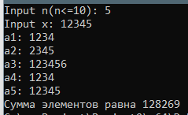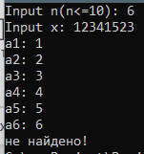  
  
  
  
  
  
2.8  
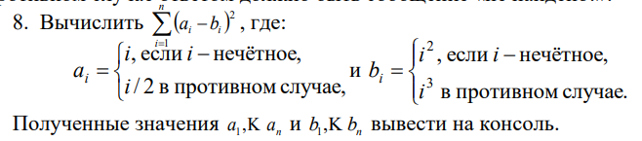  
Код  
#include <iostream>

#include <locale.h>

#include <cmath>

int main() {

setlocale(LC_ALL, "Russian");

int n = 0, sum = 0;

std::cout << "Input n(n<=10): "; std::cin >> n;

while (n > 10 || n < 0) {

std::cout << "Invalid array size\n";

std::cout << "Input n(n<=10): "; std::cin >> n;

}

int mass[10];

for (int i = 0; i < n; i++) {

if (i % 2 == 0) {

sum += pow((i / 2.) - (i * i * i), 2);

std::cout << 'a' << i << ": " << i / 2. << "\tb" << i << ": " << i * i * i << std::endl;

} else {

sum += pow(i - (i * i), 2);

std::cout << 'a' << i << ": " << i << "\tb" << i << ": " << i * i << std::endl;

}

}

std::cout << "Result = " << sum;

return 0;

}  
Решение  
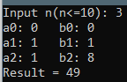  
  
  
  
  
  
  
  
  
  
  
  
  
  
2.9  
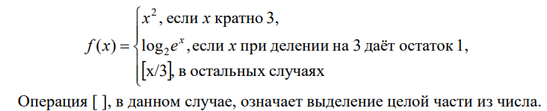  
Код  
#include <iostream>

#include <locale.h>

#include <cmath>

int main() {

setlocale(LC_ALL, "Russian");

int n = 0; float sum = 0;

std::cout << "Input n(n<=10): "; std::cin >> n;

while (n > 10 || n < 0) {

std::cout << "Invalid array size\n";

std::cout << "Input n(n<=10): "; std::cin >> n;

}

int mass[10];

for (int i = 0; i < n; i++) {

std::cout << 'a' << i + 1 << ": "; std::cin >> mass[i];

if (mass[i] % 3 == 0) {

sum += pow(mass[i], 2);

std::cout << pow(mass[i], 2) << '\n';

continue;

} if (mass[i] % 3 == 1) {

sum += mass[i] / log(2);

std::cout << mass[i] / log(2) << '\n';

continue;

} else {

sum += (int)(mass[i] / 3.);

std::cout << (int)(mass[i] / 3.) << '\n';

continue;

}

}

std::cout << "Result = " << sum;

return 0;

}  
Решение  
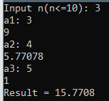

2.10  
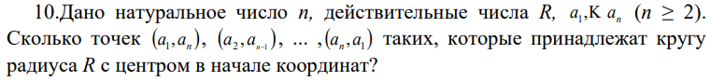

Код  
#include <iostream>

#include <locale.h>

#include <cmath>

int main() {

setlocale(LC_ALL, "Russian");

int n = 0, count = 0; float R = 0;

std::cout << "Input n(2<=n<=10): "; std::cin >> n;

while (n > 10 || n < 2) {

std::cout << "Invalid array size\n";

std::cout << "Input n(2<=n<=10): "; std::cin >> n;

}

int mass[10];

std::cout << "Input R: "; std::cin >> R;

for (int i = 0; i < n; i++) {

std::cout << 'a' << i + 1 << ": "; std::cin >> mass[i];

}

for (int i = 1; i <= n; i++) {

if ((pow(mass[i - 1], 2) + pow(mass[n - i], 2)) == R * R) {

std::cout << "(a" << i << ", a" << n - i + 1 << ") лежит на окружности\n";

count += 1;

}

else {

std::cout << "(a" << i << ", a" << n - i + 1 << ") не лежит на окружности\n";

}

}

std::cout << "count = " << count;

return 0;

}  
Решение  
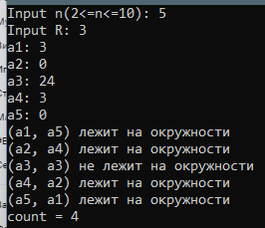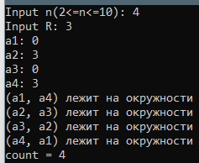

2.11  
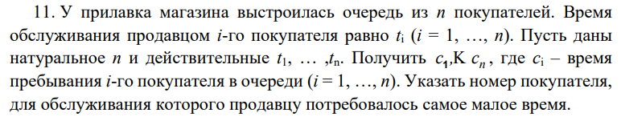

Код  
#include <iostream>

#include <locale.h>

#include <cmath>

int main() {

setlocale(LC_ALL, "Russian");

unsigned int n = 0, count = 0, min_time = 100'000, min_ind = 100'000;

std::cout << "Input n(n<=10): "; std::cin >> n;

while (n > 10 || n < 2) {

std::cout << "Invalid array size\n";

std::cout << "Input n(n<=10): "; std::cin >> n;

}

float timing[10];

float time_in_queue[10];

std::cout << "Input t1: "; std::cin >> timing[0];

time_in_queue[0] = timing[0];

for (int i = 1; i < n; i++) {

std::cout << "Input t" << i + 1 << ": "; std::cin >> timing[i];

time_in_queue[i] = timing[i] + time_in_queue[i - 1];

}

for (int i = 0; i < n; i++) {

std::cout << "tiq" << i + 1 << " = " << time_in_queue[i] << " ";

if (time_in_queue[i] < min_time) {

min_ind = 0;

}

}

std::cout << "\nindex of min time = " << min_ind;

return 0;

}

Решение  
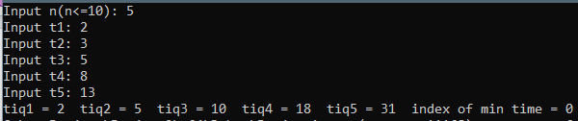

2.12  
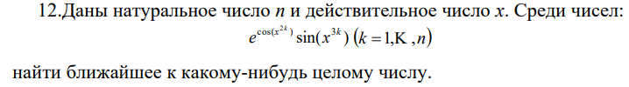  
Код  
#include <iostream>

#include <locale.h>

#include <cmath>

int main() {

setlocale(LC_ALL, "Russian");

unsigned int n = 0, x = 0; float diff1 = 0, diff2 = 100, num = 0;

std::cout << "Input n(n<=10): "; std::cin >> n;

while (n > 10 || n < 2) {

std::cout << "Invalid array size\n";

std::cout << "Input n(n<=10): "; std::cin >> n;

}

float mass[10];

std::cout << "Input x: "; std::cin >> x;

for (int i = 1; i <= n; i++) {

mass[i - 1] = exp(cos(pow(x, 2 * i))) * sin(pow(x, 3 * i));

std::cout << "a" << i << ": " << mass[i - 1] << " ";

diff1 = mass[i - 1] - (int)(mass[i - 1]);

if (abs(diff1) > 0.5)

diff1 = 1 - abs(diff1);

else

diff1 = abs(diff1);

std::cout << "diff a" << i << ": " << diff1 << " ";

if (diff1 < diff2) {

diff2 = diff1;

num = mass[i - 1];

}

}

std::cout << "\nnearest to int is " << num;

return 0;

}  
Решение  


ДЗ1  
Код  
Решение

ДЗ2  
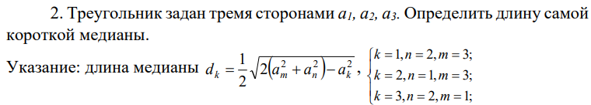  
Код  
#include <iostream>

#include <locale.h>

#include <cmath>

int main() {

setlocale(LC_ALL, "Russian");

float a1 = 0, a2 = 0, a3 = 0, d1 = 0, d2 = 0, d3 = 0, min = 0;

std::cout << "Введите a1: "; std::cin >> a1;

std::cout << "Введите a2: "; std::cin >> a2;

std::cout << "Введите a3: "; std::cin >> a3;

d1 = sqrt(2 * (pow(a3, 2) + pow(a2, 2)) - pow(a1, 2)) / 2;

std::cout << "d1 = " << d1 << '\n';

d2 = sqrt(2 * (pow(a3, 2) + pow(a1, 2)) - pow(a2, 2)) / 2;

std::cout << "d2 = " << d2 << '\n';

d3 = sqrt(2 * (pow(a1, 2) + pow(a2, 2)) - pow(a3, 2)) / 2;

std::cout << "d3 = " << d3 << '\n';

(d1 < d2) ? (d1 < d3) ? min = d1 : (d2 < d3) ? min = d2 : min = d3 : (d2 < d3) ? min = d2 : min = d3;

std::cout << "min = " << min;

return 0;

}  
Решение

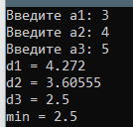

ДЗ3  
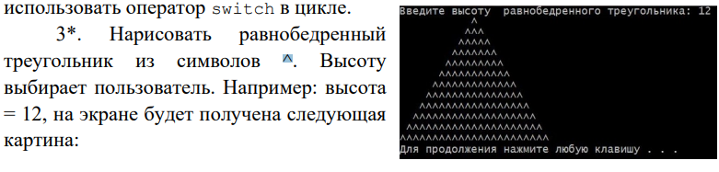  
Код  
#include <iostream>

#include <locale.h>

int main() {

setlocale(LC_ALL, "Russian");

unsigned int h = 0;

std::cout << "Введите высоту равнобедренного треугольника: "; std::cin >> h;

for (unsigned int i = h - 1, k = 1; i >= 0;) {

for (unsigned int count_space = i; count_space > 0; count_space--) {

std::cout << ' ';

}

for (unsigned int count_up = k; count_up > 0; count_up--) {

std::cout << '^';

}

k += 2;

i--;

if (i == -1)

return 0;

else

std::cout << '\n';

}

}  
Решение  
