Образец оформления отчёта по Лабораторной работе.

К Г Э У | МИНИСТЕРСТВО ВЫСШЕГО ОБРАЗОВАНИЯ И НАУКИ РОССИЙСКОЙ ФЕДЕРАЦИИ  Федеральное государственное бюджетное образовательное учреждение  высшего образования  «КАЗАНСКИЙ ГОСУДАРСТВЕННЫЙ ЭНЕРГЕТИЧЕСКИЙ УНИВЕРСИТЕТ»  (ФГБОУ ВО «КГЭУ»)

Кафедра Информатики и информационных управляющих систем

ОТЧЁТ ПО ЛАБОРАТОРНОЙ РАБОТЕ №3
ПОСТРОЕНИЕ ПРОГРАММ С АЛГОРИТМАМИ ВЕТВЛЕНИЯ

Исполнитель: | Соловьёв Леонид
Группа: | ПИ-1-22

Казань – 2022
1.1
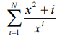
Код
#include<iostream>
#include <cmath>
int main()
{
float N, x, sum = 0, U;
std::cout << "Input N: "; std::cin >> N;
std::cout << "Input x: "; std::cin >> x;
U = x * x;
for (int i = 1; i <= N; i++) {
U = ((U / x) + (1. / pow(x, i)));
std::cout << "x" << i << " = " << U << '\n';
sum += U;
}
std::cout << "Sum = " << sum;
return 0;
}
Решение
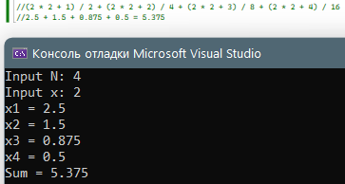
1.2
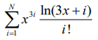
Код
#include<iostream>
#include <cmath>
int main()
{
float N, x, sum = 0, U, base, k;
std::cout << "Input N: "; std::cin >> N;
std::cout << "Input x: "; std::cin >> x;
U = log(3 * x + 1) * pow(x, 3) / 1;
for (int i = 1; i <= N; i++) {
sum += U;
std::cout << "x" << i << " = " << U << '\n';
k = log(3 * x + i + 1) / log(3 * x + i);
U *= (k * pow(x, 3) / (i + 1));
}
std::cout << "Sum = " << sum;
return 0;
}
Решение
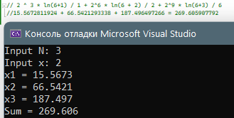

1.3
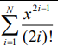
Код
#include<iostream>
#include <cmath>
int main()
{
float N, x, sum = 0, U;
std::cout << "Input N: "; std::cin >> N;
std::cout << "Input x: "; std::cin >> x;
U = 1. / x;
for (int i = 1, k = 3; i <= N; i++, k += 2) {
U *= (x * x) / (2 * i - 1) / (2 * i);
sum += U;
std::cout << "x" << i << " = " << U << '\n';
}
std::cout << "Sum = " << sum;
return 0;
}
Решение
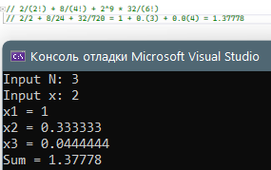\

1.4
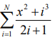
Код
#include<iostream>
#include <cmath>
int main()
{
float N, x, sum = 0, U;
std::cout << "Input N: "; std::cin >> N;
std::cout << "Input x: "; std::cin >> x;
U = x * x;
for (int i = 1, k = 1; i <= N; i++) {
k += 2;
U = ((U * (k - 2)) + (pow(i, 3) - pow((i - 1), 3))) / k;
sum += U;
std::cout << "x" << i << " = " << U << '\n';
}
std::cout << "Sum = " << sum;
return 0;
}
Решение
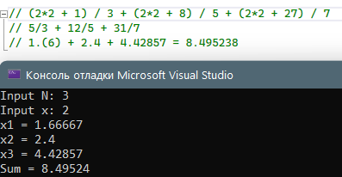
1.5
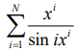
Код
#include<iostream>
#include <cmath>
int main()
{
float N, x, sum = 0, U, k;
std::cout << "Input N: "; std::cin >> N;
std::cout << "Input x: "; std::cin >> x;
U = x / sin(x);
for (int i = 1; i <= N;) {
sum += U;
std::cout << "x" << i << " = " << U << '\n';
i++;
k = sin((i - 1) * pow(x, (i - 1))) / sin(i * pow(x, i));
U *= x * k;
}
std::cout << "Sum = " << sum;
return 0;
}
Решение
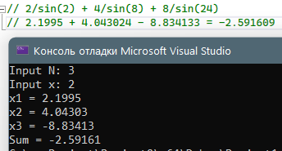

1.6
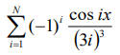
Код
#include<iostream>
#include <cmath>
int main()
{
float N, x, sum = 0, U, y;
std::cout << "Input N: "; std::cin >> N;
std::cout << "Input x: "; std::cin >> x;
U = -cos(x)/pow(3, 3);
for (int i = 1; i <= N;) {
sum += U;
std::cout << "x" << i << " = " << U << '\n';
i++;
y = cos(i * x) / cos((I - 1) * x);
U *= -1 * y * pow(3 * (I - 1), 3) / pow(3 * i, 3);
}
std::cout << "Sum = " << sum;
return 0;
}
Решение
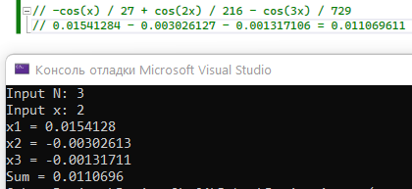

1.7
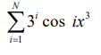
Код
#include<iostream>
#include <cmath>
int main()
{
float N, x, sum = 0, U;
std::cout << "Input N: "; std::cin >> N;
std::cout << "Input x: "; std::cin >> x;
U = 1;
int const x3 = pow(x, 3);
for (int i = 1; i <= N; i++) {
U *= 3 * cos(i * x3);
sum += U;
std::cout << "x" << i << " = " << U << '\n';
U /= cos(i * x3);
}
std::cout << "Sum = " << sum;
return 0;
}
Решение
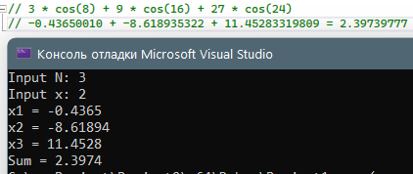

1.8
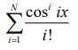
Код
#include<iostream>
#include <cmath>
int main()
{
float N, x, sum = 0, U;
std::cout << "Input N: "; std::cin >> N;
std::cout << "Input x: "; std::cin >> x;
U = 1;
int const x3 = pow(x, 3);
for (int i = 1; i <= N; i++) {
U *= pow(cos(i * x), i) / pow(cos((i - 1) * x), i - 1) / i;
sum += U;
std::cout << "x" << i << " = " << U << '\n';
}
std::cout << "Sum = " << sum;
return 0;
}
Решение
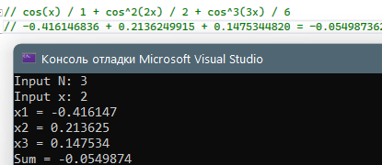
1.9
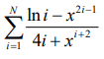
Код
#include<iostream>
#include <cmath>
int main()
{
float N, x, sum = 0, U;
std::cout << "Input N: "; std::cin >> N;
std::cout << "Input x: "; std::cin >> x;
int const x3 = pow(x, 3);
for (int i = 1; i <= N; i++) {
U = (log(i) - pow(x, 2 * i - 1)) / (4 * i + pow(x, i + 2));
sum += U;
std::cout << "x" << i << " = " << U << '\n';
}
std::cout << "Sum = " << sum;
return 0;
}
Решение
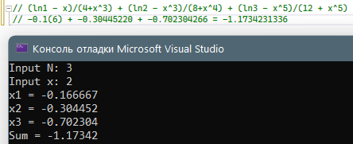
1.10
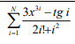
Код
#include<iostream>
#include <cmath>
int main()
{
double N, x, sum = 0, U;
std::cout << "Input N: "; std::cin >> N;
std::cout << "Input x: "; std::cin >> x;
for (int i = 1; i <= N; i++) {
int fact = 1;
for (int k = 1; k <= i; k++) {
fact *= k;
}
U = (3 * pow(x, 3 * i) - tan(i)) / (2 * fact + pow(i, 2));
sum += U;
std::cout << "x" << i << " = " << U << '\n';
}
std::cout << "Sum = " << sum;
return 0;
}
Решение
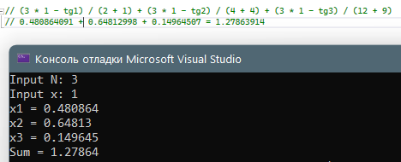
1.11
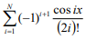
Код
#include<iostream>
#include <cmath>
int main()
{
double N, x, sum = 0, U;
std::cout << "Input N: "; std::cin >> N;
std::cout << "Input x: "; std::cin >> x;
U = -1;
for (int i = 1; i <= N; i++) {
U *= -1 / cos((i - 1) * x) * cos(i * x) / (2 * i) / (2 * i - 1);
sum += U;
std::cout << "x" << i << " = " << U << '\n';
}
std::cout << "Sum = " << sum;
return 0;
}
Решение
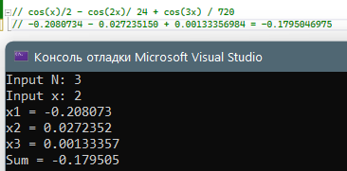
1.12
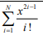
Код
#include<iostream>
#include <cmath>
int main()
{
double N, x, sum = 0, U;
std::cout << "Input N: "; std::cin >> N;
std::cout << "Input x: "; std::cin >> x;
U = x;
for (int i = 1; i <= N;) {
sum += U;
std::cout << "x" << i << " = " << U << '\n';
i++;
U *= x*x/i;
}
std::cout << "Sum = " << sum;
return 0;
}
Решение
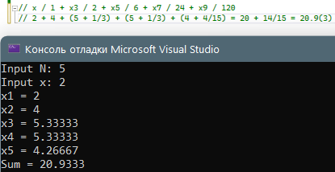

2.1
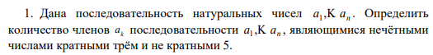
Код
#include <iostream>
#include <cmath>
int main()
{
int n, count = 0;
std::cout << "Input n(n<=30): "; std::cin >> n;
while (n > 30 || n < 0) {
std::cout << "Invalid array size\n";
std::cout << "Input n(n<=30): "; std::cin >> n;
}
int mass[30];
for (int i = 1; i <= n; i++) {
std::cout << "Input a" << i << ": "; std::cin >> mass[i - 1];
}
for (int i = 1; i <= n; i++) {
std::cout << "a" << i << ": " << mass[i - 1] << "\t\t";
}
std::cout << '\n';
for (int i = 1; i <= n; i++) {
if (mass[i - 1] % 2) {
if (mass[i - 1] % 3 == 0 && mass[i - 1] % 5 != 0) {
std::cout << "a" << i << ": true\t";
count += 1;
} else
std::cout << "a" << i << ": false\t";
} else
std::cout << "a" << i << ": false\t";
}
std::cout << "\nCount = " << count;
return 0;
}
Решение
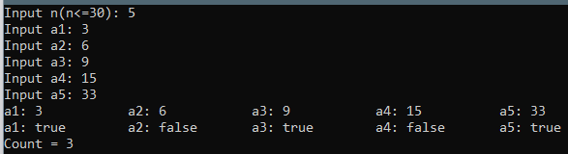
2.2
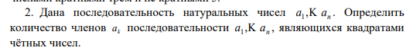
Код
#include <iostream>
#include <cmath>
int main()
{
int n, count = 0;
std::cout << "Input n(n<=30): "; std::cin >> n;
while (n > 30 || n < 0) {
std::cout << "Invalid array size\n";
std::cout << "Input n(n<=30): "; std::cin >> n;
}
int mass[30];
for (int i = 1; i <= n; i++) {
std::cout << "Input a" << i << ": "; std::cin >> mass[i - 1];
}
for (int i = 1; i <= n; i++) {
std::cout << "a" << i << ": " << mass[i - 1] << "\t\t";
}
std::cout << '\n';
for (int i = 1; i <= n; i++) {
if (mass[i - 1] % 2 == 0) {
if (pow((int)sqrt(mass[i - 1]), 2) == mass[i - 1]) {
std::cout << "a" << i << ": true\t";
count += 1;
}
else
std::cout << "a" << i << ": false\t";
}
else
std::cout << "a" << i << ": false\t";
}
std::cout << "\nCount = " << count;
return 0;
}
Решение
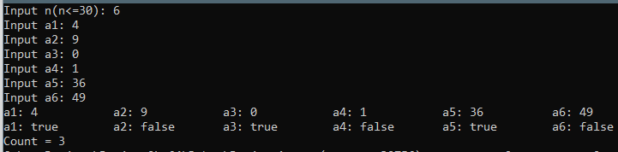
2.3
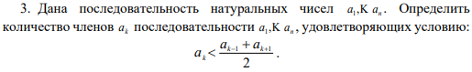
Код
#include <iostream>
#include <cmath>
int main()
{
int n, count = 0;
std::cout << "Input n(n<=30): "; std::cin >> n;
while (n > 30 || n < 0) {
std::cout << "Invalid array size\n";
std::cout << "Input n(n<=30): "; std::cin >> n;
}
int mass[30];
for (int i = 1; i <= n; i++) {
std::cout << "Input a" << i << ": "; std::cin >> mass[i - 1];
}
for (int i = 1; i <= n; i++) {
std::cout << "a" << i << ": " << mass[i - 1] << "\t\t";
}
std::cout << '\n';
for (int i = 0; i <= (n - 1); i++) {
if (i == 0 || i == (n - 1)) {
std::cout << "a" << i + 1 << ": false\t";
} else {
if (mass[i] < ((float)(mass[i - 1] + mass[i + 1]) / 2)) {
std::cout << "a" << i + 1 << ": true\t";
count += 1;
} else
std::cout << "a" << i + 1 << ": false\t";
}
}
std::cout << "\nCount = " << count;
return 0;
}
Решение
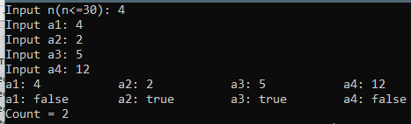
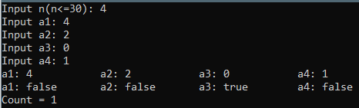

2.4
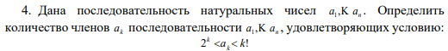
Код
#include <iostream>
#include <cmath>
int main()
{
int n, count = 0, left = 1, right = 1;
std::cout << "Input n(n<=30): "; std::cin >> n;
while (n > 30 || n < 0) {
std::cout << "Invalid array size\n";
std::cout << "Input n(n<=30): "; std::cin >> n;
}
int mass[30];
for (int i = 1; i <= n; i++) {
std::cout << "Input a" << i << ": "; std::cin >> mass[i - 1];
}
for (int i = 1; i <= n; i++) {
std::cout << "a" << i << ": " << mass[i - 1] << "\t\t";
}
std::cout << '\n';
for (int i = 1; i <= n; i++) {
left *= 2;
right *= i;
if (i < 4) {
std::cout << "a" << i << ": false" << '(' << left << ">" << right << ")\t";
continue;
}
if (left < mass[i - 1] && mass[i - 1] < right) {
std::cout << "a" << i << ": true" << '(' << left << ',' << right << ")\t";
count += 1;
} else {
std::cout << "a" << i << ": false" << '(' << left << ',' << right << ")\t";
}
}
std::cout << "\nCount = " << count;
return 0;
}
Решение
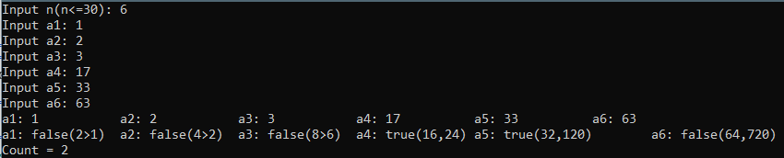
2.5
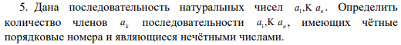
Код
#include <iostream>
#include <cmath>
int main()
{
int n, count = 0;
std::cout << "Input n(n<=30): "; std::cin >> n;
while (n > 30 || n < 0) {
std::cout << "Invalid array size\n";
std::cout << "Input n(n<=30): "; std::cin >> n;
}
int mass[30];
for (int i = 1; i <= n; i++) {
std::cout << "Input a" << i << ": "; std::cin >> mass[i - 1];
}
for (int i = 1; i <= n; i++) {
std::cout << "a" << i << ": " << mass[i - 1] << "\t\t";
}
std::cout << '\n';
for (int i = 1; i <= n; i++) {
std::cout << "a" << i << ":";
if (i % 2 == 0 && mass[i-1] % 2 == 0) {
std::cout << "true \t";
count += 1;
} else {
std::cout << "false \t";
}
}
std::cout << "\nCount = " << count;
return 0;
}
Решение
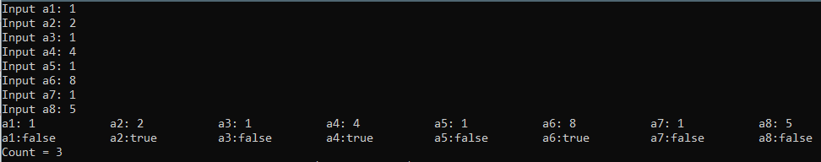
2.6
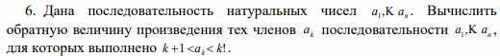
Код
#include <iostream>
#include <cmath>
int main()
{
int n, count = 0, left = 1, right = 1, mul = 1;
std::cout << "Input n(n<=30): "; std::cin >> n;
while (n > 30 || n < 0) {
std::cout << "Invalid array size\n";
std::cout << "Input n(n<=30): "; std::cin >> n;
}
int mass[30];
for (int i = 1; i <= n; i++) {
std::cout << "Input a" << i << ": "; std::cin >> mass[i - 1];
}
for (int i = 1; i <= n; i++) {
std::cout << "a" << i << ": " << mass[i - 1] << "\t\t";
}
std::cout << '\n';
for (int i = 1; i <= n; i++) {
left += 1;
right *= i;
if (i < 3) {
std::cout << "a" << i << ": false" << '(' << left << ">" << right << ")\t";
continue;
}
if (left < mass[i - 1] && mass[i - 1] < right) {
std::cout << "a" << i << ": true" << '(' << left << ',' << right << ")\t";
count += 1;
mul *= mass[i - 1];
}
else {
std::cout << "a" << i << ": false" << '(' << left << ',' << right << ")\t";
}
}
std::cout << "\n1/mul = " << 1. / mul;
return 0;
}
Решение
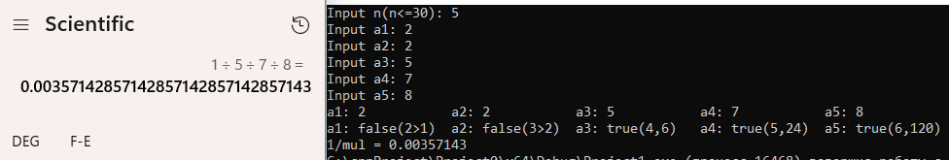

2.7
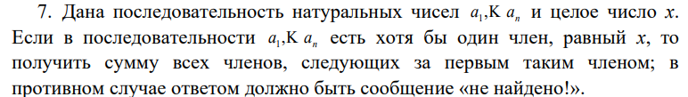
Код
#include <iostream>
#include <locale.h>
int main() {
setlocale(LC_ALL, "Russian");
int n = 0, x, sum = 0;
std::cout << "Input n(n<=10): "; std::cin >> n;
while (n > 10 || n < 0) {
std::cout << "Invalid array size\n";
std::cout << "Input n(n<=10): "; std::cin >> n;
}
int mass[10];
std::cout << "Input x: "; std::cin >> x;
int i = 1;
m0: {
for (; i <= n; i++) {
std::cout << 'a' << i << ": "; std::cin >> mass[i - 1];
if (mass[i - 1] == x) {
goto m1;
}
sum += mass[i - 1];
if (i == n) {
goto m2;
}
}
}
m1: {
for (i += 1; i <= n; i++) {
std::cout << 'a' << i << ": "; std::cin >> mass[i];
sum += mass[i];
}
std::cout << "Сумма элементов равна " << sum;
return 0;
}
m2: {
std::cout << "не найдено!";
return 0;
}
}
Решение
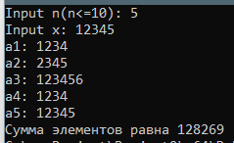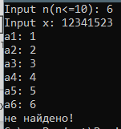
2.8
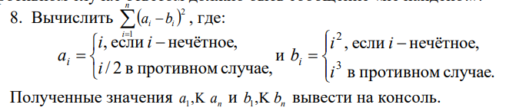
Код
#include <iostream>
#include <locale.h>
#include <cmath>
int main() {
setlocale(LC_ALL, "Russian");
int n = 0, sum = 0;
std::cout << "Input n(n<=10): "; std::cin >> n;
while (n > 10 || n < 0) {
std::cout << "Invalid array size\n";
std::cout << "Input n(n<=10): "; std::cin >> n;
}
int mass[10];
for (int i = 0; i < n; i++) {
if (i % 2 == 0) {
sum += pow((i / 2.) - (i * i * i), 2);
std::cout << 'a' << i << ": " << i / 2. << "\tb" << i << ": " << i * i * i << std::endl;
} else {
sum += pow(i - (i * i), 2);
std::cout << 'a' << i << ": " << i << "\tb" << i << ": " << i * i << std::endl;
}
}
std::cout << "Result = " << sum;
return 0;
}
Решение
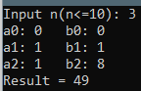
2.9
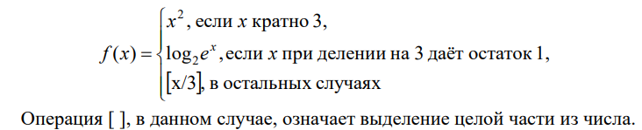
Код
#include <iostream>
#include <locale.h>
#include <cmath>
int main() {
setlocale(LC_ALL, "Russian");
int n = 0; float sum = 0;
std::cout << "Input n(n<=10): "; std::cin >> n;
while (n > 10 || n < 0) {
std::cout << "Invalid array size\n";
std::cout << "Input n(n<=10): "; std::cin >> n;
}
int mass[10];
for (int i = 0; i < n; i++) {
std::cout << 'a' << i + 1 << ": "; std::cin >> mass[i];
if (mass[i] % 3 == 0) {
sum += pow(mass[i], 2);
std::cout << pow(mass[i], 2) << '\n';
continue;
} if (mass[i] % 3 == 1) {
sum += mass[i] / log(2);
std::cout << mass[i] / log(2) << '\n';
continue;
} else {
sum += (int)(mass[i] / 3.);
std::cout << (int)(mass[i] / 3.) << '\n';
continue;
}
}
std::cout << "Result = " << sum;
return 0;
}
Решение
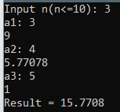

2.10
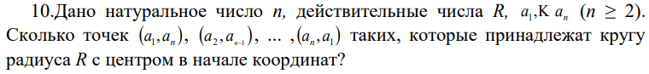
Код
#include <iostream>
#include <locale.h>
#include <cmath>
int main() {
setlocale(LC_ALL, "Russian");
int n = 0, count = 0; float R = 0;
std::cout << "Input n(2<=n<=10): "; std::cin >> n;
while (n > 10 || n < 2) {
std::cout << "Invalid array size\n";
std::cout << "Input n(2<=n<=10): "; std::cin >> n;
}
int mass[10];
std::cout << "Input R: "; std::cin >> R;
for (int i = 0; i < n; i++) {
std::cout << 'a' << i + 1 << ": "; std::cin >> mass[i];
}
for (int i = 1; i <= n; i++) {
if ((pow(mass[i - 1], 2) + pow(mass[n - i], 2)) == R * R) {
std::cout << "(a" << i << ", a" << n - i + 1 << ") лежит на окружности\n";
count += 1;
}
else {
std::cout << "(a" << i << ", a" << n - i + 1 << ") не лежит на окружности\n";
}
}
std::cout << "count = " << count;
return 0;
}
Решение
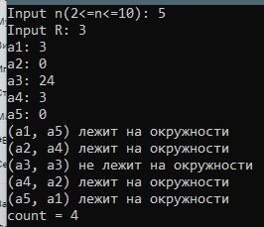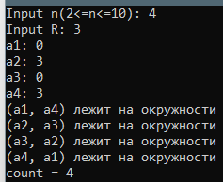

2.11
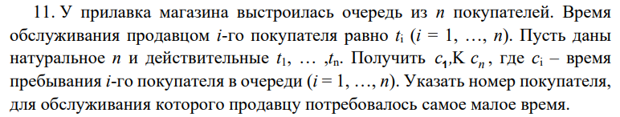
Код
#include <iostream>
#include <locale.h>
#include <cmath>
int main() {
setlocale(LC_ALL, "Russian");
unsigned int n = 0, count = 0, min_time = 100'000, min_ind = 100'000;
std::cout << "Input n(n<=10): "; std::cin >> n;
while (n > 10 || n < 2) {
std::cout << "Invalid array size\n";
std::cout << "Input n(n<=10): "; std::cin >> n;
}
float timing[10];
float time_in_queue[10];
std::cout << "Input t1: "; std::cin >> timing[0];
time_in_queue[0] = timing[0];
for (int i = 1; i < n; i++) {
std::cout << "Input t" << i + 1 << ": "; std::cin >> timing[i];
time_in_queue[i] = timing[i] + time_in_queue[i - 1];
}
for (int i = 0; i < n; i++) {
std::cout << "tiq" << i + 1 << " = " << time_in_queue[i] << " ";
if (time_in_queue[i] < min_time) {
min_ind = 0;
}
}
std::cout << "\nindex of min time = " << min_ind;
return 0;
}
Решение
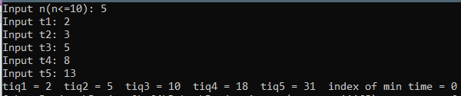
2.12
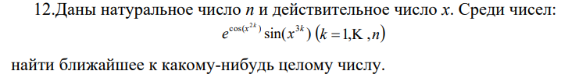
Код
#include <iostream>
#include <locale.h>
#include <cmath>
int main() {
setlocale(LC_ALL, "Russian");
unsigned int n = 0, x = 0; float diff1 = 0, diff2 = 100, num = 0;
std::cout << "Input n(n<=10): "; std::cin >> n;
while (n > 10 || n < 2) {
std::cout << "Invalid array size\n";
std::cout << "Input n(n<=10): "; std::cin >> n;
}
float mass[10];
std::cout << "Input x: "; std::cin >> x;
for (int i = 1; i <= n; i++) {
mass[i - 1] = exp(cos(pow(x, 2 * i))) * sin(pow(x, 3 * i));
std::cout << "a" << i << ": " << mass[i - 1] << " ";
diff1 = mass[i - 1] - (int)(mass[i - 1]);
if (abs(diff1) > 0.5)
diff1 = 1 - abs(diff1);
else
diff1 = abs(diff1);
std::cout << "diff a" << i << ": " << diff1 << " ";
if (diff1 < diff2) {
diff2 = diff1;
num = mass[i - 1];
}
}
std::cout << "\nnearest to int is " << num;
return 0;
}
Решение

ДЗ1
Код
Решение

ДЗ2
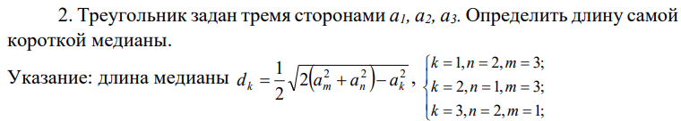
Код
#include <iostream>
#include <locale.h>
#include <cmath>
int main() {
setlocale(LC_ALL, "Russian");
float a1 = 0, a2 = 0, a3 = 0, d1 = 0, d2 = 0, d3 = 0, min = 0;
std::cout << "Введите a1: "; std::cin >> a1;
std::cout << "Введите a2: "; std::cin >> a2;
std::cout << "Введите a3: "; std::cin >> a3;
d1 = sqrt(2 * (pow(a3, 2) + pow(a2, 2)) - pow(a1, 2)) / 2;
std::cout << "d1 = " << d1 << '\n';
d2 = sqrt(2 * (pow(a3, 2) + pow(a1, 2)) - pow(a2, 2)) / 2;
std::cout << "d2 = " << d2 << '\n';
d3 = sqrt(2 * (pow(a1, 2) + pow(a2, 2)) - pow(a3, 2)) / 2;
std::cout << "d3 = " << d3 << '\n';
(d1 < d2) ? (d1 < d3) ? min = d1 : (d2 < d3) ? min = d2 : min = d3 : (d2 < d3) ? min = d2 : min = d3;
std::cout << "min = " << min;
return 0;
}
Решение
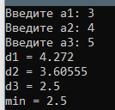

ДЗ3
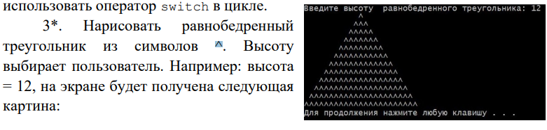
Код
#include <iostream>
#include <locale.h>
int main() {
setlocale(LC_ALL, "Russian");
unsigned int h = 0;
std::cout << "Введите высоту равнобедренного треугольника: "; std::cin >> h;
for (unsigned int i = h - 1, k = 1; i >= 0;) {
for (unsigned int count_space = i; count_space > 0; count_space--) {
std::cout << ' ';
}
for (unsigned int count_up = k; count_up > 0; count_up--) {
std::cout << '^';
}
k += 2;
i--;
if (i == -1)
return 0;
else
std::cout << '\n';
}
}
Решение
