Образец оформления отчёта по Лабораторной работе.

К Г Э У | МИНИСТЕРСТВО ВЫСШЕГО ОБРАЗОВАНИЯ И НАУКИ РОССИЙСКОЙ ФЕДЕРАЦИИ  Федеральное государственное бюджетное образовательное учреждение  высшего образования  «КАЗАНСКИЙ ГОСУДАРСТВЕННЫЙ ЭНЕРГЕТИЧЕСКИЙ УНИВЕРСИТЕТ»  (ФГБОУ ВО «КГЭУ»)

Кафедра Информатики и информационных управляющих систем

ОТЧЁТ ПО ЛАБОРАТОРНОЙ РАБОТЕ №3
ПОСТРОЕНИЕ ПРОГРАММ С АЛГОРИТМАМИ ВЕТВЛЕНИЯ

Исполнитель: | Соловьёв Леонид
Группа: | ПИ-1-22

Казань – 2022
1.1
Код
#include <iostream>
#include <cmath>
#include <ctime>

const int m = rand()%10 + 10;
const int n = rand()%10;
const float mn = (float) m / float(n);
const float nm = (float) n / float(m);

double spec_var(double t);
void xLowerThanPhi(float x, double phi);
void xEqualPhi(float x, double phi);
void xGreaterThanPhi(double phi);

int main() {
srand(time(0));
for (int i = 0; i < 2; i++) {
double phi = spec_var(rand()%1000);
float x = rand()%100;
std::cout << "phi = " << phi << std::endl;
std::cout << "x = " << x << std::endl;
if (x < phi) {
xLowerThanPhi(x, phi);
} else if (x = phi) {
xEqualPhi(x, phi);
} else {
xGreaterThanPhi(phi);
}
std::cout << '\n';
}
return 0;
}

double spec_var(double t) {
return std::exp(std::sin(t)) - std::exp(std::cos(t));
}

void xLowerThanPhi(float x, double phi) {
float zetta = std::pow(std::sin(mn), std::pow(x, 2) / (x + phi));
std::cout << "z = " << zetta;
}
void xEqualPhi(float x, double phi) {
float zetta = std::pow(phi, 2) * std::pow(x, n/4.) / (std::pow(phi, nm) * x);
std::cout << "z = " << zetta;
}
void xGreaterThanPhi(double phi) {
float zetta = std::pow((std::log(std::abs(phi)) / std::log(mn)), nm);
std::cout << "z = " << zetta;
}
Решение
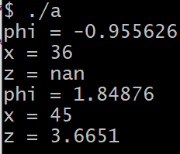

1.2
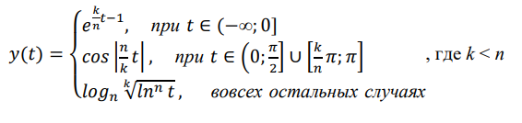
Код
#include <iostream>
#include <cmath>
#include <ctime>

const int n = rand()%10 + 10;
const int k = rand()%10;
const float kn = (float) k / float(n);
const float nk = (float) n / float(k);
const double pi = std::acos(-1.);

void uniq(float t); void tLessThan0(float t); void tGreaterThanPi(float t);

int main() {
for (int i = 0; i < 2; i++) {
srand(time(0) + i);
float t = (float) (rand()%1000 + 1) / (rand()%1000 + 1);
std::cout << "t = " << t;
if (t <= 0) {
tLessThan0(t);
} else if (t >= pi) {
uniq(t);
} else {
tGreaterThanPi(t);
}
std::cout << '\n';
}
}

void uniq(float t) {
std::cout << "\ny = " << std::cos(std::abs(nk*t));
}
void tLessThan0(float t) {
std::cout << "\ny = " << exp(kn*t - 1);
}
void tGreaterThanPi(float t) {
std::cout << "\ny = " << std::log(std::pow(std::log(t), nk)) / std::log(n);
}
Решение
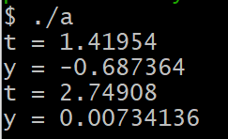

2.1
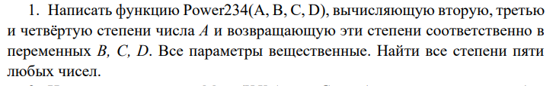
Код
#include <iostream>
#include <cmath>
void Power234(int i, int &b, int &c, int &d);

int main() {
int b, c, d;
for (int i = 0; i < 10; i++) {
Power234(i, b, c, d);
std::cout << i << " second grade: " << b << " third grade: " << c
<< " fourth grade: " << d << '\n';
}
return 0;
}

void Power234(int i, int &b, int &c, int &d) {
b = i * i; c = i * i * i; d = i * i * i * i;
}
Решение
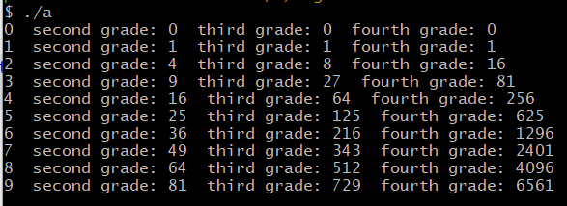

2.2
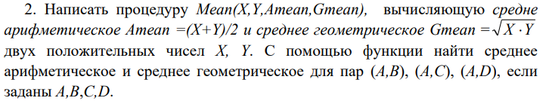
Код
#include <iostream>
#include <cmath>

void Mean(float X, float Y, float Amean, float Gmean);

int main() {
float A = 0, B = 0, C = 0, D = 0, Amean = 0, Gmean = 0;
std::cout << "Input A: "; std::cin >> A;
std::cout << "Input B: "; std::cin >> B;
Mean(A, B, Amean, Gmean);
std::cout << "\nInput C: "; std::cin >> C;
Mean(A, C, Amean, Gmean);
std::cout << "\nInput D: "; std::cin >> D;
Mean(A, D, Amean, Gmean);
return 0;
}

void Mean(float X, float Y, float Amean, float Gmean) {
Amean = (X + Y) / 2.;
Gmean = std::pow(X * Y, 0.5);
std::cout << "Amean(" << X << ',' << Y << ") = " << Amean << " Gmean(" << X << ',' << Y << ") = " << Gmean;
}
Решение
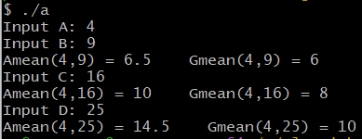
2.3
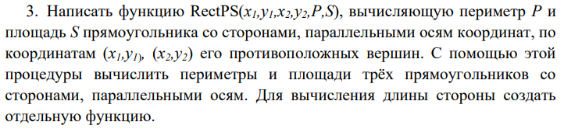
Код
#include <iostream>
#include <cmath>

void RectPS( float x1, float y1, float x2, float y2, float P, float S);

int main() {
float x1 = 0, x2 = 0, y1 = 0, y2 = 0, P = 0, S = 0;
char s = 'y';
while (s == 'y') {
std::cout << "Enter x1: "; std::cin >> x1;
std::cout << "Enter y1: "; std::cin >> y1;
std::cout << "Enter x2: "; std::cin >> x2;
std::cout << "Enter y2: "; std::cin >> y2;
RectPS(x1, y1, x2, y2, P, S);
std::cout << "\nDo you wanna calculate perimeter and square of next rectangle?\nType y(yes) or n(n): ";
std::cin >> s;
std::cout << '\n';
}
std::cout << "Thanks for using this program!";
return 0;
}

void RectPS( float x1, float y1, float x2, float y2, float P, float S) {
float a = std::abs(x2 - x1), b = std::abs(y2 - y1);
std::cout << "Lenght of a side = " << a << " Lenght of b side = " << b << '\n';
P = (a + b) * 2;
S = a * b;
std::cout << "P = " << P << " S = " << S;
}
Решение
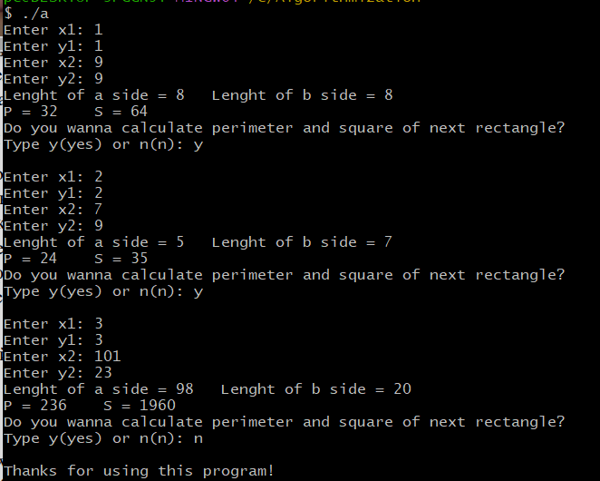

2.4
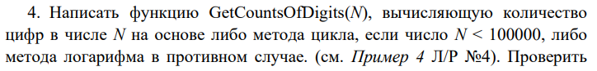
Код
#include <iostream>
#include <cmath>

void GetCountOfDigits(unsigned N);

int main() {
srand(time(0));
unsigned N = 0;
char flag = 'y';
int i = 0;
while (i < 10) {
N = (rand() * rand()) % (rand() * rand());
GetCountOfDigits(N);
i++;
}
return 0;
}

void GetCountOfDigits(unsigned N) {
unsigned num = N;
for (int i = 0; i < 10000; i++) {
if (N < std::pow(10, i + 1)) {
std::cout << "Lenght of " << num << " = " << i+1 << std::endl;
break;
}
}
Решение
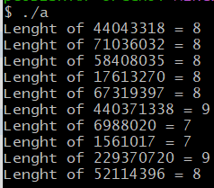
2.5
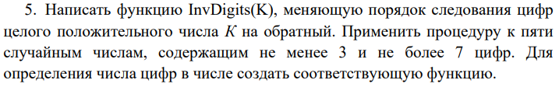
Код
#include <iostream>
#include <cmath>
#include <ctime>

void InvDigits(unsigned K);

int main() {
srand(time(0));
unsigned K = 0;
char flag = 'y';
int i = 0;
while (i < 5) {
K = (rand() * (rand()%100))%9999900 + 100;
InvDigits(K);
i++;
}
return 0;
}

void InvDigits(unsigned K) {
unsigned num = K;
(num % 10 == 0) ? num++ : num;
std::cout << "K = " << num << " revK = ";
while (num > 0) {
std::cout << num % 10;
num /= 10;
}
std::cout << '\n';
}
Решение
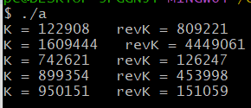

2.6
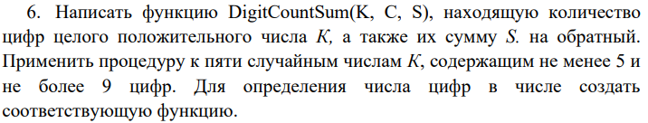
Код
#include <iostream>
#include <cmath>
#include <ctime>

void DigitCountSum(unsigned N);

int main() {
srand(time(0));
unsigned N = 0;
int i = 0;
while (i < 10) {
N = (rand() * rand()) % (rand() * rand());
DigitCountSum(N);
i++;
}
return 0;
}

void DigitCountSum(unsigned N) {
unsigned num = N;
unsigned sum = 0;
for (int i = 0; i < 10000; i++) {
if (N < std::pow(10, i + 1)) {
std::cout << "Lenght of " << num << " = " << i+1 << " Sum of " << num << " = ";
break;
}
}
while (num > 0) {
sum += num % 10;
num /= 10;
}
std::cout << sum << std::endl;
}
Решение
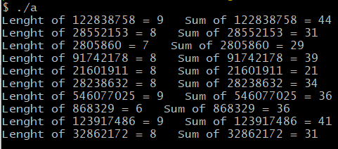

2.7
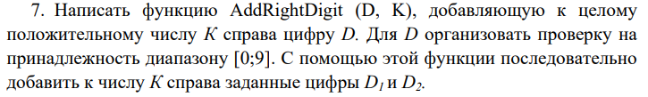
Код
#include <iostream>
#include <cmath>

void AddRightDigit(unsigned D, unsigned &K);

int main() {
unsigned K = 0, D_1 = 0, D_2 = 0;
std::cout << "Enter K: "; std::cin >> K;
std::cout << "Enter D1: "; std::cin >> D_1;
AddRightDigit(D_1, K);
std::cout << "Enter D2: "; std::cin >> D_2;
AddRightDigit(D_2, K);
return 0;
}

void AddRightDigit(unsigned D, unsigned &K) {
if (0 <= D && D < 10) {
std::cout << "Old K = " << K << std::endl;
K = K * 10 + D;
std::cout << "K after append D = " << K;
} else {
std::cout << "D not in range(10)\n";
}
}
Решение
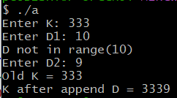 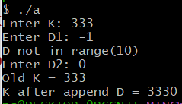

2.8
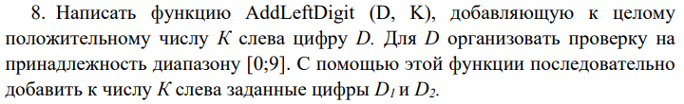
Код
#include <iostream>
#include <cmath>

void AddRightDigit(unsigned D, unsigned &K);
int Lenght(double K);

int main() {
unsigned K = 0; unsigned D_1 = 0, D_2 = 0;
std::cout << "Enter K: "; std::cin >> K;
std::cout << "Enter D1: "; std::cin >> D_1;
AddRightDigit(D_1, K);
std::cout << "Enter D2: "; std::cin >> D_2;
AddRightDigit(D_2, K);
return 0;
}

void AddRightDigit(unsigned D, unsigned &K) {
if (0 <= D && D < 10) {
std::cout << "Old K = " << K << std::endl;
K = ((K / std::pow(10, Lenght((double) K))) + D) * std::pow(10, Lenght((double) K));
std::cout << "K after append D = " << K << std::endl;
} else {
std::cout << "D not in range(10)\n";
}
}

int Lenght(double K) {
return (K == 0) ? 1 : (int) std::ceil(log10(std::abs(K) + 0.5));
}
Решение
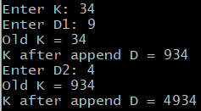 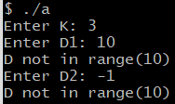

2.9
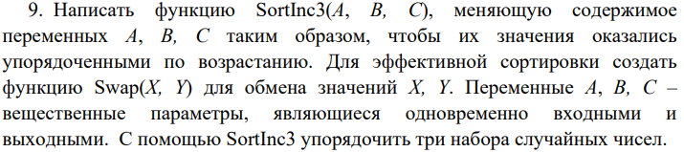
Код
#include <iostream>
#include <cmath>

void SortInc3(int &A, int &B, int &C);
void Swap(int &A, int &B);

int main() {
int A = 0, B = 0, C = 0;
std::cout << "Enter A: "; std::cin >> A;
std::cout << "Enter B: "; std::cin >> B;
std::cout << "Enter C: "; std::cin >> C;
std::cout << "Before sort: A = " << A << " B = " << B << " C = " << C << std::endl;
SortInc3(A, B, C);
std::cout << "After sort: A = " << A << " B = " << B << " C = " << C << std::endl;
return 0;
}

void Swap(int &A, int &B) {
int temporary = B;
B = A;
A = temporary;
}

void SortInc3(int &A, int &B, int &C) {
if (A > B) Swap(A, B);
if (B > C) Swap(B, C);
if (B < A) Swap(B, A);
}
Решение
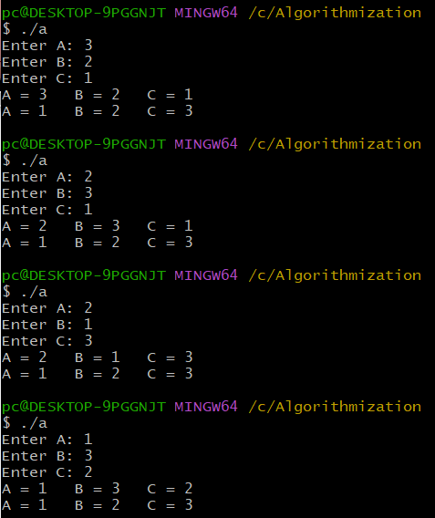

2.10
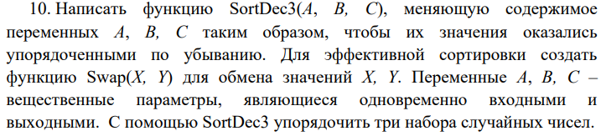
Код
#include <iostream>
#include <cmath>

void SortDec3(int &A, int &B, int &C);
void Swap(int &A, int &B);

int main() {
int A = 0, B = 0, C = 0;
std::cout << "Enter A: "; std::cin >> A;
std::cout << "Enter B: "; std::cin >> B;
std::cout << "Enter C: "; std::cin >> C;
std::cout << "Before sort: A = " << A << " B = " << B << " C = " << C << std::endl;
SortInc3(A, B, C);
std::cout << "After sort: A = " << A << " B = " << B << " C = " << C << std::endl;
return 0;
}

void Swap(int &A, int &B) {
int temporary = A;
A = B;
B = temporary;
}

void SortDec3(int &A, int &B, int &C) {
if (A < B) Swap(A, B);
if (B < C) Swap(B, C);
if (B > A) Swap(B, A);
}
Решение
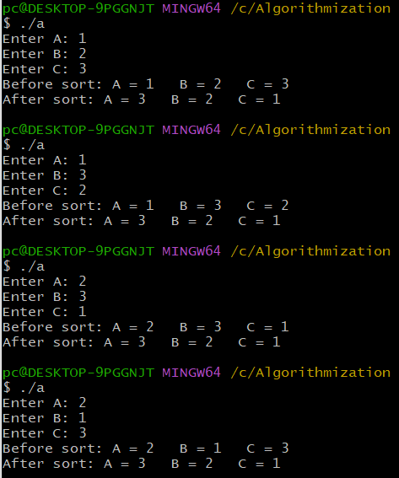

2.11
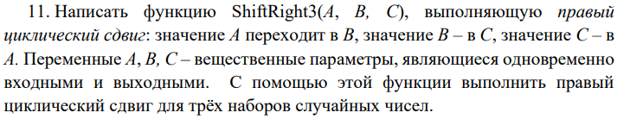
Код
#include <iostream>
#include <cmath>

void ShiftRight3(int &A, int &B, int &C);
void Swap(int &A, int &B);

int main() {
int A = 0, B = 0, C = 0;
std::cout << "Enter A: "; std::cin >> A;
std::cout << "Enter B: "; std::cin >> B;
std::cout << "Enter C: "; std::cin >> C;
std::cout << "Before shift: A = " << A << " B = " << B << " C = " << C << std::endl;
ShiftRight3(A, B, C);
std::cout << "After shift: A = " << A << " B = " << B << " C = " << C << std::endl;
return 0;
}

void Swap(int &A, int &B) {
int temporary = B;
B = A;
A = temporary;
}

void ShiftRight3(int &A, int &B, int &C) {
Swap(B, C); Swap(A, B);
}
Решение
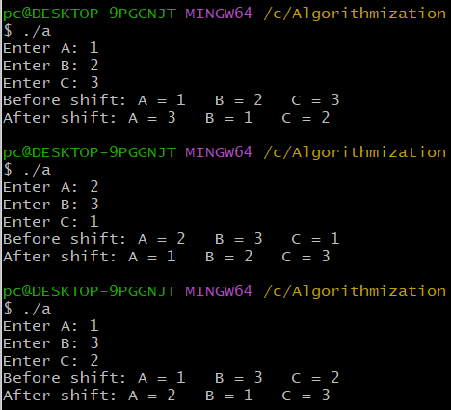

2.12
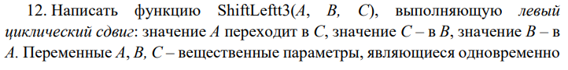
Код
#include <iostream>
#include <cmath>

void ShiftLeft3(int &A, int &B, int &C);
void Swap(int &A, int &B);

int main() {
int A = 0, B = 0, C = 0;
std::cout << "Enter A: "; std::cin >> A;
std::cout << "Enter B: "; std::cin >> B;
std::cout << "Enter C: "; std::cin >> C;
std::cout << "Before shift: A = " << A << " B = " << B << " C = " << C << std::endl;
ShiftLeft3(A, B, C);
std::cout << "After shift: A = " << A << " B = " << B << " C = " << C << std::endl;
return 0;
}

void Swap(int &A, int &B) {
int temporary = B;
B = A;
A = temporary;
}

void ShiftLeft3(int &A, int &B, int &C) {
Swap(A, B); Swap(B, C);
}
Решение
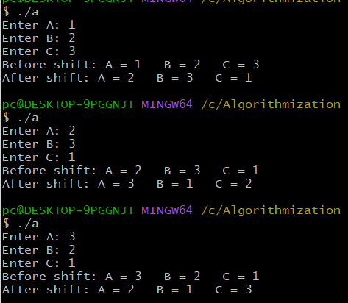

ДЗ1
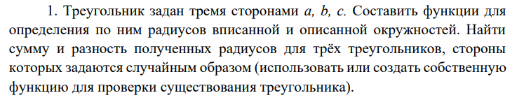
Код
#include <iostream>
#include <cmath>
#include <ctime>

void randSides(unsigned &a, unsigned &b, unsigned &c);
bool existance(unsigned a, unsigned b, unsigned c);
bool triangleExist(unsigned a, unsigned b, unsigned c);

int main() {
for (int i = 0; i < 3; i++) {
srand(time(0) + i * i);
unsigned a, b, c;
randSides(a, b, c);
std::cout << "\nRandom sides:\n\ta = " << a << "\n\tb = " << b << "\n\tc = " << c << std::endl;
if (triangleExist(a, b, c)) {
std::cout << "Triangle exists!\n";
float p = (a + b + c) / 2.;
std::cout << "\tp = " << p << std::endl;
float S = std::sqrt(p * (p-a) * (p-b) * (p - c));
std::cout << "\tS = " << S << std::endl;
float R = (a * b * c) / (4 * S);
std::cout << "\tR = " << R << std::endl;
float r = std::sqrt(S / (p*p));
std::cout << "\tr = " << r << std::endl;
std::cout << "\tR - r = " << R - r << std::endl;
std::cout << "\tR + r = " << R + r << std::endl;
} else {
std::cout << "Triangle does not exist!\n";
}
}
return 0;
}

void randSides(unsigned &a, unsigned &b, unsigned &c) {a = rand()%1000;b = rand()%1000;c = rand()%1000;}
bool triangleExist(unsigned a, unsigned b, unsigned c) { return ((a < b + c) && (b < a + c) && (c < a + b));}

Решение
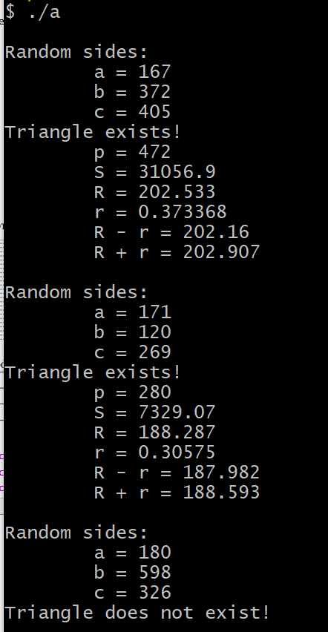

ДЗ2
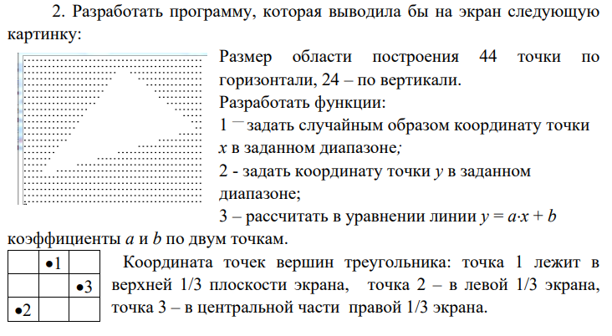
Код
#include <iostream>
#include <cmath>
#include <ctime>

void Xcoordinates(unsigned &x_1, unsigned &x_2, unsigned &x_3);
void Ycoordinates(unsigned &y_1, unsigned &y_2, unsigned &y_3);
void coutCoordinates(unsigned &x_1, unsigned &x_2, unsigned &x_3, unsigned &y_1, unsigned &y_2, unsigned &y_3);
void abparameters(unsigned x_1, unsigned y_1, unsigned x_2, unsigned y_2, double &a, double &b);
void Triangle(unsigned x_1, unsigned x_2, unsigned x_3, unsigned y_1, unsigned y_2, unsigned y_3, double a_12, double b_12, double a_23, double b_23, double a_31, double b_31);
void coutTriangle();

char mass[45][24];

int main() {
srand(time(0));
unsigned x_1, y_1, x_2, y_2, x_3, y_3;
double a_12, b_12, a_23, b_23, a_31, b_31;

Xcoordinates(x_1, x_2, x_3);
Ycoordinates(y_1, y_2, y_3);
coutCoordinates(x_1, x_2, x_3, y_1, y_2, y_3);

abparameters(x_1, y_1, x_2, y_2, a_12, b_12); //ab from 1 to 2
abparameters(x_2, y_2, x_3, y_3, a_23, b_23); //ab from 2 to 3
abparameters(x_3, y_3, x_1, y_1,a_31, b_31); //ab from 3 to 1

Triangle(x_1, x_2, x_3, y_1, y_2, y_3, a_12, b_12, a_23, b_23, a_31, b_31);
coutTriangle();
}

void Xcoordinates(unsigned &x_1, unsigned &x_2, unsigned &x_3) {
x_1 = rand()%15 + 15;
x_2 = rand()%15;
x_3 = rand()%15 + 30;}
void Ycoordinates(unsigned &y_1, unsigned &y_2, unsigned &y_3) {
y_1 = rand()%8;
y_2 = rand()%8 + 16;
y_3 = rand()%8 + 8;}
void coutCoordinates(unsigned &x_1, unsigned &x_2, unsigned &x_3, unsigned &y_1, unsigned &y_2, unsigned &y_3) {
std::cout << "Сoordinates of first dot: (" << x_1 << ',' << y_1 << ")" << std::endl;
std::cout << "Сoordinates of second dot: (" << x_2 << ',' << y_2 << ")" << std::endl;
std::cout << "Сoordinates of third dot: (" << x_3 << ',' << y_3 << ")" << std::endl;
}
void abparameters(unsigned x_1, unsigned y_1, unsigned x_2, unsigned y_2, double &a, double &b) {
double x1 = (double) x_1, y1 = (double) y_1, x2 = (double) x_2, y2 = (double) y_2;
a = (y2-y1) / (x2-x1);
b = (x1*y2 - x2*y1) / (x1-x2);
// (y1-y2)x + (x1y2 - x2y1) = (x1-x2)y
// y = ((y1-y2)/(x1-x2))x + ((x1y2 - x2y1) / (x1-x2))
}
void Triangle(unsigned x_1, unsigned x_2, unsigned x_3, unsigned y_1, unsigned y_2, unsigned y_3, double a_12, double b_12, double a_23, double b_23, double a_31, double b_31) {
for (int k = 0; k <= 23; k++) {
for (int i = 0; i <= 44; i++) {
if ((k >= (int) (i * a_12 + b_12)) && (k <= (int) (i * a_23 + b_23)) && (k >= (int) (i * a_31 + b_31))) {
mass[i][k] = ' ';
} else {
mass[i][k] = '.';
}
}
}
}
void coutTriangle() {
for (int k = 0; k <= 23; k++) {
for (int i = 0; i <= 44; i++) {
std::cout << mass[i][k];
}
std::cout << '\n';
}
}
Решение
