Образец оформления отчёта по Лабораторной работе.

К Г Э У | МИНИСТЕРСТВО ВЫСШЕГО ОБРАЗОВАНИЯ И НАУКИ РОССИЙСКОЙ ФЕДЕРАЦИИ  Федеральное государственное бюджетное образовательное учреждение  высшего образования  «КАЗАНСКИЙ ГОСУДАРСТВЕННЫЙ ЭНЕРГЕТИЧЕСКИЙ УНИВЕРСИТЕТ»  (ФГБОУ ВО «КГЭУ»)

Кафедра Информатики и информационных управляющих систем

ОТЧЁТ ПО ЛАБОРАТОРНОЙ РАБОТЕ №9
ДИНАМИЧЕСКОЕ ВЫДЕЛЕНИЕ ПАМЯТИ. РАБОТА СО ВЛОЖЕННЫМИ ЦИКЛАМИ.

Исполнитель: | Соловьёв Леонид
Группа: | ПИ-1-22

Казань – 2022
1.1
1.1
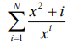
Код
#include<iostream>
#include <cmath>

double series(double x, int N);
void sum_dont_grow_index_or_max_sum(double *arr, int n);
void max_sum(double *arr, int n);

int main(){
double *mass_sum = new double[5];
double x;
std::cout << "Input x: "; std::cin >> x;
for (int i = 5; i <= 25; i+=5) {
mass_sum[(i-5)/5] = series(x, i);
std::cout << "Sum" << i << " = " << mass_sum[(i-5)/5] << '\n';
}
sum_dont_grow_index_or_max_sum(mass_sum, 5);
return 0;
}

double series(double x, int N) {
double sum = 0;
double U = x * x;
for (int i = 1; i <= N; i++) {
U = ((U / x) + (1. / pow(x, i)));
sum += U;
}
return sum;
}

void sum_dont_grow_index_or_max_sum(double *arr, int n) {
bool flag = true;
for (int i = 0; i < (n-1); i++) {
if (arr[i+1]/arr[i] <= 1.1) {
flag = false;
std::cout << "N, where sum don't grow greater than ten percent is " << (i+1) * 5;
return;
}
}
if (flag) {
max_sum(arr, n);
}
}

void max_sum(double *arr, int n) {
double max = -10000;
int ind = -1;
for (int i = 0; i < n; i++) {
if (arr[i] > max) {
max = arr[i];
ind = i;
}
}
std::cout << "Max sum in N = " << (ind+1)*5;
}
Решение
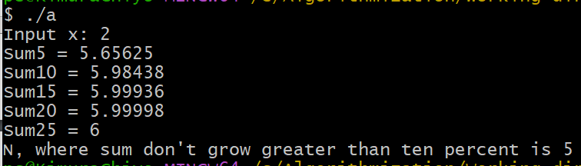
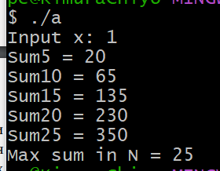
1.2
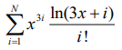
Код
#include<iostream>
#include <cmath>

double series(double x, int N);
void sum_dont_grow_index_or_max_sum(double *arr, int n);
void max_sum(double *arr, int n);

int main(){
double *mass_sum = new double[5];
double x;
std::cout << "Input x: "; std::cin >> x;
for (int i = 5; i <= 25; i+=5) {
mass_sum[(i-5)/5] = series(x, i);
std::cout << "Sum" << i << " = " << mass_sum[(i-5)/5] << '\n';
}
sum_dont_grow_index_or_max_sum(mass_sum, 5);
return 0;
}

double series(double x, int N) {
double sum = 0;
float k;
double U = log(3 * x + 1) * pow(x, 3) / 1;
for (int i = 1; i <= N; i++) {
sum += U;
k = log(3 * x + i + 1) / log(3 * x + i);
U *= (k * pow(x, 3) / (i + 1));
}
return sum;
}

void sum_dont_grow_index_or_max_sum(double *arr, int n) {
bool flag = true;
for (int i = 0; i < (n-1); i++) {
if (arr[i+1]/arr[i] <= 1.1) {
flag = false;
std::cout << "N, where sum don't grow greater than ten percent is " << (i+1) * 5;
return;
}
}
if (flag) {
max_sum(arr, n);
}
}

void max_sum(double *arr, int n) {
double max = -10000;
int ind = -1;
for (int i = 0; i < n; i++) {
if (arr[i] > max) {
max = arr[i];
ind = i;
}
}
std::cout << "Max sum in N = " << (ind+1)*5;
}
Решение
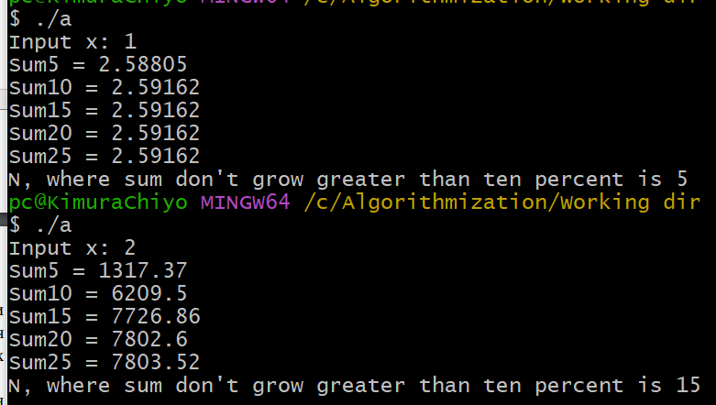
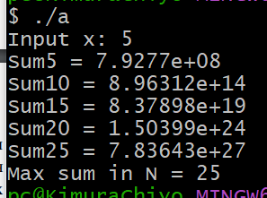

2.1
Код
#include<iostream>
#include <cmath>
#include <string>
#include <ctime>

void init_mass(int **arr, int m, int n);
std::string max_month(int **arr, int m, int n);
int min_raion(int **arr, int m, int n);

int main(){
srand(time(NULL));
int n;
std::cout << "How many raion in your city? "; std::cin >> n;

int **mass_amount = new int * [n], x;
for (int i=0; i < n; i++) {
mass_amount[i] = new int [12];
}

init_mass(mass_amount, n, 12);

std::string S = max_month(mass_amount, n, 12);
std::cout << "\nMonth with max amount of people is " << S << "\n\n";

int min_amount = min_raion(mass_amount, n, 12);
std::cout << "\nMin amount people in Raion" << min_amount+1;

return 0;
}

void init_mass(int **arr, int m, int n) {
for (int i = 0; i < m; i++) {
std::cout << "Raion" << i+1 << ":\n";
std::string month = "";
for (int k = 0; k < n; k++) {
arr[i][k] = rand()%1501 + 500;
switch (k) {
case 0: { month = "January"; break;}
case 1: { month = "February"; break;}
case 2: { month = "March"; break;}
case 3: { month = "April"; break;}
case 4: { month = "May"; break;}
case 5: { month = "June"; break;}
case 6: { month = "July"; break;}
case 7: { month = "August"; break;}
case 8: { month = "September"; break;}
case 9: { month = "October"; break;}
case 10: { month = "November"; break;}
case 11: { month = "December"; break;}
}
std::cout << "\tMonth: " << month << "\b\t\tAmount: " << arr[i][k] << '\n';
}
std::cout << '\n';
}
}

std::string max_month(int **arr, int m, int n) {
std::string month;
int ind_month;
int sum = 0;
int max_sum = 0;
for (int i = 0; i < n; i++) {
for (int k = 0; k < m; k++) {
sum += arr[k][i];
}
switch (i) {
case 0: { month = "January"; break;}
case 1: { month = "February"; break;}
case 2: { month = "March"; break;}
case 3: { month = "April"; break;}
case 4: { month = "May"; break;}
case 5: { month = "June"; break;}
case 6: { month = "July"; break;}
case 7: { month = "August"; break;}
case 8: { month = "September"; break;}
case 9: { month = "October"; break;}
case 10: { month = "November"; break;}
case 11: { month = "December"; break;}
}
std::cout << "General Amount of " << month << ": " << sum << '\n';
if (sum > max_sum) {
ind_month = i;
max_sum = sum;
}
sum = 0;
}
switch (ind_month) {
case 0: { month = "January"; break;}
case 1: { month = "February"; break;}
case 2: { month = "March"; break;}
case 3: { month = "April"; break;}
case 4: { month = "May"; break;}
case 5: { month = "June"; break;}
case 6: { month = "July"; break;}
case 7: { month = "August"; break;}
case 8: { month = "September"; break;}
case 9: { month = "October"; break;}
case 10: { month = "November"; break;}
case 11: { month = "December"; break;}
}
return month;
}
int min_raion(int **arr, int m, int n) {
int ind_raion;
int sum = 0;
int min_sum = 1000000;
for (int i = 0; i < m; i++) {
for (int k = 0; k < n; k++) {
sum += arr[i][k];
}
std::cout << "General Amount People in Raion" << i+1 << ": " << sum << std::endl;
if (sum < min_sum) {
ind_raion = i;
min_sum = sum;
}
sum = 0;
}
return ind_raion;
}
Решение
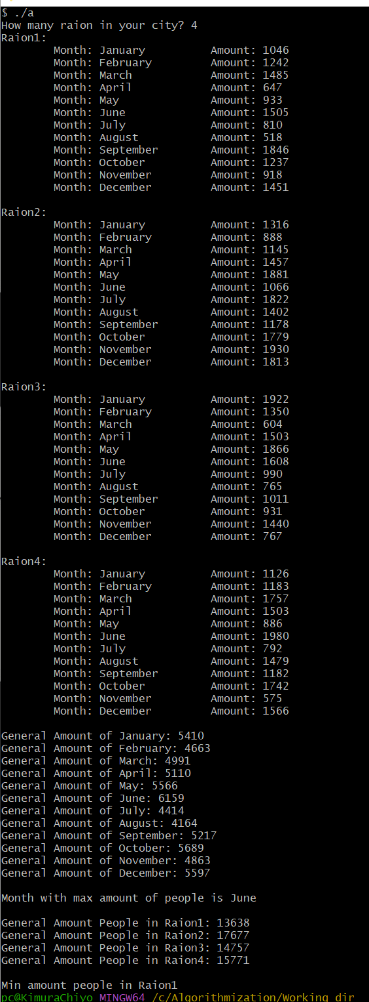

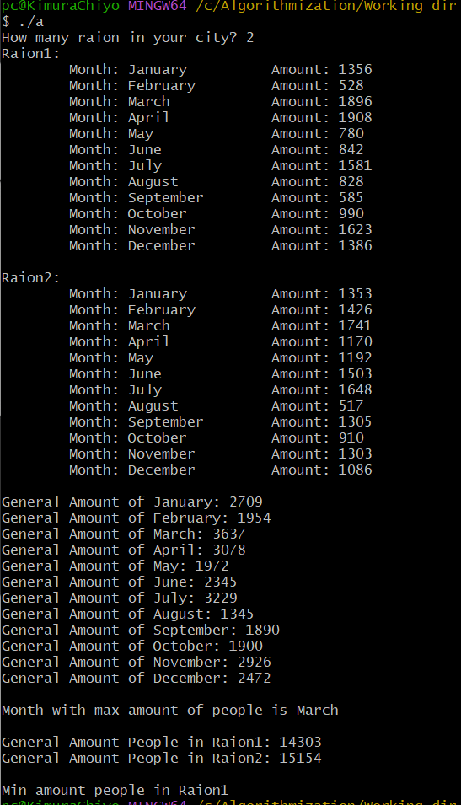
2.2
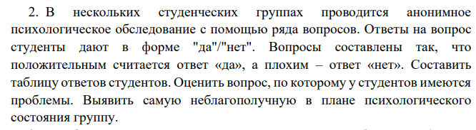
Код
#include<iostream>
#include <cmath>
#include <string>
#include <ctime>

void init_mass(int **arr, int m, int n, int x);
void max_count_no_answer(int **arr, int n, int m, int x);
void max_count_no_group(int **arr, int n, int m, int x);

int main(){
srand(time(NULL));
int n;
std::cout << "How many groups in test? "; std::cin >> n;

int x;
std::cout << "How many peoples in group? "; std::cin >> x;

int m;
std::cout << "How many questions in test? "; std::cin >> m;

int **mass_amount = new int * [n];
for (int i=0; i < n; i++) {
mass_amount[i] = new int [m];
}

init_mass(mass_amount, n, m, x);
max_count_no_answer(mass_amount, n, m, x);
std::cout << '\n';
max_count_no_group(mass_amount, n, m, x);

return 0;
}

void init_mass(int **arr, int n, int m, int x) {
for (int i = 0; i < n; i++) {
std::cout << "Group" << i+1 << ":\n";
std::string month = "";
for (int k = 0; k < m; k++) {
arr[i][k] = rand()%(x+1);
std::cout << "\tQuestion" << k+1 << "\b\tAmount of yes: " << arr[i][k] << "\tAmount of no " << x - arr[i][k] << '\n';
}
std::cout << '\n';
}
}

void max_count_no_answer(int **arr, int n, int m, int x) {
int max_no_sum = 0;
int ans;
int sum = 0;
for (int i = 0; i < m; i++) {
for (int k = 0; k < n; k++) {
sum += arr[k][i];
}
std::cout << "Question" << i+1 << ":\n\tGeneral Amount of yes: " << sum << "\n\tGeneral Amount of no: " << x*n - sum << std::endl;
if (x*n - sum > max_no_sum) {
max_no_sum = (x*n - sum);
ans = i;
}
sum = 0;
}
std::cout << "\nQuestion with bad rating is Question" << ans+1 << std::endl;
}

void max_count_no_group(int **arr, int n, int m, int x) {
int max_no_sum = 0;
int ans;
int sum = 0;
for (int i = 0; i < n; i++) {
for (int k = 0; k < m; k++) {
sum += arr[i][k];
}
std::cout << "Group" << i+1 << ":\n\tGeneral Amount of yes: " << sum << "\n\tGeneral Amount of no: " << x*m - sum << std::endl;
if (x*m - sum > max_no_sum) {
max_no_sum = (x*m - sum);
ans = i;
}
sum = 0;
}
std::cout << "\nGroup with bad rating is Group" << ans+1;
}
Решение
