Version 01

Epoch 1/20

40/40 [==============================] - 8s 103ms/step - loss: 1.5182 - accuracy: 0.4797 - val_loss: 0.7225 - val_accuracy: 0.6875

Epoch 2/20

40/40 [==============================] - 4s 89ms/step - loss: 0.7920 - accuracy: 0.6031 - val_loss: 0.6314 - val_accuracy: 0.6562

Epoch 3/20

40/40 [==============================] - 3s 86ms/step - loss: 0.7264 - accuracy: 0.6906 - val_loss: 0.5892 - val_accuracy: 0.8047

Epoch 4/20

40/40 [==============================] - 3s 86ms/step - loss: 0.6169 - accuracy: 0.7422 - val_loss: 0.5666 - val_accuracy: 0.7656

Epoch 5/20

40/40 [==============================] - 3s 86ms/step - loss: 0.6150 - accuracy: 0.7156 - val_loss: 0.5524 - val_accuracy: 0.7969

Epoch 6/20

40/40 [==============================] - 3s 86ms/step - loss: 0.5959 - accuracy: 0.7578 - val_loss: 0.5814 - val_accuracy: 0.7734

Epoch 7/20

40/40 [==============================] - 3s 86ms/step - loss: 0.5221 - accuracy: 0.7984 - val_loss: 0.4690 - val_accuracy: 0.8516

Epoch 8/20

40/40 [==============================] - 3s 87ms/step - loss: 0.4498 - accuracy: 0.8328 - val_loss: 0.5032 - val_accuracy: 0.7734

Epoch 9/20

40/40 [==============================] - 3s 87ms/step - loss: 0.4562 - accuracy: 0.8234 - val_loss: 0.4511 - val_accuracy: 0.8438

Epoch 10/20

40/40 [==============================] - 3s 86ms/step - loss: 0.4504 - accuracy: 0.8250 - val_loss: 0.4679 - val_accuracy: 0.8203

Epoch 11/20

40/40 [==============================] - 3s 87ms/step - loss: 0.4284 - accuracy: 0.8391 - val_loss: 0.4554 - val_accuracy: 0.8516

Epoch 12/20

40/40 [==============================] - 3s 86ms/step - loss: 0.4094 - accuracy: 0.8234 - val_loss: 0.4256 - val_accuracy: 0.8516

Epoch 13/20

40/40 [==============================] - 3s 87ms/step - loss: 0.3995 - accuracy: 0.8516 - val_loss: 0.5103 - val_accuracy: 0.8281

Epoch 14/20

40/40 [==============================] - 3s 86ms/step - loss: 0.4062 - accuracy: 0.8328 - val_loss: 0.3669 - val_accuracy: 0.8516

Epoch 15/20

40/40 [==============================] - 3s 86ms/step - loss: 0.3460 - accuracy: 0.8750 - val_loss: 0.3795 - val_accuracy: 0.8438

Epoch 16/20

40/40 [==============================] - 3s 87ms/step - loss: 0.3301 - accuracy: 0.8609 - val_loss: 0.3867 - val_accuracy: 0.8438

Epoch 17/20

40/40 [==============================] - 3s 86ms/step - loss: 0.2942 - accuracy: 0.8922 - val_loss: 0.4080 - val_accuracy: 0.8594

Epoch 18/20

40/40 [==============================] - 3s 86ms/step - loss: 0.3119 - accuracy: 0.8891 - val_loss: 0.3887 - val_accuracy: 0.8750

Epoch 19/20

40/40 [==============================] - 3s 86ms/step - loss: 0.3024 - accuracy: 0.8891 - val_loss: 0.4501 - val_accuracy: 0.8672

Epoch 20/20

40/40 [==============================] - 3s 87ms/step - loss: 0.3195 - accuracy: 0.8750 - val_loss: 0.4078 - val_accuracy: 0.8516

Version 02

Epoch 1/20

40/40 [==============================] - 7s 101ms/step - loss: 1.0975 - accuracy: 0.5750 - val_loss: 0.7994 - val_accuracy: 0.6250

Epoch 2/20

40/40 [==============================] - 4s 89ms/step - loss: 0.6906 - accuracy: 0.7141 - val_loss: 0.6395 - val_accuracy: 0.7266

Epoch 3/20

40/40 [==============================] - 3s 87ms/step - loss: 0.6052 - accuracy: 0.7656 - val_loss: 0.5553 - val_accuracy: 0.7344

Epoch 4/20

40/40 [==============================] - 3s 87ms/step - loss: 0.5535 - accuracy: 0.7766 - val_loss: 0.5734 - val_accuracy: 0.7578

Epoch 5/20

40/40 [==============================] - 4s 88ms/step - loss: 0.4977 - accuracy: 0.8000 - val_loss: 0.5058 - val_accuracy: 0.7734

Epoch 6/20

40/40 [==============================] - 4s 89ms/step - loss: 0.5015 - accuracy: 0.8172 - val_loss: 0.4772 - val_accuracy: 0.8125

Epoch 7/20

40/40 [==============================] - 4s 88ms/step - loss: 0.4654 - accuracy: 0.8062 - val_loss: 0.5449 - val_accuracy: 0.7578

Epoch 8/20

40/40 [==============================] - 3s 87ms/step - loss: 0.4308 - accuracy: 0.8375 - val_loss: 0.4985 - val_accuracy: 0.7969

Epoch 9/20

40/40 [==============================] - 3s 87ms/step - loss: 0.4078 - accuracy: 0.8484 - val_loss: 0.5439 - val_accuracy: 0.7891

Epoch 10/20

40/40 [==============================] - 3s 87ms/step - loss: 0.3888 - accuracy: 0.8391 - val_loss: 0.4922 - val_accuracy: 0.8047

Epoch 11/20

40/40 [==============================] - 3s 87ms/step - loss: 0.3467 - accuracy: 0.8609 - val_loss: 0.5631 - val_accuracy: 0.7812

Epoch 12/20

40/40 [==============================] - 3s 87ms/step - loss: 0.3649 - accuracy: 0.8578 - val_loss: 0.5143 - val_accuracy: 0.7578

Epoch 13/20

40/40 [==============================] - 3s 87ms/step - loss: 0.3723 - accuracy: 0.8547 - val_loss: 0.4852 - val_accuracy: 0.7969

Epoch 14/20

40/40 [==============================] - 3s 87ms/step - loss: 0.3274 - accuracy: 0.8703 - val_loss: 0.5640 - val_accuracy: 0.7812

Epoch 15/20

40/40 [==============================] - 3s 87ms/step - loss: 0.2607 - accuracy: 0.8953 - val_loss: 0.5236 - val_accuracy: 0.7969

Epoch 16/20

40/40 [==============================] - 3s 87ms/step - loss: 0.2747 - accuracy: 0.8859 - val_loss: 0.5435 - val_accuracy: 0.7734

Epoch 17/20

40/40 [==============================] - 3s 87ms/step - loss: 0.2981 - accuracy: 0.8891 - val_loss: 0.5193 - val_accuracy: 0.7969

Epoch 18/20

40/40 [==============================] - 3s 87ms/step - loss: 0.2433 - accuracy: 0.9016 - val_loss: 0.4015 - val_accuracy: 0.8594

Epoch 19/20

40/40 [==============================] - 3s 87ms/step - loss: 0.2210 - accuracy: 0.9203 - val_loss: 0.4936 - val_accuracy: 0.8203

Epoch 20/20

40/40 [==============================] - 4s 88ms/step - loss: 0.2305 - accuracy: 0.9109 - val_loss: 0.6028 - val_accuracy: 0.7891

**Version 03**

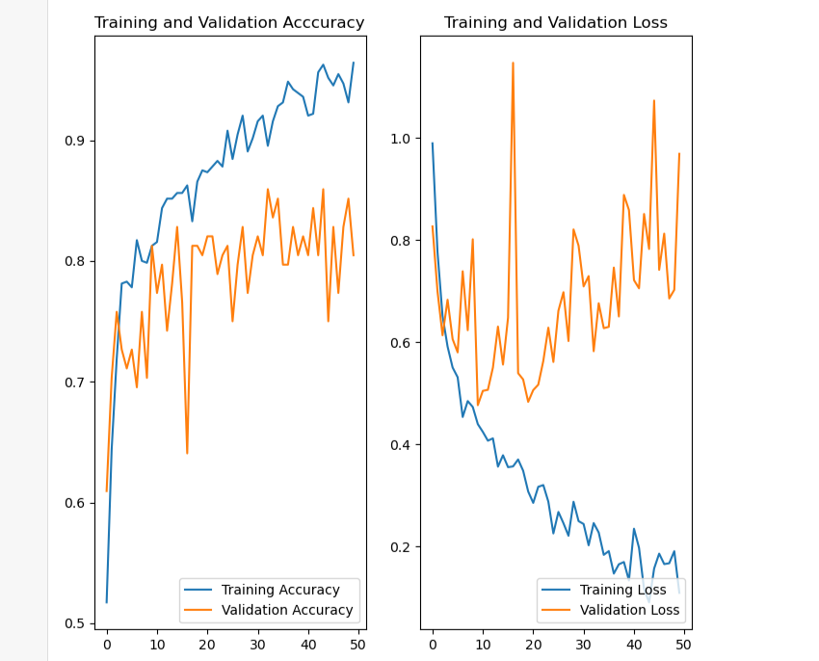

Epoch 1/50

40/40 [==============================] - 7s 118ms/step - loss: 0.9894 - accuracy: 0.5172 - val_loss: 0.8267 - val_accuracy: 0.6094

Epoch 2/50

40/40 [==============================] - 5s 114ms/step - loss: 0.7768 - accuracy: 0.6438 - val_loss: 0.6993 - val_accuracy: 0.7031

Epoch 3/50

40/40 [==============================] - 5s 114ms/step - loss: 0.6514 - accuracy: 0.7188 - val_loss: 0.6136 - val_accuracy: 0.7578

Epoch 4/50

40/40 [==============================] - 5s 116ms/step - loss: 0.5914 - accuracy: 0.7812 - val_loss: 0.6831 - val_accuracy: 0.7266

Epoch 5/50

40/40 [==============================] - 5s 114ms/step - loss: 0.5504 - accuracy: 0.7828 - val_loss: 0.6061 - val_accuracy: 0.7109

Epoch 6/50

40/40 [==============================] - 5s 114ms/step - loss: 0.5314 - accuracy: 0.7781 - val_loss: 0.5801 - val_accuracy: 0.7266

Epoch 7/50

40/40 [==============================] - 5s 114ms/step - loss: 0.4536 - accuracy: 0.8172 - val_loss: 0.7389 - val_accuracy: 0.6953

Epoch 8/50

40/40 [==============================] - 5s 114ms/step - loss: 0.4847 - accuracy: 0.8000 - val_loss: 0.6235 - val_accuracy: 0.7578

Epoch 9/50

40/40 [==============================] - 5s 114ms/step - loss: 0.4732 - accuracy: 0.7984 - val_loss: 0.8015 - val_accuracy: 0.7031

Epoch 10/50

40/40 [==============================] - 5s 114ms/step - loss: 0.4396 - accuracy: 0.8125 - val_loss: 0.4767 - val_accuracy: 0.8125

Epoch 11/50

40/40 [==============================] - 5s 114ms/step - loss: 0.4244 - accuracy: 0.8156 - val_loss: 0.5048 - val_accuracy: 0.7734

Epoch 12/50

40/40 [==============================] - 5s 114ms/step - loss: 0.4072 - accuracy: 0.8438 - val_loss: 0.5068 - val_accuracy: 0.7969

Epoch 13/50

40/40 [==============================] - 5s 114ms/step - loss: 0.4118 - accuracy: 0.8516 - val_loss: 0.5503 - val_accuracy: 0.7422

Epoch 14/50

40/40 [==============================] - 5s 115ms/step - loss: 0.3564 - accuracy: 0.8516 - val_loss: 0.6306 - val_accuracy: 0.7812

Epoch 15/50

40/40 [==============================] - 5s 114ms/step - loss: 0.3787 - accuracy: 0.8562 - val_loss: 0.5562 - val_accuracy: 0.8281

Epoch 16/50

40/40 [==============================] - 5s 114ms/step - loss: 0.3553 - accuracy: 0.8562 - val_loss: 0.6480 - val_accuracy: 0.7656

Epoch 17/50

40/40 [==============================] - 5s 114ms/step - loss: 0.3569 - accuracy: 0.8625 - val_loss: 1.1470 - val_accuracy: 0.6406

Epoch 18/50

40/40 [==============================] - 5s 114ms/step - loss: 0.3703 - accuracy: 0.8328 - val_loss: 0.5394 - val_accuracy: 0.8125

Epoch 19/50

40/40 [==============================] - 5s 114ms/step - loss: 0.3484 - accuracy: 0.8656 - val_loss: 0.5271 - val_accuracy: 0.8125

Epoch 20/50

40/40 [==============================] - 5s 113ms/step - loss: 0.3077 - accuracy: 0.8750 - val_loss: 0.4832 - val_accuracy: 0.8047

Epoch 21/50

40/40 [==============================] - 5s 114ms/step - loss: 0.2854 - accuracy: 0.8734 - val_loss: 0.5063 - val_accuracy: 0.8203

Epoch 22/50

40/40 [==============================] - 5s 114ms/step - loss: 0.3169 - accuracy: 0.8781 - val_loss: 0.5168 - val_accuracy: 0.8203

Epoch 23/50

40/40 [==============================] - 5s 114ms/step - loss: 0.3203 - accuracy: 0.8828 - val_loss: 0.5633 - val_accuracy: 0.7891

Epoch 24/50

40/40 [==============================] - 5s 114ms/step - loss: 0.2878 - accuracy: 0.8781 - val_loss: 0.6285 - val_accuracy: 0.8047

Epoch 25/50

40/40 [==============================] - 5s 114ms/step - loss: 0.2256 - accuracy: 0.9078 - val_loss: 0.5613 - val_accuracy: 0.8125

Epoch 26/50

40/40 [==============================] - 5s 115ms/step - loss: 0.2677 - accuracy: 0.8844 - val_loss: 0.6616 - val_accuracy: 0.7500

Epoch 27/50

40/40 [==============================] - 5s 114ms/step - loss: 0.2456 - accuracy: 0.9047 - val_loss: 0.6980 - val_accuracy: 0.7969

Epoch 28/50

40/40 [==============================] - 5s 114ms/step - loss: 0.2211 - accuracy: 0.9203 - val_loss: 0.6023 - val_accuracy: 0.8281

Epoch 29/50

40/40 [==============================] - 5s 114ms/step - loss: 0.2876 - accuracy: 0.8906 - val_loss: 0.8209 - val_accuracy: 0.7734

Epoch 30/50

40/40 [==============================] - 5s 114ms/step - loss: 0.2497 - accuracy: 0.9016 - val_loss: 0.7890 - val_accuracy: 0.8047

Epoch 31/50

40/40 [==============================] - 5s 114ms/step - loss: 0.2441 - accuracy: 0.9156 - val_loss: 0.7092 - val_accuracy: 0.8203

Epoch 32/50

40/40 [==============================] - 5s 114ms/step - loss: 0.2024 - accuracy: 0.9203 - val_loss: 0.7294 - val_accuracy: 0.8047

Epoch 33/50

40/40 [==============================] - 5s 114ms/step - loss: 0.2459 - accuracy: 0.8953 - val_loss: 0.5824 - val_accuracy: 0.8594

Epoch 34/50

40/40 [==============================] - 5s 114ms/step - loss: 0.2274 - accuracy: 0.9156 - val_loss: 0.6762 - val_accuracy: 0.8359

Epoch 35/50

40/40 [==============================] - 5s 114ms/step - loss: 0.1837 - accuracy: 0.9281 - val_loss: 0.6275 - val_accuracy: 0.8516

Epoch 36/50

40/40 [==============================] - 5s 114ms/step - loss: 0.1910 - accuracy: 0.9312 - val_loss: 0.6301 - val_accuracy: 0.7969

Epoch 37/50

40/40 [==============================] - 5s 116ms/step - loss: 0.1471 - accuracy: 0.9484 - val_loss: 0.7461 - val_accuracy: 0.7969

Epoch 38/50

40/40 [==============================] - 5s 115ms/step - loss: 0.1652 - accuracy: 0.9422 - val_loss: 0.6504 - val_accuracy: 0.8281

Epoch 39/50

40/40 [==============================] - 5s 117ms/step - loss: 0.1697 - accuracy: 0.9391 - val_loss: 0.8884 - val_accuracy: 0.8047

Epoch 40/50

40/40 [==============================] - 5s 117ms/step - loss: 0.1336 - accuracy: 0.9359 - val_loss: 0.8587 - val_accuracy: 0.8203

Epoch 41/50

40/40 [==============================] - 5s 117ms/step - loss: 0.2349 - accuracy: 0.9203 - val_loss: 0.7215 - val_accuracy: 0.8047

Epoch 42/50

40/40 [==============================] - 5s 114ms/step - loss: 0.1974 - accuracy: 0.9219 - val_loss: 0.7055 - val_accuracy: 0.8438

Epoch 43/50

40/40 [==============================] - 5s 114ms/step - loss: 0.1169 - accuracy: 0.9563 - val_loss: 0.8510 - val_accuracy: 0.8047

Epoch 44/50

40/40 [==============================] - 5s 114ms/step - loss: 0.0906 - accuracy: 0.9625 - val_loss: 0.7826 - val_accuracy: 0.8594

Epoch 45/50

40/40 [==============================] - 5s 114ms/step - loss: 0.1569 - accuracy: 0.9516 - val_loss: 1.0731 - val_accuracy: 0.7500

Epoch 46/50

40/40 [==============================] - 5s 114ms/step - loss: 0.1860 - accuracy: 0.9453 - val_loss: 0.7416 - val_accuracy: 0.8281

Epoch 47/50

40/40 [==============================] - 5s 117ms/step - loss: 0.1656 - accuracy: 0.9547 - val_loss: 0.8126 - val_accuracy: 0.7734

Epoch 48/50

40/40 [==============================] - 5s 118ms/step - loss: 0.1673 - accuracy: 0.9469 - val_loss: 0.6856 - val_accuracy: 0.8281

Epoch 49/50

40/40 [==============================] - 5s 114ms/step - loss: 0.1909 - accuracy: 0.9312 - val_loss: 0.7025 - val_accuracy: 0.8516

Epoch 50/50

40/40 [==============================] - 5s 114ms/step - loss: 0.1093 - accuracy: 0.9641 - val_loss: 0.9688 - val_accuracy: 0.8047

**Version 04**

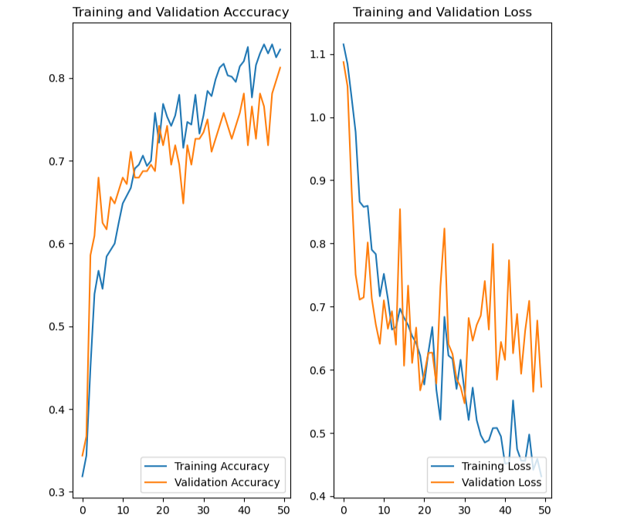

Epoch 1/50

40/40 [==============================] - 9s 129ms/step - loss: 1.1152 - accuracy: 0.3187 - val_loss: 1.0872 - val_accuracy: 0.3438

Epoch 2/50

40/40 [==============================] - 5s 117ms/step - loss: 1.0841 - accuracy: 0.3438 - val_loss: 1.0489 - val_accuracy: 0.3672

Epoch 3/50

40/40 [==============================] - 5s 118ms/step - loss: 1.0314 - accuracy: 0.4500 - val_loss: 0.8866 - val_accuracy: 0.5859

Epoch 4/50

40/40 [==============================] - 5s 115ms/step - loss: 0.9766 - accuracy: 0.5391 - val_loss: 0.7509 - val_accuracy: 0.6094

Epoch 5/50

40/40 [==============================] - 5s 114ms/step - loss: 0.8660 - accuracy: 0.5672 - val_loss: 0.7111 - val_accuracy: 0.6797

Epoch 6/50

40/40 [==============================] - 5s 113ms/step - loss: 0.8579 - accuracy: 0.5453 - val_loss: 0.7146 - val_accuracy: 0.6250

Epoch 7/50

40/40 [==============================] - 5s 113ms/step - loss: 0.8595 - accuracy: 0.5844 - val_loss: 0.8016 - val_accuracy: 0.6172

Epoch 8/50

40/40 [==============================] - 5s 114ms/step - loss: 0.7900 - accuracy: 0.5922 - val_loss: 0.7131 - val_accuracy: 0.6562

Epoch 9/50

40/40 [==============================] - 5s 114ms/step - loss: 0.7831 - accuracy: 0.6000 - val_loss: 0.6718 - val_accuracy: 0.6484

Epoch 10/50

40/40 [==============================] - 5s 113ms/step - loss: 0.7165 - accuracy: 0.6250 - val_loss: 0.6411 - val_accuracy: 0.6641

Epoch 11/50

40/40 [==============================] - 5s 113ms/step - loss: 0.7519 - accuracy: 0.6484 - val_loss: 0.7099 - val_accuracy: 0.6797

Epoch 12/50

40/40 [==============================] - 5s 114ms/step - loss: 0.7125 - accuracy: 0.6578 - val_loss: 0.6649 - val_accuracy: 0.6719

Epoch 13/50

40/40 [==============================] - 5s 114ms/step - loss: 0.6637 - accuracy: 0.6672 - val_loss: 0.6927 - val_accuracy: 0.7109

Epoch 14/50

40/40 [==============================] - 5s 114ms/step - loss: 0.6676 - accuracy: 0.6906 - val_loss: 0.6397 - val_accuracy: 0.6797

Epoch 15/50

40/40 [==============================] - 5s 114ms/step - loss: 0.6967 - accuracy: 0.6953 - val_loss: 0.8543 - val_accuracy: 0.6797

Epoch 16/50

40/40 [==============================] - 5s 114ms/step - loss: 0.6823 - accuracy: 0.7063 - val_loss: 0.6065 - val_accuracy: 0.6875

Epoch 17/50

40/40 [==============================] - 5s 114ms/step - loss: 0.6708 - accuracy: 0.6938 - val_loss: 0.7332 - val_accuracy: 0.6875

Epoch 18/50

40/40 [==============================] - 5s 114ms/step - loss: 0.6534 - accuracy: 0.7000 - val_loss: 0.6109 - val_accuracy: 0.6953

Epoch 19/50

40/40 [==============================] - 5s 114ms/step - loss: 0.6425 - accuracy: 0.7578 - val_loss: 0.6668 - val_accuracy: 0.6875

Epoch 20/50

40/40 [==============================] - 5s 114ms/step - loss: 0.6223 - accuracy: 0.7219 - val_loss: 0.5675 - val_accuracy: 0.7422

Epoch 21/50

40/40 [==============================] - 5s 114ms/step - loss: 0.5766 - accuracy: 0.7688 - val_loss: 0.5932 - val_accuracy: 0.7188

Epoch 22/50

40/40 [==============================] - 5s 115ms/step - loss: 0.6270 - accuracy: 0.7531 - val_loss: 0.6267 - val_accuracy: 0.7422

Epoch 23/50

40/40 [==============================] - 5s 115ms/step - loss: 0.6677 - accuracy: 0.7422 - val_loss: 0.6272 - val_accuracy: 0.6953

Epoch 24/50

40/40 [==============================] - 5s 114ms/step - loss: 0.5685 - accuracy: 0.7547 - val_loss: 0.5783 - val_accuracy: 0.7188

Epoch 25/50

40/40 [==============================] - 5s 114ms/step - loss: 0.5210 - accuracy: 0.7797 - val_loss: 0.7313 - val_accuracy: 0.6953

Epoch 26/50

40/40 [==============================] - 5s 114ms/step - loss: 0.6838 - accuracy: 0.7156 - val_loss: 0.8236 - val_accuracy: 0.6484

Epoch 27/50

40/40 [==============================] - 5s 113ms/step - loss: 0.6225 - accuracy: 0.7469 - val_loss: 0.6406 - val_accuracy: 0.7188

Epoch 28/50

40/40 [==============================] - 5s 114ms/step - loss: 0.6173 - accuracy: 0.7437 - val_loss: 0.6251 - val_accuracy: 0.6953

Epoch 29/50

40/40 [==============================] - 5s 114ms/step - loss: 0.5697 - accuracy: 0.7797 - val_loss: 0.5856 - val_accuracy: 0.7266

Epoch 30/50

40/40 [==============================] - 5s 114ms/step - loss: 0.6158 - accuracy: 0.7328 - val_loss: 0.5730 - val_accuracy: 0.7266

Epoch 31/50

40/40 [==============================] - 5s 114ms/step - loss: 0.5654 - accuracy: 0.7547 - val_loss: 0.5470 - val_accuracy: 0.7344

Epoch 32/50

40/40 [==============================] - 5s 113ms/step - loss: 0.5206 - accuracy: 0.7844 - val_loss: 0.6820 - val_accuracy: 0.7500

Epoch 33/50

40/40 [==============================] - 5s 113ms/step - loss: 0.5717 - accuracy: 0.7781 - val_loss: 0.6461 - val_accuracy: 0.7109

Epoch 34/50

40/40 [==============================] - 5s 114ms/step - loss: 0.5201 - accuracy: 0.7984 - val_loss: 0.6711 - val_accuracy: 0.7266

Epoch 35/50

40/40 [==============================] - 5s 113ms/step - loss: 0.4964 - accuracy: 0.8125 - val_loss: 0.6858 - val_accuracy: 0.7422

Epoch 36/50

40/40 [==============================] - 5s 114ms/step - loss: 0.4848 - accuracy: 0.8172 - val_loss: 0.7405 - val_accuracy: 0.7578

Epoch 37/50

40/40 [==============================] - 5s 114ms/step - loss: 0.4884 - accuracy: 0.8031 - val_loss: 0.6637 - val_accuracy: 0.7422

Epoch 38/50

40/40 [==============================] - 5s 114ms/step - loss: 0.5076 - accuracy: 0.8016 - val_loss: 0.7992 - val_accuracy: 0.7266

Epoch 39/50

40/40 [==============================] - 5s 113ms/step - loss: 0.5079 - accuracy: 0.7953 - val_loss: 0.5843 - val_accuracy: 0.7422

Epoch 40/50

40/40 [==============================] - 5s 113ms/step - loss: 0.4945 - accuracy: 0.8141 - val_loss: 0.6440 - val_accuracy: 0.7578

Epoch 41/50

40/40 [==============================] - 5s 114ms/step - loss: 0.4514 - accuracy: 0.8203 - val_loss: 0.6157 - val_accuracy: 0.7812

Epoch 42/50

40/40 [==============================] - 5s 114ms/step - loss: 0.4523 - accuracy: 0.8375 - val_loss: 0.7735 - val_accuracy: 0.7188

Epoch 43/50

40/40 [==============================] - 5s 113ms/step - loss: 0.5515 - accuracy: 0.7766 - val_loss: 0.6262 - val_accuracy: 0.7656

Epoch 44/50

40/40 [==============================] - 5s 115ms/step - loss: 0.4744 - accuracy: 0.8156 - val_loss: 0.6884 - val_accuracy: 0.7266

Epoch 45/50

40/40 [==============================] - 5s 114ms/step - loss: 0.4561 - accuracy: 0.8297 - val_loss: 0.5937 - val_accuracy: 0.7812

Epoch 46/50

40/40 [==============================] - 5s 114ms/step - loss: 0.4558 - accuracy: 0.8406 - val_loss: 0.6620 - val_accuracy: 0.7656

Epoch 47/50

40/40 [==============================] - 5s 114ms/step - loss: 0.4975 - accuracy: 0.8297 - val_loss: 0.7091 - val_accuracy: 0.7188

Epoch 48/50

40/40 [==============================] - 5s 114ms/step - loss: 0.4416 - accuracy: 0.8406 - val_loss: 0.5653 - val_accuracy: 0.7812

Epoch 49/50

40/40 [==============================] - 5s 114ms/step - loss: 0.4590 - accuracy: 0.8250 - val_loss: 0.6780 - val_accuracy: 0.7969

Epoch 50/50

40/40 [==============================] - 5s 114ms/step - loss: 0.4313 - accuracy: 0.8344 - val_loss: 0.5730 - val_accuracy: 0.8125