**Linear Model:**

**1.camera accessory:**

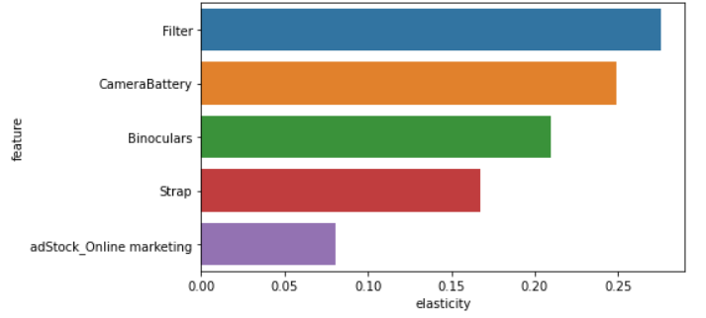

**2.Gaming**

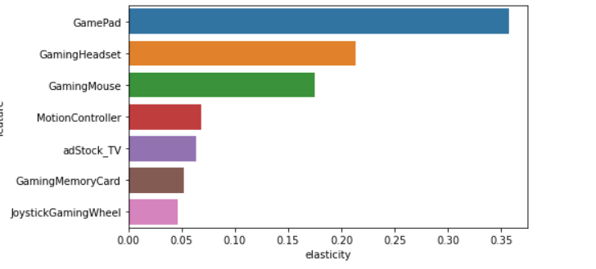

**3.Home audio**

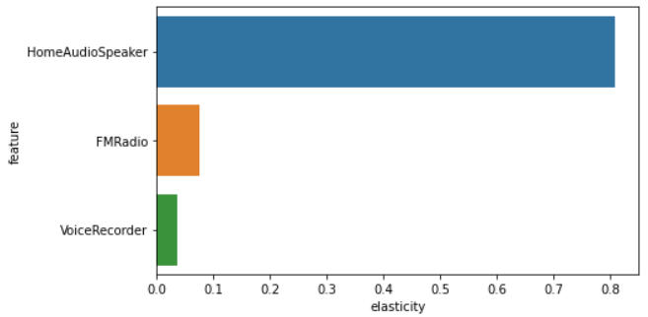

**Log linear model:**

**1.Camera accessory**

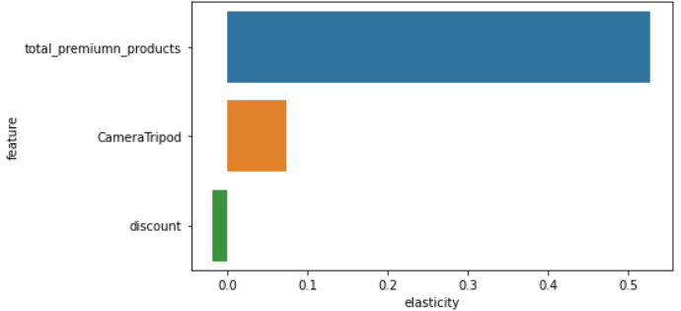

**2.Gaming:**

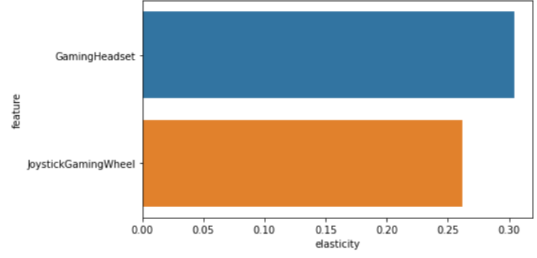

**3.Home Audio:**

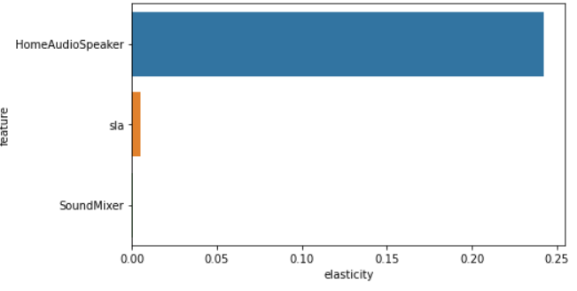

**Distributed Lag:**

**1.Camera accessory**

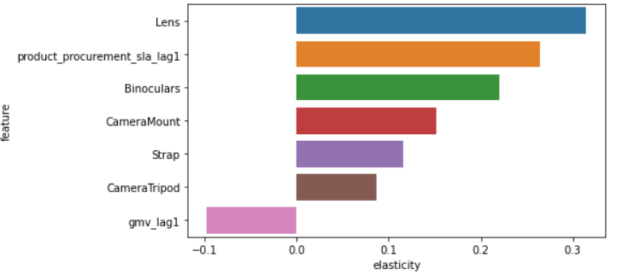

**2.Gaming:**

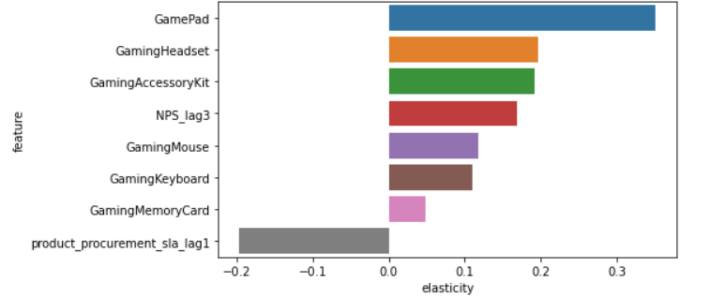

**3.** **Home audio:**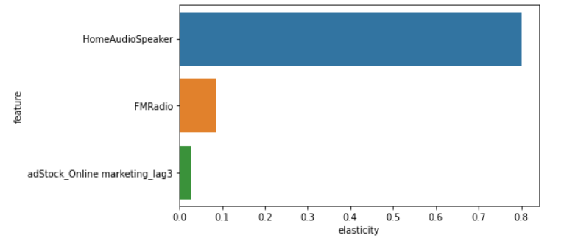

6. Recommendations

1. Camera Accessory

* ElecKart should promote products like - Filter, Camera Battery, Binoculars, Strap & Camera Tripod as it has a very positive & incremental impact on the overall Revenue(GMV) growth.
* More marketing efforts should be spent on the promotion of Premium products.
* For marketing & products promotion, it’s a good idea to invest more in Online Marketing channels as it has shown a positive impact in boosting the overall revenue for the company.
* A slight increase in product discounts could also help to increase the sales marginally.

2. Gaming Accessory

* ElecKart should promote products like – GamePad, Gaming Headset, Gaming Mouse, Gaming Memory Cards & Accessory Kits as they fetch the highest revenue(GMV) for the company.
* Marketing & Advertising spends on TV should be slightly increased as it has a positive impact on the revenue.
* An increase in NPS scores for the last 3 weeks has also contributed positively to the revenue growth of the business.
* Product Procurement SLA should be reduced for the last 1 week.

3. Home Audio

* ElecKart should promote products like – Home Audio Speakers & FM Radio as they have shown a significant positive impact on revenue(GMV) growth (especially through the sale of Home Audio Speakers) of the company.
* Marketing & Advertising spends on Online Marketing channels for the last 3 weeks should be slightly increased as it can contribute to the revenue growth marginally.
* Even if in case the SLA increases slightly, it hasn’t negatively affected the revenue growth for the business.