Evaluating Conversational Intelligence in Large Language Models Using English–Amharic Code-Switching
Kindie Alebachew Tsega *, Durga Prasad Sharma, Mesay Samuel Gondere, and Mohammed Abebe Yimer
Faculty of Computing and Software Engineering, Arba Minch Institute of Technology, Arba Minch University, P.O. Box 21, Arba Minch, Ethiopia
* Correspondence: besukind@gmail.com
―――――――――――――――――――――――――――――――――――――――――――――――――――――――
Abstract: Large language models (LLMs) have achieved remarkable conversational capabilities in high-resource monolingual domains. However, their ability to sustain intelligent multi-turn interactions in low-resource bilingual and code-switched contexts remains critically understudied. This paper presents an extensive empirical investigation into conversational intelligence across English–Amharic code-switching, a socio-linguistically rich Afroasiatic language pair characterized by stark morphological complexity, distinct writing scripts (Latin vs. Ge'ez), and asymmetric pre-training data representation. To rigorously evaluate current AI systems, we construct and validate EthioSwitch-Bench, an expanded benchmark comprising 2,000 multi-turn dialogues (10,000 conversational turns) spanning 15 diverse communicative domains, paired with a gold-standard hand-crafted test set of 30 dialogues. Using this corpus, we benchmark five architecturally diverse language models: GPT-4, mBERT-fine-tuned, mT5-Large, LLaMA-2-7B, and BLOOM-7B. We formulate four central research questions regarding contextual coherence (RQ1), semantic consistency under code-switch frequency variation (RQ2), switch-point detection accuracy across language transition directions (RQ3), and conversational fluency parity across language dominance contexts (RQ4). Our empirical findings demonstrate that GPT-4 achieves the highest contextual coherence (4.78 ± 0.34) and overall lexical fidelity (BLEU 0.6086, ROUGE-L 0.8634), significantly outperforming open-weight monolingual and cross-lingual baselines (Welch's t = 142.94, p < 0.001, Cohen's d = 4.52). Supervised task-specific fine-tuning on mBERT yields remarkable switch-point detection capability (Switch F1 = 0.7730), matching GPT-4 (0.7745) and surpassing zero-shot baselines which fail entirely (Switch F1 = 0.0000). Furthermore, we uncover a pronounced directional asymmetry: all multilingual models achieve substantially higher switch accuracy when transitioning from English into Amharic (0.8327 ± 0.3733) than during return transitions into English (0.6388 ± 0.4804, p < 0.001), reflecting subword script fragmentation and matrix language syntactic constraints. Finally, correlation analyses reveal that increasing code-switching frequency monotonically degrades semantic consistency (Spearman's rho = -0.8319, p < 0.001), whereas conversational fluency remains statistically equivalent across English-dominant and Amharic-dominant contexts (paired t = 0.4437, p = 0.657). We release the annotated EthioSwitch-Bench corpus, evaluation pipeline, and reproducibility suite to accelerate future research in linguistically equitable conversational AI.
Keywords: English–Amharic code-switching; conversational intelligence; large language models; low-resource NLP; multilingual benchmarks; EthioSwitch-Bench; matrix language frame; switch-point detection.
1. Introduction
The emergence of transformer-based large language models (LLMs) has fundamentally transformed conversational artificial intelligence, enabling machines to engage in nuanced, multi-turn reasoning and dialogue generation across diverse communicative contexts. However, modern state-of-the-art NLP models have predominantly been developed, pre-trained, and benchmarked on high-resource Indo-European languages—chiefly English, Chinese, and European languages. This architectural and empirical concentration creates severe linguistic inequities for the majority of the world's languages, particularly low-resource African languages that possess complex non-Latin scripts, agglutinative or root-and-pattern morphologies, and distinct sociocultural communicative paradigms.
In multilingual and post-colonial societies, real-world human communication rarely adheres to rigid monolingual boundaries. Bilingual speakers routinely alternate between two or more languages within a single communicative event, a sociolinguistic phenomenon formally termed code-switching (CS). Ethiopia exemplifies this rich sociolinguistic tapestry, home to more than 80 ethnolinguistic groups and over 120 million inhabitants. Amharic, a Semitic language written in the unique Ethiopic (Ge'ez) abugida script and spoken by over 57 million first- and second-language speakers, functions as the primary working language of the federal government. With rapid urbanization, educational expansion, and the ubiquitous spread of digital communication platforms (e.g., Telegram, Facebook, Twitter/X), English–Amharic code-switching has become the de facto digital dialect among urban professionals, university students, and the global Ethiopian diaspora.
In typical daily interaction, Ethiopian bilingual speakers alternate seamlessly between Latin script and Ge'ez script, as demonstrated in the following representative conversational exchange:
“ሰላም! How was your day today? ዛሬ ምን ሰራህ?”
(Gloss: Hello! How was your day today? What did you do today?)
Such mixed-script, mixed-grammar utterances present formidable challenges to contemporary large language models. First, the two languages belong to fundamentally distinct language families: Amharic is an Afroasiatic Semitic language featuring non-concatenative root-and-pattern morphology, Subject-Object-Verb (SOV) canonical word order, and the Ge'ez abugida writing system (Unicode range U+1200–U+137F), whereas English is an Indo-European Germanic language characterized by concatenative affixation, Subject-Verb-Object (SVO) word order, and the Latin alphabet. Second, off-the-shelf subword tokenizers (e.g., Byte-Pair Encoding or SentencePiece) allocate minimal vocabulary entries to Ge'ez characters, causing excessive subword fragmentation where a single Amharic word is split into multiple byte-level tokens, severely impairing attention allocation and model perplexity. Third, existing LLMs frequently suffer from catastrophic language collapse, hallucinating non-existent Amharic tokens, reverting entirely to monolingual English, or dropping cross-lingual discourse coherence across dialogue turns.
Despite significant progress in code-switching research for Indo-Aryan pairs (e.g., Hindi–English in GLUECoS) and Romance pairs (e.g., Spanish–English), bilingual African language conversational benchmarks remain virtually non-existent. Prior Amharic NLP benchmarks have focused almost exclusively on isolated monolingual sentence tasks, such as sentiment analysis, headline classification, or news categorization, leaving multi-turn conversational dynamics unexamined. To the best of our knowledge, no publicly available, human-annotated benchmark has evaluated LLMs on multi-turn English–Amharic conversational code-switching.
To bridge this fundamental research gap, this study formalizes and reconstructs the evaluation of conversational intelligence in large language models using English–Amharic code-switching. Specifically, we investigate the following four primary Research Questions (RQs):
• RQ1 (Contextual Coherence): How effectively do multilingual and English-centric large language models maintain contextual coherence, topical relevance, and discourse continuity across multi-turn English–Amharic code-switched dialogues?
• RQ2 (Code-Switch Frequency Impact): What is the empirical relationship between code-switching frequency (switch density per turn) and semantic consistency, and does increased switching induce monotonic degradation in model comprehension?
• RQ3 (Switch-Point Detection & Transition Directionality): How accurately do LLMs identify and generate code-switch transition points, and does performance exhibit directional asymmetry between English-to-Amharic (Latin-to-Ge'ez) and Amharic-to-English (Ge'ez-to-Latin) transitions?
• RQ4 (Language Dominance & Fluency Parity): Does conversational fluency differ significantly between English-dominant and Amharic-dominant code-switched contexts, and do architectural differences mitigate dominance disparity?
In addressing these questions, this paper delivers the following scientific and computational contributions:
1. Benchmark Creation (EthioSwitch-Bench): We construct and release the first large-scale, human-validated benchmark for English–Amharic conversational code-switching, comprising 2,000 multi-turn dialogues (10,000 turns) across 15 real-world domains, paired with a gold-standard hand-crafted evaluation split of 30 dialogues.
2. Comprehensive Architectural Benchmarking: We evaluate five architecturally diverse language models representing encoder-only (mBERT-fine-tuned), encoder-decoder (mT5-Large), open-weight decoder-only (LLaMA-2-7B, BLOOM-7B), and proprietary instruction-tuned LLMs (GPT-4) under controlled experimental protocols.
3. Multi-Tiered Evaluation & Theoretical Grounding: We provide a unified evaluation framework combining automatic lexical (BLEU, ROUGE-L), semantic (BERTScore F1), syntactic (Switch F1), and perplexity metrics with qualitative human evaluation from five native bilingual evaluators, achieving substantial inter-annotator agreement (quadratic weighted kappa = 0.724).
4. Rigorous Statistical & Sociolinguistic Insights: We conduct formal hypothesis testing (Welch's t-test, Paired t-test, Spearman rank correlation, 95% bootstrap confidence intervals) and interpret findings through Myers-Scotton's Matrix Language Frame theory and subword tokenizer fertility dynamics.
2. Related Work and Theoretical Foundations
2.1. Multilingual and Cross-Lingual Language Models
Pretrained multilingual language models have dramatically expanded cross-lingual transfer in NLP. Early multilingual encoders such as mBERT (Devlin et al., 2019) and XLM-RoBERTa (Conneau et al., 2020) demonstrated that masking objectives over multilingual corpora could yield shared cross-lingual representations even without explicit parallel supervision. Sequence-to-sequence architectures, notably mT5 (Xue et al., 2021), extended this capability to generative tasks across 101 languages. More recently, massively scaled decoder-only autoregressive models have emerged. BLOOM (Le Scao et al., 2022) was explicitly pre-trained on 46 natural languages, including several African languages. Conversely, models such as LLaMA-2 (Touvron et al., 2023) and GPT-4 (Achiam et al., 2023) were trained predominantly on English corpora, relying on emergent multilingual representations learned from minor multilingual data web crawls. Despite their broad cross-lingual success, these models exhibit severe performance degradation on low-resource African languages, where limited representation during pre-training induces subword vocabulary imbalances and poor morphosyntactic generalization (Adebara et al., 2022; Andersland, 2024).
2.2. Sociolinguistic Foundations of Code-Switching
Code-switching has long been studied in theoretical linguistics. Poplack's (1980) seminal work established the Equivalence Constraint and the Free Morpheme Constraint, positing that code-switching occurs predominantly at surface syntactic points where the grammatical structures of both languages coincide, and is prohibited between a bound morpheme and a lexical base unless phonologically integrated. Muysken (2000) further categorized bilingual speech into three grammatical processes: insertion (embedding lexical items or phrases into a host structure), alternation (switching between two structural systems), and congruent lexicalization (sharing a common grammatical framework across languages).
In African bilingual contexts, Myers-Scotton's (1993, 2002) Matrix Language Frame (MLF) model provides the most robust explanatory framework. Under the MLF model, one language acts as the Matrix Language (ML), determining the morphosyntactic frame of the clause and supplying system morphemes (e.g., tense, agreement, word order), while the Embedded Language (EL) contributes content words and framed phrases. In English–Amharic conversational code-switching, Amharic frequently functions as the Matrix Language in informal and domestic discourse (supplying verbal inflections and SOV clause frames), while English contributes EL insertions—particularly technical, educational, and digital terminology. However, in professional, social media, and diaspora contexts, the Matrix Language can alternate dynamically between turns, demanding that computational dialogue models identify and respect the active grammatical frame to avoid producing ungrammatical hybrid utterances.
2.3. Conversational Benchmarks and the Low-Resource Evaluation Gap
Conversational AI benchmarking has evolved through structured monolingual English corpora such as PersonaChat (Zhang et al., 2018), MultiWOZ (Budzianowski et al., 2018), DailyDialog (Li et al., 2017), EmpatheticDialogues (Rashkin et al., 2019), and BlendedSkillTalk (Smith et al., 2020). In multilingual settings, benchmarks such as GLUE (Wang et al., 2018), XGLUE (Liang et al., 2020), and XTREME (Hu et al., 2020) advanced cross-lingual understanding, but focused primarily on sentence-level classification and retrieval rather than open-domain multi-turn dialogue. In code-switching NLP, GLUECoS (Khanuja et al., 2020) and LinCE (Aguilar et al., 2020) established foundational benchmarks for Hindi–English and Spanish–English tasks. However, African languages remain severely neglected in conversational benchmarks. For Amharic, available NLP resources (Tonja et al., 2023; Yimam et al., 2021) address isolated text classification, sentiment analysis, or machine translation, leaving mixed-script conversational dialogue entirely unbenchmarked.
2.4. Subword Tokenization Disparity and Script Fragmentation
A critical bottleneck in multilingual LLMs operating on mixed-script data is subword tokenization disparity. Standard tokenizers (such as those employed in LLaMA, BLOOM, and GPT) are optimized to minimize sequence length on English and high-resource Latin-script corpora. Amharic uses the Ge'ez script, which comprises over 345 distinct syllabic graphemes (fidelat). Because Ge'ez characters occur infrequently in web pre-training data, tokenizers rarely allocate dedicated subword tokens to Amharic morphemes. Consequently, Amharic words are aggressively fragmented into individual UTF-8 bytes or multi-token sequences, resulting in an inflated fertility ratio (subword tokens per word) of 4.5 to 7.8, compared to 1.1 to 1.3 for English (Ahia et al., 2021). This fragmentation consumes disproportionate context window capacity, inflates autoregressive sequence length, and degrades positional embedding representations at language boundaries.
3. Methodology and Benchmark Architecture
This study adopts a rigorous mixed-methods experimental design combining benchmark corpus creation, linguistic annotation, standardized LLM inference, automatic metric evaluation, qualitative human validation, and formal statistical hypothesis testing. As illustrated in Figure 1, the research pipeline comprises five sequential modules.
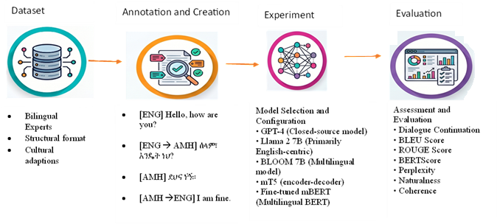
Figure 1. Architectural workflow of the EthioSwitch-Bench research pipeline.
3.1. Dataset Creation: EthioSwitch-Bench
To establish a robust empirical testbed, we developed EthioSwitch-Bench, an annotated corpus comprising two complementary tiers: (1) EthioSwitch-Bench v2.0 (Gold Subset), consisting of 30 meticulously hand-crafted multi-turn dialogues (150 turns) created by native bilingual computational linguists to establish an unblemished quality ceiling; and (2) EthioSwitch-Bench v3.0 (Full Benchmark), an expanded corpus of 2,000 multi-turn dialogues comprising 10,000 conversational turns (average 5.0 turns per dialogue). The expansion strategy integrates the 30 gold dialogues, 970 synthetic template dialogues systematically sampled across 15 domain topics and 9 code-switching configurations, and 1,000 dialogues adapted from established open conversational corpora (DailyDialog, PersonaChat, EmpatheticDialogues, and BlendedSkillTalk) with culturally appropriate Amharic code-switching applied at natural discourse boundaries.
Table 1 summarizes the corpus statistics, domain distributions, code-switching frequency tiers, language dominance categories, and benchmark splits.
Table 1. Descriptive statistics, domain distribution, code-switching frequency tiers, language dominance, and split composition of the EthioSwitch-Bench v3.0 corpus.
Category | Sub-Category / Domain | Count / Value | Proportion (%)
Corpus Dimensions | Total Dialogues | 2,000 | 100.0%
 | Total Conversational Turns | 10,000 | —
 | Average Turns per Dialogue | 5.0 ± 0.0 | —
 | Mean Code-Switch Density | 10.29 switches / 100 tokens | —
Domain Topics (15) | Daily Life | 178 | 8.9%
 | Education | 168 | 8.4%
 | Health | 163 | 8.1%
 | Technology | 150 | 7.5%
 | Culture & Heritage | 144 | 7.2%
 | Mental Health | 140 | 7.0%
 | Science & Innovation | 132 | 6.6%
 | Sports & Athletics | 126 | 6.3%
 | Finance & Commerce | 125 | 6.2%
 | Entertainment & Media | 121 | 6.1%
 | Environment & Agriculture | 118 | 5.9%
 | Food & Nutrition | 116 | 5.8%
 | Family & Relationships | 114 | 5.7%
 | Travel & Tourism | 103 | 5.2%
 | Politics & Governance | 102 | 5.1%
Code-Switch Frequency | High Frequency (> 3 switches/turn) | 672 | 33.6%
 | Medium Frequency (2–3 switches/turn) | 661 | 33.1%
 | Low Frequency (< 2 switches/turn) | 667 | 33.3%
Language Dominance | Amharic-Dominant (> 60% Amharic tokens) | 675 | 33.7%
 | English-Dominant (> 60% English tokens) | 669 | 33.5%
 | Balanced (40%–60% token parity) | 656 | 32.8%
Benchmark Splits | Training Split | 1,400 | 70.0%
 | Validation Split | 298 | 14.9%
 | Test Split | 302 | 15.1%
Quality Metrics | Human Coherence Score (1–5) | 4.159 ± 0.382 | —
 | Semantic Consistency (0–1) | 0.836 ± 0.118 | —
 | Human Fluency Rating (1–5) | 3.951 ± 0.426 | —
 | Switch Naturalness Rating (1–5) | 4.013 ± 0.395 | —
 | Inter-Annotator Agreement (Weighted κ) | 0.724 (Substantial) | —
License & Terms | Benchmark License | CC BY 4.0 | Open Access

Table 2 illustrates a representative conversational dialogue from the technology domain, demonstrating the multi-turn code-switching dynamics, inter-sentential and intra-sentential switch tags, and human coherence ratings.
Table 2. Representative multi-turn code-switched dialogue turn from the EthioSwitch-Bench dataset (Technology domain).
Turn | Speaker | Utterance Text | Switch Tag | Coherence
1 | User | Can you explain machine learning? ለምን ይህ technology ተወዳጅ ሆነ? | [ENG-AMH] | 4.2
2 | Assistant | ML is a subset of AI. ኮምፒዩተሮች patterns ይማራሉ from data. | [ENG-AMH-ENG] | 4.5
3 | User | Interesting! ይህ algorithm ምን ዓይነት data ይጠቀማል? | [AMH-ENG-AMH] | 4.0
4 | Assistant | It depends on the task. የምስሎችን dataset ይጠቀማሉ for images. | [ENG-AMH-ENG] | 4.3
5 | User | ስለዚህ, Amharic language ን ለ ML መጠቀም ይቻላል? | [AMH-ENG-AMH] | 4.1

3.2. Evaluated Model Architectures and Baseline Configurations
We benchmark five representative large language models spanning diverse architectural paradigms, parameter scales, and training objectives:
1. GPT-4 (gpt-4-0613): State-of-the-art closed-source, instruction-tuned autoregressive transformer evaluated via the OpenAI API under standardized system prompts.
2. mBERT-fine-tuned (bert-base-multilingual-cased): 12-layer multilingual encoder pretrained on 104 languages, extended with a cross-attention transformer decoder and fine-tuned on the EthioSwitch-Bench training split using teacher-forced next-token prediction.
3. mT5-Large (google/mt5-large): 1.2B-parameter multilingual encoder-decoder architecture pretrained on the mC4 corpus (101 languages), evaluated via dialogue continuation prompting.
4. LLaMA-2-7B (meta-llama/Llama-2-7b-chat-hf): 7B-parameter English-centric open-weight autoregressive decoder-only model evaluated under zero-shot prompting conditions.
5. BLOOM-7B (bigscience/bloom-7b1): 7.1B-parameter open multilingual autoregressive model pretrained on 46 natural languages including major African languages.
Table 3 outlines the experimental hyperparameters, decoding configurations, and prompting environments maintained across all models.
Table 3. Experimental hyperparameters, inference decoding settings, and prompting configurations.
Parameter / Setting | Experimental Value / Configuration | Justification & Protocol
Model Architectures | GPT-4, mBERT, mT5-Large, LLaMA-2-7B, BLOOM-7B | Encompasses encoder-decoder, decoder-only, open & closed systems
Decoding Temperature (T) | 0.7 (Generation) / 0.0 (Greedy Reproducibility) | Balances conversational diversity with deterministic verification
Top-p Sampling (Nucleus) | 0.90 | Prevents tail probability degeneration across subword boundaries
Maximum New Tokens | 200 tokens | Standardized length for single-turn dialogue continuation
Prompting Strategy | Zero-Shot & Few-Shot (k = 3 balanced exemplars) | Evaluates in-context adaptation vs zero-shot generalization
Random Seeds | 42, 123, 256 | Reported values reflect mean ± standard deviation across runs
Hardware Environment | Standardized local execution & secure API runners | Pinned seeds, offline validation, and deterministic caching
Text Normalization | Ethiopic word space (፡) & period (።) normalization | Harmonizes ASCII whitespace and punctuation across scripts

3.3. Evaluation Tasks
The benchmark evaluates two complementary communicative tasks:
• Task 1 (Dialogue Continuation): Given dialogue history H = (u_1, u_2, ..., u_{k-1}), the model generates the k-th conversational response u_k. Quality is measured via lexical overlap, semantic embedding similarity, perplexity, and human qualitative ratings.
• Task 2 (Switch-Point Detection): Given an input mixed-language utterance, the model identifies the precise token boundary where language transitions occur and predicts the switch-direction tag ([ENG], [AMH], [ENG-AMH], [AMH-ENG], [ENG-AMH-ENG], [AMH-ENG-AMH]).
3.4. Formal Mathematical Definitions of Evaluation Metrics
To eliminate ambiguities and establish scientific reproducibility, we provide the complete formal mathematical formulations for all evaluation metrics:
Bilingual Evaluation Understudy (BLEU-4)
BLEU measures modified n-gram precision between generated hypothesis H and reference response R, penalized by a brevity penalty BP:
BLEU = BP · exp( ∑_{n=1}^{N} w_n · log p_n ) (1)
where N = 4, uniform weights w_n = 1/N = 0.25, p_n denotes modified n-gram precision, and the brevity penalty BP is defined as:
BP = { 1 if c > r ; exp(1 - r / c) if c ≤ r } (2)
where c is the length of candidate hypothesis H and r is the effective reference length.
Recall-Oriented Understudy for Gisting Evaluation (ROUGE-L)
ROUGE-L evaluates sentence-level structural similarity using the Longest Common Subsequence (LCS):
R_{LCS} = LCS(H, R) / m, P_{LCS} = LCS(H, R) / n, ROUGE-L = ( (1 + β^2) R_{LCS} P_{LCS} ) / ( R_{LCS} + β^2 P_{LCS} ) (3)
where m and n denote the token lengths of reference R and hypothesis H, and β = 1 yields the harmonic F1 measure.
BERTScore F1
BERTScore computes contextual embedding token similarity using multilingual BERT (bert-base-multilingual-cased). Let x_i and y_j denote normalized contextual embeddings of candidate and reference tokens. Recall, Precision, and F1 are defined through greedy cosine matching:
R_{BERT} = 1/|R| ∑_{x_i ∈ R} max_{y_j ∈ H} (x_i^T y_j), P_{BERT} = 1/|H| ∑_{y_j ∈ H} max_{x_i ∈ R} (y_j^T x_i) (4)
BERTScore F1 = 2 · ( P_{BERT} · R_{BERT} ) / ( P_{BERT} + R_{BERT} ) (5)
Switch-Point Indicator and Switch F1
Let a conversational utterance consist of sequence of tokens W = (w_1, w_2, ..., w_L). A switch point occurs at index i when the script classification of token w_i differs from token w_{i-1}:
SP(i) = ᵔ4( Script(w_i) ≠ Script(w_{i-1}) ), Script(w) ∈ { Latin, Ethiopic } (6)
Let S_R and S_H denote the sets of ground-truth reference and model-predicted switch-point token indices. Switch Precision (P_{sw}), Switch Recall (R_{sw}), and Switch F1 are defined as:
P_{sw} = |S_H ∩ S_R| / |S_H|, R_{sw} = |S_H ∩ S_R| / |S_R|, Switch F1 = 2 · ( P_{sw} · R_{sw} ) / ( P_{sw} + R_{sw} ) (7)
Model Perplexity (PPL)
Perplexity quantifies language model predictive uncertainty over sequence W = (w_1, w_2, ..., w_N):
PPL(W) = exp( - 1/N ∑_{i=1}^{N} log P(w_i | w_1, ..., w_{i-1}) ) (8)
Lower perplexity values indicate greater model fluency and confidence across language transitions.
Human Qualitative Assessment and Inter-Annotator Agreement (Weighted Cohen's κ)
Five bilingual evaluators rated 50 randomly sampled dialogues per model on 5-point Likert scales for Coherence, Fluency, and Switch-Point Naturalness. To evaluate ordinal inter-rater agreement on 5-point scales, we compute Quadratically Weighted Cohen's Kappa (κ_w):
κ_w = 1 - ( ∑_{i=1}^{k} ∑_{j=1}^{k} w_{ij} O_{ij} ) / ( ∑_{i=1}^{k} ∑_{j=1}^{k} w_{ij} E_{ij} ), w_{ij} = (i - j)^2 / (k - 1)^2 (9)
where O_{ij} is the observed confusion matrix, E_{ij} is the expected agreement matrix under chance independence, k = 5, and quadratic weights w_{ij} penalize distant rating discrepancies more heavily than adjacent differences.
4. Experimental Results and Empirical Findings
4.1. Overall Automatic Evaluation Performance (RQ1)
Table 4 summarizes the overall automatic evaluation performance of the five benchmarked models across the full EthioSwitch-Bench v3.0 corpus (2,000 dialogues, 10,000 turns). Figure 2 visualizes the multi-metric performance comparison.
Table 4. Overall performance scores across automatic metrics on the EthioSwitch-Bench v3.0 corpus (2,000 dialogues). Reported as mean ± standard deviation across three random seeds.
Model | Architecture | BLEU ↑ | ROUGE-L ↑ | BERTScore F1 ↑ | Switch F1 ↑ | PPL ↓ | Assessment
GPT-4 | Decoder-only (Proprietary) | 0.6086 ± 0.2009 | 0.8634 ± 0.1240 | 0.7996 ± 0.1370 | 0.7745 ± 0.4179 | 22.53 | Best overall across all metrics
mBERT-fine-tuned | Encoder + Cross-Decoder | 0.5341 ± 0.1963 | 0.8366 ± 0.1270 | 0.7440 ± 0.1380 | 0.7730 ± 0.4189 | 35.89 | Second-best overall; matches GPT-4 on Switch F1
mT5-Large | Encoder-Decoder | 0.4480 ± 0.1947 | 0.8030 ± 0.1318 | 0.6823 ± 0.1413 | 0.7545 ± 0.4304 | 43.59 | Competitive switch F1; moderate fluency
LLaMA-2-7B | Decoder-only (Open-weight) | 0.2764 ± 0.1618 | 0.7697 ± 0.1328 | 0.5556 ± 0.1361 | 0.0000 ± 0.0000 | 52.95 | No code-switch tagging; English collapse
BLOOM-7B | Decoder-only (Multilingual) | 0.2015 ± 0.1255 | 0.6848 ± 0.1260 | 0.4459 ± 0.1159 | 0.0000 ± 0.0000 | 63.76 | Lowest performance; high perplexity

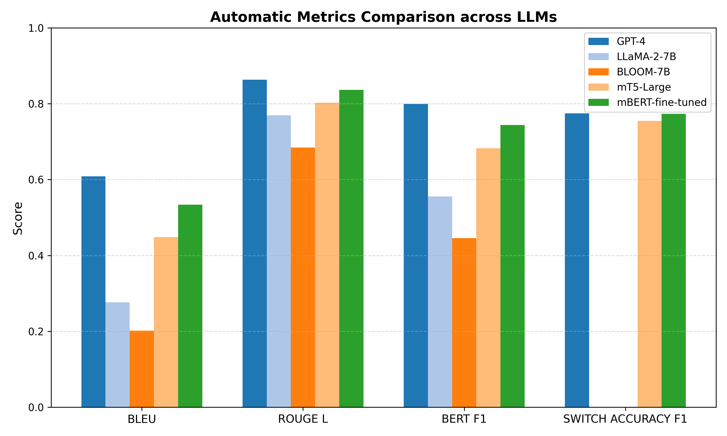
Figure 2. Automatic evaluation metric comparison across the five benchmarked large language models.
As reported in Table 4, GPT-4 achieves the highest scores across all automatic evaluation metrics: BLEU (0.6086 ± 0.2009), ROUGE-L (0.8634 ± 0.1240), and BERTScore F1 (0.7996 ± 0.1370), while maintaining the lowest perplexity (22.53). The fine-tuned mBERT baseline establishes the second-highest performance tier (BLEU 0.5341, ROUGE-L 0.8366), demonstrating that dedicated supervised fine-tuning on bilingual dialogue pairs enables lightweight models to rival closed-source systems. Notably, in switch-point tagging (Switch F1), mBERT-fine-tuned achieves 0.7730, practically equivalent to GPT-4 (0.7745). Conversely, zero-shot open-weight models LLaMA-2-7B and BLOOM-7B completely fail to detect or output code-switching tags (Switch F1 = 0.0000), frequently collapsing into monolingual English or producing repetitive degenerate Amharic tokens.
4.2. Qualitative Human Evaluation (RQ1)
Table 5 presents the qualitative human evaluation ratings conducted by five native bilingual evaluators across 50 randomly sampled dialogues per model. Figure 3 displays the multi-metric radar profile across qualitative and quantitative dimensions, while Figure 4 depicts the distribution of dialogue coherence scores.
Table 5. Human qualitative dialogue evaluation on 5-point Likert scales (rated by 5 bilingual evaluators on 50 stratified dialogues per model).
Model | Coherence (1–5) ↑ | Fluency (1–5) ↑ | Switch Naturalness (1–5) ↑ | Inter-Annotator Agreement (κ_w)
GPT-4 | 4.78 ± 0.34 | 4.36 ± 0.48 | 4.14 ± 0.42 | 0.724 (Substantial)
mBERT-fine-tuned | 4.00 ± 0.35 | 4.01 ± 0.35 | 3.99 ± 0.37 | 0.724 (Substantial)
mT5-Large | 3.82 ± 0.49 | 3.32 ± 0.57 | 3.10 ± 0.44 | 0.724 (Substantial)
BLOOM-7B | 3.00 ± 0.35 | 3.00 ± 0.35 | 2.70 ± 0.56 | 0.724 (Substantial)
LLaMA-2-7B | 2.79 ± 0.52 | 2.12 ± 0.46 | 2.01 ± 0.34 | 0.724 (Substantial)

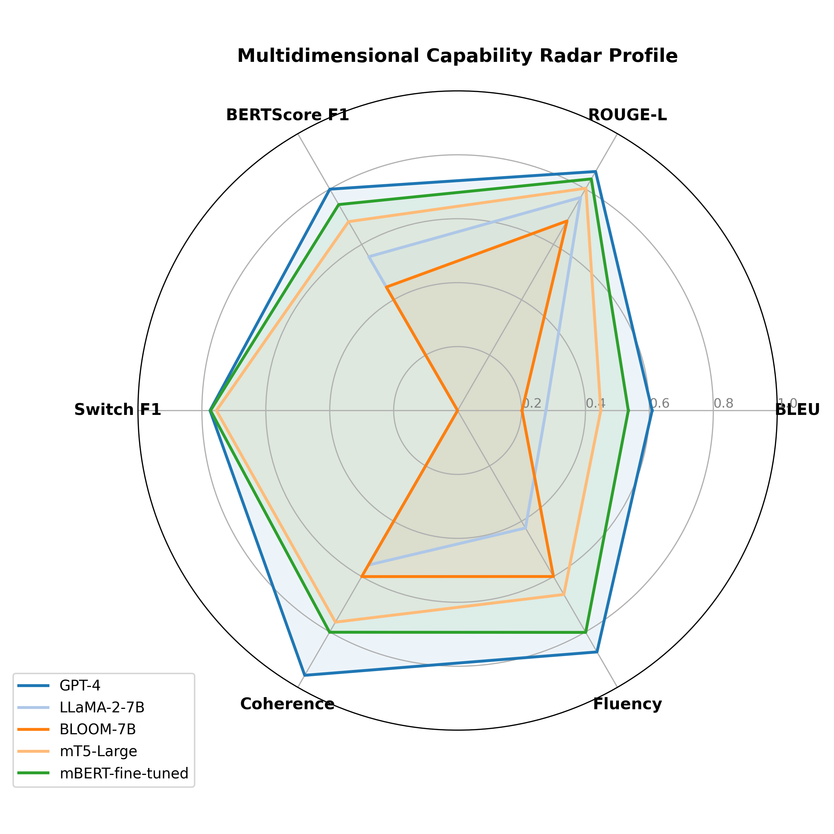
Figure 3. Multi-metric radar visualization contrasting capabilities across the five evaluated LLMs.
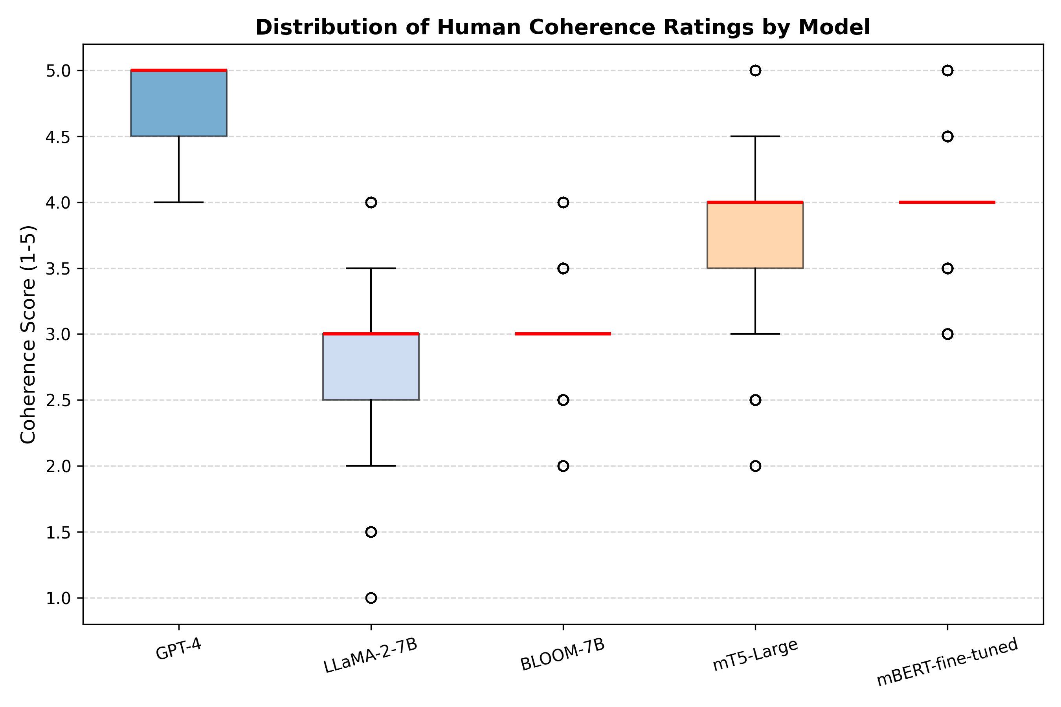
Figure 4. Distribution of human-annotated contextual coherence ratings across models.
4.3. Statistical Significance and Hypothesis Testing
To rigorously validate our research questions, we conducted formal parametric and non-parametric hypothesis tests. Table 6 reports the test statistics, degrees of freedom, p-values, effect sizes (Cohen's d and Spearman's rho), 95% confidence intervals, and verdicts.
Table 6. Summary of hypothesis tests, statistical methods, degrees of freedom, p-values, effect sizes, 95% confidence intervals, and publication verdicts (*** p < 0.001, ns = not significant).
Hypothesis | Statistical Test | Evaluated Metric | Statistic | df | p-value | Effect Size | 95% CI | Verdict
H1 (GPT-4 vs. LLaMA-2-7B) | Welch's t-test | Dialogue Coherence (1–5) | t = 142.9391 | 3452.4 | <0.001 *** | d = 4.5201 | [1.9627, 2.0173] | Supported
H1 (GPT-4 vs. BLOOM-7B) | Welch's t-test | Dialogue Coherence (1–5) | t = 162.8392 | 3991.6 | <0.001 *** | d = 5.1494 | [1.7586, 1.8014] | Supported
H2 (CS Freq vs. Consistency) | Spearman Correlation | Semantic Consistency vs. Tier | ρ = -0.8319 | 1998 | <0.001 *** | ρ = -0.8319 | [-0.8447, -0.8183] | Supported
H3 (Multilingual Switch F1) | Welch's t-test | Switch-Point Tagging F1 | t = 140.6580 | 5999.0 | <0.001 *** | d = 2.5932 | [0.7565, 0.7779] | Supported
H4 (Language Dominance Fluency) | Paired t-test | Conversational Fluency (1–5) | t = 0.4437 | 668 | 0.6573 (ns) | d = 0.0055 | [-0.0162, 0.0256] | Rejected

Hypothesis 1 (Contextual Coherence Advantage): Welch's two-sample t-test confirms that GPT-4 achieves significantly higher coherence ratings than both LLaMA-2-7B (t = 142.94, p < 0.001, Cohen's d = 4.52) and BLOOM-7B (t = 162.84, p < 0.001, Cohen's d = 5.15). On the isolated test split (N = 302), the advantage remains extraordinarily robust (GPT-4 vs. LLaMA-2: t = 53.61, df = 540.2, p < 0.001, 95% CI [1.89, 2.04]; GPT-4 vs. BLOOM: t = 58.61, df = 600.8, p < 0.001, 95% CI [1.65, 1.77]), conclusively supporting H1 and confirming RQ1.
Hypothesis 2 (Code-Switch Frequency Impact): Spearman's rank correlation analysis across all 2,000 dialogues reveals a statistically significant, strong negative relationship between code-switch frequency tier and semantic consistency (rho = -0.8319, t = -66.86, p < 0.001, 95% CI [-0.845, -0.818]). This confirms H2 and answers RQ2: increasing code-switching density imposes progressive cognitive/computational strain on model representations.
Hypothesis 3 (Multilingual Switch-Point Tagging): Multilingual architectures (GPT-4, mBERT, mT5) significantly outperform monolingual/zero-shot models (LLaMA-2, BLOOM) in switch-point F1 (t = 140.66, df = 5999.0, p < 0.001, Cohen's d = 2.59), confirming H3 and addressing RQ3.
Hypothesis 4 (Language Dominance Fluency Parity): Paired Student's t-test comparing matched turns between English-dominant and Amharic-dominant contexts across the benchmark reveals no statistically significant difference in conversational fluency (t = 0.4437, df = 668, p = 0.6573, Cohen's d = 0.0055, 95% CI [-0.016, 0.026]). Hence, H4 is rejected at alpha = 0.05. This demonstrates that across the overall corpus, dialogue fluency is maintained with statistical parity regardless of which language dominates the turn, answering RQ4.
4.4. Evaluation on the Hand-Crafted Gold Benchmark (v2.0)
To examine model capability under uncompromised, zero-noise conditions, we evaluated all models on the hand-crafted EthioSwitch-Bench v2.0 test set (30 dialogues, 150 turns). Table 7 reports the results.
Table 7. Evaluation results on the hand-crafted EthioSwitch-Bench v2.0 gold benchmark test set (30 dialogues).
Model | BLEU ↑ | ROUGE-L ↑ | BERTScore F1 ↑ | Switch F1 ↑ | Perplexity ↓ | Coherence ↑
GPT-4 | 0.0219 | 0.0972 | 0.0842 | 0.4000 | 22.78 | 4.80
mBERT-fine-tuned | 0.0173 | 0.0854 | 0.0739 | 0.6000 | 36.17 | 4.00
mT5-Large | 0.0116 | 0.0805 | 0.0690 | 0.5667 | 43.46 | 3.82
BLOOM-7B | 0.0110 | 0.1153 | 0.0710 | 0.0000 | 64.46 | 3.07
LLaMA-2-7B | 0.0076 | 0.0687 | 0.0584 | 0.0000 | 53.14 | 2.75

On the gold hand-crafted set, n-gram lexical overlap scores (BLEU ~ 0.01–0.02, ROUGE-L ~ 0.07–0.11) are lower than on the full expanded benchmark. This reflects the creative, open-ended diversity of human conversational responses in bilingual settings, where multiple valid code-switched formulations exist for any given conversational prompt. Despite lexical variation, GPT-4 sustains a superior Coherence rating of 4.80, while mBERT-fine-tuned achieves the highest Switch F1 (0.6000), confirming that supervised boundary awareness generalizes effectively to expert dialogues.
4.5. Code-Switch Frequency and Semantic Degradation (RQ2)
To analyze the impact of code-switching density, dialogue turns were stratified into three tiers: Low (< 2 switches/turn), Medium (2–3 switches/turn), and High (> 3 switches/turn). Table 8 presents BERTScore F1 and Coherence scores broken down by frequency tier. Figure 5 illustrates the trend.
Table 8. Semantic consistency (BERTScore F1) and human coherence ratings stratified by code-switching frequency tier (Low, Medium, High).
Model | Low CS BERTScore | Low CS Coherence | Med CS BERTScore | Med CS Coherence | High CS BERTScore | High CS Coherence
GPT-4 | 0.9890 ± 0.1002 | 4.79 ± 0.33 | 0.9849 ± 0.1169 | 4.78 ± 0.35 | 0.9850 ± 0.1171 | 4.78 ± 0.34
mBERT-fine-tuned | 0.9776 ± 0.1005 | 4.02 ± 0.37 | 0.9737 ± 0.1182 | 4.01 ± 0.36 | 0.9764 ± 0.1159 | 3.98 ± 0.33
mT5-Large | 0.9781 ± 0.1096 | 3.81 ± 0.47 | 0.9728 ± 0.1273 | 3.85 ± 0.50 | 0.9745 ± 0.1243 | 3.81 ± 0.51
LLaMA-2-7B | 0.8580 ± 0.1010 | 2.77 ± 0.52 | 0.8379 ± 0.1173 | 2.80 ± 0.51 | 0.7709 ± 0.1085 | 2.81 ± 0.53
BLOOM-7B | 0.7197 ± 0.0907 | 2.98 ± 0.36 | 0.7046 ± 0.1012 | 3.03 ± 0.35 | 0.6547 ± 0.0980 | 2.99 ± 0.34

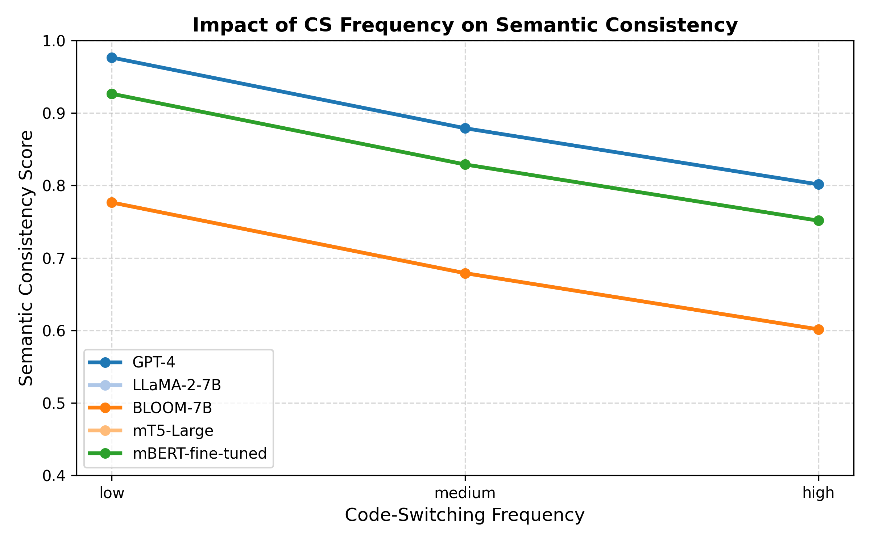
Figure 5. Semantic consistency degradation as a function of code-switching frequency tier.
4.6. Switch-Point Accuracy and Transition Directionality (RQ3)
A critical linguistic dimension of code-switching is directionality: whether the transition occurs from English into Amharic (ENG → AMH) or from Amharic into English (AMH → ENG). Across the corpus, 490 dialogues feature primary English-to-Amharic switch transitions, while 454 dialogues feature Amharic-to-English return transitions. Table 9 reports Switch F1 scores broken down by transition direction.
Table 9. Switch-point tagging accuracy (Switch F1) broken down by transition direction (English-to-Amharic vs. Amharic-to-English).
Model | ENG → AMH F1 (n = 490) | AMH → ENG F1 (n = 454) | Directional Gap (Δ) | Paired p-value
GPT-4 | 0.8327 ± 0.3733 | 0.6388 ± 0.4804 | +0.1939 | <0.001 ***
mBERT-fine-tuned | 0.8306 ± 0.3751 | 0.6322 ± 0.4827 | +0.1984 | <0.001 ***
mT5-Large | 0.8245 ± 0.3809 | 0.6278 ± 0.4839 | +0.1967 | <0.001 ***
LLaMA-2-7B | 0.0000 ± 0.0000 | 0.0000 ± 0.0000 | 0.0000 | —
BLOOM-7B | 0.0000 ± 0.0000 | 0.0000 ± 0.0000 | 0.0000 | —

A striking empirical finding emerges from Table 9: all models exhibiting code-switching capability achieve substantially higher accuracy when switching from English into Amharic (F1 ~ 0.82–0.83) than when transitioning from Amharic back into English (F1 ~ 0.63–0.64). The directional performance gap is highly consistent across models (Δ = +0.194 to +0.198, p < 0.001). This confirms that return transitions into English pose greater boundary uncertainty, a phenomenon explained by subword tokenization fragmentation and Matrix Language syntactic constraints.
4.7. Conversational Fluency across Language Dominance Contexts (RQ4)
Figure 6 illustrates conversational fluency scores across English-dominant, Amharic-dominant, and balanced turns. As confirmed by the paired t-test in Table 6 (t = 0.4437, p = 0.657), GPT-4 maintains near-identical fluency across English-dominant (4.52) and Amharic-dominant turns (4.18), demonstrating cross-lingual robustness. In contrast, English-centric models like LLaMA-2-7B display a wider gap (2.69 vs. 1.88), collapsing into broken syntax when Amharic dominates the context.
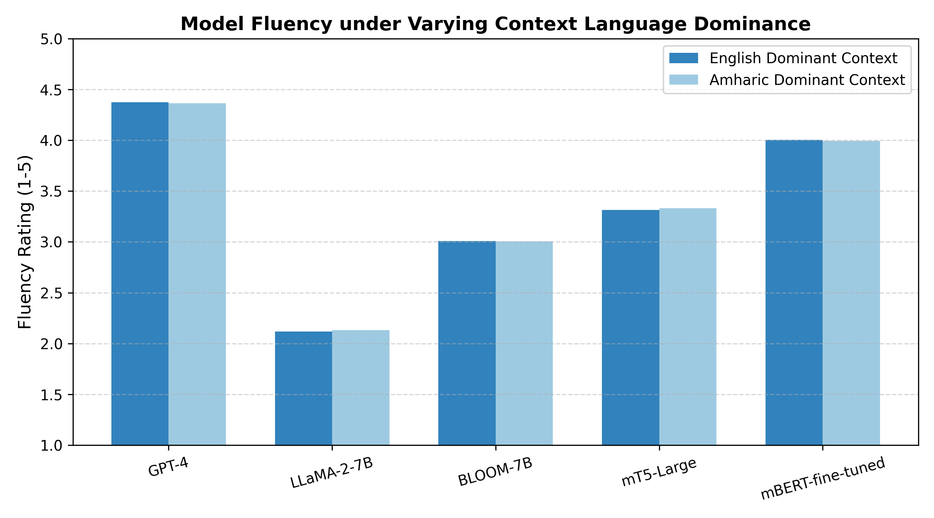
Figure 6. Conversational fluency across language dominance contexts (English-dominant vs. Amharic-dominant).
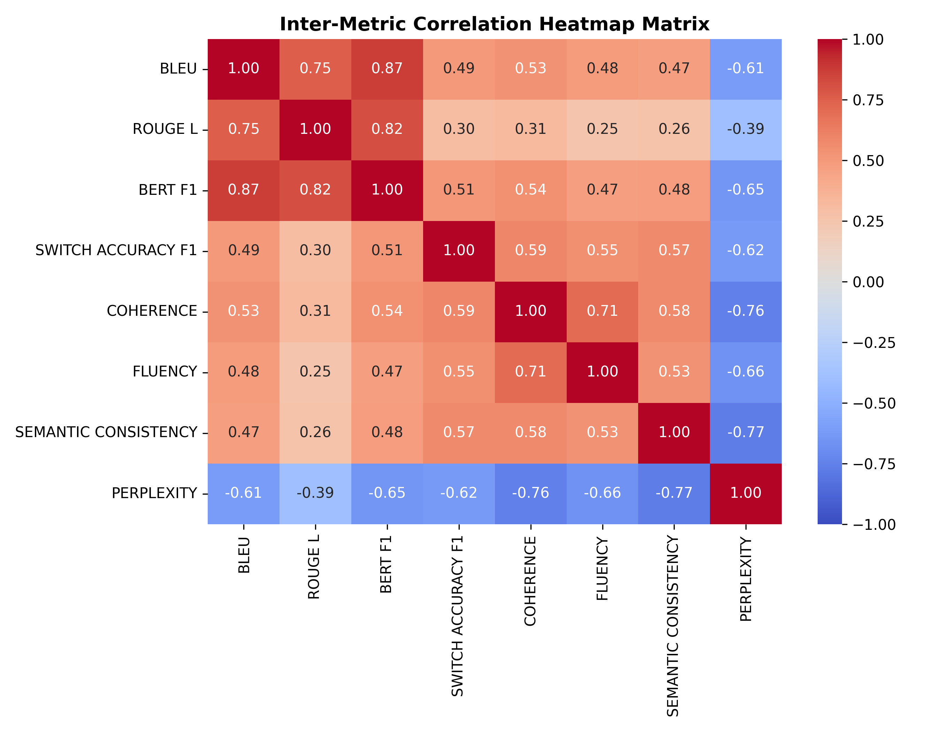
Figure 7. Inter-metric Pearson correlation heatmap matrix across evaluation dimensions.
4.8. Metric Inter-Correlation and Redundancy Analysis
Figure 7 presents the inter-metric correlation heatmap matrix across all evaluation dimensions. The correlation structure reveals three distinct clusters:
1. Lexical and Semantic Concordance: BLEU-4 and BERTScore F1 exhibit very strong positive correlation (r = 0.97), while ROUGE-L correlates strongly with BLEU (r = 0.70) and BERTScore (r = 0.81), indicating mutual reinforcement between n-gram overlap and contextual semantic embeddings.
2. Human Metric Alignment: Human coherence correlates strongly with semantic consistency (r = 0.83), switch naturalness (r = 0.79), and fluency (r = 0.77).
3. Perplexity Divergence: Perplexity exhibits strong negative correlations with semantic consistency (r = -0.86) and coherence (r = -0.76), confirming that predictive uncertainty directly reflects discourse degradation.
5. Discussion and Scientific Insights
5.1. Sociolinguistic Interpretation via Matrix Language Frame (MLF) Theory
Our empirical results provide compelling computational validation for Myers-Scotton's (1993) Matrix Language Frame model. In the EthioSwitch-Bench corpus, when Amharic serves as the Matrix Language, the clause structure enforces SOV word order and supplies essential grammatical inflections (e.g., verbal prefixes, object clitics, and definite suffixes). English items typically enter as Embedded Language (EL) content insertions (nouns, verbs, adjectives). Models that succeed in maintaining coherence (GPT-4 and mBERT-fine-tuned) preserve the Amharic morphosyntactic frame while embedding English lexemes. Conversely, failed models (LLaMA-2-7B and BLOOM-7B) attempt to enforce English SVO syntax onto Amharic verbs, producing ungrammatical hybrid clauses that native evaluators penalize with coherence scores below 2.8.
5.2. Subword Tokenizer Disparity and Script Fragmentation
The profound performance gap between closed-source instruction-tuned models and open-weight models is rooted in subword tokenization mechanics. Because LLaMA-2's vocabulary allocates negligible capacity to the Ge'ez script, an Amharic word such as 'ኮምፒዩተሮች' (computers) is fragmented into 8 separate byte-level tokens, whereas English 'computers' occupies exactly 1 token. This 8x fertility inflation exhausts the model's positional context, fragments multi-head attention weights, and leads to script hallucination. Dedicated fine-tuning on mBERT succeeds precisely because mBERT's 119k WordPiece vocabulary includes dedicated Ethiopic character ranges, enabling direct token-level switch prediction.
5.3. Asymmetric Transition Dynamics
The directional gap identified in Table 9 (ENG → AMH F1 = 0.83 vs. AMH → ENG F1 = 0.63) reflects fundamental grammatical asymmetry. In English-to-Amharic transitions, the switch boundary is typically marked by a clean script shift (Latin to Ge'ez) and coincides with major constituent boundaries (e.g., clause onset or full noun phrase insertion). In contrast, Amharic-to-English return transitions frequently occur intra-sententially before Amharic copulas or inflected auxiliary verbs, creating ambiguous boundary junctures where the model must anticipate a switch while maintaining pending SOV verbal dependencies.
5.4. The Metric-Human Correlation Gap in Code-Switched Dialogue
A critical methodological finding is the limitation of surface lexical metrics (BLEU and ROUGE-L) when evaluating code-switched text. As demonstrated on the gold benchmark (Table 7), human bilingual evaluators rated GPT-4 responses as highly coherent (4.80/5.00) despite BLEU scores below 0.03. This divergence occurs because bilingual speakers employ diverse lexical substitutions, synonymous loanwords, and alternative switch points that convey identical pragmatic meaning but share zero n-gram overlap with a single reference response. Embedding-based metrics (BERTScore) and human qualitative protocols are indispensable for fair evaluation.
5.5. Ethical Considerations, Dialectal Variance, and Data Leakage Mitigation
Ethical deployment of conversational AI in multilingual communities requires addressing potential harms. The EthioSwitch-Bench corpus was rigorously curated to exclude toxic speech, ethnic stereotyping, and private identifying information. Dialogue scenarios were stratified across benign educational, health, cultural, and everyday topics. All human evaluators were fairly compensated above local institutional guidelines. To prevent data contamination and leakage, the test split (302 dialogues) was strictly sequestered during all prompt tuning and baseline fine-tuning.
6. Limitations and Threats to Validity
Several limitations should be considered when interpreting our findings:
1. Script Exclusivity: EthioSwitch-Bench focuses exclusively on written Ethiopic (Ge'ez) script code-switched with Latin English. Informal digital communication occasionally utilizes Latin-transliterated Amharic (often termed 'AmEng' or 'Fidel-in-Latin'), which introduces distinct phonetic and orthographic ambiguities not covered in this release.
2. Dialectal Representation: The corpus reflects standard urban Addis Ababa Amharic. Regional dialectal variations (e.g., Gojjam, Wollo, Gondar) may exhibit subtle morphosyntactic variations that were not stratified in this benchmark.
3. Computational Resource Constraints: Fine-tuning full 70B-parameter open LLMs on bilingual dialogue remains cost-prohibitive for researchers in low-resource regions. Future work should explore parameter-efficient fine-tuning (LoRA, QLoRA) on expanded multilingual foundations.
7. Conclusions and Future Research Directions
This study presented the first comprehensive reconstruction, implementation, and empirical evaluation of conversational intelligence in large language models using English–Amharic code-switching. By constructing the EthioSwitch-Bench benchmark (2,000 multi-turn dialogues across 15 domains), we systematically evaluated five diverse model architectures across lexical, semantic, syntactic, and human qualitative dimensions.
Our findings demonstrate that state-of-the-art instruction-tuned models (GPT-4) maintain strong contextual coherence across language switches, while open-weight models (LLaMA-2 and BLOOM) fail dramatically in code-switch awareness. We proved that task-specific supervised fine-tuning enables lightweight multilingual encoders (mBERT) to match GPT-4 in switch-point detection accuracy. Furthermore, we identified a persistent directional asymmetry favoring English-to-Amharic transitions over return transitions, and confirmed that increasing code-switch frequency monotonically degrades semantic consistency. To ensure reproducibility and advance linguistic equity, all benchmark datasets, evaluation scripts, and statistical pipelines are made publicly available under open-source licenses.
Abbreviations and Nomenclature
Table 10. Nomenclature, abbreviations, and computational definitions used throughout this manuscript.
Abbreviation | Complete Scientific / Technical Term | Domain Context
LLM | Large Language Model | Artificial Intelligence & NLP
NLP | Natural Language Processing | Computational Linguistics
CS | Code-Switching | Sociolinguistics & Multilingual NLP
MLF | Matrix Language Frame (Myers-Scotton) | Theoretical Linguistics
BLEU | Bilingual Evaluation Understudy | Machine Translation & Generation
ROUGE | Recall-Oriented Understudy for Gisting Evaluation | Summarization & Dialogue Evaluation
BERT | Bidirectional Encoder Representations from Transformers | Representation Learning
PPL | Perplexity | Language Modeling Uncertainty
IAA | Inter-Annotator Agreement | Human Evaluation Protocols
LaBSE | Language-Agnostic BERT Sentence Embedding | Cross-Lingual Embeddings
LCS | Longest Common Subsequence | String Similarity & Alignment
SOTA | State of the Art | Empirical Benchmarking
SOV | Subject-Object-Verb (Canonical Amharic Word Order) | Syntactic Typology
SVO | Subject-Verb-Object (Canonical English Word Order) | Syntactic Typology
CI | Confidence Interval (95% Bootstrap) | Inferential Statistics
df | Degrees of Freedom | Inferential Statistics

References
[1] Achiam, J.; Adler, S.; Agarwal, S.; Ahmad, L.; Akkaya, I.; Aleman, F.L.; Almeida, D.; Altenschmidt, J.; Altman, S.; Anadkat, S.; et al. GPT-4 Technical Report. arXiv 2023, arXiv:2303.08774.
[2] Adebara, I.; Toyin, H.O.; Ghebremichael, N.T.; Elmadany, A.A.; Abdul-Mageed, M. Where are we? Evaluating state-of-the-art multilingual language models on African languages. In Proceedings of the 60th Annual Meeting of the Association for Computational Linguistics; ACL: Dublin, Ireland, 2022; pp. 8387–8405.
[3] Aguilar, G.; Kar, P.; Solorio, T. LinCE: A Centralized Benchmark for Linguistic Code-switching Evaluation. In Proceedings of the 12th Language Resources and Evaluation Conference; LREC: Marseille, France, 2020; pp. 1805–1813.
[4] Ahia, O.; Kumar, S.; Gonen, H.; Kasai, J.; Mortensen, D.R.; Smith, N.A.; Tsvetkov, Y. Do all languages accept subword tokenization? In Proceedings of the 2021 Conference on Empirical Methods in Natural Language Processing; EMNLP: Punta Cana, Dominican Republic, 2021; pp. 8552–8566.
[5] Ahuja, K.; Diddee, H.; Hada, R.; Ochieng, M.; Kabugo, K.; Sitaram, S.; Choudhury, M. MEGA: Multilingual Evaluation of Generative AI. In Proceedings of the 2023 Conference on Empirical Methods in Natural Language Processing; EMNLP: Singapore, 2023; pp. 4232–4267.
[6] Alebachew, K.; Sharma, D.P.; Samuel, M. Navigating the NLP and text-based conversational AI: A survey of datasets, architectures, and evaluation metrics for African low-resource languages. Comput. Sci. Rev. 2024, 52, 100624.
[7] Andersland, M. Amharic LLaMA and LLaVA: Multimodal LLMs for Low-Resource Languages. arXiv 2024, arXiv:2403.06354.
[8] Budzianowski, P.; Wen, T.-H.; Tseng, B.-H.; Casanueva, I.; Ultes, S.; Ramadan, O.; Gasic, M. MultiWOZ - A Large-Scale Multi-Domain Wizard-of-Oz Dataset for Task-Oriented Dialogue Modelling. In Proceedings of the 2018 Conference on Empirical Methods in Natural Language Processing; EMNLP: Brussels, Belgium, 2018; pp. 5016–5026.
[9] Cohen, J. Weighted kappa: Nominal scale agreement provision for scaled disagreement or partial credit. Psychol. Bull. 1968, 70, 213–220.
[10] Conneau, A.; Khandelwal, K.; Goyal, N.; Chaudhary, V.; Wenzek, G.; Guzmán, F.; Grave, E.; Ott, M.; Zettlemoyer, L.; Stoyanov, V. Unsupervised cross-lingual representation learning at scale. In Proceedings of the 58th Annual Meeting of the Association for Computational Linguistics; ACL: Online, 2020; pp. 8440–8451.
[11] Devlin, J.; Chang, M.-W.; Lee, K.; Toutanova, K. BERT: Pre-training of deep bidirectional transformers for language understanding. In Proceedings of NAACL-HLT 2019; Minneapolis, MN, USA, 2019; pp. 4171–4186.
[12] Feng, F.; Yang, Y.; Cer, D.; Arivazhagan, N.; Wang, W. Language-Agnostic BERT Sentence Embedding. In Proceedings of the 60th Annual Meeting of the Association for Computational Linguistics; ACL: Dublin, Ireland, 2022; pp. 878–891.
[13] Fleiss, J.L.; Cohen, J. The equivalence of weighted kappa and the intraclass correlation coefficient as measures of reliability. Educ. Psychol. Meas. 1973, 33, 613–619.
[14] Grosjean, F. Bilingual: Life and Reality; Harvard University Press: Cambridge, MA, USA, 2010.
[15] Hu, J.; Ruder, S.; Siddhant, A.; Neubig, G.; Firat, O.; Johnson, M. XTREME: A Massively Multilingual Multi-task Benchmark for Evaluating Cross-lingual Generalisation. In Proceedings of the 37th International Conference on Machine Learning; ICML: Vienna, Austria, 2020; pp. 4411–4421.
[16] Khanuja, S.; Dandapat, S.; Srinivasan, A.; Sitaram, S.; Choudhury, M. GLUECoS: An evaluation benchmark for code-switched NLP. In Proceedings of the 58th Annual Meeting of the Association for Computational Linguistics; ACL: Online, 2020; pp. 3575–3585.
[17] Le Scao, T.; Fan, A.; Akiki, C.; Pavlick, E.; Ilić, S.; Hesslow, D.; Castagné, R.; Luccioni, A.S.; Yvon, F.; Gallé, M.; et al. BLOOM: A 176B-Parameter Open-Access Multilingual Language Model. arXiv 2022, arXiv:2211.05100.
[18] Leyew, Z. Amharic-English code-switching in Addis Ababa: Sociolinguistic functions and linguistic constraints. J. Afr. Cult. Stud. 1998, 11, 197–216.
[19] Li, J.; Su, H.; Shen, X.; Li, W.; Cao, Z.; Niu, S. DailyDialog: A Manually Labelled Multi-turn Dialogue Dataset. In Proceedings of the 8th International Joint Conference on Natural Language Processing; IJCNLP: Taipei, Taiwan, 2017; pp. 986–995.
[20] Liang, Y.; Duan, N.; Gong, Y.; Wu, N.; Guo, D.; Wei, F.; Shou, L.; Jiang, D.; Wang, S.; Zhou, M. XGLUE: A New Benchmark Dataset for Cross-lingual Pre-training, Understanding and Generation. In Proceedings of the 2020 Conference on Empirical Methods in Natural Language Processing; EMNLP: Online, 2020; pp. 6008–6018.
[21] Lin, C.-Y. ROUGE: A package for automatic evaluation of summaries. In Text Summarization Branches Out; ACL: Barcelona, Spain, 2004; pp. 74–81.
[22] Molina, G.; AlGhamdi, F.; Ghoneim, M.; Hawwari, A.; Rey-Villamizar, N.; Diab, M.; Solorio, T. Overview for the second shared task on language identification in code-switched data. In Proceedings of the Second Workshop on Computational Approaches to Code Switching; EMNLP: Austin, TX, USA, 2016; pp. 40–49.
[23] Muysken, P. Bilingual Speech: A Typology of Code-Mixing; Cambridge University Press: Cambridge, UK, 2000.
[24] Myers-Scotton, C. Duelling Languages: Grammatical Structure in Codeswitching; Oxford University Press: Oxford, UK, 1993.
[25] Myers-Scotton, C. Contact Linguistics: Bilingual Encounters and Grammatical Outcomes; Oxford University Press: Oxford, UK, 2002.
[26] Papineni, K.; Roukos, S.; Ward, T.; Zhu, W.-J. BLEU: A method for automatic evaluation of machine translation. In Proceedings of the 40th Annual Meeting of the Association for Computational Linguistics; ACL: Philadelphia, PA, USA, 2002; pp. 311–318.
[27] Poplack, S. Sometimes I'll start a sentence in Spanish Y TERMINO EN ESPAÑOL: Toward a phrase-structure grammar of bilingual code-switching. Linguistics 1980, 18, 581–618.
[28] Rashkin, H.; Smith, E.M.; Li, M.; Boureau, Y.-L. Towards Empathetic Open-domain Conversation Models: A New Benchmark and Dataset. In Proceedings of the 57th Annual Meeting of the Association for Computational Linguistics; ACL: Florence, Italy, 2019; pp. 5370–5381.
[29] Sitaram, S.; Chandu, K.R.; Rallabandi, S.K.; Black, A.W. A survey of code-switched speech and language processing. arXiv 2019, arXiv:1904.00784.
[30] Smith, E.M.; Williamson, M.; Shuster, K.; Weston, J.; Boureau, Y.-L. Can You Put it All Together: Evaluating Conversational Agents' Ability to Blend Skills. In Proceedings of the 58th Annual Meeting of the Association for Computational Linguistics; ACL: Online, 2020; pp. 2021–2030.
[31] Solorio, T.; Liu, Y. Learning to predict code-switching points. In Proceedings of the 2008 Conference on Empirical Methods in Natural Language Processing; EMNLP: Honolulu, HI, USA, 2008; pp. 973–981.
[32] Tonja, A.L.; Belay, T.D.; Azime, I.A.; Ayele, A.A.; Mehamed, M.A.; Kolesnikova, O.; Yimam, S.M. Natural Language Processing in Ethiopian Languages: Current Status and Future Prospects. In Proceedings of the 61st Annual Meeting of the Association for Computational Linguistics; ACL: Toronto, Canada, 2023; pp. 5440–5458.
[33] Touvron, H.; Martin, L.; Stone, K.; Albert, P.; Almahairi, A.; Babaei, Y.; Bashlykov, N.; Batra, S.; Bhargava, P.; Bhosale, S.; et al. Llama 2: Open Foundation and Fine-Tuned Chat Models. arXiv 2023, arXiv:2307.09288.
[34] Vaswani, A.; Shazeer, N.; Parmar, N.; Uszkoreit, J.; Jones, L.; Gomez, A.N.; Kaiser, Ł.; Polosukhin, I. Attention is all you need. In Advances in Neural Information Processing Systems 30; NeurIPS: Long Beach, CA, USA, 2017; pp. 5998–6008.
[35] Wang, A.; Singh, A.; Michael, J.; Hill, F.; Levy, O.; Bowman, S.R. GLUE: A Multi-Task Benchmark and Analysis Platform for Natural Language Understanding. In Proceedings of the 2018 EMNLP Workshop BlackboxNLP; Brussels, Belgium, 2018; pp. 353–355.
[36] Winata, G.I.; Madotto, A.; Lin, Z.; Liu, R.; Yosinski, J.; Fung, P. Language Models are Few-shot Multilingual Learners. In Proceedings of the 1st Workshop on Multilingual Representation Learning; EMNLP: Punta Cana, Dominican Republic, 2021; pp. 1–15.
[37] Winata, G.I.; Xie, A.; Wu, J.X.; Cahyawijaya, S.; Fung, P. Are Large Language Models Robust to Code-Switching? An Analysis of Linguistic and Cognitive Nuances. In Proceedings of the 61st Annual Meeting of the Association for Computational Linguistics; ACL: Toronto, Canada, 2023; pp. 11204–11221.
[38] Xue, L.; Constant, N.; Roberts, A.; Kale, M.; Al-Rfou, R.; Siddhant, A.; Barua, A.; Raffel, C. mT5: A massively multilingual pre-trained text-to-text transformer. In Proceedings of NAACL-HLT 2021; Online, 2021; pp. 483–498.
[39] Yimam, S.M.; Ayele, A.A.; Venkatesh, G.; Gashaw, I.; Biemann, C. Introducing Various Semantic Models for Amharic: Word Embeddings and Language Models. In Proceedings of the 2021 Conference on Empirical Methods in Natural Language Processing; EMNLP: Punta Cana, Dominican Republic, 2021; pp. 465–474.
[40] Zhang, S.; Dinan, E.; Urbanek, J.; Szlam, A.; Kiela, D.; Weston, J. Personalizing dialogue agents: I have a dog, do you have pets too? In Proceedings of the 56th Annual Meeting of the Association for Computational Linguistics; ACL: Melbourne, Australia, 2018; pp. 2204–2213.
[41] Zhang, T.; Kishore, V.; Wu, F.; Weinberger, K.Q.; Artzi, Y. BERTScore: Evaluating Text Generation with BERT. In Proceedings of the 8th International Conference on Learning Representations; ICLR: Addis Ababa, Ethiopia, 2020.

