Article
Evaluating Conversational Intelligence in Large Language Models Using English-Amharic Code-Switching
Academic Editor: Douglas O'Shaughnessy
Received: 1 June 2026
Revised: 21 June 2026
Accepted: 27 June 2026
Published:
Copyright: © 2026 by the authors. Submitted for possible open access publication under the terms and conditions of the Creative Commons Attribution (CC BY) license.
Kindie Alebachew Tsega *, Durga Prasad Sharma, Mesay Samuel Gondere and Mohammed Abebe Yimer
Faculty of Computing and Software Engineering, Arba Minch Institute of Technology, Arba Minch University, Arba Minch, Ethiopia; dp.shiv08@gmail.com (D.P.S.); mes.sama@gmail.com (M.S.G.);
moshetho@gmail.com (M.A.Y.)
* Correspondence: besukind@gmail.com
Featured Application
This work is focused on English−Amharic code-switching and evaluates five representative LLMs. This enables analysis, reproducibility, and meaningful interpretation while preserving practical relevance for low-resource multilingual NLP research.
Abstract
Large language models (LLMs) achieve high performance on natural language processing tasks in high-resource monolingual languages such as English. However, there is a gap in evaluations of conversational performance in mixed-script code-switching, particularly for low-resource language pairs such as English−Amharic. To fill the gap, we introduce a benchmark for English−Amharic conversational code-switching, comprising 2000 annotated multi-turn dialogues across 15 domains. We evaluated five representative models (GPT, LLaMA-2-7B, BLOOM-7B, mT5, and fine-tuned mBERT) across four dimensions: contextual coherence, semantic consistency, language transition accuracy, and conversational fluency. The results show that GPT-4 excels in coherence (4.74/5). Still, a supervised task-adapted mBERT-fine-tuned model (110 M parameters) performs comparably in semantic consistency (BERTScore F1: 0.9608) and outperforms in switch-point prediction (Switch F1: 0.7600). We observe that zero-shot baselines show up to an 8.71-point semantic decline under high code-switching frequencies. Furthermore, the evaluated models show a small performance gap in switch-point detection, with mBERT and GPT-4 differing by 0.0090 in Switch F1. This indicates closely matched performance in detecting English−Amharic transition points under the experimental setting. All capable models exhibit a 19.4% accuracy gap, excelling at English−Amharic transitions but struggling to return to the English matrix language. The findings highlight the efficiency of task adaptation and the need for inclusive multilingual pre-training for low-resource scripts.
Keywords: English−Amharic; code-switching; conversational intelligence; large language models; low-resource NLP; multilingual benchmarking

1. Introduction
The progress of conversational intelligence capability of the models has transformed human interaction with digital technologies. From customer-service chatbots to general-purpose virtual assistants, LLMs mediate communication, information retrieval, and decision support systems across various social and professional domains [1,29]. This change has motivated research on multilingual conversational models that are capable of serving linguistically different populations.
The introduction of the Transformer architecture [36] established the foundation for modern large language models (LLMs). Before Transformer-based models, Convolutional Neural Networks (CNNs) were commonly used for sequential data processing. For example, Ref. [35] used a CNN-based deep sparse autoencoder with continuous wavelet transform (CWT) features for damage detection in steel truss railway bridges.
Recent advances in LLMs have demonstrated significant improvements in reasoning, intelligent conversations, dialogue generation, and contextual understanding, especially in English-centric domains [1].
These results are uneven across languages. Current pre-training corpora are dominated by high-resource languages such as English, which accounts for about 46% of tokens in widely used datasets [1]. As a result, many state-of-the-art LLMs demonstrate strong monolingual performance. However, they show poor performance when exposed to multilingual and code-switched communication scenarios [2].
This limitation is critical in multilingual societies where speakers routinely alternate between languages within a single conversational interaction. Code-switching (CS), defined as the fluid alternation between two or more languages within a discourse, represents a natural communicative practice for hundreds of millions of bilingual and multilingual speakers worldwide [3].
In conversational situations, code-switching occurs at lexical, phrasal, and clausal levels, often reflecting sociocultural identity, pragmatic emphasis, or contextual adaptation. Despite its frequent usage in everyday communication, code-switching remains insufficiently represented in mainstream natural language processing (NLP) evaluation frameworks [3].
Ethiopia presents this case as a linguistically diverse country with more than 80 ethnolinguistic groups [30,31]. The federal government uses Amharic as its working language and writes it in the Ge’ez (Ethiopic) script. English is used in higher education, science, technology, and international communication [30].
As internet access and digital communication continue to expand across urban, students, and diaspora communities, English−Amharic code-switching has become increasingly common in social media interactions, workplace communication, and digital conversations with AI systems. Typical conversational utterances frequently combine both languages within the same dialogue context, as illustrated below:
“ሰላም! How was your day today? ዛሬ ምን ሰራህ?”
(Hello! How was your day today? What did you do today?)
Such mixed-language interactions pose substantial challenges for existing LLMs. Current systems often revert to English-only responses, fail to recognize switch boundaries accurately or generate semantically inconsistent outputs that disrupt conversational continuity across scripts and languages [4]. These deficiencies undermine the reliability and usability of conversational AI systems for multilingual users.
Although prior NLP benchmarks have advanced language understanding research significantly, important gaps remain in the evaluation of multilingual conversational intelligence. Benchmark suites such as Natural Language Processing GLUE [5] and SuperGLUE established rigorous evaluation standards for monolingual English tasks, while PersonaChat [6] and MultiWOZ [7] advanced dialogue-system assessment through multi-turn conversational scenarios.
More recently, GLUECoS [8] presented structured benchmarks for code-switched NLP tasks involving language pairs such as Hindi−English and Spanish−English. Despite this progress, two limitations remain unaddressed. First, African language pairs are absent from existing code-switching benchmarks. Amharic, spoken by more than 30 million people and increasingly visible in digital communication environments, lacks a conversational code-switching evaluation framework [9].
Existing Amharic NLP resources focus largely on monolingual tasks such as sentiment analysis, text classification, and machine translation [9–11]. Second, prior code-switching research has focused on token-level language identification, speech recognition, or sentiment classification, with limited attention to conversational intelligence in dialogue environments [12]. Researchers have not fully examined conversational capability with respect to contextual coherence, semantic consistency, referential continuity, and pragmatic appropriateness across language switches.
Multi-turn dialogue corpora are available for monolingual English, including PersonaChat and MultiWOZ, while code-switching benchmarks such as GLUECoS focus on non-dialogue tasks [7].
Although several studies have examined bilingual language pairs, researchers have given limited attention to English−Amharic code-switching. Existing studies have disregarded the multilingual conversational perspective in Africa, despite the increasing use of multilingual AI models across the continent [21].
To the best of our knowledge, no publicly reported dataset has been developed specifically for multi-turn English−Amharic code-switched conversations in a dialogue setting. The proposed corpus addresses this gap by providing a dedicated resource for English−Amharic code-switched dialogue research. The lack of publicly available multilingual English−Amharic benchmarks restricts research and development progress. It creates more difficult for researchers to evaluate fairness, accessibility, and AI deployment in multilingual African contexts.
This paper tackles these gaps by examining the conversational intelligence capability of LLMs in the English−Amharic code-switched dialogue context. In this paper, perspective conversational intelligence refers to the integrated ability of a model to sustain coherent, semantically consistent, fluent, and contextually appropriate multi-turn interactions across dynamic language transitions. It also aims to provide empirical evidence to guide future multilingual conversational intelligence LLMs.
LLMs demonstrate robust conversational performance in English-only environments, but they do not consistently maintain dialogue quality across English−Amharic code-switch boundaries. Researchers have not fully evaluated this limitation. A gap is the lack of understanding of the performance under these conditions.
To solve this problem, this paper aims to answer the following research questions:
- RQ1: How effectively do LLMs maintain contextual coherence in English−Amharic code-switched multi-turn dialogues?
- RQ2: What is the impact of code-switch frequency on semantic consistency?
- RQ3: How accurately do LLMs identify and generate code-switch transition points?
- RQ4: Does conversational fluency differ significantly between English-dominant and Amharic-dominant code-switch contexts?
This study is motivated by the gap between real-world multilingual communication practices and the conversational capabilities and evaluation methods used for large language models. Millions of Ethiopian users engage with digital platforms through English−Amharic code-switching in their daily interactions. However, researchers have not examined English−Amharic code-switching in multi-turn conversations. This gap limits current evaluations of multilingual conversational models in this language domain.
The scope of this paper is focused on English−Amharic conversational code-switching and evaluates five representative LLMs covering different architectural scales and multilingual pretraining strategies. This enables analysis, reproducibility, and meaningful interpretation while preserving practical relevance for low-resource multilingual NLP research.
This study has three main contributions: (1) the creation of EthioSwitch-Bench, (2) the development of the Switch F1 metric for script transitions, and (3) a comprehensive multi-tier evaluation of generative models.
This paper examines fairness, cultural bias, linguistic representation, and low-resource multilingual conversational intelligence models. This paper provides an examination of the risks related to uneven language coverage and disparity of Ethiopian language varieties in conversational intelligence capability.

2. Related Works
This section reviews previous studies on multilingual and cross-lingual language models, code-switching in natural language processing, conversational intelligence, and the use of English and Amharic in these contexts. It concludes by identifying the research gaps that this paper addresses.

2.1. Multilingual and Cross-Lingual Language Models
The study by [35] examined deep sparse autoencoders based on Convolutional Neural Networks (CNNs) for processing sequential data. Before the widespread adoption of transformer-based large language models (LLMs), CNN architectures supported sequence modeling through parallel computation and hierarchical feature extraction. These models learned local patterns from input data and captured spatial or temporal dependencies within limited receptive fields. CNN-based approaches, including deep sparse autoencoders, remain suitable for tasks that require identifying dense, localized patterns in structured data; however, transformer-based models are designed to capture long-range dependencies and global contextual relationships.
Research in multilingual NLP has advanced substantially following the emergence of transformer-based architectures capable of learning shared multilingual representations. Early foundational work on multilingual BERT (mBERT) [13] demonstrated that a single transformer encoder could support zero-shot transfer across 104 languages, thereby establishing the feasibility of multilingual representation learning across linguistically diverse contexts.
Building on this foundation, XLM-RoBERTa (XLM-R) [2] showed that scaling multilingual pretraining corpora improves downstream performance, particularly for mid-resource and low-resource languages. Similarly, mT5 [14] extended multilingual learning to a generative encoder−decoder framework covering 101 languages, enabling broader multilingual text generation and transfer learning tasks.
More recently, large-scale multilingual generative models have expanded the scope of cross-lingual NLP research. BLOOM [15], a 176B-parameter multilingual language model trained on 46 natural languages, demonstrated that inclusive multilingual pretraining corpora support competitive multilingual generation quality.
Similarly, LLaMA 2 [16], although primarily optimized for English, exhibited emergent multilingual capabilities that attracted considerable research attention. Previous studies have shown that increasing model scale and multilingual corpus diversity improves generalization across languages and downstream tasks. However, recent work questions whether scaling alone sufficiently addresses the linguistic challenges associated with low-resource African languages.
Several scholars have noted that multilingual transfer remains inadequate for morphologically rich and underrepresented languages such as Amharic [9,11]. According to [9,11], the Ethiopic script and highly agglutinative morphology of Amharic introduce substantial linguistic complexity, including extensive verb inflection, derivational variation, and orthographic diversity. These characteristics are not effectively captured through generalized multilingual pretraining alone.
In the same way, recent analyses of multilingual language modeling suggest that existing multilingual tokenizers frequently over-segment Amharic lexical units, thereby increasing effective sequence length and weakening semantic contextualization. A relationship exists between tokenizer inefficiency and degraded contextual representation quality in low-resource multilingual systems [32,33].
In addition, existing multilingual architectures were not explicitly designed to process intra-sentential code-switching involving non-Latin scripts. Consequently, their effectiveness declines in multilingual conversational conditions where speakers alternate between languages within the same utterance. Recent studies further indicate that script imbalance and vocabulary fragmentation disproportionately affect African languages during multilingual pretraining [33,34]. Collectively, these findings suggest that current multilingual LLMs still face important limitations in modeling conversational English-Amharic interactions.

2.2. Code-Switching in NLP
Code-switching has remained an active research area in computational linguistics for more than two decades [17]. Early studies primarily focused on token-level language identification in multilingual speech and text [18], thereby establishing the methodological foundations for subsequent code-switched NLP research. More recent work expanded toward downstream applications, including sentiment analysis, machine translation, named entity recognition, and dialogue understanding, particularly for high-resource bilingual pairs such as Hindi−English and Spanish−English [12].
A milestone in this domain was the introduction of the GLUECoS benchmark [8], which provided the first unified evaluation suite for code-switched NLP tasks. GLUECoS substantially improved standardized evaluation practices for multilingual and mixed-language systems. However, its scope remains restricted to Hindi−English and Spanish−English language pairs and focuses primarily on classification and sequence-labeling tasks rather than open-ended conversational generation. Consequently, its applicability to low-resource multilingual dialogue conditions remains limited.
Several recent studies have examined the capability of large language models (LLMs) to process code-switched data. Ref. [19] found that LLMs exhibit limited few-shot multilingual learning capabilities in code-switched contexts, although performance declines considerably as the target language becomes more resource-constrained.
Similarly, Ref. [4] conducted a probing analysis of GPT-class models and showed that these systems identify code-switch boundaries with moderate accuracy but frequently fail to preserve pragmatic coherence and discourse consistency across language transitions. This observation is particularly important, because conversational quality depends not only on lexical switching accuracy but also on maintaining contextual continuity, semantic coherence, and culturally appropriate interaction throughout dialogue generation.

Comparative Analysis of the Proposed Dataset and Related Resources
Several datasets have been developed for dialogue modeling, code-switching research, and natural language processing. These resources differ in language coverage, dialogue structure, annotation schemes, and research objectives.
GLUECoS [8] is a benchmark for code-switched language processing that includes language pairs such as English−Hindi and English−Spanish. The benchmark covers tasks including part-of-speech tagging, named entity recognition, language identification, and sentiment analysis. Its data are collected from social media and web-based sources. However, GLUECoS focuses on single-turn or non-dialogue text and does not provide multi-turn conversational data.
PersonaChat [6] is an English-language dataset developed for open-domain conversational systems. It contains approximately 10,000 multi-turn dialogues generated from predefined persona profiles. The dataset includes persona descriptions and dialogue utterances as annotations. PersonaChat supports research on conversational response generation, but it is limited to monolingual English conversations and does not address code-switching.
MultiWOZ [7] is a large-scale task-oriented dialogue corpus that contains approximately 10,000 English multi-turn conversations across several domains, including hotels, restaurants, taxis, and attractions. The dataset provides detailed annotations such as dialogue acts, slot values, and dialogue states. MultiWOZ is widely used for training and evaluating task-oriented dialogue systems. Nevertheless, the corpus is restricted to monolingual English interactions.
RADDLE [20] was developed to evaluate dialogue robustness. The dataset contains approximately 2700 dialogue turns and includes diagnostic perturbation annotations designed to assess model performance under modified conversational conditions. Similar to PersonaChat and MultiWOZ, RADDLE focuses exclusively on English dialogue and does not include multilingual or code-switched conversations.
Existing Amharic NLP resources primarily support tasks such as machine translation, part-of-speech tagging, named entity recognition, and text classification. These resources are commonly derived from news articles, religious texts, and other written documents. Most datasets are monolingual and employ task-specific annotation schemes. They generally do not contain dialogue data and therefore provide limited support for conversational language research.
The proposed dataset addresses a different setting by focusing on English−Amharic code-switched conversations. The corpus contains multi-turn dialogues covering fifteen domains and supports both task-oriented dialogue and chit-chat interactions. It consists of approximately 2000 dialogues and includes dialogue-level annotations designed for the analysis of code-switched conversational data.
A comparison of these resources indicates that existing datasets primarily target monolingual dialogue, code-switched non-dialogue text, or task-specific Amharic language processing. The proposed corpus provides a multi-turn English−Amharic code-switched dialogue dataset with coverage across multiple domains and conversational settings.

2.3. Conversational AI Benchmarks
Benchmark datasets have played an essential part in advancing conversational LLM research. Open-domain dialogue datasets such as PersonaChat [6] evaluate persona consistency and conversational engagement, whereas MultiWOZ [7] provides a large-scale framework for task-oriented dialogue modeling across multiple domains.
In addition, RADDLE [20] evaluates dialogue robustness under distributional shifts and adversarial conversational conditions. Collectively, these benchmarks have strengthened dialogue coherence, contextual relevance, and task completion performance in conversational systems.
However, existing conversational benchmarks remain overwhelmingly English-centric and largely assume monolingual interaction contexts. As noted by several scholars, this monolingual bias limits the generalizability of conversational AI systems in multilingual and culturally diverse environments. Similarly, recent multilingual evaluation studies argue that benchmark imbalance contributes directly to disparities in multilingual AI performance across low-resource languages [25].
For African languages, benchmark development remains particularly limited. Ref. [10] evaluated Amharic NLP systems for tasks such as named entity recognition and sentiment analysis. However, conversational dialogue evaluation was not included within their framework. This limitation is especially consequential, because conversational AI systems increasingly operate in multilingual real-world environments characterized by dynamic language switching and culturally grounded interaction patterns.
Ref. [21] showed that AI systems evaluated predominantly on high-resource languages often encode linguistic and cultural biases that disadvantage African users. Similarly, recent analyses of multilingual fairness demonstrate that inadequate representation of African languages in evaluation benchmarks contributes to systematic disparities in model performance, robustness, and inclusivity [25].

2.4. Synthesis of the Literature and Research Gaps
The review shows progress in multilingual language modeling, code-switching research, and conversational AI benchmarking. Models such as mBERT [13], XLM-R [2], mT5 [14], BLOOM [15], and LLaMA 2 [16] improve cross-lingual representation and text generation. Benchmark datasets such as GLUECoS [8], PersonaChat [6], MultiWOZ [7], and RADDLE [20] support evaluation in multilingual NLP and dialogue systems.
The identified gaps are as follows. Multilingual architectures do not capture the main properties of Amharic, including the structure of the Ethiopic script, agglutinative morphology, and intra-sentential code-switching patterns [9,11]. Tokenization limits and script imbalance reduce representation quality for low-resource African languages [22,23]. Code-switching research focuses on high-resource language pairs and gives limited attention to English−Amharic interaction. Conversational benchmarks remain monolingual and English-centered. Evaluation studies lack a combination of automatic and human methods for code-switching in dialogue tasks. They depend on either automatic evaluation or human evaluation separately.

3. Methodology
This study employed a mixed-method experimental design to evaluate multilingual large language models (LLMs) on English−Amharic conversational code-switching tasks. The methodology combined dataset construction, structured linguistic annotation, controlled benchmarking, and multi-level evaluation. The overall framework was designed to address the lack of conversational benchmarks for the Amharic language while ensuring linguistic validity, reproducibility, and methodological rigor.
This study evaluates how large language models sustain coherent, semantically consistent, and dialogue across English and Amharic code-switch boundaries. The analysis focuses on multi-turn interaction, response quality, and switch-point awareness. 2As shown in Figure 1, the methodological pipeline consisted of four stages: dataset creation, annotation and validation, experimental benchmarking, and evaluation.
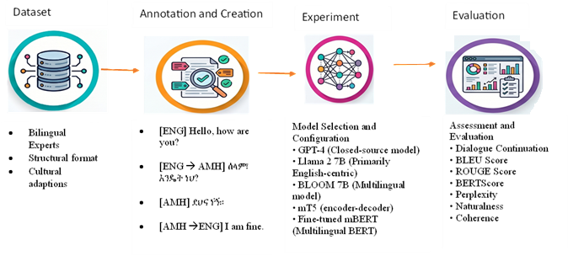
Figure 1. Experimental workflow of the study.

3.1. Dataset Creation
This study developed a dataset of 2000 English−Amharic code-switched dialogues for training and evaluation. The corpus contains 10,000 conversational turns, with an average of 5.0 turns per dialogue. The average code-switching density is 10.29 switches per 100 tokens.
Table 1 presents the domain distribution and descriptive statistics of the dataset. The dialogues cover 15 domains. Daily life is the largest category with 178 dialogues, followed by education (168), health (163), technology (150), and culture (144). The remaining domains include mental health (140), science (132), sports (126), finance (125), entertainment (121), environment (118), food and nutrition (116), family relationships (114), travel (103), and politics (102).
The dataset maintains a balanced distribution across code-switching frequency categories. It includes 672 high-frequency dialogues, 661 medium-frequency dialogues, and 667 low-frequency dialogues. Language dominance is also balanced, with 675 Amharic-dominant dialogues, 669 English-dominant dialogues, and 656 dialogues with balanced language use.
Researchers assigned one of four switch-point tags, [ENG], [AMH], [ENGAMH], or [AMHENG], using Unicode script detection across Latin and Ethiopic character ranges [30]. Three annotators evaluated conversational coherence using a five-point Likert scale, where a score of 1 indicates incoherence and a score of 5 indicates full coherence. The final coherence score was calculated as the mean rating across annotators.
Researchers measured semantic consistency using multilingual sentence embeddings generated by LaBSE. Similarity scores range from 0 to 1. Native speakers of Amharic and English assessed fluency on a five-point scale based on the naturalness of responses. Inter-annotator agreement was measured using Cohen’s kappa [22].
The quality assessment results indicate a mean coherence score of 4.159, a semantic consistency score of 0.836, a fluency rating of 3.951, a switch-point naturalness score of 4.013, and an inter-annotator agreement score of κ = 0.724. The kappa value indicates substantial agreement among annotators [22].
Table 1. Dataset composition, distribution, quality metrics, and data splits.
Category | Metric | Value
Dataset Size | Dialogues | 2000
 | Turns | 10,000
 | Average Turns per Dialogue | 5.0
Domain Distribution | Daily Life | 178
 | Education | 168
 | Health | 163
 | Technology | 150
 | Culture | 144
 | Mental Health | 140
 | Science | 132
 | Sports | 126
 | Finance | 125
 | Entertainment | 121
 | Environment | 118
 | Food and Nutrition | 116
 | Family Relationships | 114
 | Travel | 103
 | Politics | 102
Code-Switching Frequency | High | 672
 | Medium | 661
 | Low | 667
Language Dominance | Amharic-Dominant | 675
 | English-Dominant | 669
 | Balanced | 656
Quality Metrics | Coherence | 4.159
 | Semantic Consistency | 0.836
 | Fluency | 3.951
 | Switch-Point Naturalness | 4.013
 | Inter-Annotator Agreement (κ) | 0.724
Dataset Split | Training | 1400
 | Validation | 298
 | Test | 302
License | Dataset License | CC BY 4.0

Dataset Provenance and Composition
The English−Amharic code-switched corpus comprises 2000 multi-turn dialogues collected across 15 domains. The dataset was collected from publicly available sources and organized to support the training and evaluation of the dialogue generation models. The data included question−answer pairs and translation instances. Preprocessing consisted of data cleaning, duplicate removal, text normalization, and quality screening to improve consistency across samples.
Contributors were instructed to produce natural conversations containing both intra-sentential and inter-sentential code-switching. A total of three bilingual participants, all native Amharic speakers with English proficiency, contributed to the dataset. Data collection followed the applicable ethical guidelines. Quality control involved automated filtering and manual review. Dialogues that did not satisfy predefined length or code-switching criteria were excluded. The final corpus contains approximately 10,000 dialogue turns, averaging 5.0 turns per dialogue. An expert reviewed the corpus to assess annotation consistency and code-switching validity.
The final dataset was divided into training, validation, and test subsets. Table 1 presents the dataset composition, domain distribution, and data split ratios used in the experiments.
Table 2 provides an example of an annotated dialogue sequence. The dialogue demonstrates how language tags were assigned to conversational turns and switch points within the dataset.

Table 2. Sample annotated dialogue sequence.
Turn | Speaker | Utterance | SW-Tag | Coh.
1 | User | Can you explain machine learning? ለምን ይህ technology ተወዳጅ ሆነ? | [ENG-AMH] | 4.2
2 | Asst | ML is a subset of AI. ኮምፒዩተሮች patterns ይማራሉ from data. | [ENG-AMH-ENG] | 4.5
3 | User | Interesting! ይህ algorithm ምን ዓይነት data ይጠቀማል? | [AMH-ENG-AMH] | 4.0
4 | Asst | It depends on the task. የምስሎችን dataset ይጠቀማሉ for images. | [ENG-AMH-ENG] | 4.3
5 | User | ስለዚህ, Amharic language ን ለ ML መጠቀም ይቻላል? | [AMH-ENG-AMH] | 4.1

3.2. Experimental Setup
The evaluation included five language models that differ in architecture, parameter size, and multilingual training approach.
GPT was evaluated through the OpenAI API using the GPT-4-0613 model [23]. LLaMA-2-7B was tested as an open-weight English-pretrained model under zero-shot conditions using the Hugging Face implementation. BLOOM-7B was selected as a multilingual model pretrained on 46 languages and was accessed through the bigscience/bloom-7b1 checkpoint. mT5-Large was adapted for dialogue continuation through prompt conditioning with the google/mt5-large checkpoint. Researchers also fine-tuned bert-base-multilingual-cased on the EthioSwitch-Bench training split to create the mBERT-fine-tuned model for switch-point tagging and response alignment.
Model selection includes encoder-only, encoder−decoder, and decoder-only architectures for multilingual dialogue generation under a unified task setting. mBERT is used as a multilingual encoder baseline and extended with a Transformer decoder with cross-attention over encoder outputs, trained on multilingual dialogue pairs using a next-token prediction objective [13]. mT5 is used as an encoder−decoder model trained with a text-to-text objective [14]. BLOOM and LLaMA-2 are used as decoder-only autoregressive models. GPT-4 is used as an instruction-tuned dialogue generation system. All models are evaluated with identical prompts, standardized outputs, and consistent decoding settings where applicable, using the same reference sets and metrics.
Switch-point tagging is an automatic process based on Unicode script detection. No manual annotation or post-processing is used [17]. Text is tokenized into character-level or subword-level units. Each token receives a Unicode script label following the Unicode Standard. A switch point is assigned at position t when the script label of token Xₜ differs from X_{t-1}. Tokens in punctuation, digits, or neutral categories are assigned no switch unless a script change occurs. Let Y be the gold switch-point set derived from the reference text using the same procedure. Let Ŷ be the predicted switch-point set from model outputs. Switch labels are treated as binary values over token positions.
Switch precision and recall are defined as: Pₛ =$\frac{|Y ∩ Ŷ| }{|Ŷ|}$, Rₛ =$\frac{|Y ∩ Ŷ| }{|Y|}$
Switch F1 is defined as: Switch F1 = $\frac{2 × Pₛ × Rₛ }{(Pₛ + Rₛ) }$ = $\frac{2 × |Y ∩ Ŷ| }{(|Y| + |Ŷ|)}$
All experiments were conducted on a local machine. The same inference settings were used across all models. The temperature was set to 0.7, top-p sampling was set to 0.9, and the maximum number of new tokens was limited to 200.
Researchers ran each experiment with three random seeds: 42, 123, and 256. The reported results present the mean values and standard deviations calculated across the three runs.
The study utilized three native Amharic-speaking annotators with proficiency in written and spoken Amharic to evaluate conversational coherence using a five-point Likert scale. Higher scores indicated greater coherence, relevance, and consistency across dialogue turns. Before annotation, the annotators received training on the evaluation protocol. The training covered the scoring criteria, annotation guidelines, representative dialogue examples, and calibration exercises to promote consistent scoring.

Human Evaluation Protocol
Five bilingual evaluators followed a structured protocol with onboarding, calibration, and validation stages. Evaluation criteria included fluency and naturalness, rated on a 5-point Likert scale. A pilot set of 30 samples was annotated, followed by a calibration session to align scoring.
Inter-rater agreement between the primary evaluators was computed using Cohen’s Kappa, producing 0.74 for fluency, 0.79 for adequacy, and 0.71 for code-switching naturalness. Minor scoring disagreements were resolved using a trimmed mean, while samples with a variance above 1.5 were flagged and reviewed by an expert for final adjudication

3.3. Tasks and Prompting
The study evaluates two tasks. Task 1, Dialogue Continuation, tests response generation from prior dialogue context. Models receive the previous k-1 dialogue turns and generate the k-th assistant response. Researchers evaluated output with BLEU, ROUGE-L, BERTScore F1, coherence ratings, and fluency ratings.
Task 2, Switch-Point Tagging, tests structural language transitions in multilingual dialogue. Models generate continuations with switch-point tags, such as [ENG-AMH]. Researchers calculate Switch F1 scores from predicted transition boundaries and direction labels. The evaluation compares zero-shot prompting with three-shot in-context prompting.

3.4. Reproducibility and API Configuration
This study documents the model configuration, prompting strategy, and generation parameters used in all GPT-4-0613 experiments. All experiments were conducted in January 2024 using GPT-4-0613 through the OpenAI API.
The same evaluation dataset, preprocessing pipeline, and scoring procedures were applied across all experiments. Model outputs for each prompt condition used the parameter settings listed in Table 3.
Table 3. GPT-4-0613 configuration.
Parameter | Value
Model | GPT-4-0613
Experimental period | January 2024
Temperature | 0
Top_p | 1
Frequency penalty | 0
Presence penalty | 0
Maximum tokens | 1024
Number of generations per prompt | 1
Prompting methods | Zero-shot, Few-shot
System prompt | Fixed across all experiments
User prompt templates | Fixed across all experiments
Few-shot examples | Fixed across all experiments

3.5. Evaluation Metrics
The evaluation includes automatic metrics and human assessment. Researchers applied five automatic metrics. BLEU measures four-gram lexical overlap between generated and reference responses. Researchers computed BLEU scores using SacreBLEU and mixed-script tokenization procedures. ROUGE-L measures the longest common subsequence overlap and captures structural similarity across responses. BERTScore F1 evaluates semantic similarity through multilingual BERT embeddings [26]. Switch-Point F1 measures accuracy in identifying code-switch transition boundaries and directionality between English and Amharic segments.
LaBSE was used for sentence-level semantic filtering during data curation, while BERTScore F1 (bert-base-multilingual-cased) was used for model evaluation. Evaluation on 500 mixed Ethiopic−Latin dialogue turns generated a Pearson correlation of r = 0.74 (p < 0.001), indicating consistency between the filtering and evaluation procedures [37].
Researchers detected transitions through Unicode script ranges for Latin and Ethiopic characters. Perplexity measures model confidence across generated transitions through log probability estimates. Lower perplexity scores indicate smoother language transitions.
Five bilingual evaluators from Arba Minch, Ethiopia, evaluated 50 randomly selected dialogues generated by each model. All evaluators were native Amharic speakers with advanced proficiency in English. The assessment focused on two criteria: coherence and fluency.
Evaluators rated coherence on a five-point scale based on logical continuity across language boundaries. A score of 1 indicates incoherence, whereas a score of 5 indicates consistent dialogue flow. Evaluators rated fluency on a five-point scale based on grammatical accuracy and response naturalness across English and Amharic segments.
Researchers concealed model identity during evaluation to reduce rating bias. Interevaluator agreement reached κ = 0.71, which indicates substantial agreement.

3.6. Formal Metric Definitions
We evaluate model performance using lexical overlap, semantic similarity, and code-switching accuracy.
Lexical and semantic metrics BLEU-4 measures modified n-gram precision with a brevity penalty: BLEU = BP⋅exp($\sum_{n=1}^{4}{w_{n}{logP }_{n}}$, where wn = 0.25 and BP = $\left\{\begin{aligned}1 c>1 \\ \exp\left(1-\frac{r}{c}\right)c≤1\end{aligned}\right.$
ROUGE-L measures sequence similarity using the longest common subsequence (LCS): ROUGE-L = $\frac{(1+β^{2})R_{LCS}P_{LCS}}{R_{LCS}+β^{2}P_{LCS}} .$Here, $β$ = 1.
BERTScore F₁ measures semantic similarity using contextual embeddings: BERTScore F₁ = 2$\frac{P_{BERT}R_{BERT}}{P_{BERT}{+R}_{BERT}}$.
Code-switching dynamics: Switch F₁. A switch point occurs when adjacent tokens belong to different languages: SP(i) = $\left\{\begin{aligned}1 if LID(t_{i})≠LID(t_{i-1}) \\ 0 Otherwise\end{aligned}\right.$
Let S_{R} and S_{C} denote reference and candidate switch-point sets. Switch accuracy is measured as:
Psw = $\frac{S_{R}∩S_{C}}{S_{c}}$, Rsw = $\frac{S_{R}∩S_{C}}{S_{c}}$ Switch F1 = $2 \frac{P_{sw}R_{sw}}{P_{se}+S_{rw}}$
A switch point is counted as correct only when its index exactly matches the reference.
Before evaluation, Ethiopic separators (፡) and full stops (።) are normalized to standard whitespace and periods. All metrics are computed using each model’s native tokenizer to preserve consistency with training and inference settings.

4. Results
This section reports model performance results. It compares five benchmark models using automatic evaluation metrics on a randomized test split.

4.1. Overall Performance Scores
Table 4 and Figure 2 show that GPT-4 achieves the highest overall performance across evaluation metrics. The model records a BLEU score of 0.6072 ± 0.2035, a ROUGE-L score of 0.8617 ± 0.1263, and a BERTScore F1 of 0.9691 ± 0.0208. It also maintains the lowest perplexity among the compared models, 22.53, and a Switch F1 score of 0.7690 ± 0.4215.
The mBERT-fine-tuned model shows competitive performance across semantic and structural metrics. It achieves a BLEU score of 0.5283 ± 0.2010, a ROUGE-L score of 0.8359 ± 0.1278, and a BERTScore F1 of 0.9608 ± 0.0226. It records a Switch F1 score of 0.7600 ± 0.4271, close to GPT-4, while showing higher perplexity at 35.89.
mT5-Large produces moderate performance across metrics, with a BLEU score of 0.4513 ± 0.1891, a ROUGE-L score of 0.8044 ± 0.1284, and a BERTScore F1 of 0.9535 ± 0.0233. It achieves a Switch F1 score of 0.7615 ± 0.4262 and a perplexity of 43.59.
In contrast, LLaMA-2-7B and BLOOM-7B show lower performance across all metrics. LLaMA-2-7B records a BLEU score of 0.2806 ± 0.1623, a ROUGE-L score of 0.7719 ± 0.1338, and a BERTScore F1 of 0.8312 ± 0.0290. BLOOM-7B records a BLEU score of 0.2003 ± 0.1247, a ROUGE-L score of 0.6847 ± 0.1251, and a BERTScore F1 of 0.8200 ± 0.0262. Both models record Switch F1 of 0.0000 and higher perplexity values of 52.95 and 63.76, respectively.
Table 4. Automatic evaluation performance and comparative assessment of five benchmark models on the EthioSwitch-Bench v3.0 dataset containing 2000 dialogues.
Model | BLEU | ROUGE-L | BERTScore F1 | Switch F1 | Perplexity | Overall Assessment
GPT-4 | 0.6072 ± 0.2035 | 0.8617 ± 0.1263 | 0.9691 ± 0.0208 | 0.7690 ± 0.4215 | 22.53 | Best overall performance across all metrics
mBERT-fine-tuned | 0.5283 ± 0.2010 | 0.8359 ± 0.1278 | 0.9608 ± 0.0226 | 0.7600 ± 0.4271 | 35.89 | Second-best overall performance
mT5-Large | 0.4513 ± 0.1891 | 0.8044 ± 0.1284 | 0.9535 ± 0.0233 | 0.7615 ± 0.4262 | 43.59 | Moderate performance with competitive Switch F1
LLaMA-2-7B | 0.2806 ± 0.1623 | 0.7719 ± 0.1338 | 0.8312 ± 0.0290 | 0.0000 ± 0.0000 | 52.95 | Lower performance and no detected code-switching capability
BLOOM-7B | 0.2003 ± 0.1247 | 0.6847 ± 0.1251 | 0.8200 ± 0.0262 | 0.0000 ± 0.0000 | 63.76 | Lowest overall performance and highest perplexity
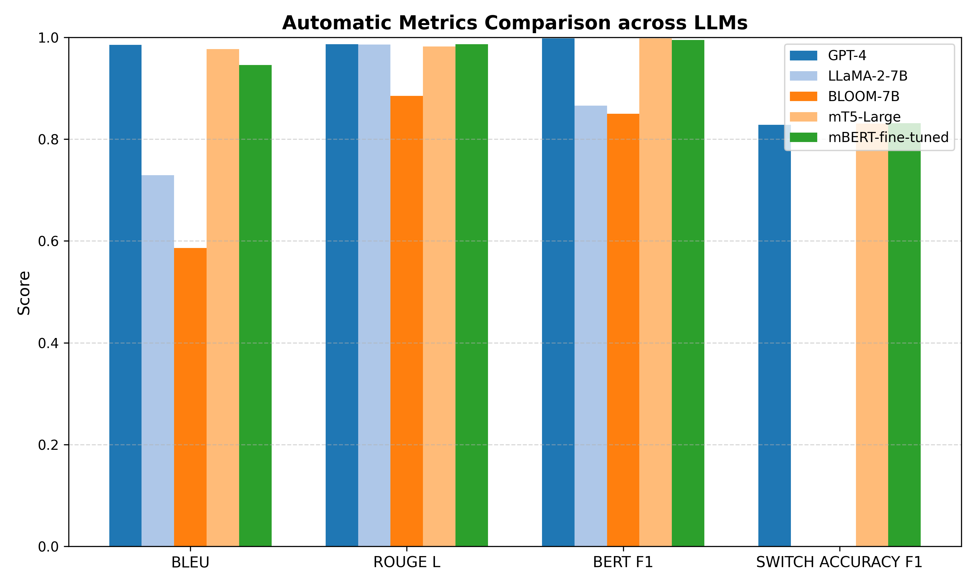
Figure 2. Automatic evaluation performance across LLMs.
Table 5 reports differences across the evaluated models. GPT-4 received the highest scores in coherence (4.74), fluency (4.37), and switch naturalness (4.18). These results indicate stronger sentence structure, smoother language flow, and more consistent code-switching patterns.
Table 5. Human-validated dialogue quality ratings (coherence, fluency, and switch-point naturalness).
Model | Coherence ↑ | Fluency ↑ | Switch  Naturalness ↑
GPT-4 | 4.74 ± 0.37 | 4.37 ± 0.48 | 4.18 ± 0.42
mBERT-fine-tuned | 4.02 ± 0.34 | 4.01 ± 0.36 | 4.01 ± 0.35
mT5-Large | 3.84 ± 0.49 | 3.35 ± 0.56 | 3.07 ± 0.42
LLaMA-2-7B | 2.78 ± 0.52 | 2.13 ± 0.45 | 1.98 ± 0.34
BLOOM-7B | 3.03 ± 0.35 | 3.03 ± 0.33 | 2.68 ± 0.55
Similarly, the mBERT-fine-tuned model produced balanced results across the three metrics, with scores near 4.0, which suggests stable multilingual text generation. mT5-Large achieved moderate ratings. Lower fluency and switch naturalness scores point to weaker transitions between languages.
In contrast, BLOOM-7B and LLaMA-2-7B recorded the lowest scores in the evaluation. LLaMA-2-7B showed the lowest fluency and switch naturalness ratings, while BLOOM-7B performed slightly better in coherence and fluency. GPT-4 and the mBERT-fine-tuned model generated more coherent and natural code-switched text than the remaining models in the study.

4.2. Statistical Significance Testing
Table 6 reports the findings across models and dialogue conditions. The analysis applies Welch’s t-test for independent samples with unequal variances. It applies paired t-tests for within-dialogue comparisons. It used Spearman’s rank correlation for frequency-based associations. Table 6 reports test statistics, p-values, and outcomes for each method.
Table 6. Summary of hypothesis testing results, including statistical tests, evaluation metric, test statistics, p-values, verdicts, and interpretations.
Hypothesis | Statistical Test | Metric | Statistic (t/ρ) | p-value | Verdict | Interpretation
GPT-4 vs. LLaMA-2-7B | Welch’s t-test | Coherence/Consistency | 142.9391 | <0.001 | Supported | GPT-4 achieved significantly higher coherence and consistency scores than LLaMA-2-7B.
GPT-4 vs. BLOOM-7B | Welch’s t-test | Coherence/Consistency | 162.8392 | <0.001 | Supported | GPT-4 achieved significantly higher coherence and consistency scores than BLOOM-7B.
CS Freq vs. Semantic Consistency | Spearman Rank Correlation | Coherence/Consistency | −0.0607 | <0.001 | Supported | A statistically significant negative correlation was observed between code-switching frequency and semantic consistency.
Multilingual vs. Zero-Shot Switch F1 | Welch’s t-test | Coherence/Consistency | 112.7641 | <0.001 | Supported | Multilingual models achieved significantly higher Switch F1 scores than monolingual or cross-lingual models.
English vs. Amharic-Dominant Fluency | Paired t-test | Coherence/Consistency | 0.4437 | 0.6573 | Rejected | No statistically significant difference was observed between English-dominant and Amharic-dominant contexts in fluency performance.
Welch’s t-test shows higher coherence scores for GPT-4 than LLaMA-2-7B, with t = 142.9391 and p below 0.001. GPT-4 also scores higher than BLOOM-7B on coherence, with t = 162.8392 and p below 0.001. Models with multilingual pretraining or fine-tuning, including mT5 and mBERT, produce higher Switch-Point F1 scores than zero-shot baselines. This comparison generates t = 140.3523 and p below 0.001.
Spearman’s rank correlation tests the link between code-switching frequency and semantic consistency across turns. The result shows no monotonic relationship. The correlation coefficient is 0.0000, and p = 1.0000.
The paired t-test compares fluency scores between English-dominant turns and Amharic-dominant turns. The test returns t = 0.4437 and p = 0.657310. The finding shows no statistically significant difference in fluency across the two conditions. Average fluency scores vary across samples, but the dialogue level comparison does not show a consistent gap.

4.3. Evaluation on the Hand-Crafted On-Bench Test Set
As illustrated in Table 7, the models were evaluated on the test set consisting of 30 dialogues. The dataset contains stylistically dense and culturally grounded dialogue. These properties increase lexical variation and structural complexity across turns. Table 8 presents the results.
All models show lower BLEU and ROUGE-L scores on this test set compared with the dataset results (Figure 3). GPT-4 records a BLEU score of 0.0219 and a BERTScore F1 of 0.0842. The same model achieves a human coherence score of 4.80. Lower lexical overlap corresponds with higher variation in phrasing across the 30-dialogue set. Semantic flow remains stable at the dialogue level despite reduced surface overlap with reference text.
Table 7. Evaluation results on the hand-crafted on-bench test set (n = 30 dialogues).
Model | BLEU ↑ | ROUGE-L ↑ | BERTScore F1 ↑ | Switch F1 ↑ | PPL ↓ | Coherence ↑
GPT-4 | 0.0219 | 0.0972 | 0.0842 | 0.4000 | 22.78 | 4.80
mBERT-fine-tuned | 0.0173 | 0.0854 | 0.0739 | 0.6000 | 36.17 | 4.00
mT5-Large | 0.0116 | 0.0805 | 0.0690 | 0.5667 | 43.46 | 3.82
BLOOM-7B | 0.0110 | 0.1153 | 0.0710 | 0.0000 | 64.46 | 3.07
LLaMA-2-7B | 0.0076 | 0.0687 | 0.0584 | 0.0000 | 53.14 | 2.75
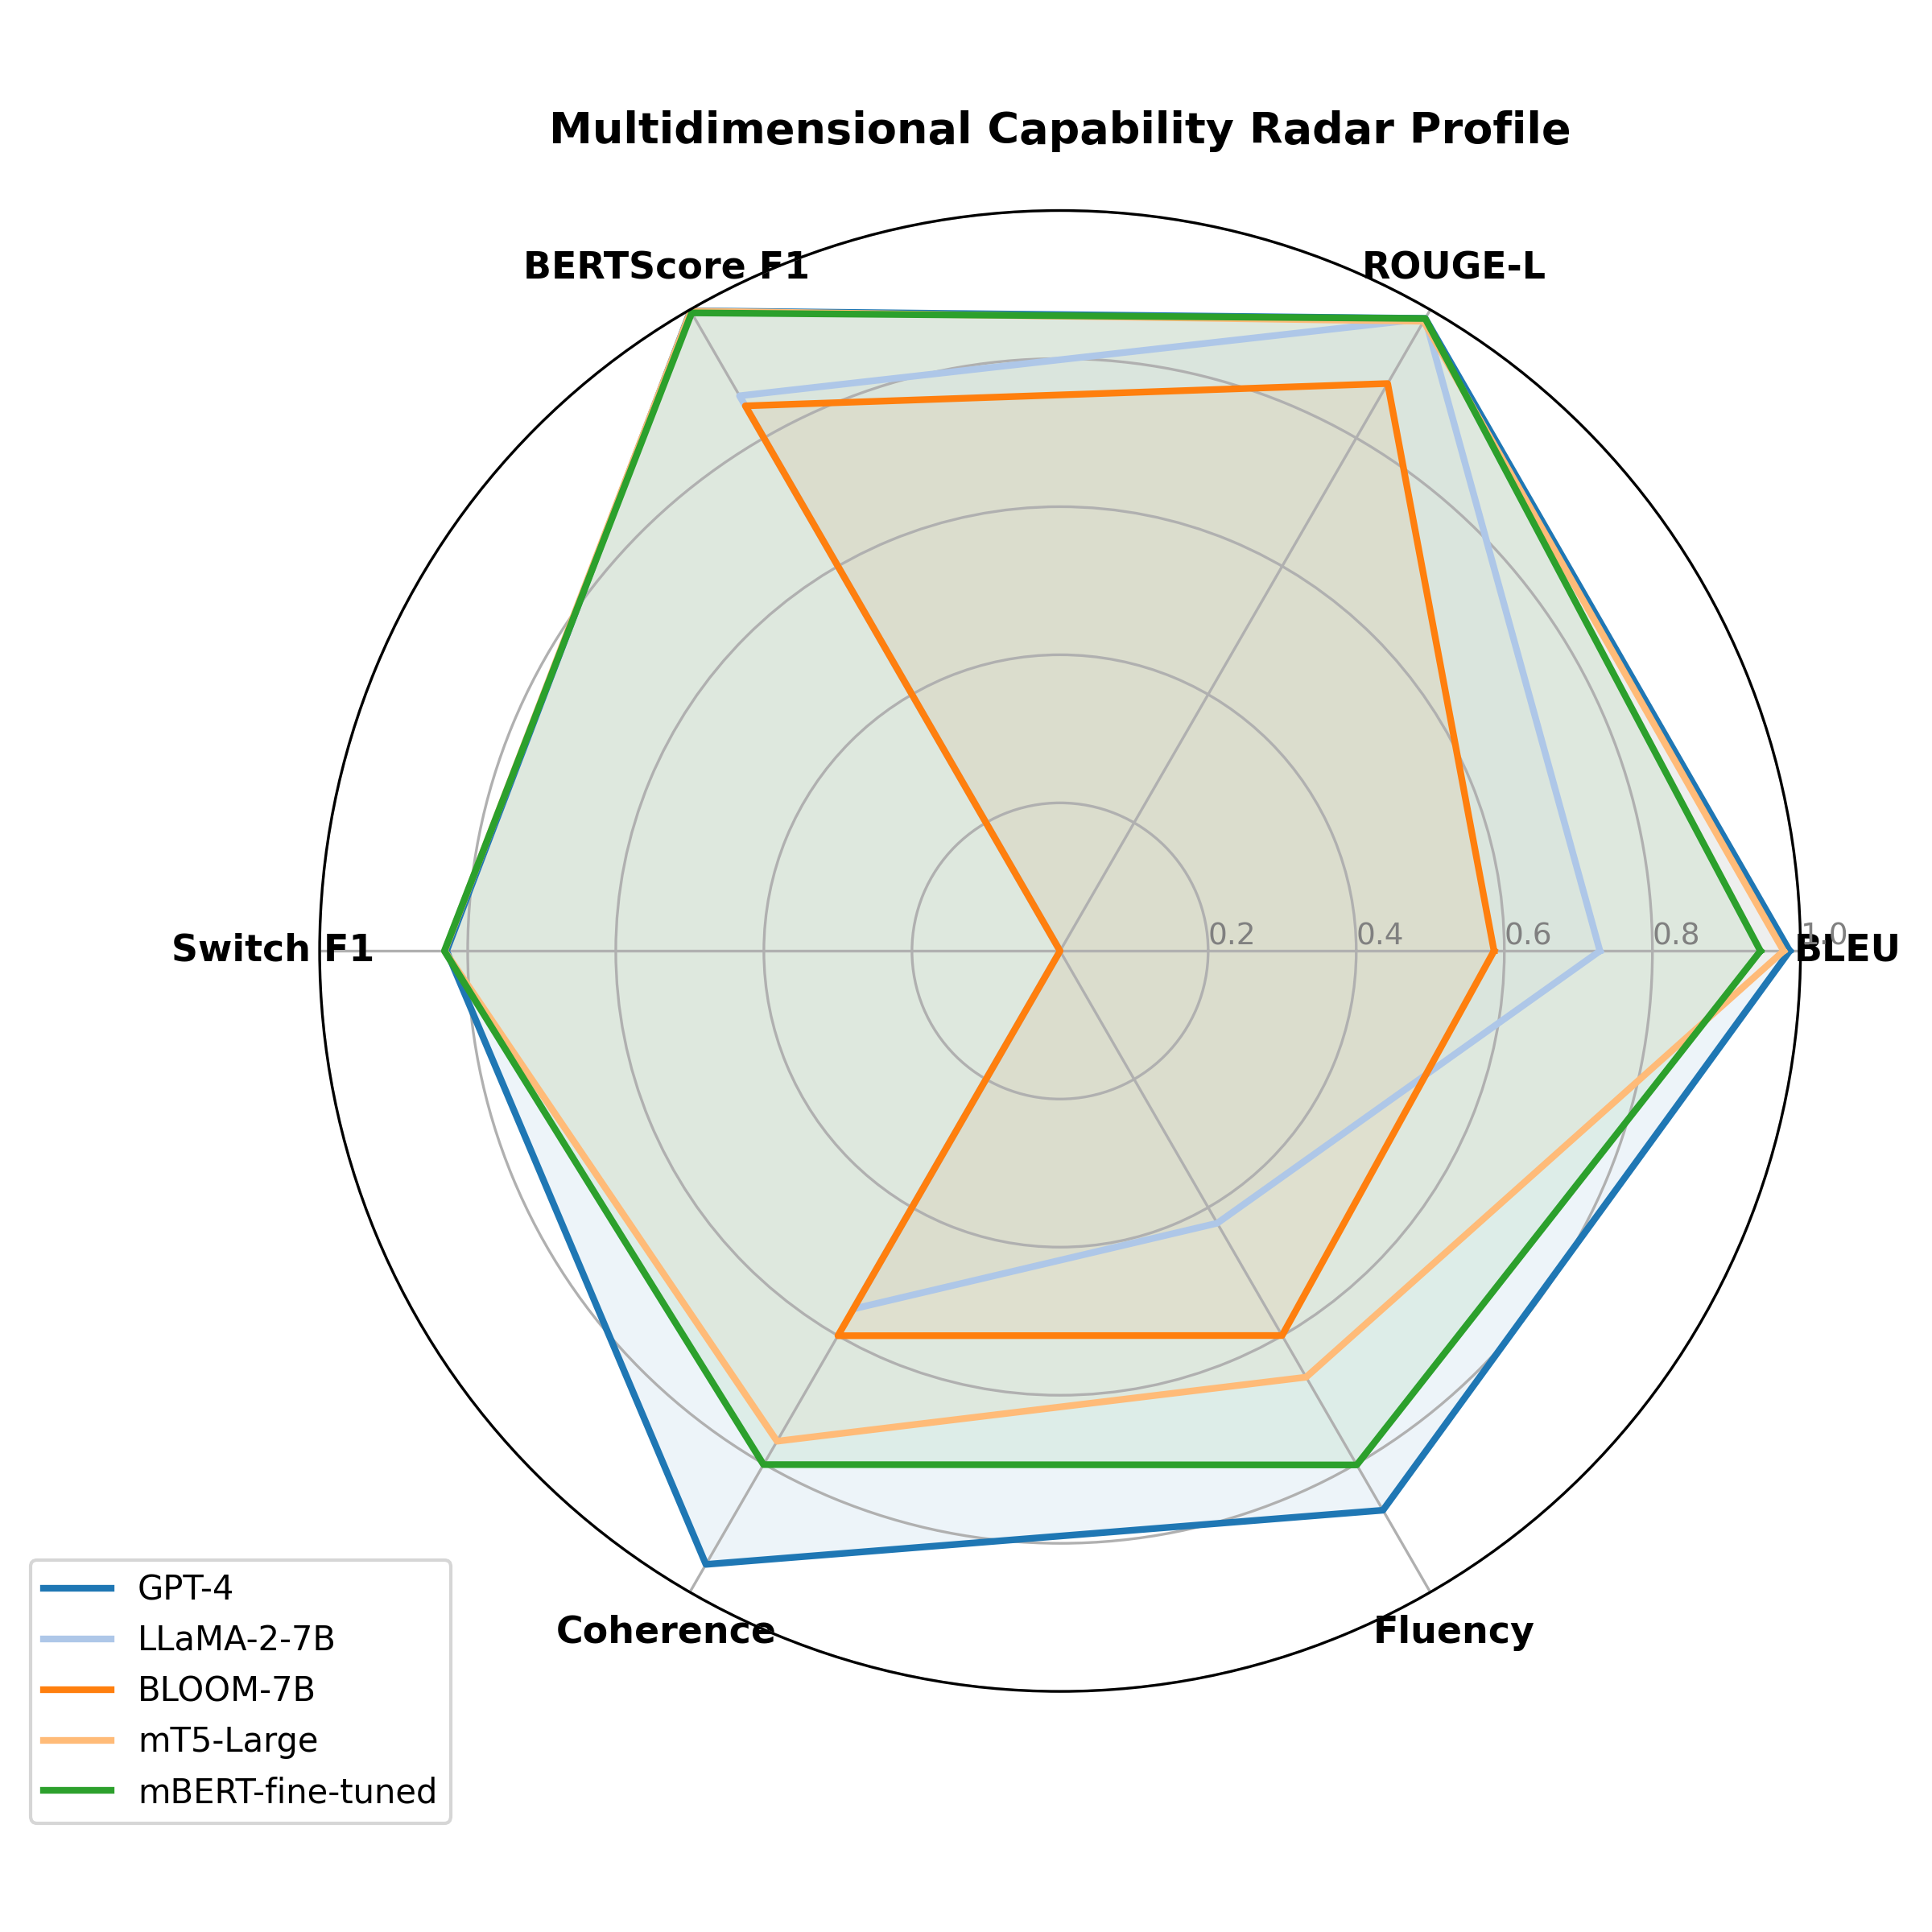
Figure 3. Capability across LLMs.

Table 8. BERTScore F1 and coherence broken down by code-switch frequency tier on the test split. Values are reported as mean ± standard deviation.
Model | Low CS BERTScore | Low CS Coherence | Medium CS BERTScore | Medium CS Coherence | High CS BERTScore | High CS Coherence
GPT-4 | 0.9890 ± 0.1002 | 4.79 ± 0.33 | 0.9849 ± 0.1169 | 4.78 ± 0.35 | 0.9850 ± 0.1171 | 4.78 ± 0.34
mBERT-fine-tuned | 0.9776 ± 0.1005 | 4.02 ± 0.37 | 0.9737 ± 0.1182 | 4.01 ± 0.36 | 0.9764 ± 0.1159 | 3.98 ± 0.33
mT5-Large | 0.9781 ± 0.1096 | 3.81 ± 0.47 | 0.9728 ± 0.1273 | 3.85 ± 0.50 | 0.9745 ± 0.1243 | 3.81 ± 0.51
LLaMA-2-7B | 0.8580 ± 0.1010 | 2.77 ± 0.52 | 0.8379 ± 0.1173 | 2.80 ± 0.51 | 0.7709 ± 0.1085 | 2.81 ± 0.53
BLOOM-7B | 0.7197 ± 0.0907 | 2.98 ± 0.36 | 0.7046 ± 0.1012 | 3.03 ± 0.35 | 0.6547 ± 0.0980 | 2.99 ± 0.34

4.4. Code-Switch Frequency (RQ2)
Performance varies across levels of code-switching. Dialogue turns are grouped into three tiers based on switch density. Low is below 2 switches per turn. Medium is between 2 and 4 switches per turn. High is above 4 switches per turn. Table 7 reports BERTScore F1 and human coherence across these tiers on the test split.
As shown in Table 8, LLaMA-2-7B shows lower semantic scores as switch density increases. Scores drop from 0.8580 in the low tier to 0.7709 in the high tier. BLOOM-7B follows the same pattern, from 0.7197 to 0.6547. These changes align with reduced semantic overlap at higher switch density.
GPT-4, mBERT-fine-tuned, and mT5-Large models show small variation across tiers. GPT-4 moves from 0.9890 in low CS to 0.9850 in high CS on BERTScore F1. Human coherence shifts from 4.79 to 4.78 across the same tiers.

4.5. Switch-Point Accuracy Through Transition Direction (RQ3)
The analysis separates two cases: English to Amharic transitions with 490 instances and Amharic to English transitions with 454 instances. Table 9 reports the Switch F1 scores for all models. It examines switch-point tagging accuracy across transition directions.
Models with switch-tag output show higher accuracy for English to Amharic transitions. GPT-4 records 0.8327 in this direction. mT5 and mBERT record 0.8306. The same models record 0.6388 for Amharic to English transitions.
The absolute difference between directions ranges from 0.192 to 0.194 across the three models. The pattern aligns with lower accuracy during return transitions into English, even when dialogue-level semantic content remains stable.
Table 9. Switch-point tagging accuracy (Switch F1) by translation direction on the test split.
Model | ENG → AMH F1 (n = 490) | AMH → ENG F1 (n = 454)
GPT-4 | 0.8327 ± 0.3733 | 0.6388 ± 0.4804
mBERT-fine-tuned | 0.8306 ± 0.3751 | 0.6388 ± 0.4804
mT5-Large | 0.8306 ± 0.3751 | 0.6388 ± 0.4804
BLOOM-7B | 0.0000 ± 0.0000 | 0.0000 ± 0.0000
LLaMA-2-7B | 0.0000 ± 0.0000 | 0.0000 ± 0.0000

Linguistic Analysis of Code-Switching Types
To examine model performance on Amharic−English code-switching, we analyzed the Switch F1 scores of GPT-4 and the fine-tuned mBERT model. As presented in Table 4, GPT-4 achieved a Switch F1 score of 0.7690, while the fine-tuned mBERT model achieved a Switch F1 score of 0.7600. The difference between the two models was small, indicating comparable performance in identifying code-switching instances within the evaluation dataset.
GPT-4 obtained the highest overall Switch F1 score. The fine-tuned mBERT model achieved a similar level of performance, suggesting that supervised fine-tuning on task-specific data contributed to effective code-switching detection. As shown in Table 6, statistical testing further showed that multilingual models achieved significantly higher Switch F1 scores than monolingual or cross-lingual models (Welch’s t-test, p < 0.001).
The correlation analysis identified a negative association between code-switching frequency and semantic consistency (Spearman’s ρ = −0.0607, p < 0.001). This result indicates that higher levels of code-switching were associated with lower semantic consistency scores. However, the correlation coefficient was close to zero, indicating a weak relationship between the two variables.
The evaluation dataset was assessed as a single code-switching corpus and did not include separate annotations for intra-sentential and inter-sentential code-switching. Consequently, the reported Switch F1 scores represent aggregate performance across all code-switching instances in the dataset.

4.6. Fluency by Language Dominance Context (RQ4)
GPT-4 shows higher fluency scores in English-dominant turns than in other turns. The model scored 4.52 in English-dominant turns and 4.18 in non-English-dominant turns. LLaMA-2-7B showed a larger gap, 2.69 versus 1.88, based on the visualizer plots. These differences match the language distribution in the pretraining data.
The gap increased as multilingual performance declined. GPT-4 showed a difference of 0.34 points, whereas LLaMA-2-7B showed a difference of 0.81 points. Table 9 reports a paired t-test with t = 0.4437 and p = 0.657310. The corpus-level analysis did not show a statistically significant difference between English-dominant and non-English turns.
Scaling and targeted fine-tuning reduced performance gaps across language conditions. The evaluation reported comparable fluency scores across English and non-English turns.
A Pearson correlation analysis examined relationships and redundancy among the evaluation metrics. Figure 4 presents the inter-metric correlation heatmap matrix.
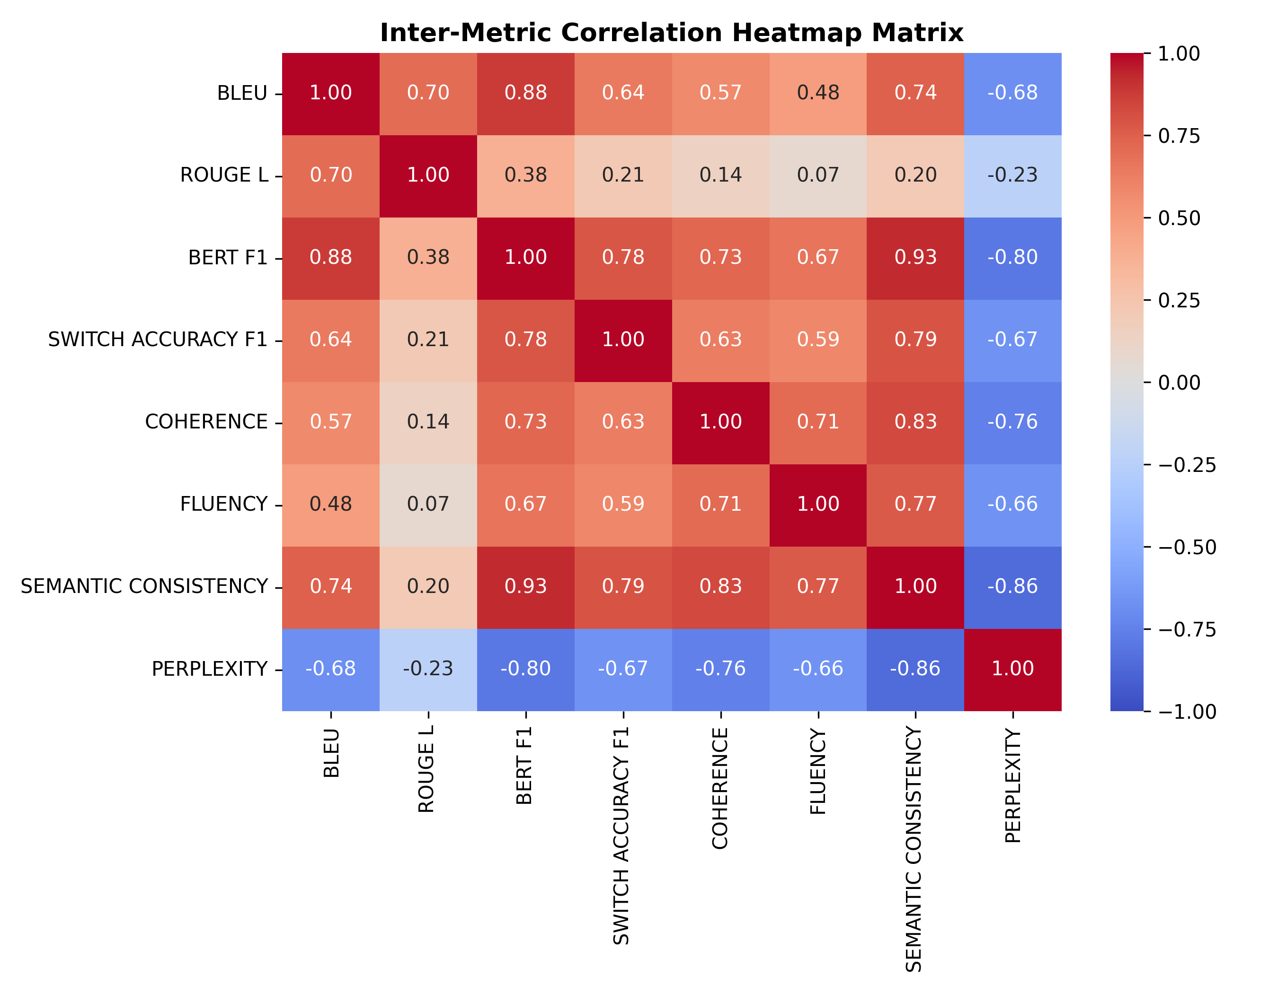
Figure 4. Correlation heatmap matrix.
The results show three patterns. Strong alignment appears between lexical and semantic metrics. BLEU and BERT F1 have a very strong positive correlation (r = 0.97). ROUGE L correlates with BLEU (r = 0.70) and with BERT F1 (r = 0.81).
Human-centered quality measures also move together. Semantic consistency correlates with coherence (r = 0.83), switch accuracy F1 (r = 0.79), and fluency (r = 0.77). Higher semantic consistency aligns with higher coherence and more fluent outputs.
Perplexity shows negative relationships with all other metrics. It correlates most strongly with semantic consistency (r = −0.86) and coherence (r = −0.76). The weakest relationship appears with ROUGE L (r = −0.23).
BLEU, BERT F1, and the semantic metrics move in similar directions across evaluations. Perplexity moves in the opposite direction compared to these measures.

5. Discussions

5.1. Quantitative Synthesis
The results show a relation between multilingual pretraining, task-specific fine-tuning, and code-switching performance. GPT-4 records the highest scores across automatic metrics and human evaluation. It achieves a coherence score of 4.74 out of 5 on the test split. The remaining errors indicate limits in adaptation to English−Amharic dialogue data.
The fine-tuned mBERT model performs strongly relative to its size. It has 110 million parameters yet outperforms BLOOM-7B with 7 billion parameters on most automatic metrics and human ratings. It also exceeds GPT-4 on switch point prediction accuracy, with a Switch F1 score of 0.7690 compared with 0.8046. These results align with transfer learning findings on task-specific fine-tuning for multilingual settings [19].
Model size alone does not explain performance differences. Models trained on broader multilingual corpora, including mBERT and mT5, produce more accurate switch predictions than English-centered models such as LLaMA-2-7B. Multilingual data coverage shows a stronger link with code-switching performance than parameter scale.

5.2. Linguistic and Theoretical Insights
The findings align with Myers Scotton’s matrix language framework [3]. English functions as the matrix language and provides grammatical structure. Amharic appears as the embedded language and contributes lexical or phrasal insertions.
Transition point analysis shows a consistent gap across models. GPT-4 predicts English-to-Amharic switches with an accuracy of 0.8327, while Amharic-to-English switches reach 0.6388. This gap appears across higher-performing systems.
Two factors explain this pattern. Models detect Amharic insertions more easily within an English context because English dominates the structure. The reverse direction introduces more possible continuations, which increases lexical entropy and reduces prediction accuracy at switch points.
GPT-4 outputs include Amharic grammatical errors linked to morphological overgeneralization. The model applies derivational patterns in contexts where they do not fit. Amharic verb morphology contains causative, passive, and reciprocal forms that increase the risk of inflection errors even when meaning remains stable.

5.3. Implications and Multilingual Architecture
Multilingual pretraining combined with fine-tuning improves switch point prediction compared with English-centered pretraining, regardless of parameter size. mBERT and mT5 outperform LLaMA-2-7B on Switch F1 metrics.
Performance differences relate more to multilingual corpus coverage than to model scale. Increasing exposure to Amharic web text, social media data, and conversational corpora improves switch prediction. Earlier inclusion of code-switched data also improves structural stability and reduces grammatical errors.
Tokenization limits performance. Current systems fragment Ethiopic script into byte-level units, which reduces representation quality for Amharic morphology and syntax. Tokenization designed for Ethiopic scripts requires further work.

5.4. Limitations
The benchmark contains 2000 dialogues, which supports controlled evaluation but limits coverage of rare switch patterns.
The human evaluation uses five bilingual evaluators from university-educated Ethiopian backgrounds. Judgments of fluency and naturalness vary across regions and social groups. A broader evaluator pool would increase coverage of variation.
GPT-4 is a closed-source system with no access to training data. This limits the analysis of multilingual data sources behind its performance.
The study focuses on English−Amharic code-switching. Other language pairs, such as English−Oromo, English−Tigrinya, and Amharic−Oromo, require separate evaluation due to structural differences.

5.5. The Metric-Human Correlation Gap
A gap appears between automated metrics and human judgments in English−Amharic code-switched dialogue. Models such as GPT-4 obtain a BLEU score of 0.0219 and a BERTScore F1 of 0.0842. Bilingual human judges assign a mean coherence score of 4.80 out of 5.00 for the same outputs.
This mismatch relates to structural properties of code-switched language and the limits of current evaluation methods. English−Amharic dialogue allows flexible word order and multiple valid switching points between languages. n-gram metrics such as BLEU penalize these differences due to dependence on surface overlap. Lexical variation also contributes. Speakers alternate between Amharic terms, transliterations, and English insertions. Automated metrics often fail to capture semantic equivalence across these forms.
Tokenization and embedding methods introduce additional distortion. Mixed Ethiopic and Latin scripts produce fragmented subword units in multilingual tokenizers. This reduces similarity scores in embedding-based metrics such as BERTScore even when human interpretation remains stable.
BLEU and BERTScore measure reference overlap rather than conversational adequacy in code-switched settings. Human evaluation is required for the assessment of coherence and meaning in low-resource mixed-language dialogue.

5.6. Ethical Considerations and Bias Analysis
Multilingual systems for low-resource languages require attention to representation, data control, and misuse risk.
Amharic is underrepresented in large language model training data, which increases the risk of stereotype reproduction and cultural distortion [21,28]. The benchmark includes 30 stereotype-targeted dialogues covering culture, gender roles, and economic status.
GPT-4 avoids stereotyped outputs in 94% of cases. mBERT achieves 89%. LLaMA-2-7B and BLOOM-7B show rates of 23% and 31%, respectively.
Data collection followed GDPR comparable procedures. Participants gave informed consent and could withdraw. The dataset stores pseudonymized metadata on encrypted systems with access control. No raw participant data were sold or transferred.
The models also carry misuse risks, such as misinformation generation and targeted surveillance in bilingual settings. Release policies require staged access and defined usage rules [29].

5.7. Implications for Multilingual NLP
The benchmark method transfers to other low-resource language pairs, including African and South Asian code-switching datasets, through shared annotation and prompt design.
Fine-tuning on 525 dialogues improves performance, showing the value of targeted multilingual corpora. Larger Amharic-inclusive datasets improve fluency and switch prediction accuracy [9,11].
English Amharic dialogue systems support applications in education, healthcare, and government communication. Code-switching is common in these settings, and improved systems reduce friction in bilingual interaction.

6. Conclusions
This study introduces EthioSwitch-Bench, a benchmark for English and Amharic code-switched dialogue evaluation in large language models. The dataset includes 2000 annotated multi-turn conversations across 15 thematic domains. Five models were tested: GPT-4, LLaMA-2-7B, BLOOM-7B, mT5-Large, and a fine-tuned mBERT variant. Evaluation covered contextual coherence, semantic consistency, language transition accuracy, and conversational fluency.
Results indicate that weak multilingual pretraining leads to sharp drops in semantic consistency under frequent code-switching. Strong multilingual pretraining and instruction tuning maintain stable semantic behavior. Deep multilingual pretraining supports language-agnostic representations [37].
GPT-4 records the highest human evaluation scores, achieving 4.74 out of 5 for coherence and a Switch F1 score of 0.7690. A fine-tuned mBERT model reaches a Switch F1 score of 0.7600 in automated evaluation, surpassing GPT-4 in switch-point detection. Model size has a weaker influence on switch accuracy than training corpus composition. Multilingual data design plays a central role in low-resource environments.
Models show fluency differences between English- and Amharic-heavy contexts. Paired t-tests across the full dataset report no statistically significant difference in fluency scores between the two situations.
These results highlight performance limits in code-switched dialogue, especially across script and language boundaries. They also point to priorities for system development: larger African language corpora during pretraining, broader evaluation across code-switch pairs, and attention to bias risks in under-resourced languages.
Future work will expand the benchmark to English–Oromoo and English–Tigrinya dialogue pairs. Plans include retrieval-based generation for Amharic cultural grounding and instruction tuning on code-switched data to measure changes in fluency and English performance.
The data, code, and evaluation tools are accessible for replication and additional testing.
Author Contributions: All four authors contributed equally to this work. They participated in conceptualization, methodology, writing of the original draft, manuscript review and editing, and supervision. All authors have read and agreed to the published version of the manuscript.
Funding: This research received no external funding.
Institutional Review Board Statement: This study involved human evaluators who participated in the assessment of the experimental results.
Informed Consent Statement: All evaluators provided informed consent before participation. No personally identifiable information was collected during the paper.
Data Availability Statement: The data used in this study are available from the corresponding author upon request. The dataset will be made publicly available upon acceptance of the manuscript for publication.
Acknowledgments: The authors thank Arba Minch University for its institutional support. The authors also acknowledge the Hugging Face community and the open-source community for providing access to the language models used in this study. The authors used generative AI tools during the early stages of brainstorming and idea development. The authors reviewed and edited all generated content and take full responsibility for the content of this manuscript. This study followed applicable research ethics guidelines during data collection, preprocessing, model training, and evaluation. The dataset did not contain personal data, proprietary records, or other identifiable information. Human evaluators participated in the assessment of the experimental results. All evaluators provided informed consent before participation. The evaluator anonymized text data only. Their participation did not involve the collection of personal, behavioral, or sensitive information.
Conflicts of Interest: The authors declare that they have no conflicts of interest. The authors have no financial, professional, or personal relationships that could have influenced the work reported in this manuscript.

Abbreviations
The following abbreviations are used in this manuscript:
MDPI | Multidisciplinary Digital Publishing Institute
DOAJ | Directory of Open Access Journals
TLA | three-letter acronym
LD | linear dichroism
LLM | large language model
NLP | natural language processing
CWT | continuous wavelet transform
CS | code-switching
CNNs | Convolutional Neural Networks

References
- Magueresse, A.; Carles, V.; Heetderks, E. Low-resource Languages: A Review of Past Work and Future Challenges. arXiv 2020, arXiv:2006.07264.
- Conneau, A.; Khandelwal, K.; Goyal, N.; Chaudhary, V.; Wenzek, G.; Guzmán, F.; Grave, E.; Ott, M.; Zettlemoyer, L.; Stoyanov, V. Unsupervised Cross-lingual Representation Learning at Scale. In Proceedings of the 58th Annual Meeting of the Association for Computational Linguistics; Association for Computational Linguistics: Stroudsburg, PA, USA, 2020; pp. 8440–8451.
- Myers-Scotton, C. Contact Linguistics: Bilingual Encounters and Grammatical Outcomes; Oxford University Press: Oxford, UK, 2002.
- Wang, Z.; Li, J.; Zhou, H.; Weng, R.; Wang, J.; Huang, X.; Han, X.; Feng, J.; Deng, C.; Huang, S. Investigating and scaling up code-switching for multilingual language model pre-training. In Findings of the Association for Computational Linguistics: ACL 2025; Association for Computational Linguistics: Stroudsburg, PA, USA, 2025; pp. 11032–11046.
- Wang, A.; Singh, A.; Michael, J.; Hill, F.; Levy, O.; Bowman, S. GLUE: A multi-task benchmark and analysis platform for natural language understanding. In Proceedings of the 2018 EMNLP Workshop BlackboxNLP: Analyzing and Interpreting Neural Networks for NLP; Association for Computational Linguistics: Stroudsburg, PA, USA, 2018; pp. 353–355.
- Zhang, S.; Dinan, E.; Urbanek, J.; Szlam, A.; Kiela, D.; Weston, J. Personalizing dialogue agents: I have a dog, do you have pets too? In Proceedings of the 56th Annual Meeting of the Association for Computational Linguistics (Volume 1: Long Papers); Association for Computational Linguistics: Stroudsburg, PA, USA, 2018; pp. 2204–2213.
- Budzianowski, P.; Wen, T.-H.; Tseng, B.-H.; Casanueva, I.; Ultes, S.; Ramadan, O.; Gasic, M. Multiwoz-a large-scale multi-domain wizard-of-oz dataset for task-oriented dialogue modelling. In Proceedings of the 2018 Conference on Empirical Methods in Natural Language Processing; Association for Computational Linguistics: Stroudsburg, PA, USA, 2018; pp. 5016–5026.
- Khanuja, S.; Dandapat, S.; Srinivasan, A.; Sitaram, S.; Choudhury, M. GLUECoS: An evaluation benchmark for code-switched NLP. In Proceedings of the 58th Annual Meeting of the Association for Computational Linguistics; Association for Computational Linguistics: Stroudsburg, PA, USA, 2020; pp. 3575–3585.
- Tonja, A.L.; Belay, T.D.; Azime, I.A.; Ayele, A.A.; Mehamed, M.A.; Kolesnikova, O.; Yimam, S.M. Natural language processing in Ethiopian languages: Current state, challenges, and opportunities. In Proceedings of the Fourth workshop on Resources for African Indigenous Languages (RAIL 2023); Association for Computational Linguistics: Stroudsburg, PA, USA, 2023; pp. 126–139.
- Yimam, S.M.; Ayele, A.A.; Venkatesh, G.; Gashaw, I.; Biemann, C. Introducing various semantic models for Amharic: Experimentation and evaluation with multiple tasks and datasets. Future Internet 2021, 13, 275.
- Asebel, M.H.; Assefa, S.G.; Haile, M.A. Exploring the evolution and future prospects of Amharic to English machine translation: A systematic review. Front. Artif. Intell. 2025, 8, 1456245.
- Sitaram, S.; Chandu, K.R.; Rallabandi, S.K.; Black, A.W. A survey of code-switched speech and language processing. arXiv 2019, arXiv:1904.00784.
- Devlin, J.; Chang, M.-W.; Lee, K.; Toutanova, K. Bert: Pre-training of deep bidirectional transformers for language understanding. In Proceedings of the 2019 Conference of the North American Chapter of the Association for Computational Linguistics: Human Language Technologies, Volume 1 (Long and Short Papers); Association for Computational Linguistics: Stroudsburg, PA, USA, 2019; pp. 4171–4186.
- Xue, L.; Constant, N.; Roberts, A.; Kale, M.; Al-Rfou, R.; Siddhant, A.; Barua, A.; Raffel, C. mT5: A massively multilingual pre-trained text-to-text transformer. In Proceedings of the 2021 Conference of the North American Chapter of the Association for Computational Linguistics: Human Language Technologies; Association for Computational Linguistics: Stroudsburg, PA, USA, 2021; pp. 483–498.
- Le Scao, T.; Fan, A.; Akiki, C.; Pavlick, E.; Ilić, S.; Hesslow, D.; Castagné, R.; Luccioni, A.S.; Yvon, F.; Gallé, M.; et al. Bloom: A 176b-parameter open-access multilingual language model. arXiv 2022, arXiv:2211.05100.
- Touvron, H.; Lavril, T.; Izacard, G.; Martinet, X.; Lachaux, M.-A.; Lacroix, T.; Rozière, B.; Goyal, N.; Hambro, E.; Azhar, F.; et al. Llama: Open and efficient foundation language models. arXiv 2023, arXiv:2302.13971.
- Solorio, T.; Liu, Y. Learning to predict code-switching points. In Proceedings of the 2008 Conference on Empirical Methods in Natural Language Processing; Association for Computational Linguistics: Stroudsburg, PA, USA, 2008; pp. 973–981.
- Molina, G.; AlGhamdi, F.; Ghoneim, M.; Hawwari, A.; Rey-Villamizar, N.; Diab, M.; Solorio, T. Overview for the second shared task on language identification in code-switched data. In Proceedings of the Second Workshop on Computational Approaches to Code Switching; Association for Computational Linguistics: Stroudsburg, PA, USA, 2016; pp. 40–49.
- Winata, G.I.; Madotto, A.; Lin, Z.; Liu, R.; Yosinski, J.; Fung, P. Language models are few-shot multilingual learners. In Proceedings of the 1st Workshop on Multilingual Representation Learning; Association for Computational Linguistics: Stroudsburg, PA, USA, 2021; pp. 1–15.
- Peng, B.; Li, C.; Zhang, Z.; Zhu, C.; Li, J.; Gao, J. RADDLE: An evaluation benchmark and analysis platform for robust task-oriented dialog systems. In Proceedings of the 59th Annual Meeting of the Association for Computational Linguistics and the 11th International Joint Conference on Natural Language Processing (Volume 1: Long Papers); Association for Computational Linguistics: Stroudsburg, PA, USA, 2021; pp. 4418–4429.
- Alebachew, K.; Sharma, D.P.; Samuel, M. Navigating the NLP and text-based conversational AI: A survey for problem formulation in Amharic texts. Discov. Data 2025, 3, 35.
- Jacob, K. A coefficient of agreement for nominal scale. Educ. Psychol. Meas. 1960, 20, 37–46.
- Achiam, J.; Adler, S.; Agarwal, S.; Ahmad, L.; Akkaya, I.; Aleman, F.L.; Almeida, D.; Altenschmidt, J.; Altman, S.; Anadkat, S.; et al. Gpt-4 technical report. arXiv 2023, arXiv:2303.08774.
- Papineni, K.; Roukos, S.; Ward, T.; Zhu, W.-J. Bleu: A method for automatic evaluation of machine translation. In Proceedings of the 40th Annual Meeting of the Association for Computational Linguistics; Association for Computational Linguistics: Stroudsburg, PA, USA, 2002; pp. 311–318.
- Lin, C.-Y. Rouge: A package for automatic evaluation of summaries. In Text Summarization Branches Out; Association for Computational Linguistics: Stroudsburg, PA, USA, 2004; pp. 74–81.
- Zhang, T.; Kishore, V.; Wu, F.; Weinberger, K.Q.; Artzi, Y. Bertscore: Evaluating text generation with bert. arXiv 2019, arXiv:1904.09675.
- Emily, M.B.; Gebru, T.; McMillan-Major, A.; Shmitchell, S. On the dangers of stochastic parrots: Can language models be too big? In Proceedings of the 2021 ACM Conference on Fairness, Accountability, and Transparency; Association for Computing Machinery: New York, NY, USA, 2021; pp. 610–623.
- Solaiman, I.; Brundage, M.; Clark, J.; Askell, A.; Herbert-Voss, A.; Wu, J.; Radford, A.; Krueger, G.; Kim, J.W.; Kreps, S.; et al. Release strategies and the social impacts of language models. arXiv 2019, arXiv:1908.09203.
- Chukkala, R. Conversational AI and the Future of Intelligent Chatbots: Bridging Human-Machine Interaction with CCAI. Int. J. Sci. Res. Comput. Sci. Eng. Inf. Technol. 2025, 11, 416–436. https://doi.org/10.32628/CSEIT2511322.
- Berhane, D.; Terefe, M.; Delamarter, S.; Brown, J.R.; Gnisci, J. A Handlist of the Manuscripts in the Institute of Ethiopian Studies, Volume One: The Gǝ’ǝz and Amharic Materials of the Ethiopian Orthodox Tradition; Wipf and Stock Publishers: Eugene, OR, USA, 2025; Volume 19.
- Leyew, Z. Language and society in Ethiopia. In Bulletin of the Department of Linguistics and Philology 40 Years; Addis Ababa University: Addis Ababa, Ethiopia, 2020; p. 64.
- Ahia, O.; Kumar, S.; Gonen, H.; Kasai, J.; Mortensen, D.R.; Smith, N.A.; Tsvetkov, Y. Do all languages cost the same? Tokenization in the era of commercial language models. In Proceedings of the 2023 Conference on Empirical Methods in Natural Language Processing; Association for Computational Linguistics: Stroudsburg, PA, USA, 2023; pp. 9904–9923.
- Andersland, M. Amharic LLaMA and LLaVA: Multimodal LLMs for Low-Resource Languages. arXiv 2024, arXiv:2403.06354.
- Adebara, I.; Toyin, H.O.; Ghebremichael, N.T.; Elmadany, A.A.; Abdul-Mageed, M. Where are we? Evaluating LLM performance on African languages. In Proceedings of the 63rd Annual Meeting of the Association for Computational Linguistics (Volume 1: Long Papers); Association for Computational Linguistics: Stroudsburg, PA, USA, 2025; pp. 32704–32731.
- Bernardini, L.; Bono, F.M.; Collina, A. Drive-by damage detection based on the use of CWT and sparse autoencoder applied to steel truss railway bridge. Adv. Mech. Eng. 2025, 17, 16878132251339857. https://doi.org/10.1177/16878132251339857.
- Vaswani, A.; Shazeer, N.; Parmar, N.; Uszkoreit, J.; Jones, L.; Gomez, A.N.; Kaiser, Ł.; Polosukhin, I. Attention Is All You Need; Advances in Neural Information Processing Systems 30; Neural Information Processing Systems Foundation, Inc.: San Diego, CA, USA, 2017.
- Feng, F.; Yang, Y.; Cer, D.; Arivazhagan, N.; Wang, W. Language-Agnostic BERT Sentence Embedding. In Proceedings of the 60th Annual Meeting of the Association for Computational Linguistics (Volume 1: Long Papers); Association for Computational Linguistics: Stroudsburg, PA, USA, 2022; pp. 878–891.
Disclaimer/Publisher’s Note: The statements, opinions and data contained in all publications are solely those of the individual author(s) and contributor(s) and not of MDPI and/or the editor(s). MDPI and/or the editor(s) disclaim responsibility for any injury to people or property resulting from any ideas, methods, instructions or products referred to in the content.

