PostgreSQL SELECT
SELECT | The SELECTstatement has the following clauses:  • Select distinct rows using DISTINCT operator.  • Sort rows usingORDER BY clause.  • Filter rows using WHERE clause.  • Select a subset of rows from a table using LIMIT or FETCH clause.  • Group rows into groups using GROUP BY clause.  • Filter groups using HAVING clause.  • Join with other tables using joins such as INNER JOIN, LEFT JOIN, FULL OUTER JOIN, CROSS JOIN clauses.  • Perform set operations using UNION, INTERSECT, and EXCEPT.
SELECT | PostgreSQL evaluates the FROM clause before the SELECT clause in the SELECT statement:  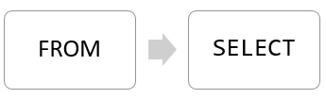
SELECT | The following illustrates the syntax of the SELECT statement: | SELECT  select_list  FROM  table_name;
SELECT | If you specify a list of columns, you need to place a comma (,) between two columns to separate them. | SELECT  first_name,  last_name,  email  FROM  customer;
SELECT | If you want to select data from all the columns of the table, you can use an asterisk (*) | SELECT *
SELECT | Using PostgreSQL SELECT statement with expressions example.  In this example, we used the concatenation operator || to concatenate the first name, space, and last name of every customer. | SELECT  first_name || ' ' || last_name,  email  FROM  customer;
SELECT | Using PostgreSQL SELECT statement with expressions example | SELECT 5 * 3;

PostgreSQL SELECT DISTINCT
DISTINCT | The DISTINCT clause is used in the SELECT statement to remove duplicate rows from a result set. The DISTINCT clause keeps one row for each group of duplicates. The DISTINCTclause can be applied to one or more columns in the select list of the SELECT statement.
DISTINCT | The following illustrates the syntax of the DISTINCT clause:  In this statement, the values in the column1 column are used to evaluate the duplicate. | SELECT  DISTINCT column1  FROM  table_name;
DISTINCT | If you specify multiple columns, the DISTINCT clause will evaluate the duplicate based on the combination of values of these columns.  In this case, the combination of values in both column1 and column2 columns will be used for evaluating the duplicate. | SELECT  DISTINCT column1, column2  FROM  table_name;
DISTINCT | PostgreSQL also provides the DISTINCT ON (expression) to keep the “first” row of each group of duplicates using the following syntax:  The order of rows returned from the SELECT statement is unspecified therefore the “first” row of each group of the duplicate is also unspecified.  It is a good practice to always use the ORDER BY clause with the DISTINCT ON(expression) to make the result set predictable.  Notice that the DISTINCT ON expression must match the leftmost expression in the ORDER BY clause. | SELECT  DISTINCT ON (column1) column_alias,  column2  FROM  table_name  ORDER BY  column1,  column2;

PostgreSQL Column Alias
A column alias allows you to assign a column or an expression in the select list of a SELECT statement a temporary name. The column alias exists temporarily during the execution of the query.

The main purpose of column aliases is to make the headings of the output of a query more meaningful.
The following illustrates the syntax of using a column alias: | SELECT column_name AS alias_name  FROM table_name;
In this syntax, the column_name is assigned an alias alias_name. The AS keyword is optional so you can omit it like this: | SELECT column_name alias_name  FROM table_name;
The following syntax illustrates how to set an alias for an expression in the SELECT clause: | SELECT expression AS alias_name  FROM table_name;
Assigning a column alias to an expression example  The following query returns the full names of all customers. It constructs the full name by concatenating the first name, space, and the last name: | SELECT  first_name || ' ' || last_name AS full_name  FROM  customer;
Column aliases that contain spaces | column_name AS "column alias"
Summary
• Assign a column or an expression a column alias using the syntax column_name AS alias_name or expression AS alias_name.
• The AS keyword is optional.
• Use double quotes (“) to surround a column alias that contains spaces.

PostgreSQL Table Aliases
Table aliases temporarily assign tables new names during the execution of a query.

The following illustrates the syntax of a table alias: | table_name AS alias_name;
In this syntax, the table_name is assigned an alias as alias_name. Similar to column aliases, the AS keyword is optional. It means that you omit the AS keyword like this: | table_name alias_name;
Table aliases have several practical applications.

• Using table aliases for the long table name to make queries more readable.
• Using table aliases in join clauses.
• Using table aliases in self-join
PostgreSQL ORDER BY
ORDER BY | When you query data from a table, the SELECT statement returns rows in an unspecified order. To sort the rows of the result set, you use the ORDER BY clause in the SELECT statement.  The ORDER BY clause allows you to sort rows returned by a SELECT clause in ascending or descending order based on a sort expression.
ORDER BY | PostgreSQL evaluates the clauses in the SELECT statment in the following order: FROM, SELECT, and ORDER BY:  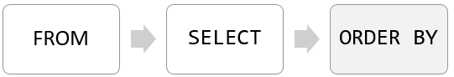  Due to the order of evaluation, if you have a column alias in the SELECT clause, you can use it in the ORDER BY clause.
ORDER BY | Summary  • Use the ORDER BY clause in the SELECT statement to sort rows.  • Use the ASC option to sort rows in ascending order and DESC option to sort rows in descending order. The ORDER BY clause uses the ASC option by default.  • Use NULLS FIRST and NULLS LAST options to explicitly specify the order of NULL with other non-null values.
ORDER BY | The following illustrates the syntax of the ORDER BY clause:  In this syntax:  • First, specify a sort expression, which can be a column or an expression, that you want to sort after the ORDER BY keywords. If you want to sort the result set based on multiple columns or expressions, you need to place a comma (,) between two columns or expressions to separate them.  • Second, you use the ASC option to sort rows in ascending order and the DESC option to sort rows in descending order. If you omit the ASC or DESC option, the ORDER BY uses ASC by default. | SELECT  select_list  FROM  table_name  ORDER BY  sort_expression1 [ASC | DESC],  ...  sort_expressionN [ASC | DESC];
ORDER BY | 1) Using PostgreSQL ORDER BY clause to sort rows by one column  The following query uses the ORDER BY clause to sort customers by their first names in ascending order:  The ASC option is the default, you can omit it. | SELECT first_name,  last_name  FROM  customer  ORDER BY  first_name ASC;
ORDER BY | 2) Using PostgreSQL ORDER BY clause to sort rows by one column in descending order | SELECT first_name,  last_name  FROM  customer  ORDER BY  last_name DESC;
ORDER BY | 3) Using PostgreSQL ORDER BY clause to sort rows by multiple columns  The following statement selects the first name and last name from the customer table and sorts the rows by the first name in ascending order and last name in descending order:  In this example, the ORDER BY clause sorts rows by values in the first name column first. And then it sorts the sorted rows by values in the last name column. | SELECT first_name,  last_name  FROM  customer  ORDER BY  first_name ASC,  last_name DESC;
ORDER BY | 4) Using PostgreSQL ORDER BY clause to sort rows by expressions  The following statement selects the first names and their lengths. It sorts the rows by the lengths of the first names: | SELECT first_name,  LENGTH(first_name) len  FROM  customer  ORDER BY  len DESC;
NULLS FIRST  NULLS LAST | The NULLS FIRST option places NULL before other non-null values and the NULL LAST option places NULL after other non-null values. | SELECT num  FROM sort_demo  ORDER BY num DESC NULLS LAST;
ASC | To sort rows in ascending order
DESC | To sort rows in descending order

PostgreSQL WHERE
WHERE | The SELECT statement returns all rows from one or more columns in a table. To select rows that satisfy a specified condition, you use a WHERE clause.
WHERE | The syntax of the PostgreSQL WHERE clause is as follows: | SELECT select_list  FROM table_name  WHERE condition  ORDER BY sort_expression
WHERE | The WHERE clause appears right after the FROM clause of the SELECT statement. The WHERE clause uses the condition to filter the rows returned from the SELECT clause.  The condition must evaluate to true, false, or unknown. It can be a boolean expression or a combination of boolean expressions using the AND and OR operators.  The query returns only rows that satisfy the condition in the WHERE clause. In other words, only rows that cause the condition evaluates to true will be included in the result set.  PostgreSQL evaluates the WHERE clause after the FROM clause and before the SELECT and ORDER BY clause:  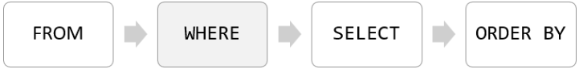  If you use column aliases in the SELECT clause, you cannot use them in the WHERE clause.  Besides the SELECT statement, you can use the WHERE clause in the UPDATE and DELETE statement to specify rows to be updated or deleted.
To form the condition in the WHERE clause, you use comparison and logical operators:
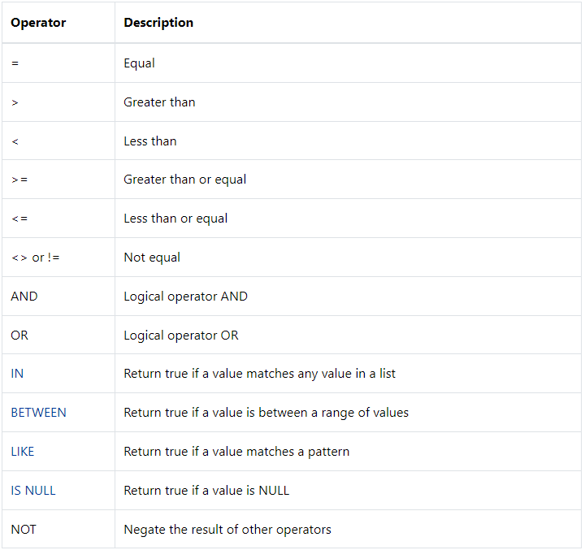
PostgreSQL LIMIT
LIMIT | PostgreSQL LIMIT is an optional clause of the SELECT statement that constrains the number of rows returned by the query.
LIMIT | The following illustrates the syntax of the LIMIT clause:  The statement returns row_count rows generated by the query. If row_count is zero, the query returns an empty set. In case row_count is NULL, the query returns the same result set as it does not have the LIMIT clause. | SELECT select_list  FROM table_name  ORDER BY sort_expression  LIMIT row_count
OFFSET | In case you want to skip a number of rows before returning the row_count rows, you use OFFSET clause placed after the LIMIT clause as the following statement:  The statement first skips row_to_skip rows before returning row_count rows generated by the query. If row_to_skip is zero, the statement will work like it doesn’t have the OFFSET clause.  Because a table may store rows in an unspecified order, when you use the LIMIT clause, you should always use the ORDER BY clause to control the row order. If you don’t use the ORDER BY clause, you may get a result set with the unspecified order of rows. | SELECT select_list  FROM table_name  LIMIT row_count OFFSET row_to_skip;

PostgreSQL FETCH
FETCH | To constrain the number of rows returned by a query, you often use the LIMIT clause. The LIMIT clause is widely used by many relational database management systems such as MySQL, H2, and HSQLDB. However, the LIMIT clause is not a SQL-standard.  To conform with the SQL standard, PostgreSQL supports the FETCH clause to retrieve a number of rows returned by a query. Note that the FETCH clause was introduced in SQL:2008.
FETCH | FETCH vs. LIMIT  The FETCH clause is functionally equivalent to the LIMIT clause. If you plan to make your application compatible with other database systems, you should use the FETCH clause because it follows the standard SQL.
FETCH | The following illustrates the syntax of the PostgreSQL FETCH clause:  OFFSET start { ROW | ROWS }  FETCH { FIRST | NEXT } [ row_count ] { ROW | ROWS } ONLY  In this syntax:  • ROW is the synonym for ROWS, FIRST is the synonym for NEXT . SO you can use them interchangeably  • The start is an integer that must be zero or positive. By default, it is zero if the OFFSET clause is not specified. In case the start is greater than the number of rows in the result set, no rows are returned;  • The row_count is 1 or greater. By default, the default value of row_count is 1 if you do not specify it explicitly.

PostgreSQL IN
IN | You use IN operator in the WHERE clause to check if a value matches any value in a list of values.
IN | The syntax of the IN operator is as follows:  The IN operator returns true if the value matches any value in the list i.e., value1 , value2 , … | value IN (value1,value2,...)
IN | The list of values can be a list of literal values such as numbers, strings or a result of a SELECT statement like this:  The query inside the parentheses is called a subquery, which is a query nested inside another query. | value IN (SELECT column_name FROM table_name);
IN | The query that uses the IN operator is shorter and more readable than the query that uses equal (=) and OR operators. In addition, PostgreSQL executes the query with the IN operator much faster than the same query that uses a list of OR operators.
NOT IN | You can combine the IN operator with the NOT operator to select rows whose values do not match the values in the list.
 | For example, the following statement finds all rentals with the customer id is not 1 or 2. | SELECT customer_id,  rental_id,  return_date  FROM  rental  WHERE  customer_id NOT IN (1, 2);
PostgreSQL IN with a subquery
The following query returns a list of customer ids from the rental table with the return date is 2005-05-27:
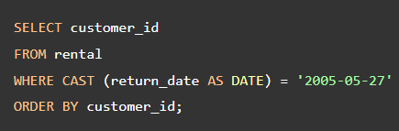

Because this query returns a list of values, you can use it as the input of the IN operator like this:
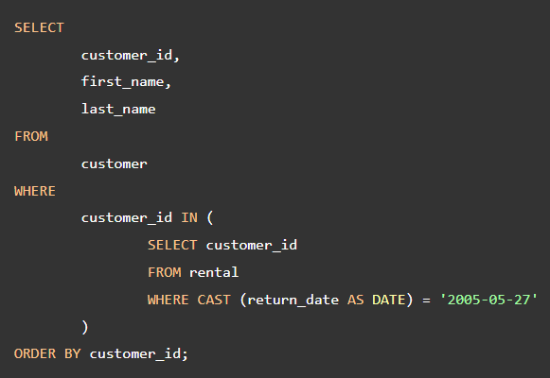
PostgreSQL BETWEEN
BETWEEN | You use the BETWEEN operator to match a value against a range of values. The following illustrates the syntax of the BETWEEN operator:  If the value is greater than or equal to the low value and less than or equal to the high value, the expression returns true, otherwise, it returns false. | value BETWEEN low AND high;
NOT BETWEEN | If you want to check if a value is out of a range, you combine the NOT operator with the BETWEEN operator as follows: | value NOT BETWEEN low AND high;

PostgreSQL LIKE and ILIKE
LIKE | PostgreSQL LIKE and ILIKE operators to query data using pattern matchings. | SELECT first_name,  last_name  FROM customer  WHERE  first_name LIKE 'Jen%';
LIKE | You construct a pattern by combining literal values with wildcard characters and use the LIKE or NOT LIKE operator to find the matches. PostgreSQL provides you with two wildcards:  • Percent sign ( %) matches any sequence of zero or more characters.  • Underscore sign ( _) matches any single character.
LIKE | You can combine the percent ( %) with underscore ( _) to construct a pattern as the following example:  The pattern _her% matches any string that:  • Begin with any single character (_)  • And is followed by the literal string her.  • And is ended with any number of characters. | SELECT first_name,  last_name  FROM customer  WHERE  first_name LIKE '_her%'  ORDER BY  first_name;
NOT LIKE | The following query uses the NOT LIKE operator to find customers whose first names do not begin with Jen: | SELECT first_name,  last_name  FROM customer  WHERE  first_name NOT LIKE 'Jen%'  ORDER BY  first_name
ILIKE | PostgreSQL supports the ILIKE operator that works like the LIKE operator. In addition, the ILIKE operator matches value case-insensitively. For example: | SELECT first_name,  last_name  FROM customer  WHERE  first_name ILIKE 'BAR%';

PostgreSQL also provides some operators that act like the LIKE, NOT LIKE, ILIKE and NOT ILIKE operator as shown below:
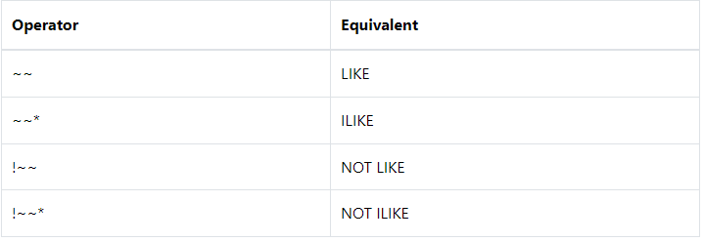

PostgreSQL IS NULL
IS NULL | In the database world, NULL means missing information or not applicable. NULL is not a value, therefore, you cannot compare it with any other values like numbers or strings. The comparison of NULL with a value will always result in NULL, which means an unknown result.
IS NULL | The statement returns no row. This is because the expression phone = NULL in the WHERE clause always returns false.  Even though there is a NULL in the phone column, the expression NULL = NULL returns false. This is because NULL is not equal to any value even itself. | SELECT id,  first_name,  last_name,  email,  phone  FROM  contacts  WHERE  phone = NULL;
IS NULL | To check whether a value is NULL or not, you use the IS NULL operator instead: | value IS NULL
IS NOT NULL | To check if a value is not NULL, you use the IS NOT NULL operator: | value IS NOT NULL

PostgreSQL Joins
PostgreSQL join is used to combine columns from one (self-join) or more tables based on the values of the common columns between related tables. The common columns are typically the primary key columns of the first table and foreign key columns of the second table.
PostgreSQL supports inner join, left join, right join, full outer join, cross join, natural join, and a special kind of join called self-join.
Most of the time, the tables that you want to join will have columns with the same name e.g., id column like customer_id.
If you reference columns with the same name from different tables in a query, you will get an error. To avoid the error, you need to qualify these columns fully using the following syntax: table_name.column_name
In practice, you will use table aliases to assign the joined tables short names to make the query more readable.
USING | Since both tables have the same customer_id column, you can use the USING syntax: | SELECT c.customer_id,  first_name,  last_name,  email,  amount,  payment_date  FROM  customer c  INNER JOIN payment p  ON p.customer_id = c.customer_id  WHERE  c.customer_id = 2;
USING |  | SELECT customer_id,  first_name,  last_name,  amount,  payment_date  FROM  customer  INNER JOIN payment USING(customer_id)  ORDER BY payment_date;

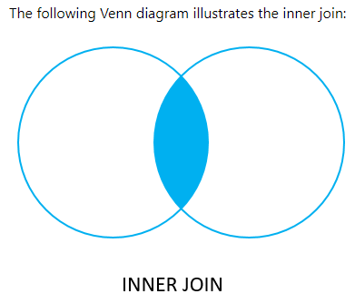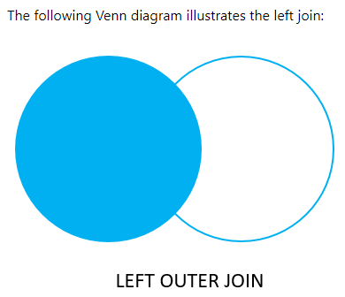

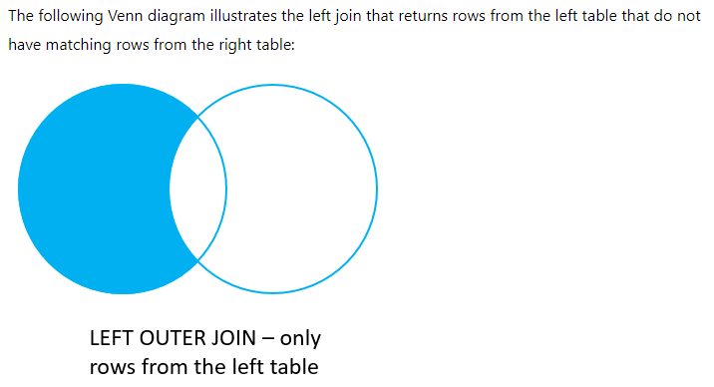
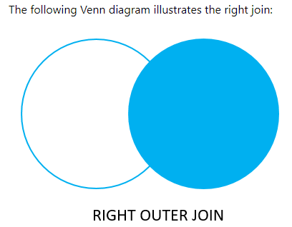
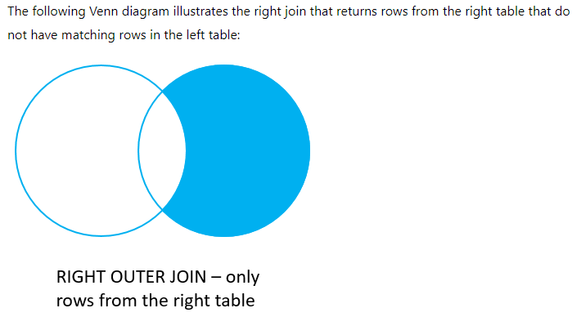

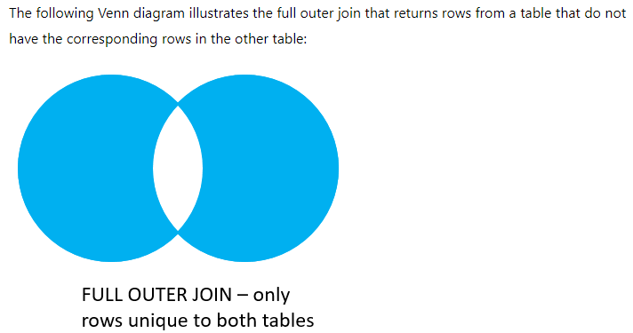
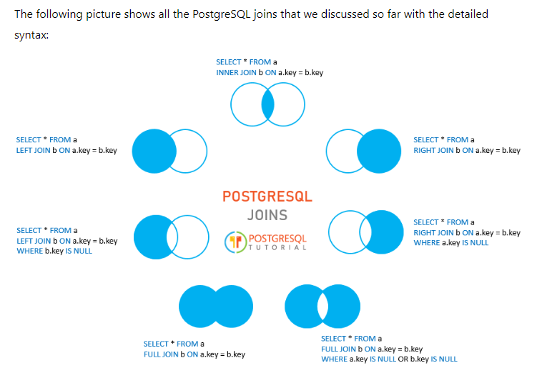

PostgreSQL INNER JOIN
How the INNER JOIN works.  For each row in the table A, inner join compares the value in the pka column with the value in the fka column of every row in the table B:  • If these values are equal, the inner join creates a new row that contains all columns of both tables and adds it to the result set.  • In case these values are not equal, the inner join just ignores them and moves to the next row. |  |  | 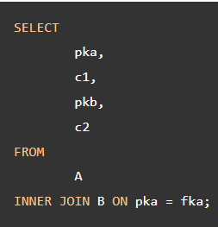
1) Using PostgreSQL INNER JOIN to join two tables.

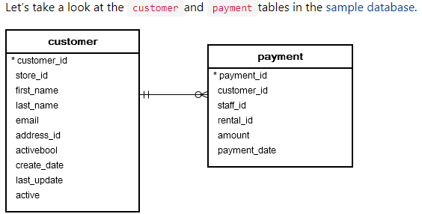
In these tables, whenever a customer makes a payment, a new row is inserted into the payment table.

Each customer may have zero or many payments. However, each payment belongs to one and only one customer. The customer_id column establishes the relationship between the two tables.
The following statement uses the INNER JOIN clause to select data from both tables: |  | 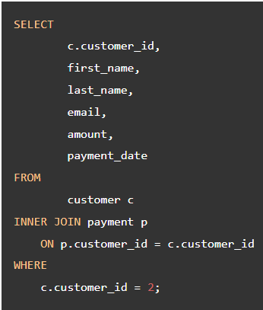
2) Using PostgreSQL INNER JOIN to join three tables.
The following diagram illustrates the relationship between three tables: staff, payment, and customer.

• Each staff handles zero or many payments. And each payment is processed by one and only one staff.
• Each customer made zero or many payments. Each payment is made by one customer.
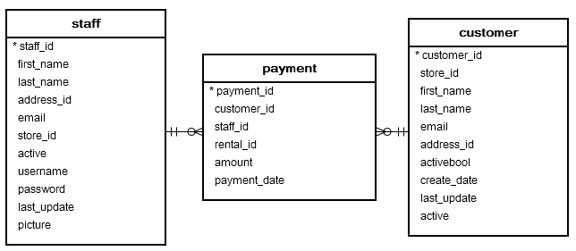

To join the three tables, you place the second INNER JOIN clause after the first INNER JOIN clause as the following query:  To join more than three tables, you apply the same technique. | 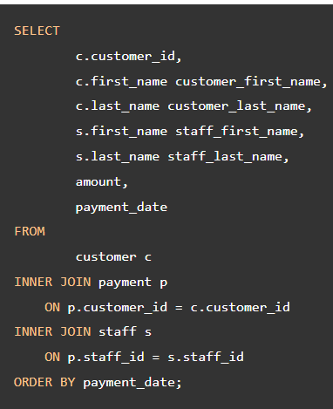

PostgreSQL LEFT JOIN
The LEFT JOIN clause starts selecting data from the left table. For each row in the left table, it compares the value in the pka column with the value of each row in the fka column in the right table.  • If these values are equal, the left join clause creates a new row that contains columns that appear in the SELECT clause and adds this row to the result set.  • In case these values are not equal, the left join clause also creates a new row that contains columns that appear in the SELECT clause. In addition, it fills the columns that come from the right table with NULL.  Note that the LEFT JOIN is also referred to as LEFT OUTER JOIN. |  |  | 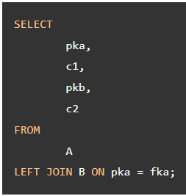
Let’s look at the following film and inventory tables from the sample database.
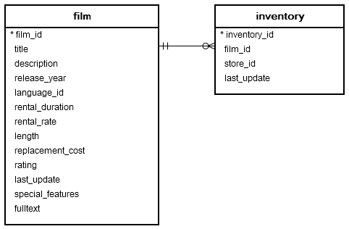
Each row in the film table may have zero or many rows in the inventorytable. Each row in the inventory table has one and only one row in the film table.

The film_id column establishes the link between the film and inventory tables.
The following statement uses the LEFT JOIN clause to join film table with the inventorytable:  When a row from the film table does not have a matching row in the inventorytable, the value of the inventory_id column of this row is NULL. | 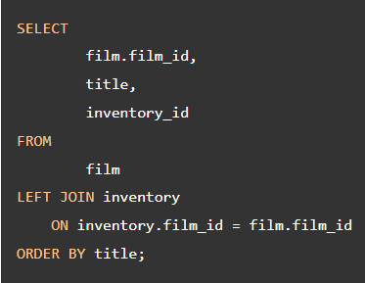
The following statement adds a WHERE clause to find the films that are not in the inventory: |  | 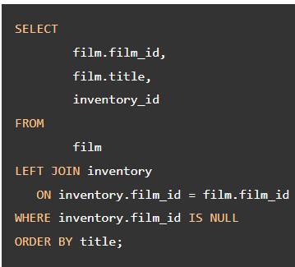

PostgreSQL RIGHT JOIN
The following statement uses the RIGHT JOIN to select data from the films and film_reviews tables:  In this statement, films is the left table and film_reviews is the right table.  The RIGHT JOIN clause starts selecting data from the right table (film_reviews).  • For each row from the right table (film_reviews), it checks if the value in the film_id column of the film_reviews table equals the value in the film_id column of every row from the left table (films).  • If they are equal, the RIGHT JOIN creates a new row that contains columns from both tables specified in the SELECT clause and includes this new row in the result set.  • Otherwise, the RIGHT JOIN still creates a new row that contains columns from both tables and includes this new row in the result set. However, it fills the columns from the left table (films) with NULL.  In other words, the RIGHT JOIN selects all rows from the right table whether or not they have matching rows from the left table. | 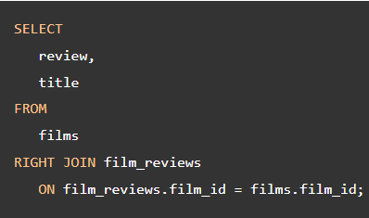  Note that the RIGHT OUTER JOIN is the same as RIGHT JOIN. The OUTER keyword is optional

PostgreSQL Self-Join
A self-join is a regular join that joins a table to itself. In practice, you typically use a self-join to query hierarchical data or to compare rows within the same table.
To form a self-join, you specify the same table twice with different table aliases and provide the join predicate after the ON keyword.
The following query uses an INNER JOIN that joins the table to itself:  In this syntax, the table_name is joined to itself using the INNER JOIN clause. |  | 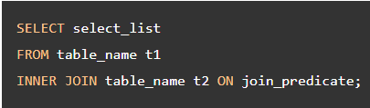
Also, you can use the LEFT JOIN or RIGHT JOIN clause to join table to itself like this: |  | 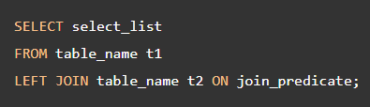
1) Querying hierarchical data example.  This query references the employees table twice, one as the employee and the other as the manager. It uses table aliases e for the employee and m for the manager. | 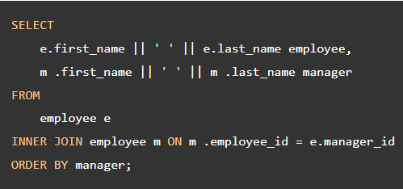
2) Comparing the rows with the same table.  See the following film table from the DVD rental database:  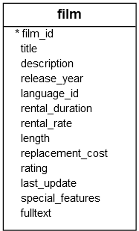  The following query finds all pair of films that have the same length.  The join predicate matches two different films (f1.film_id <> f2.film_id) that have the same length (f1.length = f2.length) |  | 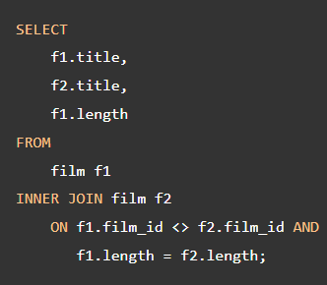

PostgreSQL FULL OUTER JOIN
Suppose that you want to perform a full outer join of two tables: A and B. The following illustrates the syntax of the FULL OUTER JOIN:  In this syntax, the OUTER keyword is optional.  The full outer join combines the results of both the left join and the right join.  • If the rows in the joined table do not match, the full outer join sets NULL values for every column of the table that does not have the matching row.  • If a row from one table matches a row in another table, the result row will contain columns populated from columns of rows from both tables. |  |  | 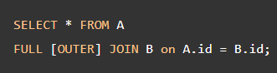
use the FULL OUTER JOIN to query data from both employees and departments tables. |  | 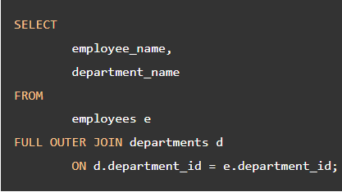
To find the department that does not have any employees, you use a WHERE clause as follows: |  | 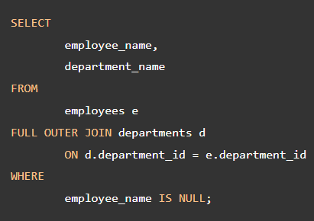
To find an employee who does not belong to any department, you check for the NULL of the department_name in the WHERE clause as the following statement: | 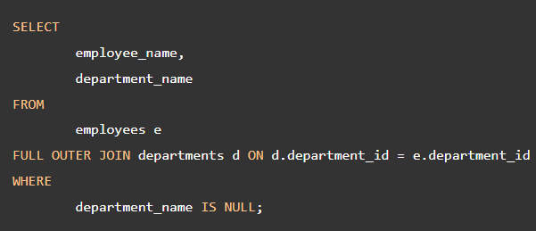

PostgreSQL Cross Join By Example
A CROSS JOIN clause allows you to produce a Cartesian Product of rows in two or more tables.
Different from other join clauses such as LEFT JOIN or INNER JOIN, the CROSS JOIN clause does not have a join predicate.
Suppose you have to perform a CROSS JOIN of two tables T1 and T2.
If T1 has n rows and T2 has m rows, the result set will have nxm rows. For example, the T1 has 1,000 rows and T2 has 1,000 rows, the result set will have 1,000 x 1,000 = 1,000,000 rows.
The following illustrates the syntax of the CROSS JOIN syntax: | 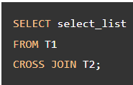
The following statement is equivalent to the above statement: | 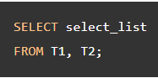
Also, you can use an INNER JOIN clause with a condition that always evaluates to true to simulate the cross-join: | 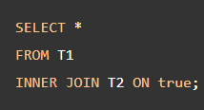
The following statement uses the CROSS JOIN operator to join table T1 with table T2.  The following picture illustrates the result of the CROSS JOIN when joining the table T1 to the table T2:  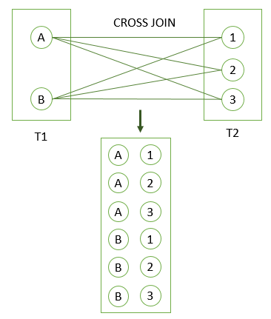 | 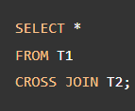  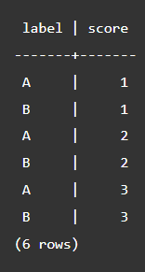

PostgreSQL NATURAL JOIN Explained By Examples
A natural join is a join that creates an implicit join based on the same column names in the joined tables.  The following shows the syntax of the PostgreSQL natural join: |  | 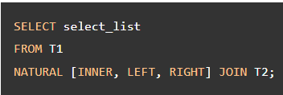
The following statement uses the NATURAL JOIN clause to join the products table with the categories table: |  |  | 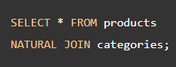
The above statement is equivalent to the following statement that uses the INNER JOIN clause. | 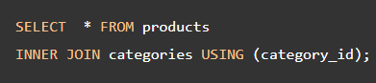
The convenience of the NATURAL JOIN is that it does not require you to specify the join clause because it uses an implicit join clause based on the common column.

However, you should avoid using the NATURAL JOIN whenever possible because sometimes it may cause an unexpected result.

For example, See the following city and country tables from the sample database:
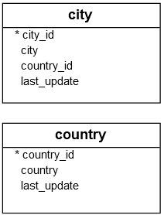
Both tables have the same country_id column so you can use the NATURAL JOIN to join these tables as follows:
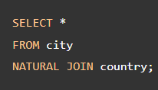
The query returns an empty result set.

The reason is that…

Both tables also have another common column called last_update, which cannot be used for the join. However, the NATURAL JOIN clause just uses the last_update column.

PostgreSQL GROUP BY
GROUP BY | The GROUP BY clause divides the rows returned from the SELECT statement into groups. For each group, you can apply an aggregate function e.g., SUM() to calculate the sum of items or COUNT() to get the number of items in the groups.
GROUP BY | The following statement illustrates the basic syntax of the GROUP BY clause:  In this syntax:  First, select the columns that you want to group e.g., column1 and column2, and column that you want to apply an aggregate function (column3).  Second, list the columns that you want to group in the GROUP BY clause.  The statement clause divides the rows by the values of the columns specified in the GROUP BY clause and calculates a value for each group. |  |  | SELECT  column_1,  column_2,  ...,  aggregate_function(column_3)  FROM  table_name  GROUP BY  column_1,  column_2,  ...;
GROUP BY | It’s possible to use other clauses of the SELECT statement with the GROUP BY clause.  PostgreSQL evaluates the GROUP BY clause after the FROM and WHERE clauses and before the HAVING SELECT, DISTINCT, ORDER BY and LIMIT clauses.  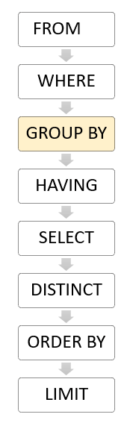
GROUP BY | 1) Using PostgreSQL GROUP BY without an aggregate function example  In this case, the GROUP BY works like the DISTINCT clause that removes duplicate rows from the result set. |  |  |  |  | SELECT  customer_id  FROM  payment  GROUP BY  customer_id;
GROUP BY | 2) Using PostgreSQL GROUP BY with SUM() function example  The GROUP BY clause is useful when it is used in conjunction with an aggregate function.  For example, to select the total amount that each customer has been paid, you use the GROUP BY clause to divide the rows in the payment table into groups grouped by customer id. For each group, you calculate the total amounts using the SUM() function.  The following query uses the GROUP BY clause to get the total amount that each customer has been paid:  The GROUP BY clause sorts the result set by customer id and adds up the amount that belongs to the same customer. Whenever the customer_id changes, it adds the row to the returned result set |  |  |  | 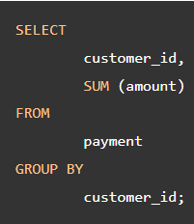
GROUP BY | 3) Using PostgreSQL GROUP BY clause with the JOIN clause  The following statement uses the GROUP BY clause with the INNER JOIN clause the get the total amount paid by each customer.  Unlike the previous example, this query joins the payment table with the customer table and group customers by their names. | 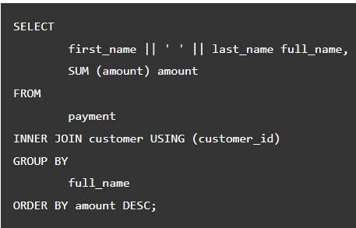
GROUP BY | 4) Using PostgreSQL GROUP BY with COUNT() function example  To find the number of payment transactions that each staff has processed, you group the rows in the payment table by the values in the staff_id column and use the COUNT() function to get the number of transactions:  The GROUP BY clause divides the rows in the payment into groups and groups them by value in the staff_id column. For each group, it returns the number of rows by using the COUNT() function. |  |  | 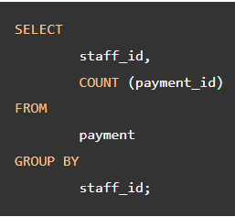
GROUP BY | 5) Using PostgreSQL GROUP BY with multiple columns  The following example uses multiple columns in the GROUP BY clause:  In this example, the GROUP BY clause divides the rows in the payment table by the values in the customer_id and staff_id columns. For each group of (customer_id, staff_id), the SUM() calculates the total amount. |  |  |  | 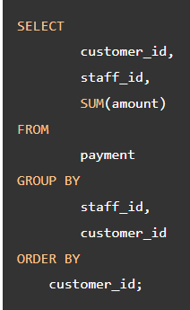
GROUP BY | 6) Using PostgreSQL GROUP BY clause with a date column  The payment_date is a timestamp column. To group payments by dates, you use the DATE() function to convert timestamps to dates first and then group payments by the result date: |  | 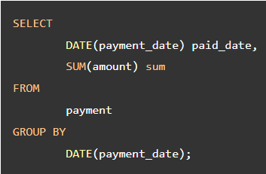

PostgreSQL HAVING
HAVING | The HAVING clause specifies a search condition for a group or an aggregate. The HAVING clause is often used with the GROUP BY clause to filter groups or aggregates based on a specified condition.
HAVING | The following statement illustrates the basic syntax of the HAVINGclause:  In this syntax, the group by clause returns rows grouped by the column1. The HAVING clause specifies a condition to filter the groups.  It’s possible to add other clauses of the SELECT statement such as JOIN, LIMIT, FETCH etc. | 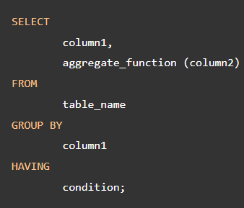
HAVING | PostgreSQL evaluates the HAVING clause after the FROM, WHERE, GROUP BY, and before the SELECT, DISTINCT, ORDER BY and LIMIT clauses.  Since the HAVING clause is evaluated before the SELECT clause, you cannot use column aliases in the HAVING clause. Because at the time of evaluating the HAVING clause, the column aliases specified in the SELECT clause are not available.  HAVING vs. WHERE  The WHERE clause allows you to filter rows based on a specified condition. However, the HAVING clause allows you to filter groups of rows according to a specified condition.  In other words, the WHERE clause is applied to rows while the HAVING clause is applied to groups of rows. |  |  | 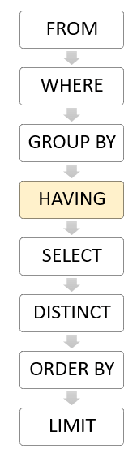
HAVING | 1) Using PostgreSQL HAVING clause with SUM function example. (or COUNT function)  The following query uses the GROUP BY clause with the SUM() function to find the total amount of each customer and adds the HAVING clause to select the only customers who have been spending more than 200: |  | 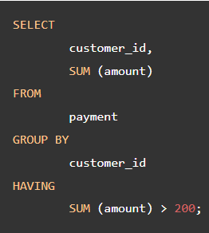

PostgreSQL UNION and UNION ALL
UNION | The UNION operator combines result sets of two or more SELECT statements into a single result set.
UNION | The following illustrates the syntax of the UNION operator that combines result sets from two queries: |  | SELECT select_list_1  FROM table_expresssion_1  UNION  SELECT select_list_2  FROM table_expression_2
UNION | To combine the result sets of two queries using the UNION operator, the queries must conform to the following rules:  The number and the order of the columns in the select list of both queries must be the same.  The data types must be compatible.  The UNION operator removes all duplicate rows from the combined data set. To retain the duplicate rows, you use the the UNION ALL instead. | The following Venn digram illustrates how to the UNION works:  
UNION | PostgreSQL UNION with ORDER BY clause  The UNION operator may place the rows from the result set of the first query before, after, or between the rows from the result set of the second query.  To sort rows in the final result set, you use the ORDER BY clause in the second query. If you place the ORDER BY clause at the end of each query, the combined result set will not be sorted as you expected.  Because when UNION operator combines the sorted result sets from each query, it does not guarantee the order of rows in the final result set.  In practice, you often use the UNION operator to combine data from similar tables, which are not perfectly normalized, in the data warehouse or business intelligence systems.

PostgreSQL INTERSECT Operator
INTERSECT | Like the UNION and EXCEPT operators, the PostgreSQL INTERSECT operator combines result sets of two or more SELECT statements into a single result set.  The INTERSECT operator returns any rows that are available in both result sets.
INTERSECT | The following illustration shows the final result set produced by the INTERSECT operator.  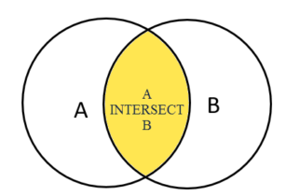  The final result set is represented by the yellow area where circle A intersects with circle B. | The following illustrates the syntax of the INTERSECT operator:  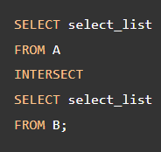
INTERSECT | To use the INTERSECT operator, the columns that appear in the SELECT statements must follow the folowing rules:  • The number of columns and their order in the SELECT clauses must be the same.  • The data types of the columns must be compatible.
PostgreSQL EXCEPT
EXCEPT | Like the UNION and INTERSECT operators, the EXCEPT operator returns rows by comparing the result sets of two or more queries.  The EXCEPT operator returns distinct rows from the first (left) query that are not in the output of the second (right) query.
EXCEPT | The following illustrates the syntax of the EXCEPT operator. | SELECT select_list  FROM A  EXCEPT  SELECT select_list  FROM B;
EXCEPT | The queries that involve in the EXCEPT need to follow these rules:  • The number of columns and their orders must be the same in the two queries.  • The data types of the respective columns must be compatible. | The following Venn diagram illustrates the EXCEPT operator:  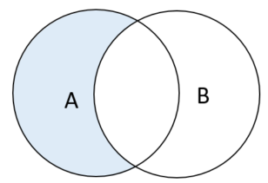

PostgreSQL GROUPING SETS (GROUP BY, GROUPING SETS, GROUPING)
GROUP BY | A grouping set is a set of columns by which you group by using the GROUP BY clause.
GROUP BY | A grouping set is denoted by a comma-separated list of columns placed inside parentheses: |  | (column1, column2, ...)
GROUP BY | The following query uses the GROUP BY clause to return the number of products sold by brand and segment. In other words, it defines a grouping set of the brand and segment which is denoted by (brand, segement) |  |  | 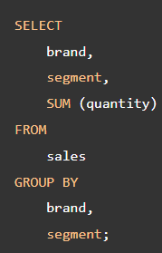
GROUP BY | Suppose that you want to get all the grouping sets by using a single query. To achieve this, you may use the UNION ALL to combine all the queries above.  Because UNION ALL requires all result sets to have the same number of columns with compatible data types, you need to adjust the queries by adding NULL to the selection list of each as shown below: →  This query generated a single result set with the aggregates for all grouping sets.  Even though the above query works as you expected, it has two main problems.  • First, it is quite lengthy.  • Second, it has a performance issue because PostgreSQL has to scan the sales table separately for each query. |  |  |  |  |  | SELECT  brand,  segment,  SUM (quantity)  FROM  sales  GROUP BY  brand,  segment  UNION ALL  SELECT  brand,  NULL,  SUM (quantity)  FROM  sales  GROUP BY  brand  UNION ALL  SELECT  NULL,  segment,  SUM (quantity)  FROM  sales  GROUP BY  segment  UNION ALL  SELECT  NULL,  NULL,  SUM (quantity)  FROM  sales;
GROUPING SETS | To make it more efficient, PostgreSQL provides the GROUPING SETS clause which is the subclause of the GROUP BY clause.  The GROUPING SETS allows you to define multiple grouping sets in the same query.
GROUPING SETS | The general syntax of the GROUPING SETS is as follows: →  In this syntax, we have four grouping sets (c1,c2), (c1), (c2), and (). |  |  |  | SELECT  c1,  c2,  aggregate_function(c3)  FROM  table_name  GROUP BY  GROUPING SETS (  (c1, c2),  (c1),  (c2),  ()  );
GROUPING SETS | To apply this syntax to the above example, you can use GROUPING SETS clause instead of the UNION ALL clause like this: →  This query is much shorter and more readable. In addition, PostgreSQL will optimize the number of times it scans the sales table and will not scan multiple times. |  |  |  |  | SELECT  brand,  segment,  SUM (quantity)  FROM  sales  GROUP BY  GROUPING SETS (  (brand, segment),  (brand),  (segment),  ()  );
GROUPING | The GROUPING() function accepts an argument which can be a column name or an expression: | GROUPING( column_name | expression)
GROUPING | The column_name or expression must match with the one specified in the GROUP BY clause.  The GROUPING() function returns bit 0 if the argument is a member of the current grouping set and 1 otherwise.  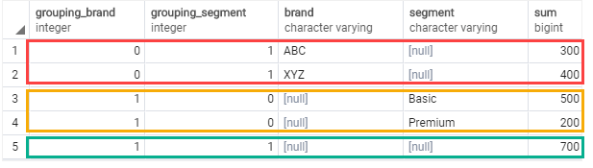  As shown in the screenshot, when the value in the grouping_brand is 0, the sum column shows the subtotal of the brand.  When the value in the grouping_segment is zero, the sum column shows the subtotal of the segment. |  | SELECT  GROUPING(brand) grouping_brand,  GROUPING(segment) grouping_segment,  brand,  segment,  SUM (quantity)  FROM  sales  GROUP BY  GROUPING SETS (  (brand),  (segment),  ()  )  ORDER BY  brand,  segment;

PostgreSQL CUBE
CUBE | PostgreSQL CUBE is a subclause of the GROUP BY clause. The CUBE allows you to generate multiple grouping sets.  A grouping set is a set of columns to which you want to group.
CUBE | The following illustrates the syntax of the CUBE subclause: →  In this syntax:  • First, specify the CUBE subclause in the the GROUP BY clause of the SELECT statement.  • Second, in the select list, specify the columns (dimensions or dimension columns) which you want to analyze and aggregation function expressions.  • Third, in the GROUP BY clause, specify the dimension columns within the parentheses of the CUBE subclause. | SELECT  c1,  c2,  c3,  aggregate (c4)  FROM  table_name  GROUP BY  CUBE (c1, c2, c3);
CUBE | The query generates all possible grouping sets based on the dimension columns specified in CUBE. The CUBE subclause is a short way to define multiple grouping sets so the following are equivalent: →  In general, if the number of columns specified in the CUBE is n, then you will have 2n combinations. | 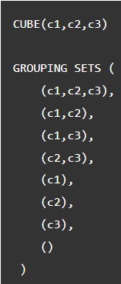
CUBE | PostgreSQL allows you to perform a partial cube to reduce the number of aggregates calculated. The following shows the syntax: | SELECT  c1,  c2,  c3,  aggregate (c4)  FROM  table_name  GROUP BY  c1,  CUBE (c1, c2);

PostgreSQL ROLLUP
ROLLUP | The PostgreSQL ROLLUP is a subclause of the GROUP BY clause that offers a shorthand for defining multiple grouping sets. A grouping set is a set of columns by which you group.  Different from the CUBE subclause, ROLLUP does not generate all possible grouping sets based on the specified columns. It just makes a subset of those.  The ROLLUP assumes a hierarchy among the input columns and generates all grouping sets that make sense considering the hierarchy. This is the reason why ROLLUP is often used to generate the subtotals and the grand total for reports.
ROLLUP | For example, the CUBE (c1,c2,c3) makes all eight possible grouping sets: | (c1, c2, c3)  (c1, c2)  (c2, c3)  (c1,c3)  (c1)  (c2)  (c3)  ()
ROLLUP | However, the ROLLUP(c1,c2,c3) generates only four grouping sets, assuming the hierarchy c1 > c2 > c3 as follows: | (c1, c2, c3)  (c1, c2)  (c1)  ()
ROLLUP | A common use of ROLLUP is to calculate the aggregations of data by year, month, and date, considering the hierarchy year > month > date  The following illustrates the syntax of the PostgreSQL ROLLUP:  It is also possible to do a partial roll up to reduce the number of subtotals generated.  It is also possible to do a partial roll up to reduce the number of subtotals generated. | SELECT  c1,  c2,  c3,  aggregate(c4)  FROM  table_name  GROUP BY  ROLLUP (c1, c2, c3);

PostgreSQL Subquery
A subquery is a query nested inside another query such as SELECT, INSERT, DELETE and UPDATE. In this tutorial, we are focusing on the SELECT statement only.
To construct a subquery, we put the second query in brackets and use it in the WHERE clause as an expression:  The query inside the brackets is called a subquery or an inner query. The query that contains the subquery is known as an outer query.  PostgreSQL executes the query that contains a subquery in the following sequence:  • First, executes the subquery.  • Second, gets the result and passes it to the outer query.  • Third, executes the outer query. |  |  |  | SELECT film_id,  title,  rental_rate  FROM film  WHERE  rental_rate > (  SELECT  AVG (rental_rate)  FROM  film  );
PostgreSQL subquery with IN operator.
A subquery can return zero or more rows. To use this subquery, you use the IN operator in the WHERE clause.
For example, to get films that have the returned date between 2005-05-29 and 2005-05-30, you use the following query: |  | SELECT film_id,  title  FROM film  WHERE  film_id IN (  SELECT  inventory.film_id  FROM  rental  INNER JOIN inventory ON inventory.inventory_id = rental.inventory_id  WHERE  return_date BETWEEN '2005-05-29'  AND '2005-05-30'  );
EXISTS | PostgreSQL subquery with EXISTS operator.  The following expression illustrates how to use a subquery with EXISTS operator:  EXISTS subquery  A subquery can be an input of the EXISTS operator. If the subquery returns any row, the EXISTS operator returns true. If the subquery returns no row, the result of EXISTS operator is false.
EXISTS | The EXISTS operator only cares about the number of rows returned from the subquery, not the content of the rows, therefore, the common coding convention of EXISTS operator is as follows: EXISTS (SELECT 1 FROM tbl WHERE condition);
EXISTS | The query works like an inner join on the customer_id column. However, it returns at most one row for each row in the customer table even though there are some corresponding rows in the payment table. |  | SELECT first_name,  last_name  FROM customer  WHERE  EXISTS (  SELECT  1  FROM  payment  WHERE  payment.customer_id = customer.customer_id );

PostgreSQL ANY Operator
 | The PostgreSQL ANY operator compares a value to a set of values returned by a subquery.
ANY | The following illustrates the syntax of the ANY operator:  In this syntax:  • The subquery must return exactly one column.  • The ANY operator must be preceded by one of the following comparison operator =, <=, >, <, > and <>  • The ANY operator returns true if any value of the subquery meets the condition, otherwise, it returns false.  Note that SOME is a synonym for ANY, meaning that you can substitute SOME for ANY in any SQL statement. | expresion operator ANY(subquery)
ANY | The following example returns the maximum length of film grouped by film category: | SELECT  MAX( length )  FROM  film  INNER JOIN film_category  USING(film_id)  GROUP BY  category_id;
ANY | You can use this query as a subquery in the following statement that finds the films whose lengths are greater than or equal to the maximum length of any film category :  For each film category, the subquery finds the maximum length. The outer query looks at all these values and determines which film’s lengths are greater than or equal to any film category’s maximum length.  Note that if the subquery does not return any rows, the entire query returns an empty result set. | SELECT title  FROM film  WHERE length >= ANY(  SELECT MAX( length )  FROM film  INNER JOIN film_category USING(film_id)  GROUP BY category_id );
ANY | ANY vs. IN  The = ANY is equivalent to IN operator.

PostgreSQL ALL Operator
ALL | The PostgreSQL ALL operator allows you to query data by comparing a value with a list of values returned by a subquery.
ALL | The following illustrates the syntax of the ALL operator:  In this syntax:  • The ALL operator must be preceded by a comparison operator such as equal (=), not equal (!=), greater than (>), greater than or equal to (>=), less than (<), and less than or equal to (<=).  • The ALL operator must be followed by a subquery which also must be surrounded by the parentheses. | comparison_operator ALL (subquery)
ALL | With the assumption that the subquery returns some rows, the ALL operator works as follows:  column_name > ALL (subquery) the expression evaluates to true if a value is greater than the biggest value returned by the subquery.  column_name >= ALL (subquery) the expression evaluates to true if a value is greater than or equal to the biggest value returned by the subquery.  column_name < ALL (subquery) the expression evaluates to true if a value is less than the smallest value returned by the subquery.  column_name <= ALL (subquery) the expression evaluates to true if a value is less than or equal to the smallest value returned by the subquery.  column_name = ALL (subquery) the expression evaluates to true if a value is equal to any value returned by the subquery.  column_name != ALL (subquery) the expression evaluates to true if a value is not equal to any value returned by the subquery.  In case the subquery returns no row, then the ALL operator always evaluates to true.
ALL | To find all films whose lengths are greater than the list of the average lengths above, you use the ALL and greater than operator (>) as follows:  As you can see clearly from the output, the query return all films whose lengths are greater than the biggest value in the average length list returned by the subquery. |  | SELECT  film_id,  title,  length  FROM  film  WHERE  length > ALL (  SELECT  ROUND(AVG (length),2)  FROM  film  GROUP BY  rating  )  ORDER BY  length;

PostgreSQL EXISTS
EXISTS | The EXISTS operator is a boolean operator that tests for existence of rows in a subquery.
EXISTS | The following illustrates syntax of the EXISTS operator: | EXISTS (subquery)
EXISTS | The EXISTS accepts an argument which is a subquery.  If the subquery returns at least one row, the result of EXISTS is true. In case the subquery returns no row, the result is of EXISTS is false.  The EXISTS operator is often used with the correlated subquery.  The result of EXISTS operator depends on whether any row returned by the subquery, and not on the row contents. Therefore, columns that appear on the SELECT clause of the subquery are not important.
EXISTS | For this reason, the common coding convention is to write EXISTS in the following form:  Note that if the subquery returns NULL, the result of EXISTS is true. |  | SELECT  column1  FROM  table_1  WHERE  EXISTS( SELECT  1  FROM  table_2  WHERE  column_2 = table_1.column_1);
EXISTS | A) Find customers who have at least one payment whose amount is greater than 11.  The following statement returns customers who have paid at least one rental with an amount greater than 11: →  In this example, for each customer in the customer table, the subquery checks the payment table to find if that customer made at least one payment (p.customer_id = c.customer_id) and the amount is greater than 11 ( amount > 11) |  | SELECT first_name,  last_name  FROM customer c  WHERE EXISTS  (SELECT 1  FROM payment p  WHERE p.customer_id = c.customer_id  AND amount > 11 )  ORDER BY first_name,  last_name;
NOT EXISTS | B) NOT EXISTS example  The NOT operator negates the result of the EXISTS operator. The NOT EXISTS is opposite to EXISTS. It means that if the subquery returns no row, the NOT EXISTS returns true. If the subquery returns one or more rows, the NOT EXISTS returns false.  The following example returns customers have not made any payment that greater than 11. |  | SELECT first_name,  last_name  FROM customer c  WHERE NOT EXISTS  (SELECT 1  FROM payment p  WHERE p.customer_id = c.customer_id  AND amount > 11 )  ORDER BY first_name,  last_name;
EXISTS and NULL | C) EXISTS and NULL  If the subquery returns NULL, EXISTS returns true. See the following example: →  In this example, the subquery returned NULL, therefore, the query returned all rows from the customer table. |  | SELECT first_name,  last_name  FROM customer  WHERE  EXISTS( SELECT NULL )  ORDER BY  first_name,  last_name;

PostgreSQL CTE (common table expressions)
CTE | A common table expression is a temporary result set which you can reference within another SQL statement including SELECT, INSERT, UPDATE or DELETE.  Common Table Expressions are temporary in the sense that they only exist during the execution of the query.
CTE | The following shows the syntax of creating a CTE: →  In this syntax:  • First, specify the name of the CTE following by an optional column list.  • Second, inside the body of the WITH clause, specify a query that returns a result set. If you do not explicitly specify the column list after the CTE name, the select list of the CTE_query_definition will become the column list of the CTE.  • Third, use the CTE like a table or view in the statement which can be a SELECT, INSERT, UPDATE, or DELETE.  Common Table Expressions or CTEs are typically used to simplify complex joins and subqueries in PostgreSQL. |  | WITH cte_name (column_list) AS (  CTE_query_definition  )  statement;
CTE | A simple PostgreSQL CTE example  We will use the film and rental tables from the sample database for the demonstration.  The common table expression has two parts:  The first part defines the name of the CTE which is cte_film.  The second part defines a SELECT statement that populates the expression with rows.  We then used the cte_film CTE in the SELECT statement to return only films whose lengths are ‘Long’. | WITH cte_film AS (  SELECT  film_id,  title,  (CASE  WHEN length < 30 THEN 'Short'  WHEN length < 90 THEN 'Medium'  ELSE 'Long'  END) length  FROM  film  )  SELECT  film_id,  title,  length  FROM  cte_film  WHERE  length = 'Long'  ORDER BY  title;
CTE | Joining a CTE with a table example →  In this example:  • First, the CTE returns a result set that includes staff id and the number of rentals.  • Then, join the staff table with the CTE using the staff_id column. | WITH cte_rental AS (  SELECT staff_id,  COUNT(rental_id) rental_count  FROM rental  GROUP BY staff_id  )  SELECT s.staff_id,  first_name,  last_name,  rental_count  FROM staff s  INNER JOIN cte_rental USING (staff_id);
CTE | Using CTE with a window function example.  The following statement illustrates how to use the CTE with the RANK() window function:  In this example:  • First, we defined a CTE that returns the film ranking by length for each film rating.  • xSecond, we selected only films whose length rankings are one. | WITH cte_film AS (  SELECT film_id,  title,  rating,  length,  RANK() OVER (  PARTITION BY rating  ORDER BY length DESC)  length_rank  FROM  film  )  SELECT *  FROM cte_film  WHERE length_rank = 1;
CTE | PostgreSQL CTE advantages.  The following are some advantages of using common table expressions or CTEs:  • Improve the readability of complex queries. You use CTEs to organize complex queries in a more organized and readable manner.  • Ability to create recursive queries. Recursive queries are queries that reference themselves. The recursive queries come in handy when you want to query hierarchical data such as organization chart or bill of materials.  • Use in conjunction with window functions. You can use CTEs in conjunction with window functions to create an initial result set and use another select statement to further process this result set.

Learn PostgreSQL Recursive Query By Example
WITH RECURSIVE | PostgreSQL provides the WITH statement that allows you to construct auxiliary statements for use in a query.  These statements are often referred to as common table expressions or CTEs. The CTEs are like temporary tables that exist only during the execution of the query.  A recursive query is a query that refers to a recursive CTE. The recursive queries are useful in many situations such as querying hierarchical data like organizational structure, bill of materials, etc.
WITH RECURSIVE | The following illustrates the syntax of a recursive CTE:  A recursive CTE has three elements:  • Non-recursive term: the non-recursive term is a CTE query definition that forms the base result set of the CTE structure.  • Recursive term: the recursive term is one or more CTE query definitions joined with the non-recursive term using the UNION or UNION ALL operator. The recursive term references the CTE name itself.  • Termination check: the recursion stops when no rows are returned from the previous iteration. | WITH RECURSIVE cte_name AS(  CTE_query_definition -- non-recursive term  UNION [ALL]  CTE_query definion -- recursive term  ) SELECT * FROM cte_name;
WITH RECURSIVE | PostgreSQL executes a recursive CTE in the following sequence:  - Execute the non-recursive term to create the base result set (R0).  - Execute recursive term with Ri as an input to return the result set Ri+1 as the output.  - Repeat step 2 until an empty set is returned. (termination check)  - Return the final result set that is a UNION or UNION ALL of the result set R0, R1, … Rn

PostgreSQL INSERT
INSERT INTO | The PostgreSQL INSERT statement allows you to insert a new row into a table.  Summary  •Use PostgreSQL INSERT statement to insert data into a table.  •Use the RETURNING clause to get the inserted rows.
INSERT INTO | The following illustrates the most basic syntax of the INSERT statement:  In this syntax:  • First, specify the name of the table (table_name) that you want to insert data after the INSERT INTO keywords and a list of comma-separated columns (colum1, column2, ....).  • Second, supply a list of comma-separated values in a parentheses (value1, value2, ...) after the VALUES keyword. The columns and values in the column and value lists must be in the same order. |  |  |  |  | INSERT INTO table_name(column1, column2, …)  VALUES (value1, value2, …);
INSERT INTO | The INSERT statement returns a command tag with the following form: →  OID is an object identifier. PostgreSQL used the OID internally as a primary key for its system tables. Typically, the INSERT statement returns OID with value 0. The count is the number of rows that the INSERT statement inserted successfully. |  |  |  |  |  | INSERT oid count
INSERT INTO | RETURNING clause  The INSERT statement also has an optional RETURNING clause that returns the information of the inserted row.
INSERT INTO | If you want to return the entire inserted row, you use an asterisk (*) after the RETURNING keyword: |  |  |  | INSERT INTO table_name(column1, column2, …)  VALUES (value1, value2, …)  RETURNING *;
INSERT INTO | If you want to return just some information of the inserted row, you can specify one or more columns after the RETURNING clause. |  |  |  | INSERT INTO table_name(column1, column2, …)  VALUES (value1, value2, …)  RETURNING id;
INSERT INTO | To rename the returned value, you use the AS keyword followed by the name of the output. For example: |  |  |  | INSERT INTO table_name(column1, column2, …)  VALUES (value1, value2, …)  RETURNING output_expression AS output_name;
INSERT INTO | 1) PostgreSQL INSERT – Inserting a single row into a table.  The following statement creates a new table calledlinksfor the demonstration:  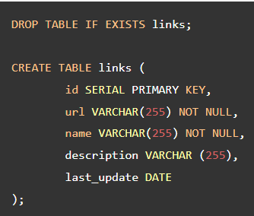
INSERT INTO | The following statement inserts a new row into the links table:  To insert character data, you enclose it in single quotes (‘) for example 'PostgreSQL Tutorial'.  If you omit required columns in the INSERT statement, PostgreSQL will issue an error. In case you omit an optional column, PostgreSQL will use the column default value for insert.  In this example, the description is an optional column because it doesn’t have a NOT NULL constraint. Therefore, PostgreSQL uses NULL to insert into the description column.  PostgreSQL automatically generates a sequential number for the serial column so you do not have to supply a value for the serial column in the INSERT statement. |  | INSERT INTO links (url, name)  VALUES('https://www.postgresqltutorial.com','PostgreSQL Tutorial');  The statement returns the following output: INSERT 0 1
INSERT INTO | 2) PostgreSQL INSERT – Inserting character string that contains a single quote  If you want to insert a string that contains a single quote (') such as O'Reilly Media, you have to use an additional single quote (') to escape it. For example: |  |  | INSERT INTO links (url, name)  VALUES('http://www.oreilly.com','O''Reilly Media');  Output: INSERT 0 1
INSERT INTO | 3) PostgreSQL INSERT – Inserting a date value  To insert a date value into a column with the DATE type, you use the date in the format 'YYYY-MM-DD'.  The following statement inserts a new row with a specified date into the links table: | INSERT INTO links (url, name, last_update)  VALUES('https://www.google.com','Google','2013-06-01');  Output: INSERT 0 1
INSERT INTO | 4) PostgreSQL INSERT- Getting the last insert id  To get the last insert id from inserted row, you use the RETURNING clause of the INSERTstatement.  For example, the following statement inserts a new row into the links table and returns the last insert id: |  |  |  | INSERT INTO links (url, name)  VALUES('http://www.postgresql.org','PostgreSQL')  RETURNING id;

PostgreSQL INSERT Multiple Rows
INSERT INTO | To insert multiple rows into a table using a single INSERT statement, you use the following syntax:  In this syntax:  • First, specify the name of the table that you want to insert data after the INSERT INTO keywords.  • Second, list the required columns or all columns of the table in parentheses that follow the table name.  • Third, supply a comma-separated list of rows after the VALUES keyword. |  | INSERT INTO table_name (column_list)  VALUES  (value_list_1),  (value_list_2),  ...  (value_list_n);
INSERT INTO | To insert multiple rows and return the inserted rows, you add the RETURNING clause as follows: | RETURNING * | output_expression;
INSERT INTO | Summary: • Specify multiple value lists in the INSERT statement to insert multiple rows into a table.  • Use RETURNING clause to return the inserted rows.

PostgreSQL Upsert Using INSERT ON CONFLICT statement
INSERT INTO | In relational databases, the term upsert is referred to as merge. The idea is that when you insert a new row into the table, PostgreSQL will update the row if it already exists, otherwise, it will insert the new row. That is why we call the action is upsert (the combination of update or insert).
INSERT INTO | To use the upsert feature in PostgreSQL, you use the INSERT ON CONFLICT statement as follows: | INSERT INTO table_name(column_list)  VALUES(value_list)  ON CONFLICT target action;
INSERT INTO | PostgreSQL added the ON CONFLICT target action clause to the INSERT statement to support the upsert feature.  In this statement, the target can be one of the following:  • (column_name) – a column name.  • ON CONSTRAINT constraint_name – where the constraint name could be the name of the UNIQUE constraint.  • WHERE predicate – a WHERE clause with a predicate.  The action can be one of the following:  • DO NOTHING – means do nothing if the row already exists in the table.  • DO UPDATE SET column_1 = value_1, .. WHERE condition – update some fields in the table.

PostgreSQL UPDATE
UPDATE | The PostgreSQL UPDATE statement allows you to modify data in a table. The following illustrates the syntax of the UPDATE statement:  In this syntax:  • First, specify the name of the table that you want to update data after the UPDATE keyword.  • Second, specify columns and their new values after SET keyword. The columns that do not appear in the SET clause retain their original values.  • Third, determine which rows to update in the condition of the WHERE clause.  The WHERE clause is optional. If you omit the WHERE clause, the UPDATE statement will update all rows in the table. | UPDATE table_name  SET column1 = value1,  column2 = value2,  ...  WHERE condition;  When the UPDATE statement is executed successfully, it returns the following command tag:  UPDATE count  The count is the number of rows updated including rows whose values did not change.
UPDATE | Returning updated rows  The UPDATE statement has an optional RETURNING clause that returns the updated rows: | RETURNING * | output_expression AS output_name;
UPDATE | Summary  • Use the PostgreSQL UPDATE statement to update data in one or more columns of a table.  • Use the RETURNING clause to return the updated rows from the UPDATE statement

PostgreSQL UPDATE Join with Practical Examples
Sometimes, you need to update data in a table based on values in another table. In this case, you can use the PostgreSQL UPDATE join syntax as follows: | UPDATE t1  SET t1.c1 = new_value  FROM t2  WHERE t1.c2 = t2.c2;
To join to another table in the UPDATE statement, you specify the joined table in the FROM clause and provide the join condition in the WHERE clause. The FROM clause must appear immediately after the SET clause.

For each row of table t1, the UPDATE statement examines every row of table t2. If the value in the c2 column of table t1 equals the value in the c2 column of table t2, the UPDATE statement updates the value in the c1 column of the table t1 the new value (new_value).

PostgreSQL DELETE
DELETE | The PostgreSQL DELETE statement allows you to delete one or more rows from a table.  Summary  • Use the DELETE FROM statement to delete one or more rows from a table.  • Use the WHERE clause to specify which rows to be deleted.  • Use the RETURNING clause to return the deleted rows.
DELETE | The following shows basic syntax of the DELETE statement:  In this syntax:  • First, specify the name of the table from which you want to delete data after the DELETE FROM keywords.  • Second, use a condition in the WHERE clause to specify which rows from the table to delete. |  | DELETE FROM table_name  WHERE condition;
DELETE | The WHERE clause is optional. If you omit the WHERE clause, the DELETE statement will delete all rows in the table.  The DELETE statement returns the number of rows deleted. It returns zero if the DELETE statement did not delete any row.
DELETE | To return the deleted row(s) to the client, you use the RETURNING clause as follows:  The asterisk (*) allows you to return all columns of the deleted row from the table_name.  To return specific columns, you specify them after the RETURNING keyword. | DELETE FROM table_name  WHERE condition  RETURNING (select_list | *)*)
DELETE | Note that the DELETE statement only removes data from a table. It doesn’t modify the structure of the table. If you want to change the structure of a table such as removing a column, you should use the ALTER TABLE statement.
DELETE | Using PostgreSQL DELETE to delete multiple rows from the table | DELETE FROM links  WHERE id IN (6,5)
DELETE | Using PostgreSQL DELETE to delete all rows from the table | DELETE FROM table name

PostgreSQL DELETE JOIN
PostgreSQL doesn’t support the DELETE JOIN statement. However, it does support the USING clause in the DELETE statement that provides similar functionality as the DELETE JOIN.
The following shows the syntax of the DELETE statement with the USING clause:  In this syntax:  • First, specify the table expression after the USING keyword. It can be one or more tables.  • Then, use columns from the tables that appear in the USING clause in the WHERE clause for joining data. |  | DELETE FROM table_name1  USING table_expression  WHERE condition  RETURNING returning_columns;
For example, the following statement uses the DELETE statement with the USING clause to delete data from t1 that has the same id as t2: |  |  | DELETE FROM t1  USING t2  WHERE t1.id = t2.id
Delete join using a subquery
The USING clause is not a part of the SQL standard. It means that the USING clause may not available in other database systems.

If you plan to make your application compatible with other database products, you should not use the USING clause in the DELETE statement. Instead, you can use a subquery.
The following statement uses the DELETE statement to delete all contacts whose phones are in the blacklist table:  In this example, the subquery returns a list of phones from the blacklist table and the DELETE statement deletes the contacts whose phones match with the phones returned by the subquery. | DELETE FROM contacts  WHERE phone IN (SELECT phone FROM blacklist);

PostgreSQL Transaction
What is a database transaction
A database transaction is a single unit of work that consists of one or more operations.

A classical example of a transaction is a bank transfer from one account to another. A complete transaction must ensure a balance between the sender and receiver accounts. It means that if the sender account transfers X amount, the receiver receives X amount, no more or no less.

A PostgreSQL transaction is atomic, consistent, isolated, and durable. These properties are often referred to as ACID:
• Atomicity guarantees that the transaction completes in an all-or-nothing manner.
• Consistency ensures the change to data written to the database must be valid and follow predefined rules.
• Isolation determines how transaction integrity is visible to other transactions.
• Durability makes sure that transactions that have been committed will be stored in the database permanently.
BEGIN | Begin a transaction  To start a transaction, you use the following statement: |  | BEGIN TRANSACTION;
BEGIN | or: |  | BEGIN WORK;
BEGIN | or just: |  | BEGIN;
COMMIT | Commit a transaction  To make the change become visible to other sessions (or users) you need to commit the transaction by using this statement: |  | COMMIT WORK;  Or COMMIT TRANSACTION;  Or simply COMMIT;
 | Put it all together. | 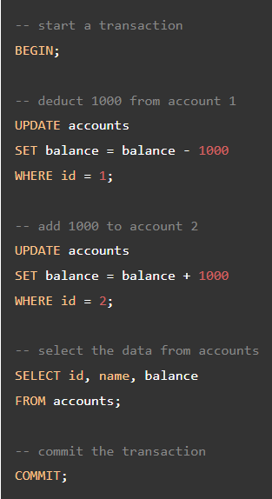
ROLLBACK | Rolling back a transaction  To roll back or undo the change of the current transaction, you use any of the following statement: | ROLLBACK WORK;  Or:  ROLLBACK TRANSACTION;  Or in short:  ROLLBACK;
 | Put it all toegher. | 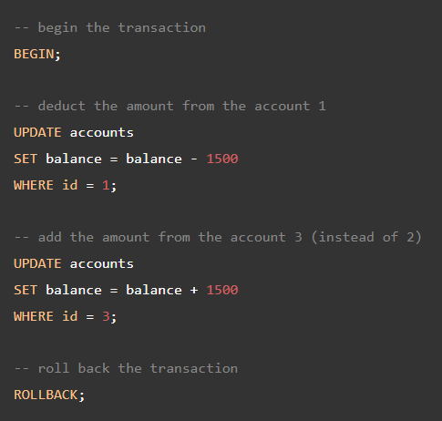

Import CSV File Into PostgreSQL Table
COPY  DELIMITER  CSV | we will show you various ways to import a CSV file into a PostgreSQL table
COPY  DELIMITER  CSV | Import a CSV file into a table using COPY statement.
COPY  DELIMITER  CSV | To import this CSV file into the persons table, you use COPY statement as follows: | COPY persons(first_name, last_name, dob, email)  FROM 'C:\sampledb\persons.csv'  DELIMITER ','  CSV HEADER;
COPY  DELIMITER  CSV | PostgreSQL gives back the following message:  It means that two rows have been copied. Let’s check the persons table. |  |  | COPY 2
COPY  DELIMITER  CSV | First, you specify the table with column names after the COPY keyword. The order of the columns must be the same as the ones in the CSV file. In case the CSV file contains all columns of the table, you don’t need to specify them explicitly, for example:  Second, you put the CSV file path after the FROM keyword. Because CSV file format is used “,” you need to specify DELIMITER as well as CSV clauses.  Third, specify the HEADER keyword to indicate that the CSV file contains a header. When the COPY command imports data, it ignores the header of the file. |  | COPY sample_table_name  FROM 'C:\sampledb\sample_data.csv'  DELIMITER ','  CSV HEADER;
COPY  DELIMITER  CSV | Notice that the file must be read directly by the PostgreSQL server, not by the client application. Therefore, it must be accessible by the PostgreSQL server machine. Also, you need to have superuser access in order to execute the COPY statement successfully.
COPY  DELIMITER  CSV | Import CSV file into a table using pgAdmin
COPY  DELIMITER  CSV | In case you need to import a CSV file from your computer into a table on the PostgreSQL database server, you can use the pgAdmin.  The following statement truncates the persons table so that you can re-import the data.  TRUNCATE TABLE persons  RESTART IDENTITY;  First, right-click the persons table and select the Import/Export… menu item:  Second, (1) switch to import, (2) browse to the import file, (3) select the format as CSV, (4) select the delimiter as comma (,):  Third, click the columns tab, uncheck the id column, and click the OK button:  Finally, wait for the import process to complete.

Export PostgreSQL Table To CSV File
COPY  DELIMITER  CSV | you will learn various techniques to export data from PostgreSQL tables to CSV files.
COPY  DELIMITER  CSV | Export data from a table to CSV using COPY statement
COPY  DELIMITER  CSV | The easiest way to export data of a table to a CSV file is to use COPY statement. For example, if you want to export the data of the persons table to a CSV file named persons_db.csv in the C:\tmp folder, you can use the following statement: |  | COPY persons TO 'C:\tmp\persons_db.csv'  DELIMITER ','  CSV HEADER;
COPY  DELIMITER  CSV | In some cases, you want to export data from just some columns of a table to a CSV file. To do this, you specify the column names together with table name after COPY keyword.  If you don’t want to export the header, which contains the column names of the table, just remove the HEADER flag in the COPY statement. | COPY persons(first_name,last_name,email)  TO 'C:\tmp\persons_partial_db.csv' DELIMITER ',' CSV HEADER;
COPY  DELIMITER  CSV | Notice that the CSV file name that you specify in the COPY command must be written directly by the server. It means that the CSV file must reside on the database server machine, not your local machine. The CSV file also needs to be writable by the user that PostgreSQL server runs as.
COPY  DELIMITER  CSV | Export data from a table to CSV file using the \copy command.  In case you have the access to a remote PostgreSQL database server, but you don’t have sufficient privileges to write to a file on it, you can use the PostgreSQL built-in command \copy.  The \copy command basically runs the COPY statement above. However, instead of server writing the CSV file, psql writes the CSV file, transfers data from the server to your local file system. To use \copy command, you just need to have sufficient privileges to your local machine. It does not require PostgreSQL superuser privileges.  For example, if you want to export all data of the persons table into persons_client.csv file, you can execute the \copy command from the psql client as follows:  \copy (SELECT * FROM persons) to 'C:\tmp\persons_client.csv' with csv

PostgreSQL Data Types
 | in this tutorial, you will learn about PostgreSQL data types including Boolean, character, numeric, temporal, array, json, uuid, and special types.
PostgreSQL supports the following data types:
• Boolean
• Character types such as char, varchar, and text.
• Numeric types such as integer and floating-point number.
• Temporal types such as date, time, timestamp, and interval
• UUID for storing Universally Unique Identifiers
• Array for storing array strings, numbers, etc.
• JSON stores JSON data
• hstore stores key-value pair
• Special types such as network address and geometric data.
Boolean | A Boolean data type can hold one of three possible values: true, false or null. You use boolean or bool keyword to declare a column with the Boolean data type.  When you insert data into a Boolean column, PostgreSQL converts it to a Boolean value  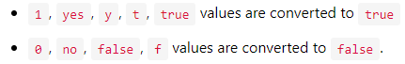  When you select data from a Boolean column, PostgreSQL converts the values back e.g.,  t to true, f to false and space to null.
Character | PostgreSQL provides three character data types: CHAR(n), VARCHAR(n), and TEXT  • CHAR(n) is the fixed-length character with space padded. If you insert a string that is shorter than the length of the column, PostgreSQL pads spaces. If you insert a string that is longer than the length of the column, PostgreSQL will issue an error. Without the length specifier (n) is the same as the CHAR(1).  • VARCHAR(n) is the variable-length character string. With VARCHAR(n), you can store up to n characters. PostgreSQL does not pad spaces when the stored string is shorter than the length of the column.  • TEXT or VARCHAR is the variable-length character string. Theoretically, text data is a character string with unlimited length.
Numeric | The following illustrate the syntax of the NUMERIC type: NUMERIC(precision, scale)  In this syntax, the precision is the total number of digits and the scale is the number of digits in the fraction part. For example, the number 1234.567 has the precision 7 and scale 3.  In addition to holding numeric values, the NUMERIC type can also hold a special value called NaN which stands for not-a-number.  The following example updates the price of the product id 1 to NaN :  UPDATE products  SET price = 'NaN'  WHERE id = 1;  Notice that you must use single quotes to wrap the NaN as shown in the UPDATE statement above.  Typically, the NaN is not equal to any number including itself. It means that the expression NaN = NaN returns false.  However, two NaN values are equal and NaN is greater than other numbers. This implementation allows PostgreSQL to sort NUMERIC values and use them in tree-based indexes.  ————————————————  PostgreSQL provides two distinct types of numbers:  • integers  • floating-point numbers  There are three kinds of integers in PostgreSQL:  • Small integer ( SMALLINT) is 2-byte signed integer that has a range from -32,768 to 32,767.  • Integer ( INT) is a 4-byte integer that has a range from -2,147,483,648 to 2,147,483,647.  • Serial is the same as integer except that PostgreSQL will automatically generate and populate values into the SERIAL column. This is similar to AUTO_INCREMENT column in MySQL or AUTOINCREMENT column in SQLite.  There three main types of floating-point numbers:  • float(n) is a floating-point number whose precision, at least, n, up to a maximum of 8 bytes.  • realor float8is a 4-byte floating-point number.  • numeric or numeric(p,s) is a real number with p digits with s number after the decimal point. The numeric(p,s) is the exact number.  If precision is not required, you should not use the NUMERIC type because calculations on NUMERIC values are typically slower than integers, floats, and double precisions.
Temporal data | The temporal data types allow you to store date and /or time data. PostgreSQL has five main temporal data types:  • DATEstores the dates only.  • TIMEstores the time of day values.  • TIMESTAMPstores both date and time values.  • TIMESTAMPTZ is a timezone-aware timestamp data type. It is the abbreviation for timestamp with the time zone.  INTERVAL stores periods of time.  The TIMESTAMPTZ is the PostgreSQL’s extension to the SQL standard’s temporal data types.
Array | In PostgreSQL, you can store an array of strings, an array of integers, etc., in array columns. The array comes in handy in some situations e.g., storing days of the week, months of the year.
JSON | PostgreSQL provides two JSON data types: JSON and JSONB for storing JSON data.  The JSON data type stores plain JSON data that requires reparsing for each processing, while JSONB data type stores JSON data in a binary format which is faster to process but slower to insert. In addition, JSONB supports indexing, which can be an advantage.
UUID | The UUID data type allows you to store Universal Unique Identifiers defined by RFC 4122 . The UUID values guarantee a better uniqueness than SERIAL and can be used to hide sensitive data exposed to the public such as values of id in URL.
Special data types | Besides the primitive data types, PostgreSQL also provides several special data types related to geometric and network.  • box– a rectangular box.  • line – a set of points.  • point– a geometric pair of numbers.  • lseg– a line segment.  • polygon– a closed geometric.  • inet– an IP4 address.  • macaddr– a MAC address.

The Ultimate Guide to PostgreSQL Date By Examples
To store date values, you use the PostgreSQL DATE data type. PostgreSQL uses 4 bytes to store a date value. The lowest and highest values of the DATE data type are 4713 BC and 5874897 AD.

When storing a date value, PostgreSQL uses the yyyy-mm-dd format e.g., 2000-12-31. It also uses this format for inserting data into a date column.

If you create a table that has a DATE column and you want to use the current date as the default value for the column, you can use the CURRENT_DATE after the DEFAULT keyword.
DATE | For example, the following statement creates the documents table that has the posting_date column with the DATE data type. The posting_date column accepts the current date as the default value. |  | DROP TABLE IF EXISTS documents;  CREATE TABLE documents (  document_id serial PRIMARY KEY,  header_text VARCHAR (255) NOT NULL,  posting_date DATE NOT NULL DEFAULT CURRENT_DATE  );  INSERT INTO documents (header_text)  VALUES('Billing to customer XYZ');  SELECT * FROM documents;
NOW()::date | Get the current date  To get the current date and time, you use the built-in NOW() function. However, to get the date part only (without the time part), you use the double colons (::) to cast a DATETIME value to a DATE value.  The following statement returns the current date of the database server: → |  |  | SELECT NOW()::date;  Another way to get current date is to use the CURRENT_DATE as follows:  SELECT CURRENT_DATE;  The result is in the format: yyyy-mm-dd. However, you can output a date value to various formats.
CHAR(NOW() :: DATE () | Output a PostgreSQL date value in a specific format  To output a date value in a specific format, you use the TO_CHAR() function. The TO_CHAR() function accepts two parameters. The first parameter is the value that you want to format, and the second one is the template that defines the output format.  For example, to display the current date in dd/mm/yyyy format, you use the following statement: → |  |  |  |  | SELECT TO_CHAR(NOW() :: DATE, 'dd/mm/yyyy');
NOW() | Get the interval between two dates  To get the interval between two dates, you use the minus (-) operator.  The following example gets service days of employees by subtracting the values in the hire_date column from today’s date: → |  |  |  |  | SELECT  first_name,  last_name,  now() - hire_date as diff  FROM  employees;
AGE() | Calculate ages in years, months, and days  To calculate age at the current date in years, months, and days, you use the AGE() function.  The following statement uses the AGE() function to calculate the ages of employees in the employees table. |  |  |  |  |  | SELECT  employee_id,  first_name,  last_name,  AGE(birth_date)  FROM  employees;
AGE() | If you pass a date value to the AGE() function, it will subtract that date value from the current date. If you pass two arguments to the AGE() function, it will subtract the second argument from the first argument.  For example, to get the age of employees on 01/01/2015, you use the following statement: |  |  |  | SELECT  employee_id,  first_name,  last_name,  age('2015-01-01',birth_date)  FROM  employees;
EXTRACT() | Extract year, quarter, month, week, day from a date value  To get the year, quarter, month, week, day from a date value, you use the EXTRACT() function.  The following statement extracts the year, month, and day from the birth dates of employees: | SELECT  employee_id,  first_name,  last_name,  EXTRACT (YEAR FROM birth_date) AS YEAR,  EXTRACT (MONTH FROM birth_date) AS MONTH,  EXTRACT (DAY FROM birth_date) AS DAY  FROM  employees;

Understanding PostgreSQL Timestamp Data Types
TIMESTAMP | PostgreSQL provides you with two temporal data types for handling timestamp:  • timestamp: a timestamp without timezone one.  • timestamptz: timestamp with a timezone.  The timestamp datatype allows you to store both date and time. However, it does not have any time zone data. It means that when you change the timezone of your database server, the timestamp value stored in the database will not change automatically.  The timestamptz datatype is the timestamp with the time zone. The timestamptz datatype is a time zone-aware date and time data type.  PostgreSQL stores the timestamptz in UTC value.  • When you insert a value into a timestamptz column, PostgreSQL converts the timestamptz value into a UTC value and stores the UTC value in the table.  • When you query timestamptz from the database, PostgreSQL converts the UTC value back to the time value of the timezone set by the database server, the user, or the current database connection.

A Comprehensive Look at PostgreSQL Interval Data Type
INTERVAL | The interval data type allows you to store and manipulate a period of time in years, months, days, hours, minutes, seconds, etc. The following illustrates the interval type: |  |  |  |  |  |  | @ interval [ fields ] [ (p) ]
INTERVAL | An interval value requires 16 bytes storage size that can store a period with the allowed range from -178,000,000 years to 178,000,000 years.  In addition, an interval value can have an optional precision value p with the permitted range is from 0 to 6. The precisionp is the number of fraction digits retained in the second field.  The at sign ( @) is optional therefore you can omit it.
INTERVAL | The following examples show some interval values: | interval '2 months ago';  interval '3 hours 20 minutes';
INTERVAL | Internally, PostgreSQL stores interval values as months, days, and seconds. The months and days values are integers while the seconds can field can have fractions.  The interval values are very useful when doing date or time arithmetic. For example, if you want to know the time of 3 hours 2 minutes ago at the current time of last year, you can use the following statement: | SELECT  now(),  now() - INTERVAL '1 year 3 hours 20 minutes'  AS "3 hours 20 minutes ago of last year";
INTERVAL | PostgreSQL provides you with the following verbose syntax to write the interval values: →  • quantity is a number, sign + or - is also accepted  • unit can be any of millennium, century, decade, year, month, week, day, hour, minute, second, millisecond, microsecond, or abbreviation (y, m, d, etc.,) or plural forms (months, days, etc.).  • direction can be ago or empty string '' |  |  |  | quantity unit [quantity unit...] [direction]
INTERVAL | his format is called postgres_verbose which is also used for the interval output format. The following examples illustrate some interval values that use the verbose syntax: |  |  | INTERVAL '1 year 2 months 3 days';  INTERVAL '2 weeks ago';
INTERVAL | ISO 8601 interval format  In addition to the verbose syntax above, PostgreSQL allows you to write the interval values using ISO 8601 time intervals in two ways: format with designators and alternative format.  The ISO 8601 format with designators is like this: | P quantity unit [ quantity unit ...] [ T [ quantity unit ...]]  In this format, the interval value must start with the letter P. The letter T is for determining time-of-day unit.
INTERVAL | The following table illustrates the ISO 8601 interval unit abbreviations:  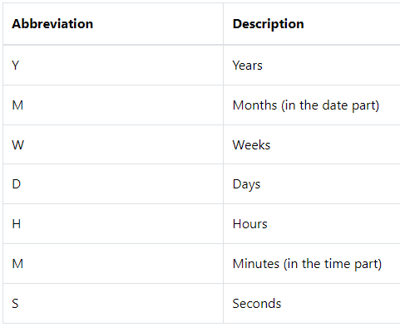  Note that M can be months or minutes depending on whether it appears before or after the letter T.
INTERVAL | For example, the interval of 6 years 5 months 4 days 3 hours 2 minutes 1 second can be written in the ISO 8601 designators format as follows: |  |  |  |  |  |  |  |  | P6Y5M4DT3H2M1S
INTERVAL | The alternative form of ISO 8601 is |  |  |  |  |  | P [ years-months-days ] [ T hours:minutes:seconds ]
INTERVAL | It also must start with the letter P, and the letter T separates the date and time parts of the interval value. For example, the interval of 6 years 5 months 4 days 3 hours 2 minutes 1 second can be written in the ISO 8601 alternative form as: |  |  |  |  |  |  |  | P0006-05-04T03:02:01
INTERVAL | The output style of interval values is set by using the SET intervalstyle command, for example: →  PostgreSQL provides four output formats: sql standard, postgres, postgresverbose, and iso_8601. PostgresQL uses the postgres style by default for formatting the interval values. |  |  |  |  |  |  |  | SET intervalstyle = 'sql_standard';
INTERVAL | 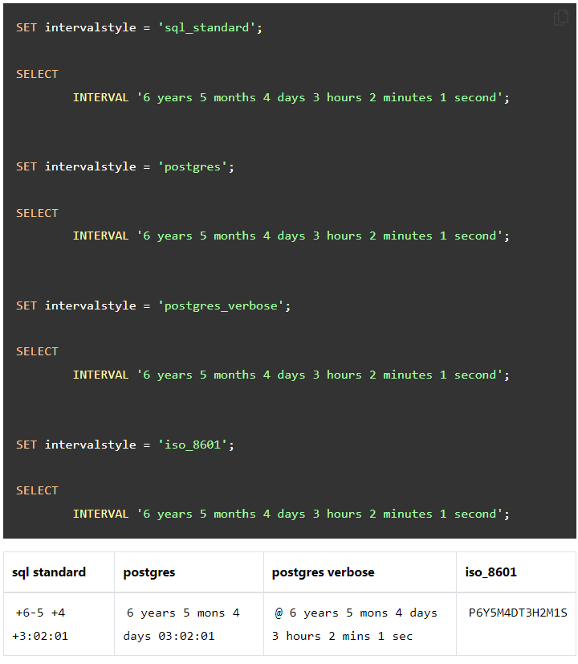
INTERVAL | Interval operators  You can apply the arithmetic operator ( +, -, *, etc.,) to the interval values, for examples: |  | SELECT  INTERVAL '2h 50m' + INTERVAL '10m'; -- 03:00:00  SELECT  INTERVAL '2h 50m' - INTERVAL '50m'; -- 02:00:00  SELECT  600 * INTERVAL '1 minute'; -- 10:00:00
INTERVAL | Converting PostgreSQL interval to string  To convert an interval value to string, you use the TO_CHAR() function. →  The TO_CHAR() function takes the first argument as an interval value, the second one as the format, and returns a string that represents the interval in the specified format.  See the following example: → |  |  |  |  | TO_CHAR(interval,format)  SELECT  TO_CHAR(  INTERVAL '17h 20m 05s',  'HH24:MI:SS'  );
INTERVAL | Extracting data from a PostgreSQL interval  To extract field such as year, month, date, etc., from an interval, you use the EXTRACT() function. →  The field can be the year, month, date, hour, minutes, etc., that you want to extract from the interval. The extract function returns a value of type double precision.  See the following example: →  In this example, we extracted the minute from the interval of 5 hours 21 minutes and it returned 21 as expected: |  |  |  |  | EXTRACT(field FROM interval)  SELECT  EXTRACT (  MINUTE  FROM  INTERVAL '5 hours 21 minutes'  );
INTERVAL | Adjusting interval values  PostgreSQL provides two functions justifydays and justifyhours that allows you to adjust the interval of 30-day as one month and the interval of 24-hour as one day: →  In addition, the justify_interval function adjusts interval using justifydays and justifyhours with additional sign adjustments: → |  |  |  |  | SELECT  justify_days(INTERVAL '30 days'),  justify_hours(INTERVAL '24 hours');  SELECT  justify_interval(interval '1 year -1 hour');

A Quick Guide To The PostgreSQL TIME Data Type
TIME | The following statement illustrates how to declare a column with the TIME data type: →  A time value may have a precision up to 6 digits. The precision specifies the number of fractional digits placed in the second field. |  | column_name TIME(precision);
TIME | The TIME data type requires 8 bytes and its allowed range is from 00:00:00 to 24:00:00. The following illustrates the common formats of the TIME values: →  For example: → |  |  |  |  |  | HH:MI  HH:MI:SS  HHMISS  01:02  01:02:03  010203
TIME | If you want to use the precision, you can use the following formats: →  In this form, p is the precision. For example: →  PostgreSQL actually accepts almost any reasonable TIME format including SQL-compatible, ISO 8601, etc. |  |  |  |  | MI:SS.pppppp  HH:MI:SS.pppppp  HHMISS.pppppp  04:59.999999  04:05:06.777777  040506.777777
TIME | The following statement illustrates how to declare a column whose data type is TIME with time zone: |  |  | column TIME with time zone
TIME | To get the current time with time zone, you use the CURRENT_TIME function as follows: |  |  |  | SELECT CURRENT_TIME;
TIME | To get the current time with a specific precision, you use the CURRENT_TIME(precision) function: |  |  |  | SELECT CURRENT_TIME(5);
TIME | To get the local time, you use the LOCALTIME function:  Similarly, to get the local time with a specific precision, you use the LOCALTIME(precision) function. |  |  |  | SELECT LOCALTIME
TIME | To convert time to a different time zone, you use the following form: | [TIME with time zone] AT TIME ZONE time_zone
TIME | To extracting hours, minutes, seconds from a time value, you use the EXTRACT function as follows: | EXTRACT(field FROM time_value);
TIME | PostgreSQL allows you to apply arithmetic operators such as +, -, and * on time values and between time and interval values.  The following statement returns an interval between two time values: | SELECT time '10:00' - time '02:00' AS result;

The Basics Of PostgreSQL UUID Data Type
UUID stands for Universal Unique Identifier defined by RFC 4122 and other related standards. A UUID value is 128-bit quantity generated by an algorithm that make it unique in the known universe using the same algorithm. The following shows some examples of the UUID values: | 40e6215d-b5c6-4896-987c-f30f3678f608  6ecd8c99-4036-403d-bf84-cf8400f67836  3f333df6-90a4-4fda-8dd3-9485d27cee36
As you can see, a UUID is a sequence of 32 digits of hexadecimal digits represented in groups separated by hyphens.

Because of its uniqueness feature, you often found UUID in the distributed systems because it guarantees a better uniqueness than the SERIAL data type which generates only unique values within a single database.

To stores UUID values in the PostgreSQL database, you use the UUID data type.
PostgreSQL allows you store and compare UUID values but it does not include functions for generating the UUID values in its core.

Instead, it relies on the third-party modules that provide specific algorithms to generate UUIDs. For example the uuid-ossp module provides some handy functions that implement standard algorithms for generating UUIDs.
To install the uuid-ossp module, you use the CREATE EXTENSION statement as follows: | CREATE EXTENSION IF NOT EXISTS "uuid-ossp";
To generate the UUID values based on the combination of computer’s MAC address, current timestamp, and a random value, you use the uuid_generate_v1() function: | SELECT uuid_generate_v1();
If you want to generate a UUID value solely based on random numbers, you can use the uuid_generate_v4() function. For example: | SELECT uuid_generate_v4();

PostgreSQL Array
Array plays an important role in PostgreSQL. Every data type has its own companion array type e.g., integer has an integer[] array type, character has character[] array type, etc. In case you define your own data type, PostgreSQL creates a corresponding array type in the background for you.

PostgreSQL allows you to define a column to be an array of any valid data type including built-in type, user-defined type or enumerated type.
The following CREATE TABLE statement creates the contacts table with the phones column is defined as an array of text. →  The phones column is a one-dimensional array that holds various phone numbers that a contact may have. |  | CREATE TABLE contacts (  id serial PRIMARY KEY,  name VARCHAR (100),  phones TEXT []  );
The following statement inserts a new contact into the contacts table. | INSERT INTO contacts (name, phones)  VALUES('John Doe',ARRAY [ '(408)-589-5846','(408)-589-5555' ]);
We used the ARRAY constructor to construct an array and insert it into the contacts table. You can also use curly braces as follows: | INSERT INTO contacts (name, phones)  VALUES('Lily Bush','{"(408)-589-5841"}'),  ('William Gate','{"(408)-589-5842","(408)-589-58423"}');
The statement above inserts two rows into the contacts table. Notice that when you use curly braces, you use single quotes ' to wrap the array and double quotes " to wrap text array items.
Query array data  We access array elements using the subscript within square brackets []. By default, PostgreSQL uses one-based numbering for array elements. It means the first array element starts with number 1. Suppose, we want to get the contact’s name and the first phone number, we use the following query: |  | SELECT  name,  phones [ 1 ]  FROM  contacts;
We can use array element in the WHERE clause as the condition to filter the rows. For example, to find out who has the phone number (408)-589-58423 as the second phone number, we use the following query. |  | SELECT  name  FROM  contacts  WHERE  phones [ 2 ] = '(408)-589-58423';
Modifying PostgreSQL array  PostgreSQL allows you to update each element of an array or the whole array. The following statement updates the second phone number of William Gate. |  | UPDATE contacts  SET phones [2] = '(408)-589-5843'  WHERE ID = 3;
The following statement updates an array as a whole. |  | UPDATE contacts  SET phones = '{"(408)-589-5843"}'  WHERE id = 3;
Search in PostgreSQL Array  Suppose, we want to know who has the phone number (408)-589-5555 regardless of position of the phone number in the phones array, we use ANY() function as follows: |  | SELECT  name,  phones  FROM  contacts  WHERE  '(408)-589-5555' = ANY (phones);
Expand Arrays  PostgreSQL provides the unnest() function to expand an array to a list of rows. For example, the following query expands all phone numbers of the phones array. |  | SELECT  name,  unnest(phones)  FROM  contacts;

PostgreSQL hstore
The hstore module implements the hstore data type for storing key-value pairs in a single value.
The hstore data type is very useful in many cases, such as semi-structured data or rows with many attributes that are rarely queried. Notice that keys and values are just text strings only.
Before working with the hstore data type, you need to enable the hstore extension which loads the contrib module to your PostgreSQL instance. |  | CREATE EXTENSION hstore;
We create a table named books that has three columns: |  | CREATE TABLE books (  id serial primary key,  title VARCHAR (255),  attr hstore  );
We use the INSERT statement to insert data into the hstore column as follows: | INSERT INTO books (title, attr)  VALUES  (  'PostgreSQL Tutorial',  '"paperback" => "243",  "publisher" => "postgresqltutorial.com",  "language" => "English",  "ISBN-13" => "978-1449370000",  "weight" => "11.2 ounces"'  );
Query data from an hstore column
Querying data from an hstore column is similar to querying data from a column with native data type using the SELECT statement
Postgresql hstore provides the -> operator to query the value of a specific key from an hstore column. For example, if we want to know ISBN-13 of all available books in the books table, we can use the -> operator as follows: | SELECT attr -> 'ISBN-13' AS isbn  FROM  books;
You can use the -> operator in the WHERE clause to filter the rows whose values of the hstore column match the input value. For example, the following query retrieves the title and weight of a book that has ISBN-13 value matches 978-1449370000: | SELECT title, attr -> 'weight' AS weight  FROM  books  WHERE  attr -> 'ISBN-13' = '978-1449370000';
With hstore column, you can easily add a new key-value pair to existing rows e.g., you can add free shipping key to the attr column of the books table as follows: | UPDATE books  SET attr = attr || '"freeshipping"=>"yes"' :: hstore;
You can update existing key-value pair using the UPDATE statement. The following statement updates the value of the "freeshipping" key to "no". | UPDATE books  SET attr = attr || '"freeshipping"=>"no"' :: hstore;
PostgreSQL allows you to remove existing key-value pair from an hstore column. For example, the following statement removes the "freeshipping"=>"no" key-value pair in the attr column. | UPDATE books  SET attr = delete(attr, 'freeshipping');
You can check for a specific key in an hstore column using the ? operator in the WHERE clause. For example, the following statement returns all rows with attr contains key publisher. | SELECT  title,  attr->'publisher' as publisher,  attr  FROM books  WHERE attr ? 'publisher';
You can query based on the hstore key-value pair using the @> operator. The following statement retrieves all rows which attr column contains a key-value pair that matches "weight"=>"11.2 ounces". | SELECT title  FROM books  WHERE  attr @> '"weight"=>"11.2 ounces"' :: hstore;
You can query the rows whose hstore column contain multiple keys using ?& operator. For example, you can get books where attr column contains both language and weight keys.  To check if a row whose hstore column contains any key from a list of keys, you use the ?| operator instead of the ?& operator. | SELECT title  FROM books  WHERE attr ?& ARRAY [ 'language', 'weight' ];
To get all keys from an hstore column, you use the akeys() function as follows: | SELECT akeys (attr)  FROM books;
Or you can use the svals() function if you want to get the result as a set. | SELECT svals (attr)  FROM books;
PostgreSQL provides the hstore_to_json() function to convert hstore data to JSON. See the following statement: | SELECT  title,  hstore_to_json (attr) json  FROM books;
To convert hstore data to sets, you use the each() function as follows: | SELECT title,  (EACH(attr) ).*  FROM books;

PostgreSQL JSON
JSON stands for JavaScript Object Notation. JSON is an open standard format that consists of key-value pairs.

The main usage of JSON is to transport data between a server and a web application. Unlike other formats, JSON is human-readable text.

PostgreSQL supports native JSON data type since version 9.2. It provides many functions and operators for manipulating JSON data.
Let’s get started by creating a new table for practicing with JSON data type →.  The orders table consists of two columns:  • The id column is the primary key column that identifies the order.  • The info column stores the data in the form of JSON. |  |  |  | CREATE TABLE orders (  id serial NOT NULL PRIMARY KEY,  info json NOT NULL  );
To insert data into a JSON column, you have to ensure that data is in a valid JSON format. The following INSERT statement inserts a new row into the orders table.  It means John Doe bought 6 bottle of beers. | INSERT INTO orders (info)  VALUES('{ "customer": "John Doe", "items": {"product": "Beer","qty": 6}}');
To query JSON data, you use the SELECT statement, which is similar to querying other native data types: |  |  |  |  | SELECT info FROM orders;
PostgreSQL provides two native operators -> and ->> to help you query JSON data.  • The operator -> returns JSON object field by key.  • The operator ->> returns JSON object field by text.  The following query uses the operator -> to get all customers in form of JSON: |  |  |  |  | SELECT info -> 'customer' AS customer  FROM orders;
And the following query uses operator ->> to get all customers in form of text: |  |  |  |  | SELECT info ->> 'customer' AS customer  FROM orders;
Because -> operator returns a JSON object, you can chain it with the operator ->> to retrieve a specific node. For example, the following statement returns all products sold: →  First info -> 'items' returns items as JSON objects. And then info->'items'->>'product' returns all products as text. |  |  | SELECT info -> 'items' ->> 'product' as product  FROM orders  ORDER BY product;
We can use the JSON operators in WHERE clause to filter the returning rows. For example, to find out who bought Diaper, we use the following query: → |  |  | SELECT info ->> 'customer' AS customer  FROM orders  WHERE info -> 'items' ->> 'product' = 'Diaper';
To find out who bought two products at a time, we use the following query: →  Notice that we used the type cast to convert the qty field into INTEGER type and compare it with two. |  | SELECT info ->> 'customer' AS customer,  info -> 'items' ->> 'product' AS product  FROM orders  WHERE CAST ( info -> 'items' ->> 'qty' AS INTEGER) = 2
We can apply aggregate functions such as MIN, MAX, AVERAGE, SUM, etc., to JSON data. For example, the following statement returns minimum quantity, maximum quantity, average quantity and the total quantity of products sold. |  | SELECT  MIN (CAST (info -> 'items' ->> 'qty' AS INTEGER)),  MAX (CAST (info -> 'items' ->> 'qty' AS INTEGER)),  SUM (CAST (info -> 'items' ->> 'qty' AS INTEGER)),  AVG (CAST (info -> 'items' ->> 'qty' AS INTEGER))  FROM orders;
The json_each() function allows us to expand the outermost JSON object into a set of key-value pairs. See the following statement:  If you want to get a set of key-value pairs as text, you use the json_each_text() function instead. |  |  |  |  |  | SELECT json_each (info)  FROM orders;
To get a set of keys in the outermost JSON object, you use the json_object_keys() function. The following query returns all keys of the nested items object in the info column |  |  |  |  | SELECT json_object_keys (info->'items')  FROM orders;
The json_typeof() function returns type of the outermost JSON value as a string. It can be number, boolean, null, object, array, and string.  The following query return the data type of the items: |  |  |  |  | SELECT json_typeof (info->'items')  FROM orders;

A Look at PostgreSQL User-defined Data Types
Besides built-in data types, PostgreSQL allows you to create user-defined data types through the following statements:
• CREATE DOMAIN creates a user-defined data type with constraints such as NOT NULL, CHECK, etc.
• CREATE TYPE creates a composite type used in stored procedures as the data types of returned values.
CREATE DOMAIN | PostgreSQL CREATE DOMAIN statement  In PostgreSQL, a domain is a data type with optional constraints e.g., NOT NULL and CHECK. A domain has a unique name within the schema scope.  Domains are useful for centralizing the management of fields with common constraints. For example, some tables may have the same column that do not accept NULL and spaces.
CREATE DOMAIN | The following statement create a table named mailing_list: →  In this table, both first_name and last_name columns do not accept null and spaces. Instead of defining the CHECK constraint, you can create a contact_name domain and reuse it in multiple columns. |  |  |  |  | CREATE TABLE mailing_list (  id SERIAL PRIMARY KEY,  first_name VARCHAR NOT NULL,  last_name VARCHAR NOT NULL,  email VARCHAR NOT NULL,  CHECK (  first_name !~ '\s'  AND last_name !~ '\s'  )  );
CREATE DOMAIN | The following statement uses the CREATE DOMAIN to create a new domain called contact_name with the VARCHAR datatype and do not accept NULL and spaces: |  |  | CREATE DOMAIN contact_name AS  VARCHAR NOT NULL CHECK (value !~ '\s');
CREATE DOMAIN | And you use contact_name as the datatype of the first_name and last_name columns as a regular built-in type: |  |  |  | CREATE TABLE mailing_list (  id serial PRIMARY KEY,  first_name contact_name,  last_name contact_name,  email VARCHAR NOT NULL  );
CREATE DOMAIN | The following statement inserts a new row into the mailing_list table:  PostgreSQL issued the following error because the first name contains a space: |  |  |  | INSERT INTO mailing_list (first_name, last_name, email)  VALUES('Jame V','Doe','jame.doe@example.com');
CREATE DOMAIN | To change or remove a domain, you use the ALTER DOMAIN or DROP DOMAIN respectively.
CREATE DOMAIN | Getting domain information  To get all domains in a specific schema, you use the following query: |  | SELECT typname  FROM pg_catalog.pg_type  JOIN pg_catalog.pg_namespace  ON pg_namespace.oid = pg_type.typnamespace  WHERE  typtype = 'd' and nspname = '<schema_name>';
CREATE DOMAIN | The following statement returns domains in the public schema of the current database: |  | SELECT typname  FROM pg_catalog.pg_type  JOIN pg_catalog.pg_namespace  ON pg_namespace.oid = pg_type.typnamespace  WHERE  typtype = 'd' and nspname = 'public';
CREATE TYPE | The CREATE TYPE statement allows you to create a composite type, which can be used as the return type of a function.  Suppose you want to have a function that returns several values: film_id, title, and release_year. The first step is to create a type e.g., film_summary as follows: |  |  | CREATE TYPE film_summary AS (  film_id INT,  title VARCHAR,  release_year SMALLINT  );
CREATE TYPE | Second, use the film_summary data type as the return type of a function: | CREATE OR REPLACE FUNCTION get_film_summary (f_id INT)  RETURNS film_summary AS  $$  SELECT  film_id,  title,  release_year  FROM  film  WHERE  film_id = f_id ;  $$  LANGUAGE SQL;
CREATE TYPE | Third, call the get_film_summary() function: |  |  | SELECT * FROM get_film_summary (40);
CREATE TYPE | To change a user-defined type, you use the ALTER TYPE statement. To remove a user-defined type, you use the DROP TYPE statement.
CREATE TYPE | If you use the psql program, you can list all user-defined types in the current database using the \dT or \dT+ command:

PostgreSQL CREATE TABLE
CREATE TABLE | To create a new table, you use the CREATE TABLE statement. The following illustrates the basic syntax of the CREATE TABLE statement: → |  | CREATE TABLE [IF NOT EXISTS] table_name (  column1 datatype(length) column_contraint,  column2 datatype(length) column_contraint,  column3 datatype(length) column_contraint,  table_constraints  );
CREATE TABLE | In this syntax: ↑  • First, specify the name of the table after the CREATE TABLE keywords.  • Second, creating a table that already exists will result in a error. The IF NOT EXISTS option allows you to create the new table only if it does not exist. When you use the IF NOT EXISTS option and the table already exists, PostgreSQL issues a notice instead of the error and skips creating the new table.  • Third, specify a comma-separated list of table columns. Each column consists of the column name, the kind of data that column stores, the length of data, and the column constraint. The column constraints specify rules that data stored in the column must follow. For example, the not-null constraint enforces the values in the column cannot be NULL. The column constraints include not null, unique, primary key, check, foreign key constraints.  • Finally, specify the table constraints including primary key, foreign key, and check constraints.  Note that some table constraints can be defined as column constraints like primary key, foreign key, check, unique constraints.
CREATE TABLE | Constraints. PostgreSQL includes the following column constraints:  • NOT NULL – ensures that values in a column cannot be NULL.  • UNIQUE – ensures the values in a column unique across the rows within the same table.  • PRIMARY KEY – a primary key column uniquely identify rows in a table. A table can have one and only one primary key. The primary key constraint allows you to define the primary key of a table.  • CHECK – a CHECK constraint ensures the data must satisfy a boolean expression.  • FOREIGN KEY – ensures values in a column or a group of columns from a table exists in a column or group of columns in another table. Unlike the primary key, a table can have many foreign keys.  Table constraints are similar to column constraints except that they are applied to more than one column.
CREATE TABLE | Summary  • Use the CREATE TABLE statement to create a new table.  • Use the IF NOT EXISTS option to create the new table only if it does not exist.  • Apply the primary key, foreign key, not null, unique, and check constraints to columns of a table.
CREATE TABLE | PostgreSQL CREATE TABLE examples  The following statement creates the accounts table: | CREATE TABLE accounts (  user_id serial PRIMARY KEY,  username VARCHAR ( 50 ) UNIQUE NOT NULL,  password VARCHAR ( 50 ) NOT NULL,  email VARCHAR ( 255 ) UNIQUE NOT NULL,  created_on TIMESTAMP NOT NULL,  last_login TIMESTAMP  );
CREATE TABLE | The following statement creates the roles table that consists of two columns: role_id and role_name: | CREATE TABLE roles(  role_id serial PRIMARY KEY,  role_name VARCHAR (255) UNIQUE NOT NULL  );
CREATE TABLE | The following statement creates the account_roles table that has three columns: user_id, role_id and grant_date. | CREATE TABLE account_roles (  user_id INT NOT NULL,  role_id INT NOT NULL,  grant_date TIMESTAMP,  PRIMARY KEY (user_id, role_id),  FOREIGN KEY (role_id)  REFERENCES roles (role_id),  FOREIGN KEY (user_id)  REFERENCES accounts (user_id)  );
CREATE TABLE | The following shows the relationship between the accounts, roles, and account_roles tables:  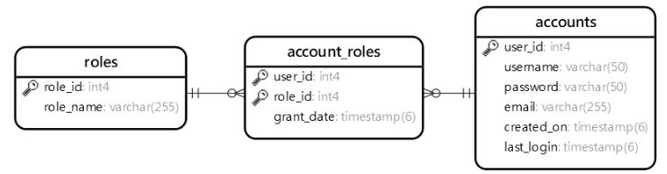

PostgreSQL SELECT INTO
SELECT INTO | The PostgreSQL SELECT INTO statement creates a new table and inserts data returned from a query into the table.  The new table will have columns with the names the same as columns of the result set of the query. Unlike a regular SELECT statement, the SELECT INTO statement does not return a result to the client.
SELECT INTO | The following illustrates the syntax of the PostgreSQL SELECT INTO statement: | SELECT  select_list  INTO [ TEMPORARY | TEMP | UNLOGGED ] [ TABLE ] new_table_name  FROM  table_name  WHERE  search_condition;
SELECT INTO | To create a new table with the structure and data derived from a result set, you specify the new table name after the INTO keyword.  The TEMP or TEMPORARY keyword is optional; it allows you to create a temporary table instead.  The UNLOGGED keyword if available will make the new table as an unlogged table.  The WHERE clause allows you to specify the rows from the original tables that should be inserted into the new table. Besides the WHERE clause, you can use other clauses in the SELECT statement for the SELECT INTO statement such as INNER JOIN, LEFT JOIN, GROUP BY, and HAVING.  Note that you cannot use the SELECT INTO statement in PL/pgSQL because it interprets the INTO clause differently. In this case, you can use the CREATE TABLE AS statement which provides more functionality than the SELECT INTO statement.
SELECT INTO | PostgreSQL SELECT INTO examples  The following statement creates a new table called film_r that contains films with the rating R and rental duration 5 days from the film table. |  | SELECT  film_id,  title,  rental_rate  INTO TABLE film_r  FROM  film  WHERE  rating = 'R'  AND rental_duration = 5  ORDER BY  title;

PostgreSQL CREATE TABLE AS
CREATE TABLE AS | The CREATE TABLE AS statement creates a new table and fills it with the data returned by a query.
CREATE TABLE AS | Note that the CREATE TABLE AS statement is similar to the SELECT INTO statement, but the CREATE TABLE AS statement is preferred because it is not confused with other uses of the SELECT INTO syntax in PL/pgSQL. In addition, the CREATE TABLE AS statement provides a superset of functionality offered by the SELECT INTO statement.
CREATE TABLE AS | The following shows the syntax of the CREATE TABLE AS statement:  In this syntax:  • First, specify the new table name after the CREATE TABLE clause.  • Second, provide a query whose result set is added to the new table after the AS keyword. | CREATE TABLE new_table_name  AS query;
CREATE TABLE AS | The TEMPORARY or TEMP keyword allows you to to create a temporary table: | CREATE TEMP TABLE new_table_name  AS query;
CREATE TABLE AS | The UNLOGGED keyword allows the new table to be created as an unlogged table: | CREATE UNLOGGED TABLE new_table_name  AS query;
CREATE TABLE AS | The columns of the new table will have the names and data types associated with the output columns of the SELECT clause.  If you want the table columns to have different names, you can specify the new table columns after the new table name: | CREATE TABLE new_table_name ( column_name_list)  AS query;
CREATE TABLE AS | In case you want to avoid an error by creating a new table that already exists, you can use the IF NOT EXISTS option as follows: | CREATE TABLE IF NOT EXISTS new_table_name  AS query;
CREATE TABLE AS | PostgreSQL CREATE TABLE AS statement examples.  The following statement creates a table that contains action films that belong to category one. | CREATE TABLE action_film AS  SELECT  film_id,  title,  release_year,  length,  rating  FROM  film  INNER JOIN film_category USING (film_id)  WHERE  category_id = 1;
CREATE TABLE AS | If the SELECT clause contains expressions, it is a good practice to override the columns, for example:  This example statement created a new table film_rating and filled it with the summary data from the film table. It explicitly specified the column names for the new table instead of using the column names from the SELECT clause. | CREATE TABLE IF NOT EXISTS film_rating (rating, film_count)  AS  SELECT  rating,  COUNT (film_id)  FROM  film  GROUP BY  rating;

Using PostgreSQL SERIAL To Create Auto-increment Column
In PostgreSQL, a sequence is a special kind of database object that generates a sequence of integers. A sequence is often used as the primary key column in a table.
When creating a new table, the sequence can be created through the SERIAL pseudo-type as follows: |  |  | CREATE TABLE table_name(  id SERIAL  );
By assigning the SERIAL pseudo-type to the id column, PostgreSQL performs the following:

• First, create a sequence object and set the next value generated by the sequence as the default value for the column.
• Second, add a NOT NULL constraint to the id column because a sequence always generates an integer, which is a non-null value.
• Third, assign the owner of the sequence to the id column; as a result, the sequence object is deleted when the id column or table is dropped
Behind the scenes, the following statement:
CREATE TABLE table_name(
id SERIAL
);

is equivalent to the following statements:
CREATE SEQUENCE table_name_id_seq;

CREATE TABLE table_name (
id integer NOT NULL DEFAULT nextval('table_name_id_seq')
);

ALTER SEQUENCE table_name_id_seq
OWNED BY table_name.id;
PostgreSQL provides three serial pseudo-types SMALLSERIAL, SERIAL, and BIGSERIAL with the following characteristics:
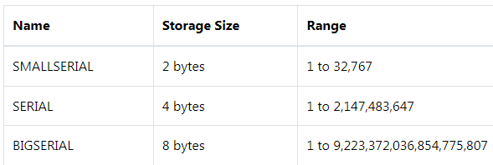
It is important to note that the SERIAL does not implicitly create an index on the column or make the column as the primary key column. However, this can be done easily by specifying the PRIMARY KEY constraint for the SERIAL column.
The following statement creates the fruits table with the id column as the SERIAL column: |  | CREATE TABLE fruits(  id SERIAL PRIMARY KEY,  name VARCHAR NOT NULL  );
To assign the default value for a serial column when you insert row into the table, you ignore the column name or use the DEFAULT keyword in the INSERT statement.  See the following example: |  | INSERT INTO fruits(name)  VALUES('Orange');  Or  INSERT INTO fruits(id,name)  VALUES(DEFAULT,'Apple');
To get the sequence name of a SERIAL column in a table, you use the pg_get_serial_sequence() function as follows: | pg_get_serial_sequence('table_name','column_name')
If you want to get the value generated by the sequence when you insert a new row into the table, you use the RETURNING id clause in the INSERT statement.  The following statement inserts a new row into the fruits table and returns the value generated for the id column. |  |  | INSERT INTO fruits(name)  VALUES('Banana')  RETURNING id;
The sequence generator operation is not transaction-safe. It means that if two concurrent database connections attempt to get the next value from a sequence, each client will get a different value. If one client rolls back the transaction, the sequence number of that client will be unused, creating a gap in the sequence.

PostgreSQL Sequences
CREATE SEQUENCES | By definition, a sequence is an ordered list of integers. The orders of numbers in the sequence are important. For example, {1,2,3,4,5} and {5,4,3,2,1} are entirely different sequences.  A sequence in PostgreSQL is a user-defined schema-bound object that generates a sequence of integers based on a specified specification.  To create a sequence in PostgreSQL, you use the CREATE SEQUENCE statement.
CREATE SEQUENCES | The following illustrates the syntax of the CREATE SEQUENCE statement: |  | CREATE SEQUENCE [ IF NOT EXISTS ] sequence_name  [ AS { SMALLINT | INT | BIGINT } ]  [ INCREMENT [ BY ] increment ]  [ MINVALUE minvalue | NO MINVALUE ]  [ MAXVALUE maxvalue | NO MAXVALUE ]  [ START [ WITH ] start ]  [ CACHE cache ]  [ [ NO ] CYCLE ]  [ OWNED BY { table_name.column_name | NONE } ]
CREATE SEQUENCES | • Specify the name of the sequence after the CREATE SEQUENCE clause. The IF NOT EXISTS conditionally creates a new sequence only if it does not exist.  The sequence name must be distinct from any other sequences, tables, indexes, views, or foreign tables in the same schema.  • Specify the data type of the sequence. The valid data type is SMALLINT, INT, and BIGINT. The default data type is BIGINT if you skip it.  The data type of the sequence which determines the sequence’s minimum and maximum values.  • The increment specifies which value to be added to the current sequence value to create new value.  A positive number will make an ascending sequence while a negative number will form a descending sequence.  The default increment value is 1.  • Define the minimum value and maximum value of the sequence. If you use NO MINVALUEand NO MAXVALUE, the sequence will use the default value.  For an ascending sequence, the default maximum value is the maximum value of the data type of the sequence and the default minimum value is 1.  In case of a descending sequence, the default maximum value is -1 and the default minimum value is the minimum value of the data type of the sequence.  • The START clause specifies the starting value of the sequence.  The default starting value is minvalue for ascending sequences and maxvalue for descending ones.  • The CACHE determines how many sequence numbers are preallocated and stored in memory for faster access. One value can be generated at a time.  By default, the sequence generates one value at a time i.e., no cache.  • The CYCLE allows you to restart the value if the limit is reached. The next number will be the minimum value for the ascending sequence and maximum value for the descending sequence.  If you use NO CYCLE, when the limit is reached, attempting to get the next value will result in an error.  The NO CYCLE is the default if you don’t explicitly specify CYCLE or NO CYCLE.  • The OWNED BY clause allows you to associate the table column with the sequence so that when you drop the column or table, PostgreSQL will automatically drop the associated sequence.  Note that when you use the SERIAL pseudo-type for a column of a table, behind the scenes, PostgreSQL automatically creates a sequence associated with the column.
CREATE SEQUENCES | 1) Creating an ascending sequence example  This statement uses the CREATE SEQUENCE statement to create a new ascending sequence starting from 100 with an increment of 5: |  |  |  |  | CREATE SEQUENCE mysequence  INCREMENT 5  START 100;
CREATE SEQUENCES | To get the next value from the sequence to you use the nextval() function: |  | SELECT nextval('mysequence');  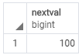  If you execute the statement again, you will get the next value from the sequence:  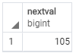
CREATE SEQUENCES | 2) Creating a descending sequence example  The following statement creates a descending sequence from 3 to 1 with the cycle option: |  |  |  | CREATE SEQUENCE three  INCREMENT -1  MINVALUE 1  MAXVALUE 3  START 3  CYCLE;
CREATE SEQUENCES | When you execute the following statement multiple times, you will see the number starting from 3, 2, 1 and back to 3, 2, 1 and so on: |  |  |  | SELECT nextval('three');
CREATE SEQUENCES | 3) Creating a sequence associated with a table column  First, create a new table named order_details: |  |  | 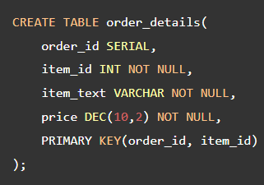
CREATE SEQUENCES | Second, create a new sequence associated with the item_id column of the order_details table: |  |  | 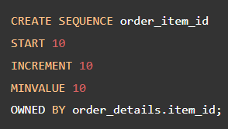
CREATE SEQUENCES | Third, insert three order line items into the order_details table:  In this statement, we used the nextval() function to fetch item id value from the order_item_id sequence. | 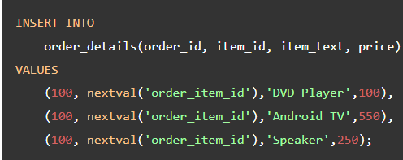
CREATE SEQUENCES | Fourth, query data from the order_details table: |  |  |  |  |  | SELECT  order_id,  item_id,  item_text,  price  FROM  order_details;
CREATE SEQUENCES | Listing all sequences in a database  To list all sequences in the current database, you use the following query: |  |  |  |  |  | SELECT  relname sequence_name  FROM  pg_class  WHERE  relkind = 'S';
CREATE SEQUENCES | Deleting sequences  If a sequence is associated with a table column, it will be automatically dropped once the table column is removed or the table is dropped.  You can also remove a sequence manually using the DROP SEQUENCE statement: →  In this syntax:  • First, specify the name of the sequence which you want to drop. The IF EXISTS option conditionally deletes the sequence if it exists. In case you want to drop multiple sequences at once, you can use a list of comma-separated sequence names.  • Then, use the CASCADE option if you want to recursively drops objects that depend on the sequence, and objects that depend on the dependent objects and so on. |  |  |  |  |  | DROP SEQUENCE [ IF EXISTS ] sequence_name [, ...]  [ CASCADE | RESTRICT ];
CREATE SEQUENCES | PostgreSQL DROP SEQUENCE statement examples  This statement drops the table order_details. Since the sequence order_item_id associates with the item_id of the order_details, it is also dropped automatically: |  |  |  |  |  | DROP TABLE order_details;

PostgreSQL Identity Column
GENERATED AS IDENTITY | PostgreSQL version 10 introduced a new constraint GENERATED AS IDENTITY that allows you to automatically assign a unique number to a column.  The GENERATED AS IDENTITY constraint is the SQL standard-conforming variant of the good old SERIAL column.
GENERATED AS IDENTITY | The following illustrates the syntax of the GENERATED AS IDENTITY constraint:  In this syntax:  • The type can be SMALLINT, INT, or BIGINT.  • The GENERATED ALWAYS instructs PostgreSQL to always generate a value for the identity column. If you attempt to insert (or update) values into the GENERATED ALWAYS AS IDENTITY column, PostgreSQL will issue an error.  • The GENERATED BY DEFAULT also instructs PostgreSQL to generate a value for the identity column. However, if you supply a value for insert or update, PostgreSQL will use that value to insert into the identity column instead of using the system-generated value.  PostgreSQL allows you a table to have more than one identity column. Like the SERIAL, the GENERATED AS IDENTITY constraint also uses the SEQUENCE object internally. | column_name type GENERATED { ALWAYS | BY DEFAULT } AS IDENTITY[ ( sequence_option ) ]
GENERATED AS IDENTITY | GENERATED ALWAYS example.  First, create a table named color with the color_id as the identity column. →  Because color_id column has the GENERATED AS IDENTITY constraint, PostgreSQL generates a value for it as shown in the query below.  Third, insert a new row by supplying values for both color_id and color_name columns. PostgreSQL issued the following error.  To fix the error, you can use the OVERRIDING SYSTEM VALUE clause as follows →  Or use GENERATED BY DEFAULT AS IDENTITY instead. |  | CREATE TABLE color (  color_id INT GENERATED ALWAYS AS IDENTITY,  color_name VARCHAR NOT NULL  );  ———————————————  INSERT INTO color (color_id, color_name)  OVERRIDING SYSTEM VALUE  VALUES(2, 'Green');
GENERATED AS IDENTITY | GENERATED BY DEFAULT AS IDENTITY example.  First, drop the color table and recreate it. This time we use the GENERATED BY DEFAULT AS IDENTITY instead →  Second, insert a row into the color table. It works as expected. Third, insert another row with a value for the color_id column. Unlike the previous example that uses the GENERATED ALWAYS AS IDENTITY constraint, the statement above works perfectly fine. |  | DROP TABLE color;  CREATE TABLE color (  color_id INT GENERATED BY DEFAULT AS IDENTITY,  color_name VARCHAR NOT NULL  );
GENERATED AS IDENTITY | Sequence options example.  Because the GENERATED AS IDENTITY constraint uses the SEQUENCE object, you can specify the sequence options for the system-generated values.  For example, you can specify the starting value and the increment as follows: →  In this example, the system-generated value for the color_id column starts with 10 and the increment value is also 10. First, insert a new row into the color table.  The starting value for color_id column is ten as shown below. Second, insert another row into the color table. |  | DROP TABLE color;  CREATE TABLE color (  color_id INT GENERATED BY DEFAULT AS IDENTITY  (START WITH 10 INCREMENT BY 10),  color_name VARCHAR NOT NULL  );
GENERATED AS IDENTITY | Adding an identity column to an existing table.  You can add identity columns to an existing table by using the following form of the ALTER TABLE statement → | ALTER TABLE table_name  ALTER COLUMN column_name  ADD GENERATED { ALWAYS | BY DEFAULT } AS IDENTITY { ( sequence_option ) }
GENERATED AS IDENTITY | Changing an identity column.  You can change the characteristics of an existing identity column by using the following ALTER TABLE statement: | ALTER TABLE table_name  ALTER COLUMN column_name  { SET GENERATED { ALWAYS| BY DEFAULT } |  SET sequence_option | RESTART [ [ WITH ] restart ] }
GENERATED AS IDENTITY | Removing the GENERATED AS IDENTITY constraint  The following statement removes the GENERATED AS IDENTITY constraint from an existing table: | ALTER TABLE table_name  ALTER COLUMN column_name  DROP IDENTITY [ IF EXISTS ]

PostgreSQL ALTER TABLE
 | To change the structure of an existing table, you use PostgreSQL ALTER TABLE statement.
 | The following illustrates the basic syntax of the ALTER TABLE statement: | ALTER TABLE table_name action;
PostgreSQL provides you with many actions:
• Add a column
• Drop a column
• Change the data type of a column
• Rename a column
• Set a default value for the column.
• Add a constraint to a column.
• Rename a table
ADD COLUMN | To add a new column to a table, you use ALTER TABLE ADD COLUMN statement: →  When you add a new column to the table, PostgreSQL appends it at the end of the table. PostgreSQL has no option to specify the position of the new column in the table.  To add multiple columns to an existing table, you use multiple ADD COLUMN clauses in the ALTER TABLE statement as follows: → | ALTER TABLE table_name  ADD COLUMN column_name datatype column_constraint;  ———————  ALTER TABLE table_name  ADD COLUMN column_name1 data_type constraint,  ADD COLUMN column_name2 data_type constraint,  ...  ADD COLUMN column_namen data_type constraint;
DROP COLUMN | To drop a column from a table, you use ALTER TABLE DROP COLUMN statement: →  If the column that you want to remove is used in other database objects such as views, triggers, stored procedures, etc., you cannot drop the column because other objects are depending on it. In this case, you need to add the CASCADE option to the DROP COLUMN clause to drop the column and all of its dependent objects: →  If you remove a column that does not exist, PostgreSQL will issue an error. To remove a column only if it exists, you can add the IF EXISTS option as follows: →  If you want to drop multiple columns of a table in a single command, you use multiple DROP COLUMN clause like this: → | ALTER TABLE table_name  DROP COLUMN column_name;  ——————————  ALTER TABLE table_name  DROP COLUMN column_name CASCADE;  ———————————  ALTER TABLE table_name  DROP COLUMN IF EXISTS column_name;  ———————————  ALTER TABLE table_name  DROP COLUMN column_name1,  DROP COLUMN column_name2,  ...;
RENAME COLUMN | To rename a column, you use the ALTER TABLE RENAME COLUMN TO statement: | ALTER TABLE table_name  RENAME COLUMN column_name  TO new_column_name;
SET DEFAULT  or  DROP DEFAULT | To change a default value of the column, you use ALTER TABLE ALTER COLUMN SET DEFAULT or DROP DEFAULT: →  To change the data types of multiple columns in a single statement, you use multiple ALTER COLUMN clauses like this: →  PostgreSQL allows you to convert the values of a column to the new ones while changing its data type by adding a USING clause as follows: →  The USING clause specifies an expression that allows you to convert the old values to the new ones.  If you omit the USING clause, PostgreSQL will cast the values to the new ones implicitly. In case the cast fails, PostgreSQL will issue an error and recommends you provide the USING clause with an expression for the data conversion.  The expression after the USING keyword can be as simple as column_name::new_data_type such as price::numeric or as complex as a custom function. | ALTER TABLE table_name  ALTER COLUMN column_name  [SET DEFAULT value | DROP DEFAULT];  ————————  ALTER TABLE table_name  ALTER COLUMN column_name1 [SET DATA] TYPE new_data_type,  ALTER COLUMN column_name2 [SET DATA] TYPE new_data_type,  ...;  ———————  ALTER TABLE table_name  ALTER COLUMN column_name TYPE new_data_type USING expression;
NOT NULL | To change the NOT NULL constraint, you use ALTER TABLE ALTER COLUMN statement: | ALTER TABLE table_name  ALTER COLUMN column_name  [SET NOT NULL| DROP NOT NULL];
ADD CHECK | To add a CHECK constraint, you use ALTER TABLE ADD CHECK statement: | ALTER TABLE table_name  ADD CHECK expression;
ADD CONSTRAINT | Generailly, to add a constraint to a table, you use ALTER TABLE ADD CONSTRAINT statement: | ALTER TABLE table_name  ADD CONSTRAINT constraint_name constraint_definition;
RENAME TO | To rename a table you use ALTER TABLE RENAME TO statement:  If you try to rename a table that does not exist, PostgreSQL will issue an error. To avoid this, you add the IF EXISTS option as follows:  To rename multiple tables, you have to execute multiple ALTER TABLE RENAME TO statements. It’s not possible to rename multiple taable using a singe ALTER TABLE statement.  The COLUMN keyword in the statement is optional therefore you can omit it.  For some reason, if you try to rename a column that does not exist, PostgreSQL will issue an error. Unfortunately that PostgreSQL does not provide the IF EXISTS option for the RENAME clause.  To rename multiple columns, you need to execute the ALTER TABLE RENAME COLUMN statement multiple times, one column at a time: → | ALTER TABLE table_name  RENAME TO new_table_name;  ALTER TABLE IF EXISTS table_name  RENAME TO new_table_name;  ———————  ALTER TABLE table_name  RENAME column_name1 TO new_column_name1;  ALTER TABLE table_name  RENAME column_name2 TO new_column_name2;
DROP TABLE | To drop a table from the database, you use the DROP TABLE statement as follows: →  If you remove a table that does not exist, PostgreSQL issues an error. To avoid this situation, you can use the IF EXISTS option.  In case the table that you want to remove is used in other objects such as views, triggers, functions, and stored procedures, the DROP TABLE cannot remove the table. In this case, you have two options:  • The CASCADE option allows you to remove the table and its dependent objects.  • The RESTRICT option rejects the removal if there is any object depends on the table. The RESTRICT option is the default if you don’t explicitly specify it in the DROP TABLE statement. | DROP TABLE [IF EXISTS] table_name  [CASCADE | RESTRICT];

PostgreSQL TRUNCATE TABLE
TRUNCATE TABLE | To remove all data from a table, you use the DELETE statement. However, when you use the DELETE statement to delete all data from a table that has a lot of data, it is not efficient.
TRUNCATE TABLE | In this case, you need to use the TRUNCATE TABLE statement: | TRUNCATE TABLE table_name;
TRUNCATE TABLE | The TRUNCATE TABLE statement deletes all data from a table without scanning it. This is the reason why it is faster than the DELETE statement.  In addition, the TRUNCATE TABLE statement reclaims the storage right away so you do not have to perform a subsequent VACUMM operation, which is useful in the case of large tables.
TRUNCATE TABLE | Besides removing data, you may want to reset the values in the identity column by using the RESTART IDENTITY option like this: | TRUNCATE TABLE table_name  RESTART IDENTITY;
TRUNCATE TABLE | By default, the TRUNCATE TABLE statement uses the CONTINUE IDENTITY option. This option basically does not restart the value in sequence associated with the column in the table.
TRUNCATE TABLE | To remove all data from multiple tables at once, you separate each table by a comma (,) as follows: |  | TRUNCATE TABLE  table_name1,  table_name2,  ...;
TRUNCATE TABLE | In practice, the table you want to truncate often has the foreign key references from other tables that are not listed in the TRUNCATE TABLE statement.  By default, the TRUNCATE TABLE statement does not remove any data from the table that has foreign key references.  To remove data from a table and other tables that have foreign key reference the table, you use CASCADE option in the TRUNCATE TABLE statement as follows : |  | TRUNCATE TABLE table_name  CASCADE;
TRUNCATE TABLE | By default, the TRUNCATE TABLE statement uses the RESTRICT option which prevents you from truncating the table that has foreign key constraint references.
TRUNCATE TABLE | Even though the TRUNCATE TABLE statement removes all data from a table, it does not fire any ON DELETE triggers associated with the table.  To fire the trigger when the TRUNCATE TABLE command applied to a table, you must define BEFORE TRUNCATE and/or AFTER TRUNCATE triggers for that table.
TRUNCATE TABLE | The TRUNCATE TABLE is transaction-safe. It means that if you place it within a transaction, you can roll it back safely.

PostgreSQL temporary table
CREATE TEMPORARY TABLE | A temporary table, as its name implied, is a short-lived table that exists for the duration of a database session. PostgreSQL automatically drops the temporary tables at the end of a session or a transaction. A temporary table is visible only to the session that creates it. In other words, it is invisible to other sessions.
CREATE TEMPORARY TABLE | To create a temporary table, you use the CREATE TEMPORARY TABLE statement:  The TEMP and TEMPORARY keywords are equivalent so you can use them interchangeably: | CREATE TEMPORARY TABLE temp_table_name(  column_list  );

PostgreSQL copy table statement
To copy a table completely, including both table structure and data, you use the following statement: |  | CREATE TABLE new_table AS  TABLE existing_table;
To copy a table structure without data, you add the WITH NO DATA clause to the CREATE TABLE statement as follows: |  | CREATE TABLE new_table AS  TABLE existing_table  WITH NO DATA;
To copy a table with partial data from an existing table, you use the following statement: →  The condition in the WHERE clause of the query defines which rows of the existing table will be copied to the new table.  Note that all the statement above copy table structure and data but do not copy indexes and constraints of the existing table. |  | CREATE TABLE new_table AS  SELECT  *  FROM  existing_table  WHERE  condition;
To add the primary key and UNIQUE constraints to the contact_backup table, you use the following ALTER TABLE statements: | ALTER TABLE contact_backup ADD PRIMARY KEY(id);  ALTER TABLE contact_backup ADD UNIQUE(email);

PostgreSQL Primary Key
PRIMARY KEY | A primary key is a column or a group of columns used to identify a row uniquely in a table.  You define primary keys through primary key constraints. Technically, a primary key constraint is the combination of a not-null constraint and a UNIQUE constraint.  A table can have one and only one primary key. It is a good practice to add a primary key to every table. When you add a primary key to a table, PostgreSQL creates a unique B-tree index on the column or a group of columns used to define the primary key.
PRIMARY KEY | Normally, we add the primary key to a table when we define the table’s structure using CREATE TABLE statement. | CREATE TABLE TABLE (  column_1 data_type PRIMARY KEY,  column_2 data_type,  …  );
PRIMARY KEY | In case the primary key consists of two or more columns, you define the primary key constraint as follows: | CREATE TABLE TABLE (  column_1 data_type,  column_2 data_type,  …  PRIMARY KEY (column_1, column_2)  );
PRIMARY KEY | It is rare to define a primary key for existing table. In case you have to do it, you can use the ALTER TABLE statement to add a primary key constraint. |  | ALTER TABLE table_name ADD PRIMARY KEY (column_1, column_2);
PRIMARY KEY | To remove an existing primary key constraint, you also use the ALTER TABLE statement with the following syntax: | ALTER TABLE table_name DROP CONSTRAINT primary_key_constraint;

PostgreSQL Foreign Key
FOREIGN KEY | A foreign key is a column or a group of columns in a table that reference the primary key of another table.  The table that contains the foreign key is called the referencing table or child table. And the table referenced by the foreign key is called the referenced table or parent table.  A table can have multiple foreign keys depending on its relationships with other tables.  In PostgreSQL, you define a foreign key using the foreign key constraint. The foreign key constraint helps maintain the referential integrity of data between the child and parent tables.  A foreign key constraint indicates that values in a column or a group of columns in the child table equal the values in a column or a group of columns of the parent table.
FOREIGN KEY | The following illustrates a foreign key constraint syntax:  In this syntax:  • First, specify the name for the foreign key constraint after the CONSTRAINT keyword. The CONSTRAINT clause is optional. If you omit it, PostgreSQL will assign an auto-generated name.  • Second, specify one or more foreign key columns in parentheses after the FOREIGN KEY keywords.  • Third, specify the parent table and parent key columns referenced by the foreign key columns in the REFERENCES clause.  • Finally, specify the delete and update actions in the ON DELETE and ON UPDATE clauses.  The delete and update actions determine the behaviors when the primary key in the parent table is deleted and updated. Since the primary key is rarely updated, the ON UPDATE action is not often used in practice. We’ll focus on the ON DELETE action.  PostgreSQL supports the following actions:  • SET NULL  • SET DEFAULT  • RESTRICT  • NO ACTION  • CASCADE |  |  |  | [CONSTRAINT fk_name]  FOREIGN KEY(fk_columns)  REFERENCES parent_table(parent_key_columns)  [ON DELETE delete_action]  [ON UPDATE update_action]
FOREIGN KEY | PostgreSQL foreign key constraint examples  The following statements create the customers and contacts tables: →  In this example, the customers table is the parent table and the contacts table is the child table.  Each customer has zero or many contacts and each contact belongs to zero or one customer.  The customer_id column in the contacts table is the foreign key column that references the primary key column with the same name in the customers table.  The following foreign key constraint fk_customer in the contacts table defines the customer_id as the foreign key: ↓  CONSTRAINT fk_customer  FOREIGN KEY(customer_id)  REFERENCES customers(customer_id)  Because the foreign key constraint does not have the ON DELETE and ON UPDATE action, they default to NO ACTION. |  | DROP TABLE IF EXISTS customers;  DROP TABLE IF EXISTS contacts;  CREATE TABLE customers(  customer_id INT GENERATED ALWAYS AS IDENTITY,  customer_name VARCHAR(255) NOT NULL,  PRIMARY KEY(customer_id)  );  CREATE TABLE contacts(  contact_id INT GENERATED ALWAYS AS IDENTITY,  customer_id INT,  contact_name VARCHAR(255) NOT NULL,  phone VARCHAR(15),  email VARCHAR(100),  PRIMARY KEY(contact_id),  CONSTRAINT fk_customer  FOREIGN KEY(customer_id)  REFERENCES customers(customer_id)  );
FOREIGN KEY | NO ACTION  The following inserts data into the customers and contacts tables.  The following statement deletes the customer id 1 from the customers table.  Because of the ON DELETE NO ACTION, PostgreSQL issues a constraint violation because the referencing rows of the customer id 1 still exist in the contacts table.  The RESTRICT action is similar to the NO ACTION. The difference only arises when you define the foreign key constraint as DEFERRABLE with an INITIALLY DEFERRED or INITIALLY IMMEDIATE mode. We’ll discuss more on this in the subsequent tutorial.
FOREIGN KEY | SET NULL  The SET NULL automatically sets NULL to the foreign key columns in the referencing rows of the child table when the referenced rows in the parent table are deleted.  The following statements drop the sample tables and re-create them with the foreign key that uses the SET NULL action in the ON DELETE clause: →  To see how the SET NULL works, let’s delete the customer with id 1 from the customers table.  Because of the ON DELETE SET NULL action, the referencing rows in the contacts table set to NULL. The following statement displays the data in the contacts table.  As can be seen clearly from the output, the rows that have the customer_id 1 now have the customer_id sets to NULL | DROP TABLE IF EXISTS contacts;  DROP TABLE IF EXISTS customers;  CREATE TABLE customers(  customer_id INT GENERATED ALWAYS AS IDENTITY,  customer_name VARCHAR(255) NOT NULL,  PRIMARY KEY(customer_id)  );  CREATE TABLE contacts(  contact_id INT GENERATED ALWAYS AS IDENTITY,  customer_id INT,  contact_name VARCHAR(255) NOT NULL,  phone VARCHAR(15),  email VARCHAR(100),  PRIMARY KEY(contact_id),  CONSTRAINT fk_customer  FOREIGN KEY(customer_id)  REFERENCES customers(customer_id)  ON DELETE SET NULL  );  INSERT INTO customers(customer_name)  VALUES('BlueBird Inc'),  ('Dolphin LLC');  INSERT INTO contacts(customer_id, contact_name, phone, email)  VALUES(1,'John Doe','(408)-111-1234','john.doe@bluebird.dev'),  (1,'Jane Doe','(408)-111-1235','jane.doe@bluebird.dev'),  (2,'David Wright','(408)-222-1234','david.wright@dolphin.dev');
FOREIGN KEY | CASCADE  The ON DELETE CASCADE automatically deletes all the referencing rows in the child table when the referenced rows in the parent table are deleted. In practice, the ON DELETE CASCADE is the most commonly used option.  The following statements recreate the sample tables. However, the delete action of the fk_customer changes to CASCADE: →  The following statement deletes the customer id 1.  Because of the ON DELETE CASCADE action, all the referencing rows in the contacts table are automatically deleted. | DROP TABLE IF EXISTS contacts;  DROP TABLE IF EXISTS customers;  CREATE TABLE customers(  customer_id INT GENERATED ALWAYS AS IDENTITY,  customer_name VARCHAR(255) NOT NULL,  PRIMARY KEY(customer_id)  );  CREATE TABLE contacts(  contact_id INT GENERATED ALWAYS AS IDENTITY,  customer_id INT,  contact_name VARCHAR(255) NOT NULL,  phone VARCHAR(15),  email VARCHAR(100),  PRIMARY KEY(contact_id),  CONSTRAINT fk_customer  FOREIGN KEY(customer_id)  REFERENCES customers(customer_id)  ON DELETE CASCADE  );  INSERT INTO customers(customer_name)  VALUES('BlueBird Inc'),  ('Dolphin LLC');  INSERT INTO contacts(customer_id, contact_name, phone, email)  VALUES(1,'John Doe','(408)-111-1234','john.doe@bluebird.dev'),  (1,'Jane Doe','(408)-111-1235','jane.doe@bluebird.dev'),  (2,'David Wright','(408)-222-1234','david.wright@dolphin.dev');
FOREIGN KEY | SET DEFAULT  The ON DELETE SET DEFAULT sets the default value to the foreign key column of the referencing rows in the child table when the referenced rows from the parent table are deleted.
FOREIGN KEY | Add a foreign key constraint to an existing table  To add a foreign key constraint to the existing table, you use the following form of the ALTER TABLE statement: →  When you add a foreign key constraint with ON DELETE CASCADE option to an existing table, you need to follow these steps:  First, drop existing foreign key constraints: →  First, add a new foreign key constraint with ON DELETE CASCADE action: → |  |  | ALTER TABLE child_table  ADD CONSTRAINT constraint_name  FOREIGN KEY (fk_columns)  REFERENCES parent_table (parent_key_columns);  ———————————  ALTER TABLE child_table  DROP CONSTRAINT constraint_fkey;  ———————————  ALTER TABLE child_table  ADD CONSTRAINT constraint_fk  FOREIGN KEY (fk_columns)  REFERENCES parent_table(parent_key_columns)  ON DELETE CASCADE;

PostgreSQL CHECK Constraint
CHECK | You will learn about the PostgreSQL CHECK constraints and how to use them to constrain values in columns of a table based on a boolean expression.  A CHECK constraint is a kind of constraint that allows you to specify if values in a column must meet a specific requirement.  The CHECK constraint uses a Boolean expression to evaluate the values before they are inserted or updated to the column.  If the values pass the check, PostgreSQL will insert or update these values to the column. Otherwise, PostgreSQL will reject the changes and issue a constraint violation error.
CHECK | Typically, you use the CHECK constraint at the time of creating the table using the CREATE TABLE statement.  The following statement defines an employees table:  The employees table has three CHECK constraints:  • First, the birth date ( birth_date) of the employee must be greater than 01/01/1900. If you try to insert a birth date before 01/01/1900, you will receive an error message.  • Second, the joined date ( joined_date) must be greater than the birth date ( birth_date). This check will prevent from updating invalid dates in terms of their semantic meanings.  • Third, the salary must be greater than zero, which is obvious. | DROP TABLE IF EXISTS employees;  CREATE TABLE employees (  id SERIAL PRIMARY KEY,  first_name VARCHAR (50),  last_name VARCHAR (50),  birth_date DATE CHECK (birth_date > '1900-01-01'),  joined_date DATE CHECK (joined_date > birth_date),  salary numeric CHECK(salary > 0)  );
CHECK | However, if you want to assign aCHECK constraint a specific name, you can specify it after the CONSTRAINT expression as follows: |  | column_name data_type CONSTRAINT constraint_name CHECK(...)
CHECK | See the following example: |  | ...  salary numeric CONSTRAINT positive_salary CHECK(salary > 0)  ...
CHECK | To add CHECK constraints to existing tables, you use the ALTER TABLE statement. Suppose, you have an existing table in the database named prices_list → |  |  | CREATE TABLE prices_list (  id serial PRIMARY KEY,  product_id INT NOT NULL,  price NUMERIC NOT NULL,  discount NUMERIC NOT NULL,  valid_from DATE NOT NULL,  valid_to DATE NOT NULL  );
CHECK | Now, you can use ALTER TABLE statement to add the CHECK constraints to the prices_list table. The price and discount must be greater than zero and the discount is less than the price. Notice that we use a Boolean expression that contains the AND operators. |  |  | ALTER TABLE prices_list  ADD CONSTRAINT price_discount_check  CHECK (  price > 0  AND discount >= 0  AND price > discount  );
CHECK | The valid to date ( valid_to) must be greater than or equal to valid from date ( valid_from). |  |  | ALTER TABLE prices_list  ADD CONSTRAINT valid_range_check  CHECK (valid_to >= valid_from);

PostgreSQL UNIQUE Constraint
You will learn about PostgreSQL UNIQUE constraint to make sure that values stored in a column or a group of columns are unique across rows in a table.
Sometimes, you want to ensure that values stored in a column or a group of columns are unique across the whole table such as email addresses or usernames.

PostgreSQL provides you with the UNIQUE constraint that maintains the uniqueness of the data correctly.

When a UNIQUE constraint is in place, every time you insert a new row, it checks if the value is already in the table. It rejects the change and issues an error if the value already exists. The same process is carried out for updating existing data.

When you add a UNIQUE constraint to a column or a group of columns, PostgreSQL will automatically create a unique index on the column or the group of columns.
The following statement creates a new table named person with a UNIQUE constraint for the email column. |  | CREATE TABLE person (  id SERIAL PRIMARY KEY,  first_name VARCHAR (50),  last_name VARCHAR (50),  email VARCHAR (50) UNIQUE  );
Note that the UNIQUE constraint above can be rewritten as a table constraint as shown in the following query: |  | CREATE TABLE person (  id SERIAL PRIMARY KEY,  first_name VARCHAR (50),  last_name VARCHAR (50),  email VARCHAR (50),  UNIQUE(email)  );
PostgreSQL allows you to create a UNIQUE constraint to a group of columns using the following syntax: →  The combination of values in column c2 and c3 will be unique across the whole table. The value of the column c2 or c3 needs not to be unique. |  | CREATE TABLE table (  c1 data_type,  c2 data_type,  c3 data_type,  UNIQUE (c2, c3)  );
Sometimes, you may want to add a unique constraint to an existing column or group of columns. Let’s take a look at the following example.  First, suppose you have a table named equipment: → |  | CREATE TABLE equipment (  id SERIAL PRIMARY KEY,  name VARCHAR (50) NOT NULL,  equip_id VARCHAR (16) NOT NULL  );
Second, create a unique index based on the equip_id column. | CREATE UNIQUE INDEX CONCURRENTLY equipment_equip_id  ON equipment (equip_id);
Third, add a unique constraint to the equipment table using the equipment_equip_id index. |  | ALTER TABLE equipment  ADD CONSTRAINT unique_equip_id  UNIQUE USING INDEX equipment_equip_id;
Notice that the ALTER TABLE statement acquires an exclusive lock on the table. If you have any pending transactions, it will wait for all transactions to complete before changing the table. Therefore, you should check the pg_stat_activity table to see the current pending transactions that are on-going using the following query: →  You should look at the result to find the state column with the value idle in transaction. Those are the transactions that are pending to complete. |  | SELECT  datid,  datname,  usename,  state  FROM  pg_stat_activity;

PostgreSQL Not-Null Constraint
You will learn about PostgreSQL not-null constraint to ensure the values of a column are not null.
In database theory, NULL represents unknown or information missing. NULL is not the same as an empty string or the number zero.

Suppose that you need to insert an email address of a contact into a table. You can request his or her email address. However, if you don’t know whether the contact has an email address or not, you can insert NULL into the email address column. In this case, NULL indicates that the email address is not known at the time of recording.

NULL is very special. It does not equal anything, even itself. The expression NULL = NULL returns NULL because it makes sense that two unknown values should not be equal.
To control whether a column can accept NULL, you use the NOT NULL constraint: →  If a column has a NOT NULL constraint, any attempt to insert or update NULL in the column will result in an error. | CREATE TABLE table_name(  ...  column_name data_type NOT NULL,  ...  );
The following CREATE TABLE statement creates a new table name invoices with the not-null constraints. →  This example uses the NOT NULL keywords that follow the data type of the product_id and qty columns to declare NOT NULL constraints.  Note that a column can have multiple constraints such as NOT NULL, check, unique, foreign key appeared next to each other. The order of the constraints is not important. PostgreSQL can check the constraint in the list in any order. | CREATE TABLE invoices(  id SERIAL PRIMARY KEY,  product_id INT NOT NULL,  qty numeric NOT NULL CHECK(qty > 0),  net_price numeric CHECK(net_price > 0)  );
If you use NULL instead of NOT NULL, the column will accept both NULL and non-NULL values. If you don’t explicitly specify NULL or NOT NULL, it will accept NULL by default.
To add the NOT NULL constraint to a column of an existing table, you use the following form of the ALTER TABLE statement: | ALTER TABLE table_name  ALTER COLUMN column_name SET NOT NULL;
Besides the NOT NULL constraint, you can use a CHECK constraint to force a column to accept not NULL values. The NOT NULL constraint is equivalent to the following CHECK constraint: →  This is useful because sometimes you may want either column a or b is not null, but not both. | CHECK(column IS NOT NULL)
For example, you may want either username or email column of the user tables is not null or empty. In this case, you can use the CHECK constraint as follows: | CREATE TABLE users (  id serial PRIMARY KEY,  username VARCHAR (50),  password VARCHAR (50),  email VARCHAR (50),  CONSTRAINT username_email_notnull CHECK (  NOT (  ( username IS NULL OR username = '' )  AND  ( email IS NULL OR email = '' )  )  )  );

Compare Two Tables in PostgreSQL
There are several ways to compare the content of two tables to find the differences between them. We will show you two commonly used techniques to compare data of two tables.
Compare two tables using EXCEPT and UNION operators.  To find the rows in the foo table but not in the bar table, we use the following query: | SELECT ID,  NAME,  'not in bar' AS note  FROM  foo  EXCEPT  SELECT  ID,  NAME,  'not in bar' AS note  FROM  Bar
We used EXCEPT operator that returns the rows in the foo table but not in the bar table. We can apply the same technique to find the rows that are in the bar table but not in the foo table. | SELECT ID,  NAME,  'not in foo' AS note  FROM  bar  EXCEPT  SELECT  ID,  NAME,  'not in foo' AS note  FROM  foo
We use UNION operator to combine the result of both queries to find:
• Rows in the bar table but not in the foo table
• Rows in the foo table but not in the bar table.
Compare two tables using OUTER JOIN  We can use the outer join to compare two tables as follows: | SELECT id,  name  FROM  foo  FULL OUTER JOIN bar USING (id, name)  WHERE  foo.id IS NULL  OR bar.id IS NULL;
To find the number of rows that are in the foo table but not bar table and vice versa, we use the COUNT function as follows: | SELECT COUNT (*)  FROM  foo  FULL OUTER JOIN bar USING (id, name)  WHERE  foo.id IS NULL  OR bar.id IS NULL;

How to Generate a Random Number in a Range
Random() | this tutorial shows you how to develop a user-defined function that generates a random number between two numbers.
Random() | PostgreSQL provides the random() function that returns a random number between 0 and 1. The following statement returns a random number between 0 and 1. | SELECT random();
Random() | To generate a random number between 1 and 11, you use the following statement: | SELECT random() * 10 + 1 AS RAND_1_11;
Random() | If you want to generate the random number as an integer, you apply the floor() function to the expression as follows: | SELECT floor(random() * 10 + 1)::int;
Random() | Generally, to generate a random number between two integers l and h, you use the following statement: | SELECT floor(random() * (h-l+1) + l)::int;
Random() | You can develop a user-defined function that returns a random number between two numbers l and h: | CREATE OR REPLACE FUNCTION random_between(low INT ,high INT)  RETURNS INT AS  $$  BEGIN  RETURN floor(random()* (high-low + 1) + low);  END;  $$ language 'plpgsql' STRICT;
Random() | The following statement calls the random_between() function and returns a random number between 1 and 100: | SELECT random_between(1,100);
Random() | If you want to get multiple random numbers between two integers, you use the following statement: | SELECT random_between(1,100)  FROM generate_series(1,5);

How To Delete Duplicate Rows in PostgreSQL
Finding duplicate rows  If the table has few rows, you can see which ones are duplicate immediately. However, it is not the case with the big table.  The find the duplicate rows, you use the following statement: |  | SELECT  fruit,  COUNT( fruit )  FROM  basket  GROUP BY  fruit  HAVING  COUNT( fruit )> 1  ORDER BY  fruit;
Deleting duplicate rows using DELETE USING statement  The following statement uses the DELETE USING statement to remove duplicate rows: →  In this example, we joined the basket table to itself and checked if two different rows (a.id < b.id) have the same value in the fruit column.  As you can see, the statement removed the duplicate rows with lowest ids and keep the one with the highest id.  If you want to keep the duplicate rows with the lowest id, you use just need to flip the operator in the WHERE clause |  | DELETE FROM  basket a  USING basket b  WHERE  a.id < b.id  AND a.fruit = b.fruit;
Deleting duplicate rows using subquery  The following statement uses a suquery to delete duplicate rows and keep the row with the lowest id. →  In this example, the subquery returned the duplicate rows except for the first row in the duplicate group. And the outer DELETE statement deleted the duplicate rows returned by the subquery. | DELETE FROM basket  WHERE id IN  (SELECT id  FROM  (SELECT id,  ROW_NUMBER() OVER( PARTITION BY fruit  ORDER BY id ) AS row_num  FROM basket ) t  WHERE t.row_num > 1 );
In case you want to delete duplicate based on values of multiple columns, here is the query template: →  In this case, the statement will delete all rows with duplicate values in the column_1 and column_2 columns. | DELETE FROM table_name  WHERE id IN  (SELECT id  FROM  (SELECT id,  ROW_NUMBER() OVER( PARTITION BY column_1,  column_2  ORDER BY id ) AS row_num  FROM table_name ) t  WHERE t.row_num > 1 );
Deleting duplicate rows using an immediate table  To delete rows using an immediate table, you use the following steps:  • Create a new table with the same structure as the one whose duplicate rows should be removed.  • Insert distinct rows from the source table to the immediate table.  • Drop the source table.  • Rename the immediate table to the name of the source table.  The following illustrates the steps of removing duplicate rows from the basket table: | -- step 1  CREATE TABLE basket_temp (LIKE basket);  -- step 2  INSERT INTO basket_temp(fruit, id)  SELECT  DISTINCT ON (fruit) fruit,  id  FROM basket;  -- step 3  DROP TABLE basket;  -- step 4  ALTER TABLE basket_temp  RENAME TO basket;

PostgreSQL CASE
CASE  WHEN  THEN  ELSE  END | The PostgreSQL CASE expression is the same as IF/ELSE statement in other programming languages. It allows you to add if-else logic to the query to form a powerful query.  Since CASE is an expression, you can use it in any places where an expression can be used e.g.,SELECT, WHERE, GROUP BY, and HAVING clause.  The CASE expression has two forms: general and simple form.
CASE  WHEN  THEN  ELSE  END | 1) General PostgreSQL CASE expression  The following illustrates the general form of the CASE statement: |  |  |  | CASE  WHEN condition_1 THEN result_1  WHEN condition_2 THEN result_2  [WHEN ...]  [ELSE else_result]  END
CASE  WHEN  THEN  ELSE  END | In this syntax, each condition (condition_1, condition_2…) is a boolean expression that returns either true or false.  When a condition evaluates to false, the CASE expression evaluates the next condition from the top to bottom until it finds a condition that evaluates to true.  If a condition evaluates to true, the CASE expression returns the corresponding result that follows the condition. For example, if the condition_2 evaluates to true, the CASE expression returns the result_2. Also, it immediately stops evaluating the next expression.  In case all conditions evaluate to false, the CASE expression returns the result (else_result) that follows the ELSE keyword. If you omit the ELSE clause, the CASE expression returns NULL.
CASE  WHEN  THEN  ELSE  END | A) A general CASE example  Suppose you want to label the films by their length based on the following logic:  • If the lengh is less than 50 minutes, the film is short.  • If the length is greater than 50 minutes and less than or equal to 120 minutes, the film is medium.  • If the length is greater than 120 minutes, the film is long.  To apply this logic, you can use the CASE expression in the SELECT statement as follows: →  Note that we placed a column alias duration after the CASE expression. |  |  | SELECT title,  length,  CASE  WHEN length> 0  AND length <= 50 THEN 'Short'  WHEN length > 50  AND length <= 120 THEN 'Medium'  WHEN length> 120 THEN 'Long'  END duration  FROM film  ORDER BY title;
CASE  WHEN  THEN  ELSE  END | B) Using CASE with an aggregate function example  Suppose that you want to assign price segments to films with the following logic:  • If the rental rate is 0.99, the film is economic.  • If the rental rate is 1.99, the film is mass.  • If the rental rate is 4.99, the film is premium.  And you want to know the number of films that belong to economy, mass, and premium.  In this case, you can use the CASE expression to construct the query as follows: →  In this example, we used the CASE expression to return 1 or 0 if the rental rate falls into each price segment. And we applied the SUM function to calculate the total of films for each price segment. |  | SELECT  SUM (CASE  WHEN rental_rate = 0.99 THEN 1  ELSE 0  END  ) AS "Economy",  SUM (  CASE  WHEN rental_rate = 2.99 THEN 1  ELSE 0  END  ) AS "Mass",  SUM (  CASE  WHEN rental_rate = 4.99 THEN 1  ELSE 0  END  ) AS "Premium"  FROM  film;
CASE  WHEN  THEN  ELSE  END | 2) Simple PostgreSQL CASE expression  PostgreSQL provides another form of the CASE expression called simple form as follows: → |  | CASE expression  WHEN value_1 THEN result_1  WHEN value_2 THEN result_2  [WHEN ...]  ELSE  else_result  END
CASE  WHEN  THEN  ELSE  END | The CASE first evaluates the expression and compares the result with each value( value_1, value_2, …) in the WHEN clauses sequentially until it finds the match.  Once the result of the expression equals a value (value1, value2, etc.) in a WHEN clause, the CASE returns the corresponding result in the THEN clause.  If CASE does not find any matches, it returns the else_result in that follows the ELSE, or NULL value if the ELSE is not available.
CASE  WHEN  THEN  ELSE  END | A) Simple PostgreSQL CASE expression example  The following statement uses the CASE expression to add the rating description to the output: | SELECT title,  rating,  CASE rating  WHEN 'G' THEN 'General Audiences'  WHEN 'PG' THEN 'Parental Guidance Suggested'  WHEN 'PG-13' THEN 'Parents Strongly Cautioned'  WHEN 'R' THEN 'Restricted'  WHEN 'NC-17' THEN 'Adults Only'  END rating_description  FROM film  ORDER BY title;
CASE  WHEN  THEN  ELSE  END | B) Using simple PostgreSQL CASE expression with aggregate function example  The following statement uses CASE expression with the SUM function to calculate the number of films in each rating: | SELECT  SUM(CASE rating  WHEN 'G' THEN 1  ELSE 0  END) "General Audiences",  SUM(CASE rating  WHEN 'PG' THEN 1  ELSE 0  END) "Parental Guidance Suggested",  SUM(CASE rating  WHEN 'PG-13' THEN 1  ELSE 0  END) "Parents Strongly Cautioned",  SUM(CASE rating  WHEN 'R' THEN 1  ELSE 0  END) "Restricted",  SUM(CASE rating  WHEN 'NC-17' THEN 1  ELSE 0  END) "Adults Only"  FROM film;

PostgreSQL COALESCE
COALESCE | You will learn about the PostgreSQL COALESCE function that returns the first non-null argument. You will learn how to apply this function in SELECT statement to handle null values effectively.
COALESCE | The syntax of the COALESCE function is as follows: | COALESCE (argument_1, argument_2, …);
COALESCE | The COALESCE function accepts an unlimited number of arguments. It returns the first argument that is not null. If all arguments are null, the COALESCE function will return null.  The COALESCE function evaluates arguments from left to right until it finds the first non-null argument. All the remaining arguments from the first non-null argument are not evaluated.  The COALESCE function provides the same functionality as NVL or IFNULL function provided by SQL-standard. MySQL has IFNULL function, while Oracle provides NVL function.
COALESCE | We often use the COLAESCE function to substitute a default value for null values when we querying the data. For example, we want to display the excerpt from a blog post, if the excerpt is not provided, we can use the first 150 characters of the of the content of the post. To achieve this, we can use the COALESCE function as follows: |  |  |  | SELECT  COALESCE (excerpt, LEFT(CONTENT, 150))  FROM  posts;
COALESCE | PostgreSQL COALESCE example  Let’s take a look at an example of using COALESCE function. First, we create a table named items using CREATE TABLE statement as follows: |  | CREATE TABLE items (  ID serial PRIMARY KEY,  product VARCHAR (100) NOT NULL,  price NUMERIC NOT NULL,  discount NUMERIC  );
COALESCE | Second, we insert some records into the items table using INSERT statement as follows: |  | INSERT INTO items (product, price, discount)  VALUES  ('A', 1000 ,10),  ('B', 1500 ,20),  ('C', 800 ,5),  ('D', 500, NULL);
COALESCE | Third, we query the net prices of the products using the following formula: →  If you look at the fourth row, you will notice that the net price of the product D is null which seems not correct. The issue is the discount of the product D is null, therefore when we take the null value to calculate the net price, PostgreSQL returns null. |  |  | SELECT product,  (price - discount) AS net_price  FROM items;
COALESCE | The get the right price, we need to assume that if the discount is null, it is zero. Then we can use the COALESCE function as follows: →  Now the net price of product D is 500 because we use zero instead of null value when we calculated the net price. |  |  | SELECT product,  (price - COALESCE(discount,0)) AS net_price  FROM items;
COALESCE | Besides using the COALESCE function, you can use the CASE expression to handle the null values in this case. See the following query that uses the CASE expression to achieve the same result above. →  In the query above we say if the discount is null then use zero (0) otherwise use discount value to in the expression that calculate the net price.  In terms of performance, COALESCE function and CASE expression are the same. We prefer COALESCE function than CASE expression because COALESCE function makes the query shorter and easier to read. |  |  | SELECT  product,  (  price - CASE  WHEN discount IS NULL THEN  0  ELSE  discount  END  ) AS net_price  FROM  items;
PostgreSQL ISNULL
ISNULL | SQL Server supports ISNULL function that replaces NULL with a specified replacement value: |  | ISNULL(expression, replacement)
ISNULL | If the expression is NULL, then the ISNULL function returns the replacement. Otherwise, it returns the result of the expression.
ISNULL | PostgreSQL does not have the ISNULL function. However, you can use the COALESCE function which provides similar functionality. Note that the COALESCE function returns the first non-null argument, so the following syntax has a similar effect as the ISNULL function above: | COALESCE(expression,replacement)
ISNULL | In addition to COALESCE function, you can use the CASE expression: | SELECT  CASE WHEN expression IS NULL  THEN replacement  ELSE expression  END AS column_alias;

PostgreSQL NULLIF
NULLIF | he NULLIF function is one of the most common conditional expressions provided by PostgreSQL. The following illustrates the syntax of the NULLIF function: →  The NULLIF function returns a null value if argument_1 equals to argument_2, otherwise it returns argument_1. |  |  |  |  |  | NULLIF(argument_1,argument_2);
NULLIF | See the following examples: |  |  |  | SELECT NULLIF (1, 1); -- return NULL  SELECT NULLIF (1, 0); -- return 1  SELECT NULLIF ('A', 'B'); -- return A
NULLIF | Let’s take a look at an example of using the NULLIF function.  First, we create a table named posts as follows: |  |  |  | CREATE TABLE posts (  id serial primary key,  title VARCHAR (255) NOT NULL,  excerpt VARCHAR (150),  body TEXT,  created_at TIMESTAMP DEFAULT CURRENT_TIMESTAMP,  updated_at TIMESTAMP  );
NULLIF | Second, we insert some sample data into the posts table. →  Third, our goal is to display the posts overview page that shows title and excerpt of each posts. In case the excerpt is not provided, we use the first 40 characters of the post body. We can simply use the following query to get all rows in the posts table. |  |  |  | INSERT INTO posts (title, excerpt, body)  VALUES  ('test post 1','test post excerpt 1','test post body 1'),  ('test post 2','','test post body 2'),  ('test post 3', null ,'test post body 3');
NULLIF | We see the null value in the excerpt column. To substitute this null value, we can use the COALESCE function as follows: |  |  |  | SELECT id,  title,  COALESCE (excerpt, LEFT(body, 40))  FROM posts;
NULLIF | Unfortunately, there is mix between null value and ” (empty) in the excerpt column. This is why we need to use the NULLIF function: →  Let’s examine the expression in more detail:  • First, the NULLIF function returns a null value if the excerpt is empty, otherwise it returns the excerpt. The result of the NULLIF function is used by the COALESCE function.  • Second, the COALESCE function checks if the first argument, which is provided by the NULLIF function, if it is null, then it returns the first 40 characters of the body; otherwise it returns the excerpt in case the excerpt is not null. |  |  |  |  | SELECT id,  title,  COALESCE (  NULLIF (excerpt, ''),  LEFT (body, 40)  )  FROM  posts;
NULLIF | Another great example of using the NULLIF function is to prevent division-by-zero error. Let’s take a look at the following example.  First, we create a new table named members: |  |  | CREATE TABLE members (  ID serial PRIMARY KEY,  first_name VARCHAR (50) NOT NULL,  last_name VARCHAR (50) NOT NULL,  gender SMALLINT NOT NULL -- 1: male, 2 female  );
NULLIF | Second, we insert some rows for testing: |  | INSERT INTO members (first_name, last_name, gender)  VALUES ('John', 'Doe', 1),  ('David', 'Dave', 1),  ('Bush', 'Lily', 2);
NULLIF | Third, if we want to calculate the ratio between male and female members, we use the following query: | SELECT (  SUM (CASE WHEN gender = 1 THEN 1 ELSE 0 END) /  SUM (CASE WHEN gender = 2 THEN 1 ELSE 0 END)  ) * 100 AS "Male/Female ratio"  FROM members;
NULLIF | To calculate the total number of male members, we use the SUM function and CASE expression. If the gender is 1, the CASE expression returns 1, otherwise it returns 0; the SUM function is used to calculate total of male members. The same logic is also applied for calculating the total number of female members.  Then the total of male members is divided by the total of female members to return the ratio. In this case, it returns 200%, which is correct .
NULLIF | Fourth, let’s remove the female member.  And execute the query to calculate the male/female ratio again, we got the following error message:  [Err] ERROR: division by zero
NULLIF | The reason is that the number of female is zero. To prevent this division by zero error, we use the NULLIF function as follows: | SELECT  (  SUM (CASE WHEN gender = 1 THEN 1 ELSE 0 END) /  NULLIF (SUM (CASE WHEN gender = 2 THEN 1 ELSE 0 END), 0)  ) * 100 AS "Male/Female ratio"  FROM members;
NULLIF | The NULLIF function checks if the number of female members is zero, it returns null. The total of male members is divided by a null value returns a null value, which is correct.

Using PostgreSQL CAST To Convert a Value of One Type to Another
CAST | Use PostgreSQL CAST operator to convert a value of one type to another.
CAST | The following illustrates the syntax of type CAST: | CAST ( expression AS target_type );
CAST | In this syntax:  • First, specify an expression that can be a constant, a table column, an expression that evaluates to a value.  • Then, specify the target data type to which you want to convert the result of the expression.
CAST | PostgreSQL type cast :: operator  Besides the type CAST syntax, you can use the following syntax to convert a value of one type into another: |  |  | expression::type
CAST | See the following example: |  |  | SELECT  '100'::INTEGER,  '01-OCT-2015'::DATE;
CAST | 1) Cast a string to an integer example |  | SELECT CAST ('100' AS INTEGER);
CAST | 2) Cast a string to a date example |  | SELECT  CAST ('2015-01-01' AS DATE),  CAST ('01-OCT-2015' AS DATE);
CAST | 3) Cast a string to a double example →  Whoops, we got the following error message:  [Err] ERROR: type "double" does not exist  LINE 2: CAST ('10.2' AS DOUBLE)  To fix this, you need to use DOUBLE PRECISION instead of DOUBLE as follows: → |  | SELECT CAST ('10.2' AS DOUBLE);  SELECT CAST ('10.2' AS DOUBLE PRECISION);
CAST | 4) Cast a string to a boolean example |  | SELECT  CAST('true' AS BOOLEAN),  CAST('false' as BOOLEAN),  CAST('T' as BOOLEAN),  CAST('F' as BOOLEAN);
CAST | 5) Convert a string to a timestamp example |  | SELECT '2019-06-15 14:30:20'::timestamp;
CAST | 6) Convert a string to an interval example |  | SELECT '15 minute'::interval,  '2 hour'::interval,  '1 day'::interval,  '2 week'::interval,  '3 month'::interval;
CAST | 7) Using CAST with table data example.  Now, we have to convert all values in the rating column into integers, all other A, B, C ratings will be displayed as zero. To do this, you use the CASE expression with the type CAST as shown in the following query: |  | SELECT  id,  CASE  WHEN rating~E'^\\d+$' THEN  CAST (rating AS INTEGER)  ELSE  0  END as rating  FROM  ratings;

PostgreSQL EXPLAIN
EXPLAIN | How to use the PostgreSQL EXPLAIN statement to display the execution plan of a statement.  The EXPLAIN statement returns the execution plan which PostgreSQL planner generates for a given statement.  The EXPLAIN shows how tables involved in a statement will be scanned by index scan or sequential scan, etc., and if multiple tables are used, what kind of join algorithm will be used.  The most important and useful information that the EXPLAIN statement returns are start-cost before the first row can be returned and the total cost to return the complete result set.
EXPLAIN | The following shows the syntax of the EXPLAIN statement: | EXPLAIN [ ( option [, ...] ) ] sql_statement;
EXPLAIN | where option can be one of the following: →  The boolean specifies whether the selected option should be turned on or off. You can use TRUE, ON, or 1 to enable the option, and FALSE, OFF, or 0 to disable it. If you omit the boolean, it defaults to ON. | ANALYZE [ boolean ]  VERBOSE [ boolean ]  COSTS [ boolean ]  BUFFERS [ boolean ]  TIMING [ boolean ]  SUMMARY [ boolean ]  FORMAT { TEXT | XML | JSON | YAML }
EXPLAIN | ANALYZE  The ANALYZE option causes the sql_statement to be executed first and then actual run-time statistics in the returned information including total elapsed time expended within each plan node and the number of rows it actually returned.  The ANALYZE statement actually executes the SQL statement and discards the output information, therefore, if you want to analyze any statement such as INSERT, UPDATE, or DELETE without affecting the data, you should wrap the EXPLAIN ANALYZE in a transaction, as follows: | BEGIN;  EXPLAIN ANALYZE sql_statement;  ROLLBACK;
EXPLAIN | VERBOSE  The VERBOSE parameter allows you to show additional information regarding the plan. This parameter sets to FALSE by default.
EXPLAIN | COSTS  The COSTS option includes the estimated startup and total costs of each plan node, as well as the estimated number of rows and the estimated width of each row in the query plan. The COSTS defaults to TRUE.
EXPLAIN | BUFFERS  This parameter adds information to the buffer usage. BUFFERS only can be used when ANALYZE is enabled. By default, the BUFFERS parameter set to FALSE.
EXPLAIN | TIMING  This parameter includes the actual startup time and time spent in each node in the output. The TIMING defaults to TRUE and it may only be used when ANALYZE is enabled.
EXPLAIN | SUMMARY  The SUMMARY parameter adds summary information such as total timing after the query plan. Note that when ANALYZE option is used, the summary information is included by default.
EXPLAIN | FORMAT  Specify the output format of the query plan such as TEXT, XML, JSON, and YAML. This parameter is set to TEXT by default.

PostgreSQL Aggregate Functions
AVG()  COUNT()  MAX()  MIN()  SUM() | Aggregate functions perform a calculation on a set of rows and return a single row. PostgreSQL provides all standard SQL’s aggregate functions as follows:  • AVG() – return the average value. The AVG() function ignores NULL values.  • COUNT() – return the number of values. It does not consider NULL values in the column.  • MAX() – return the maximum value.  • MIN() – return the minimum value. The DISTINCT does not have any effects on the MIN() function.  • SUM() – return the sum of all or distinct values. The SUM() function ignores NULL.  We often use the aggregate functions with the GROUP BY clause in the SELECT statement. In these cases, the GROUP BY clause divides the result set into groups of rows and the aggregate functions perform a calculation on each group e.g., maximum, minimum, average, etc.  You can use aggregate functions as expressions only in the following clauses:  • SELECT clause.  • HAVING clause.
ROUND() | The ROUND() function was used to round the result to 2 decimal places. | SELECT ROUND( AVG( replacement_cost ), 2 ) avg_replacement_cost  FROM film;
GREATEST() | Function returns the greatest value from a list of values. | SELECT user_id,  GREATEST (rank_1, rank_2, rank_3) AS largest_rank  FROM ranks;
LEAST() | To find the minimum value of two or more columns, you use the LEAST() function: | SELECT user_id,  LEAST (rank_1, rank_2, rank_3) AS lowest_rank  FROM ranks;
ARRAY_AGG() | ARRAY_AGG() function is an aggregate function that accepts a set of values and returns an array in which each value in the set is assigned to an element of the array.  Syntax:  ARRAY_AGG(expression [ORDER BY [sort_expression {ASC | DESC}], [...])
ARRAY_AGG() | The following example uses the ARRAY_AGG() function to return the list of film title and a list of actors for each film:  As you can see, the actors in each film are arbitrarily ordered. To sort the actors by last name or first name, you can use the ORDER BYclause in the ARRAY_AGG() function. |  |  | SELECT  title,  ARRAY_AGG (first_name || ' ' || last_name) actors  FROM film  INNER JOIN film_actor USING (film_id)  INNER JOIN actor USING (actor_id)  GROUP BY title  ORDER BY title;
ARRAY_AGG() | This example uses the ARRAY_AGG() function to return a list of films and a list of actors for each film sorted by the actor’s first name: |  |  | SELECT title,  ARRAY_AGG (first_name || ' ' || last_name  ORDER BY first_name) actors  FROM film  INNER JOIN film_actor USING (film_id)  INNER JOIN actor USING (actor_id)  GROUP BY title  ORDER BY title;
STRING_AGG() | STRING_AGG() function is an aggregate function that concatenates a list of strings and places a separator between them. The function does not add the separator at the end of the string.  Syntax:  STRING_AGG ( expression, separator [order_by_clause] )  The STRING_AGG() is similar to the ARRAY_AGG() function except for the return type. The return type of the STRING_AGG() function is the string while the return type of the ARRAY_AGG() function is the array.
STRING_AGG() | This example uses the STRING_AGG() function to return a list of actor’s names for each film from the film table: |  | SELECT f.title,  STRING_AGG (a.first_name || ' ' || a.last_name,','  ORDER BY a.first_name, a.last_name  ) actors  FROM film f  INNER JOIN film_actor fa USING (film_id)  INNER JOIN actor a USING (actor_id)  GROUP BY f.title;
STRING_AGG() | The following example uses the STRING_AGG() function to build an email list for each country. The email in each list separated by a semi-colon. |  | SELECT country,  STRING_AGG (email, ';') email_list  FROM customer  INNER JOIN address USING (address_id)  INNER JOIN city USING (city_id)  INNER JOIN country USING (country_id)  GROUP BY country  ORDER BY country;

PostgreSQL Date Functions
The following page shows the most commonly used PostgreSQL date functions that allow you to manipulate date and time values effectively.
Function | Return Type | Description
AGE | INTERVAL | Calculate ages between two timestamps and returns a “symbolic” result which uses years and months
AGE | INTERVAL | Calculate ages between current date (at midnight) and a timestamp and returns a “symbolic” result which uses years and months
CLOCK_TIMESTAMP | TIMESTAMPTZ | Return the current date and time which changes during statement execution
CURRENT_DATE | DATE | Return the current date
CURRENT_TIME | TIMESTAMPTZ | Return the current time
CURRENT_TIMESTAMP | TIMESTAMPTZ | Return the current date and time with time zone at which the current transaction starts
DATE_PART | DOUBLE PRECISION | Get a field of a timestamp or an interval e.g., year, month, day, etc.
DATE_TRUNC | TIMESTAMP | Return a timestamp truncated to a specified precision
EXTRACT | DOUBLE PRECISION | Same as DATE_PART() function
ISFINITE | BOOLEAN | Check if a date, a timestamp, or an interval is finite or not (not +/-infinity)
JUSTIFY_DAYS | INTERVAL | Adjust interval so 30-day time periods are represented as months
JUSTIFY_HOURS | INTERVAL | Adjust interval so 24-hour time periods are represented as days
JUSTIFY_INTERVAL | INTERVAL | Adjust interval using justify_days and justify_hours, with additional sign adjustments
LOCALTIME | TIME | Return the time at which the current transaction start
LOCALTIMESTAMP | TIMESTAMP | Return the date and time at which the current transaction start
NOW | TIMESTAMPTZ | Return the date and time with time zone at which the current transaction start
STATEMENT_TIMESTAMP | TIMESTAMPTZ | Return the current date and time at which the current statement executes
TIMEOFDAY | TEXT | Return the current date and time, like clock_timestamp, as a text string)
TRANSACTION_TIMESTAMP | TIMESTAMPTZ | Same as NOW() function
TO_DATE | DATE | Convert a string to a date
TO_TIMESTAMP | TIMESTAMPTZ | Convert a string to a timestamp

The field argument specifies which field to extract from the date/time value.
The following table illustrates the valid field values:
Field Value | TIMESTAMP | Interval
CENTURY | The century | The number of centuries
DAY | The day of the month (1-31) | The number of days
DECADE | The decade that is the year divided by 10 | Sames as TIMESTAMP
DOW | The day of week Sunday (0) to Saturday (6) | N/A
DOY | The day of year that ranges from 1 to 366 | N/A
EPOCH | The number of seconds since 1970-01-01 00:00:00 UTC | The total number of seconds in the interval
HOUR | The hour (0-23) | The number of hours
ISODOW | Day of week based on ISO 8601 Monday (1) to Sunday (7) | N/A
ISOYEAR | ISO 8601 week number of year | N/A
MICROSECONDS | The seconds field, including fractional parts, multiplied by 1000000 | Sames as TIMESTAMP
MILLENNIUM | The millennium | The number of millennium
MILLISECONDS | The seconds field, including fractional parts, multiplied by 1000 | Sames as TIMESTAMP
MINUTE | The minute (0-59) | The number of minutes
MONTH | Month, 1-12 | The number of months, modulo (0-11)
QUARTER | Quarter of the year | The number of quarters
SECOND | The second | The number of seconds
TIMEZONE | The timezone offset from UTC, measured in seconds | N/A
TIMEZONE_HOUR | The hour component of the time zone offset | N/A
TIMEZONE_MINUTE | The minute component of the time zone offset | N/A
WEEK | The number of the ISO 8601 week-numbering week of the year | N/A
YEAR | The year | Sames as TIMESTAMP

The following table illustrates the template patterns for formatting date values:
Pattern | Description
Y,YYY | year in 4 digits with comma
YYYY | year in 4 digits
YYY | last 3 digits of year
YY | last 2 digits of year
Y | The last digit of year
IYYY | ISO 8601 week-numbering year (4 or more digits)
IYY | Last 3 digits of ISO 8601 week-numbering year
IY | Last 2 digits of ISO 8601 week-numbering year
I | Last digit of ISO 8601 week-numbering year
BC, bc, AD or ad | Era indicator without periods
B.C., b.c., A.D. ora.d. | Era indicator with periods
MONTH | English month name in uppercase
Month | Full capitalized English month name
month | Full lowercase English month name
MON | Abbreviated uppercase month name e.g., JAN, FEB, etc.
Mon | Abbreviated capitalized month name e.g, Jan, Feb, etc.
mon | Abbreviated lowercase month name e.g., jan, feb, etc.
MM | month number from 01 to 12
DAY | Full uppercase day name
Day | Full capitalized day name
day | Full lowercase day name
DY | Abbreviated uppercase day name
Dy | Abbreviated capitalized day name
dy | Abbreviated lowercase day name
DDD | Day of year (001-366)
IDDD | Day of ISO 8601 week-numbering year (001-371; day 1 of the year is Monday of the first ISO week)
DD | Day of month (01-31)
D | Day of the week, Sunday (1) to Saturday (7)
ID | ISO 8601 day of the week, Monday (1) to Sunday (7)
W | Week of month (1-5) (the first week starts on the first day of the month)
WW | Week number of year (1-53) (the first week starts on the first day of the year)
IW | Week number of ISO 8601 week-numbering year (01-53; the first Thursday of the year is in week 1)
CC | Century e.g, 21, 22, etc.
J | Julian Day (integer days since November 24, 4714 BC at midnight UTC)
RM | Month in uppercase Roman numerals (I-XII; I=January)
rm | Month in lowercase Roman numerals (i-xii; i=January)

AGE() | We typically have to calculate ages in business applications e.g., ages of people, years of services of employees, etc. In PostgreSQL, you can use the AGE() function to achieve these tasks.
AGE() | The following illustrates the syntax of the AGE() function: |  |  |  | AGE(timestamp,timestamp);
AGE() | The AGE() function accepts two TIMESTAMP values. It subtracts the second argument from the first one and returns an interval as a result. |  |  | SELECT AGE('2017-01-01','2011-06-24');
AGE() | If you want to take the current date as the first argument, you can use the following form of the AGE() function: |  |  |  |  |  |  |  |  | AGE(timestamp);
AGE() | For example, if someone has a birth date2000-01-01 and the current date is 2017-03-20, his/her age will be: |  |  |  |  | SELECT current_date,  AGE(timestamp '2000-01-01');
CURRENT_TIMESTAMP() | Function returns the current date and time with time zone, which is the time when the transaction starts. |  |  |  |  | CURRENT_TIMESTAMP(precision)
CURRENT_TIMESTAMP() | In PostgreSQL, the TRANSACTION_TIMESTAMP() function is equivalent to the CURRENT_TIMESTAMP function. However, the function name TRANSACTION_TIMESTAMP clearly reflects what the function returns.
DATE_PART() | Function extracts a subfield from a date or time value. The following illustrates the DATE_PART() function: |  |  |  |  |  |  |  |  | DATE_PART(field,source)
DATE_PART() | The field is an identifier that determines what field to extract from the source. The values of the field must be in a list of permitted values mentioned below:  • century • decade • year • month • day • hour • minute • second • microseconds • • milliseconds • dow • doy • epoch • isodow • isoyear • timezone • timezone_hour • timezone_minute  The source is a temporal expression that evaluates to TIMESTAMP, TIME, or INTERVAL. If the source evaluates to DATE, the function will cast to TIMESTAMP.  The DATE_PART() function returns a value whose type is double precision.
DATE_PART() | The following example extracts the century from a time stamp: |  | SELECT date_part('century',TIMESTAMP '2017-01-01');
DATE_PART() | To extract the day of week and or day of year from a time stamp, you use the following statement: | SELECT date_part('dow',TIMESTAMP '2017-03-18 10:20:30') dow,  date_part('doy',TIMESTAMP '2017-03-18 10:20:30') doy;
LOCALTIME | Function returns the current time at which the current transaction starts.  Noted that the LOCATIME function returns a TIME value without time zone while the CURRENT_TIME function returns a TIME with time zone. |  |  |  |  |  |  |  |  |  |  | LOCALTIME(precision)
LOCALTIMESTAMP | Function returns the current date and time at which the current transaction starts.  The LOCALTIMESTAMP function returns a TIMESTAMP value without time zone while the CURRENT_TIMESTAMP function returns a TIMESTAMP with time zone. |  |  |  |  |  |  | LOCALTIMESTAMP(precision)
EXTRACT() | Function retrieves a field such as a year, month, and day from a date/time value. |  |  |  |  |  |  |  | EXTRACT(field FROM source)
EXTRACT() | The field argument specifies which field to extract from the date/time value.  The source is a value of type TIMESTAMP or INTERVAL. If you pass a DATE value, the function will cast it to a TIMESTAMP value.
TO_DATE() | The TO_DATE() function converts a string literal to a date value. |  |  |  |  |  |  |  |  |  |  |  |  | TO_DATE(text,format);
TO_DATE() | The TO_DATE() function accepts two string arguments. The first argument is the string that you want to convert to a date. The second one is the input format. The TO_DATE() function returns a date value. |  |  |  |  |  | SELECT TO_DATE('20170103','YYYYMMDD');
TO_TIMESTAMP() | Function converts a string to a timestamp according to the specified format. |  |  |  |  |  | TO_TIMESTAMP(timestamp, format)
TO_TIMESTAMP() | The following statement uses the TO_TIMESTAMP() function to convert a string to a timestamp: |  |  |  |  |  |  |  |  |  |  |  | SELECT TO_TIMESTAMP(  '2017-03-31 9:30:20',  'YYYY-MM-DD HH:MI:SS'  );
NOW() | The NOW() function returns the current date and time. The return type of the NOW() function is the timestamp with time zone. |  |  |  |  |  |  |  |  |  |  |  |  |  | SELECT NOW();
NOW() | The value returned by the NOW() function is adjusted to the new timezone.  If you want get the current date and time without timezone, you can cast it explicitly as follows: |  |  |  |  |  |  |  |  |  | SELECT NOW()::timestamp;
pg_sleep() | function pauses the current session’s process sleep a specified of seconds.
TIMEOFDAY() | If you want to get the current date and time that does advance during the transaction, you can use the TIMEOFDAY() function.
TIMEOFDAY() | The date_trunc function truncates a TIMESTAMP or an INTERVAL value based on a specified date part e.g., hour, week, or month and returns the truncated timestamp or interval with a level of precision. |  |  |  |  |  |  |  |  |  |  |  | date_trunc('datepart', field)

PostgreSQL String Functions
This page provides you with the most commonly used PostgreSQL string functions that allow you to manipulate string data effectively.
Function | Description | Example | Result
ASCII | Return the ASCII code value of a character or Unicode code point of a UTF8 character | ASCII(char)  ASCII(‘A’) | 65
CHR | Convert an ASCII code to a character or a Unicode code point to a UTF8 character | CHR(num)  CHR(65) | ‘A’
CONCAT | Concatenate two or more strings into one | 'Concatenation' || ' ' || 'Operator' AS result_string;  CONCAT(str_1, str_2, ...)  CONCAT(‘A’,’B’,’C’) | ‘ABC’
CONCAT_WS | Concatenate strings with a separator | CONCAT_WS(separator,str_1,str_2,...);  CONCAT_WS(‘,’,’A’,’B’,’C’) | ‘A,B,C’
FORMAT | Format arguments based on a format string | FORMAT(format_string [, format_arg [, ...] ])  FORMAT(‘Hello %s’,’PostgreSQL’) | ‘Hello PostgreSQL’
INITCAP | Convert words in a string to title case | INITCAP(string_expression)  INITCAP(‘hI tHERE’) | Hi There
LEFT | Return the first n character in a string | LEFT(string, n)  LEFT(‘ABC’,1) | ‘A’
LENGTH | Return the number of characters in a string | LENGTH(string);  LENGTH(‘ABC’) | 3
LOWER | Convert a string to lowercase | LOWER(string_expression)  LOWER(‘hI tHERE’) | ‘hi there’
LPAD | Pad on the left a string with a character to a certain length | LPAD(string, length[, fill])  LPAD(‘123′, 5, ’00’) | ‘00123’
LTRIM | Remove the longest string that contains specified characters from the left of the input string | LTRIM(‘00123’) | ‘123’
MD5 | Return MD5 hash of a string in hexadecimal | MD5(‘ABC’)
POSITION | Return the location of a substring in a string | POSITION(substring in string)  POSTION(‘B’ in ‘A B C’) | 3
REGEXP_MATCHES | Match a POSIX regular expression against a string and returns the matching substrings | REGEXP_MATCHES(source_string, pattern [, flags]);  SELECT REGEXP_MATCHES(‘ABC’, ‘^(A)(..)$’, ‘g’); | {A,BC}
REGEXP_REPLACE | Replace substrings that match a POSIX regular expression by a new substring | REGEXP_REPLACE(source, pattern, new_text [,flags]);  REGEXP_REPLACE(‘John Doe’,'(.*) (.*)’,’\2, \1′); | ‘Doe, John’
REPEAT | Repeat string the specified number of times | REPEAT(‘*’, 5) | ‘*****’
REPLACE | Replace all occurrences in a string of substring from with substring to.  If you want to search and replace a substring in a table column, you use the following syntax: | REPLACE(source, old_text, new_text );  REPLACE(‘ABC’,’B’,’A’);  UPDATE table name  SET column_name = REPLACE(column,old_text,new_text)  WHERE condition | ‘AAC’
REVERSE | Return reversed string. | REVERSE(‘ABC’) | ‘CBA’
RIGHT | Return last n characters in the string. When n is negative, return all but first |n| characters. | RIGHT(string, n)  RIGHT(‘ABC’, 2) | ‘BC’
RPAD | Pad on the right of a string with a character to a certain length | RPAD(‘ABC’, 6, ‘xo’) | ‘ABCxox’
RTRIM | Remove the longest string that contains specified characters from the right of the input string | RTRIM(‘abcxxzx’, ‘xyz’) | ‘abc’
SPLIT_PART | Split a string on a specified delimiter and return nth substring | SPLIT_PART(string, delimiter, position)  SPLIT_PART(‘2017-12-31′,’-‘,2) | ’12’
SUBSTRING | • Extract a substring from a string.  • In addition to the SQL-standard substring function, PostgreSQL allows you to use extract a substring that matches a POSIX regular expression. The following illustrates the syntax of the substring function with POSIX regular expression:  SUBSTRING(string FROM pattern) or  SUBSTRING(string,pattern);  • Besides POSIX regular expression pattern, you can use SQL regular expression pattern to extract a substring from a string using the following syntax: SUBSTRING(string FROM pattern FOR escape-character)  • PostgreSQL provides another function named substr that has the same functionality as the substring function. | SUBSTRING ( string ,start_position , length )  SUBSTRING(‘ABC’,1,1)  SUBSTRING ('The house no. is 9001','([0-9]{1,4})' | A’
TRIM | Remove the longest string that contains specified characters from the left, right or both of the input string | TRIM([LEADING | TRAILING | BOTH] [characters] FROM string)  TRIM(‘ ABC ‘) | ‘ABC’
UPPER | Convert a string to uppercase | UPPER(string_expression)  UPPER(‘hI tHERE’) | ‘HI THERE’
TRANSLATE() | Given a set of characters, the TRANSLATE() function replaces any characters in the source string that match the set with the characters in the new_set. | TRANSLATE(source, set, new_set);  TRANSLATE(string, from, to);
OCTET_LENGTH() | To get the number of bytes in a string | OCTET_LENGTH(string);
BIT_LENGTH() | To measure the number of bits of a string | BIT_LENGTH(string);
BTRIM | Remove specified characters from the left and right of the input string | BTRIM(string, [character]);
TO_CHAR() | Converts a timestamp, an interval, an integer, a double precision, or a numeric value to a string. | TO_CHAR(expression, format)
TO_NUMBER() | Converts a character string to a numeric value. | TO_NUMBER(string, format)

PostgreSQL Math Functions
This page provides you with the most commonly used PostgreSQL Math functions that help you perform various math operations quickly and effectively.
Function | Description | Example | Result
ABS | Calculate the absolute value of a number.  Besides the ABS() function, you can use the absolute operator @ | ABS(-10);  SELECT @ -15; | 10
CBRT | Calculate the cube root of a number | CBRT(8) | 2
CEIL | Round a number up to the nearest integer, which is greater than or equal to a specified number | CEIL(-12.8) | -12
CEILING | Same as CEIL
DEGREES | Convert radians to degrees | DEGREES(0.8) | 45.83662361
DIV | Return the integer quotient of two numeric values | DIV(8,3) | 2
EXP | Return the exponential value in the scientific notation of a number | EXP(1) | 2.718281828
FLOOR | Round a number down to the nearest integer, which is less than or equal to the number | FLOOR(10.6) | 10
LN | Return the natural logarithm of a numeric value | LN(3) | 1.098612289
LOG | Return the base 10 logarithms of a numeric value | LOG(1000) | 3
LOG | Return the logarithm of a numeric value to a specified base | LOG(2, 64) | 6
MOD | Divide the first parameter by the second one and return the remainder | MOD(x,y)  MOD(10,4) | 2
PI | Return the value of PI | PI() | 3.141592654
POWER | Raise a numeric value to the power of a second numeric value | POWER(5, 3) | 125
RADIANS | Convert degrees to radians | RADIANS(60) | 1.047197551
ROUND | Round a number to the nearest integer or to a specified decimal places | ROUND (source [ , n ] )  ROUND(10.3) | 10
SCALE | Return the number of decimal digits in the fractional part | SCALE(1.234) | 3
SIGN | Return the sign (positive, negative) of a numeric value | SIGN(-1) | -1
SQRT | Return the square root of a numeric value | SQRT(3.0) | 1.732050808
TRUNC | Truncate a numeric value to a whole number of the specified decimal places | TRUNC(number [, precision])  TRUNC(12.3) | 12
WIDTH_BUCKET | Assign values to buckets in an equi-width histogram.
RANDOM | Return a random number that ranges from 0 to 1 |  | 0.968435665

PostgreSQL Window Functions
 | PostgreSQL Window Function Syntax | window_function(arg1, arg2,..) OVER (  [PARTITION BY partition_expression]  [ORDER BY sort_expression [ASC | DESC] [NULLS {FIRST | LAST }])
In this syntax:

• window_function(arg1,arg2,...)
The window_function is the name of the window function. Some window functions do not accept any argument.

• The PARTITION BY clause divides rows into multiple groups or partitions to which the window function is applied. Like the example above, we used the product group to divide the products into groups (or partitions).

The PARTITION BY clause is optional. If you skip the PARTITION BY clause, the window function will treat the whole result set as a single partition.

• The ORDER BY clause specifies the order of rows in each partition to which the window function is applied.

The ORDER BY clause uses the NULLS FIRST or NULLS LAST option to specify whether nullable values should be first or last in the result set. The default is NULLS LAST option.

• The frame_clause defines a subset of rows in the current partition to which the window function is applied. This subset of rows is called a frame.
 | If you use multiple window functions in a query: |  | SELECT  wf1() OVER(PARTITION BY c1 ORDER BY c2),  wf2() OVER(PARTITION BY c1 ORDER BY c2)  FROM table_name;
 | you can use the WINDOW clause to shorten the query as shown in the following query: |  | SELECT  wf1() OVER w,  wf2() OVER w,  FROM table_name  WINDOW w AS (PARTITION BY c1 ORDER BY c2);
 | It is also possible to use the WINDOW clause even though you call one window function in a query: |  | SELECT wf1() OVER w  FROM table_name  WINDOW w AS (PARTITION BY c1 ORDER BY c2);

The following table lists all window functions provided by PostgreSQL. Note that some aggregate functions such as AVG(), MIN(), MAX(), SUM(), and COUNT() can be also used as window functions.
ROW_NUMBER | Number the current row within its partition starting from 1. Function assigns a sequential number to each row in each partition:  SELECT product_name, group_name, price,  ROW_NUMBER () OVER (PARTITION BY group_name ORDER BY price)  FROM products  INNER JOIN product_groups USING (group_id);
RANK | Rank the current row within its partition with gaps. Function assigns ranking within an ordered partition. If rows have the same values, the RANK() function assigns the same rank, with the next ranking(s) skipped:  SELECT product_name, group_name, price,  RANK () OVER (PARTITION BY group_name ORDER BY price)  FROM products  INNER JOIN product_groups USING (group_id);  In the laptop product group, both Dell Vostro and Sony VAIO products have the same price, therefore, they receive the same rank 1. The next row in the group is HP Elite that receives the rank 3 because the rank 2 is skipped.
PERCENT_RANK | Return the relative rank of the current row (rank-1) / (total rows – 1). Function assigns a rank to each row within an ordered partition, but the ranks have no gap. In other words, the same ranks are assigned to multiple rows and no ranks are skipped:  SELECT product_name, group_name, price,  DENSE_RANK () OVER (PARTITION BY group_name ORDER BY price)  FROM products  INNER JOIN product_groups USING (group_id);  Within the laptop product group, rank 1 is assigned twice to Dell Vostro and Sony VAIO. The next rank is 2 assigned to HP Elite.
FIRST_VALUE | Return a value evaluated against the first row within its partition. Function returns a value evaluated against the first row within its partition:  SELECT product_name, group_name, price,  FIRST_VALUE (price) OVER (PARTITION BY group_name ORDER BY price)  AS lowest_price_per_group  FROM products  INNER JOIN product_groups USING (group_id);
LAST_VALUE | Return a value evaluated against the last row within its partition. Function returns a value evaluated against the last row in its partition:  SELECT product_name, group_name, price,  LAST_VALUE (price) OVER (PARTITION BY group_name ORDER BY  price RANGE BETWEEN UNBOUNDED PRECEDING  AND UNBOUNDED FOLLOWING  ) AS highest_price_per_group  FROM products  INNER JOIN product_groups USING (group_id);  Notice that we added the frame clause RANGE BETWEEN UNBOUNDED PRECEDING AND UNBOUNDED FOLLOWING because by default the frame clause is RANGE BETWEEN UNBOUNDED PRECEDING AND CURRENT ROW.
LAG | Return a value evaluated at the row that is at a specified physical offset row before the current row within the partition. Function has the ability to access data from the previous row:  LAG (expression [,offset] [,default]) over_clause;  The following statement uses the LAG() function to return the prices from the previous row and calculates the difference between the price of the current row and the previous row:  SELECT product_name, group_name, price,  LAG (price, 1) OVER (PARTITION BY group_name ORDER BY price) AS prev_price,  price - LAG (price, 1) OVER (PARTITION BY group_name ORDER BY price) AS cur_prev_diff  FROM products  INNER JOIN product_groups USING (group_id);
LEAD | Return a value evaluated at the row that is offset rows after the current row within the partition. Function can access data from the next row:  LEAD (expression [,offset] [,default]) over_clause;  In this syntax:  • expression – a column or expression to compute the returned value.  • offset – the number of rows preceding ( LAG)/ following ( LEAD) the current row. It defaults to 1.  • default – the default returned value if the offset goes beyond the scope of the window. The default is NULL if you skip it.  The following statement uses the LEAD() function to return the prices from the next row and calculates the difference between the price of the current row and the next row:  SELECT product_name, group_name, price,  LEAD (price, 1) OVER (PARTITION BY group_name ORDER BY price) AS next_price,  price - LEAD (price, 1) OVER (PARTITION BY group_name ORDER BY price) AS cur_next_diff  FROM products  INNER JOIN product_groups USING (group_id);
CUME_DIST | Return the relative rank of the current row. Sometimes, you may want to create a report that shows the top or bottom x% values from a data set, for example, top 1% of products by revenue:  CUME_DIST() OVER (  [PARTITION BY partition_expression, ... ]  ORDER BY sort_expression [ASC | DESC], ...)  The following example returns the sales amount percentile for each sales employee in 2018:  SELECT name, year, amount,  CUME_DIST() OVER (ORDER BY amount)  FROM sales_stats  WHERE year = 2018;  The following example uses the CUME_DIST() function to calculate the sales percentile for each sales employee in 2018 and 2019:  SELECT name, year, amount,  CUME_DIST() OVER (PARTITION BY year ORDER BY amount)  FROM sales_stats;
DENSE_RANK | Rank the current row within its partition without gaps. The DENSE_RANK() assigns a rank to every row in each partition of a result set. Different from the RANK() function, the DENSE_RANK() function always returns consecutive rank values. For each partition, the DENSE_RANK() function returns the same rank for the rows which have the same values:  DENSE_RANK() OVER (  [PARTITION BY partition_expression, ... ]  ORDER BY sort_expression [ASC | DESC], ...)  • This statement uses the DENSE_RANK() function to rank products by list prices:  SELECT product_id, product_name, price,  DENSE_RANK () OVER (ORDER BY price DESC) price_rank  FROM products;  In this example, we skipped the PARTITION BY clause, therefore, the DENSE_RANK() function treated the whole result set as a single partition. The DENSE_RANK() function assigned a rank to each product based on the price order from high to low specified by the ORDER BY clause.  • The following example assigns a rank to every product in each product group:  SELECT product_id, product_name, group_id, price,  DENSE_RANK () OVER ( PARTITION BY group_id ORDER BY price DESC) price_rank  FROM products;  In this example, the PARTITION BY clause distributed the products into product groups. The ORDER BY clause sorted products in each group by their prices from high to low to which the DENSE_RANK() function is applied.  • The following statement uses the DENSE_RANK() function with a CTE to return the most expensive product in each product group:  WITH cte AS(  SELECT product_id, product_name, group_id, price,  DENSE_RANK () OVER (PARTITION BY group_id ORDER BY price DESC) price_rank  FROM products  )  SELECT product_id, product_name, price  FROM cte  WHERE price_rank = 1;
NTILE | Divide rows in a partition as equally as possible and assign each row an integer starting from 1 to the argument value. F unction allows you to divide ordered rows in the partition into a specified number of ranked groups as equal size as possible. These ranked groups are called buckets. The NTILE() function assigns each group a bucket number starting from 1. For each row in a group, the NTILE() function assigns a bucket number representing the group to which the row belongs.  NTILE(buckets) OVER (  [PARTITION BY partition_expression, ... ]  [ORDER BY sort_expression [ASC | DESC], ...])

Name | Description
NTH_VALUE | Return a value evaluated against the nth row in an ordered partition.

Пройти Advanced все
Пройти Functions все
Пройти все Administration
JDBC посмотреть
PostgreSQL PL/pgSQL джуну не нужен (если не требуют в вакансии)
Можно посмотреть план обучения у яндекса и джавараш

