Deep Learning Lab Course
Second Exercise

Kinan Alzouabi

Implementing a CNN in Tensorflow:

I have Implemented LeNet with some help of 2 useful tutorials which are: https://www.tensorflow.org/tutorials/estimators/cnn and https://chromium.googlesource.com/external/github.com/tensorflow/tensorflow/+/r0.7/tensorflow/g3doc/tutorials/mnist/pros/index.md
They helped me to get more familiar with Tensorflow and it’s concepts. As a result, I had the following learning curve in Figure 1.

Learning Rate:

After implementing the neural network and making sure that it works correctly, we will have a look on the effect of the learning rate on the network’s performance. We tried the following values for the learning rate: {0.1, 0.01, 0.001, 0.0001}. We can see the results in Table1 and Figure 2.

Learning rate | Minimum error
0.1
0.01
0.001
0.0001

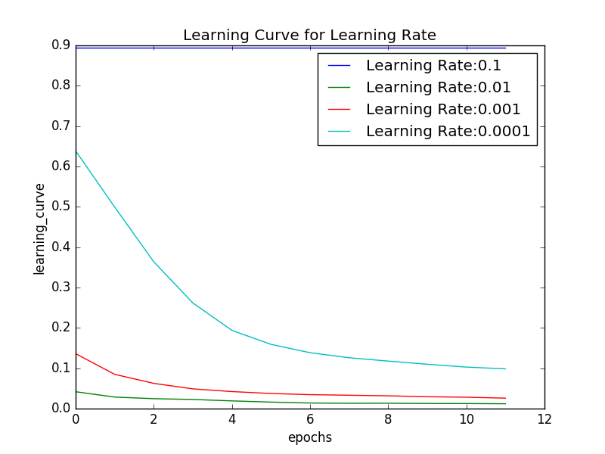
Figure 2, Learning Curves according to different learning rates

We can see that with a learning rate of 0.1, the networks doesn’t learn anything because 0.1 is too big. On the other hand, 0.0001 is too small and it will take much more time to achieve an acceptable accuracy. 0.001 is good but we can see that 0.01 has the best result.

Convolution Type:

In this experiment we are trying out the following filter sizes {1, 3, 5, 7} (the same for height and width) and the results are in Figure 3.
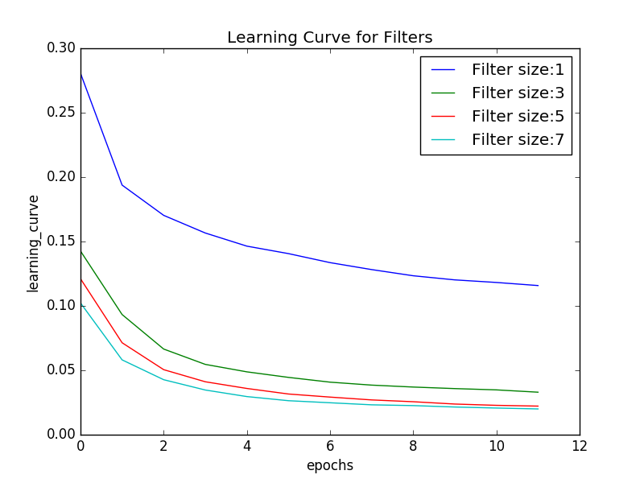
Figure 3, Learning Curves according to different filter size

We can see that the largest filter size gave the best accuracy. With a filter size of size 1, the CNN would work as a normal neural network. And with larger filter the CNN is showing it’s potential.
I think that if we need big amount of pixels to recognize the object then, we need larger filters. However, if the difference between objects is small or found in local features, we should use small filters.
Random Search:

As you can see, setting the hyperparameters correctly makes a huge difference. Unfortunately, the most hyperparameter are not easily transferable across datasets, for instance the optimal learning rate depends on the dataset. Besides the learning rate and the filter sizes, there are more hyperparameters that can be tuned. In the last part of this exercise we will apply random search to
automatically tune the following hyperparameters:
• learning rate ∈ [10 −4 , 10 −1 ]
• batch size ∈ [16, 128]
• number of filters ∈ [2 3 , 2 6 ]
• filter size ∈ {3, 5}
Make sure that you optimize the first three on a logarithmic scale and that
the filter size is a categorical hyperparameter. Run random search for 50 iter-
ations where each function evaluation has a budget of 6 epochs. We will use
the HpBandster (https://github.com/automl/HpBandSter) package for random
search. You can install via ’pip install hpbandster’ .
In order to evaluate the progress of random search, plot the validation per-
formance of the best found configuration after each iteration. Finally, evaluate
the test performance of the best configuration that you found.

