ER Diagram Documentation
This document outlines the entities, attributes, and relationships based on the provided Entity-Relationship (ER) diagram for the system.

1. Entities and Attributes

CUSTOMUSER
Attributes: Id (PK), Password, Last_login, Is_superuser, First_name, Last_name, Email, Is_staff, Is_active, Date_joined, Role, Profile_photo, Is_approved

STUDENT
Attributes: User_id (PK, FK), Semester, Year, Section, Register_number, Dept_id (FK)

TEACHER
Attributes: User_id (PK, FK), Phone, Biometric_id, Max_load_per_week, Designation, Dept_id (FK)

DEPARTMENT
Attributes: Id (PK), Dept_name

SUBJECT
Attributes: Id (PK), Subject_name, Subject_code, Credit_hours, Type, Dept_id (FK)

TEACHER_SUBJECTS_OF_INTEREST
Attributes: Id (PK), Teacher_id (FK), Subject_id (FK)

TIMETABLE
Attributes: Id (PK), Day, Start_time, End_time, Room_number, Section, Subject_id (FK), Teacher_id (FK)

ATTENDANCE_SESSION
Attributes: Id (PK), Subject_code, Subject_name, Section, Faculty_name, Date, Period_index, Time_slot, Created_at, Created_by_id (FK)

ATTENDANCE_RECORD
Attributes: Id (PK), Status, Student_id (FK), Session_id (FK)

LEAVE_REQUEST
Attributes: Id (PK), Start_date, End_date, Reason, Status, Created_at, Teacher_id (FK)

SUBSTITUTE_REQUEST
Attributes: Id (PK), Date, Status, Created_at, Original_teacher_id (FK), Substitute_teacher_id (FK), Timetable_slot_id (FK)

NOTIFICATION
Attributes: Id (PK), Message, Is_read, Notification_type, User_id (FK)

CUSTOMUSER_GROUPS
Attributes: Id (PK), Customuser_id (FK), Group_id (FK)

AUTH_GROUP
Attributes: Id (PK), Name

AUTH_GROUP_PERMISSIONS
Attributes: Id (PK), Group_id (FK), Permission_id (FK)

AUTH_PERMISSION
Attributes: Id (PK), Name, Content_type_id, Codename

2. Relationships
Entity 1 | Entity 2 | Cardinality | Description
CUSTOMUSER | STUDENT | 1 to 1 (IS_A) | A student is a specific type of custom user.
CUSTOMUSER | TEACHER | 1 to 1 (IS_A) | A teacher is a specific type of custom user.
DEPARTMENT | STUDENT | 1 to N | A department can have multiple students.
DEPARTMENT | TEACHER | 1 to N | A department can have multiple teachers.
DEPARTMENT | SUBJECT | 1 to N | A department offers multiple subjects.
TEACHER | TEACHER_SUBJECTS_OF_INTEREST | 1 to N | A teacher can be interested in multiple subjects.
SUBJECT | TEACHER_SUBJECTS_OF_INTEREST | 1 to N | A subject can be of interest to multiple teachers.
TEACHER | TIMETABLE | 1 to N | A teacher can have multiple timetable slots.
SUBJECT | TIMETABLE | 1 to N | A subject can be assigned to multiple timetable slots.
TEACHER | ATTENDANCE_SESSION | 1 to N | A teacher can create multiple attendance sessions.
ATTENDANCE_SESSION | ATTENDANCE_RECORD | 1 to N | An attendance session contains multiple attendance records.
STUDENT | ATTENDANCE_RECORD | 1 to N | A student has multiple attendance records.
TEACHER | LEAVE_REQUEST | 1 to N | A teacher can submit multiple leave requests.
TEACHER | SUBSTITUTE_REQUEST | 1 to N | A teacher can request multiple substitutions.
TIMETABLE | SUBSTITUTE_REQUEST | 1 to N | A timetable slot can have substitute requests.
CUSTOMUSER | NOTIFICATION | 1 to N | A custom user can receive multiple notifications.
CUSTOMUSER | CUSTOMUSER_GROUPS | 1 to N | A user can belong to multiple groups.
AUTH_GROUP | CUSTOMUSER_GROUPS | 1 to N | A group can contain multiple users.
AUTH_GROUP | AUTH_GROUP_PERMISSIONS | 1 to N | A group can have multiple permissions.
AUTH_PERMISSION | AUTH_GROUP_PERMISSIONS | 1 to N | A permission can be assigned to multiple groups.

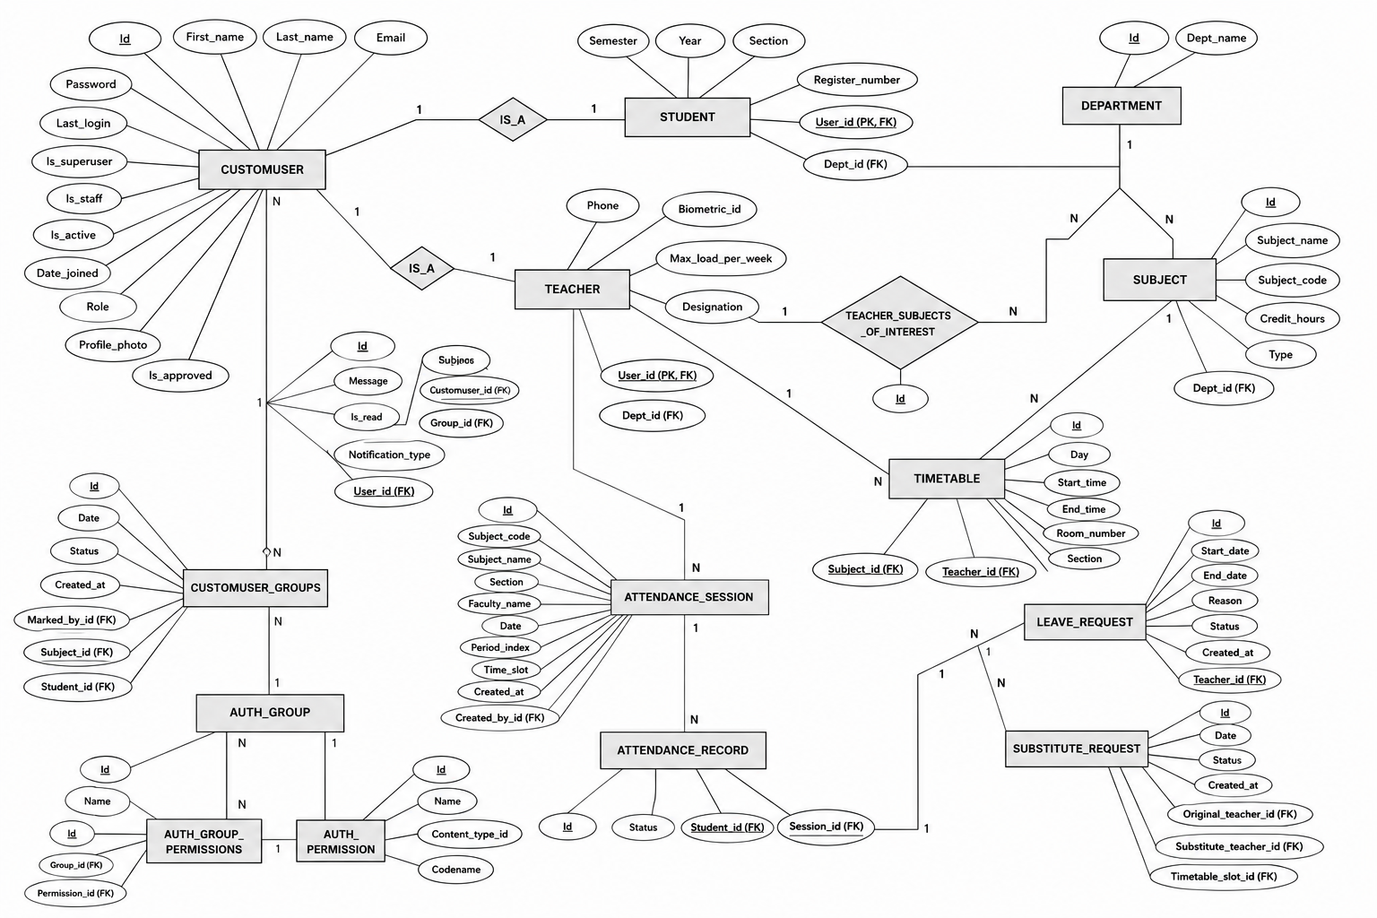
ER Diagram:

