Project MSMe - Comprehensive Administrator Guide

1. Introduction
Welcome to the Administrator User Manual. As an administrator, you hold the highest level of access in the Project MSMe ecosystem. This guide provides a detailed, step-by-step walkthrough of all administrative capabilities, including user management, AI-driven timetable generation, and handling faculty leaves.

2. Accessing the Admin Dashboard
The Admin Dashboard is your central hub for all operations. From here, you can view the health of the system and access all primary modules.
Step 1: Open your browser - Navigate to the web portal login page.
Step 2: Log In - Enter your administrative email and password.
Step 3: Dashboard View - Upon successful authentication, you will be redirected to the main Admin Dashboard.
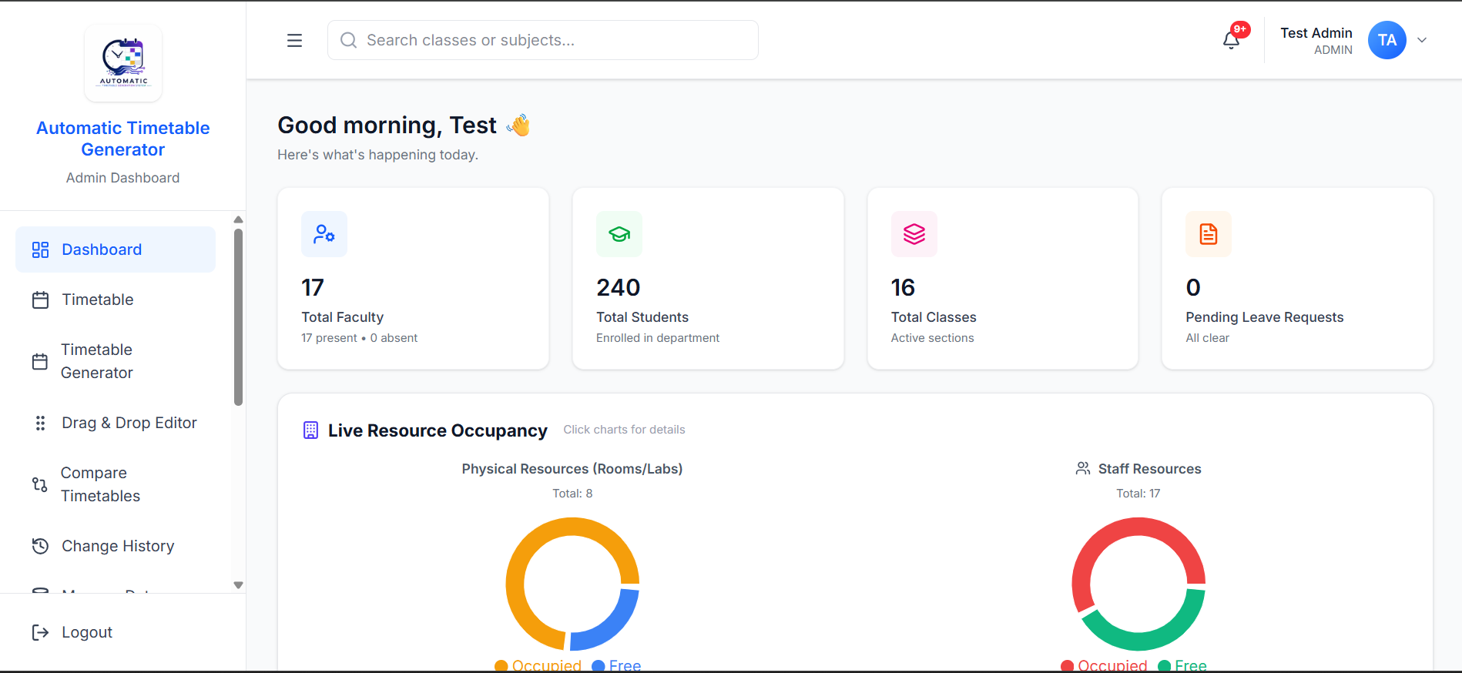

3. Account Management
For security purposes, when a new teacher registers on the platform, their account must be manually approved by an administrator before they can access the system.

3.1 Approving New Teachers
Step 1: Navigate to Users - Click on the "Users" or "Account Management" tab in the left sidebar.
Step 2: Locate Pending Accounts - Look for the section titled "Pending Approvals". This list contains all newly registered accounts.
Step 3: Review Details - Review the teacher's name, department, and email address to verify their identity.
Step 4: Approve Account - Click the green "Approve" button next to their name. The teacher will immediately gain access to the platform.
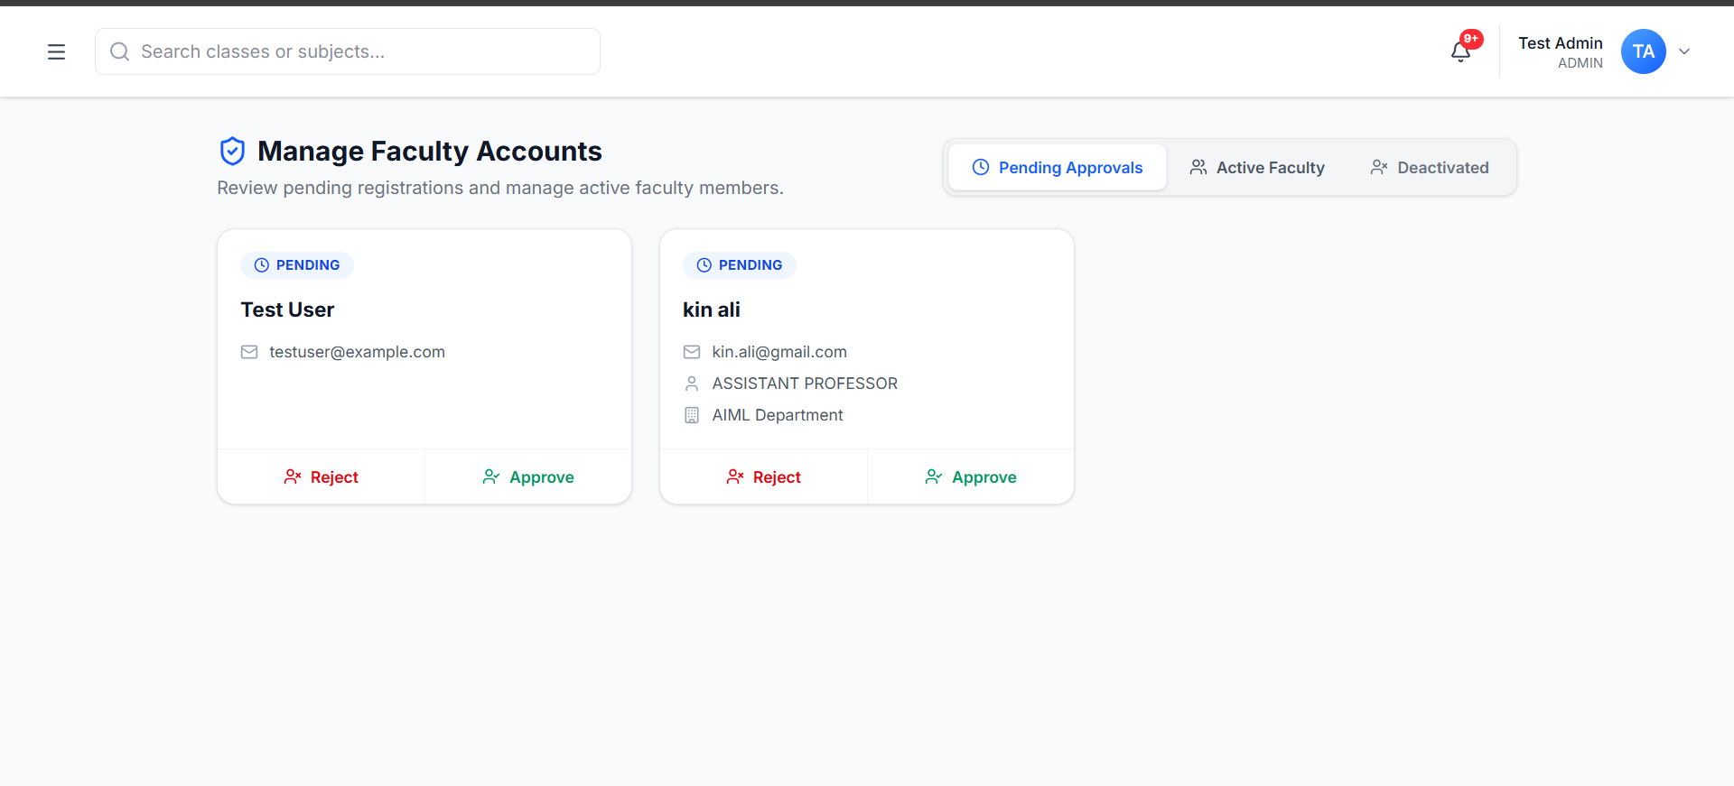

3.2 Managing Active Users
Step 1: View Active Users - Scroll down to the "Active Users" table.
Step 2: Promote Faculty - To promote a teacher to a Head of Department (HOD), click the "Promote to Super Teacher" button. This grants them department-level admin rights.
Step 3: Deactivate Account - To remove access from a teacher who has left the institution, click the red "Deactivate" button. This preserves their historical data but prevents login.
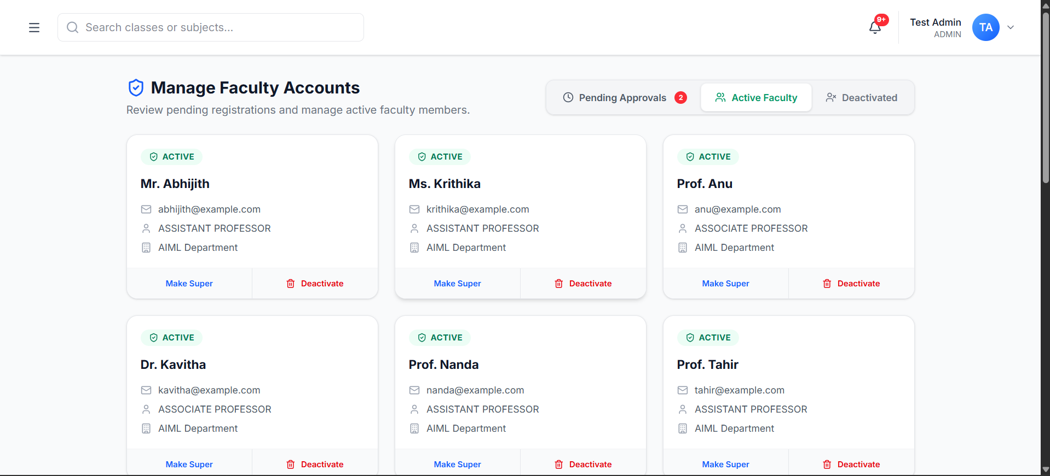
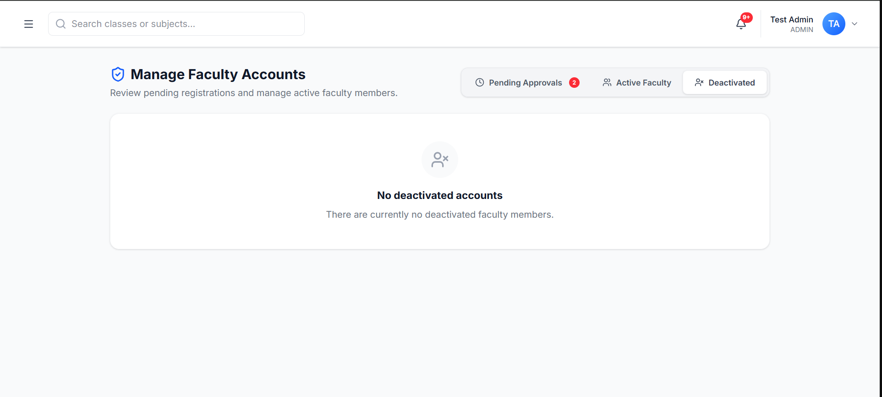

4. AI Timetable Generation
Project MSMe uses a powerful AI model to automatically generate conflict-free schedules for the entire institution based on your natural language constraints.

4.1 Creating a New Timetable
Step 1: Open Generator - Click on "Generate Timetable" in the sidebar.
Step 2: Enter Constraints - In the text box provided, type any specific constraints you have in plain English. For example: "Ensure Mr. Smith has no classes on Friday afternoons because he is on half-day leave." or "Do not schedule consecutive Math classes for Section 3A."
[ 📸 PLACEHOLDER: Please insert screenshot of Timetable Generator screen showing the natural language text box here ]
Step 3: Run AI Solver - Click the "Preview" button. The AI solver will begin processing. Note: This process requires heavy computation and may take up to 2 minutes.
Step 4: Review Preview - Once complete, the system will display a visual grid of the newly generated schedule. Review it to ensure your constraints were met.
[ 📸 PLACEHOLDER: Please insert screenshot of The generated timetable preview grid here ]
Step 5: Publish Timetable - If you are satisfied with the schedule, click "Apply to Live". This will instantly update the schedules for all teachers and students on their dashboards and mobile apps.

5. Leave & Substitution Management
When a teacher applies for leave, the system intelligently calculates the optimal substitute teachers for their classes and handles the assignment automatically.
Step 1: View Leaves - Go to the "Leave Requests" tab.
Step 2: Review Request - Review the pending leave requests, including the dates and reason provided by the teacher.
Step 3: Approve & Trigger AI - Click "Approve". Behind the scenes, the AI will find teachers who are free during those periods and send them a substitution request.
[ 📸 PLACEHOLDER: Please insert screenshot of Leave request table showing the Approve button here ]

