Fall Community Open House plan
To: Dr. Helen Marsh, President
From: Dana Whitcombe, Executive Director, Office of Communications
Prepared by: Jordan Lee, Executive Assistant
Date: October 1, 2026

Purpose
This memo sets out the plan for the Fall Community Open House on Saturday, November 14, 2026, and asks for your approval of the schedule below.
Schedule
Doors open at 9:00 a.m. Each department hosts a table in the Student Center, and campus tours leave from the main entrance every half hour.
Time | Event | Location
9:00 a.m. | Welcome from the President | Student Center
9:30 a.m. | Department tables open | Student Center
10:00 a.m. | Campus tours begin | Main entrance
12:00 p.m. | Closing and lunch | Library lawn

RSVPs so far
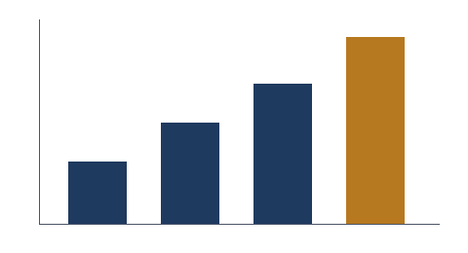
RSVPs have tripled since the first week, to 120. We expect about 200 guests.
RSVP deadline: Friday, November 6, 2026.

