## General

* If some aspect of a process has not been included in the instructions, use values appropriate for your context or defaults.
* Assume case sensitivity. Consistent case following conventions is a good habit.

## Create a new project

1. Launch Visual Studio
   1. If Visual Studio is already running, File - New – Project.
2. Click “Create a new project”.
3. 
4. Select “Asp.Net Web Core Application”. Click “Next”
5. 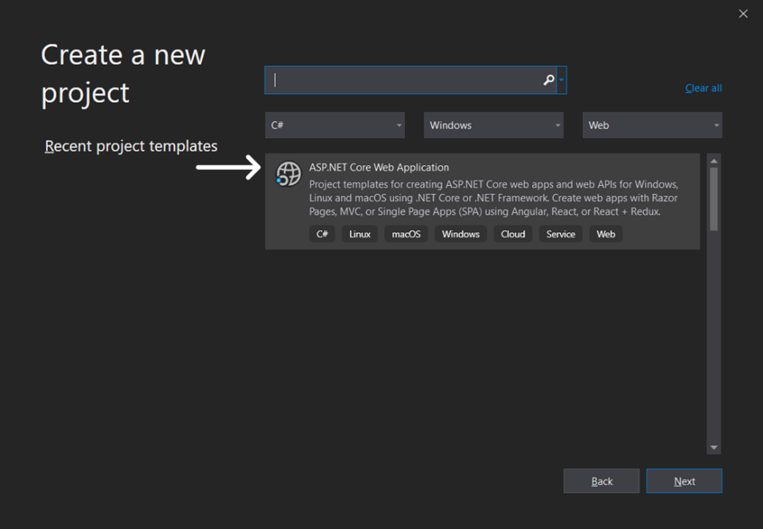
6. Select “Project Name”, enter “WebApplication”. Select “Location”, enter a location that is best for your preferences. Click “Create”.
   1. Do not enter a space between “Web” and “Application”.
   2. Capitalize “W” in “Web”. Capitalize “A” in “Application”.
7. 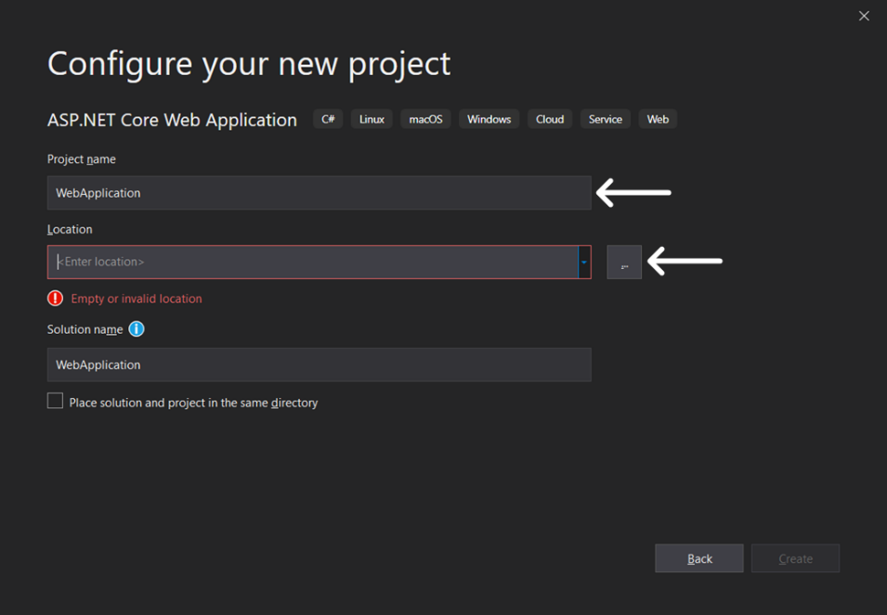
8. Select the “Web Application (Model-View-Controller). Under “Authentication”, click “Change”.
9. 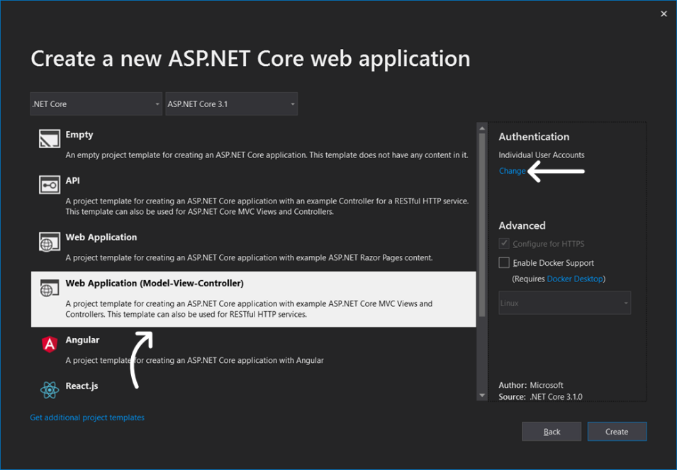
10. Select “Individual User Accounts”. Select “Store user accounts in-app”. Click “OK”.
11. 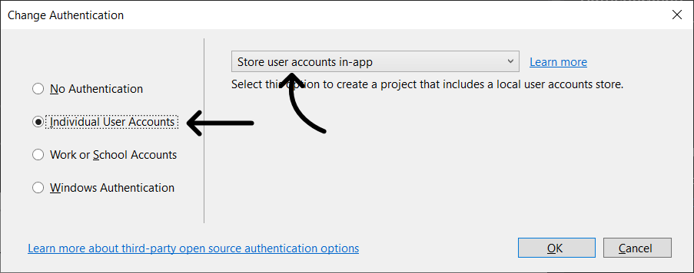
12. Click “Create”.
13. 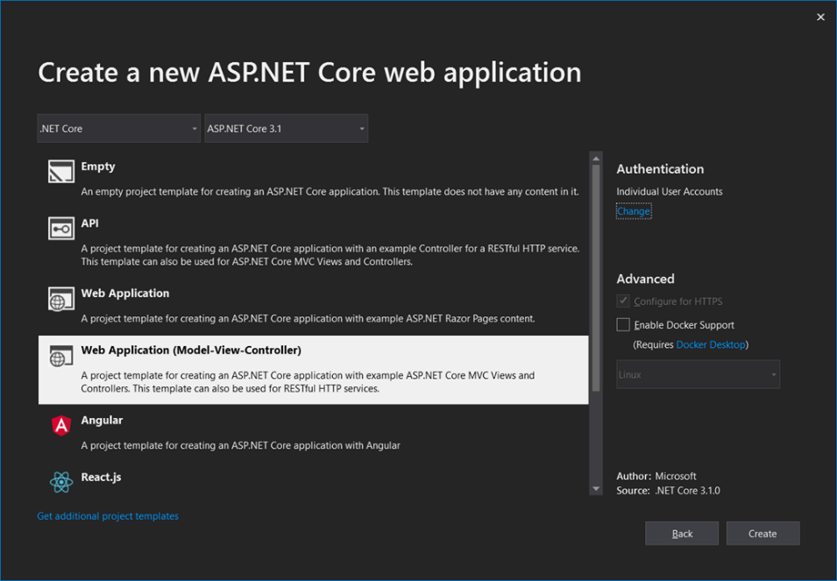
14. Enjoy!
15. 