KISHOR KUMAR KRISHNA  DATA SCIENTIST | AGENTIC AI SYSTEMS | BUSINESS INTELLIGENCE & ANALYTICS  New Delhi, India • 8130075849 • kishorkrishna123@gmail.com  linkedin.com/in/kishor-kumar-krishna • github.com/Kindkrishna | 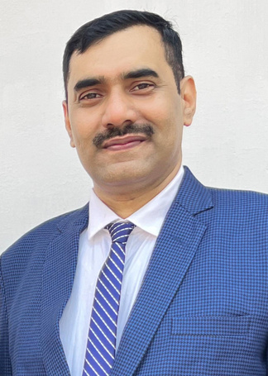

PROFILE
As a Border Security Force Soldier since 2002 and a postgraduate in Data Science & AI from IIIT-Bangalore, I bring a rare combination of disciplined leadership and applied technical expertise. My career in the BSF has sharpened my strategic planning, decision-making, and team management abilities, while my academic and professional development in data science has built strong analytical, statistical, and programming skills.

Data professional with a Post Graduate degree in Data Science & AI (IIIT Bangalore) and 20+ years of leadership experience in large-scale operations. Skilled in Python, machine learning, statistical modelling, and BI tools (Power BI, Tableau), with hands-on experience building Agentic AI systems — multi-agent architectures, RAG pipelines, and Model Context Protocol (MCP) integrations. Proven track record managing multi-crore budgets, cross-functional teams, and data-driven reporting systems at national scale. Strong problem-solver with a track record of translating complex data into actionable, high-impact decisions.
CORE SKILLS
Agentic AI Systems • Multi-Agent Architectures • Model Context Protocol (MCP) • RAG (Retrieval-Augmented Generation) • Python (OOP, Async, APIs) • Machine Learning & AI • Statistical Modeling • Data Analysis & Visualization • SQL / MySQL • Power BI • Tableau • AWS • Microsoft Excel • Budget & Program Management • Leadership & Team Management • Strategic Planning & Decision-Making
PROFESSIONAL EXPERIENCE
Soldier, Border Security Force (Ministry of Home Affairs, India) Jan 2002 – Present
• Handled performance data of 1000+ athletes across 30 sports and oversaw ₹25 crore sports equipment procurement; built systems for efficient data handling, reporting, and performance monitoring.
• Key member of the Sports Authority of India's ₹30 crore national initiative "Sports for Peace and Development in the Nation" — managed complete budget monitoring and execution of sports events for border-domain youth.
• Administered and maintained departmental IT infrastructure, including servers, networking systems, and data security.
• Applied data-driven insights to tackle complex operational challenges, demonstrating strong leadership, discipline, adaptability, and cross-functional collaboration.
PROJECTS
Lead Scoring Case Study — X Education (EdTech)
Improved lead conversion from 30% to ~75% by building a logistic regression model (85% accuracy, AUC-ROC 0.88) to score 9,000+ leads and identify hot prospects. Tools: Python, Pandas, NumPy, Scikit-learn, Matplotlib, Seaborn, Jupyter Notebook.
EDUCATION & CERTIFICATIONS
Post Graduate Diploma, Data Science & AI — IIIT Bangalore 2024 – 2025
GPA: 3.5 / 4.0
Agentic AI Systems — IIT Madras (in collaboration with Intellipaat) 2026 – Present
Multi-Agent Systems, RAG, Model Context Protocol (MCP), AI Agents on Microsoft Azure, Capstone Project — Ongoing
B.Com, Accounting — Lalit Narayan Mithila University (LNMU), Darbhanga 1998 – 2002
AWARDS & HONORS
• Director General, BSF — Commendation Roll & Cash Reward for outstanding performance (Awarded Twice, 2025)
• Inspector General, BSF — Commendation Card for outstanding performance (Awarded Five Times, 2025)
LANGUAGES
English — Professional Working Proficiency • Hindi — Native

