Issouf kindo

CS7050

Project 00

1. Seed clusters have to be well chosen to avoid having empty clusters.
2. There is not wrong answered since both method will result in I, j and k in the same cluster, but an optimal solution would be assigning them a the same time
3. I iterated through the constrains and if the length is 2 I assign the label of the first id to the second
4. Run results:
5. constraints  
   A screenshot of a computer

   Description automatically generated with low confidence

1000

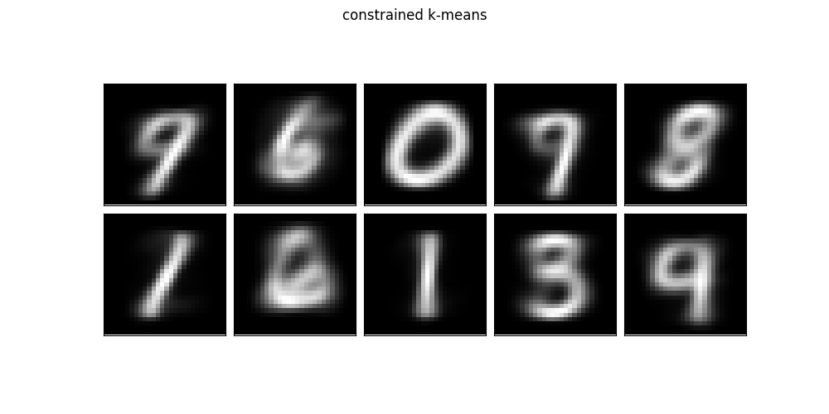10000

100000

1. Roughly 55,000 since that is the total number of data points in the dataset. In this algorithm it is not guaranteed since the must links are selected randomly.