1

Introductions

to kinect:

* Understand Kinect Device :

Welcome to the world of motion computing with Kinect, Kinect is motion-sensing device which was originally developed for Xbox 360 gaming development, this device stand out among others because is not hand-controlled device, but rather detects your body position, motion, and voice. Wonder Kinect holds the Guinness World Record for being the “fastest selling consumer electronics device”. On of the key selling points of the Kinect was the idea of “hands-free control” with virtual reality world, it provide a Natural User Interface (NUI) for interaction with body motion and gesture.

It has now outgrown its Xbox roots and the Kinect sensor is no longer limited to only gamming. Kinect for windows is specially designed for helping developers to write their own code and develop real life application with human gesture, body motion, voice recorder, and others.

Microsoft attached some of Tools and studio that help developer to interact with feature in Kinect like Software Development Kit (SDK).

* Component of Kinect for Windows:

Kinect is horizontal device with depth sensor, color camera, and set of microphones inside small flat box key components:

* Color Camera
* Infrared emitter
* IR depth sensor
* Tilt motor
* Microphone array
* LED

1. **The color camera**

This color camera is responsible for capturing and streaming the color video data. The Kinect color stream supports a speed of 30 **frames per second** (**FPS**) at a resolution of 640 x 480 pixels, and a maximum resolution of 1280 x 960 pixels at up to 12 FPS. The value of frames per second can vary depending on the resolution used for the image frame.

1. **IR emitter and IR depth sensor**

Kinect depth sensors consist of an IR emitter and an IR depth sensor. Both of them work together to make things happen. This emits infrared light in a pseudo-random dot" pattern over everything in front of it. IR depth sensor reads them from the objects and converts them into depth information by measuring the distance between the sensor and the object from where the IR dot was read.

1. **Tilt motor**

The base and body part of the sensor are connected by a tiny motor. It is used to change the camera and sensor's angles, to get the correct position of the human skeleton within the room. You can adapt it using Kinect toolkit studio

1. **Microphone array**

The Kinect device exhibits great support for audio with the help of a microphone array. The microphone array consists of four different microphones that are placed in a linear order

1. **LED**

An LED is placed in between the camera and the IR projector. It is used for indicating the status of the Kinect device. The green color of the LED indicates that the Kinect device drivers have loaded properly

* **Kinect for Windows versus Kinect for**

**Xbox**

Although "Kinect for Windows" and "Kinect for Xbox" are similar in many respects, Kinect for Windows is primarily a developing device and not for gaming purposes. Unless you can develop applications that use either the Kinect for Windows sensor or the Kinect for Xbox sensor. The Kinect for Xbox sensor was built to track players that are up to 12 feet (4.0 meters) away from the sensor. But it fails to track objects that are very close (80 cm) that mean it not support Near Mode, manually by code can enables Near Modetracking. You should have USB cable to connect Kinect on your PC to begin develop and run applications

* **Where can you use Kinect**

By now it has already use Kinect Xbox for virtual games, and behind it new opportunity for the developer to build a wide range of applications using Kinect Windows

These can include:

* Capturing real-time video using the color sensor
* Tracking a human body and then responding to its movements and gestures as a natural user interface (our project concept)
* Measuring the distances of objects and responding
* Analyzing 3D data and making a 3D model and measurement
* Generating a depth map of the objects tracked
* Recognizing a human voice and developing hands-free applications that can be controlled by voice
* **SDK and the Developer Toolkit**

Microsoft support for Kinect windows developer tools to control with features in kinect, like Kinect studio to check all feature. Toolkit contain some beginning project with C/C# programming language with implemented library run and get source code of them like face detection, voice API , Camera, Depth, and Skeleton stream. You can run any project on Visual studio 2010 or higher version with install SDK of Kinect

* **Features of the Kinect for Windows SDK**

The Kinect SDK provides a library to directly interact with the camera sensors, the microphone array, and the motor. We can even extend an application for gesture recognition using our body motion, and also enable an application with the capability of speech recognition. The following is the list of operations that you can perform with Kinect SDK.

• Capturing and processing the color image data stream

• Processing the depth image data stream

• Capturing the infrared stream

• Tracking human skeleton and joint movements

• Human gesture recognition

• Capturing the audio stream

• Enabling speech recognition

2

Gersture Reconation Structure

* Introduction

**Gesture recognition** is one of the hallmarks of the Kinect. The amount of research that has gone into the development of gesture technology. **Gestures***,* in terms can be described as actions that convey a message. This simple action could be a waving of the hands, moving of wrists, gesture recognition. Gesture recognition relies on of mathematical algorithms and skeleton tracking to recognize and classify the gestures, when we talk about a natural user interface, gesture recognition is the primary thing that comes to minds

* **Approaches for gesture recognition**

The approaches can be varied depending upon the gestures you choose and how you are applying them to your application

• **Rule based approach**

1. Basic gesture recognition

Basic gesture detection depends on some pre-defined set of conditions known as the **result set**. If the performed action is matched with the result set, we can say that the user has performed a certain gesture



1. Algorithmic gesture recognition

The algorithmic approach uses a set of predefined conditions

and parameters to detect and validate a gesture against each of them. With the algorithmic approach, we basically validate a gesture as it is being performed, by ensuring the start points, constraints, parameters, and the end points are always valid.

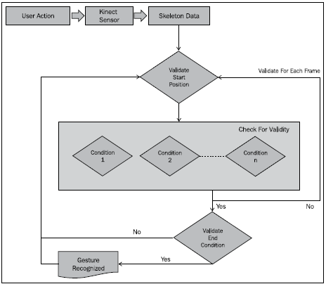

**• Pattern approach**  
 is one of the advanced approaches in gesture detection are not straightforward it provide some calculations and training data for types of gesture that can say to what degree the users are performing the exercise correctly, rather than just saying yes or no. In technical terms, we need a flexible data structure representation that can calculate the probabilities and can reach a decision based on the user's inputs. One of the best approaches to solve this kind of problem is a **Neural network or Hidden Markov Model techniques.**