JIRA Checker — Architecture & Structure
QA Test Center GUI — proof-of-concept tab, built 2026-09-14, updated same day with live Confluence retrieval
Prepared by: Reeve, with Claude Code (QA Test Center project) • Status: Working POC, verified live end-to-end (interpretation + not-ready/Hold path); Check→Commit not yet exercised on a real ticket

This document describes how the “JIRA Checker” tab works: what problem it solves, how a Jira ticket turns into an automated check, which files were added or changed, the exact request/response contract of each endpoint, the design rules it deliberately follows (and why), and what is explicitly out of scope for this first version.

1. Purpose
JIRA Checker is a new tab inside the existing QA Test Center GUI. Given a Jira ticket key, it: reads and interprets the ticket, decides whether it's actually ready to be checked, runs a real automated check when it is, shows the drafted Jira comment for human review, and only then — on an explicit click — posts that comment and moves the ticket forward (or places it On Hold if the ticket wasn't ready in the first place).
It is one part of a larger team initiative: merging separate QA automation projects (this GUI, a Jira-ticket-interpreting agent, and a CMS-automation project) into a single tool ahead of this year's AI-themed hackathon, and as a lasting replacement for manual on-demand ticket checking.

Design principle: reuse, don't regenerate
Rather than have AI write new Playwright test code for every ticket — unreviewed, untrusted, and against this project's own coding standards — JIRA Checker maps each ticket to one of a small, fixed, already-reviewed set of Playwright spec files. AI's job is interpretation (which existing test applies, and what to check), never code generation.

2. Flow Diagram
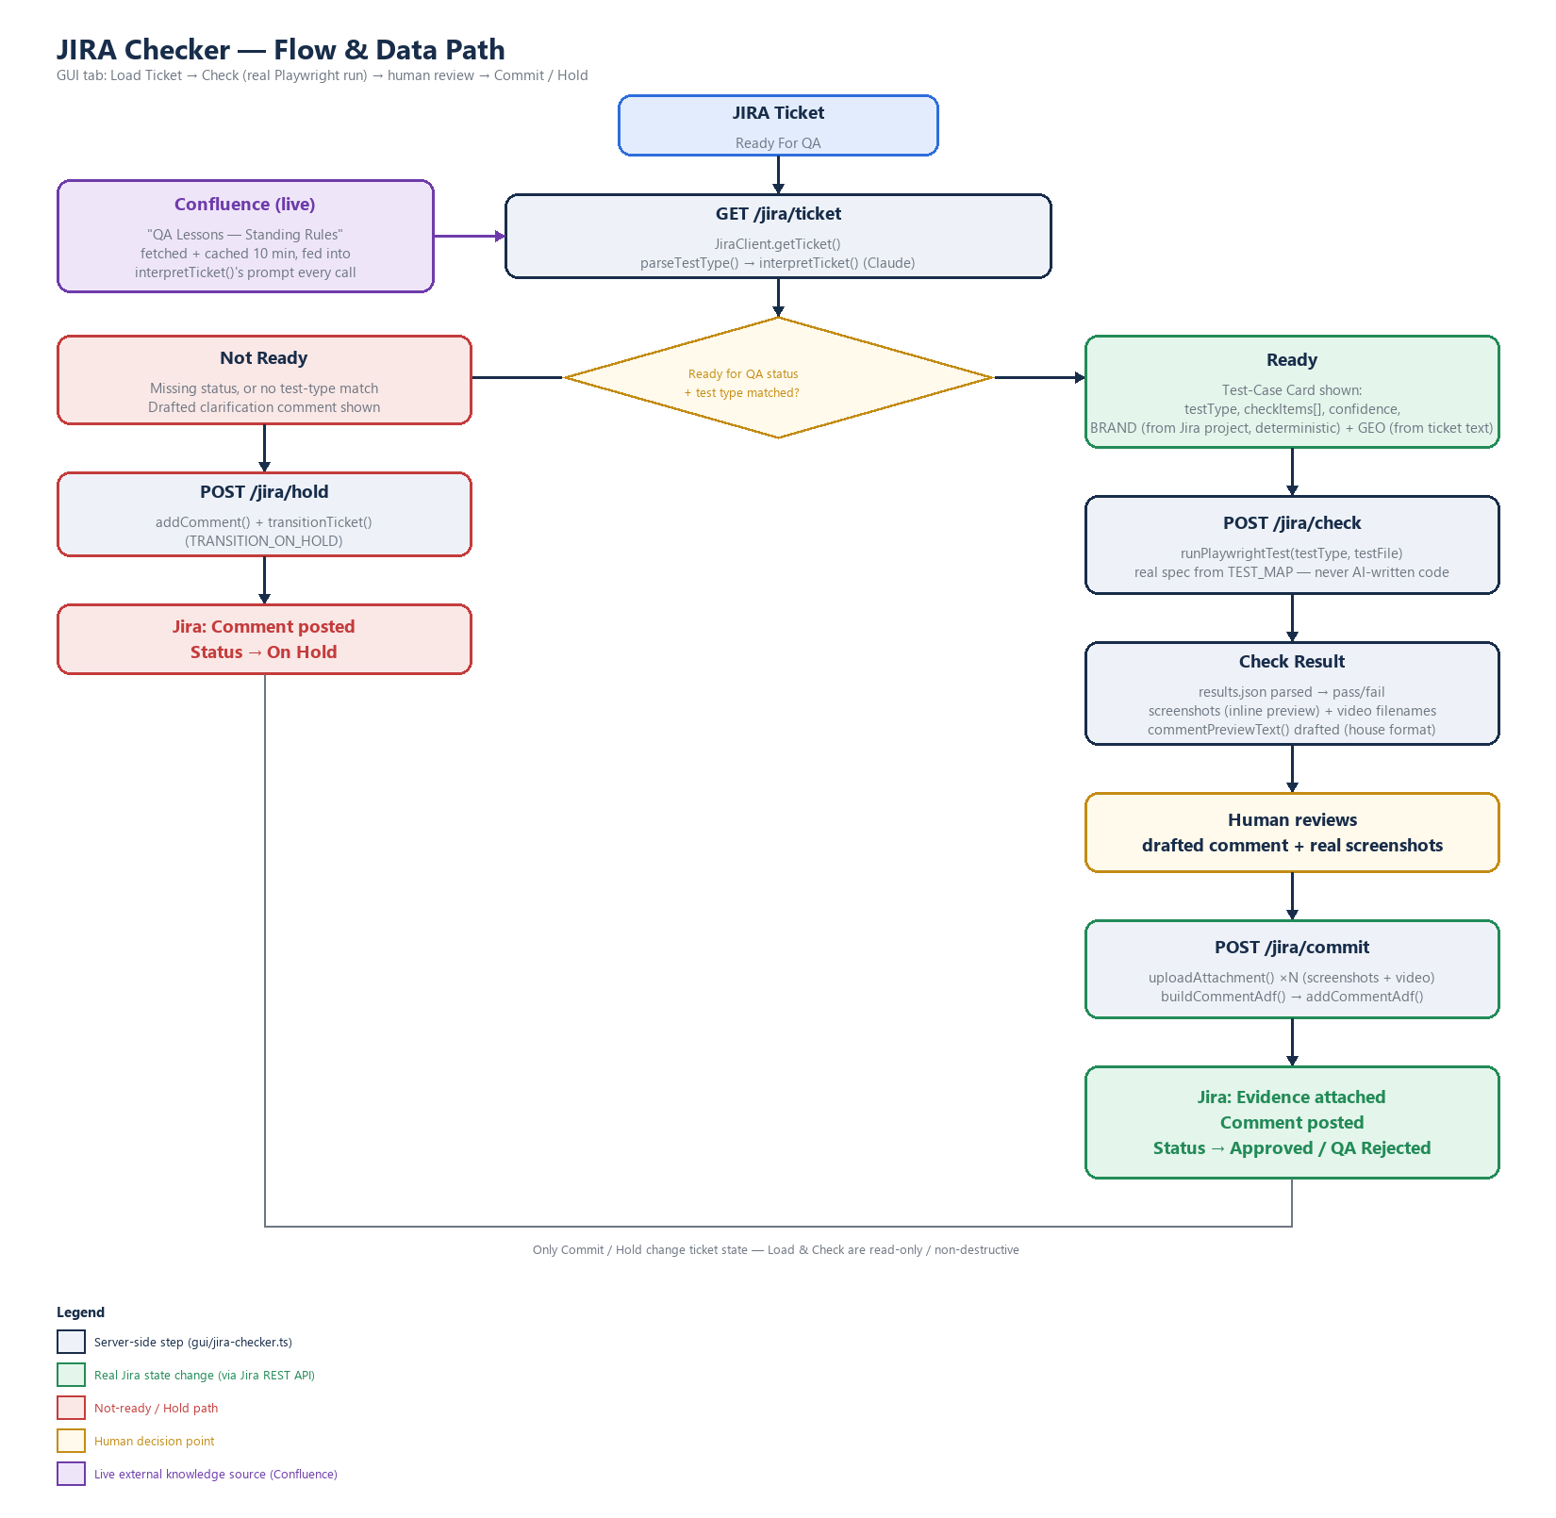
Figure 1 — JIRA Checker request flow. Blue = read/interpret, amber = human decision point, green = a real Jira state change, red = the not-ready/hold path, purple = a live external knowledge source (Confluence).

2.1 Live Confluence Retrieval — The Knowledge Supplier
This is the newest piece, added the same day as the initial build. The working mental model for the whole consolidation effort:
the GUI is the factory that operates; Confluence is the supplier that provides knowledge and skill.
Before this was wired in, the house comment format and QA judgement calls baked into JIRA Checker were a one-time, hand-copied snapshot of what Confluence said when it was written — accurate at the time, but frozen. If Reyn corrected a rule on Confluence tomorrow, JIRA Checker would have no way of knowing.

How it works
- src/confluence-client.ts fetches a Confluence page's body live via the real Confluence REST API (/wiki/rest/api/content/{id}), reusing the same JIRA_EMAIL/JIRA_API_TOKEN credentials JiraClient already uses — an Atlassian API token is account-wide, not product-specific, so no new credential was needed.
- The fetched HTML (Confluence's "storage" format) is stripped down to plain text — good enough for an AI prompt, not meant to preserve exact visual formatting.
- Results are cached in memory for 10 minutes. A normal batch of ticket checks doesn't re-hit Confluence on every single ticket, but a page edit is live again within 10 minutes — no code change, no redeploy.
- It fails soft: any fetch error (network, permissions, Confluence downtime) logs a warning and returns the last good cached copy if one exists, otherwise null — a Confluence outage never blocks a Jira ticket check, it just runs that one time without the extra context.
- src/ticket-interpreter.ts's interpretTicket() — the same function both the CLI agent and JIRA Checker call — now fetches "QA Lessons — Standing Rules" (Confluence page 282001429, space QKB) on every interpretation call and appends it to Claude's system prompt as authoritative, current context, ahead of the check-items/confidence judgement.
Net effect, verified live 2026-09-14: a real fetch against the real Confluence page returned its full text (8,019 characters), and a real ticket interpretation call completed successfully with that context included — with zero warnings logged, confirming the fetch is silently succeeding on the real path, not just in isolation.
Scope note: only the Standing Rules page is wired in so far. The Jira comment template itself (Pre-Checked/Post-Checked structure in src/jira-comment.ts) is still hand-coded, informed by both the Standing Rules and Reporting Protocols pages as they were at the time of writing — not fetched live. Making the comment template itself dynamically follow Confluence is a larger, separate piece of work (see the accompanying missing-reference-files report's §6 for how the still-missing jira-comment-format.md file relates to this).

3. Step-by-Step Flow

3.1 Load Ticket — GET /jira/ticket
Triggered when the user types a ticket key and clicks “Load Ticket.”
- JiraClient.getTicket(key) fetches the ticket from the real Jira REST API (v3), using credentials already configured in .env (JIRA_EMAIL, JIRA_API_TOKEN, JIRA_BASE_URL).
- Readiness gate, step one: the ticket's status must be “Ready For QA.” Anything else (Closed, In Progress, etc.) returns ready: false immediately, with a plain-English reason — no further processing happens.
- Readiness gate, step two — test type detection, in order:
- Keyword match: a literal “Test Type: login” line in the description (no AI call needed).
- AI fallback: interpretTicket() sends the summary + description to Claude, which returns a testType matched against a fixed list of 25 supported types, 2–5 checkItems describing what will be verified, a confidence rating, and any extracted params (brand, GEO, tracking tag IDs).
- If no test type can be determined, or no QA URL is configured for the extracted brand/GEO, the ticket is marked not ready but holdable, and a clarification comment is drafted server-side for the user to review.
- If everything matches, the response includes the matched testType, its testFile, the checkItems, confidence, and params — this is what renders as the Test-Case Card.

3.2 Check — POST /jira/check
Triggered by clicking “Check” on a ready ticket's card. Nothing in Jira changes yet.
- Brand/GEO params (if present) resolve to a QA URL via helpers/brand-urls.ts and are injected into the environment the same way the existing CLI agent does it.
- runPlaywrightTest(testType, testFile) actually spawns npx playwright test <file> — a real browser run against the real QA site, not a simulated or AI-guessed result.
- Playwright's own results.json is parsed for pass/fail counts, error messages, and any captured screenshots.
- commentPreviewText() renders the exact house-style comment (Pre-Checked / Scope Checked / Overall Result / etc.) as plain text for on-screen review — no attachments yet, since screenshots are only uploaded at Commit time.
- The full result is cached server-side, keyed by ticket key, so Commit doesn't need to re-run the test or have the client round-trip local screenshot file paths.

3.3 Commit — POST /jira/commit (ready path)
The only button on the ready path that changes Jira state. Requires a prior, matching Check result.
- Transition the ticket to “In Review.”
- Upload each captured screenshot as a real Jira attachment (jira.uploadAttachment).
- Build the final ADF (Atlassian Document Format) comment — same builder used by Check's preview, now with real attachment thumbnails embedded — and post it.
- Transition the ticket to “Approved” (pass) or “QA Rejected” (fail), based on the real test result.
- Any failure along the way (e.g. comment posted but transition failed) is reported back explicitly as a warning — it never silently claims success.

3.4 Hold — POST /jira/hold (not-ready path)
The equivalent “Commit” action when a ticket wasn't ready to check.
- Posts the drafted clarification comment as-is (or as edited, in a future version) to the ticket.
- Transitions the ticket to “On Hold.”

4. Files Added / Changed
File | Change | Why
src/confluence-client.ts | New | Live Confluence page fetcher — reuses JiraClient's own credentials, 10-minute cache, fails soft. See §2.1.
src/ticket-interpreter.ts | Changed | interpretTicket() now fetches the Standing Rules page live and appends it to Claude's system prompt; BRAND is no longer extracted by AI (see §5's params rules).
src/jira-comment.ts | New | Extracted the ADF comment builder out of src/agent.ts so the CLI and the new GUI tab share one implementation instead of two copies that could drift apart. Also adds phase-aware (pre/post-check) wording and video-link rendering.
src/agent.ts | Changed | Now imports buildCommentAdf from jira-comment.ts instead of defining it locally. CLI behavior is unchanged.
src/jira-client.ts | Changed | JiraTicket now carries the real projectKey field from Jira's own API response, not a guess from the ticket key string.
src/test-runner.ts | Changed | TestRunResult now also collects videoPaths (previously only screenshotPaths — video attachments were silently dropped).
helpers/brand-urls.ts | Changed | Added resolveBrandFromProjectKey() — deterministic Jira-project-to-brand mapping, confirmed against the live Jira project list (two overrides: ICE36→I36, LP1→LP).
gui/jira-checker.ts | New | The five Express routes described in §3 (including /jira/check/cancel), pre/post-check phase detection, deterministic BRAND resolution, and the in-memory Check→Commit session cache.
gui/server.ts | Changed | Registers the new routes; added express.json() body parsing (previously only multipart/form-data was handled).
gui/public/index.html | Changed | New “JIRA Checker” tab button and panel markup (ticket card, test-case card, result card with evidence gallery, outcome card).
gui/public/app.js | Changed | New self-contained jiraChecker() block wiring the tab's buttons to the endpoints, including inline screenshot rendering and a Cancel handler.
gui/public/styles.css | Changed | New .comment-preview, .evidence-gallery, and .video-note styles.

Reused as-is (already existed before this POC)
- src/jira-client.ts — Jira REST API wrapper (fetch ticket, transition, comment, upload attachment).
- src/ticket-interpreter.ts — Claude-based test-type + check-item interpretation.
- src/requirements-parser.ts — keyword-based Test Type: line parsing.
- src/test-runner.ts — the TEST_MAP of 25 test types to spec files, and the Playwright process runner.
- helpers/brand-urls.ts — brand/GEO → QA URL resolution.

5. Endpoint Reference

GET /jira/ticket?key=<KEY-or-full-ticket-URL>
Accepts either a bare key ("SC-963") or a pasted browser URL ("https://prime-online.atlassian.net/browse/SC-963") — extractIssueKey() parses either form.
Response (ready):
{ key, summary, status, priority, ready: true,
phase: "pre-check"|"post-check",
testType, testFile, checkItems: string[],
confidence: "high"|"low",
params: { BRAND, GEO, ... } }
Response (not ready):
{ key, summary, status, priority, ready: false,
holdable: boolean, reason: string,
clarificationComment?: string }
phase is "pre-check" for status "Ready For QA", or "post-check" for "Production QA"/"Approved" — anything else is not ready. BRAND always comes from resolveBrandFromProjectKey(ticket.projectKey), never from AI.

POST /jira/check
Body: { key, phase, testType, testFile, checkItems, params }
Response:
{ success, passed, failed, skipped, durationMs,
errors: string[],
screenshots: { filename, dataUri }[],
videoFilenames: string[],
preview: string }
screenshots are returned as real inline base64 images (read straight from the local test-results folder) so the GUI's preview shows exactly what Commit will post — not just a count.

POST /jira/check/cancel
Body: { key }
Response: { cancelled: true }
Discards a pending Check result server-side without posting anything — backs the Cancel button on the result card.

POST /jira/commit
Body: { key }
Response:
{ committed: true,
status: "Approved"|"QA Rejected"|"Closed",
warnings: string[] }
Pre-check ends in Approved/QA Rejected; post-check always ends in Closed (per Reporting Protocol §5.3/§5.4) — a failed post-check adds a warning that a new defect ticket should be filed separately, since that's not yet automated.

POST /jira/hold
Body: { key, comment }
Response: { held: true }

6. Design Rules Baked In (and why)
- Only Commit and Hold change Jira state. Matches the standing rule already documented in the JIRA QA Helper knowledge base: commenting can happen freely, but any status transition, field edit, or ticket creation needs an explicit per-action human confirmation, every time — no standing approval.
- Check runs a real, existing spec — never AI-generated test code. AI interpretation only selects which of 25 already-reviewed Playwright specs applies. This avoids the exact failure mode the team already learned from: LLM-based judgment (e.g. the 2026-08-26 crawl) is useful for scoping but not defensible as audit evidence on its own.
- A ticket that isn't ready never gets test cases guessed for it. The status + test-type gate mirrors the Reporting Protocol's own Pre-Check Readiness Checklist — an untestable ticket gets a clarification request, not a best-effort check.
- The drafted comment always uses the house format. commentPreviewText() and buildCommentAdf() render the same Pre-Checked / Scope Checked / Overall Result structure already standardized in the QA Reporting Protocols and QA Lessons pages, so JIRA Checker output reads identically to a human-written comment.
- Human reviews the drafted comment before it's ever posted. The Check step never talks to Jira — it only returns a preview. This preserves the “draft it, show it, then post” rule already established for comments, while still gating the higher-risk status transition behind its own explicit Commit click.

7. Explicitly Out of Scope for This POC
- Bulk mode — checking every ticket under a release/fixVersion URL in one pass. The current tab handles one ticket at a time.
- Automatable-vs-manual tagging within a single ticket's check items. Some check items (VPN/GEO-dependent behavior, Figma visual comparison, mobile-viewport toggling, category-correctness judgment calls) are documented team-wide as manual-only — this POC doesn't yet split a ticket's checklist into automated vs. human-confirmed lines.
- Generating a new permanent regression spec from a one-off ticket check. Today's Check only exercises an existing spec; turning a valuable one-off check into a saved, reusable spec is a deliberately separate, judgment-gated action for a later version.
- Full-page screenshot capture. Playwright's screenshot: 'on' config captures only the current viewport at test-end, not the full scrollable page — confirmed as the reason a real check on a live ticket (LP1-445) only showed page header, not body content. Fixable with a one-line global config change, but that affects the whole regression suite's evidence size, not just JIRA Checker — deliberately left for a separate decision rather than changed silently.
- Wiring gui/visual-compare.ts's existing AI-vision comparison (site-vs-site / asset-vs-site) into JIRA Checker. Some tickets (e.g. LP1-445, a QA-vs-Production content/translation mismatch) need this instead of a structural Playwright spec — matching them to the nearest-named spec instead produces a check that verifies the wrong thing. Not yet wired in.
- True Figma-link resolution. A ticket's own attached mockup image can already be checked via the existing Visual Check tab manually; pulling directly from a Figma smart-link in ticket text would need a Figma API token and new integration work.
- Live Confluence retrieval for the other three missing reference files (test-case-standard.md, jira-comment-format.md, verification-techniques.md) — only Standing Rules is wired in so far (see §2.1); those three aren't recoverable from Confluence at all yet (see the companion missing-reference-files report).
- Any UI polish beyond bare functionality — cards, not a true modal; alerts, not toasts. Matches this project's established practice of proving functionality first and doing a design pass later.

8. What Has Been Verified Live
Tested against the real Jira instance (prime-online.atlassian.net) and the real Confluence knowledge base on 2026-09-14:
- SC-1 (nonexistent key) → clean 404 handling.
- SC-941, SNG-1457 (real, Closed tickets) → correctly blocked with a “not Ready” reason.
- SC-963 (real, “Approved” ticket) → confirmed AI genuinely reads full ticket content, including the “For QA” checklist, even when it correctly can't match a test type (App Install Toaster has no automated spec) — checkItems were specific and accurate, not generic.
- SNG-1361 (real, “Ready For QA” ticket, content-only ticket with no matching test type) → status/phase gate passed, AI interpretation correctly found no match, returned a working drafted clarification comment naming only GEO (not brand, since BRAND is now resolved deterministically) — the full “ask for clarification, then Hold” path, proven against a live ticket.
- MC-1257 (real, “Approved” ticket, “MC AB: Contact us page”) → resolved ready: true, phase: "post-check", testType "contact us", BRAND="MC" (from the Jira project, not guessed), GEO="AB" (from ticket text) — proves the full brand/GEO/phase pipeline end to end.
- Live Confluence fetch (page 282001429, “QA Lessons — Standing Rules”) → returned 8,019 real characters on a direct test, and a subsequent real ticket-interpretation call completed with zero warnings logged, confirming the fetch succeeds silently on the actual code path (not just in isolation).
Not yet exercised: a full Check → Commit cycle against a real ticket, since that would actually run a live Playwright test, upload a real attachment, and post/transition a real ticket. This needs a ticket whose description matches one of the 25 supported test types, picked deliberately rather than at random.

