Can We Run Our Automated Test Scripts on BrowserStack?
Findings from our BrowserStack meeting — prepared for leadership review
Date: September 17, 2026
Prepared by: Reeve, QA

Bottom Line
Not yet. Our BrowserStack account is missing the one specific add-on that runs our automated test scripts. This has nothing to do with location/country testing, and it is not something “connecting Claude via MCP” can work around — the add-on simply isn’t on the account yet.

What We Were Trying to Do
During our meeting with BrowserStack, a developer mentioned we could connect our AI assistant (Claude) to BrowserStack using something called “MCP,” and asked whether that would let us run our existing automated test suite (our P1 / P2 / P3 checklist) on real devices and browsers through BrowserStack, including testing different countries/locations.
We looked into what that would actually require.

What We Found
BrowserStack isn’t one single product — it’s several separate add-ons, each turned on (and paid for) independently. Our account currently has:
- Live — lets a person manually open one webpage on one real device at a time. Good for spot-checking, not for running a full automated suite.
- App Automate (free tier) — runs automated tests, but only against a packaged mobile app (like something already published to an app store). It cannot run our website test scripts.
- Automate — this is the one that actually runs an automated website test suite like ours. This is not on our account.
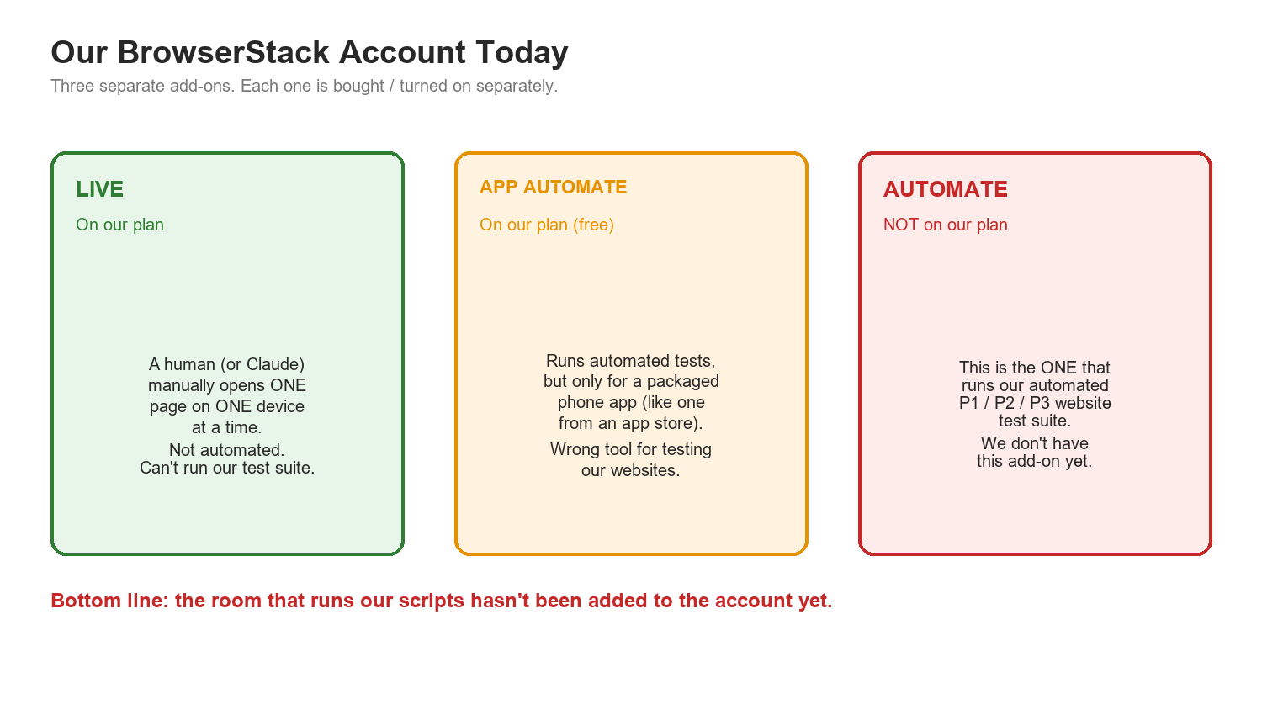

Because “Automate” isn’t part of the plan yet, there is currently no BrowserStack product that our P1/P2/P3 suite can run on — regardless of country, device, or browser.

Why “Just Connect MCP” Doesn’t Solve It
MCP is best thought of as a universal remote control — it lets Claude operate whatever BrowserStack tools we already have access to, using plain English instead of clicking through a dashboard. What it cannot do is grant access to a product we haven’t purchased or enabled. Connecting MCP to our account today would let Claude open a single manual session (using Live) — it would not let Claude run our automated suite, because the automated-testing product itself is missing.
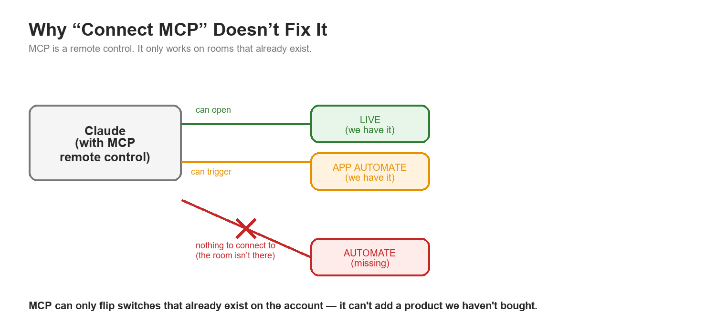

This also answers the related question we raised: could Claude, using a browser extension, simply navigate to BrowserStack’s website, pick a device, and click through our test suite by hand? Even if that were technically possible, it would only replicate what Live already offers — one manual session, one page at a time. It would not run our actual automated regression suite, which is built to run many checks quickly and consistently without a person (or AI) clicking through each step. Manual navigation and automated testing are fundamentally different tools, and neither the Chrome-navigation idea nor MCP changes which BrowserStack product we have access to.

What Needs to Happen Next
- Add the “Automate” product to our BrowserStack account. This is the missing piece — everything else (MCP, geo-testing, device choice) is secondary until this is in place.
- Confirm actual pricing directly with our BrowserStack account contact — published list pricing is a rough guide only; real contract pricing may differ.
- Country/location testing (e.g. UK, ES) is a separate, smaller add-on decision we can revisit once Automate itself is confirmed — it does not need to be solved today.

Recommendation
Go back to BrowserStack with one specific ask: “Please add Automate (web) to our account, and confirm the cost.” Once that’s active, we can pilot running one small test suite on it before deciding whether to expand further.

