JIRA Checker — How It Works, and a Flow Review
Prepared for Reyn — for review and UX/flow improvement
Date: 2026-09-15
Author: Reeve (with Claude Code)
Repo: kd-post-qa — branch feature/jira-checker-test-cases-and-reliability (PR #72)

1. What This Tool Is For
JIRA Checker is a tab inside the QA Test Center GUI. You give it one Jira ticket (paste the key or the browser URL), and it reads the ticket, figures out what needs to be tested, and either runs a real automated check against it or hands you a ready-to-execute manual test case — every ticket gets one or the other, never nothing.
The guiding idea, agreed with Reeve during build: “the GUI is the factory that operates, Confluence is the supplier that provides knowledge and skill.” The tool's own code only knows the mechanics (how to log into a ticket, how to run a spec, how to post a comment). Everything about what “good” QA judgement looks like — the Standing Rules, the Test Case Standard, the Comment Format — is read live from your Confluence knowledge base every time, not hardcoded. When you edit a page, the tool's behaviour changes within a few minutes, with no code change or redeploy.

Safety model — what's automatic vs. what needs a human
Nothing writes to Jira until a person clicks a button. Loading a ticket, drafting a test case, running an automated Check, and running an AI-vision Compare are all read-only from Jira's point of view — they can be tried, cancelled, and re-tried freely. Only two actions ever touch the real ticket:
- Commit — posts the check result comment, uploads evidence, and transitions the ticket's status
- Hold — posts a clarification comment and moves the ticket to On Hold
Both require you to have already reviewed a preview of exactly what will be posted.

2. The Flow, Start to Finish
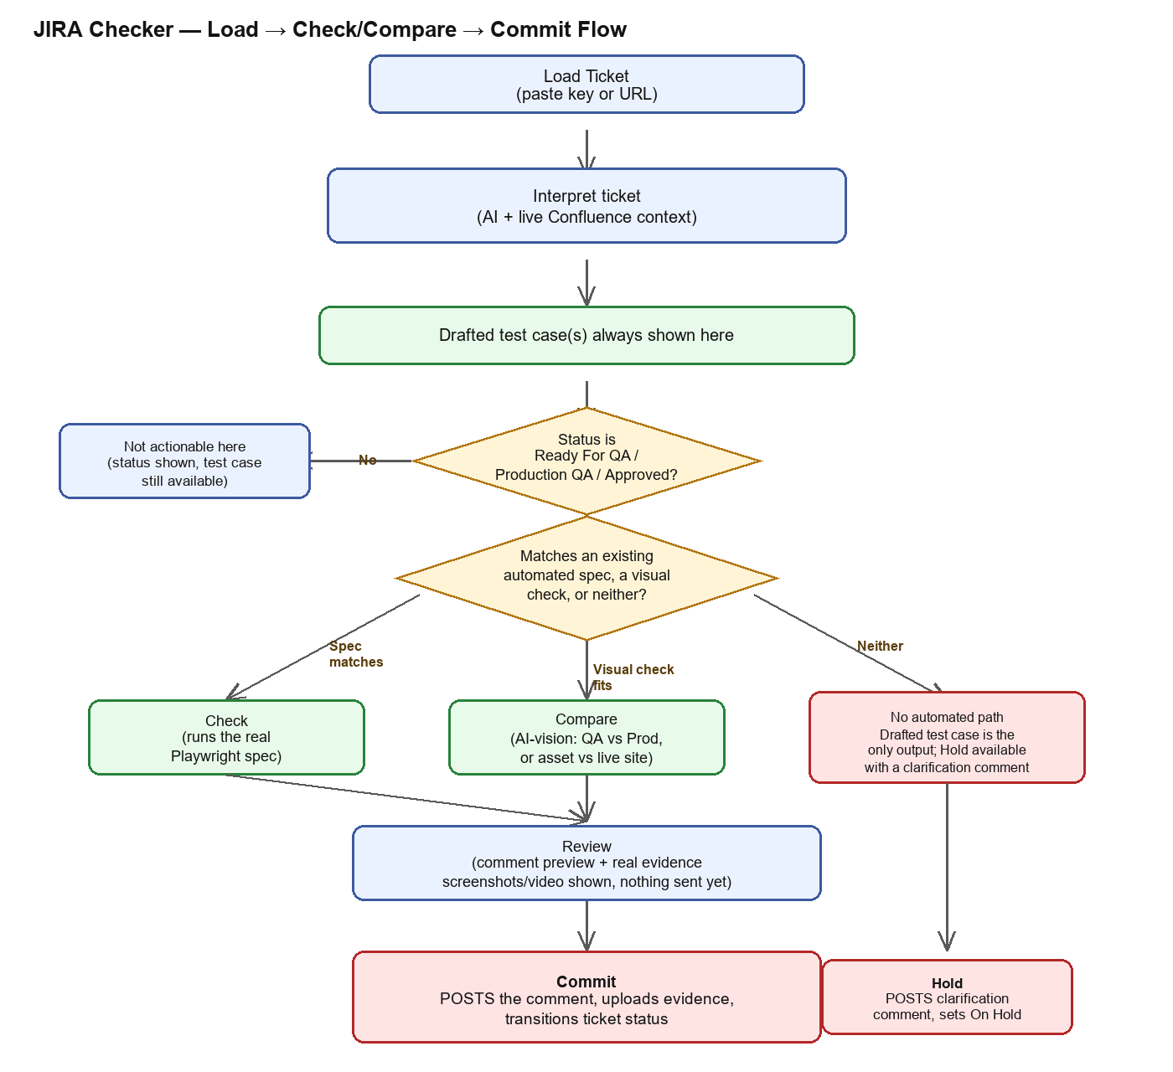
(Diagram: solid boxes are read-only steps; red boxes are the only two steps that write to Jira.)

3. Stage-by-Stage Walkthrough

3.1 Load Ticket
You type or paste a ticket key or a full browser URL (either works — a URL is parsed down to the key automatically). The tool then:
- Fetches the ticket from Jira (summary, description, status, priority, attachments).
- Resolves the brand deterministically from the ticket's Jira PROJECT, never guessed from the title text — e.g. any ticket filed under the SC project is Slingo, full stop. Only the GEO/market still has to come from the ticket's own text.
- Checks the ticket's status. Only “Ready For QA” (treated as a pre-check, first-time verification before release) and “Production QA” / “Approved” (treated as a post-check, confirming on the live site) are actionable. Any other status still shows a drafted test case, just with no Check/Compare/Commit buttons — useful for planning ahead on a ticket that isn't ready yet.

3.2 Interpret the Ticket
This is the one step that calls Claude. Before asking it anything, the tool tries a cheap keyword match against the ticket description first (no AI needed) for the test type. Either way, the AI call always runs now, because it's also the only source of the drafted test case (see 3.3).
The AI call's system prompt is built fresh every time from:
- The ticket's own title, description, and whether it has an image attachment
- The list of test types the tool can already run automatically (the curated Playwright spec library)
- Four Confluence pages, fetched live and in parallel, every single call:
- QA Lessons — Standing Rules (page 282001429)
- KD QA Test Case & Jira Workflow — the Skill page (281968663)
- Test Case Standard, ISTQB CTFL v4.0 / IEEE 829 (283017220)
- Verification Techniques (283115527)
- Plus a live, dynamic lookup: the tool lists every page under the JIRA QA Helper KB root and pulls in any page whose title shares a keyword with this specific ticket (e.g. a Genting Safer Play ticket automatically also gets that project's own reference pages, capped at 3 extra pages).
The AI's answer is one JSON object: which test type matches (if any), 2–5 plain-English check items, whether it also looks like a visual/content-mismatch or new-asset ticket, any extracted parameters (GEO, tag IDs, etc.), and the drafted test case(s).

3.3 Drafted Test Case — shown for every single ticket
This is the newest and most important piece: as of today, every ticket gets 1–4 test cases drafted in the exact shape Reyn's Test Case Standard defines — test case ID (TC-<ticket number>-NNN), title, requirement reference, brand/GEO, platform, environment, preconditions, test data, numbered steps with expected results, notes, and an Automatable/Manual tag.
This happens whether or not an automated spec exists, whether or not the brand resolves, whether or not the ticket's status is even actionable. The point: a QA engineer never gets “please clarify” with nothing else — they always get something they could run by hand today.
Known limitation worth reviewing: the AI drafts one behaviour per case per the standard's rule, but there's no check yet that it actually split things correctly for a complex ticket — worth spot-checking real tickets.

3.4 The Three Outcomes After Interpretation
Outcome | What's shown | What you can do
Matches an automated spec | Test type, scope-to-check list, confidence (high/low) | Click Check — runs the real Playwright spec
No spec, but looks like a visual/content issue | Which kind (QA-vs-Production content mismatch, or new-asset-vs-live-site), scope-to-check list | Click Compare — AI-vision check against real screenshots
Neither, or missing brand/GEO/QA URL | A reason, plus a drafted clarification comment | Click “Commit — Post & Put On Hold”, or leave it and revisit later
Note: a ticket can ALSO get a secondary “this might really need a visual check instead” suggestion even when a spec matched — shown as a warning with its own “Compare instead” button, since a structural Playwright spec won't catch a translation error or a swapped image.

3.5 Check / Compare
Check runs the real, existing Playwright spec (never AI-generated code) with the resolved brand/GEO/params injected as environment variables, then reads back the real pass/fail counts, error messages, screenshots, and video from the actual test run.
Compare has two flavours depending on what the ticket needs: capturing a full-page screenshot of both the QA and Production sites and asking Claude to compare them field by field (site-vs-site), or downloading the ticket's own attached image and checking it against several frames of the live site to catch carousel/rotation issues (asset-vs-site).
Either way, the result is held in memory only, keyed by ticket, until Commit or Cancel — nothing is posted to Jira at this point.

3.6 Review
Before Commit, you see exactly what would be posted: the comment text rendered in the house format, and the real evidence — actual screenshots inline (not thumbnails; click to open full-size) and a note of which videos will be attached.

3.7 Commit / Hold — the only two writes
Commit does three things in order, gated behind your click:
- Transitions the ticket to “In Review” (pre-check only — post-check skips this).
- Uploads every screenshot/video as a real Jira attachment, then posts the comment (in the house format — see 3.8) with them embedded inline.
- Transitions to the final status: pre-check goes to Approved or QA Rejected depending on pass/fail; post-check ALWAYS goes to Closed regardless of pass/fail (a failed post-check should get a new ticket filed for the defect — not yet automated, just flagged as a warning today).
Hold posts the drafted clarification comment as-is and moves the ticket to On Hold. That's it — no test result to post.

3.8 The Comment Format
As of today the posted comment's shape follows Reyn's “Jira Comment Format Reference” exactly: a Pre-Checked/Post-Checked header, a “Scope Checked” bulleted list, a “Platform and GEOs Checked” section with the real GEO/platform (previously this said “N/A” always — now fixed), an “Overall Result” heading with the ✅/❌ verdict as its own line, and — for a clean post-check pass only — a “Documentation” section instead of referencing the pre-check's wording.
One known gap, flagged in code rather than silently ignored: the format reference wants each screenshot placed directly under the specific bullet it evidences. Today's evidence is still grouped in one section at the end, because nothing in the pipeline currently maps a given screenshot back to a specific check item or defect.

4. Confluence Pages This Tool Depends On
Editing any of these pages changes JIRA Checker's behaviour within about 10 minutes (the cache TTL) — no code change needed.
Page | Confluence ID | Used for
QA Lessons — Standing Rules | 282001429 | Always included — practical house rules for checkItems/confidence
KD QA Test Case & Jira Workflow (Skill) | 281968663 | Always included — the house workflow reference
Test Case Standard (ISTQB CTFL v4.0 / IEEE 829) | 283017220 | Always included — the authoritative shape for drafted test cases
Verification Techniques | 283115527 | Always included — how a check should actually be performed
Jira Comment Format Reference | 283344898 | Hand-synced into code (not live-fetched — see note below)
JIRA QA Helper KB root and its other children | 281968642 | Dynamically searched per ticket, top 3 keyword-relevant matches included
Note on the Comment Format Reference: unlike the other four, this one is NOT fetched live. The posted comment is built as a structured document (ADF) directly in code, not generated by an AI call, so the format had to be transcribed into src/jira-comment.ts by hand. If you edit that Confluence page, someone needs to re-sync the code to match — it won't happen automatically the way the other four do.

5. Open Questions — Where Your Review Would Help Most
These are the rough edges known today. None of them are secretly broken — they're places where a UX/flow judgement call was made under time pressure and could probably be better.

5.1 Every ticket load is now a real, uncached AI call
Since a drafted test case is now mandatory, Load Ticket always calls Claude — observed around 10–50 seconds depending on how much the ticket needs. Is that an acceptable wait for a single-ticket workflow, or should there be a faster “just show me the scope, skip the full test case” mode for quick look-ups?

5.2 Evidence isn't matched to specific check items
As noted in 3.8, screenshots are grouped in one section instead of sitting under the specific bullet they prove. Fixing this properly would need the Playwright specs themselves to tag which check item each screenshot belongs to — a bigger change. Is the grouped version acceptable for now, or does the per-bullet placement matter enough to prioritise?

5.3 A ticket can show a clarification AND a drafted test case at once
When JIRA Checker can't automate a ticket, it now shows both a “please clarify” draft comment AND a full drafted test case, side by side. Is showing both together clear, or does it read as contradictory (“you don't understand this ticket, but here's a detailed test plan for it”)?

5.4 No bulk / multi-ticket mode yet
Today's flow is strictly one ticket at a time. The original hackathon plan mentioned a bulk release-URL mode (feed it a whole fixVersion) as a v2 goal — still not built. Worth prioritising against other gaps?

5.5 Test-case generation and reuse
A “Generate Test Script” idea — have the tool write a brand-new Playwright spec for a ticket with no automated coverage, and remember it for next time — was explored and shelved for now (see note below). Automated coverage today only grows if a human writes a new spec by hand and adds it to the curated map in src/test-runner.ts.
Why it was shelved: getting the Claude Code CLI to write that file completely unattended, safely scoped to one folder, and safe against a ticket's own text trying to steer it (prompt injection), turned out not to have a clean solution with the permission flags this CLI version exposes in a git-tracked folder — the modes tested either ignored the folder scoping entirely or denied the write outright with no human available to approve it. A disposable-worktree design would likely solve this properly but wasn't built. Flagging for your awareness in case this is worth revisiting with more time, or in case Reyn's own JIRA QA Helper tooling already has an answer to this.

5.6 The “7-point Test Cases Created checklist” is still missing
Referenced from the Skill page's reference map, this checklist has never been found in Confluence, the project export, or anyone's machine (same fate as the original test-case-standard.md, jira-comment-format.md, and verification-techniques.md — three of which you've since rewritten fresh; this fourth one hasn't been reconstructed yet). Nothing in JIRA Checker currently checks against it because it doesn't exist anywhere to check against.

6. Where Things Live in the Repo
File | What's in it
gui/jira-checker.ts | All 6 routes (ticket/check/compare/check-cancel/commit/hold), the visual-check comment builder, session handling between Check and Commit
src/ticket-interpreter.ts | The Claude call that interprets a ticket — system prompt assembly, Confluence context fetching, JSON parsing, test-case normalization
src/jira-comment.ts | The functional-check comment builder (ADF) shared with the CLI agent, plus the plain-text preview renderer
src/confluence-client.ts | Live Confluence REST fetcher — page text and child-page listing, both cached 10 minutes, fails soft
src/agent.ts | The original CLI version of this same flow (single ticket per run, no GUI) — shares jira-comment.ts with the GUI
gui/public/index.html / app.js / styles.css | The JIRA Checker tab's UI — ticket card, drafted test case panel, check/compare result panel, commit outcome

