The Modern Difficulties for Developing an E-Commerce Website in 2022

By Gareth Craig

Applied Computing

[L00129014@atu.ie](mailto:%20L00129014@atu.ie)

Wednesday, 21 December 2022

**Introduction**

The increase in online shopping due to the Covid-19 pandemic has meant that the standard in which people expect to receive when shopping online has also increased and with high expectations comes greater skills and qualifications needed to meet them. I believe that due to the complexity, professional expectations, and skills required that a single business owner could not produce their own suitable e-commerce website to compete with today’s expectations.

The first introduction to e-commerce was a lot further back than you would think. In fact, the first e-commerce shop predates the advent of the World Wide Web and was operated using a dial up bulletin board system (Ang 2021a). Boston Computer Exchange (BCE) was the first online marketplace that allowed for people to buy and sell used computers (Ang 2021b). The only drawback to this design was the restricted technology and the effort required to complete a sale or a purchase.

By the 1990’s the Internet has already established itself as a major global centre for connection and communication. In 1994, Netscape's Navigator and Mosaic were the two most widely used web browsers, with around ten million unique visitors each month. In the same year, Jeff Bezos established Amazon, which now serves as an online marketplace for hundreds of thousands of unique goods. He launched his own e-commerce website in 1999 after the company quickly expanded to become among the biggest in the world. After 30 days of operation, it was shipping books to forty-five different nations, and after two years it surpassed all other retailers in the US. Fast forward to 2022, Amazon now employ more than 70,000 people in tech roles and around 35,000 of them are software engineers.

Up until this point, if you were a developer creating websites, you need only know HTML, or XML to create a website. Developers didn’t design websites to suit the visually impaired, or the colour blind. They simple developed what worked for them. Design and User Experience had not received much consideration or investigation; therefore, web developers were not required to know any UX/UI skills. That is, until 1995, when Donald Norman, Jim Miller, and Austin Henderson from Apple Computer gave a presentation at CHI ’95 Mosaic of Creativity called What You See, Some of What's in the Future, and How We Go About Doing It: HI at Apple Computer. This presentation introduced the concept of analysing your target audience and designing to their needs to create a product that was easy to understand and even easier to sell. Rather the goal was to make a service or product that was almost intuitive for the user to understand and learn. The same way of thinking was depicted in Don't Make Me Think (Krug 2000). Krug discusses the idea that a well-designed computer programme or website should allow users to complete their intended tasks in the simplest, most straightforward manner possible.

Microsoft started to sell the Zune handheld devices in 2009 and the website developed for this product was a far stretch from what people were used to at that time. Its flat design, contrasting colours and use of imagery clearly depicted a website that was modern and stylish which perfectly represented the product that they were selling (Web Design Museum 2009). This sleek design matched perfectly with the futuristic theme that the product itself was trying to portray and suited the consumers idea of what to expect when they got their hands on the device.

Figure – Image of Zune Website (Zune 2009)

**Discussion**

Web developers in the 1990’s were required to have known either HTML, XML, or XHML and maybe CSS. They could use C++ for the backend but primarily a markup language and CSS were all that was required to produce a sufficient website at the time. With the release of JavaScript 1.0 in 1995 it allowed developers to create interactive websites using an object-oriented language. When we compare this to the average skills that a graduate will acquire after completing an honours degree in computing science, it demonstrates the significant increase in expectations of what a developer’s skills must be to work in this current day workforce. Developers can no longer rely solely on a handful of programming languages, they must be well versed in critical thinking, problem solving, design awareness, frameworks, developing trends such as PWA’s and more. When we investigate the skills, a professional developer possess it stems down to being able to make the important decisions such as selecting the correct language to use on a project and knowing what works and what weaknesses might arise in future development. Being able to implement new and evolving technology to help ease workload such as AI Chats for customer service will allow a website to evolve with the times to meet these ever-growing expectations. Understanding the end goal of a project or a website is core in making the right decisions at the beginning. These are challenges that most graduate developers will struggle with for years when entering the industry, so imagine the overwhelming sense of difficulty to someone who has never been formally taught how to code or design a website would feel. There are options however that will cut out some of the work for absolute beginners.

For non-coding or design skilled people, start-ups can use Shopify, WordPress, WooCommerce and other e-commerce software solutions which provide the tools to allow them to setup a website and theme it to their liking without the need to understand domain names, security certificates, and the other must haves that websites need. They can manoeuvre their products around, setup sections for banners and graphics as well as managing uploads of product descriptions and managing stock levels. The software however doesn’t teach the users about the attributes needed to create a great professional website. The need for well thought out UX/UI design doesn’t come with the click of a button. This misconception that simply having the tools will allow for someone to create a striving business that competes against larger brands is why 90% of e-commerce businesses started, end up failing (Gauthier *et al.* 2019). Simply putting a hammer into someone’s hand does not make them a carpenter.

Developers are known to be mathematical in the sense that when working with websites, there are varying factors such as screen size, orientation of the device and image sizes and more. Three types of math that a good developer will poses are arithmetic, algebra and boolean logic. Arithmetic math will be used to calculate varying sizes of elements on the website. Algebra functions will then take in the value and apply the equation. For example, an image might need to be 100% of the screen size – 30px, therefore it would require a variable with the screen size value inside that and then apply the -30px to that leaving the developer with the desired result. Boolean logic is equally just as important, especially when developing a website for e-commerce as these booleans will be used to trigger certain events. If the customer orders a product, then after payment has been received the boolean logic will tell the server to send out an email with the order information. This is just one example, however, that level of logic is fundamental in any developer’s role. Being able to break down big problems into solvable smaller problems is what makes a good developer.

An IDE (Integrated Development Environment) is a developer’s best friend. There are many diverse types, and they all look different, but ultimately, they all do the same thing, which is to allow the developer to programme. Some IDEs have unique features inside such as IntelliSense, which predicts what you are typing and makes suggestions on how to finish it. Most of them will also have a debugger which allows for step-by-step analysis of the code, and some have very little so that they can be lightweight and straightforward. Developers use different IDEs for different languages, for example a popular choice for HTML programming would be Visual Studio Code. IDE’s take some time to understand, and different languages can sometimes only be written in certain IDE’s. It is important for a beginner to get a customed to the IDE that they will be using.

HTML is used by 94.8% of websites worldwide and is the foundation of the website (W3Techs 2022a). Here the developer implements the core design of the website using tags and attributes to make up various parts of the website such as the navigation, the body of the website and the content that is situated inside it as well as the footer which can contain all the information a consumer might require regarding business address, contact information and legal documents such as cookie policies, returns, shipping and GDPR. CSS is used by 94.8% of websites to add styling to the website (W3Techs 2022b). Developers will use this to add colouring to the website, change font size and font types, creating grids and flex boxes for proper organising and creating media queries which will account for multiple screen sizes and devices. Since Q1 and Q2 of 2022, 58.99% of global website traffic worldwide is mobile devices (Statista 2022). Developers should be very aware that having one layout for one static screen size will not work in 2022. JavaScript is used by 97.4% of websites to add extra functionality to websites (W3Techs 2022c).JavaScript is the first language we have discussed that uses an object-oriented programming model which makes it more complicated to learn as there are more complex methods and classes behind it.

The introduction of libraries to web development is fantastic way of increasing productivity. Bootstrap is a fitting example of a library that was created with the sole purpose of increasing fast turnaround designs for websites geared towards an e-commerce design. It can provide template code for various things such as customer reviews, product carousel, hero banners and other components that an e-commerce website would need. It is also compatible with other libraries such as Angular which is a development platform built on TypeScript (Angular 2022). Angular allows developers to create a component-based framework for scalable web applications. This is important in e-commerce as it means the developer can return variables with the customers name and email address which can be inputted into a purchase receipt or invoice upon completing a purchase.

Web developers must have a place to retain product and customer data and the best place to do this is a database. There are various databases available such as Amazon Web Services, Oracle, MySQL, MongoDB etc but regardless of which one is chosen it is important that security is the main goal. A customer’s information is personal to them and if there were to be a breach of that information, then that business is liable for damages and a hefty fine will be imposed on them for that information getting out.

A designer looking to create an online presence in 2022 needs to understand their audience. Who is it that they are looking to sell to? Are they older, younger, or both? Are they using mobile devices, computers, iPads, or tablets? Where are they situated, locally or internationally? These are questions that should be answered before beginning to programme an application. Finding out this information and incorporating it into the wireframe and prototype will mean that the website is fulfilling its consumers needs and expectations.

Compared to the earlier years of web development, more research has been put into behavioural studies and marketing which has produced clear results that to create a reliable website, you need to account for the experience that the consumer is having while browsing your website. User Experience is a task that requires reiteration upon every choice. Testing to see if the current layout works and how consumers feel is how a well refined UX is created. UX is one of the hardest jobs to do in any profession. Understanding the strengths and weakness of consumers is vital when approaching this task. Having a well-researched target audience will make the UX design significantly more approachable than going at it blind.

A firm understanding of the prototyping stage will allow a designer to develop the base layout of the website and all the subsequent pages that are a part of it. Creating an organic flow will make sure that users are able to seek out the relevant information quickly and confidently on the website. If a designer were to neglect the User Experience, then it is 70% more likely that that e-commerce website will fail (Gajic 2022). It is then their job to scope the project in and begin designing the components such as buttons, menu’s, forms, and other interactive sections on the website. By focusing on increasing the quality of UI on the website, it will increase the conversion rate by 200% (Anic 2022). To create an interactive prototype with the previously created screens, a designer will need to use prototyping software to do this. There are loads of options when it comes to choices, popular options include Figma which is free to use, and there is also Adobe XD which is also very popular but requires a license. By using one of these applications, designers can link all the screens together and provide an impressive looking prototype that will display all the functionality required to make a good judgement on whether anything needs revisited for editing. The entire design process should be accounted for and prototyped before programming begins. After completing and reviewing the prototype a designer could ask some friends, family, or the public to complete some basic tasks and events such as trying to find the product page or accessing the customer account panel. This is referred to as testing. Depending on what stage of the project you are on it can either be alpha or beta testing. Alpha testing is conducted internally, while beta tests are conducted on the intended audience. This can be done using paper or digital means, it is a fantastic way of seeing if the User Experience is positive, or if something needs reworked or redesigned before submitting the final design for development.

Once happy with the prototype, development begins. As the development process begins this means that a developer begins working on their allocated jobs and tasks. Larger companies will assign tasks to the developer and tells them what programming language they are using and if there is any external libraries as well. An individual developer does not have this luxury and will be required to research into what the best programming language is for the job and if any external libraries should be used. This is vital part of the website’s lifecycle. Spending time developing a website with the wrong code base could set back a developer many weeks or months depending on how much work has been completed. When choosing a programming language, things to consider would be whether you are hosting your own items in your database, if so, a language that works well with MySQL or Oracle would be favourable. Since this is an e-commerce website, looking into an external library such as Angular could help speed up the development process.

Once the languages and libraries have been selected and the coding completed and the site is fully functional and live, the designer then needs to populate the store with the relevant items. It is important that when producing product photos that they are high quality and every product photo either has the same theme or connection to the website. It is important to remember that as a designer we do want great resolution images and assets, but you must be mindful of website load times. Customers make their first judgement within 0.05 seconds on whether they want to continue to stay on your page (Lynkova 2022d). It is important that not only do designers provide consumers with excellent quality product photos, but that the website load times are low, and the website performs as the consumer would expect. On average, 47% of website visitors will leave the site within 2 seconds or less if it has not loaded (Lynkova 2022b). That is why it is so important to produce both a lower sized file for product overview purposes and then after the users has selected the product, display a higher resolution product photo then.

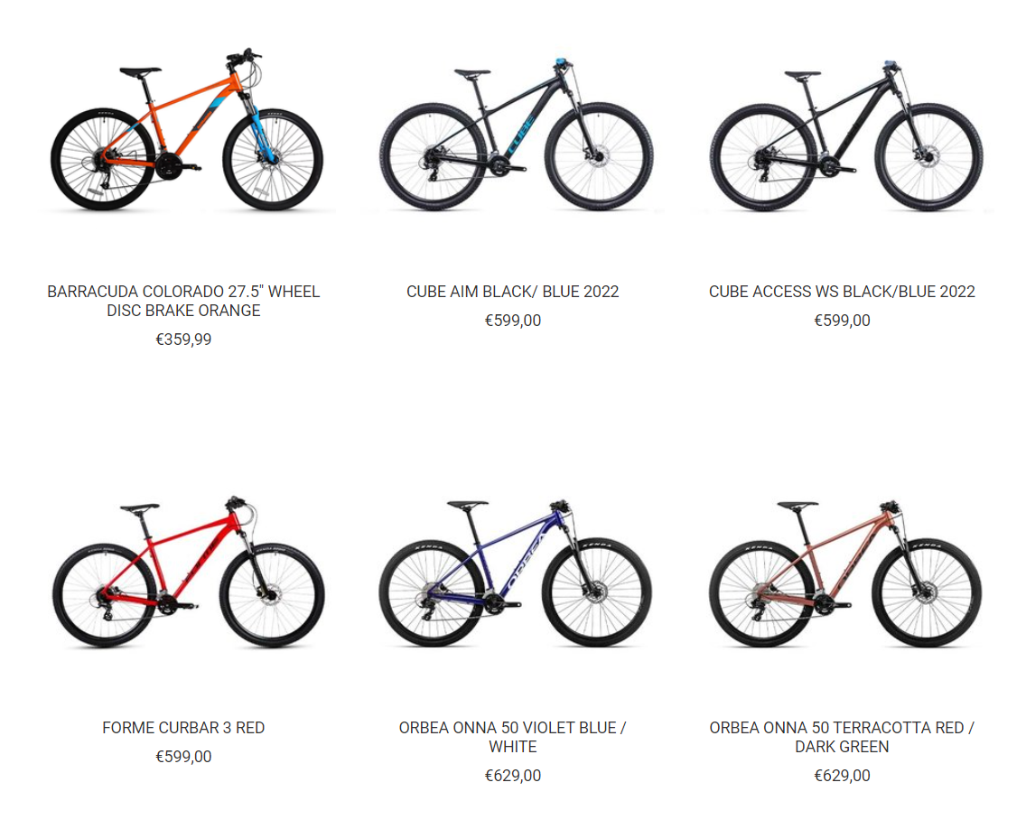

Figure – (Craig 2022a)

As we can see from Figure 2, although all the bicycles are a different brand and the imagery is supplied from different manufacturers, the web designer has edited the photos to contain a drop shadow below all the bicycle wheels. It is hard to tell that the product images are edited since they all look the same to the naked eye, but it can be seen by the fact that some of the shadows are wider and darker underneath some of the wheels. This means that shadows have been added in post-production, most likely using a photo editing software suite such as Adobe Photoshop or GIMP.

In addition to product photos, 54% consumers expect a tailored experience when they shop online (Lynkova 2022c). To satisfy their expectations, designers must strive to create custom graphics that point the consumer to the feature that they want to find. Figure 3 below perfectly demonstrates the use of custom graphics. The banner is eye catching and uses contrasting colour to bring the viewer into the text which clearly points out that it is in relation to the “Christmas Club” users. Users of this feature can then make quick and secure payments by clicking the “Easi Payment” button located on top of the banner at the bottom left.

Figure – (Craig 2022b)

For designers looking to create custom graphics, then they should use a vector-based illustration application like Adobe Illustrator, which can support the exporting of SVF and raster type files such as PNG or JPEG. SVGs (Scalable Vector Graphics) are smaller in size than most regular raster image type such as PNG or JPEG and can be scaled up in size without losing quality. When using SVG images, designers can be confident in knowing that their website complies with the standards set out by the W3C. SVG files do not work as well for realistic photos unlike PNG files which do. SVGs are also great for using in animations or small motion graphics which can be achieved using CSS or JavaScript.

If a designer wanted to do the animation or motion graphics, they could use Adobe After Effects. Adobe After Effects it a post-production video editing software that can create anything from simple animations to advanced motion graphics. By creating a video and displaying It as a background as opposed to a normal static image, conversion rates can be increased up to as much as 138% (Lynkova 2022a).

The average completion time of a computer science course is 3 years for a full-time student and 4 years for a part time student looking to gather a level 7 bachelor’s degree (Indeed Editorial Team 2021). Within them 3-4 years a student will be taught the fundamentals of web development which will cover HTML, CSS, JavaScript, and jQuery. They will then cover server-side programming such as PHP, Node.js or AJAX along with maybe Python. For their object orientated programming they will be taught C#, Java and then certain frameworks that go along with them languages such as entity framework, asp.net and various other libraries. These courses tend to be around 7-8 hours a day with a 1–2-hour self-taught section in the evening for someone looking to really drive in the lessons they have been taught that day. That is a range of 40-50 hours per week spent learning coding. That is not contributing to the other skills an e-commerce business start-up should possess such as UX, UI, photo editing, illustration, wireframing, prototyping, video editing or motion graphics.

**Conclusion**

Modern, sleek, fast, efficient, intelligent, easy to use, unique, are all words that are thrown around when we talk about great websites. Is this something that is achieved easily and without thought? Absolutely not. To create a great website that could rival that of Nike or Puma would require more than just experience in both web design and web development. It would require an entire team of trained professionals in branding, marketing, and economics.

An e-commerce start-up business would require that the developer have a clear and logical approach to the development of the website and the technologies that it would incorporate for it to have any chance of being successful. Regardless of the aid that e-commerce software solutions such as Shopify provide, I believe that it would take several years and several failed projects to gain the necessary technical, soft, and hard skills required to build a successful business. It is also very dangerous to setup a custom developed website without the correct security. A breach of data could result in customer debit/credit card information being lost, as well as addresses and other personal information that is protected under the GDPR laws. Any breach of GDPR will result in a possible legal issue that could jeopardise the business.

If an e-commerce business was setup regardless of current skills and qualifications, even with a great product it would require professional imagery and assets to gain the attention and retention of users. Having not been taught how to use any Adobe software or product photography then I fail to see how they could produce the professional assets that consumers would expect to see. With no qualifications the site would surely have issues that would become frustrating to users and would in time fail due to bad conversion rates. It is an unfortunate circumstance that such few businesses can become profitable and successful even with the help of online tools and software. The financial side of earning these skills are also something that should be warranted. Obtaining the skills and qualifications needed to create a successful e-commerce website can be expensive, as it often requires thousands of euros for tuition and hundreds of hours of learning.

Amazon, Nike, Puma, Apple, Google, and many other industry leading companies have gathered some of the most intelligent and creative people from around the planet to work for them. Each employee has presumably spent years in education as well as crafting their skills to suit their specific role in the company. They have worked on challenging projects, made mistakes, and learnt from them. This is why I believe that a single business owner could not produce their own suitable e-commerce website to compete with today’s expectations.

**References**

Ang, C. (2021a) Timeline: Key Events in the History of Online Shopping [online], *Visual Capitalist*, available: https://www.visualcapitalist.com/sp/history-of-online-shopping/ [accessed 1 Dec 2022].

Ang, C. (2021b) Timeline: Key Events in the History of Online Shopping [online], *Visual Capitalist*, available: https://www.visualcapitalist.com/sp/history-of-online-shopping/#:~:text=By%201982%2C%20the%20world%E2%80%99s%20first%20eCommerce%20company%20launched.%20The%20Boston%20Computer%20Exchange%20(BCE)%20was%20an%20online%20marketplace%20for%20people%20to%20buy%20and%20sell%20used%20computers. [accessed 1 Dec 2022].

Angular (2022) Angular - What Is Angular? [online], available: https://angular.io/guide/what-is-angular [accessed 2 Dec 2022].

Anic, L. (2022) 31 Impressive Web Design Statistics for 2022 [online], *JOLA Branding*, available: https://www.jolabranding.com/post/web-design-statistics [accessed 29 Nov 2022].

Craig, G (2022a) Bicycle images [image], available: https://github.com/Kinetikku/lkBikes/blob/main/Picture2.png [accessed 30 Nov 2022].

Craig, G (2022b) Header Banner [image], available: https://github.com/Kinetikku/lkBikes/blob/main/Picture1.png [accessed 30 Nov 2022].

Gajic, A. (2022) UX Statistics [online], *Truelist*, available: https://truelist.co/blog/ux-statistics/#:~:text=70%25%20of%20online%20businesses%20fall%20through%20because%20of%20bad%20UX.,-If%20we%20didn&text=User%20experience%20statistics%20show%20that%20as%20many%20as%2070%25%20of,(Uxeria) [accessed 10 Nov 2022].

Gauthier, J., Stangler, D., Penzel, M., Morelix, A., Arora, L., Ortmans, J., de la Tour, A., Goeldel, N., and Rigby, D. (2019) *Global Startup Ecosystem Report 2019*, Startup Genome, available: https://startupgenome.com/reports/global-startup-ecosystem-report-2019 [accessed 12 Dec 2022].

Indeed Editorial Team (2021) What Is a Computer Science Degree? (With Skills and Careers) [online], *Indeed*, available: https://uk.indeed.com/career-advice/career-development/computer-science-degree.

Krug, S. (2000) *Don’t Make Me Think*, #1. ed, New Riders.

Lynkova, D. (2022a) Website Design Industry Statistics [online], *TechJury*, available: https://techjury.net/blog/website-design-industry-statistics/#:~:text=When%20you%20switch%20to%20a%20video%20background%2C%20there%20is%20a%20138%25%20improvement%20in%20conversion%20rate [accessed 10 Nov 2022].

Lynkova, D. (2022b) Website Design Industry Statistics [online], *TechJury*, available: https://techjury.net/blog/website-design-industry-statistics/#:~:text=47%25%20of%20people%20expect%20websites%20to%20load%20in%202%20seconds%20or%20less. [accessed 10 Nov 2022].

Lynkova, D. (2022c) Website Design Industry Statistics [online], *TechJury*, available: https://techjury.net/blog/website-design-industry-statistics/#:~:text=54%25%20of%20users%20prefer%20personal%20online%20experiences. [accessed 10 Nov 2022].

Lynkova, D. (2022d) Website Design Industry Statistics [online], *TechJury*, available: https://techjury.net/blog/website-design-industry-statistics/#:~:text=Users%20spend%20an%20average%20of%200.05%20seconds%20on%20deciding%20whether%20to%20stay%20on%20your%20site%20or%20leave. [accessed 10 Nov 2022].

Statista (2022) Global Mobile Traffic 2022 [online], *Statista*, available: https://www.statista.com/statistics/277125/share-of-website-traffic-coming-from-mobile-devices/ [accessed 2 Dec 2022].

W3Techs (2022a) Usage Statistics and Market Share of HTML5 for Websites, November 2022 [online], available: https://w3techs.com/technologies/details/ml-html5 [accessed 29 Nov 2022].

W3Techs (2022b) Usage Statistics of Inline CSS for Websites, November 2022 [online], available: https://w3techs.com/technologies/details/ce-inlinecss [accessed 29 Nov 2022].

W3Techs (2022c) Usage Statistics of JavaScript as Client-Side Programming Language on Websites, November 2022 [online], available: https://w3techs.com/technologies/details/cp-javascript [accessed 29 Nov 2022].

Web Design Museum (2009) Zune Media Player and Flat Design - 2009 | Web Design Museum [online], available: https://www.webdesignmuseum.org/web-design-history/zune-media-player-and-flat-design-2009 [accessed 2 Dec 2022].