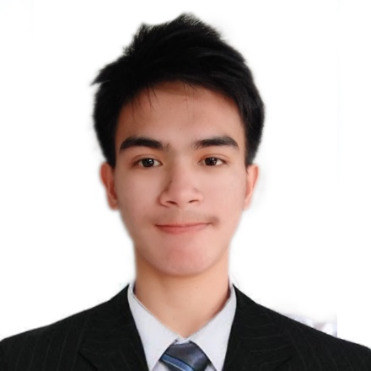**PAUL KENNETH SOLOMON QUINTO**

9003 Gemini St.,Nueva Villa, Alangilan, Batangas City, Batangas

Contact No. : +639565176896

E-mail Address: [kinetzki2k20@gmail.com](mailto:kinetzki2k20@gmail.com)

Online Portfolio:

**Objective:**

To obtain a challenging and rewarding position as a software developer, where I can apply my programming skills and passion for technology to contribute to innovative projects.

**Personal Information:**

Nickname: Kenneth

Date of Birth: October 28, 2001

Place of Birth: Calapan City, Oriental Mindoro

Religion: Roman Catholic

Nationality: Filipino

Height: 5’6”

Weight: 55kg

Age: 22 y / o

Premarital Status: Single

**Technical Skills:**

* Programming Languages: Python (Django, Flask), Java (Spring), .NET Core, C#, C++
* Web Development: HTML, CSS, JavaScript(React, Express, etc.)
* Database Management: MySQL, SQL, Firebase
* Front-End Development: HTML, CSS, JavaScript
* Operating Systems: Linux, Windows
* Shell Scripting: Bash
* Version Control: Git, GitHub
* Software Proficiency: Microsoft Word, Excel, PowerPoint
* Graphic Design: Adobe Photoshop, Adobe Premiere, Adobe After Effects
* 3D Modeling: Blender

**Seminars and Trainings Attended:**

* **CCNAv7: Introduction to Networks course - 2022**

Mark Rondol P. Abdon, Batangas State University

* **CCNAv7: Switching, Routing, and Wireless Essentials course - 2023**

Mark Rondol P. Abdon, Batangas State University

* **CCNAv7: Enterprise Networking, Security, and Automation course - 2023**

Mark Rondol P. Abdon, Batangas State University

* **Project Management: Agile Methodology – February 4, 2023**

CpE-gnite 2023, Amphitheater, Batangas State University

* **Jobs and Careers in Computer Engineering - February 4, 2023**

CpE-gnite 2023: Amphitheater, Batangas State University

**Competitions:**

* **Regional Programming Competition – Python (Champion)**

Institute of Computer Engineers of the Philippines (ICpEP)

November 2023

* **Regional Programming Competition – Python (Participant)**

Institute of Computer Engineers of the Philippines (ICpEP)

November 2021

* **CPElympics Programming Competition – Python (1st Place)**

Computer Engineering Students' Organization (CURSOR)

April 15, 2023

**Educational Attainment:**

Tertiary **Batangas State University – Alangilan Campus**

Bachelor of Science in Computer Engineering

Alangilan, Batangas City, Batangas

August 2020 – June 2024

Secondary **Baco National High School**

Poblacion, Baco, Oriental Mindoro

June 2014 – March 2020

Primary **Paspasin Elementary School**

Paspasin, Calangatan, San Teodoro, Oriental Mindoro

June 2008 – March 2014

**Working Experience:**

* **Summer Job –** Treasurer’s Office of the Municipality of San Teodoro Oriental Mindoro

Delivering vouchers and managing digital documents.

(April 10, 2019- May 10, 2019)

* **Immersion –** Municipality Of Baco Oriental Mindoro

Designing property layouts using AUTOCAD.

(January – March 2020)