Test 1 For Database Management Fall 2016 (MSBA)
Dr. Chon Abraham
Date:
Type Name ____VJ DAVEY______________

*This test is an individual effort but you may use any class materials or online resource other than another individual for assistance and by printing your name you adhere to this requirement.*

Instructions:
(a) LOAD test1_msba16.sql and USE it for this test’s SQL questions.
/* I put all tables from across the various exercises into one database for use in the test. Be sure to look through the .sql and refresh your Navigator in Workbench to see the tables in this database to know the attributes contained and PK/FK constraints*/

(b) Cut and past all .mwb files into the respective questions into this document. I do not need a separate .mwb file

(c) Create a .sql with comments indicating the question number that the code is answering. Submit this .sql with this .doc in your test 1 submission link as Test1_YourLastName.sql and Test1_YourLastName .doc or docx. Cut and paste all SQL into this document as well so that I can award partial credit even it something does not run.

Question 1: (10 pts = 1pt each)

RACE

* race_name
* race_length
* race_date

RESULT
time

RUNNER

* runner_id
runner_l_name

Is president of

CLUB

* club_name
club_address
club_city
club_state
club_telephone

Organizes

From the above data model, it can be inferred that… [Answer (T)RUE or (F)ALSE]:

1) This data model does not support the situation where two runners would have the exact same time in a particular race.

ANSWER: _F___

2) A runner does not need to be part of a club to participate in a race.

ANSWER: __F__

3) The table RUNNER, when created, will have one FK

ANSWER: __T__

4) The table RACE, when created, will have a composite PK made of 4 columns.

ANSWER: __T__

5) This data model does not support the situation where one runner has the exact same time in two different races.

ANSWER: __F__

6) Having referential integrity means that a runner’s resulting time in a race cannot be stored unless the runner has an associated runner_id stored in the RUNNER table and the race information is stored in the RACE table. ANSWER: __T__

7) The CLUB and RESULT tables are both independent tables. ANSWER:__F__

8) The phrase “Is president of” is a describing a recursive relationship. ANSWER: _T__

9) Joins between the RUNNER, RESULT, RACE, and CLUB tables are required to get the name of the race, the resulting time for a runner, the runner’s name and the club’s name in the output for a single query. ANSWER:__F__

10) A join between the RUNNER, RESULT, and CLUB tables will give you the name of the race, the resulting time for a runner, the runner’s name and the club’s telephone number in the output for a query.
ANSWER:_T__

Question 2: (5 pts) (cut and paste a screenshot of your .mwb)

In designing an application to store appointments between professors and students, a database must be created. For each appointment, the application needs to know the date, start time, duration, who were the student and faculty involved, and what was the purpose of the appointment. For example, an appointment might be scheduled on October 7, 10:00am, for 15 minutes, between the student Joe Smith and the faculty Dana Abraham, to clarify data management concepts (i.e., purpose for the appointment).

You can assume that each appointment is between one faculty and one student. Also, note that it is possible for a given student to meet more than once, on a given day, with a given faculty.

Insert your .mwb screenshot for the data model to accurately represent the situation above:

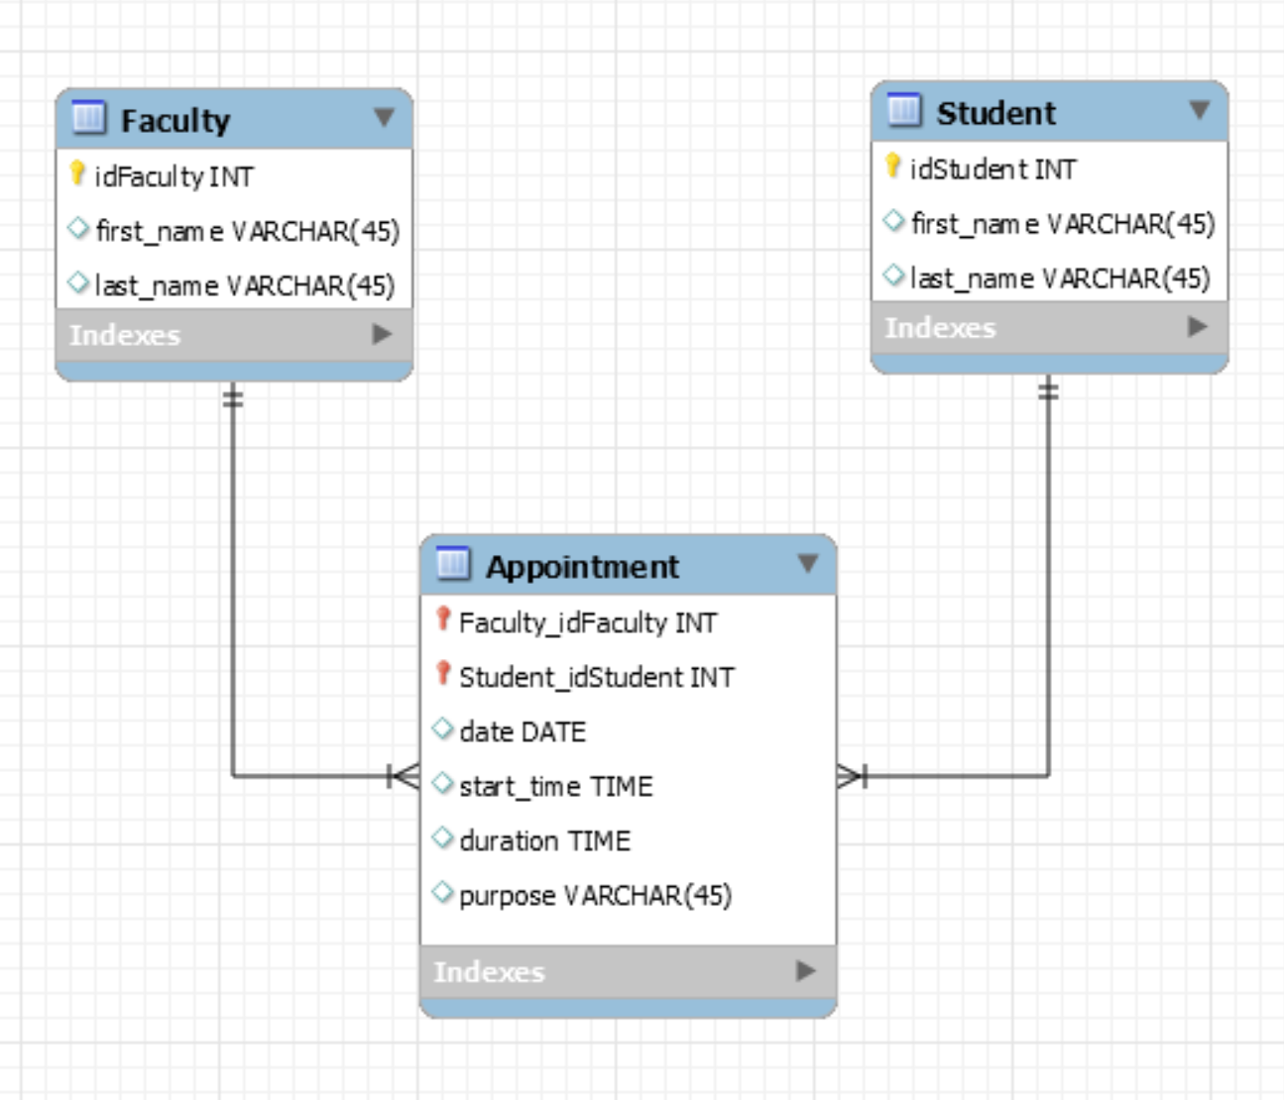

Question 3: (10 pts) (cut and paste a screenshot of your .mwb)

The Virginia Best Hospital is a not-for-profit general hospital. It is a relatively small hospital, with some 200 beds at the present time. The director of Virginia Best Hospital has provided the following information about the hospital’s environment:

- The hospital includes many facilities (located all over Virginia). A facility maintains a number of laboratories (such as radiology, hematology, and so on). A facility has a unique identification number, address, phone number, and type of care (short-term/long-term). Laboratory identification numbers are unique within a given facility, but they may be redundant across facilities.

- Each facility has a number of physicians working for it. A physician, however, can only work for one facility. The hospital does not need to keep track of the fact that a physician may have worked for other facilities in the past. Basic information must be kept about each physician (i.e., identification number and name).

- Each laboratory offers many types of tests. A type of test can be offered by many laboratories. A blood test, for instance, can be offered by either a hematology laboratory or by a toxicology laboratory.

- Each laboratory has one physician at its head. A physician cannot head more than one laboratory (if any).

Insert the screen shot of the data model to accurately represent the situation above:
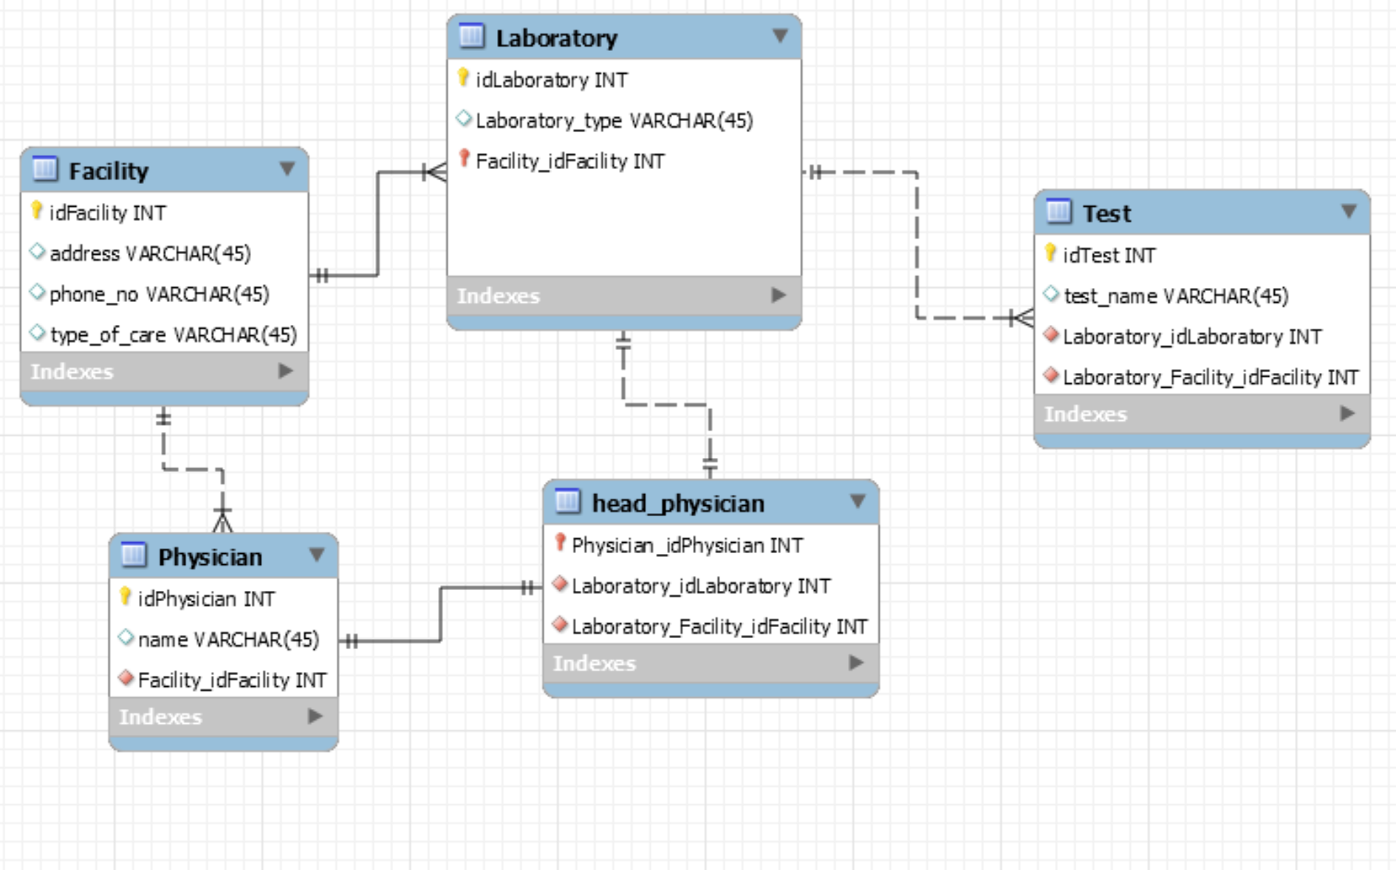

Answer the following questions using the tables below. Note: Attributes COURSECREDIT and DURATION-VALIDITY have a number data type, and all other attributes have a text data type. DURATION-VALIDITY refers to the time period (counted in number of semesters) during which a student must have taken the prerequisite in order for it to be considered as valid.

Consider the following data model:

COURSE

* courseid
coursedesc
coursecredit

PREREQ

Duration-validity

COURSE Table
Primary key: COURSEID
Foreign keys: none

courseID | courseDesc | courseCredit
CSCI1111 | Intro to Computers | 4
EC101 | Intro to Electronic Commerce | 3
EC205 | Management of Virtual Organizations | 6
ENG1111 | English1 | 2
FIN1111 | FINANCE1 | 3
FIN3333 | FINANCE2 | 3
FIN4444 | Corporate Fin | 3
FIN5555 | Real Estate | 3
FIN6666 | Investments | 3
FR101 | French 1 | 2
MA1111 | College Algebra | 4
MA2222 | Calculus1 | 4

PREREQ Table
Primary key: COURSEID & PREREQID
Foreign keys: COURSEID (references the COURSE table)
PREREQID (references the COURSE table)
courseID | prereqID | duration-validity
EC205 | EC101 | 3
FIN3333 | CSCI1111 | 9
FIN3333 | ENG1111
FIN3333 | FIN1111 | 9
FIN3333 | MA1111 | 15
FIN3333 | MA2222 | 15
FIN4444 | FIN3333 | 6
FIN5555 | FIN3333 | 6
FIN6666 | FIN3333 | 6

Question 4 (4pts): Write the CREATE TABLE statement for the Prereq table. Do not re-create this statement in the Test1.mdb.
CREATE TABLE IF NOT EXISTS `prereq` (
`prereq_id` TEXT NOT NULL,
`prereq_course_id` TEXT NOT NULL,
`duration_validity` INT,
PRIMARY KEY (`prereq_id`, `prereq_course_id`),
CONSTRAINT `fk_prereq_prereqid`
FOREIGN KEY (`prereq_id`)
REFERENCES `course`(`courseid`))
CONSTRAINT `fk_prereq_courseid`
FOREIGN KEY (`prereq_course_id`)
REFERENCES `course`(`courseid`));

Question 5 (3pts): Write the SQL to generate the list of all prerequisite id(s) (prereqIDs) for the course that has the description “Management of Virtual Organizations”. [Hint: Looking for the prerequisites for Management of Virtual Organizations, which is the main course not the prerequisite course.]

select prereqID
from prereq,course
where prereq.courseID = course.courseID and course.courseDesc = "Management of Virtual Organizations";

PREREQID
EC101
Question 6 (3pts): Write the SQL statement to generate the list of course descriptions and course credits of all the courses that have a prerequisite that has a course description starting with the letter E and ending with the number 1. [Hint: You can solve this by creating a copy of the Course table or using an IN and you must use a pattern matching command meet conditions for the prerequisite course description.]
select courseDesc, courseCredit
from course,prereq
where prereq.courseID = course.courseID
and prereq.prereqID in (
select courseID from course
where courseDesc like 'E%1'
);

COURSEDESC | COURSECREDIT
FINANCE2 | 3

Consider the data model & sample tables below for the following questions.

WORKER

* worker_id
worker_name
hrly_rate
skill_type

BUILDING

* bldg_id
bldg_address
bldg_type
bldg_qlty_lv
ASSIGNMENT

Start_date
Num_days

supervises

Table WORKER
Primary key: WORKER_ID
Foreign key: none

WORKER_ID | WORKER_NAME | HRLY_RATE | SKILL_TYPE
1235 | Faraday | 12.50 | Electric
1412 | Nemo | 13.75 | Plumbing
2920 | Garret | 10.00 | Roofing
3231 | Mason | 17.40 | Framing
9909 | Smith | 15.00 | Electric
- etc. -

Table ASSIGNMENT
Primary key: WORKER_ID + BLDG_ID
Foreign keys: WORKER_ID (references the WORKER Table)
BLDG_ID (references the BUILDING Table)

WORKER_ID | BLDG_ID | START_DATE | NUM_DAYS
1235 | 321 | 8/10/2001 | 5
1412 | 321 | 8/1/2001 | 10
1235 | 515 | 5/17/2001 | 22
2920 | 460 | 9/15/2001 | 18

Table BUILDING
Primary key: BLDG_ID
Foreign key: BLDG_SUP (references the WORKER Table)

BLDG_ID | BLDG_ADDRESS | BLDG_TYPE | BLDG_QLTY_LV | BLDG_SUP
321 | 123 Elm | Office | 2A | 1412
435 | 456 Maple | Retail | 1B | 1235
515 | 789 Oak | Residence | 3A | 9909
460 | 1011 Birch | Office | 2A | 2920

Note#1: Attribute HRLY_RATE in the WORKER table and NUM_DAYS in the ASSIGNMENT table have a number data type; START_DATE in the ASSIGNMENT table has a date data type; and all other attributes have a text data type.

Note#2: Assume that we only need to keep track of the current work assignments for each worker (i.e., we do not need to keep track of the history of a worker’s previous work assignments on different buildings).

Question 7 (3pts): In which table would you create an attribute to represent the worker who supervises a building? Why? Should this attribute be constrained as a foreign key?

I would create that attribute in the building table. This attribute would be created here because Every building can have one supervisor but not all workers have to be supervisors. This would have to be a foreign key referencing worker because a building cannot have a supervisor that doesn’t exist as a worker.

Question 8 (3pts): Write the SQL code to generate the average weekly salary, assume a 36 hour work week (i.e., get the average of (hrly_rate *36) of all the “office” building supervisors. Label the average weekly salary as Supervisor's Average Weekly Salary. [Hint: Building supervisors are just workers who are designated as a supervisor (i.e., building.bldg_sup matches a worker.worker_id.) .

select avg(36*Hrly_rate) as 'Supervisors Average Weekly Salary'
from worker
where worker_id in (
select BLDG_SUP
from building
where BLDG_TYPE='Office'
);

"Supervisor's Average Weekly Salary"
427.5

Question 9 (3pts): Write the SQL code to generate the list of workers (by worker name) who are paid more than $15 an hour and possess one of the following skills: Electric, Roofing, Framing. Order the result in descending order of worker name. [Hint: Using an IN for the skill types makes it easier to write this query].

select Worker_name
from worker
where Hrly_rate > 15 and (Skill_type ='Electric' or Skill_type = 'Roofing' or Skill_type = 'Framing')
order by Worker_name desc;

WORKER_NAME
Mason

Question 10 (3pts): For each building type (BLDG_TYPE), indicate the total number of workers assigned, only if this total number is = 3. Label your count as Total Number of Assigned Workers. [Hint: There are multiple records for each building type and they need to be grouped as such, then restrict the query to show only those groups based on their records having certain conditions.]

select BLDG_TYPE, count(worker_id) as 'Total Number of Assigned Workers'
from building,assignment
where building.BLDG_ID = assignment.bldg_id
group by BLDG_TYPE
having count(worker_id) = 3;

BLDG_TYPE | 'Total Number of Assigned Workers'
Office | 3

Question 11 (3pts): Write the SQL code to generate the list of workers (by worker id and name) who supervise a building without being assigned to it. [Hint: You can use a NOT IN or NOT EXISTS to answer this question, where you are looking for worker_id (s) that appear in the Building table as bldg_sup (s) but that don’t appear in the Assignment table as a corresponding worker_id.]

select worker_id, Worker_name
from worker
where worker_id in (select bldg_sup from building)
and worker_id not in (
select worker_id
from assignment
);

Query1
WORKER_ID | WORKER_NAME
9909 | Smith

Question 12 (3pts) Compute the average time between order date and ship date for each customer ordered by the largest difference.

select customerName, avg(datediff(shippedDate, orderDate))
from customers, orders
where customers.customerNumber = orders.customerNumber
group by customerName
order by avg(datediff(shippedDate, orderDate)) desc;

Partial Results are:
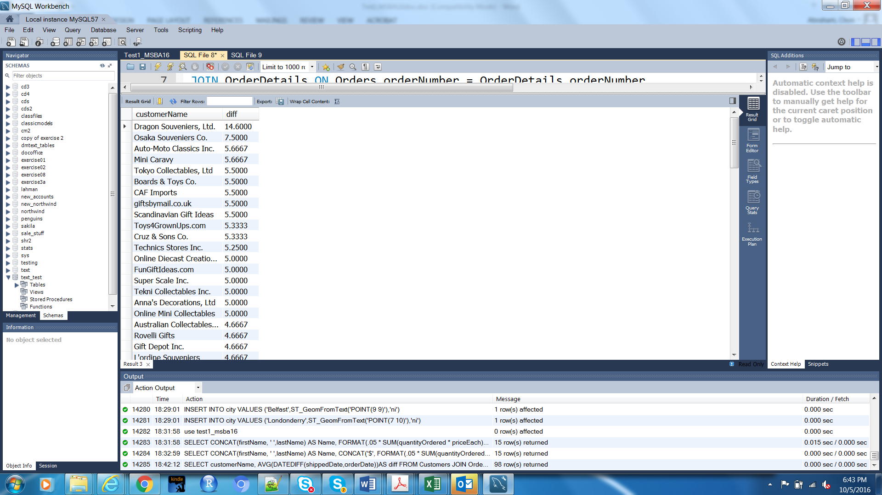

Question 13 (4pts) Show all employees and their supervisors and the titles even if the employees do not have a supervisor. All data you need to return resides in the Employees table.

select a.lastName, a.firstName, a.reportsTo, a.lastName, a.firstName, a.jobTitle
from employees a left join employees b
on a.reportsTo = b.employeeNumber;

A partial result set looks like this:
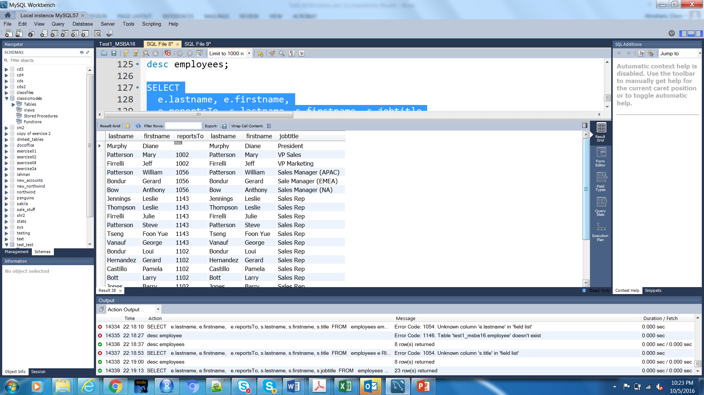

Question 14 (4pts) Write a query using CASE that shows buy prices for Products that are higher than the average for all buy prices in the Products table. Display also text description for the productline. See notes from Marathon Consulting from 30 Sep on CASE.
select products.productline as 'Category', textDescription as 'Promo', productName, buyPrice,
CASE
WHEN buyPrice > (select avg(buyPrice) from products) THEN 'Priced above average buy price'
WHEN buyPrice < (select avg(buyPrice) from products) THEN 'Priced below average buy price'
ELSE 'Priced at average buy price'
END AS 'Comment'
from products, productlines
where products.productLine = productlines.productLine;

A partial result set looks like:
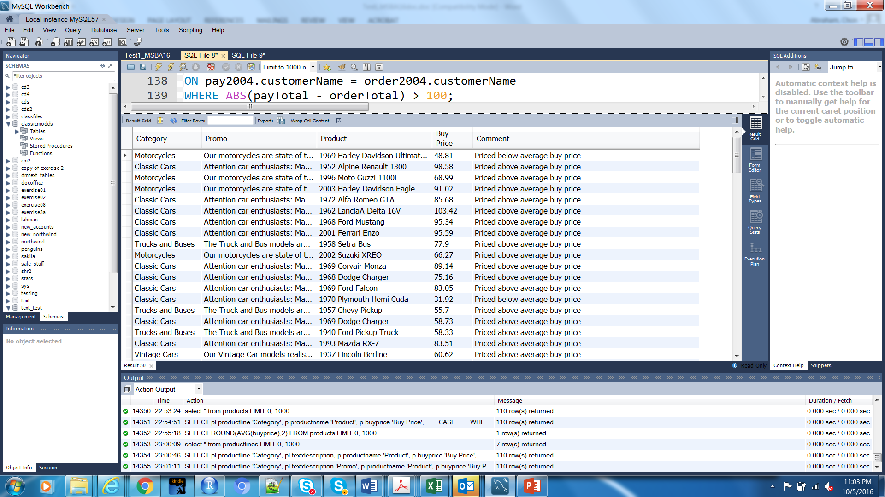

Question 15 (4pts) Write the code for a procedure to increase the price of a specified product category by a given percentage using the Products table. Do not actually create the procedure or call it to run in the test1_MSBA16 database. You can however use the Classicmodels database to test your code. How could you call and test your procedure? See notes from Marathon Consulting Sept 30 presentation.
DELIMITER //
DROP PROCEDURE IF EXISTS increasePrice//
CREATE PROCEDURE increasePrice
(
productNum varchar(15),
percentage double
)
BEGIN

UPDATE products
SET buyPrice = (1 + percentage) * buyPrice
WHERE productCode = productNum;
END//
DELIMITER ;
I would test my procedure in the following manner:
SELECT productCode, buyprice from products where productCode='S10_1678';
CALL increasePrice ('S10_1678', .05);
SELECT productCode, buyprice from products where productCode='S10_1678';
This would run a query that shows the original buyprice for one specific product, then use my procedure to increase the price, and then run a second query which shows the updated price. Since this is done with the CM database, there is no need to worry about the data being changed, as the database can be reverted back to its original state with the original sql script for the database.

Question 16 (4pts) Create a query that returns the sum of orders submitted by customers handled by employees. Find the Order Total using priceEach * quantityOrdered from the Orderdetails table. Othere tables required in the query are employees, customers (which includes the salesper who is an employee), and orders. Use IFNULL and WITHROLLUP (see Chp 4 slides).

SELECT IFNULL(c.categoryname, 'Grand Total') 'Category',
IFNULL(p.productname, 'Category Summary') 'Product Name',
SUM(od.quantity) 'Total Units Sold',
MAX(od.quantity) 'Max Units Sold',
MIN(od.quantity) 'Min Units Sold',
ROUND(AVG(od.quantity)) 'Avg Units Sold'
FROM categories c JOIN products p ON (c.categoryID = p.categoryID)
JOIN order_details od ON (p.productID = od.productID)
GROUP BY c.categoryname, p.productname WITH ROLLUP;

A partial result set showing the Grand Total line is as follows:

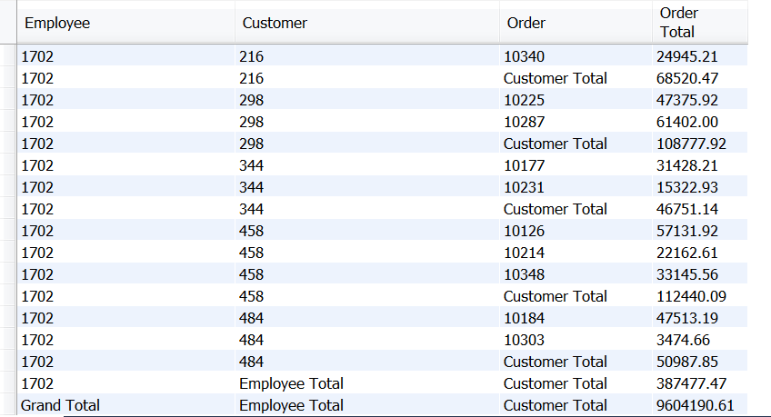

Question 17 (4pts) Compute the commission for each sales representative, assuming the commission is 5% of the value of an order (i.e., quantityOrdered * priceEach). Sort by employee last name and first name. The following table are used in this query from the Classic Models database that have been imported into the Test1_MSBA16 database: Employees, Customers, and OrderDetails. Concatenations and alias’s are needed for the result set.

select concat(employees.firstName, ' ' ,employees.lastName) as 'Name', round(sum(.05*(quantityOrdered * priceEach)),0) as 'Commission'
from orderdetails join orders
on (orderdetails.orderNumber = orders.orderNumber)
join customers
on (orders.customerNumber = customers.customerNumber)
join employees
on (customers.salesRepEmployeeNumber = employees.employeeNumber)
group by (employees.lastName)
;

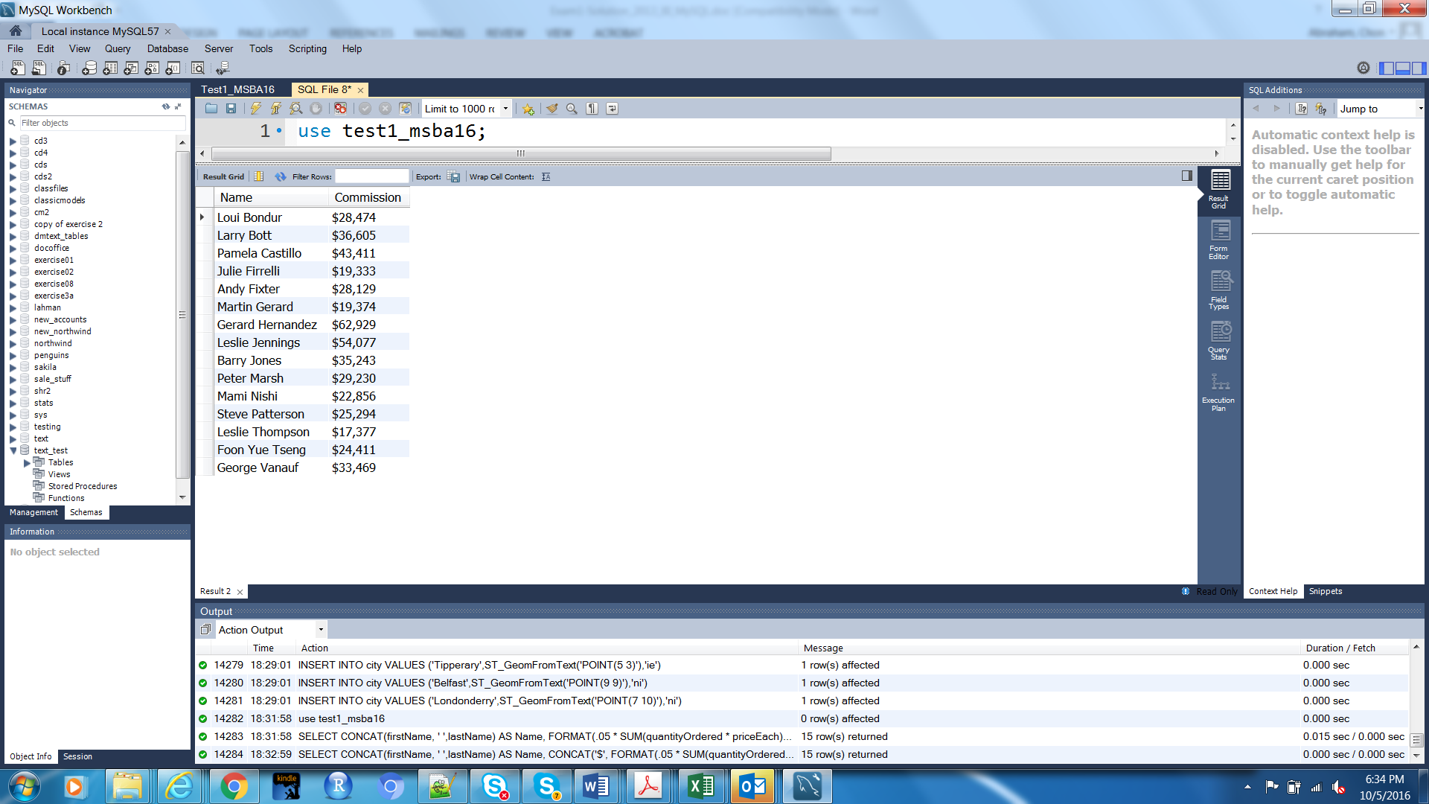

Question 18 (6pts) Compute the total value ordered, total amount paid, and their difference for each customer for orders placed in 2004 and payments received in 2004. Only report those customers where the absolute value (hint see https://dev.mysql.com/doc/refman/5.7/en/numeric-functions.html) of the difference is greater than $100. (Hint: Create a view for the total paid and a view for the total ordered then use both of those views as a single select statement like we did in Chp 4 slides on Views).

CREATE VIEW totalpaid (customerNumber, totalpaid)
AS
select customerNumber, sum(amount)
from payments
where year(paymentDate) = 2004
group by customerNumber;
CREATE VIEW totalordered (customerNumber, totalordered)
AS
select customerNumber, sum(priceEach*quantityOrdered)
from orderdetails od join orders o on od.orderNumber = o.orderNumber
where year(orderDate) = 2004
group by customerNumber;

select c.customerName 'customer', round(totalpaid,2) 'payments', round(totalordered,2) 'orders', round((totalpaid - totalordered),2) 'difference'
from totalpaid tp join totalordered tor on tp.customerNumber = tor.customerNumber
join customers c on tor.customerNumber = c.customerNumber
where abs(totalpaid - totalordered) > 100
order by c.customerName;

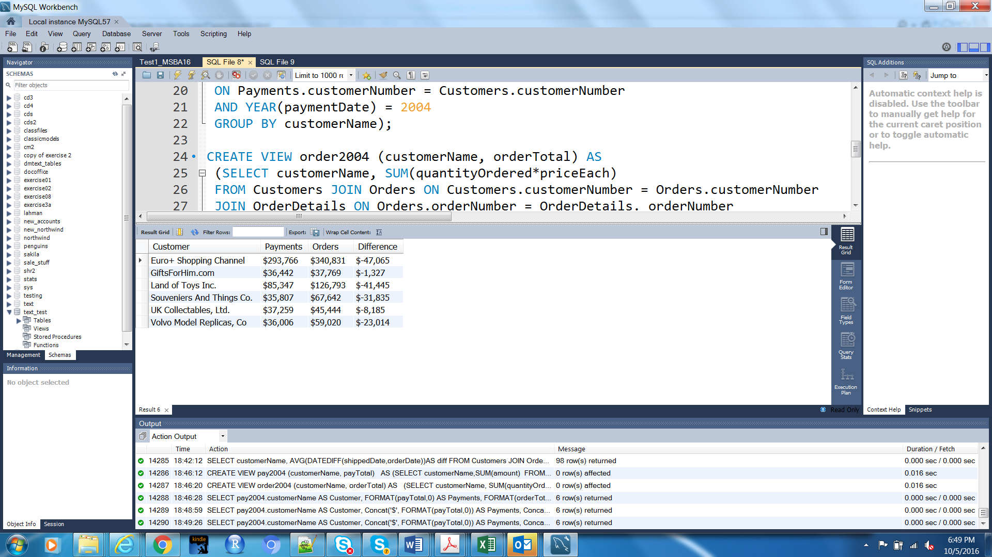
Question 19 (8pts) Review Chp 11 of the text (pgs 309-315) and slides posted in BB that demonstrate spatial data applications in MySQL that use basic functions such as latitude (x coordinate of a point), longitude (y coordinate of a point), and the length of a string from point to point. If you describe the Offices and Customers tables (i.e, DESC Office and DESC Customers, you will see that the locations are by points with x and y coordinates) Discussions from the Spatial Data session with Aid Data Personnel will be helpful to reference as well.
- (4pts) Write the SQL for which customers are south east of the New York office? Use x(variable) and y(variable) functions for the comparison of customerLocation to officeLocation in relation to NYC as the city.
select customerName, city
from customers
where st_x(customerLocation) < (select st_x(officeLocation)
from offices
where city = 'NYC'
) AND
st_y(customerLocation) < (select st_y(officeLocation)
from offices
where city = 'NYC'
);

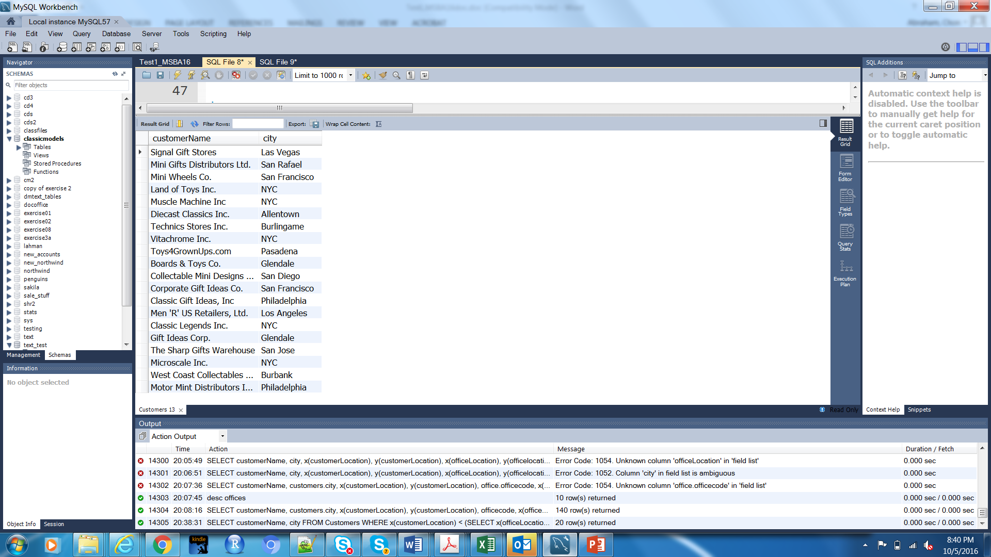

- (4pts) Which customers are closest to the Tokyo office? Use GLength(LINESTRING) function for (customerLocation, officeLocation) in a subquery to determine the MIN distance.
select c.customerName, c.city
from customers c, offices o
where o.city = 'Tokyo'
and (st_length(linestring(c.customerLocation, o.officeLocation))) < 50;

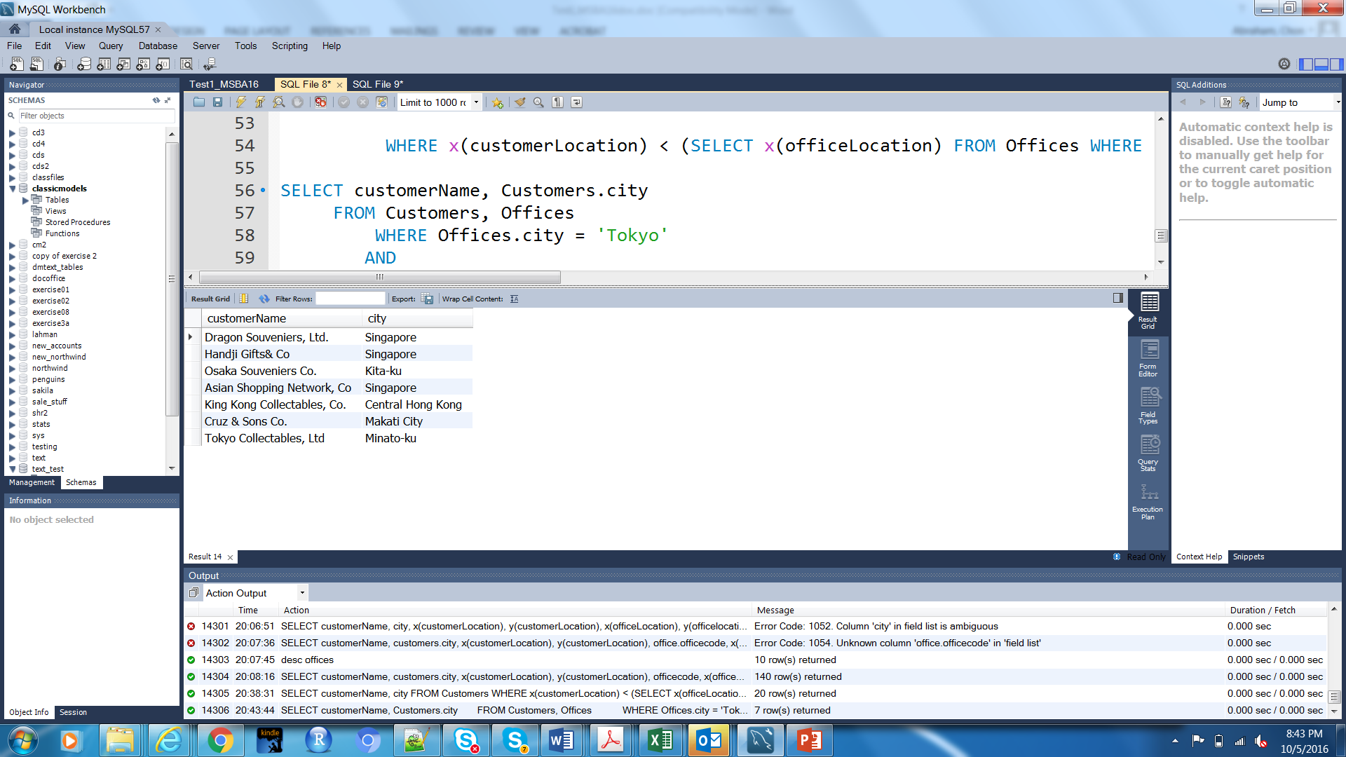
Question 20 (6pts): Relational databases and normalization

- (1pt) What are the primary components of a relational database ? Be descriptive about the characteristics and reference normalization.
A relational database is a database which consists of several tables that are all related to each other in some way. Each table contains rows of data where each row consists of several columns of data. All rows in the table should have the same number of columns, though the values for some columns may be null valued. These columns cannot be null valued for columns which uniquely identify one row from another in the table, IE the primary key. Some columns will be shared across tables. Columns which appear in more than one table define relationships between tables. Rows of different tables which share column values for a specific column are related. Some tables require that data which appears in these shared columns exist in a different table beforehand as a reference before the data can be entered into the table. This is called a foreign key.
Normalization is a technique which is vital in database construction, and typically normalizing databases to at least the 3NF is acceptable. 1NF seeks to eliminate redundancy, 2NF seeks to make sure all data in the table is dependent on the primary key and not extraneous, 3NF seeks to make sure all non-key columns are independent of one another and not dependent on anything but the primary key.

- (1pt)Why should databases be normalized?
Databases should be normalized because normalization reduces redundancy, makes a database take up less computer resources, and makes the overall database easier to query and build upon.

- (4pts) Create a normalized data model for the following un-normalized data (cut and paste a screen shot of your .mwb):
  - Professors are restricted to indicating one preference for a type of Teaching Assistant (TA) that should always remain current (i.e., profs may not indicate multiple TA types as preferences)
  - Professors can be assigned multiple TAs and TA’s can be assigned to multiple professors
  - TAs of the same type receive the same stipend
  - You may add additional attributes based on your assumptions
Prof | Prof_TA_Pref _Type | TA_1 | TA_1_Stipend | TA_1_Type | TA_2 | TA_2_Stipend | TA_2_Type
Dana  James | Graduate_MBA | James  Lee | $10,000 | Graduate_MBA | Mary Moore | $10,000 | Graduate_MMR
Billy  Smith | Graduate_MMR | Carl  Man | $10,000 | Graduate_MMR
Kathy  Jones | Undergrad_BBA | Doug  Sims | $5,000 | Undergrad_BBA | Blake Ives | $10,000 | Graduate_MBA

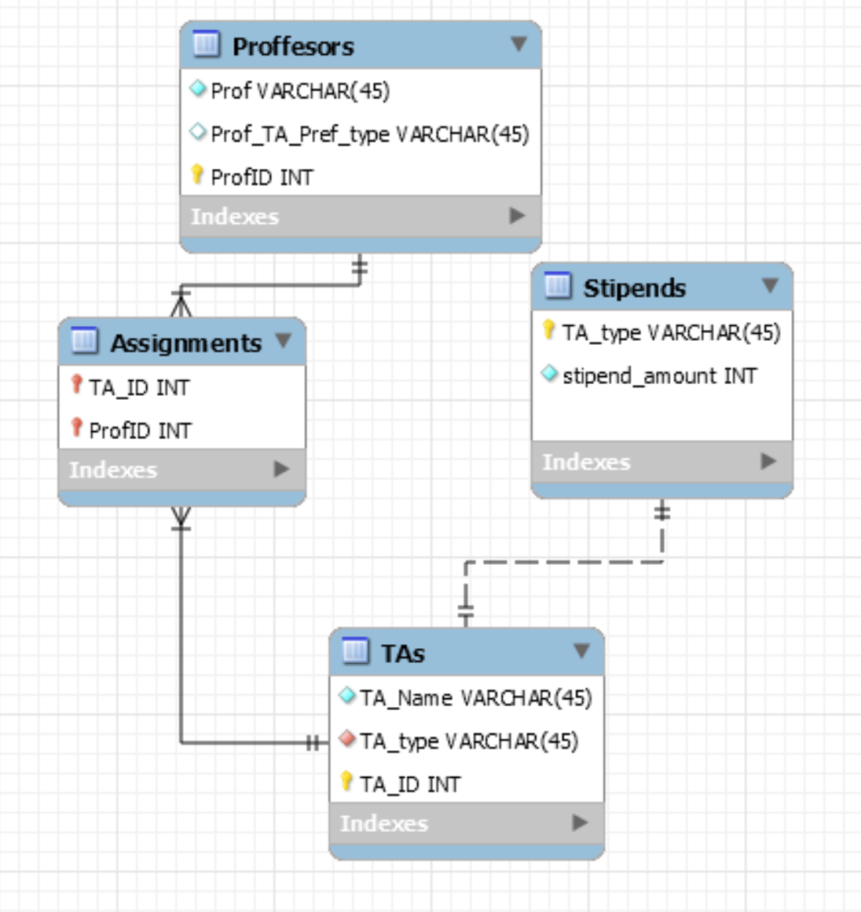

Question 21 (3pts) In very basic terms, explain what the universal quantifier known as “for all”
or when a condition is true “for all” rows (i.e., transactions) in a table. How is this type of query
executed (i.e., what are the main SQL commands for implementing this type of query? See
Chapter 5 slides.

The universal qualifier known as “for all” is known as the Divide in SQL. It returns when for all instances where the testing condition is always met. It is written in SQL by using a NOT EXISTS clause to transform the problem. For example, in a database that records people, trips, and a relation for those two tables, a query for finding all people who have appeared on all possible trips would turn into a query for finding all people such that there does not exist a trip in which this person wasn’t present. The use of the NOT EXISTS ultimately functions as a conditional statement that filters out rows that don’t meet our specifications.

Question 22 (1pts) What is a regular expression, what SQL command can it replace, and provide an example? (See Chp 3 slides)

A regular expression is an expression used to pattern match strings of text. It can replace the sql ‘=’ command when matching for strings in the where or having clauses. Using the “like” function allows you to use a regular expression to pattern match text in a database and return specific rows that match the pattern. An example of a regular expression in a sql query would be:

Select * from alphabet
Where word like ‘r%c%r’;

This would return all rows from a table called alphabet where the data in the column corresponding to word contains text that starts with the letter r, contains the letter c, and ends with the letter r.

Question 23 (3pts) What are pros and cons of doing spatial data as SQL in relational database as opposed to running SQL in GIS packages such as PostGIS ( refer to discussion with the Aid Data personnel or research an answer).

PROS OF DOING SPATIAL DATA AS SQL IN RELATIONAL DATABASE
- Compatibility with outside languages such as R and Python
- Lower learning curve for someone already using SQL

CONS OF DOING SPATIAL DATA AS SQL IN RELATIONAL DATABASE
- Potentially costly (MySQL is proprietary)
- More limited spatial functions

PROS OF RUNNING SQL IN GIS PACKAGES
- Compatibility with outside languages such as R and Python
- Open Source and Free (with Postgres/PostGIS)
- Expanded spatial functionality
- Support for rasters and 3D

CONS OF RUNNING SQL IN GIS PACKAGES
- Potential for too many features added for a simpler spatial problem, bloating (though this may be more of a user problem than anything else)

Extra Credit (5pts)

- Use R or RStudio to run an SQL query and then visualize the results. Prepare a line plot with appropriate labels for total payments for each month in 2004. All attributes are in the Payments table. You can cut and paste your code here and a screenshot of the visualization.
***
Just copy paste into old SQL which does a mysql query
The SQL structure is
SELECT ________(paymentDate) AS Month, _____(amount) AS Sum
FROM Payments
WHERE _______(paymentDate) = 2004
GROUP BY _______(paymentDate)
#VJ Davey
#10/17/2016
#extra credit
library(DBI)
conn<-dbConnect() #insert your connection stuff here.
sql<-"
SELECT month(paymentDate) AS Month, round(sum(amount),2) AS Sum
FROM Payments
WHERE year(paymentDate) = 2004
GROUP BY month(paymentDate);
"
res <- dbGetQuery(conn, sql)
res
library(ggplot2)
ggplot(data = res, aes(x = Month, y = Sum)) + geom_line()+labs(title="Monthly Payment Totals", y="Payment Totals ($)")+scale_x_continuous(breaks=seq(1,12,1))+scale_y_continuous(breaks=seq(0,900000,60000))
