Test 1 For Database Management Fall 2016 (MSBA)
Dr. Chon Abraham
Date:
Type Name ___________________________

*This test is an individual effort but you may use any class materials or online resource other than another individual for assistance and by printing your name you adhere to this requirement.*

Instructions:
(a) LOAD test1_msba16.sql and USE it for this test’s SQL questions.
/* I put all tables from across the various exercises into one database for use in the test. Be sure to look through the .sql and refresh your Navigator in Workbench to see the tables in this database to know the attributes contained and PK/FK constraints*/

(b) Cut and past all .mwb files into the respective questions into this document. I do not need a separate .mwb file

(c) Create a .sql with comments indicating the question number that the code is answering. Submit this .sql with this .doc in your test 1 submission link as Test1_YourLastName.sql and Test1_YourLastName .doc or docx. Cut and paste all SQL into this document as well so that I can award partial credit even it something does not run.

Question 1: (10 pts = 1pt each)

RACE

* race_name
* race_length
* race_date

RESULT
time

RUNNER

* runner_id
runner_l_name

Is president of

CLUB

* club_name
club_address
club_city
club_state
club_telephone

Organizes

From the above data model, it can be inferred that… [Answer (T)RUE or (F)ALSE]:

1) This data model does not support the situation where two runners would have the exact same time in a particular race.

ANSWER: ____

2) A runner does not need to be part of a club to participate in a race.

ANSWER: ____

3) The table RUNNER, when created, will have one FK

ANSWER: ____

4) The table RACE, when created, will have a composite PK made of 4 columns.

ANSWER: ____

5) This data model does not support the situation where one runner has the exact same time in two different races.

ANSWER: ____

6) Having referential integrity means that a runner’s resulting time in a race cannot be stored unless the runner has an associated runner_id stored in the RUNNER table and the race information is stored in the RACE table. ANSWER: ____

7) The CLUB and RESULT tables are both independent tables. ANSWER:____

8) The phrase “Is president of” is a describing a recursive relationship. ANSWER: ___

9) Joins between the RUNNER, RESULT, RACE, and CLUB tables are required to get the name of the race, the resulting time for a runner, the runner’s name and the club’s name in the output for a single query. ANSWER:____

10) A join between the RUNNER, RESULT, and CLUB tables will give you the name of the race, the resulting time for a runner, the runner’s name and the club’s telephone number in the output for a query.
ANSWER:___

Question 2: (5 pts) (cut and paste a screenshot of your .mwb)

In designing an application to store appointments between professors and students, a database must be created. For each appointment, the application needs to know the date, start time, duration, who were the student and faculty involved, and what was the purpose of the appointment. For example, an appointment might be scheduled on October 7, 10:00am, for 15 minutes, between the student Joe Smith and the faculty Dana Abraham, to clarify data management concepts (i.e., purpose for the appointment).

You can assume that each appointment is between one faculty and one student. Also, note that it is possible for a given student to meet more than once, on a given day, with a given faculty.

Insert your .mwb screenshot for the data model to accurately represent the situation above:

Question 3: (10 pts) (cut and paste a screenshot of your .mwb)

The Virginia Best Hospital is a not-for-profit general hospital. It is a relatively small hospital, with some 200 beds at the present time. The director of Virginia Best Hospital has provided the following information about the hospital’s environment:

- The hospital includes many facilities (located all over Virginia). A facility maintains a number of laboratories (such as radiology, hematology, and so on). A facility has a unique identification number, address, phone number, and type of care (short-term/long-term). Laboratory identification numbers are unique within a given facility, but they may be redundant across facilities.

- Each facility has a number of physicians working for it. A physician, however, can only work for one facility. The hospital does not need to keep track of the fact that a physician may have worked for other facilities in the past. Basic information must be kept about each physician (i.e., identification number and name).

- Each laboratory offers many types of tests. A type of test can be offered by many laboratories. A blood test, for instance, can be offered by either a hematology laboratory or by a toxicology laboratory.

- Each laboratory has one physician at its head. A physician cannot head more than one laboratory (if any).

Insert the screen shot of the data model to accurately represent the situation above:

Answer the following questions using the tables below. Note: Attributes COURSECREDIT and DURATION-VALIDITY have a number data type, and all other attributes have a text data type. DURATION-VALIDITY refers to the time period (counted in number of semesters) during which a student must have taken the prerequisite in order for it to be considered as valid.

Consider the following data model:

COURSE

* courseid
coursedesc
coursecredit

PREREQ

Duration-validity

COURSE Table
Primary key: COURSEID
Foreign keys: none

courseID | courseDesc | courseCredit
CSCI1111 | Intro to Computers | 4
EC101 | Intro to Electronic Commerce | 3
EC205 | Management of Virtual Organizations | 6
ENG1111 | English1 | 2
FIN1111 | FINANCE1 | 3
FIN3333 | FINANCE2 | 3
FIN4444 | Corporate Fin | 3
FIN5555 | Real Estate | 3
FIN6666 | Investments | 3
FR101 | French 1 | 2
MA1111 | College Algebra | 4
MA2222 | Calculus1 | 4

PREREQ Table
Primary key: COURSEID & PREREQID
Foreign keys: COURSEID (references the COURSE table)
PREREQID (references the COURSE table)
courseID | prereqID | duration-validity
EC205 | EC101 | 3
FIN3333 | CSCI1111 | 9
FIN3333 | ENG1111
FIN3333 | FIN1111 | 9
FIN3333 | MA1111 | 15
FIN3333 | MA2222 | 15
FIN4444 | FIN3333 | 6
FIN5555 | FIN3333 | 6
FIN6666 | FIN3333 | 6

Question 4 (4pts): Write the CREATE TABLE statement for the Prereq table. Do not re-create this statement in the Test1.mdb.

Question 5 (3pts): Write the SQL to generate the list of all prerequisite id(s) (prereqIDs) for the course that has the description “Management of Virtual Organizations”. [Hint: Looking for the prerequisites for Management of Virtual Organizations, which is the main course not the prerequisite course.]

PREREQID
EC101
Question 6 (3pts): Write the SQL statement to generate the list of course descriptions and course credits of all the courses that have a prerequisite that has a course description starting with the letter E and ending with the number 1. [Hint: You can solve this by creating a copy of the Course table or using an IN and you must use a pattern matching command meet conditions for the prerequisite course description.]

COURSEDESC | COURSECREDIT
FINANCE2 | 3

Consider the data model & sample tables below for the following questions.

WORKER

* worker_id
worker_name
hrly_rate
skill_type

BUILDING

* bldg_id
bldg_address
bldg_type
bldg_qlty_lv
ASSIGNMENT

Start_date
Num_days

supervises

Table WORKER
Primary key: WORKER_ID
Foreign key: none

WORKER_ID | WORKER_NAME | HRLY_RATE | SKILL_TYPE
1235 | Faraday | 12.50 | Electric
1412 | Nemo | 13.75 | Plumbing
2920 | Garret | 10.00 | Roofing
3231 | Mason | 17.40 | Framing
9909 | Smith | 15.00 | Electric
- etc. -

Table ASSIGNMENT
Primary key: WORKER_ID + BLDG_ID
Foreign keys: WORKER_ID (references the WORKER Table)
BLDG_ID (references the BUILDING Table)

WORKER_ID | BLDG_ID | START_DATE | NUM_DAYS
1235 | 321 | 8/10/2001 | 5
1412 | 321 | 8/1/2001 | 10
1235 | 515 | 5/17/2001 | 22
2920 | 460 | 9/15/2001 | 18

Table BUILDING
Primary key: BLDG_ID
Foreign key: BLDG_SUP (references the WORKER Table)

BLDG_ID | BLDG_ADDRESS | BLDG_TYPE | BLDG_QLTY_LV | BLDG_SUP
321 | 123 Elm | Office | 2A | 1412
435 | 456 Maple | Retail | 1B | 1235
515 | 789 Oak | Residence | 3A | 9909
460 | 1011 Birch | Office | 2A | 2920

Note#1: Attribute HRLY_RATE in the WORKER table and NUM_DAYS in the ASSIGNMENT table have a number data type; START_DATE in the ASSIGNMENT table has a date data type; and all other attributes have a text data type.

Note#2: Assume that we only need to keep track of the current work assignments for each worker (i.e., we do not need to keep track of the history of a worker’s previous work assignments on different buildings).

Question 7 (3pts): In which table would you create an attribute to represent the worker who supervises a building? Why? Should this attribute be constrained as a foreign key?

Question 8 (3pts): Write the SQL code to generate the average weekly salary, assume a 36 hour work week (i.e., get the average of (hrly_rate *36) of all the “office” building supervisors. Label the average weekly salary as Supervisor's Average Weekly Salary. [Hint: Building supervisors are just workers who are designated as a supervisor (i.e., building.bldg_sup matches a worker.worker_id.) .

"Supervisor's Average Weekly Salary"
427.5

Question 9 (3pts): Write the SQL code to generate the list of workers (by worker name) who are paid more than $15 an hour and possess one of the following skills: Electric, Roofing, Framing. Order the result in descending order of worker name. [Hint: Using an IN for the skill types makes it easier to write this query].

WORKER_NAME
Mason

Question 10 (3pts): For each building type (BLDG_TYPE), indicate the total number of workers assigned, only if this total number is = 3. Label your count as Total Number of Assigned Workers. [Hint: There are multiple records for each building type and they need to be grouped as such, then restrict the query to show only those groups based on their records having certain conditions.]

BLDG_TYPE | 'Total Number of Assigned Workers'
Office | 3

Question 11 (3pts): Write the SQL code to generate the list of workers (by worker id and name) who supervise a building without being assigned to it. [Hint: You can use a NOT IN or NOT EXISTS to answer this question, where you are looking for worker_id (s) that appear in the Building table as bldg_sup (s) but that don’t appear in the Assignment table as a corresponding worker_id.]

Query1
WORKER_ID | WORKER_NAME
9909 | Smith

Question 12 (3pts) Compute the average time between order date and ship date for each customer ordered by the largest difference.

Partial Results are:
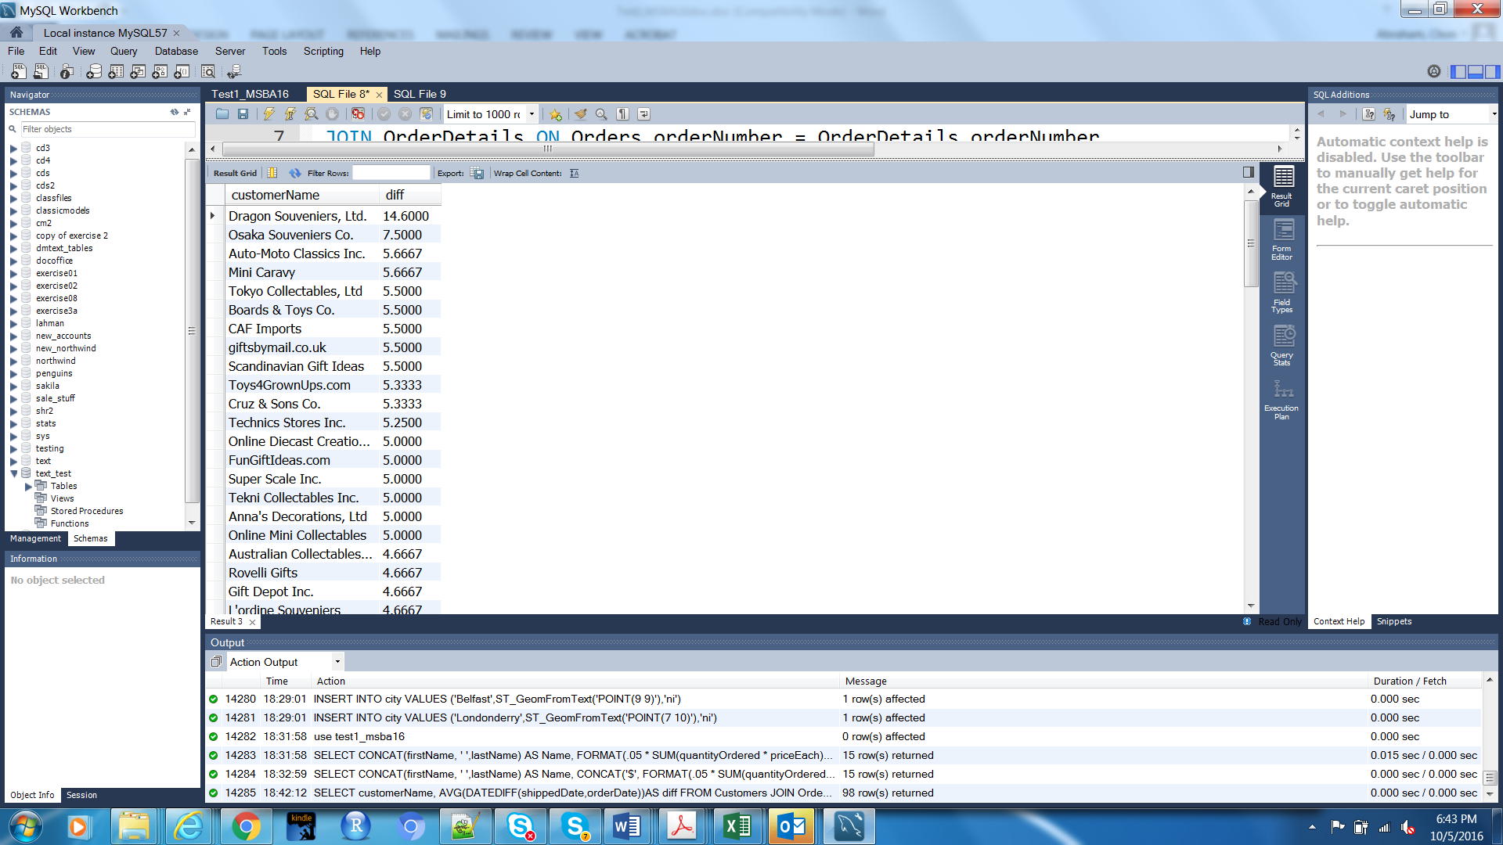

Question 13 (4pts) Show all employees and their supervisors and the titles even if the employees do not have a supervisor. All data you need to return resides in the Employees table.

A partial result set looks like this:
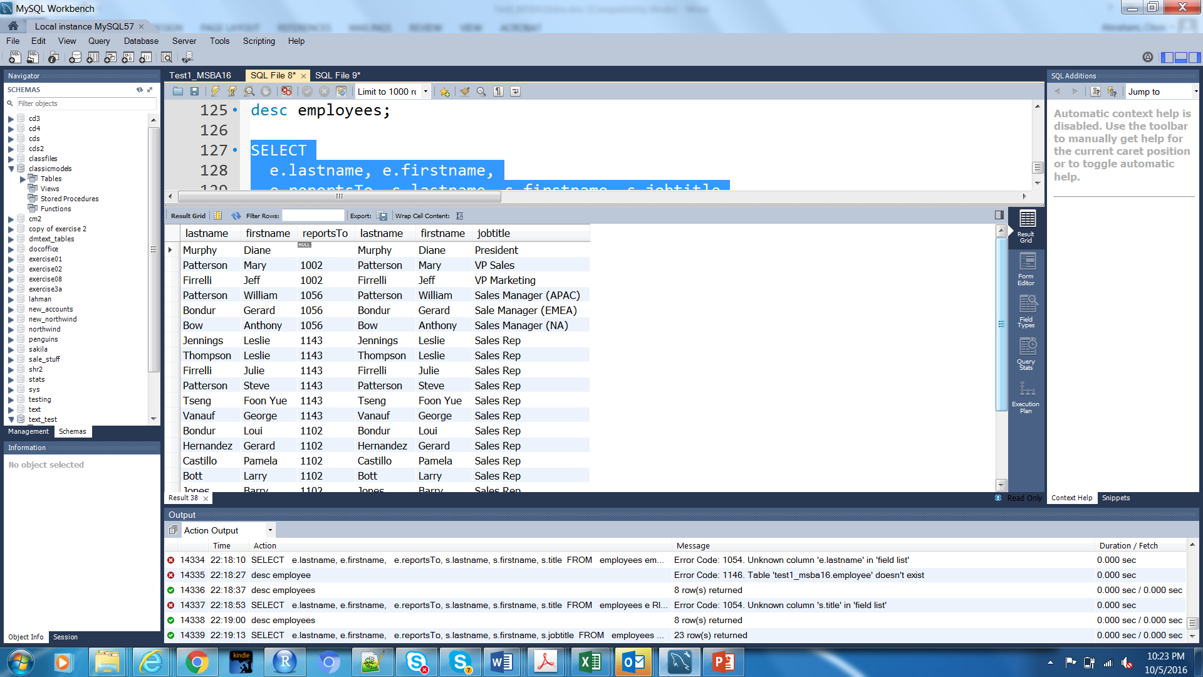

Question 14 (4pts) Write a query using CASE that shows buy prices for Products that are higher than the average for all buy prices in the Products table. Display also text description for the productline. See notes from Marathon Consulting from 30 Sep on CASE.

A partial result set looks like:
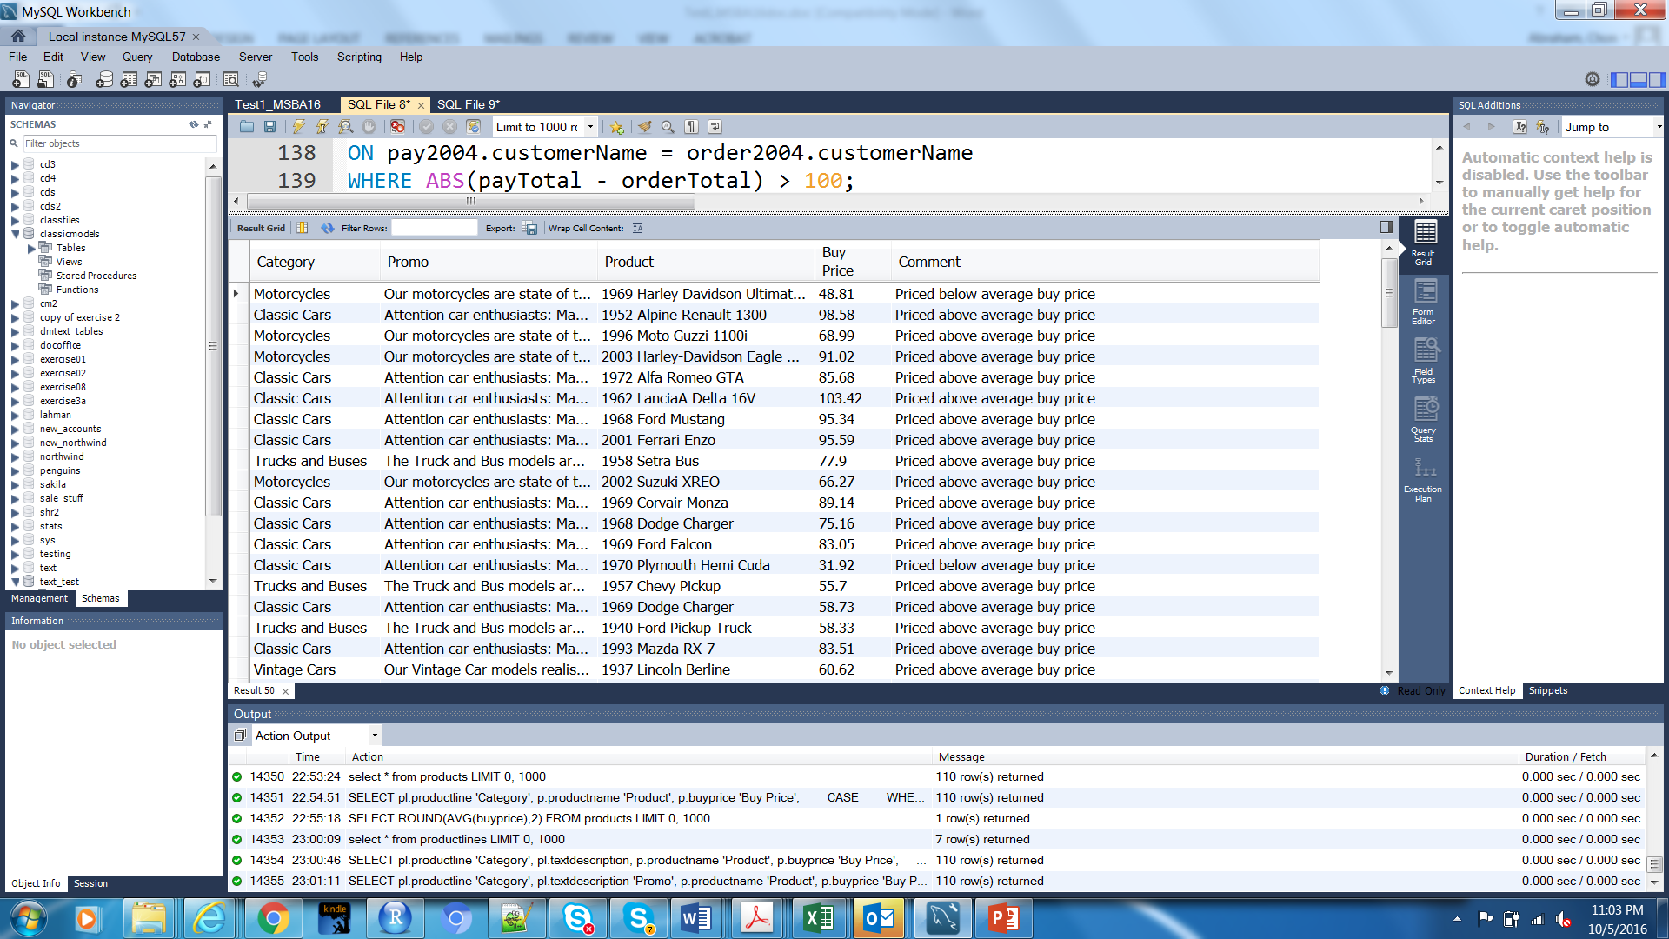

Question 15 (4pts) Write they code for a procedure to increase the price of a specified product category by a given percentage using the Products table. Do not actually create the procedure or call it to run in the test1_MSBA16 database. You can however use the Classicmodels database to test your code. How could you call and test your procedure? See notes from Marathon Consulting Sept 30 presentation.

Question 16 (4pts) Create a query that returns the sum of orders submitted by customers handled by employees. Find the Order Total using priceEach * quantityOrdered from the Orderdetails table. Othere tables required in the query are employees, customers (which includes the salesper who is an employee), and orders. Use IFNULL and WITHROLLUP (see Chp 4 slides).

A partial result set showing the Grand Total line is as follows:

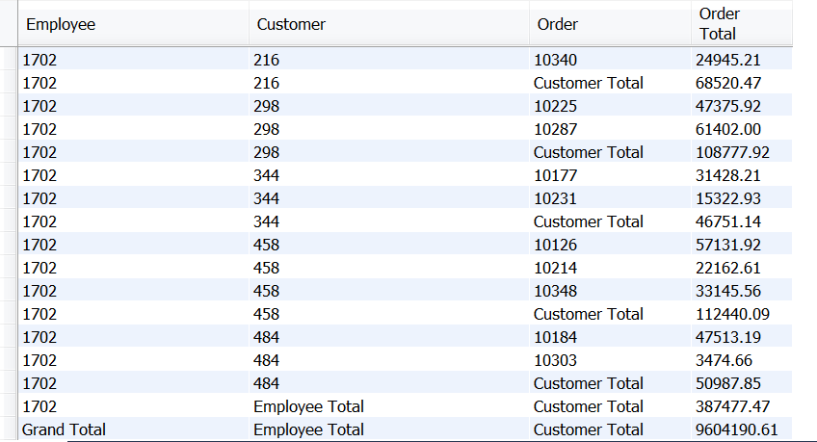

Question 17 (4pts) Compute the commission for each sales representative, assuming the commission is 5% of the value of an order (i.e., quantityOrdered * priceEach). Sort by employee last name and first name. The following table are used in this query from the Classic Models database that have been imported into the Test1_MSBA16 database: Employees, Customers, and OrderDetails. Concatenations and alias’s are needed for the result set.

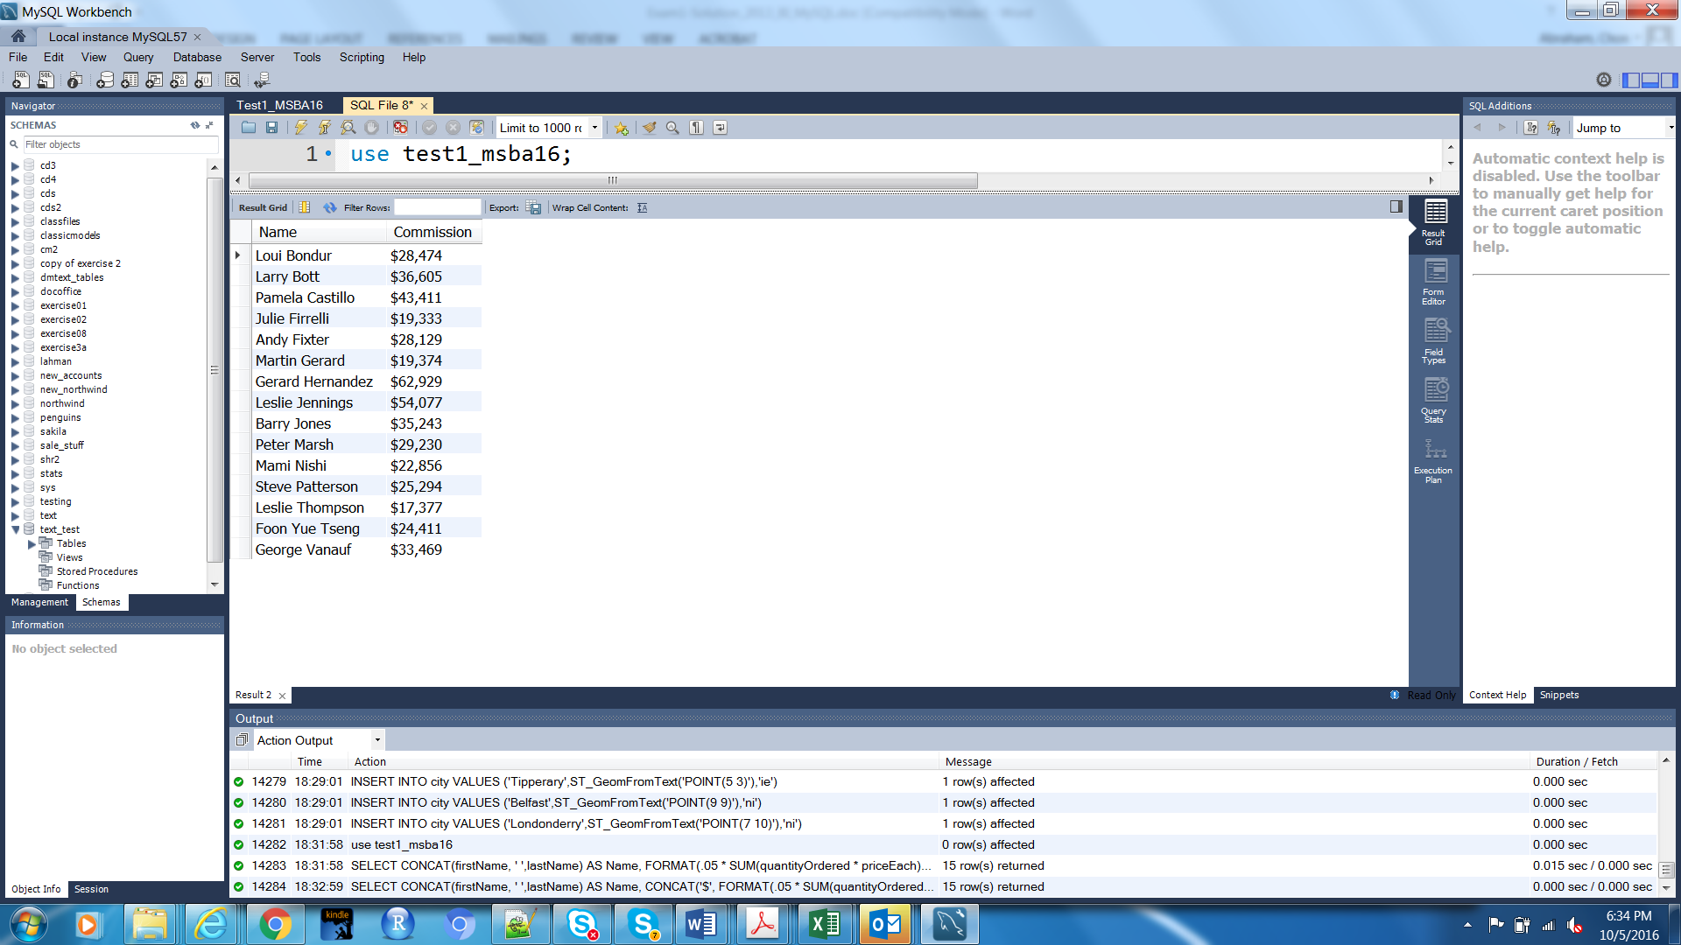

Question 18 (6pts) Compute the total value ordered, total amount paid, and their difference for each customer for orders placed in 2004 and payments received in 2004. Only report those customers where the absolute value (hint see https://dev.mysql.com/doc/refman/5.7/en/numeric-functions.html) of the difference is greater than $100. (Hint: Create a view for the total paid and a view for the total ordered then use both of those views as a single select statement like we did in Chp 4 slides on Views).

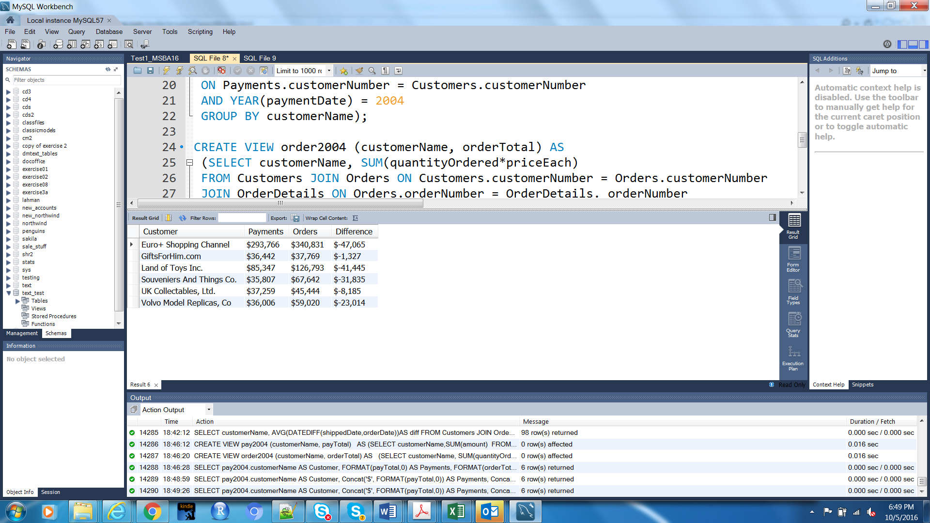
Question 19 (8pts) Review Chp 11 of the text (pgs 309-315) and slides posted in BB that demonstrate spatial data applications in MySQL that use basic functions such as latitude (x coordinate of a point), longitude (y coordinate of a point), and the length of a string from point to point. If you describe the Offices and Customers tables (i.e, DESC Office and DESC Customers, you will see that the locations are by points with x and y coordinates) Discussions from the Spatial Data session with Aid Data Personnel will be helpful to reference as well.
- (4pts) Write the SQL for which customers are south east of the New York office? Use x(variable) and y(variable) functions for the comparison of customerLocation to officeLocation in relation to NYC as the city.

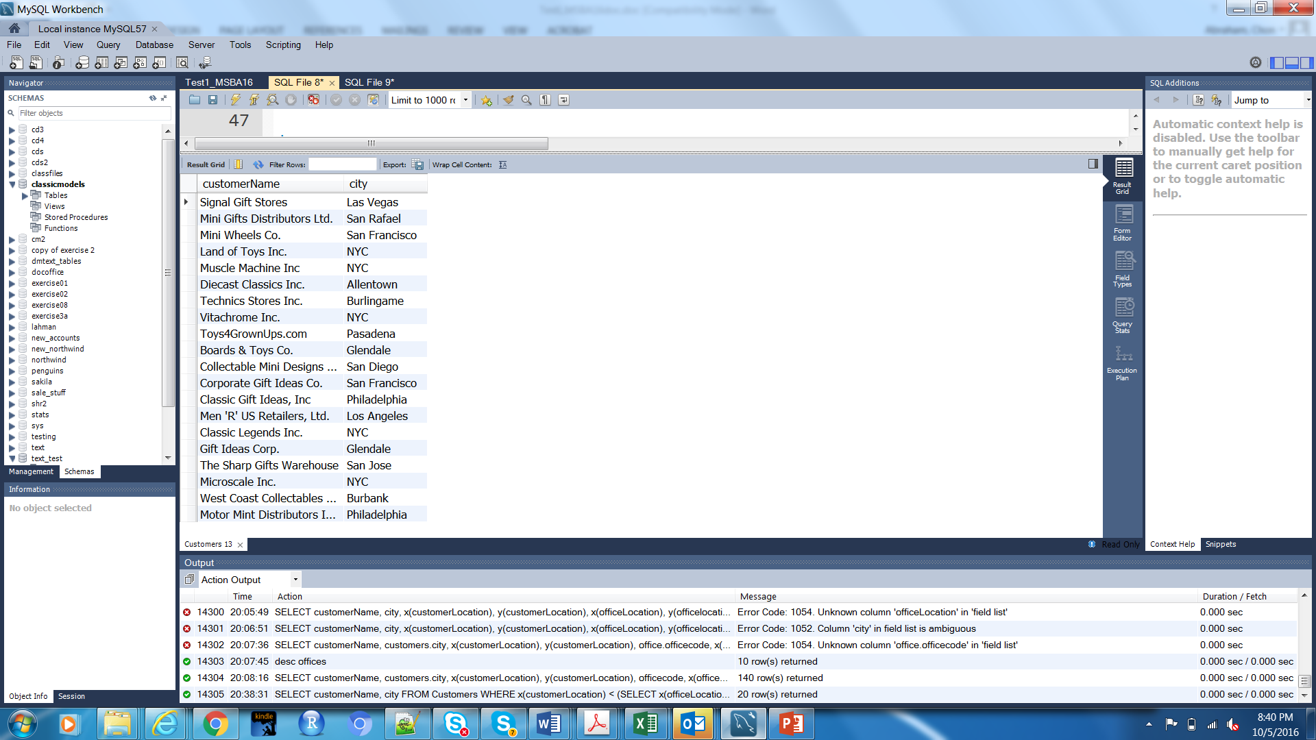
- (4pts) Which customers are closest to the Tokyo office? Use GLength(LINESTRING) function for (customerLocation, officeLocation) in a subquery to determine the MIN distance.

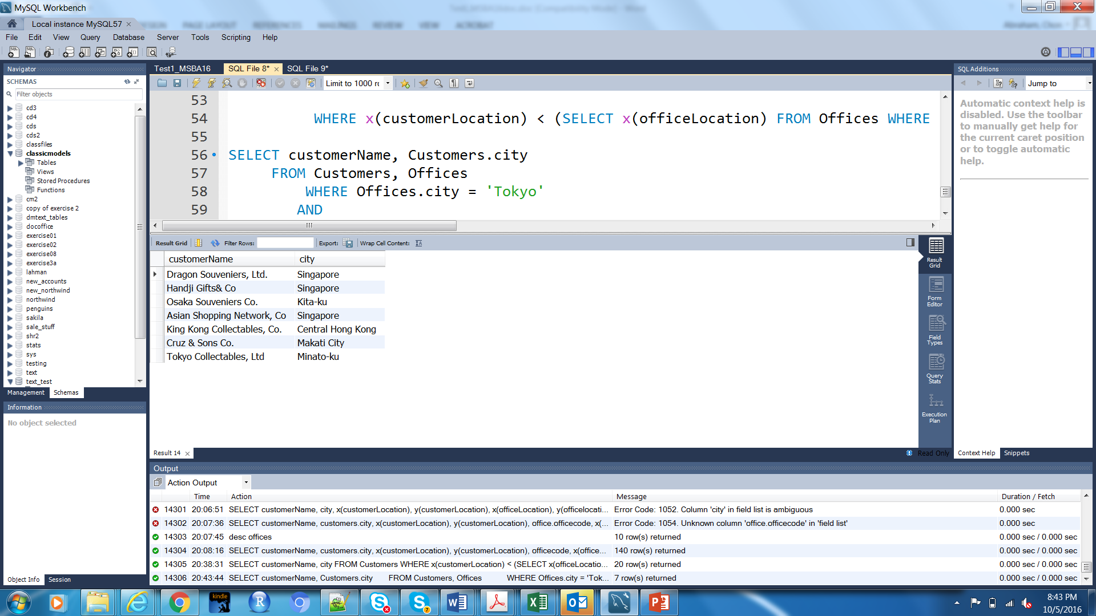
Question 20 (6pts): Relational databases and normalization

- (1pt) What are the primary components of a relational database ? Be descriptive about the characteristics and reference normalization.

- (1pt)Why should databases be normalized?

- (4pts) Create a normalized data model for the following un-normalized data (cut and paste a screen shot of your .mwb):
  - Professors are restricted to indicating one preference for a type of Teaching Assistant (TA) that should always remain current (i.e., profs may not indicate multiple TA types as preferences)
  - Professors can be assigned multiple TAs and TA’s can be assigned to multiple professors
  - TAs of the same type receive the same stipend
  - You may add additional attributes based on your assumptions
Prof | Prof_TA_Pref _Type | TA_1 | TA_1_Stipend | TA_1_Type | TA_2 | TA_2_Stipend | TA_2_Type
Dana  James | Graduate_MBA | James  Lee | $10,000 | Graduate_MBA | Mary Moore | $10,000 | Graduate_MMR
Billy  Smith | Graduate_MMR | Carl  Man | $10,000 | Graduate_MMR
Kathy  Jones | Undergrad_BBA | Doug  Sims | $5,000 | Undergrad_BBA | Blake Ives | $10,000 | Graduate_MBA

Question 21 (3pts) In very basic terms, explain what the universal quantifier known as “for all”
or when a condition is true “for all” rows (i.e., transactions) in a table. How is this type of query
executed (i.e., what are the main SQL commands for implementing this type of query? See
Chapter 5 slides.

Question 22 (1pts) What is a regular expression, what SQL command can it replace, and provide an example? (See Chp 3 slides)

Question 23 (3pts) What are pros and cons of doing spatial data as SQL in relational database as opposed to running SQL in GIS packages such as PostGIS ( refer to discussion with the Aid Data personnel or research an answer).

Extra Credit (5pts)

- Use R or RStudio to run an SQL query and then visualize the results. Prepare a line plot with appropriate labels for total payments for each month in 2004. All attributes are in the Payments table. You can cut and paste your code here and a screenshot of the visualization.

The SQL structure is
SELECT ________(paymentDate) AS Month, _____(amount) AS Sum
FROM Payments
WHERE _______(paymentDate) = 2004
GROUP BY _______(paymentDate)

