NAME: ____________________________________

Exercice #1 – Topics from Chapter 3

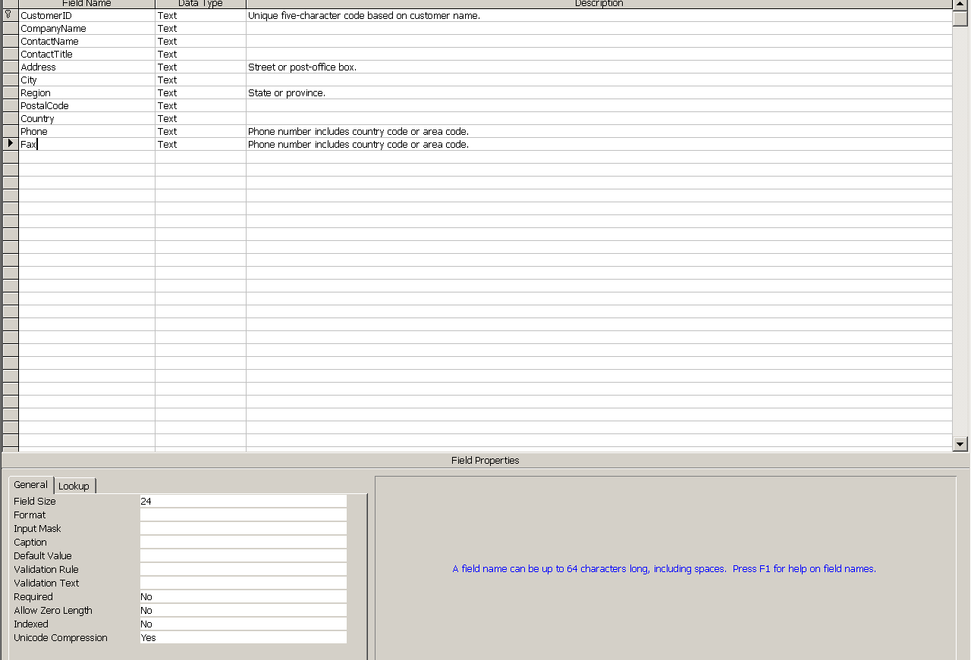

Answer the following questions based on the table above.

- List the company name, city, region and postal code for all Customers. Put the list in order of region, then city.

- List the company name, city, region and postal code for all Customers who are located in Oregon. Put the list in order of region, then city, then company name. (Hints: OR is the Region value when a company is located in Oregon.)

- List the company name, city, region and postal code for all Customers who are located in Oregon or Washington. Put the list in descending order of region, then in ascending order of city and company name.

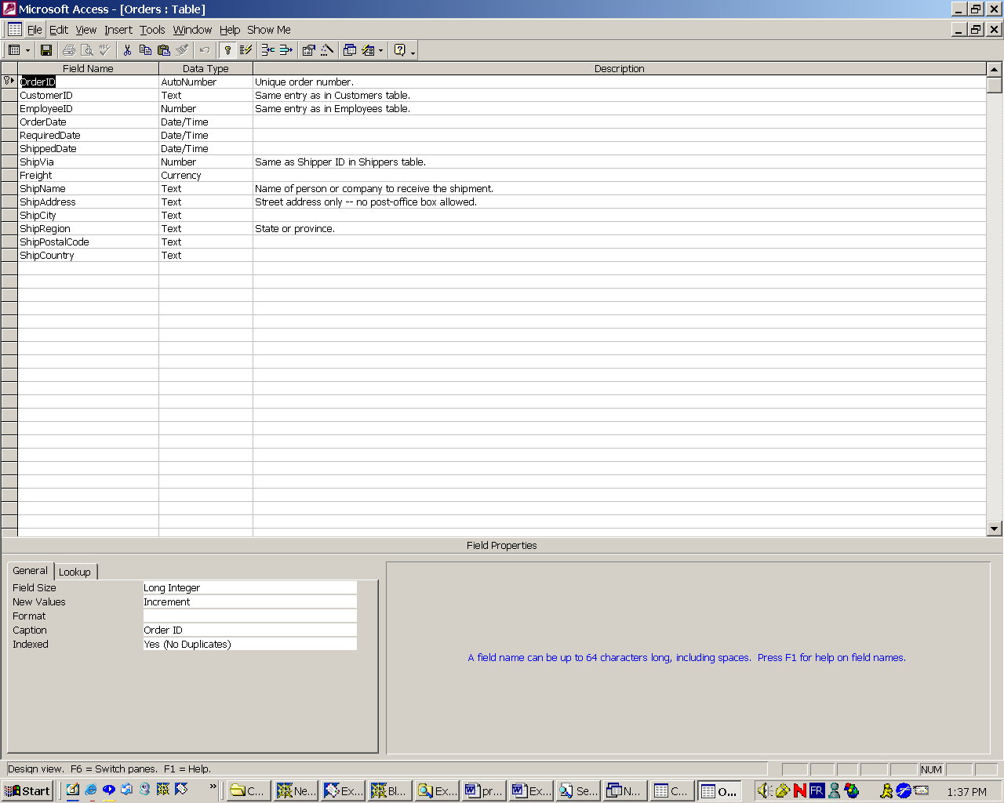

Answer the following questions based on the table above.

- List the order ID, customer ID, and date for all orders placed by customers with the ID 'QUICK' , 'FRANK' or 'RANCH'. Put the list in order of customer ID, then date.

- Show the customer ID and number of orders placed by customers with the ID 'QUICK' , 'FRANK' or 'RANCH'. Put the list in order of customer ID. (Hint: The results will have two columns and three rows.)

- Repeat the query for Problem 5, but label the number of orders placed column with the heading "OrdersPlaced."

- Write a query that answers the following question. How many different customers have placed orders?

- Write a query that answers the following question. How many orders were placed in May of 1998? Use the heading "Orders placed in May 1998" as your column heading.

- Write a query that answers the following question. How many different customer placed orders in May of 1998?

- Show the customers and the count of their orders for customers with orders greater than 10 and average freight costs more than 100. Show the freight cost as currency with $ and show the column title as Freight Cost (hint use a concatenation for the $ and average freight cost formatted to show two decimal places).

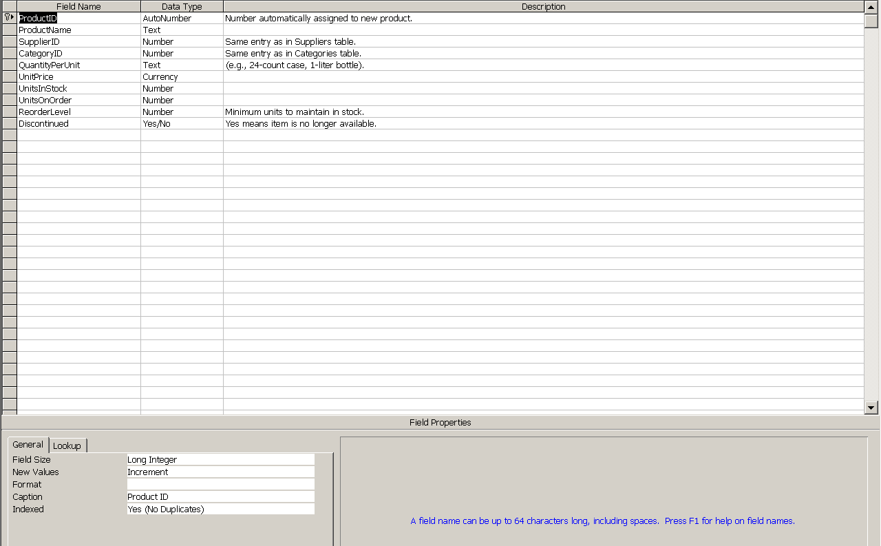

Answer this last question based on the table above.

- List the product ID, supplier ID, number of units in stock and discontinued status (1 = yes, 0 = no) of all products that are supplied by suppliers 2 or 12 that have not been discontinued and that have less than 60 units in stock. Put the list in order of supplier ID, then in descending order of the quantity of units in stock.

