Exercise # 3a – Topics from Chapter 3, 4 and 5

NAME: ____________________________________

Considering the data model & tables below, answer the questions on the next page.
Note#1: Attribute HRLY_RATE in the WORKER table and NUM_DAYS in the ASSIGNMENT table have a number data type; START_DATE in the ASSIGNMENT table has a date data type; and all other attributes have a text data type.
Note#2: Assume that we only need to keep track of the current work assignments for each worker (i.e., we do not need to keep track of the history of a worker’s previous work assignments on different buildings).

WORKER

* worker_id
worker_name
hrly_rate
skill_type

BUILDING

* bldg_id
bldg_address
bldg_type
bldg_qlty_lv
ASSIGNMENT

start_date
num_days

WORKER Table
Primary key: WORKER_ID
Foreign key: none

WORKER_ID | WORKER_NAME | HRLY_RATE | SKILL_TYPE
1235 | Faraday | 12.50 | Electric
1412 | Nemo | 13.75 | Plumbing
2920 | Garret | 10.00 | Roofing
3231 | Mason | 17.40 | Framing
9909 | Smith | 15.00 | Electric
- etc. -

ASSIGNMENT Table
Primary key: WORKER_ID + BLDG_ID
Foreign keys: WORKER_ID (references the WORKER Table)
BLDG_ID (references the BUILDING Table)

WORKER_ID | BLDG_ID | START_DATE | NUM_DAYS
1235 | 321 | 8/10/2001 | 5
1412 | 321 | 8/1/2001 | 10
1235 | 515 | 5/17/2001 | 22
2920 | 460 | 9/15/2001 | 18
- etc. -

BUILDING Table
Primary key: BLDG_ID
Foreign keys: none

BLDG_ID | BLDG_ADDRESS | BLDG_TYPE | BLDG_QLTY_LV
321 | 123 Elm | Office | 2A
435 | 456 Maple | Retail | 1B
515 | 789 Oak | Residence | 3A
460 | 1011 Birch | Office | 2A
- etc. -

Q1. List the weekly pay for each electrician (show the worker’s name and weekly pay) who has an assignment on a particular building. Assume a 36-hour workweek. List each worker’s name once.

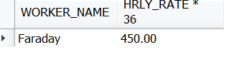

Q2. List the skill types of workers who are assigned to building 321. Show the worker’s name and skill type. Order by descending order of worker’s hourly rate.

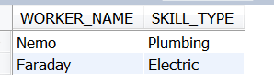

Q3. List the highest and the lowest hourly wages paid to a worker. Then rewrite the query to add the workers names with a UNION to get the following:

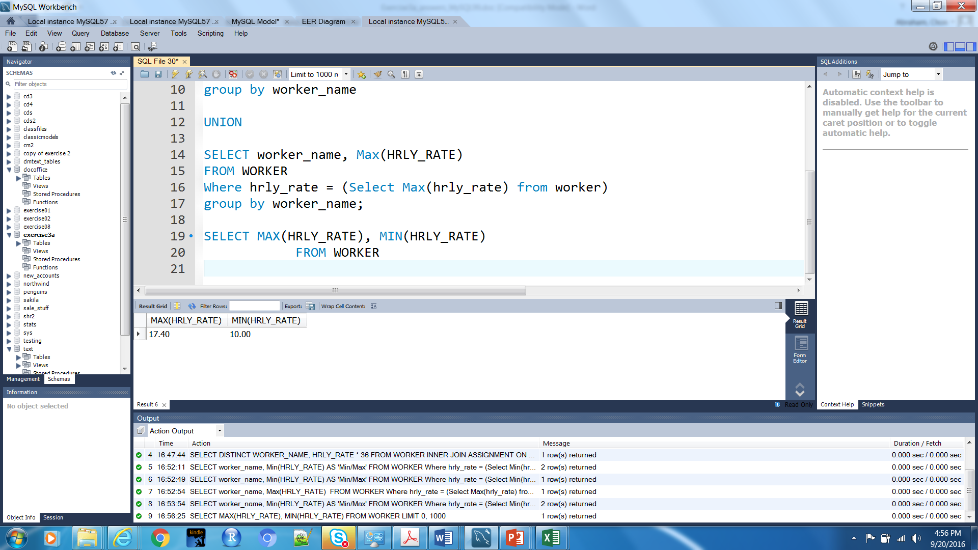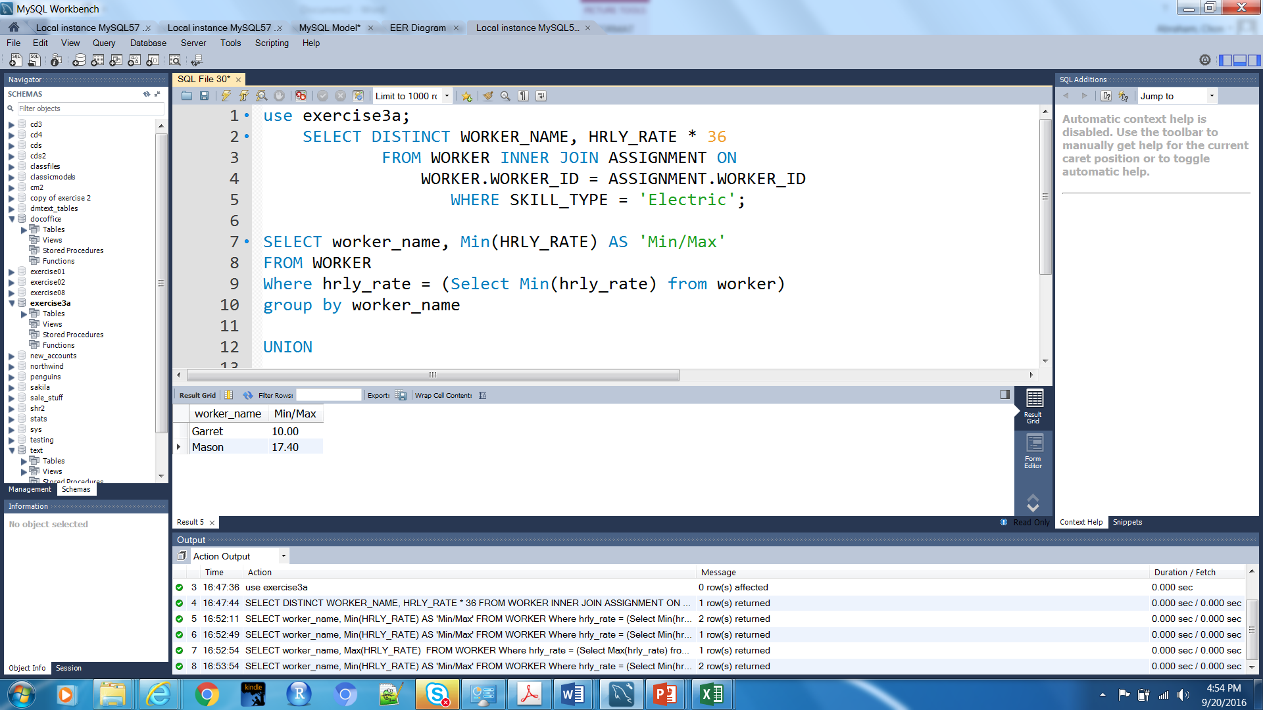

Q4. For the office buildings only, list the worker ID and building ID for the assignments that have started after 09/10/2001. To see the date format stored do: Select DATE(start_date) from assignment limit 1;
Then rewrite the query to show the name(s) of the worker.

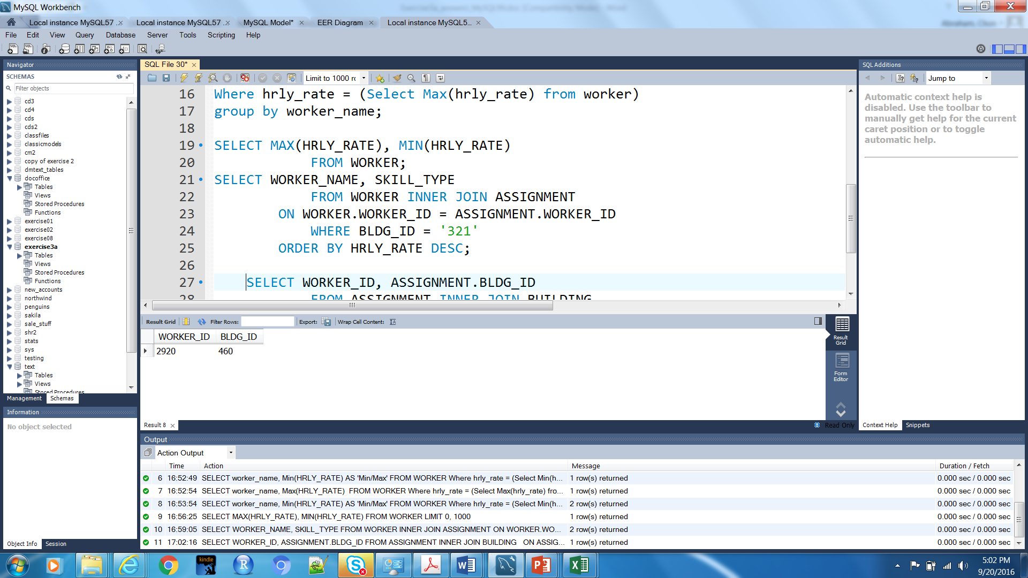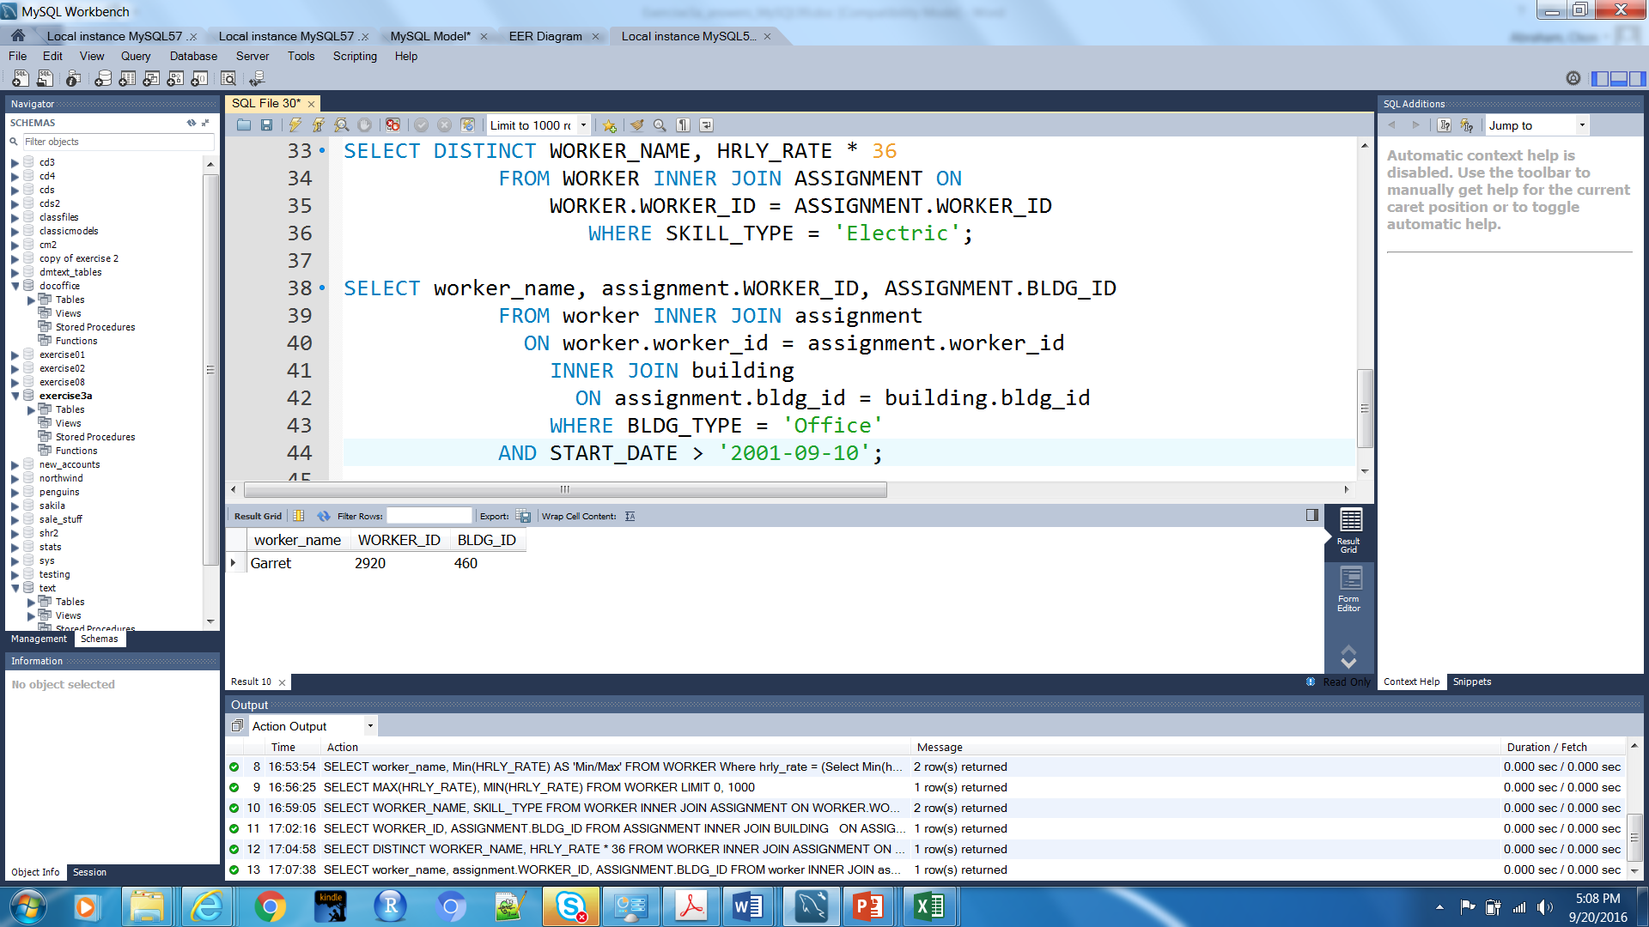

Q5. For each building quality level (BLDG_QLTY_LV), indicate the total number of workers assigned, only if this total number is greater than one. For the sample data show, your query should give the following result:

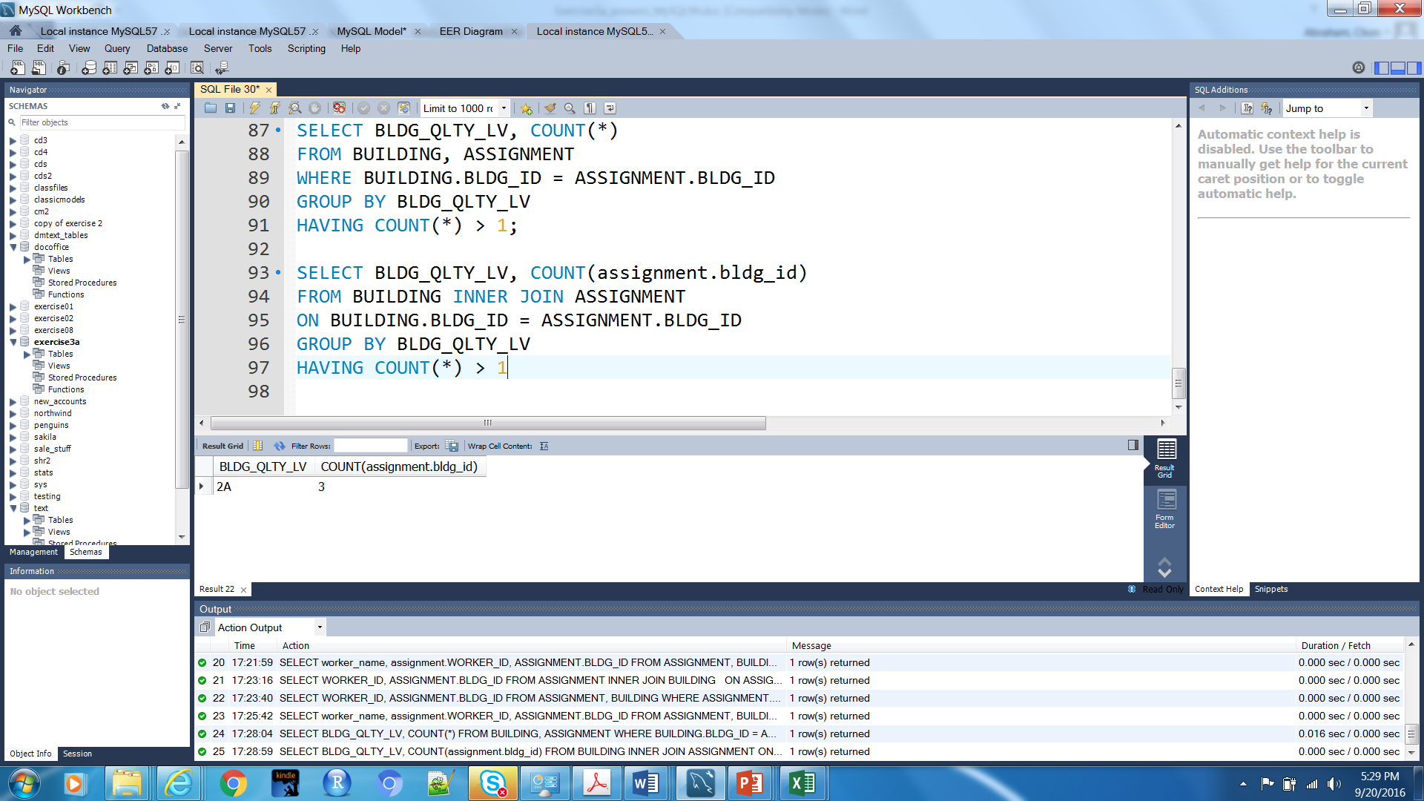

Q6. List the addresses of the buildings for which at least one assigned worker has either the “plumbing” or “electric” skill. Do not include any duplicate in the resulting addresses.

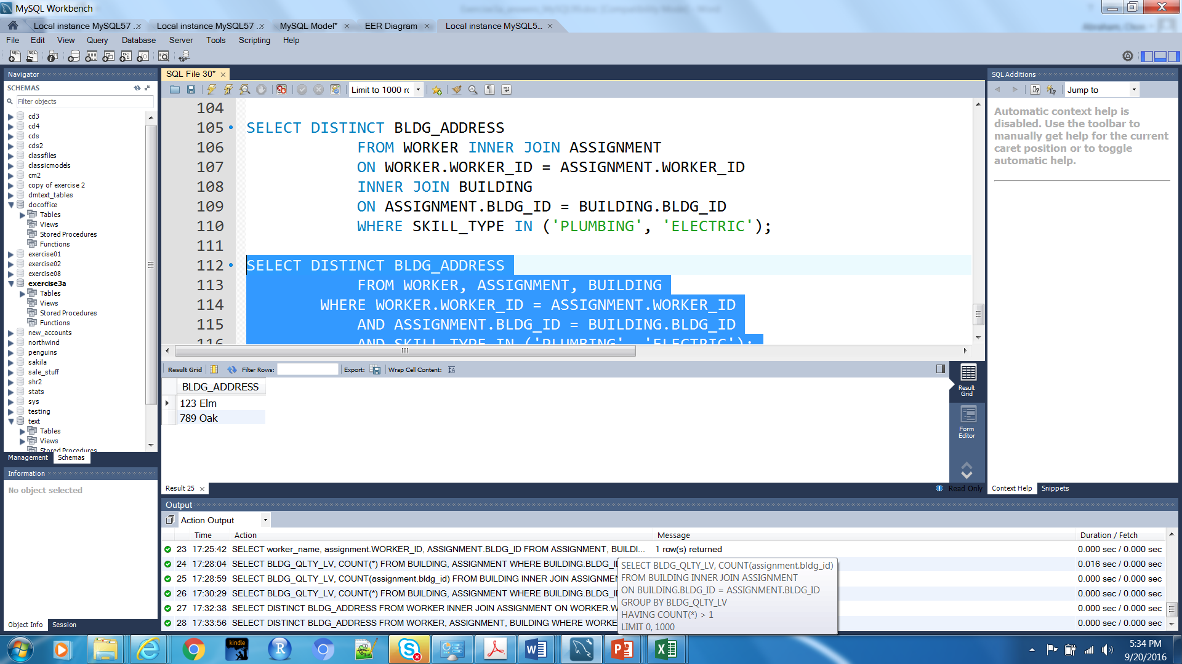

Q7. List the workers who get an hourly pay rate between $10 and $15 (inclusively) and work on an office building. Show the worker’s name and hourly pay rate.

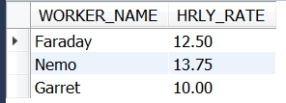

Q8: List the worker, assignment, and building information for workers who have been assigned to buildings but also display those building that have not been worked on. Try using an INNER and RIGHT JOIN. Make the results look like this:

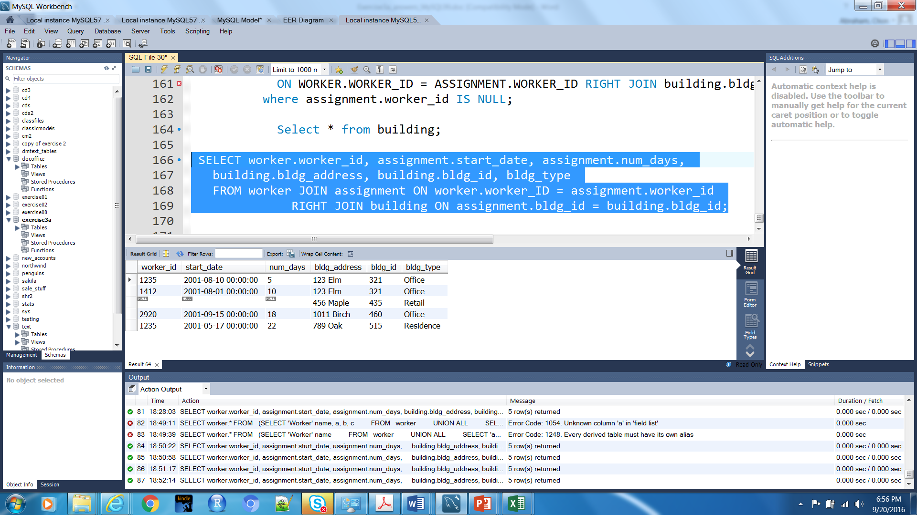

Q9: What are the restrictions with the current data model? How would you alter the data model to handle this issue? (Think about storing historical information.)

